Design for class “Order”
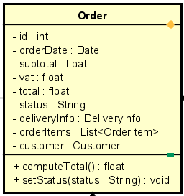
Table 1. Attribute Design
# | Name | Data type | Default value | Description
1 | id | int | 0 | Unique order ID
2 | orderDate | Date | current date | Timestamp when the order is created
3 | subtotal | float | 0.0 | Subtotal cost (sum of items)
4 | tax | float | 0.0 | VAT or additional tax
5 | total | float | 0.0 | Total amount after tax
6 | status | String | "CREATED" | Current order status
7 | deliveryInfo | DeliveryInfo | null | Associated delivery info
8 | orderItems | List | empty list | List of order items
9 | customer | Customer | null | Customer placing the order

Table 2. Operation Design
# | Name | Return type | Description / Purpose
1 | computeTotal() | float | Calculate subtotal + tax → total
2 | setStatus(status) | void | Update the order’s status

Method Design:
- computeTotal
- Parameter:

- Exception:

- Method:
  - subtotal = sum of all item.computeSubTotal().
  - total = subtotal + tax.
  - Return total.
- setStatus
- Parameter:
  - status: String

- Exception:

- Method:
  - Assign new status to order.
  - No return value.

