Design for class “OrderItem”
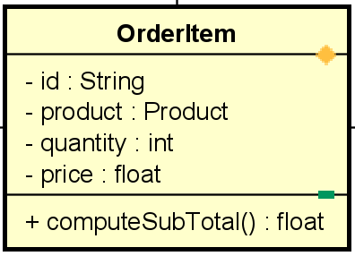
Table 1. Attribute Design
# | Name | Data type | Default value | Description
1 | id | String | "" | Unique item identifier
2 | product | Product | null | Associated product
3 | quantity | int | 1 | Selected quantity
4 | price | float | 0.0 | Unit price at order time

Table 2. Operation Design
# | Name | Return type | Description / Purpose
1 | computeSubTotal() | float | Compute quantity × price

Method Design:
- setController
- Parameter:

- Exception:

- Method:
  - Return quantity × price.

