Design for class “PayOrderController”
Inheritance of class “BaseController”
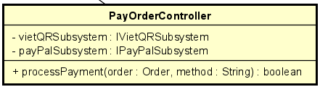
Table 1. Attribute Design
# | Name | Data type | Default value | Description
1 | vietQRSubsystem | IVietQRSubsystem | null | Subsystem used for generating and checking VietQR payment.
2 | payPalSubsystem | IPayPalSubsystem | null | Subsystem for PayPal payment processing.

Table 2. Operation Design
# | Name | Return type | Description
1 | processPayment(order, method) | boolean | Initiate payment using the selected method and return success or failure.

Method Design:
- processPayment
- Parameter:
  - order: Order - the order being paid.
  - method: String - "QR" or "PAYPAL".

- Exception:
  - PaymentFailureException if subsystem reports payment error.
  - UnsupportedPaymentMethodException if method is unknown.

- Method:
  - If method == "QR" → call vietQRSubsystem.createPayment(order).
  - Else if method == "PAYPAL" → call payPalSubsystem.process(order).
  - Wait for callback/confirmation if required.
  - Return true if payment succeeds.

