Design for class “PlaceOrderController”
Inheritance of class “BaseController”
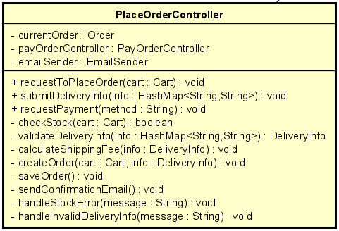
Table 1. Attribute Design
# | Name | Data type | Default value | Description
1 | currentOrder | Order | null | The order currently being created or processed.
2 | payOrderController | PayOrderController | null | Controller responsible for handling the payment sub-flow.

Table 2. Operation Design
# | Name | Return type | Description / Purpose
1 | requestToPlaceOrder(cart) | void | Start the order placement process by validating cart and checking stock.
2 | submitDeliveryInfo(info) | void | Validate delivery info and attach it to the order.
3 | requestPayment(method) | void | Initiate payment using the specified method (QR/PayPal).
4 | checkStock(cart) | boolean | Check if each product in cart has sufficient stock.
5 | validateDeliveryInfo(info) | DeliveryInfo | Validate and convert raw input info into a DeliveryInfo object.
6 | calculateShippingFee(info) | void | Compute delivery fee based on weight, province, or policy.
7 | createOrder(cart, info) | void | Create an Order object and assign subtotal, VAT, items.
8 | saveOrder() | void | Persist the newly created order to the database.
9 | sendConfirmationEmail() | void | Send an email notifying the user of the successful order.
10 | handleStockError  (message) | void | Present user with stock-related errors.
11 | handleInvalidDeliveryInfo  (message) | void | Present user with delivery-information errors.

Method Design:
- requestToPlaceOrder
- Parameter:
  - cart: Cart - the user’s current cart.

- Exception:
  - OutOfStockException if some products lack sufficient stock.

- Method:
  - Call checkStock(cart).
  - If false → call handleStockError(message).
  - If true → proceed to construct delivery info screen.
  - Store cart temporarily or prepare draft order.
- submitDeliveryInfo
- Parameter:
  - info: HashMap<String, String> — raw input fields from DeliveryInfoScreen.

- Exception:
  - InvalidDeliveryInfoException if any field is invalid or missing.

- Method:
  - Call validateDeliveryInfo(info) to get a DeliveryInfo object.
  - Call calculateShippingFee(deliveryInfo) to compute the shipping fee.
  - Call createOrder(cart, deliveryInfo) to form the full order.
  - Navigate to InvoiceScreen.
- requestPayment
- Parameter:
  - method: String — e.g., "QR" or "PAYPAL".

- Exception:
  - UnsupportedPaymentMethodException if method is not recognized.

- Method:
  - Call payOrderController.processPayment(currentOrder, method).
  - If success → save order & send confirmation email.
  - Navigate to SuccessfulOrderScreen.
  - If failure → show appropriate error message.
- checkStock
- Parameter:
  - cart: Cart

- Exception:

- Method:
  - For each OrderItem in cart:
    - Call product.checkStock(quantity).
  - Return true only when all items satisfy stock requirement.
- validateDeliveryInfo
- Parameter:
  - info: HashMap<String, String>
    - Return: DeliveryInfo

- Exception:
  - InvalidDeliveryInfoException if missing fields or wrong format.

- Method:
  - Validate name, phone number, address, province.
  - Construct and return DeliveryInfo object.
- calculateShippingFee
- Parameter:
  - info: DeliveryInfo

- Exception:

- Method:
  - Compute shipping fee based on weight, province, or rule.
  - Assign to info.fee.
- createOrder
- Parameter:
  - cart: Cart
  - info: DeliveryInfo

- Exception:

- Method:
  - Instantiate currentOrder.
  - Copy items from cart to orderItems.
  - Compute subtotal, vat, total.
  - Attach DeliveryInfo to order.
- saveOrder
- Parameter:

- Exception:
  - DatabaseWriteException if saving fails.

- Method:
  - Persist order to database.
  - Update product stock.
- sendConfirmationEmail
- Parameter:

- Exception:
  - EmailSendFailureException

- Method:
  - Build email content summarizing the order.
  - Invoke email subsystem to send.
- handleStockError
- Parameter:
  - message: String

- Exception:

- Method:
  - Display error dialog.
  - Ensure user remains on CartScreen.
- handleInvalidDeliveryInfo
- Parameter:
  - message: String

- Exception:

- Method:
  - Show invalid info message on DeliveryInfoScreen.

