Design for class “Product”
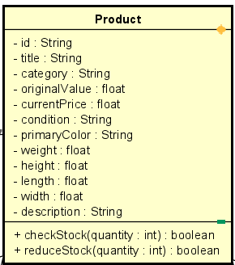
Table 1. Attribute Design
# | Name | Data type | Default value | Description
1 | id | String | "" | The unique identifier of the product
2 | name | String | "" | Display name of the product
3 | category | String | "" | Category/type to which this product belongs
4 | originalValue | float | 0.0 | Original/base value of the product
5 | currentPrice | float | 0.0 | Current selling price of the product
6 | condition | String | "" | New/used/like new… condition of the product
7 | manufacturer | String | "" | Manufacturer or production brand
8 | weight | float | 0.0 | Physical weight of the product
9 | height | float | 0.0 | Physical height (dimension)
10 | length | float | 0.0 | Physical length (dimension)
11 | width | float | 0.0 | Physical width (dimension)
12 | description | String | "" | Short textual description of the product

Table 2. Operation Design
# | Name | Return type | Description / Purpose
1 | checkStock(quantity) | boolean | Check whether the available stock is sufficient
2 | reduceStock(quantity) | boolean | Reduce the stock by given quantity after purchase

Method Design:
- checkStock
- Parameter:
  - quantity: int. The required quantity of the product.

- Exception:

- Method:
  - Check whether the product’s stock is greater than or equal to quantity.
  - If stock is enough → return true.
  - Else → return false.
- reduceStock
- Parameter:
  - quantity: int. The amount to reduce from product stock.

- Exception:

- Method:
  - Call checkStock(quantity).
  - If false → return false.
  - Else subtract quantity from stock.
  - Save the updated product stock to database.
  - Return true.

