Design for class “SuccessfulOrderScreen”
Inheritance of class “CustomerScreen”
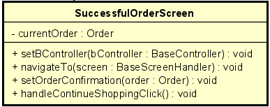
Table 1. Attribute Design
# | Name | Data type | Default value | Description
1 | currentOrder | Order | null | The finalized completed order.

Table 2. Operation Design
# | Name | Return type | Description
1 | setOrderConfirmation(order) | void | Display success message for this order.
2 | handleContinueShoppingClick() | void | Navigate back to product browsing.

Method Design:
- setOrderConfirmation
- Parameter:
  - order: Order - the confirmed order to display.

- Exception:

- Method:
  - Store currentOrder = order.
  - Populate UI elements with order confirmation number, order summary, estimated delivery.
  - Optionally display a “Download/Print Invoice” button bound to the order.
- handleContinueShoppingClick
- Parameter:

- Exception:

- Method:
  - Perform navigation to the product listing or home screen: call navigateTo(homeScreen) or equivalent.
  - Clear temporary UI state related to the completed order (optionally clear cart).
  - If needed, call BaseController or PlaceOrderController callbacks to refresh product list or cart information.

