PART1

1. Write method reverse the stack
2. Write a method stutter that takes a stack of integers as a parameter and replaces every value in the stack with two occurrences of that value. For example, suppose the stack stores these values:

bottom [3, 7, 1, 14, 9] top

Then the stack should store these values after the method terminates:

bottom [3, 3, 7, 7, 1, 1, 14, 14, 9, 9] top

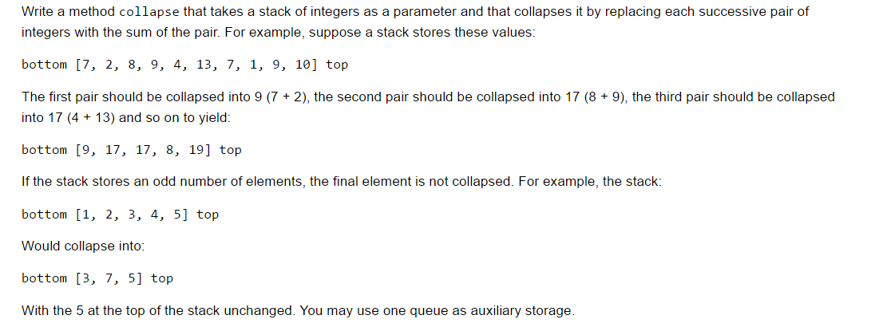

1. Write a method equals that takes as parameters two stacks of integers and returns true if the two stacks are equal and that returns false otherwise. To be considered equal, the two stacks would have to store the same sequence of integer values in the same order. Your method is to examine the two stacks but must return them to their original state before terminating. You may use one stack as auxiliary storage.
2. Question

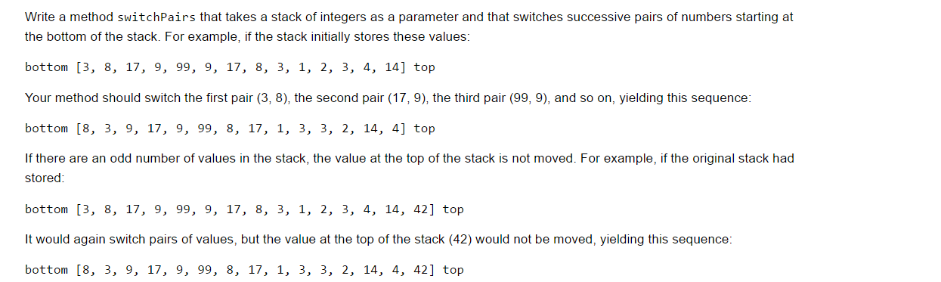

1. Question

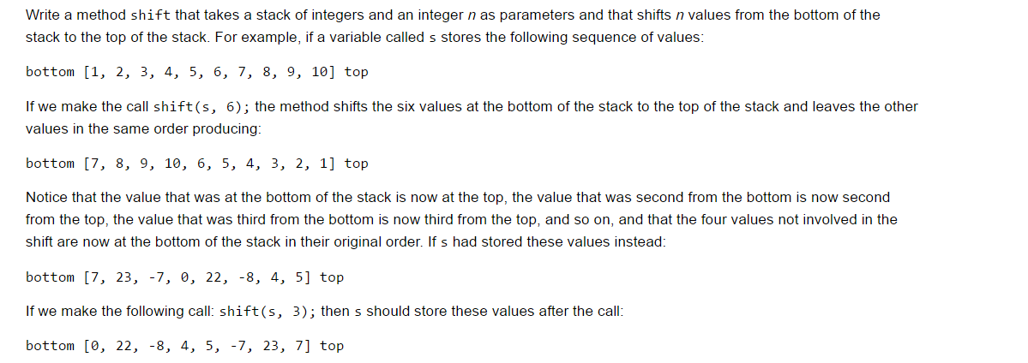

1. Question

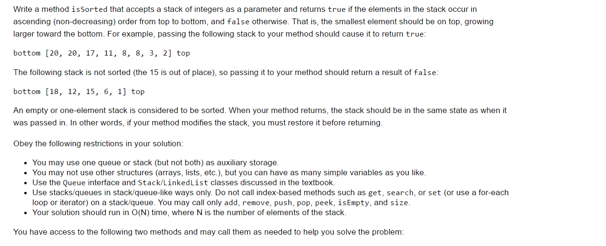

1. Question

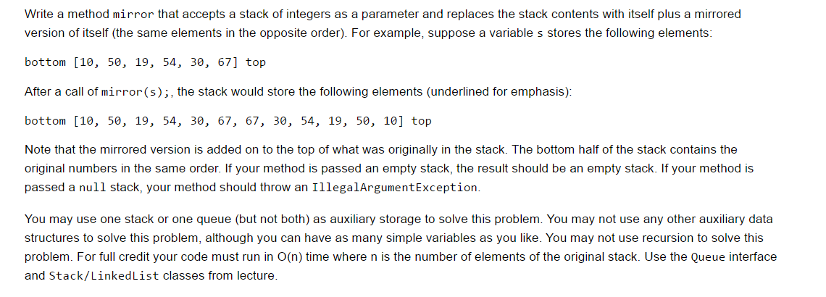

1. Question

