**Research about Transmission Control Protocol** **and Network Simulation**

Nguyen Thu Trang, Nguyen Ngoc Hai, Nguyen Ngoc Huy, Tong Minh Tuan

# **Introduction**

The text-chat system is a simple chat program using TCP service written by JAVA language. This software helps people to communicate with each other. The software has 2 parts: the first one is controller installed on server and the last one is chat program installed on client.

Network Simulation is a technique where a program models the behavior of a network either by calculating the interaction between the different network entities using mathematical formulas, or actually capturing and playing back observations from a production network.

# **Overall description**

## **The text-chat system**

The program is aimed toward small group users who want to communicate with each other for many purposes such as: chatting, work, share information … This software will share content from client with any client connecting to server. This is not a chat system between 2 people, just active for group. It’s quite easy to use and simple to design. It runs on any operating system that has internet and web browsing.

## **Network Simulation**

A network simulator is a software program that imitates the working of a computer network. In simulators, the computer network is typically modeled with devices, traffic, … and the performance is analyzed. Typically, users can then customize the simulator to fulfill their specific analysis needs. The notable network simulators available are NS-2 and OPNET and others.

# **Software Features**

## **The text-chat system**

1. Server controller

Server controller work by TCP/IP protocol, server controller has an IP address and will accept all connection from client

Server has 2 functions: Receive and transfer all data from client to any client.

* 1. Server interface

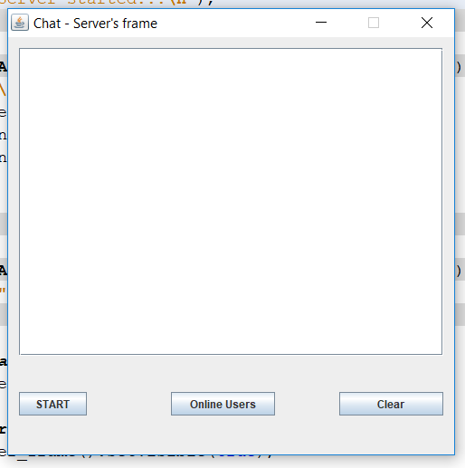

This is server interface include :

If you click on START button, server will start and waiting for connection from client.

Online Users button display all users connecting to server

Clear button clear log screen.

* 1. **Demo run server**

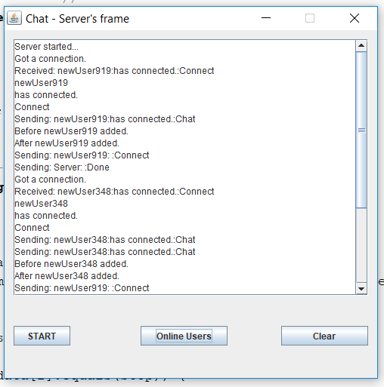

Server started and accept connection from user.

1. **Client chat program**

Client program work by TCP/IP protocol, only connecting to server.

Client program has 2 functions: Receive and transfer all data to server.

* 1. Client interface

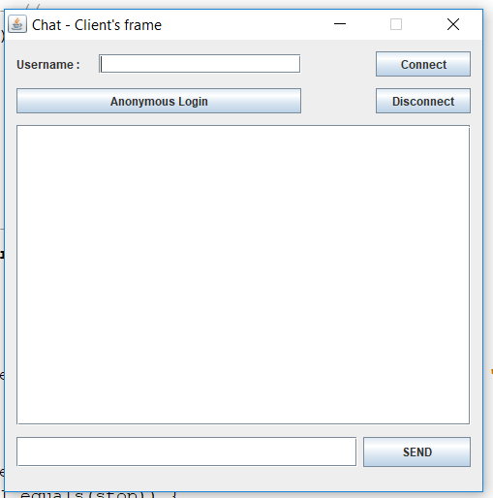

This is user interface include:

Connect button is to connect client with server.

Disconnect is to disconnect between client and server.

Send button is to transfer data from client to server.

Anonymous Login button create an random username and connect to server.

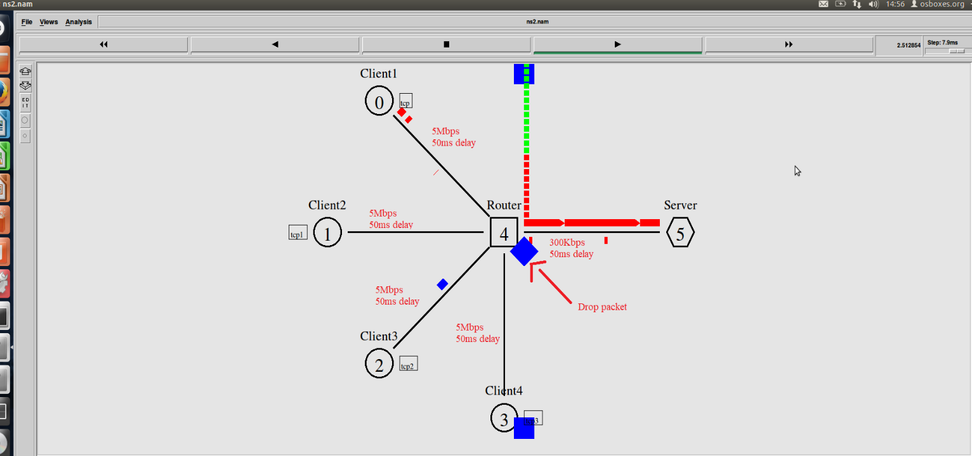**2.2 Demo run client**

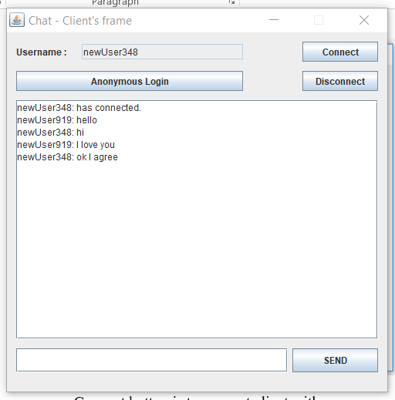

Connect to server successful and chat with another client

## **Network Simulation**

1. **Analyzing simulation**

In this project, we use ns2 to simulate how packets were sent from clients to server.

The network consists of 4 client nodes (0, 1, 2, 4), 1 router node (4) and 1 server node (5). All duplex-links between clients and router are the same, with 5Mbps of bandwidth, 50ms of delay and DropTail queue (actually useless because clients are hosts). Also, the duplex-link between router and server has 300kbps of bandwidth, 50ms of delay and DropTail queue. The smaller bandwidth on router-server link makes it the bottleneck.

We set the queue at router to contain maximum 20 packet so that packet drop event could exist 🡪 packet retransmit. TCP agents are attached to all clients **and a connection is established to a “TCPSink" agent attached to** server in order to establish TCP connection between client and server. TCPSink agent at server sends ACK packets back to clients and also frees reveive packet. As default, the maximum size of a packet that a "TCP" agent can generate is 1000bytes. A "TCPSink" agent generates and sends ACK packets to the sender (tcp agent) and frees the received packets. The ftp is set to start at 0.50 sec and stop at 28.5 sec.

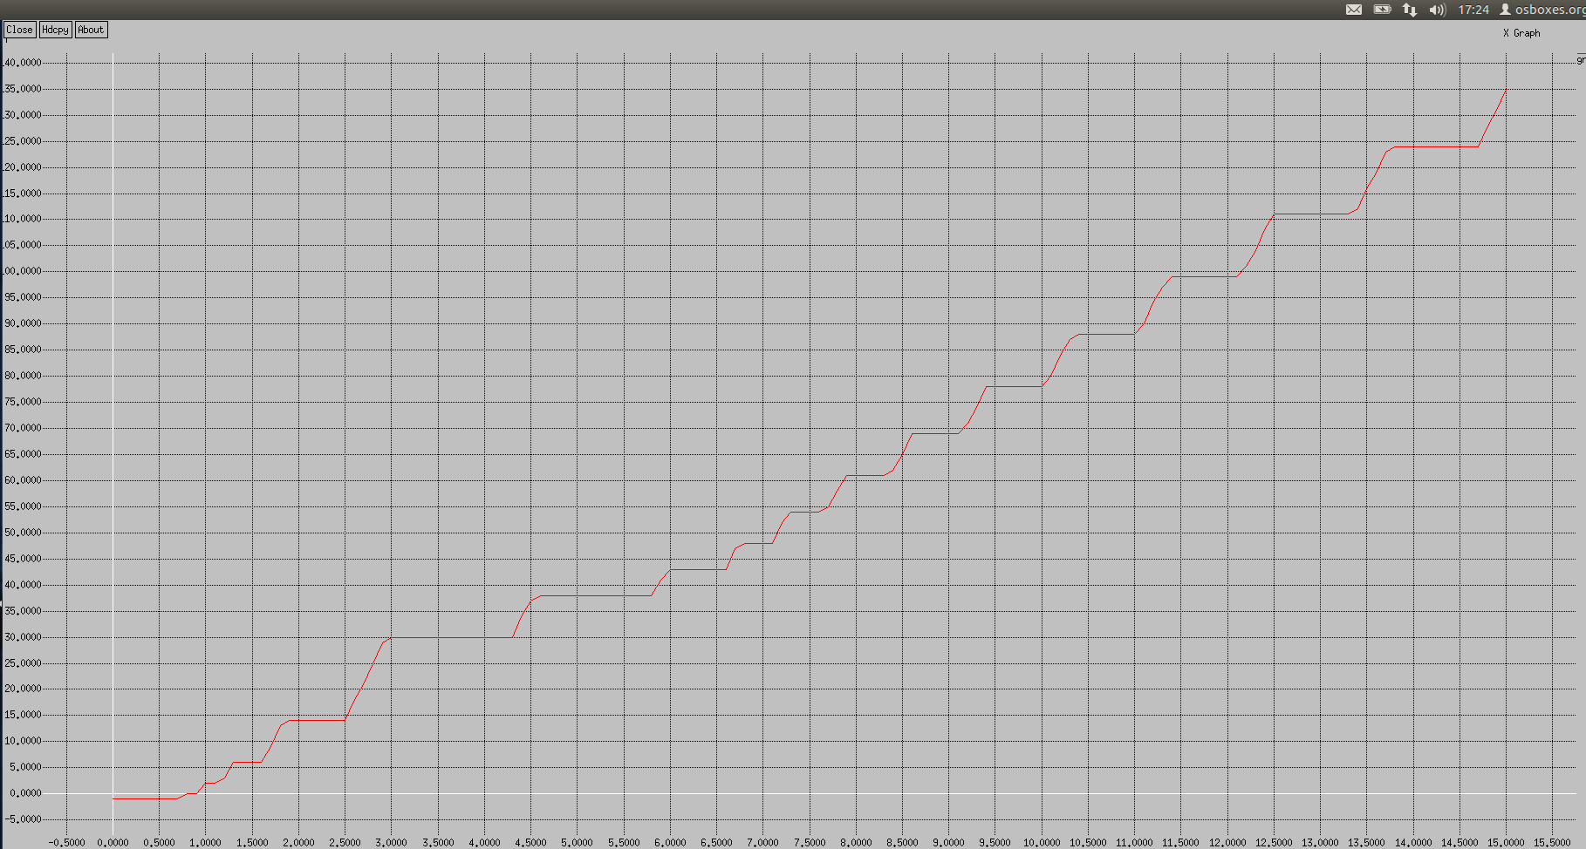

1. **Evaluation graph**

The graph below is generate by xgraph to examine the ack values of TCP connection between client 1 (node 0) and server:

Because the maximum value of ACK packet is 200, we could conclude that the number of successful sent packets is 201 (the beginning ack is 0). Since the total number of sent packets at client 1 is about $\frac{50 packets/\sec{ × 28 secs} }{4 (number of clients)}$ $≈$ 350 (note that 50 packets/sec is bottleneck bandwidth, 28 seconds is the tranmission time – FTP start sending at T = 0.5 and stop at T = 28.5), so this is about an 82% goodput.

# **conclusion**

The text-chat system is a simple program base on TCP protocol. Some advantages of it is that is easy to use, simple to design, rarely to make error and only depend on internet bandwidth. However, this system cannot be popular and widely-used because it don’t any security operation, difficult to share important information and only uses for small group.

Network simulation helps us visualize the process of a system by simulating the process. Shows how the clients move to reach the server. It makes the system clearer.

# **REFERENCES**

# [1]T S Pradeep Kumar, "Print the Congestion Window Graph”, <https://www.nsnam.com/2013/04/printcongestion-window-graph-in-ns2.html>, April 23, 2013.

# [2]Peter L Dordal, “Department of Computer Science”, 16 Network Simulations: ns-2, <http://intronetworks.cs.luc.edu/current/html/ns.html?fbclid=IWAR3PGUZpRrWulubGT31YVXHkud6wWsliqAuFNQZ8EF4z8cy3V6TEBh3HvQ#network-simulations-ns-2>.

[3]Kurose Ross, "Telnet: A Case Study for Sequence and Acknowledgment Numbers", Computer

Networking A Top Down Approach - 6th edition.