
Requirement & Design Specification
AI-powered Viva Exam System (AIVES)
Subject: SWD392
Version: 1.0
– Ho Chi Minh City, November 2026 –

Record of Changes
Version | Date | A* M, D | In charge | Change Description
V1.0 | 06/11 | A | Tuấn | Part 1: requirement (NCN7), analysis, high-level design, mapping and alternative architectures
*A - Added M - Modified D - Deleted

Contents
I. Requirement Specification 4
I.1 Problem description 4
I.2 Major Features 4
I.3 System context 5
I.4 Nonfunctional Requirements 5
I.5 Functional requirements 5
I.5.1 Use case diagrams 7
I.5.2 Use case descriptions 10
I.5.3 Activity diagrams 14
I.6 Data Requirements 19
II. Analysis models 21
II.1 Interaction diagrams 21
II.2 State diagram 25
III. Design specification 29
III.1 Integrated Communication Diagrams 29
III.2 System High-Level Design 31
III.3 Component and Package Diagram 32
III.4 Detail Design 33
III.5 Database Design 38
IV. Implementation 43
IV.1 Map architecture to the structure of the project 43
IV.2 Map Class Diagram and Interaction Diagram to Code 44
V. Applying Alternative Architecture Patterns 46
V.1 Applying the service-oriented architecture 46
V.2 Applying Service Discovery Pattern in the service-oriented architecture 47

I. Requirement Specification

I.1 Problem description
Purpose: Build AIVES, a web-based system that supports oral (viva) examinations. Lecturers manage the question bank and rubrics and run the exam sessions; students take an AI-led viva interview by voice; the system transcribes the answers, evaluates them against the rubric and gives lecturers grading suggestions that the lecturer reviews and confirms. Administrators manage accounts, roles, courses and the assignment of lecturers to courses. The system requirements are described as follows:
1. The administrator creates accounts for lecturers and students. Each account has a user code, full name, e-mail and one role (ADMIN, LECTURER or STUDENT). The system sends the account information and a temporary password to the user by e-mail.
2. The administrator can view, search, update and delete accounts, and can reset a user's password.
3. The administrator manages courses (course code, course name, department) and assigns lecturers to courses. Only users with the lecturer role can be assigned.
4. On first login with a temporary password the user must change the password before using any other function.
5. Lecturers manage the question bank and rubrics of their courses, create exams and monitor the viva sessions of their students.
6. Students attend the viva session: the AI asks questions by voice, the student answers by voice and the system transcribes the answer.
7. The system evaluates each answer against the rubric and gives the lecturer a suggested score and comments; the final score is decided by the lecturer.

I.2 Major Features

I.2.1 Features for lecturers are as follows
- F01: Question bank and rubric management (module 1).
- F02: Exam management and student registration (module 2).
- F03: Monitor viva sessions and review transcripts (module 3).
- F04: Review AI grading suggestions and confirm final scores (module 4).

I.2.2 Features for students are as follows
- F05: Take the viva interview: listen to the AI question, answer by voice, see the live transcript.
- F06: View the result after the lecturer confirms the score.

I.2.3 Features for administrators are as follows
- F07: Account management: create, view/search, update, delete users, reset password and send the account e-mail.
- F08: Course management: create, view/search, update and delete courses.
- F09: Lecturer assignment: assign / unassign lecturers to courses, view the lecturers of a course and the courses of a lecturer.
- F10: Authentication: log in, change password (mandatory at first login), view the current user.

I.3 System context
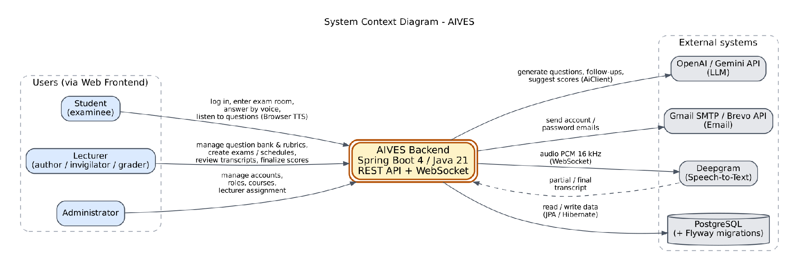
Figure I-1 System context diagram
Figure I-1 shows the system context of AIVES. External users are the Lecturer, the Student and the Administrator. External systems are the speech-to-text service (Deepgram), the generative AI services (OpenAI / Gemini, called through the AiClient interface), the mail service (Gmail SMTP or Brevo) and the PostgreSQL database. Text-to-speech is performed by the browser of the student.

I.4 Nonfunctional Requirements
NF-01 Maintainability: layered architecture organised by feature (Controller → Service → Repository), AI and speech providers hidden behind interfaces, schema changes only through Flyway migrations.
NF-02 Performance: the delay between the end of a student's answer and the next AI question should stay short enough for a natural conversation; speech is streamed (PCM 16 kHz over WebSocket).
NF-03 Accuracy: speech recognition is configured for Vietnamese (Deepgram nova-3, language vi).
NF-04 Security and privacy: JWT authentication, role-based access (/api/admin/** only for ADMIN), BCrypt password hashing, recordings and transcripts accessible only to authorised users.
NF-05 Human in the loop: AI results are only suggestions; the lecturer confirms every final score.

I.5 Functional requirements
AIVES covers account administration, course-scoped question and rubric preparation, examination scheduling, spoken interview execution and lecturer approval of AI-assisted grades. The requirements below follow that workflow.
ID |  | Observed functional baseline
FR-QBR-01 |  | The system authenticates requests and restricts course resources to assigned Lecturers or Administrators, except the authenticated template endpoint.
FR-QBR-02 |  | The system searches course questions by status, Bloom level and case-insensitive content keyword, returns a page ordered by latest update, and retrieves details.
FR-QBR-03 |  | The system creates manual questions in DRAFT with required course, nonblank content and Bloom level, plus optional same-course rubric.
FR-QBR-04 |  | The system replaces submitted question details, retaining its creator and resetting status to DRAFT; cross-course movement requires access to both courses.
FR-QBR-05 |  | The system sets an existing authorized question to APPROVED, including repeated approval; downstream exam selection considers only approved in-course questions.
FR-QBR-06 |  | The system removes a question only when no question attempt references it.
FR-QBR-07 |  | The system supplies an XLSX template and validates first-sheet import rows before saving any; any row validation error yields count zero and row feedback.
FR-QBR-08 |  | The system generates 1–20 draft questions from eligible indexed course sources, defaults missing Bloom selection to UNDERSTAND, and links generated questions to selected source records.
FR-QBR-09 |  | The system returns course rubric lists and details, including criteria and derived total maximum score.
FR-QBR-10 |  | The system creates a course rubric with a nonempty criterion collection and validates names and positive minimum maximum-score values.
FR-QBR-11 |  | The system replaces a rubric's details and full criterion set; it does not implement rubric versioning or a used-rubric edit block.
FR-QBR-12 |  | The system removes a rubric only when no question references it and cascades removal to owned criteria.
FR-QBR-13 |  | The system stores and extracts PDF/DOCX/PPTX source uploads within the configured service size limit and records READY or FAILED after synchronous indexing.
FR-QBR-14 |  | The system lists source document metadata and indexing outcomes without exposing extracted text or provider IDs in DocumentResponse.
FR-QBR-15 |  | The system blocks deletion of a source referenced by generated questions; otherwise it removes provider file, local file and database record in that order.
FR-QBR-16 |  | The system returns structured resource/validation/business errors; import row errors and FAILED indexing are carried in otherwise successful HTTP responses.
Requirement | Use case |  | Primary actor
FR EM 01 | UC EM 01 Browse examinations |  | Lecturer
FR EM 02 | UC EM 02 Create an examination |  | Lecturer
FR EM 03 | UC EM 03 Revise examination information |  | Lecturer
FR EM 04 | UC EM 04 Configure a permitted question pool |  | Lecturer
FR EM 05 | UC EM 05 Assign candidates |  | Lecturer
FR EM 06 | UC EM 06 Allocate schedules and assigned questions |  | Lecturer
FR EM 07 | UC EM 07 Reschedule one candidate |  | Lecturer
FR EM 08 | UC EM 08 Monitor and recover attempts |  | Lecturer
FR EM 09 | UC EM 09 View a personal schedule |  | Student
FR EM 10 | UC EM 10 View a personal slot and hand off to interview |  | Student

I.5.1 Use case diagrams
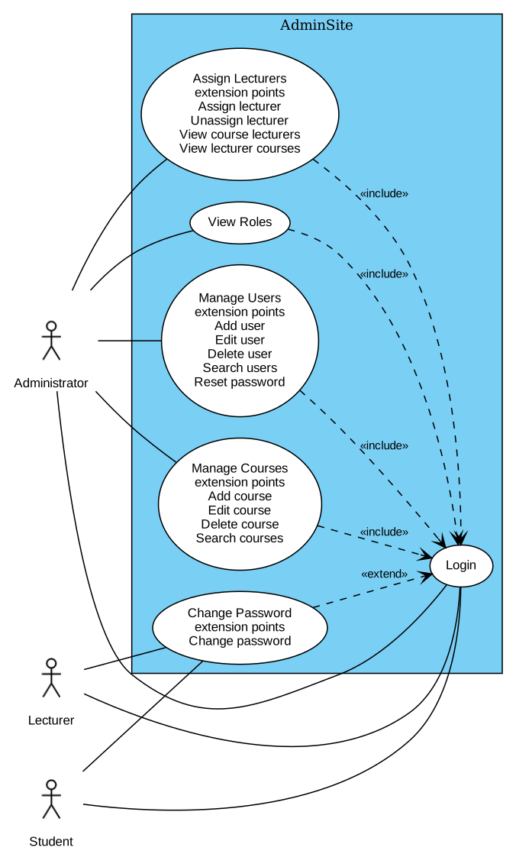
Figure I-2 Overview Use Case Diagram of Admin Site
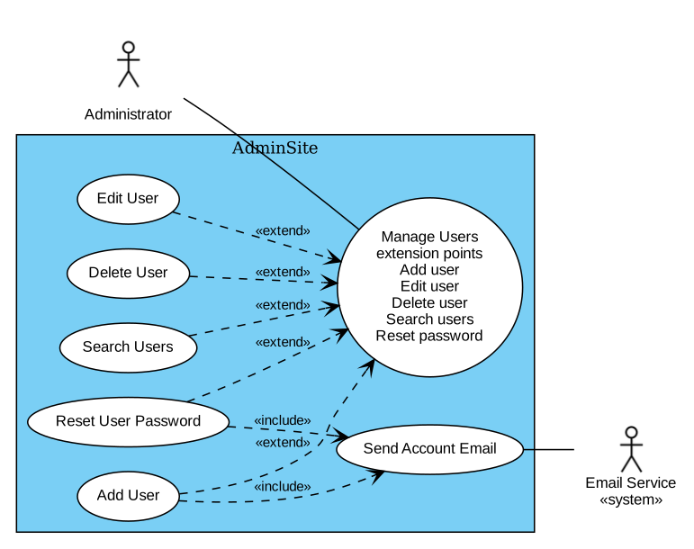
Figure I-3 Detailed Use Case Diagram for Manage Users
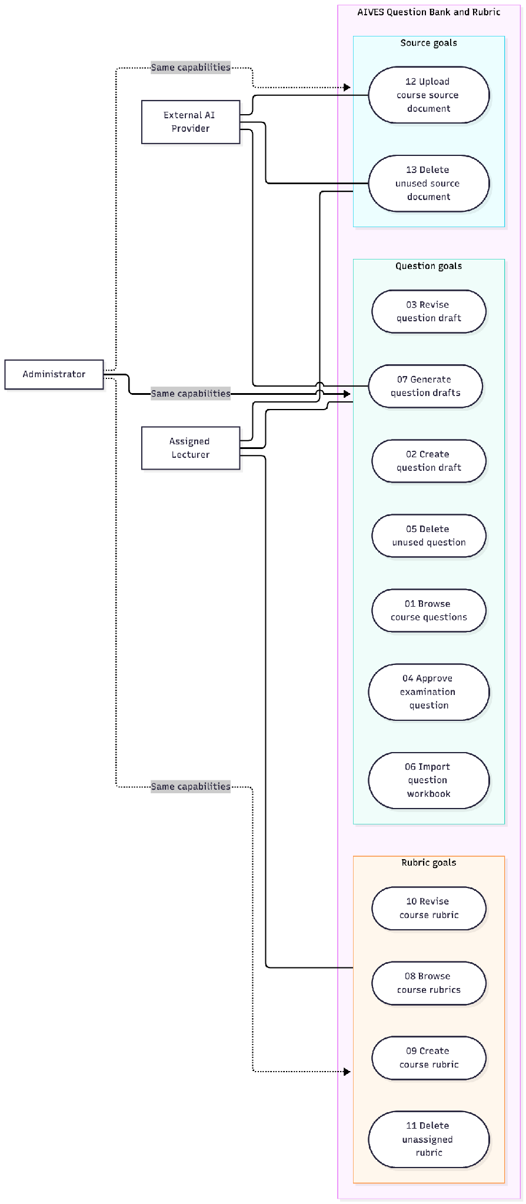
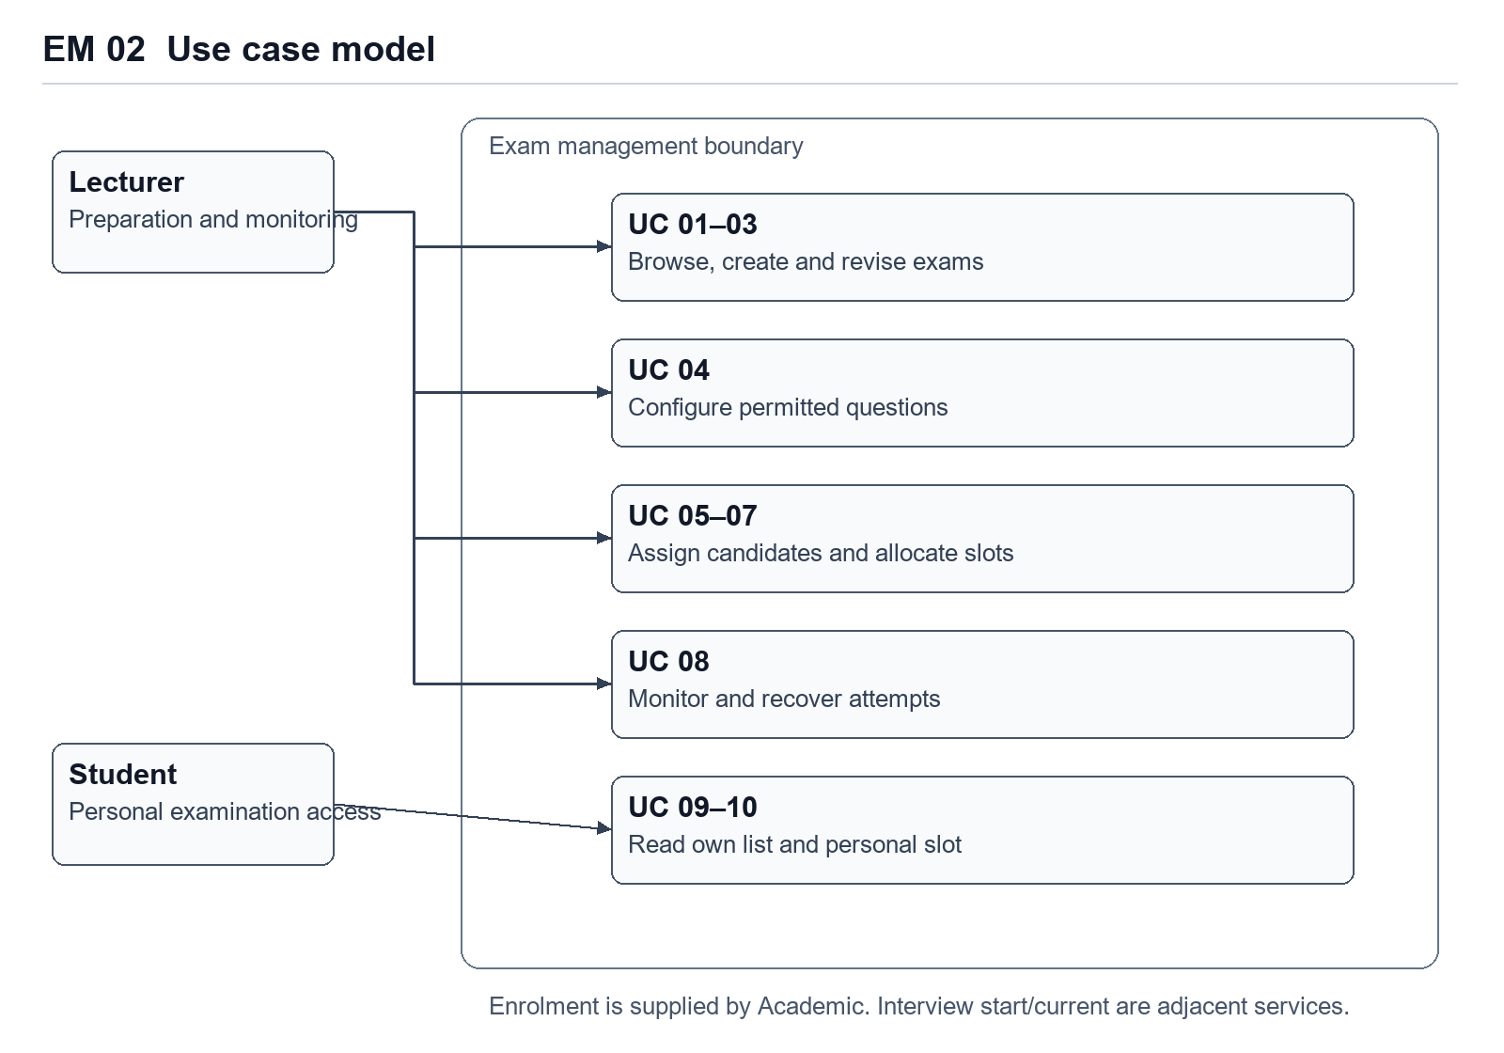
Figure EM 02. Use case relationships. Course enrolment is an academic prerequisite. Starting the interview belongs to the adjacent interview module.
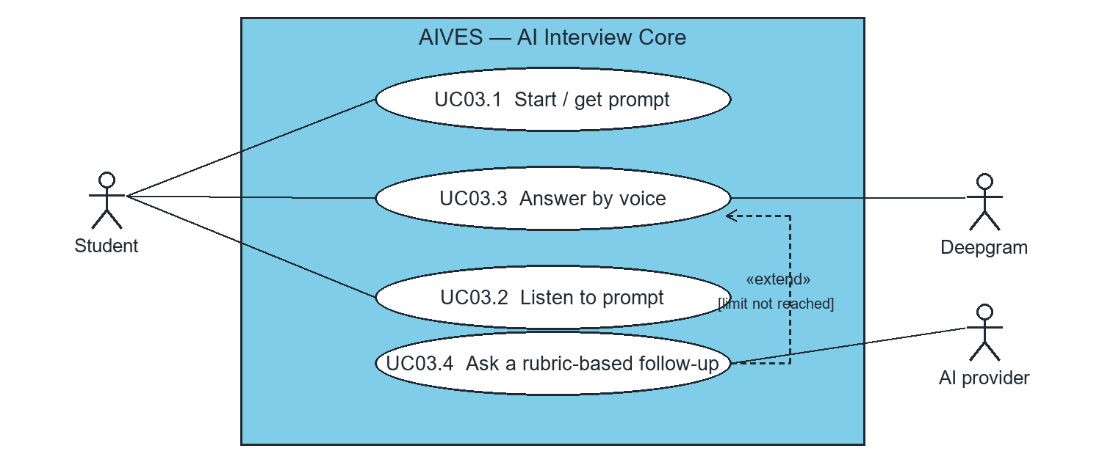
Figure 1. Use cases for the AI Interview Core.

I.5.2 Use case descriptions

Administration and authentication
Use case | Goal | Result or guard
UC-01 | Manage users | List accounts with role and keyword filters.
UC-02 | Add user | Validate unique user code and email, assign a valid role and send the temporary credentials.
UC-03 | Edit user | Validate and save changes to the selected account.
UC-04 | Delete user | Confirm deletion and enforce applicable integrity rules.
UC-05 | Assign lecturer to course | Verify the course and lecturer role before assigning the account.
UC-06 | Change password | Verify the current password, store a new hash and clear the first-login restriction.

Representative administration flows
Table I-2 Use case description for Add User
ID and Name: | UC-02 Add user
Created By: | Vinh Date Created: 06/11/2026
Primary Actor: | Administrator (Admin) Secondary Actors: Mail service
Description: | This use case allows the Administrator to create a new user account.
Trigger: | The Admin selects the Add User option from the Manage Users section.
Preconditions: | PRE-1. The Administrator is logged into AIVES.  PRE-2. The Administrator is authorized (role ADMIN) and has already changed the temporary password.
Postconditions: | POST-1. Successful addition: the new user is saved, an account e-mail is sent and the user list is updated.  POST-2. Unsuccessful addition: the system shows feedback to the Admin and no user is created.
Normal Flow: | 1. The Admin selects Add User from the Manage Users section.  2. The system displays the add user form.  3. The system retrieves the list of roles and fills the role dropdown.  4. The Admin fills in userCode, fullName, email, initial password and selects a role (See A4.1).  5. The Admin submits "add user".  6. The system validates the input data (See E6.1).  7. The system checks that the e-mail and user code are unique and that the role is valid (See E7.1).  8. The system saves the user with mustChangePassword = true and sends the account e-mail (user code and temporary password) to the user.  9. The system displays a confirmation message that the user was added successfully.
Alternative Flows: | A4.1 Select Cancel (Step 4)  1. The Admin selects the Cancel button.  2. The system closes the Add User screen and returns to the Manage Users screen.
Exceptions: | E6.1 Invalid Data (Step 6): the system returns 400 with the error of each field and prompts the Admin to correct the data.  E7.1 Duplicate or invalid (Step 7): the e-mail or user code already exists (409) or the role is invalid (400); the system displays an error message.
Priority: | High
Business Rules: | BR-1. User code and e-mail must be unique.  BR-2. The role must be ADMIN, LECTURER or STUDENT.  BR-3. A new account must change the password at first login (mustChangePassword = true); the password is stored hashed (BCrypt).
Table I-6 Use case description for Change Password
ID and Name: | UC-06 Change password
Created By: | Vinh Date Created: 06/11/2026
Primary Actor: | Lecturer, Student, Administrator (User)
Description: | This use case allows a user to change the password; it is mandatory at the first login with a temporary password.
Trigger: | The user logs in with a temporary password, or selects Change Password.
Preconditions: | PRE-1. The user has an account in the system.  PRE-2. The user knows the current (temporary) password.
Postconditions: | POST-1. Successful change: the new password is stored and mustChangePassword = false.  POST-2. Unsuccessful change: the password is not changed.
Normal Flow: | 1. The user enters the account and the temporary password and submits login.  2. The system authenticates the user and returns an access token (mustChangePassword = true); until the password is changed the other APIs answer 428.  3. The system displays the change password form.  4. The user enters the current password and the new password.  5. The user submits "change password".  6. The system validates the current password (See E6.1) and updates the password.  7. The system displays a success message and asks the user to log in again.
Alternative Flows:
Exceptions: | E6.1 Wrong current password or invalid new password (Step 6): the system displays an error message.
Priority: | High
Business Rules: | BR-1. While mustChangePassword = true, all requests except login and change password are rejected with 428.

Question bank and rubric
Use case | Goal | Result or guard
UC-QBR-01 | Browse course questions | Return the filtered, course-scoped question list.
UC-QBR-02 | Create a question draft | Validate question fields and source references before storing a draft.
UC-QBR-03 | Revise a question draft | Update a permitted draft in the selected course.
UC-QBR-04 | Approve a question | Make the question eligible for examination allocation.
UC-QBR-05 | Delete an unused question | Reject deletion while dependent examination records exist.
UC-QBR-06 | Import a workbook | Validate and import workbook questions under the course.
UC-QBR-07 | Generate AI drafts | Generate candidate questions from eligible source documents and save them as drafts.
UC-QBR-08 | Browse rubrics | List course rubrics and their criteria.
UC-QBR-09 | Create a rubric | Store the rubric definition and weighted criteria.
UC-QBR-10 | Revise a rubric | Replace permitted criteria within a transaction.
UC-QBR-11 | Delete an unassigned rubric | Reject deletion when the rubric is referenced.
UC-QBR-12 | Upload a source | Store the course document and track indexing status.
UC-QBR-13 | Delete an unused source | Check dependencies before removing the document.

Examination management
Use case | Goal | Result or guard
UC-EM-01 | Browse exams | Filter and page the permitted catalogue.
UC-EM-02 | Create an exam | Store the course-linked exam definition and configuration.
UC-EM-03 | Revise exam information | Validate changes against the exam state.
UC-EM-04 | Configure a question pool | Select eligible questions and validate the pool against the exam configuration.
UC-EM-05 | Assign candidates | Create personal attempts for valid candidates.
UC-EM-06 | Allocate schedules and questions | Assign time slots and main questions to candidate attempts.
UC-EM-07 | Reschedule one candidate | Change a permitted slot without modifying unrelated attempts.
UC-EM-08 | Monitor and recover attempts | Inspect candidate progress and apply permitted recovery actions.
UC-EM-09 | View personal schedule | List slots belonging to the authenticated student.
UC-EM-10 | Open a personal slot | Confirm ownership and readiness before handoff to the interview.

Interview execution and grading
Use case | Goal | Result or guard
UC-VG-01 | Start an interview | Check ownership, readiness and assigned questions before opening the first turn.
UC-VG-02 | Deliver a prompt | Return the current prompt for browser text-to-speech.
UC-VG-03 | Submit a spoken answer | Transcribe speech and submit the answer against the current prompt identifier.
UC-VG-04 | Generate a follow-up | Choose a rubric-guided follow-up while the turn budget allows.
UC-VG-05 | Handle a timeout | Check the server deadline and apply the timeout transition.
UC-VG-06 | Complete a question attempt | Advance to the next question or finish the interview.
UC-VG-07 | Compute an AI evaluation | Match transcript evidence to rubric criteria and persist the suggested result.
UC-VG-08 | Review transcript and score | Show transcript evidence, criteria and AI feedback to the lecturer.
UC-VG-09 | Override and finalize a grade | Record the lecturer decision and make the confirmed result available.
UC-VG-10 | View published results | Show the released result to its student.

I.5.3 Activity diagrams
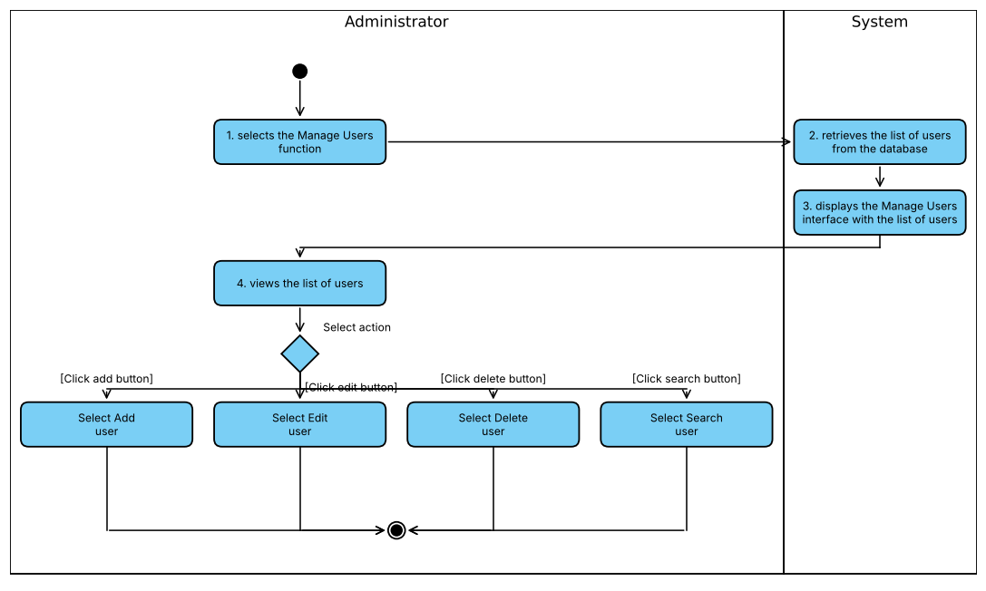
Figure I-5 Activity diagram modeling event flows of use case Manage Users

ACT 01 Browse questions and rubrics UC 01 08
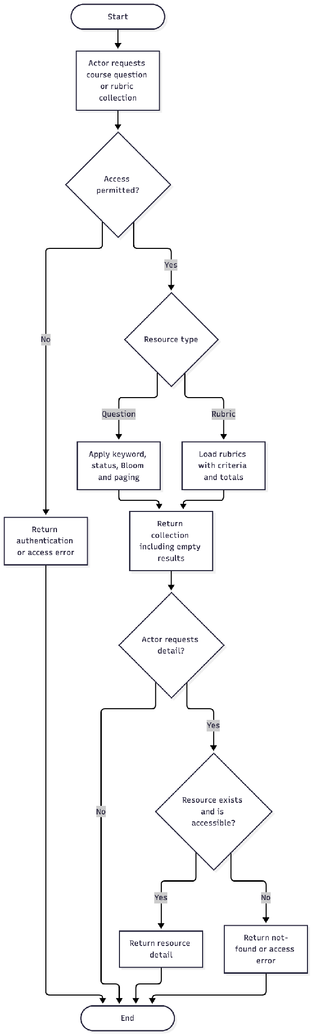

ACT 05 Generate drafts UC 07
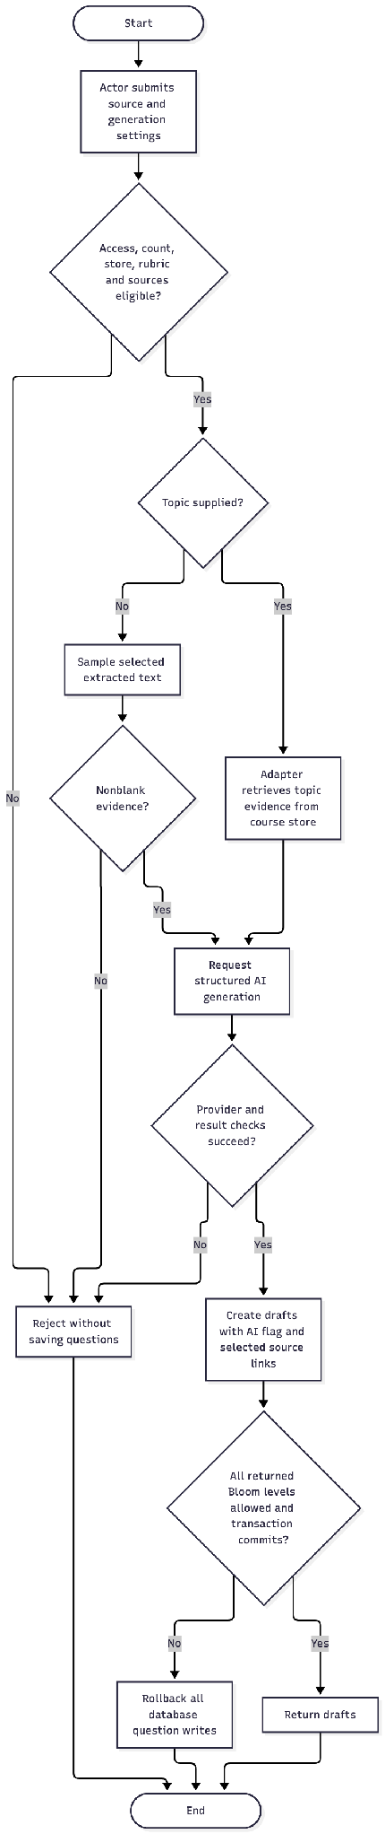

ACT 06 Upload and index source UC 12
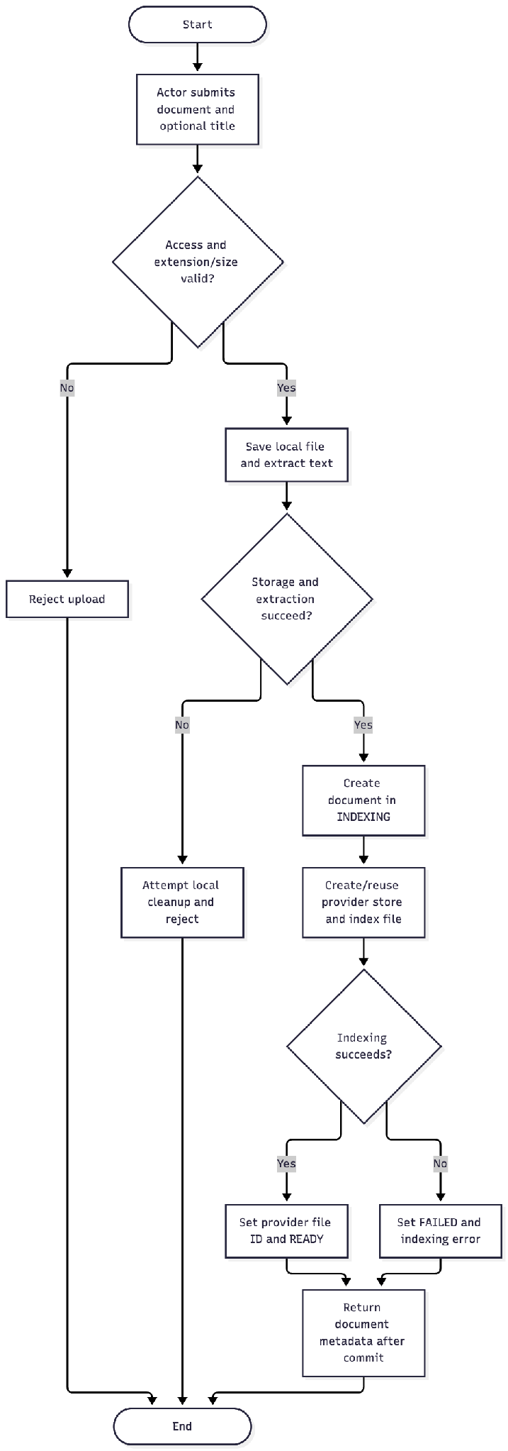
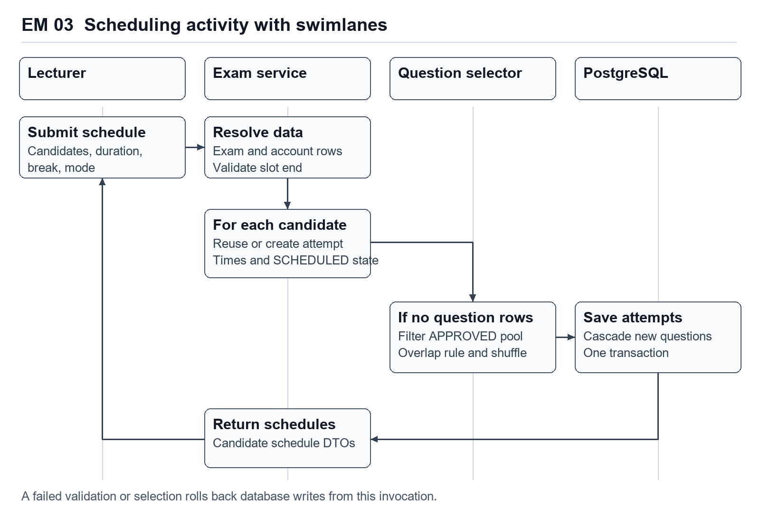
Figure EM 03. Preparation workflow across the lecturer, examination service, question selector and database.
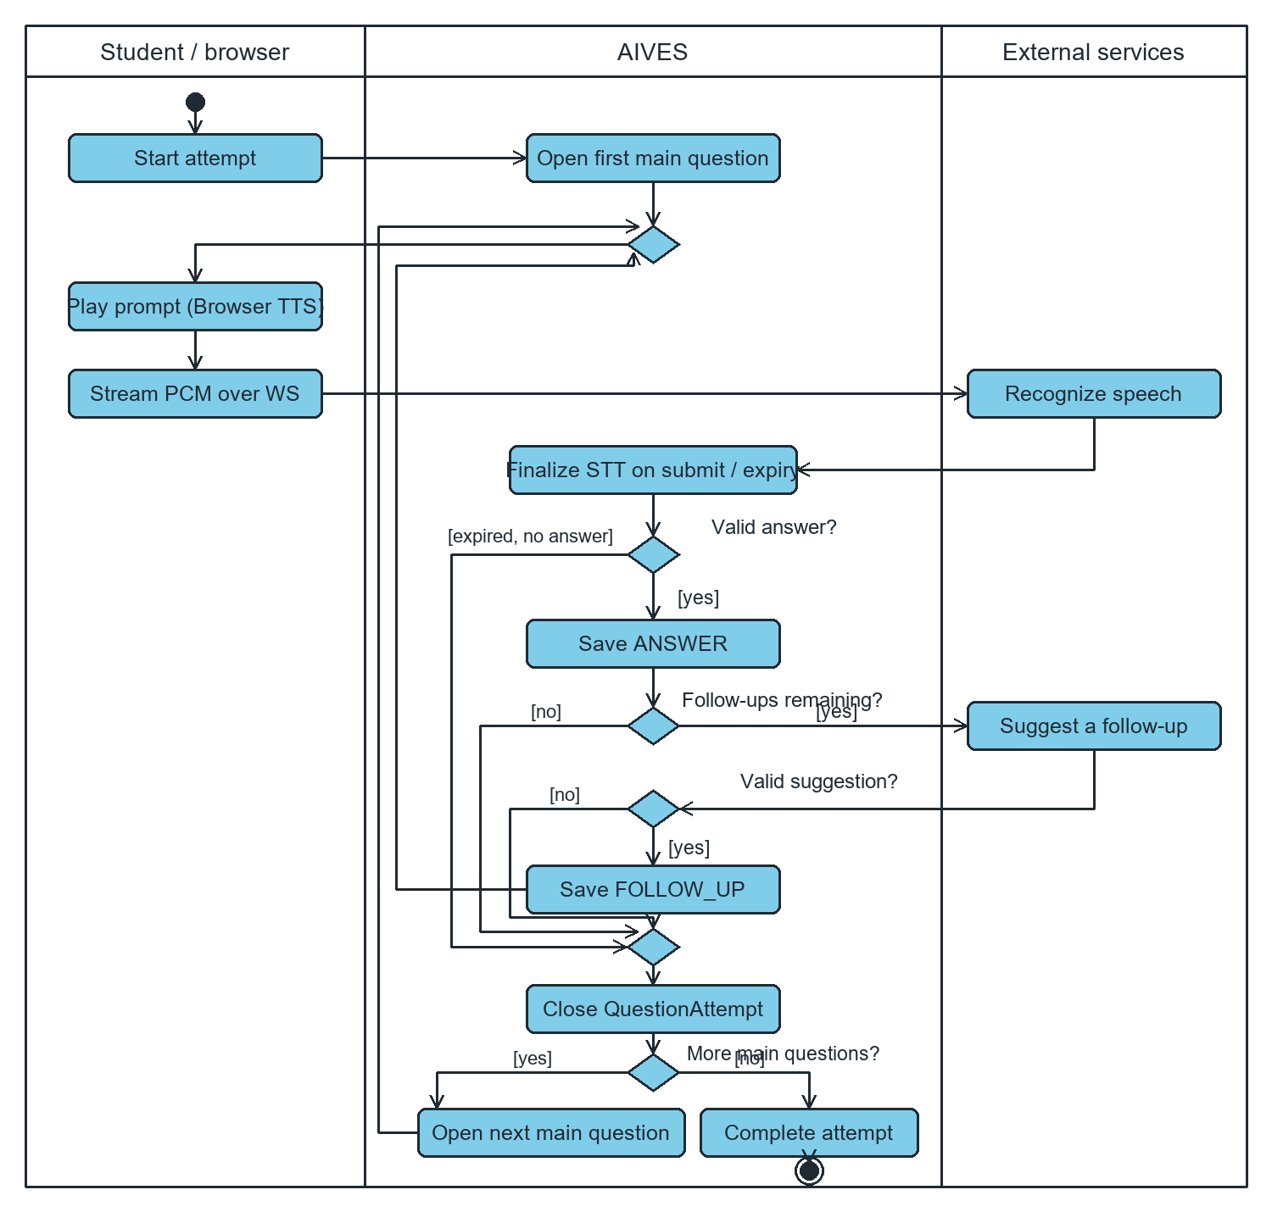
Figure 2. Activity flow from starting an attempt through follow-up, advancement, or completion. The worker checks active attempts roughly once per second to handle deadlines and resume processing from stored transcripts.

I.6 Data Requirements
The domain contains Course, Lecturer assignment, Question, Rubric, RubricCriterion and source Document. Each new managed question has one course and creator; zero or one rubric; zero or more source documents. A rubric owns a collection of criteria; each criterion contributes its maximum score to a derived total. Source associations are many-to-many. QuestionAttempt is an adjacent examination entity used as a removal guard.
A source record carries an uploaded filename, internal filename/path, extracted text, provider identifier, size/type, uploader and indexing outcome. These internal fields are not all exposed to clients. A user account and assignment exist in the Academic module. Per-entity field definitions, nullability, PK/FK rules and physical index differences are in Section III.5.
Data-quality expectations derived from application checks: nonblank question text, valid Bloom enum, same-course question/rubric references and positive criterion maximums. The database does not enforce all of these rules; see the schema-gap inventory. No approved retention period, question-version history, criterion-version history, or audit-event store was supplied.
The module requires an existing course, account records, approved course questions and optional course rubric links. Course enrolment determines the list offered by the lecturer interface. Candidate assignment creates ExamAttempt records, whereas automatic scheduling also creates QuestionAttempt records when the attempt has no assigned questions.
Question pool selection is stored as questionIds inside exams.exam_config. This JSON array has application-level reference checks. Each assigned main question becomes a question_attempts row with a real foreign key to questions. Changing the configuration does not automatically rebuild an existing attempt's question collection.

II. Analysis models

II.1 Interaction diagrams
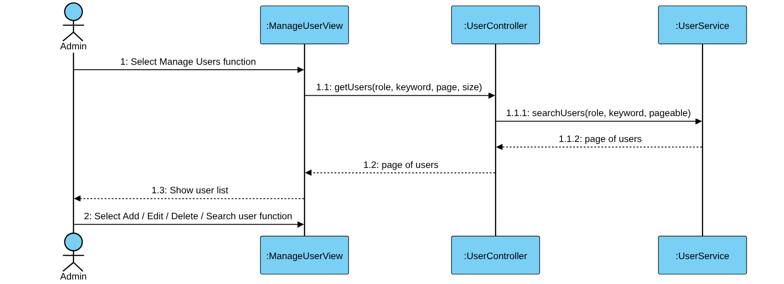
Figure II-1 Sequence Diagram for Manage Users Use Case
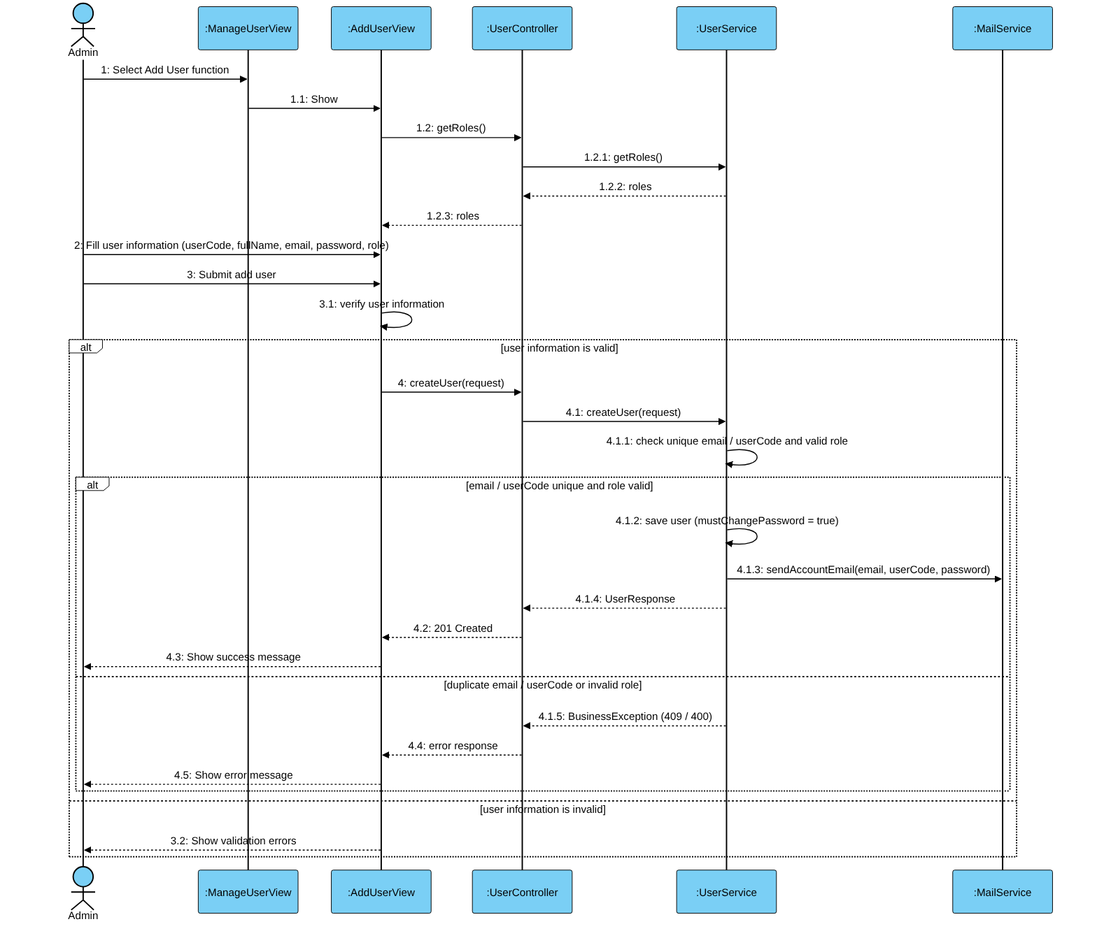
Figure II-2 Sequence Diagram for Add User Use Case
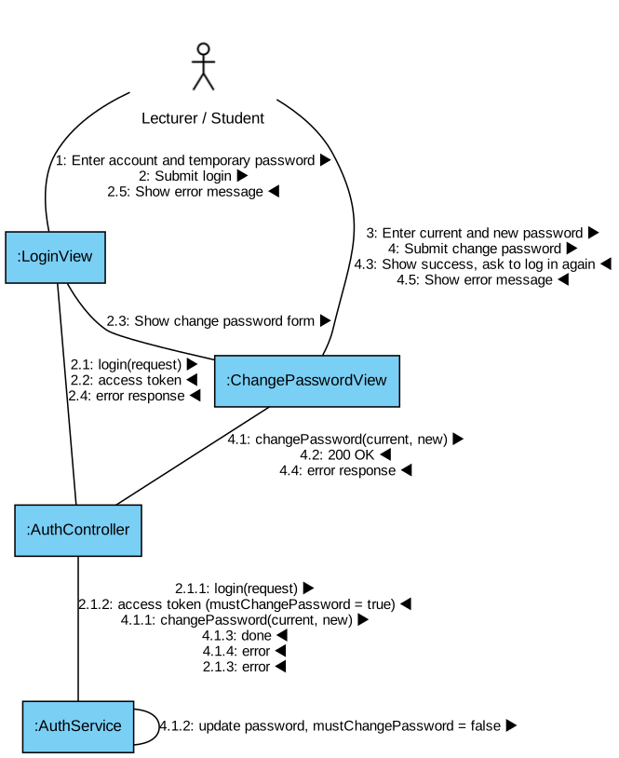
Figure II-12 Communication Diagram for Change Password Use Case
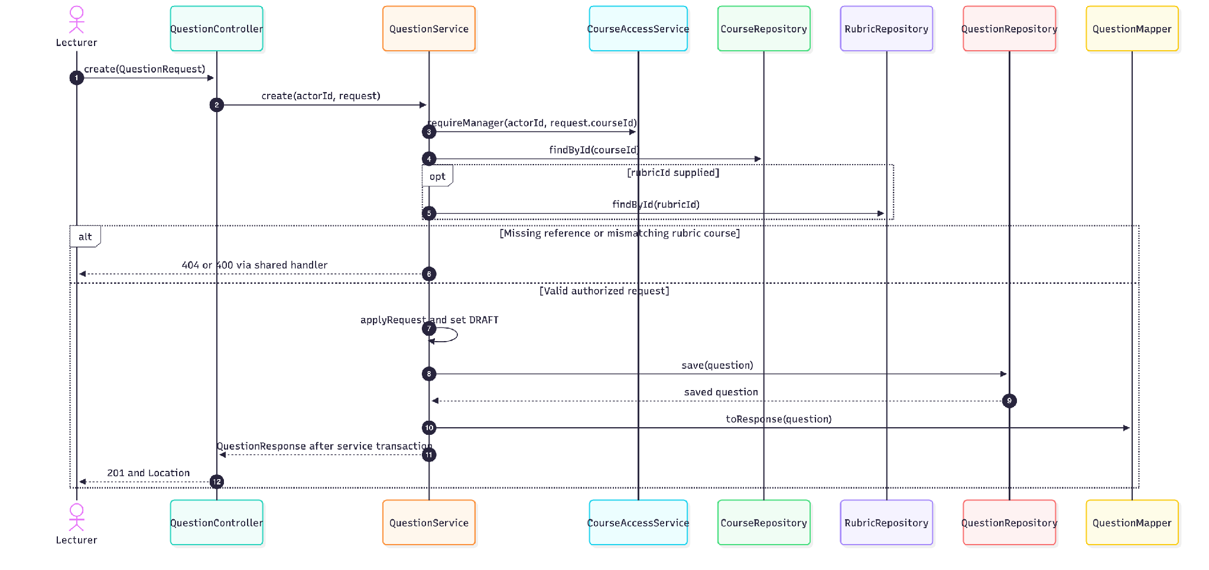
DTO Bean Validation precedes controller dispatch. CourseAccessService returns the creator. The optional rubric is resolved and checked against the course, with content trimmed before storage.
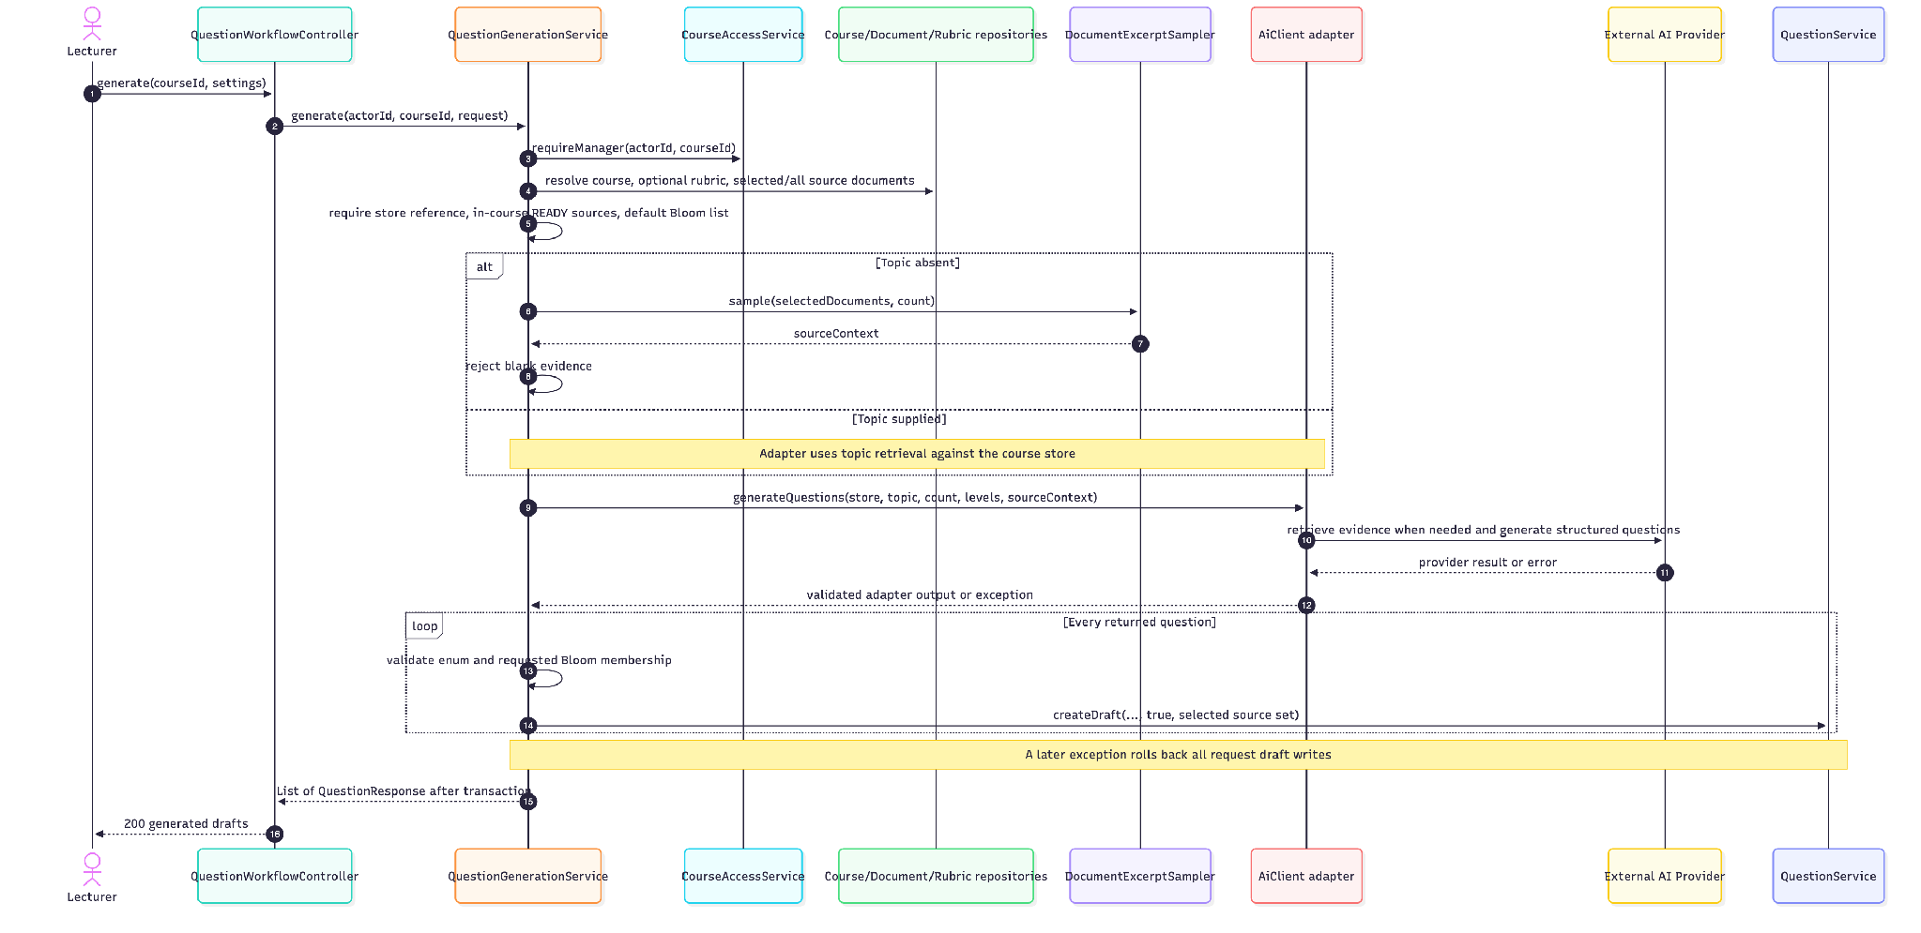
Eligibility, provider or output failure aborts generation. Selected-source association does not guarantee strict selected-file retrieval in topic mode. Adapter protocols and retry/count checks differ; sequence is a business-interface view.
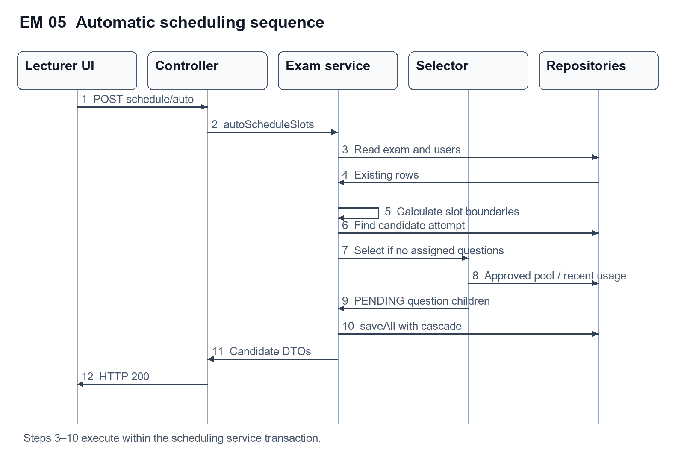
Figure EM 05. Automatic scheduling interaction. The save operation cascades new assigned questions within the same database transaction.
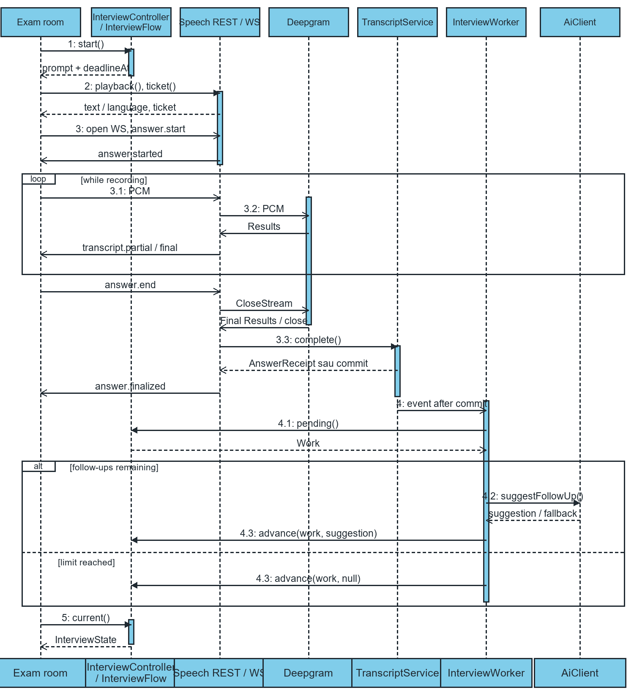
Figure 3. Sequence for a successful answer. Each transcript.final event finalizes one segment. The answer.finalized event confirms that the complete answer has been stored. During processing, current returns PROCESSING. The client can poll again for the next prompt or COMPLETED.

II.2 State diagram
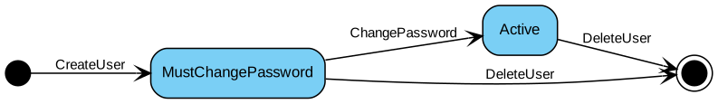
Figure II-13 State diagram model states of a User account object

ST 01 Question lifecycle
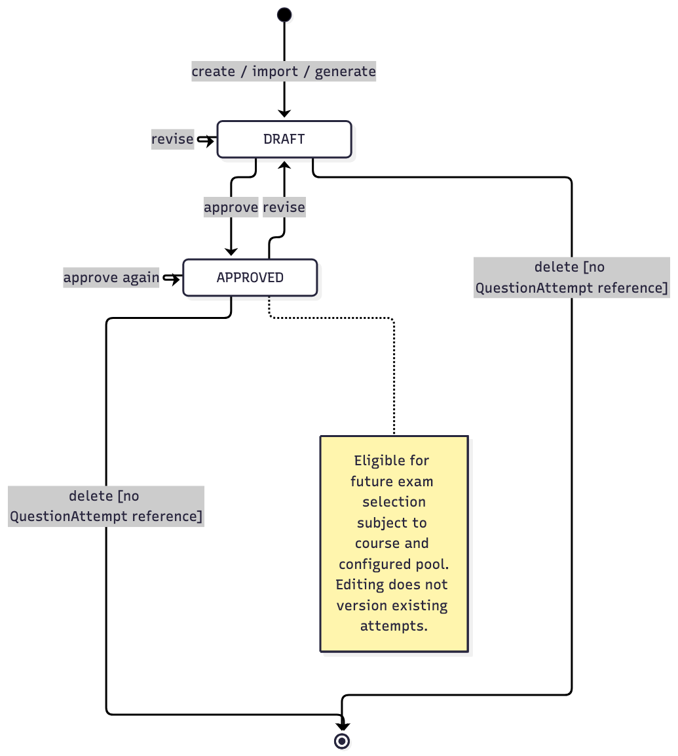

ST 02 Document indexing lifecycle
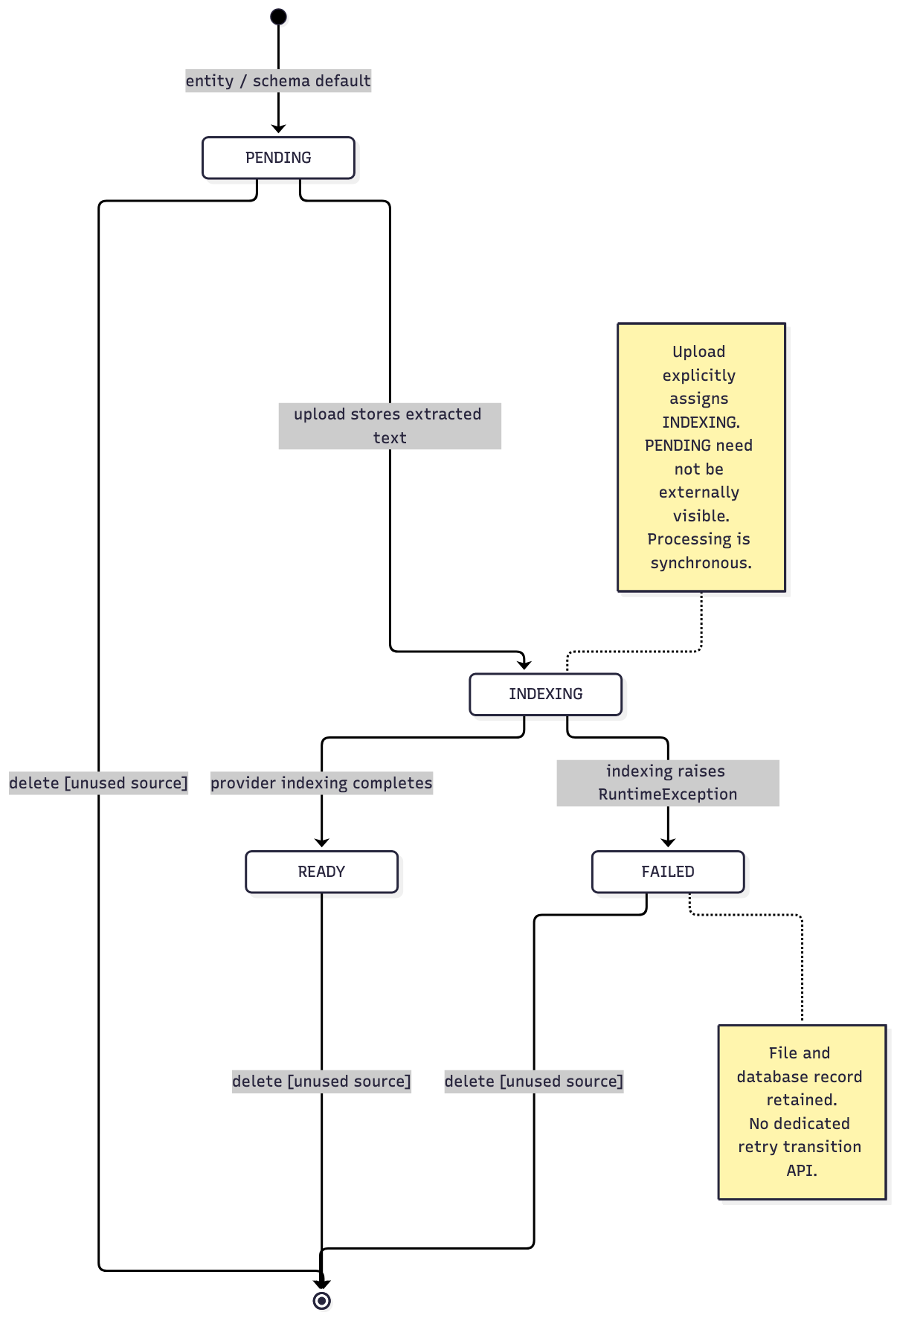
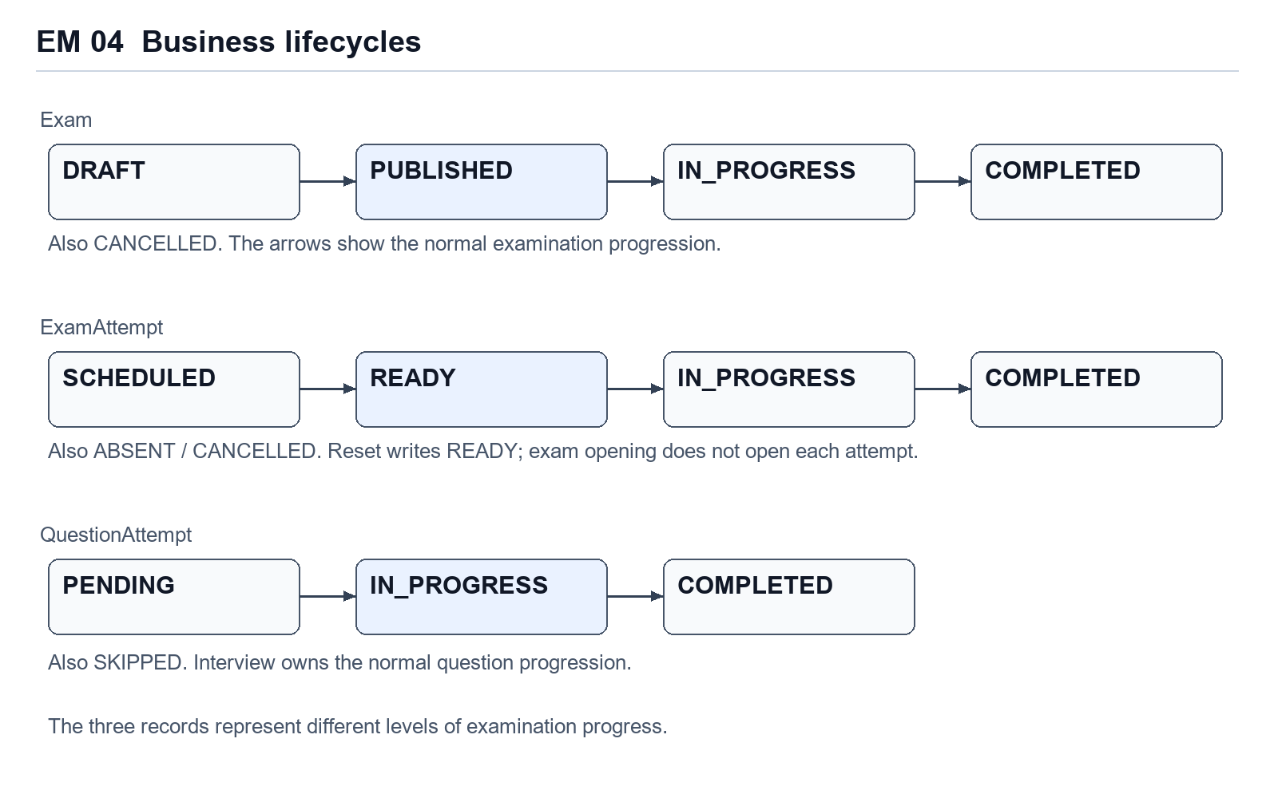
Figure EM 04. Separate examination, student-attempt and assigned-question lifecycles. Arrows describe the normal business progression.
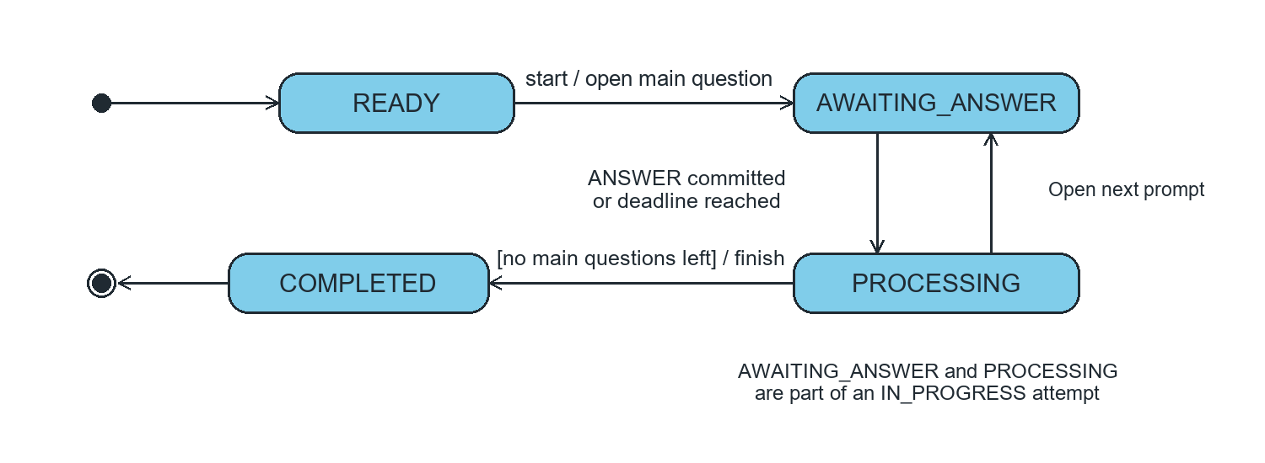
Figure 4. Lifecycle exposed by InterviewState.Status. AWAITING_ANSWER and PROCESSING both correspond to ExamAttemptStatus.IN_PROGRESS. At the deadline, the API can report PROCESSING before the worker finalizes or skips the prompt.

State transitions and consistency
An exam attempt is allocated before the student starts the interview. Opening a ready attempt records the first main-question turn and exposes the deadline. Each accepted answer advances the current prompt, starts a follow-up, or closes the question attempt. The lecturer reviews the resulting transcript and AI evaluation before confirming the score.

III. Design specification

III.1 Integrated Communication Diagrams
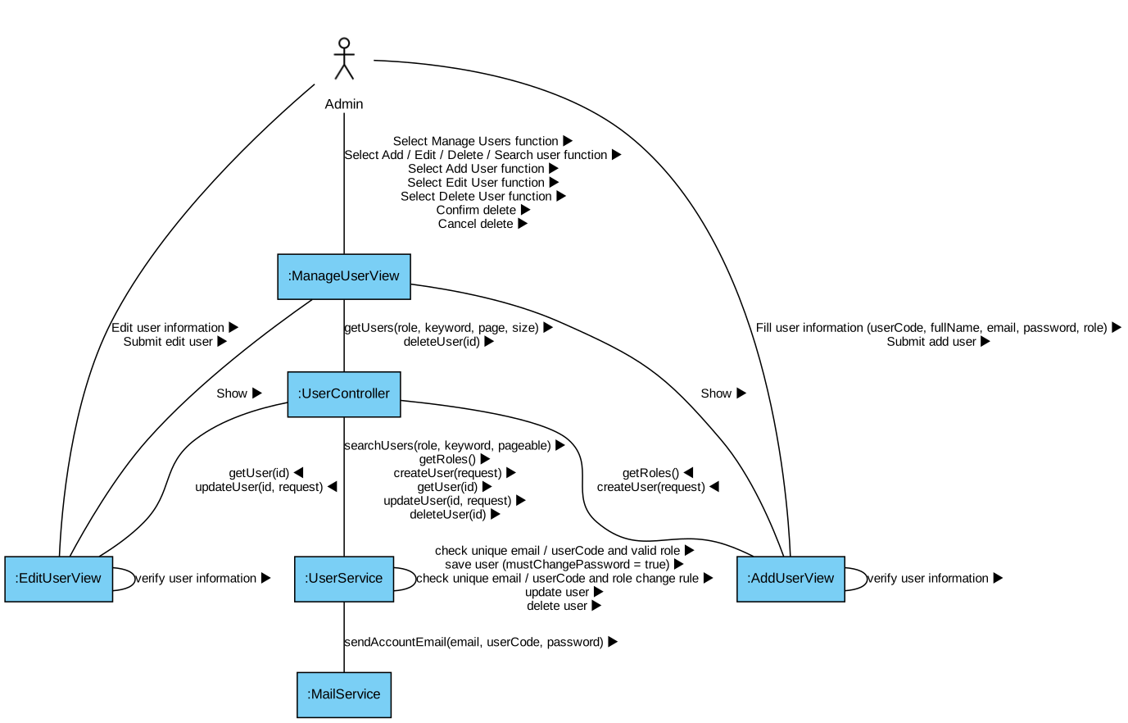
Figure III-1 Integrated communication diagram of Manage Users, Add User, Edit User, Delete User
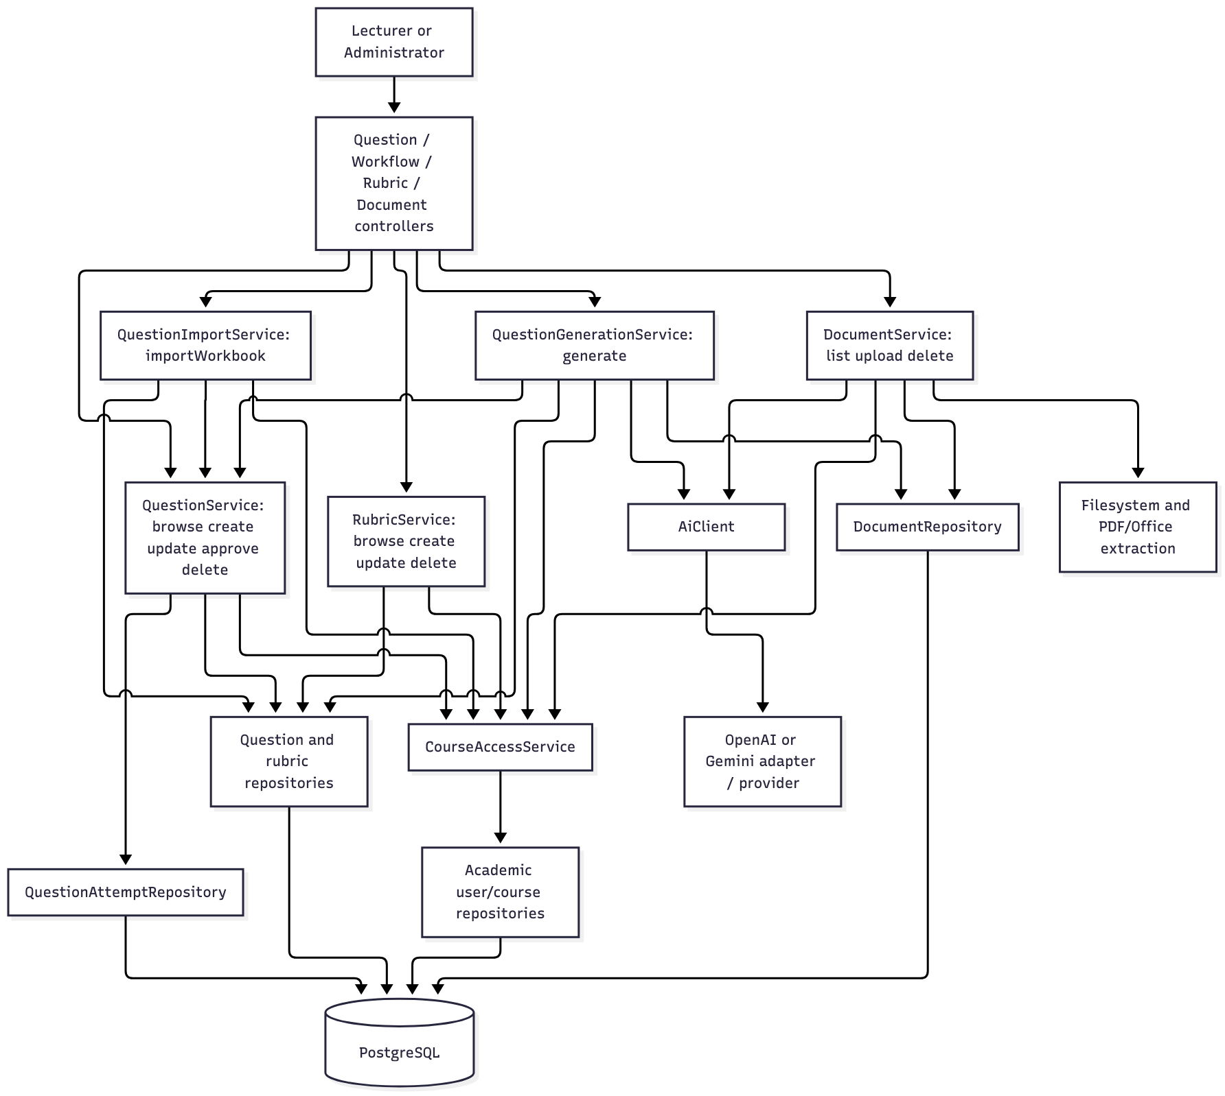
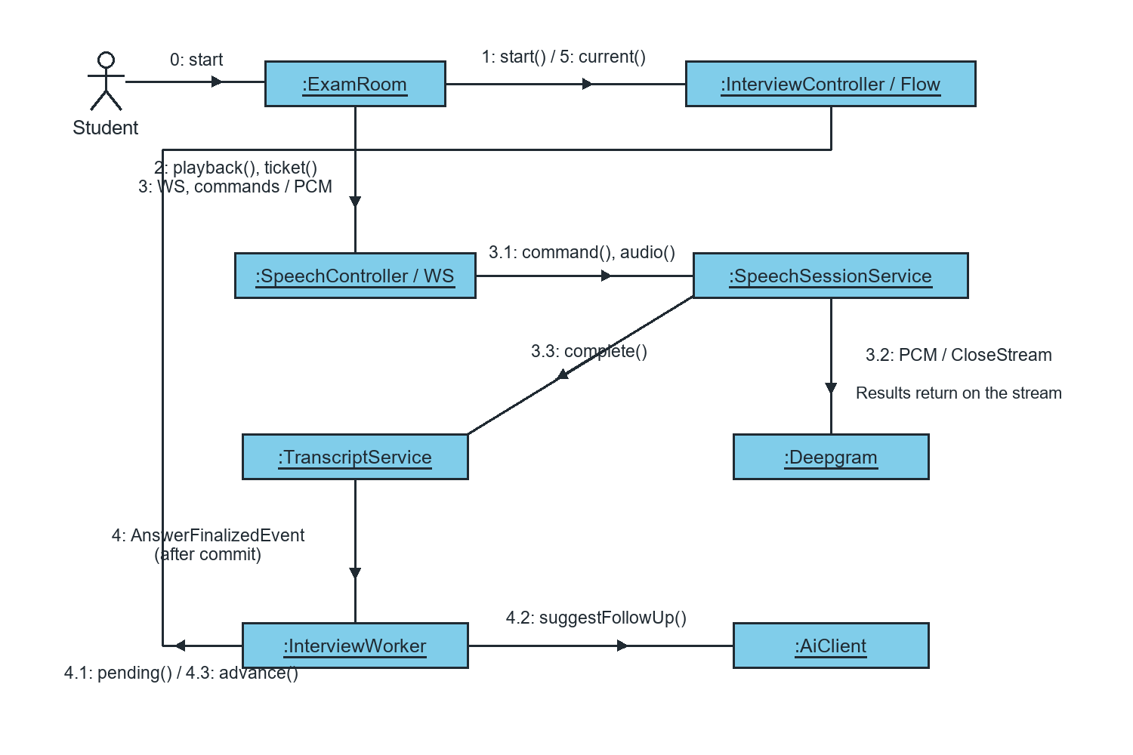
Figure 5. Numbered messages in the integrated interview flow. Messages 3.3 and 4.1–4.3 cover persistence and the follow-up decision.

III.2 System High-Level Design
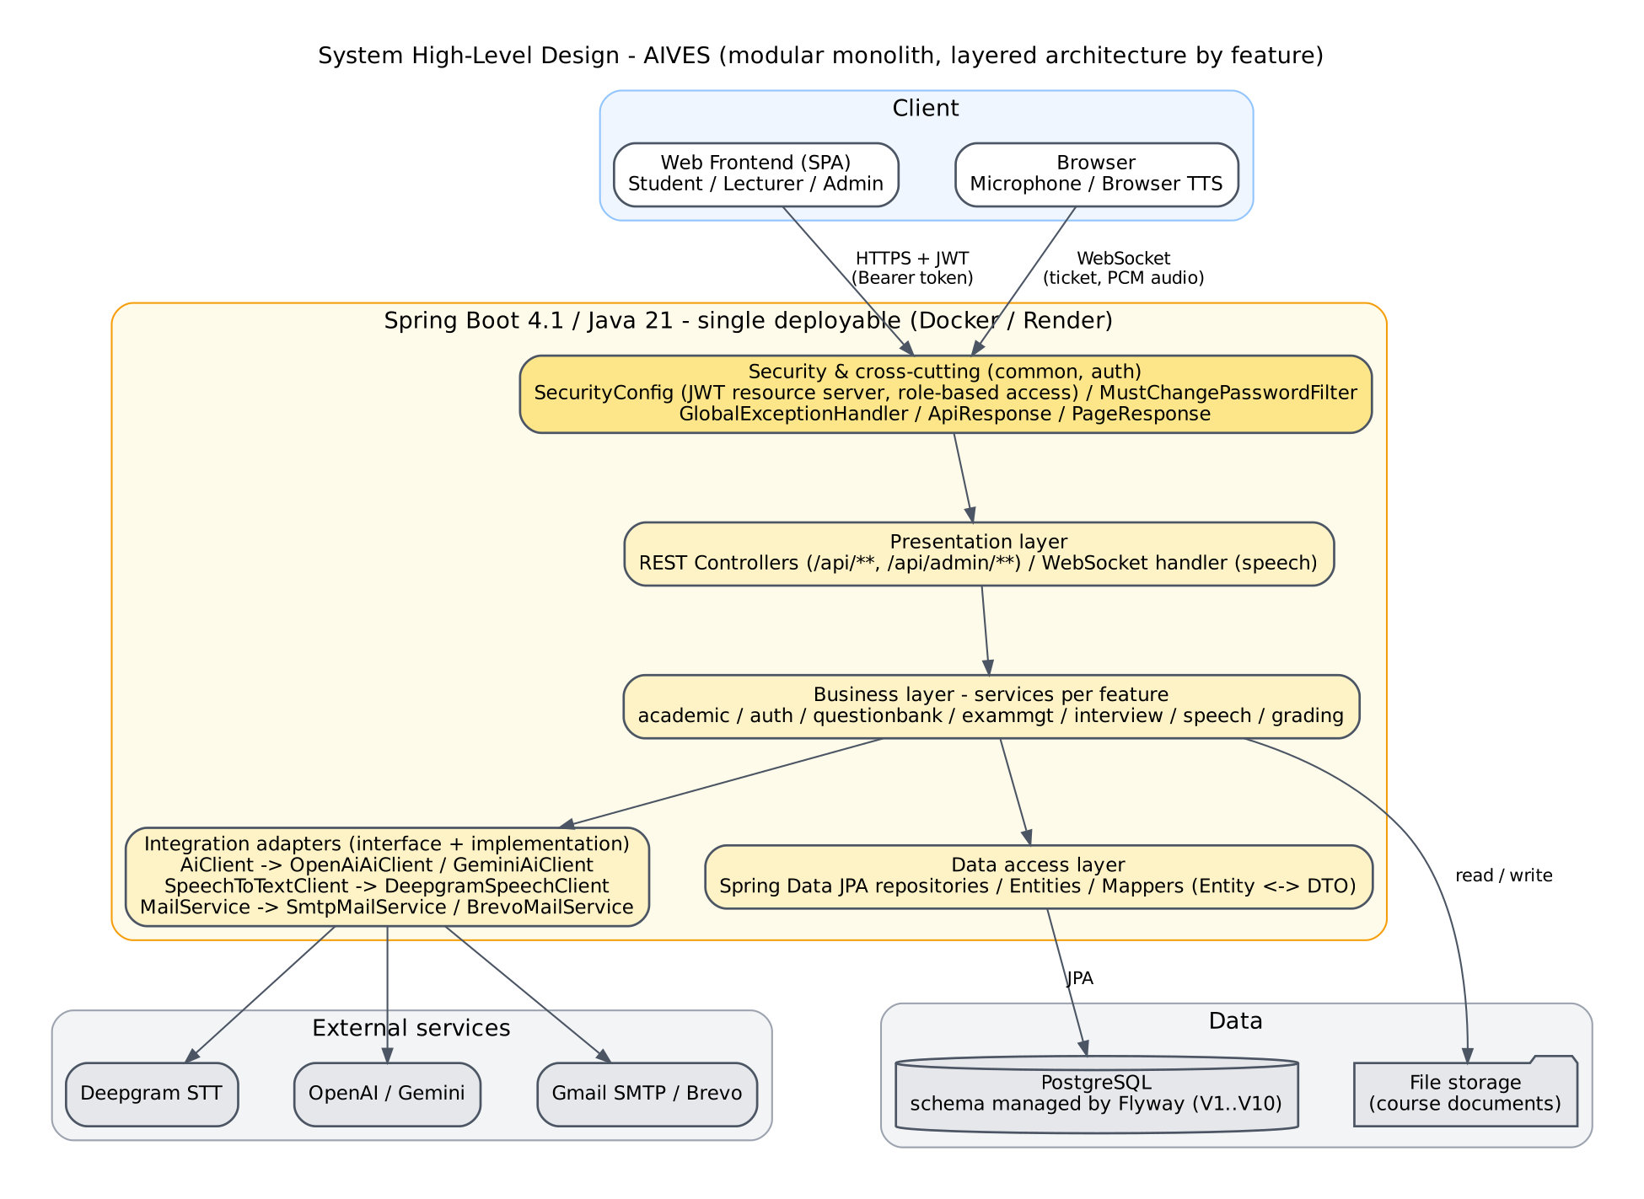
Figure III-2 High-level design of the AIVES system
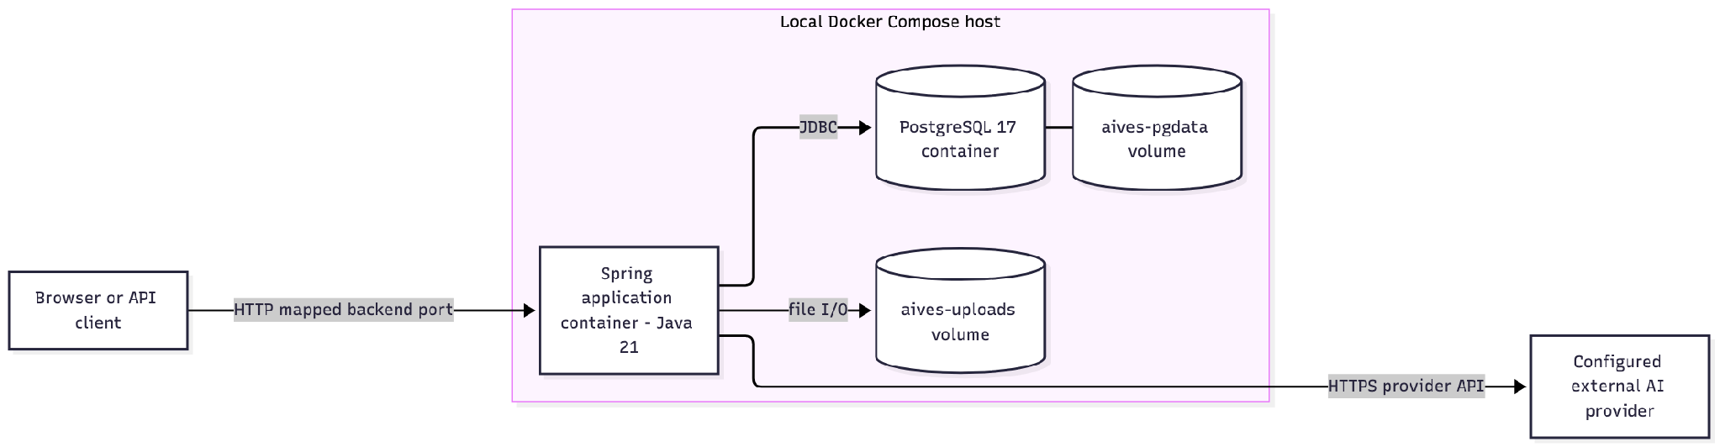

III.3 Component and Package Diagram
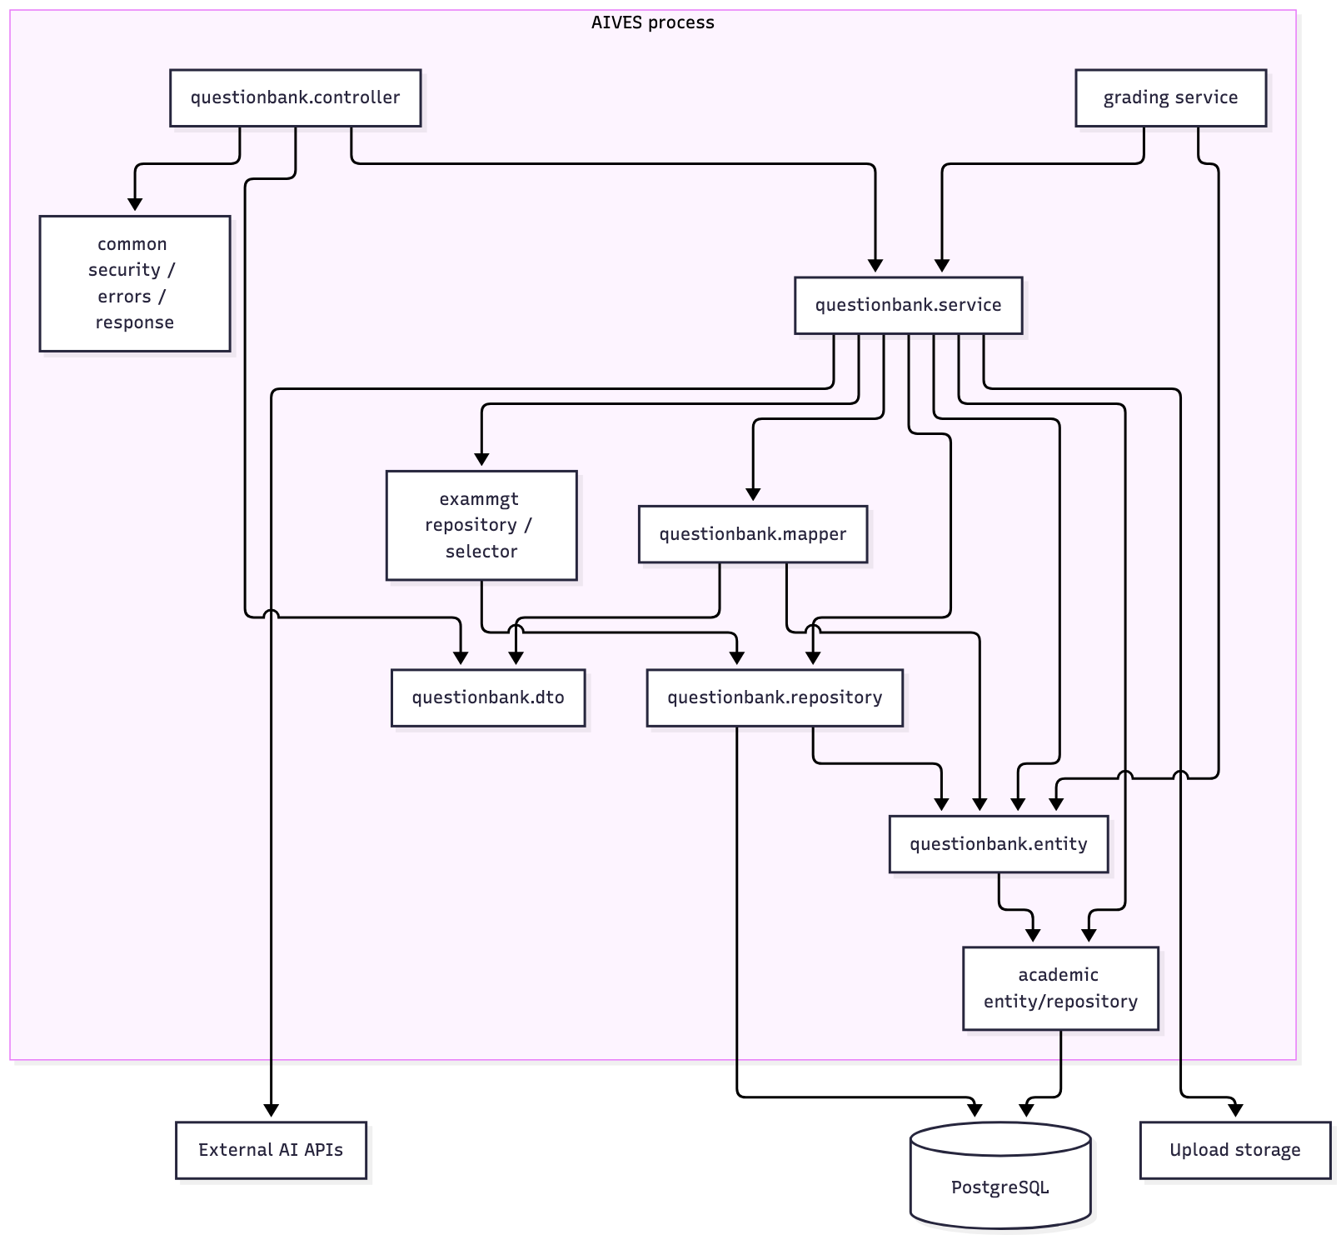

III.4 Detail Design
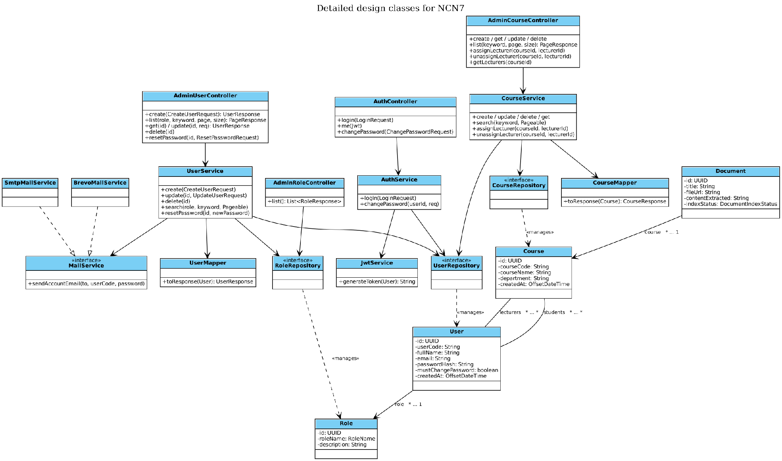
Figure III-3 Detailed Design Classes for System Administration and Authentication
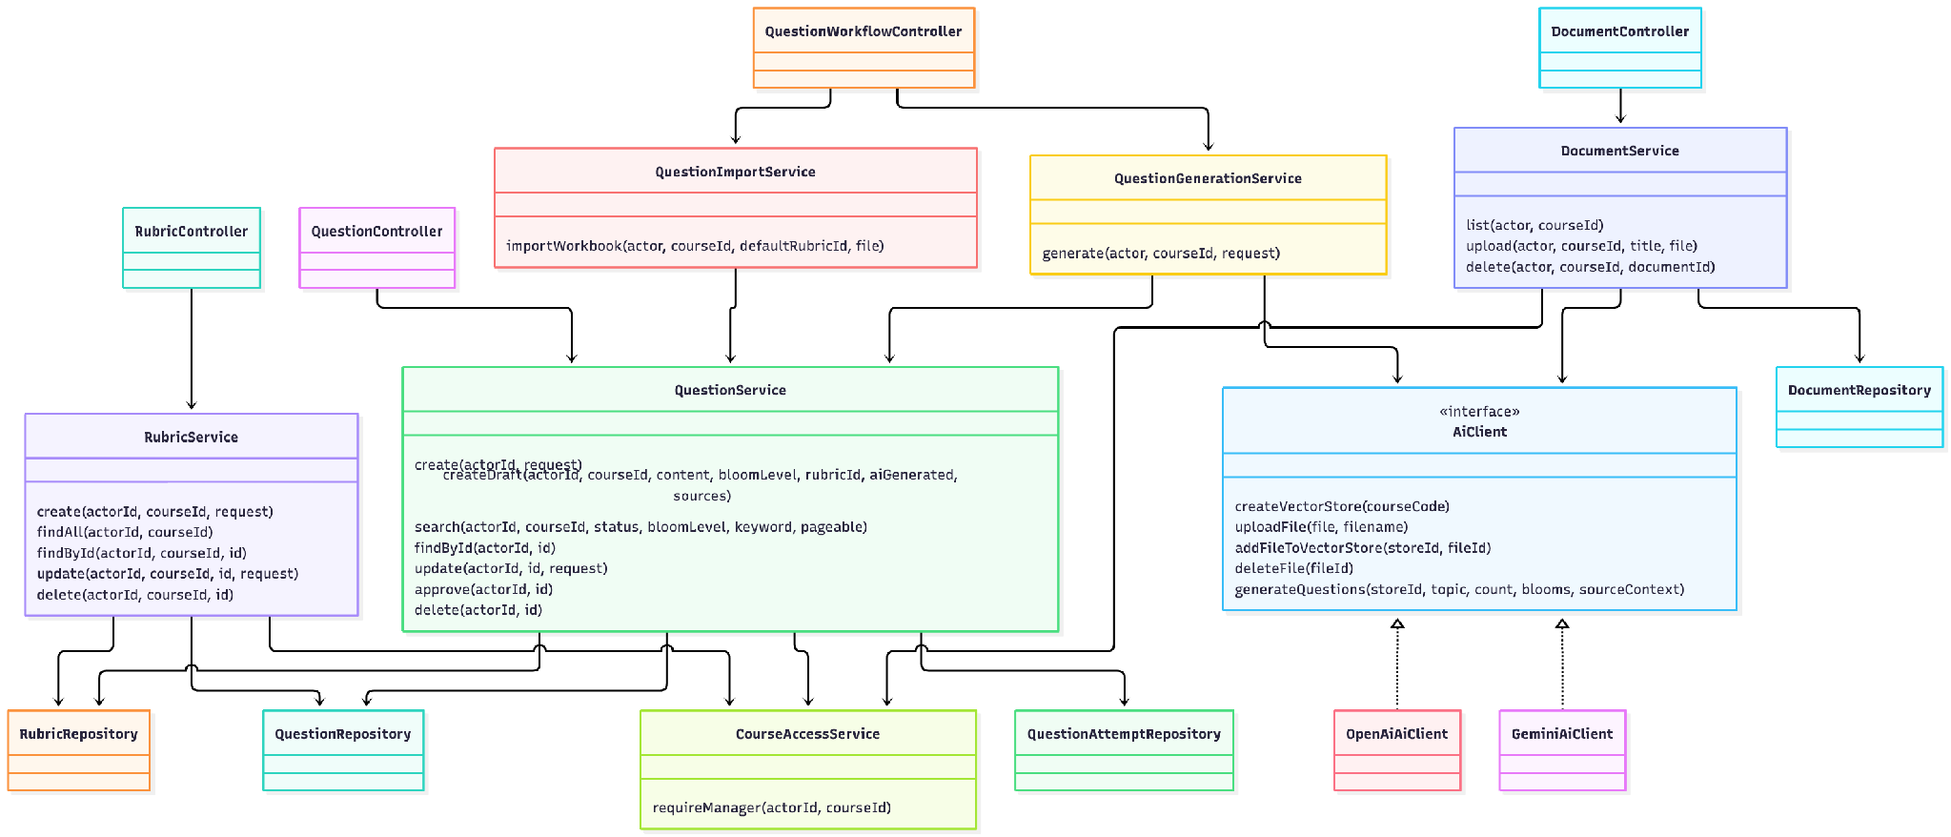
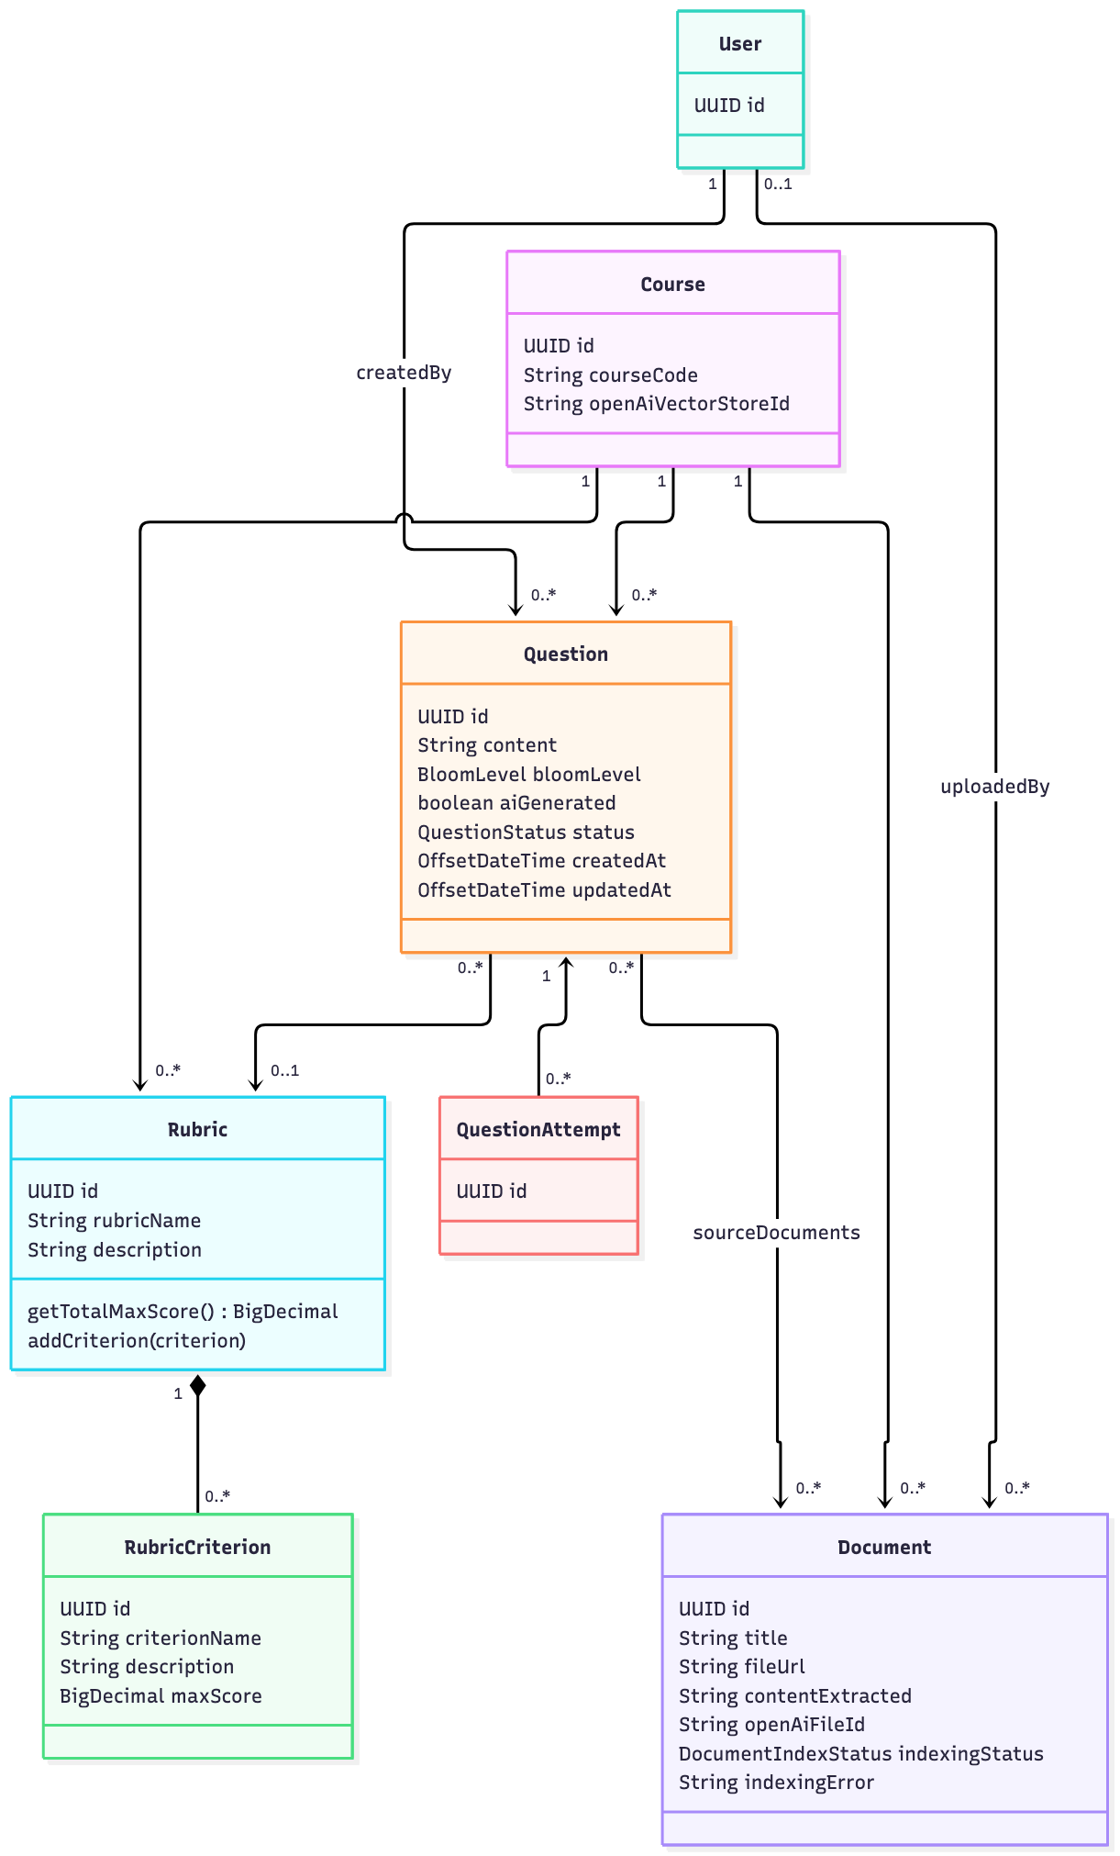

Exam Management

Scheduling design
SIMULTANEOUS is the default mode. Each selected candidate receives the examination start instant and an end instant obtained by adding slotDurationMinutes. The total required examination window is the duration of one slot. Each candidate retains an individual attempt ID and slot number.
SEQUENTIAL advances the next slot start after the prior slot end and breakDurationMinutes. For n candidates, duration d and break b, the required window is n × d + (n − 1) × b. For example, four students with 15-minute slots and 2-minute breaks need 66 minutes. The same four students need a 15-minute examination window in SIMULTANEOUS mode.
The request requires at least one student ID and a slot duration of at least five minutes. Break duration is nonnegative and defaults to two minutes. Each calculated slot end must fit inside the examination end. A failure throws a business exception and rolls back the current transaction.

Question allocation design
The selector starts from APPROVED questions in the examination course. A nonempty configured questionIds array restricts the pool. If any configured ID no longer corresponds to an approved question in that course, allocation fails. An empty questionIds array means that the approved course pool is used.
When antiOverlapEnabled is true and the candidate slot number exceeds one, the selector excludes question IDs used in the previous two slot-number positions. If the remaining pool is smaller than maxMainQuestions, it falls back to the approved pool after configured-ID restriction. It shuffles that pool and selects up to maxMainQuestions entries.
If the available approved pool is smaller than maxMainQuestions, the selector returns the available questions. The overlap fallback can reuse approved questions from the configured pool. The report describes random selection and does not assign a weighted Bloom algorithm to this implementation.

Transaction design

AI Interview Core
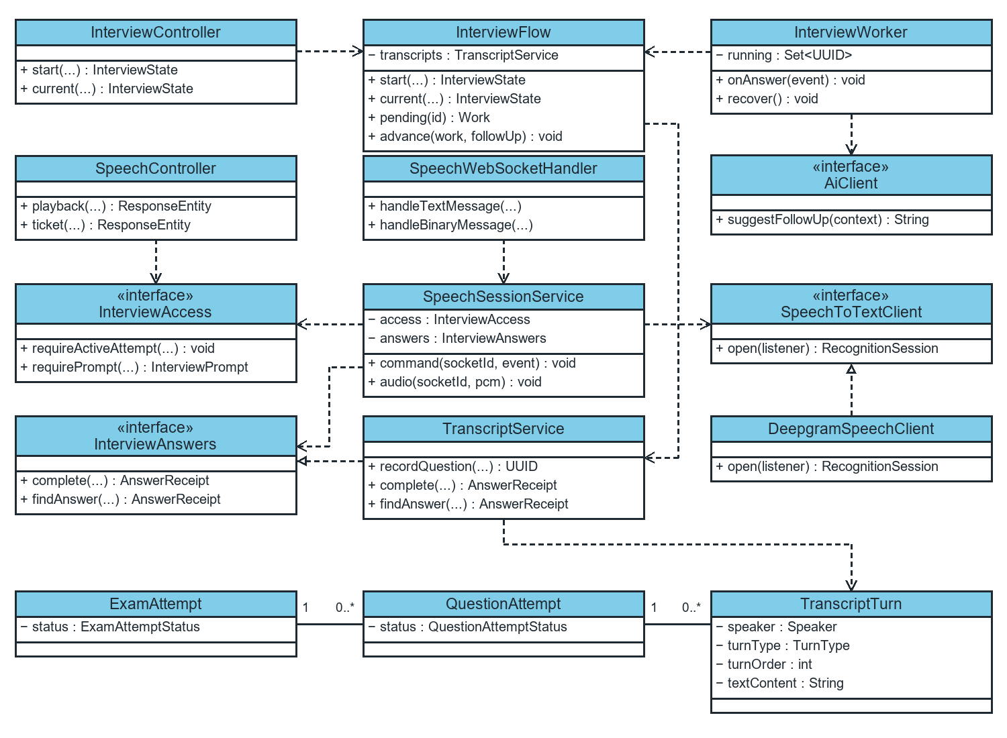
Figure 6. Main classes and interfaces of the AI Interview Core.
InterviewFlow depends on ExamAttemptRepository, QuestionAttemptRepository, TranscriptTurnRepository, TranscriptService, and InterviewAccessService. start opens a main question. pending reads the current question history and creates Work(attemptId, turnId, deadline, context). advance locks the attempt and assigned question, then verifies that turnId is still the latest turn before storing a follow-up or advancing.
InterviewWorker tracks active work by attemptId in running and calls AiClient through an executor. onAnswer runs after commit, and recover scans IN_PROGRESS attempts. The exam configuration sets maxFollowUpQuestions, which defaults to 2. A follow-up must contain usable text after normalization, contain at most 10,000 characters, and differ from previous AI prompts.
SpeechTicketService stores Grant(studentId, attemptId, expiresAt, jwtExpiresAt) in memory. issue checks access, and SpeechHandshakeInterceptor calls consume to redeem the ticket once. SpeechWebSocketHandler forwards JSON and binary frames to SpeechSessionService. The service maintains each connection and buffer, uses InterviewAccess to validate prompts, opens a stream through SpeechToTextClient, and saves answers through InterviewAnswers. TranscriptAccumulator combines recognition results by segment.
TranscriptService implements InterviewAnswers. recordQuestion stores AI turns. complete stores a STUDENT turn, links it to its prompt, and publishes AnswerFinalizedEvent. findAnswer retrieves the receipt. A lock on QuestionAttempt protects turnOrder allocation, and unique constraints on answerId and responseToTurnId prevent duplicate answers.
An ExamAttempt contains multiple QuestionAttempt records, each of which can contain multiple ordered TranscriptTurn records. A turn stores speaker, turnType, textContent, turnOrder, and answer linkage. questionTurnId identifies the AI prompt's TranscriptTurn. questionAttemptId identifies the assigned main question and stays the same across follow-ups.
SpeechController.playback retrieves an InterviewPrompt through InterviewAccess and returns QuestionPlayback. BrowserTextToSpeechClient supports browser TTS. QuestionSpeechService provides create and read operations for server audio when configured.

AI grading and review
The evaluation flow retrieves the relevant transcript and rubric, invokes the configured AI provider, and stores criterion-level feedback and the suggested score. The lecturer reviews that evidence and can enter a final score. The published result is based on the lecturer’s decision.

III.5 Database Design

DB 01 Physical relationship model
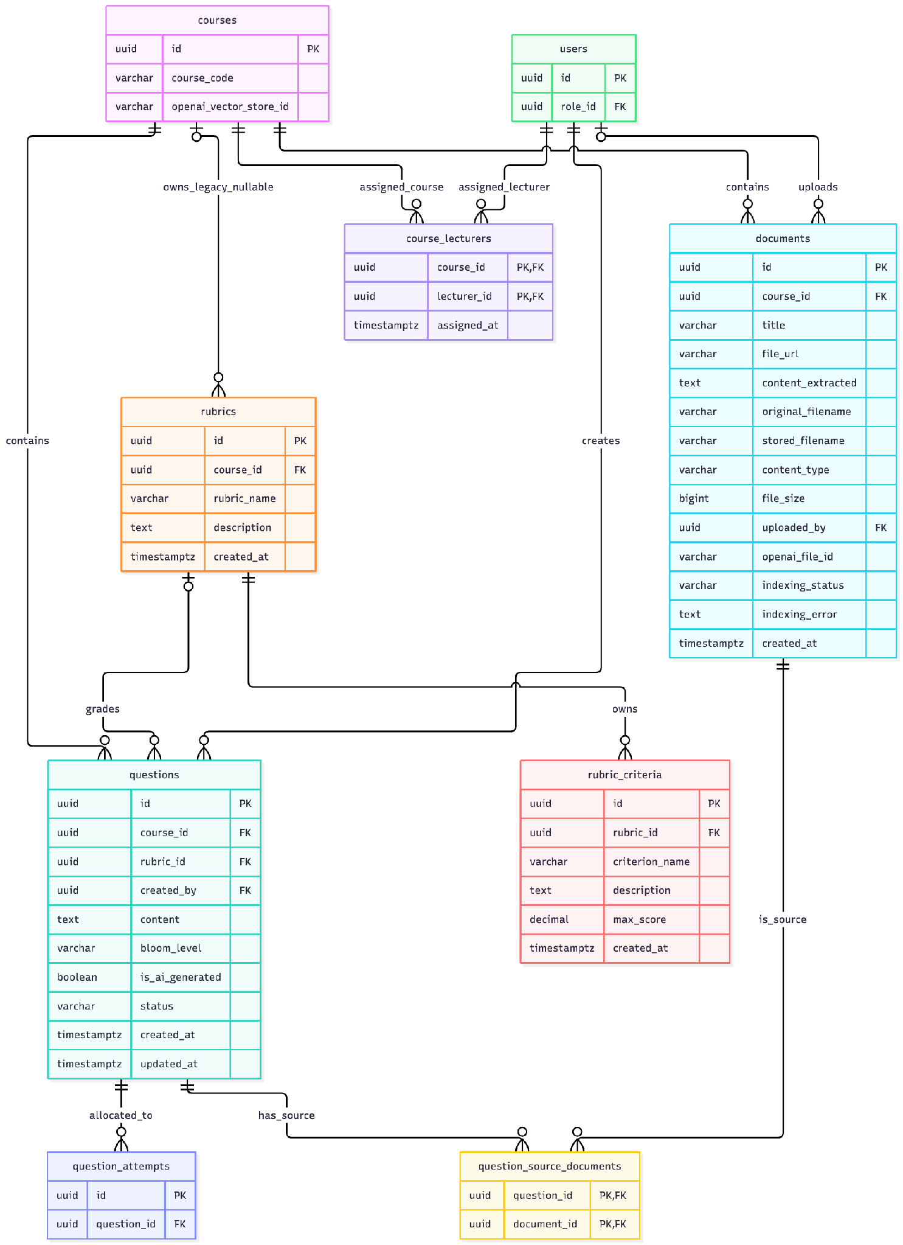

III 5 2 Physical model
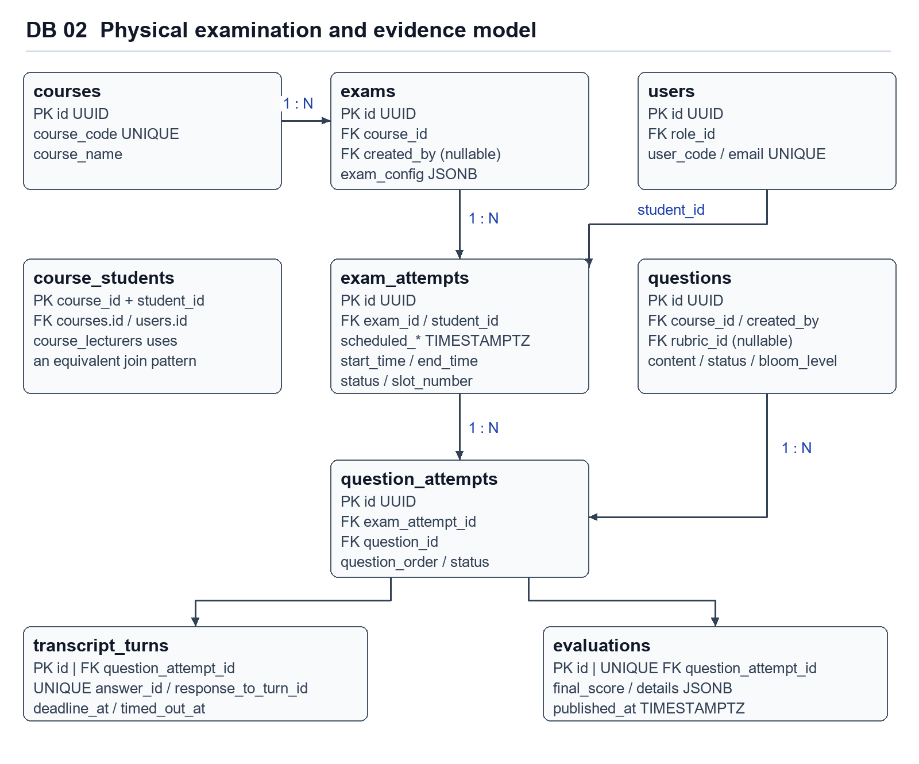

III 5 3 Relational keys and deletion behaviour
- exams.course_id references courses with ON DELETE CASCADE. exams.created_by is a nullable user reference introduced in V4. Creation service code currently does not populate this field.
- exam_attempts.exam_id and student_id reference exams and users with ON DELETE CASCADE. A shared examination can therefore be removed with its dependent attempts at the database level.
- question_attempts.exam_attempt_id and question_id reference exam_attempts and questions with ON DELETE CASCADE. Application-level protection against removal of referenced questions is consequently important.
- transcript_turns.question_attempt_id references question_attempts. response_to_turn_id is a unique self-reference introduced in V7, with cascading deletion. answer_id is a separate nullable unique idempotency key.
- evaluations.question_attempt_id is a unique foreign key, expressing at most one evaluation per QuestionAttempt. graded_by is a user reference. published_at distinguishes a finalized score from a score released to the student.
- course_students and course_lecturers use composite primary keys. The keys prevent duplicate membership or lecturer assignment for the same course and user. User role eligibility is an application check.

III 5 4 Index and representation design
Foreign-key indexes support joins from examinations to candidates, assigned questions, transcript turns and grading data. V4 adds indexes on exam status, creator, attempt status and scheduled times. idx_exam_attempts_student_exam accelerates lookup but does not enforce uniqueness. V7 adds unique indexes through answer_id and response_to_turn_id constraints.
The Java names actualStartTime and actualEndTime in ExamAttempt map to physical start_time and end_time. The database dictionary distinguishes these mapped fields from the additional actual_start_time and actual_end_time columns introduced by V4.
Version | Relevant schema change
V1 | Core academic, question, examination, transcript and grading tables and FK indexes.
V2 | ADMIN, LECTURER and STUDENT role seed rows.
V3 | course_lecturers composite key and lecturer lookup index.
V4 | Exam status/creator, scheduled and extra actual timing columns, slot/access fields, question order and indexes.
V5 | Account must_change_password flag.
V6 | Course-scoped rubric/source extensions and question_source_documents.
V7 | Unique answer and response linkage for transcript idempotency.
V8 | Question-turn deadline and timeout instants.
V9 | course_students composite key and student lookup index.
V10 | evaluations.published_at for student result release.

B 1 Examination definition
Column | SQL definition | Purpose or mapping
id | UUID PRIMARY KEY | Exam identifier. DEFAULT gen_random_uuid().
course_id | UUID NOT NULL FK | courses.id, ON DELETE CASCADE.
title | VARCHAR(255) NOT NULL | Display name. API requires nonblank text.
start_time / end_time | TIMESTAMPTZ NOT NULL | Shared examination window.
exam_config | JSONB NULL | Pool IDs and examination parameters.
status | VARCHAR(50) NULL | V4 DEFAULT 'DRAFT'. Enum values are checked in Java.
created_by | UUID NULL FK | users.id. V4 field currently not populated by createExam.
created_at | TIMESTAMPTZ NULL | DEFAULT CURRENT_TIMESTAMP and JPA creation timestamp.
totalCandidates | Computed Java property | Hibernate formula counts distinct students. Not a physical column.

B 2 Personal attempt
Column | SQL definition | Purpose or mapping
id | UUID PRIMARY KEY | Individual attempt identifier.
exam_id | UUID NOT NULL FK | exams.id, ON DELETE CASCADE.
student_id | UUID NOT NULL FK | users.id, ON DELETE CASCADE.
scheduled_start_time / scheduled_end_time | TIMESTAMPTZ NULL | V4 planned slot boundaries.
start_time / end_time | TIMESTAMPTZ NULL | V1 columns mapped by actualStartTime/actualEndTime.
actual_start_time / actual_end_time | TIMESTAMPTZ NULL | Additional V4 columns. Not mapped by current ExamAttempt entity.
slot_number | INT NULL | V4 allocation sequence. Uniqueness is not declared.
access_code | VARCHAR(50) NULL | V4 optional slot access data.
status | VARCHAR(50) NULL | DEFAULT 'SCHEDULED'. Student and monitoring state.
audio_record_url | VARCHAR(500) NULL | Optional evidence reference.
created_at | TIMESTAMPTZ NULL | DEFAULT CURRENT_TIMESTAMP.

B 1 Transcript turn
Column | SQL definition | Purpose or mapping
id |  | Turn identifier. DEFAULT gen_random_uuid().
question_attempt_id |  | question_attempts.id, ON DELETE CASCADE.
turn_order |  | Sequential order of turn in question attempt.
speaker |  | Originator: AI or STUDENT.
text_content |  | Verbatim text transcript or prompt.
audio_clip_url |  | Audio evidence storage link.
turn_type |  | Classification: MAIN_QUESTION, FOLLOW_UP, STUDENT_ANSWER.
answer_id |  | V7 client idempotency token.
response_to_turn_id |  | V7 self-reference to transcript_turns.id.
deadline_at |  | V8 response timeout deadline.
timed_out_at |  | V8 timestamp if turn exceeded deadline.
created_at |  | DEFAULT CURRENT_TIMESTAMP.

B 2 Evaluation definition
Column | SQL definition | Purpose or mapping
id
question_attempt_id
graded_by
ai_suggested_score
final_score
overall_feedback
evaluation_details
status
published_at
created_at
updated_at

Core persistence and constraints
Data group | Purpose and relationship
Accounts, roles and courses | Accounts have one role. Lecturer assignments connect eligible accounts to courses and define the scope of course administration.
Questions, rubrics and teaching sources | Questions and rubrics belong to a course. Criteria belong to their rubric. Source links preserve the relationship between generated drafts and course materials.
Exam and exam attempt | The exam defines the session configuration and permitted questions. Each candidate receives a personal attempt and scheduled slot.
Question attempt and transcript turn | Assigned questions belong to a personal attempt. Transcript turns retain the prompt, response, order and timing needed to resume and audit an interview.
Evaluation and final grade | The evaluation stores AI evidence and criterion details. The lecturer confirms the grade before the result is released.

IV. Implementation

IV.1 Map architecture to the structure of the project
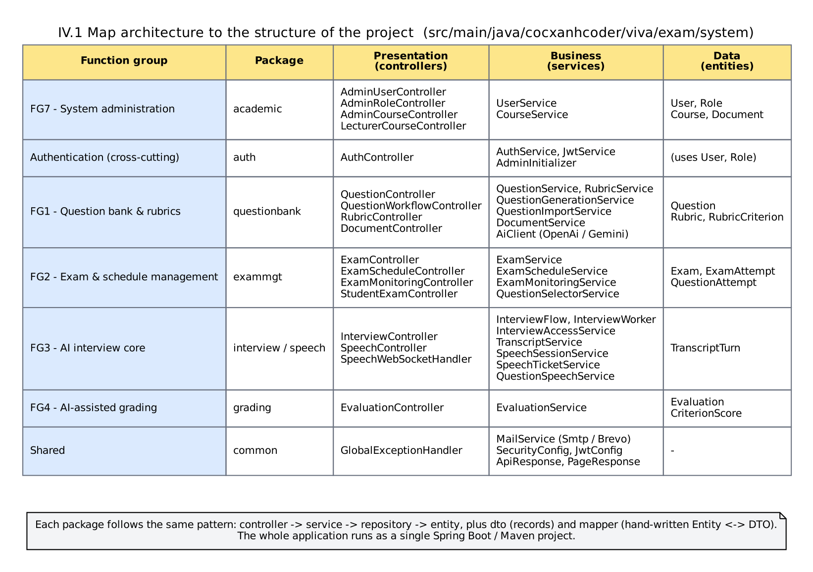
Figure IV-1 The structure of the project
Responsibility | Existing implementation
REST boundary | questionbank/controller/QuestionController.java, QuestionWorkflowController.java, RubricController.java, DocumentController.java.
Request/result contracts | questionbank/dto/ records; common ApiResponse and PageResponse.
Goal orchestration | QuestionService, RubricService, QuestionImportService, QuestionGenerationService, DocumentService.
Shared authorization | CourseAccessService, shared SecurityConfig and MustChangePasswordFilter.
Domain state | questionbank/entity/Question, Rubric, RubricCriterion, enums; academic Document, Course, User.
Persistence | Bank repositories, academic DocumentRepository, CourseRepository, UserRepository; exam QuestionAttemptRepository.
External AI boundary | AiClient, OpenAiAiClient, GeminiAiClient, DocumentExcerptSampler.
Mapping | QuestionMapper, RubricMapper; document mapping is private in DocumentService.
Schema/configuration | src/main/resources/db/migration/; application.yml; compose.yaml; Dockerfile; render.yaml.

IV.2 Map Class Diagram and Interaction Diagram to Code
The Spring Boot backend organizes controllers, services and repositories by feature. Controllers enforce the API contract, services apply workflow and business rules, and repositories read and write PostgreSQL. Flyway owns schema evolution. AI and speech providers sit behind interfaces so their integrations can change independently of examination rules.
Method | Path | Success response
POST | /api/v1/exams | 201 ExamResponse
GET | /api/v1/exams | 200 Spring Page<ExamResponse>
GET | /api/v1/exams/{id} | 200 ExamDetailResponse
PUT | /api/v1/exams/{id} | 200 ExamResponse
PATCH | /api/v1/exams/{id}/status | 200 ExamResponse
DELETE | /api/v1/exams/{id} | 204 with no body
GET / PUT | /api/v1/exams/{examId}/question-config | 200 QuestionConfigDto
POST | /api/v1/exams/{examId}/candidates | 200 List<CandidateScheduleResponse>
POST | /api/v1/exams/{examId}/schedule/auto | 200 List<CandidateScheduleResponse>
PUT | /api/v1/exams/{examId}/schedule/reschedule | 200 CandidateScheduleResponse
GET | /api/v1/exams/{examId}/schedule | 200 List<CandidateScheduleResponse>
GET | /api/v1/exams/{examId}/monitor | 200 ExamMonitoringResponse
POST | /api/v1/exams/{examId}/attempts/{attemptId}/reset | 200 CandidateScheduleResponse
POST | /api/v1/exams/{examId}/attempts/{attemptId}/absent | 200 CandidateScheduleResponse
GET | /api/v1/student/exams | 200 PageResponse<StudentExamSummary>
GET | /api/v1/student/exams/{examId}/my-slot | 200 StudentExamSlotResponse
Method | Path | Success response
 | /api/v1/interviews/{attemptId}/start
 | /api/v1/interviews/{attemptId}/current
 | /api/v1/interviews/{attemptId}/turns/{turnId}/answer
 | /api/v1/interviews/{attemptId}/turns/{turnId}/timeout
 | /api/v1/interviews/{attemptId}/complete
 | /api/v1/grading/attempts/{attemptId}/evaluation
 | /api/v1/grading/evaluations/{evaluationId}
 | /api/v1/grading/evaluations/{evaluationId}/publish
 | /api/v1/student/results/{attemptId}

Verification and acceptance
Area | Acceptance check
Authorization | Reject access to administration routes for other roles, block protected operations before first-password change, and enforce course and attempt ownership.
Question preparation | Verify draft creation, eligible source selection, workbook validation, rubric changes and protection of referenced resources.
Examination allocation | Verify candidate assignment, permitted question selection, non-conflicting scheduling and independent rescheduling.
Interview | Verify start recovery, prompt playback, speech transcription, answer submission, timeout handling and advancement.
Grading | Verify criterion feedback, lecturer override, confirmation and student access to the published result.

V. Applying Alternative Architecture Patterns

V.1 Applying the service-oriented architecture
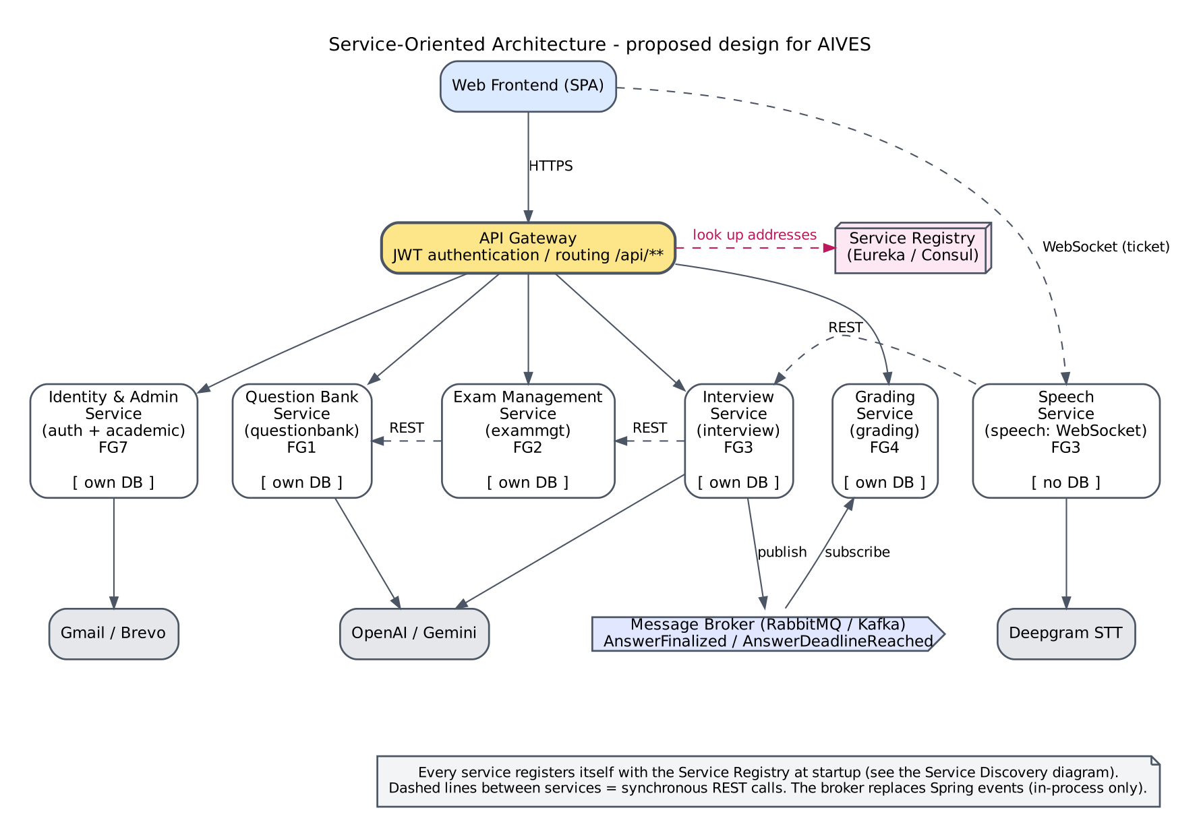
Figure V-1 Service-oriented architecture of AIVES

Reuse through an application API
The existing REST API already separates clients from backend business logic. A future additional client could reuse it, subject to supported authentication, CORS, versioning and DTO contracts. This does not require splitting repositories into an independently deployed service merely to reproduce the sample's SOA example.

Asynchronous document and generation processing
A confirmed requirement for long-running operations or retryable recovery could justify jobs and a worker. This would change UC-07/12 from one synchronous completion to submit/status/result interactions. Proposed design work would include a job identity, idempotency, retained source snapshot, cancellation policy, retry budget, provider reconciliation and access checks at submission and retrieval. None exists as a job subsystem in the inspected code.

V.2 Applying Service Discovery Pattern in the service-oriented architecture
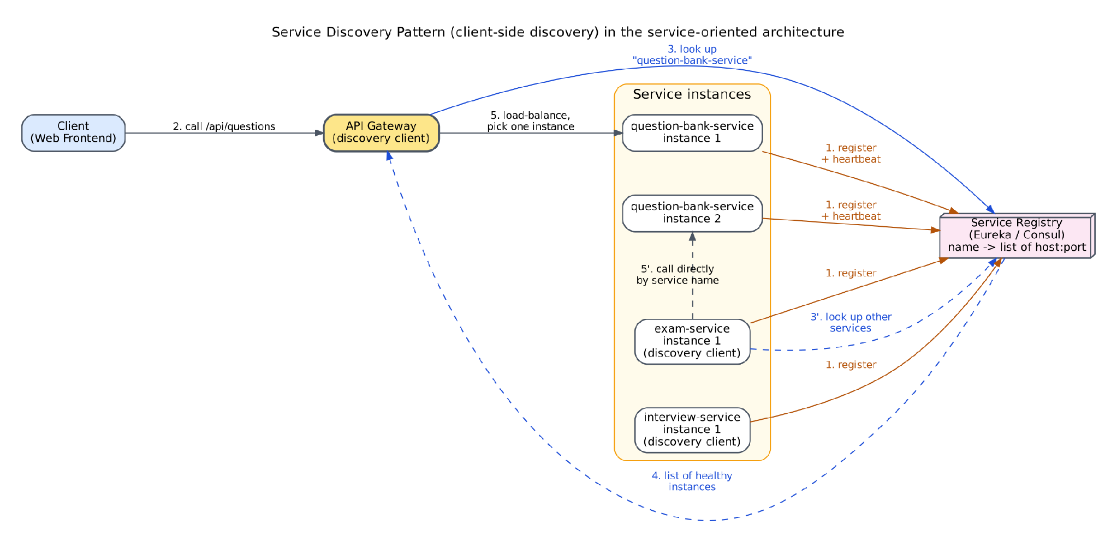
Figure V-2 Service discovery pattern in AIVES
Service discovery is unnecessary for the current single backend process. Consider independent services only after evidence supports separate scaling, ownership or isolation. Extracting this module would first require resolving its dependencies on Academic access, QuestionAttempt deletion guards and Grading rubric reads. A network split introduces consistency and authorization problems that in-process calls currently avoid; the choice of discovery mechanism is deployment-dependent and TBD.
Option | Benefit / prerequisite / unresolved cost
Retain modular monolith | Lowest architectural change; improve internal interfaces and measured bottlenecks. No new operational platform required.
Add background worker | Separates slow provider work from request latency; requires durable jobs, idempotency, progress contract and reconciliation.
External object storage | Could support multi-instance source access; requires data migration, scoped access, lifecycle policy and external-effect recovery. Current code stores local paths.
Extract independent bank service | Could support separate team release/scaling; requires API boundaries for assignments, attempts and grading, data ownership and consistency policy.
Discovery/load balancing | Relevant after multiple independently addressed instances/services exist; topology, service registry and capacity evidence TBD.
No speculative technologies, cost numbers or performance improvements are asserted as facts.

