
Requirement & Design Specification
AI-powered Viva Exam System (AIVES)
Subject: SWD392
Version: 1.0
– Ho Chi Minh City, November 2026 –

Record of Changes
Version | Date | A* M, D | In charge | Change Description
V1.0 | 06/11 | A | Tuấn | Part 1: requirement (NCN7), analysis, high-level design, mapping and alternative architectures
*A - Added M - Modified D - Deleted

Contents
I. Requirement Specification 4
I.1 Problem description 4
I.2 Major Features 5
I.3 System context 6
I.4 Nonfunctional Requirements 8
I.5 Functional requirements 10
I.5.1 Use case diagrams 11
I.5.2 Use case descriptions 16
I.5.3 Activity diagrams 48
I.6 Data Requirements 60
II. Analysis models 62
II.1 Interaction diagrams 62
II.2 State diagram 84
III. Design specification 90
III.1 Integrated Communication Diagrams 90
III.2 System High-Level Design 92
III.3 Component and Package Diagram 95
III.4 Detail Design 95
III.5 Database Design 101
IV. Implementation 113
IV.1 Map architecture to the structure of the project 113
IV.2 Map Class Diagram and Interaction Diagram to Code 114
V. Applying Alternative Architecture Patterns 127
V.1 Applying the service-oriented architecture 127
V.2 Applying Service Discovery Pattern in the service-oriented architecture 128

I. Requirement Specification

I.1 Problem description
Purpose: Build AIVES, a web-based system that supports oral (viva) examinations. Lecturers manage the question bank and rubrics and run the exam sessions; students take an AI-led viva interview by voice; the system transcribes the answers, evaluates them against the rubric and gives lecturers grading suggestions that the lecturer reviews and confirms. Administrators manage accounts, roles, courses and the assignment of lecturers to courses. The system requirements are described as follows:
1. The administrator creates accounts for lecturers and students. Each account has a user code, full name, e-mail and one role (ADMIN, LECTURER or STUDENT). The system sends the account information and a temporary password to the user by e-mail.
2. The administrator can view, search, update and delete accounts, and can reset a user's password.
3. The administrator manages courses (course code, course name, department) and assigns lecturers to courses. Only users with the lecturer role can be assigned.
4. On first login with a temporary password the user must change the password before using any other function.
5. Lecturers manage the question bank and rubrics of their courses, create exams and monitor the viva sessions of their students.
6. Students attend the viva session: the AI asks questions by voice, the student answers by voice and the system transcribes the answer.
7. The system evaluates each answer against the rubric and gives the lecturer a suggested score and comments; the final score is decided by the lecturer.

Question Bank and Rubric
Lecturers need a course-scoped source of oral-examination questions and reusable grading standards. A question bank separates preparation from eligibility for examination use through DRAFT and APPROVED states. A rubric groups named criteria and maximum scores so that downstream grading can evaluate an answer consistently. AI-assisted preparation depends on uploaded teaching material and produces drafts that still require human review.
The current module provides manual entry, Excel import and document-grounded AI generation. It controls access through course assignments, prevents removal of referenced content in selected workflows, and exposes source indexing outcomes. The main business result is a reusable collection of approved questions associated with suitable grading standards. The system currently allows questions without rubrics; AI grading later refuses such questions. This is a cross-module policy gap, not a requirement to silently make rubric assignment mandatory.

Exam Management
An oral examination needs more preparation than a course question list. A lecturer must identify participants, define a valid examination window, decide which approved questions may be used and assign an individual attempt to each candidate. Students need a personal schedule linked to their account. During execution, lecturers need to distinguish an examination that is open from a student attempt that is ready, active or completed.
AIVES represents these responsibilities through three separate records. Exam stores the shared examination definition. ExamAttempt stores one student's participation and allocated slot. QuestionAttempt stores one main question assigned within that attempt. This separation allows several students to share a time window while retaining independent questions, transcripts and results.

AI Interview Core
This module starts exam attempts that are ready, plays prompts, transcribes spoken answers, stores the conversation, asks rubric-based follow-up questions, and advances through the exam. The student is the primary actor. Deepgram provides speech-to-text (STT), the configured AI provider suggests follow-ups through AiClient, and the browser reads prompts aloud using text-to-speech (TTS).

I.2 Major Features

I.2.1 Features for lecturers are as follows
- F01: Question bank and rubric management (module 1).
- F02: Exam management and student registration (module 2).
- F03: Monitor viva sessions and review transcripts (module 3).
- F04: Review AI grading suggestions and confirm final scores (module 4).

I.2.2 Features for students are as follows
- F05: Take the viva interview: listen to the AI question, answer by voice, see the live transcript.
- F06: View the result after the lecturer confirms the score.

I.2.3 Features for administrators are as follows
- F07: Account management: create, view/search, update, delete users, reset password and send the account e-mail.
- F08: Course management: create, view/search, update and delete courses.
- F09: Lecturer assignment: assign / unassign lecturers to courses, view the lecturers of a course and the courses of a lecturer.
- F10: Authentication: log in, change password (mandatory at first login), view the current user.

Question Bank and Rubric
Feature | Scope / use cases
F-QBR-01 — Find question material | Browse/filter/page questions and view details; UC-QBR-01.
F-QBR-02 — Prepare question material | Create and revise drafts, optional rubric assignment; UC-QBR-02/03.
F-QBR-03 — Control question eligibility | Approve questions and remove unused questions; UC-QBR-04/05.
F-QBR-04 — Import question material | Download XLSX template and import all-or-nothing validated rows; UC-QBR-06.
F-QBR-05 — Generate question material | Select course sources and request AI-generated drafts; UC-QBR-07.
F-QBR-06 — Define grading standards | Browse/create/revise/remove rubrics and owned criteria; UC-QBR-08–11.
F-QBR-07 — Prepare source material | Upload, extract, index, list and remove unused course documents; UC-QBR-12/13.

Exam Management
Feature | Delivered capability
F EM 01 Examination definition | Create, list, inspect, revise, change status and delete exams under current service restrictions.
F EM 02 Question configuration | Maintain a validated permitted pool and per-turn answer/follow-up limits.
F EM 03 Candidate preparation | Create personal attempts for selected accounts and offer course-enrolled students through the academic interface.
F EM 04 Scheduling | Allocate simultaneous or sequential slots, generate assigned questions and change individual times.
F EM 05 Monitoring | Read status counts, reset an attempt and mark absence.
F EM 06 Student access | Read paginated personal schedules and the authenticated student's own slot.

I.3 System context
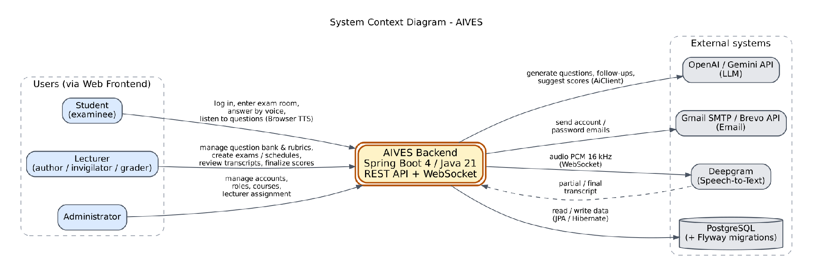
Figure I-1 System context diagram
Figure I-1 shows the system context of AIVES. External users are the Lecturer, the Student and the Administrator. External systems are the speech-to-text service (Deepgram), the generative AI services (OpenAI / Gemini, called through the AiClient interface), the mail service (Gmail SMTP or Brevo) and the PostgreSQL database. Text-to-speech is performed by the browser of the student.

Question Bank and Rubric
Primary external role: Lecturer assigned to the course. Administrator substitutes for course managers across courses. Student does not operate the management functions. AI Provider supports indexing/generation; local storage and PostgreSQL are internal infrastructure. Academic assignment, examination scheduling and grading are adjacent modules inside the AIVES backend, not external human actors.
Inputs: authenticated requests, course/question/rubric/document references, question details, rubric criteria, XLSX rows, document files and generation settings. Outputs: resource details, paginated question results, import errors/counts, indexing outcomes and saved draft questions.

CTX 01 System context logical system boundary flowchart
Figure CTX-01 is included in the diagram appendices.

Role access matrix
Role | Effective capability
Assigned Lecturer | Course questions, rubrics and documents; including approval of own questions. Updates moving a question require access to both courses.
Unassigned Lecturer | Denied course-resource management.
Administrator | Same management goals without assignment restriction. Some list endpoints do not separately verify course existence.
Student / other role | Denied by CourseAccessService for management operations.
Any authenticated role | Import-template download is the exception: controller does not invoke course assignment checks; the password-change filter still applies.
Authentication and mandatory password change belong to shared security. They are preconditions, not invented included UCs.

Detailed diagrams

CTX 01 System context logical system boundary flowchart
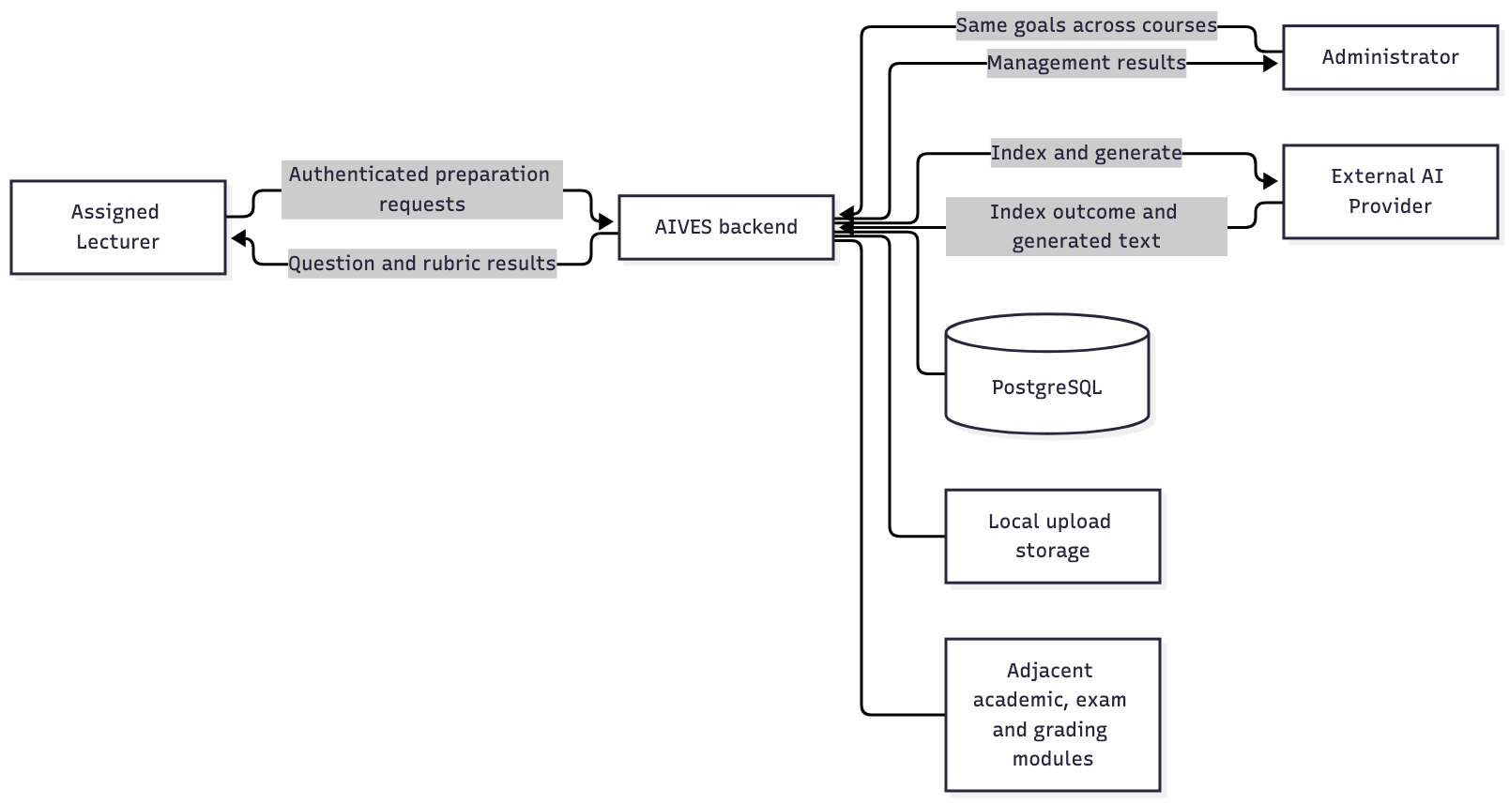

Exam Management
The Lecturer is the primary actor for examination preparation and monitoring. The Student reads the schedule of the authenticated account and passes an attempt identifier to the interview module. The Administrator manages course assignments and enrolment through the academic module. The approved question bank supplies candidate questions. Interview executes the assigned questions, and Grading evaluates the evidence associated with each QuestionAttempt.
React calls REST controllers with JWT bearer tokens. The application uses Java 21, Spring Boot, Spring Data JPA and PostgreSQL. Flyway migrations define the physical schema. All feature packages execute in one backend application. Database writes within a scheduling service call share one Spring transaction.
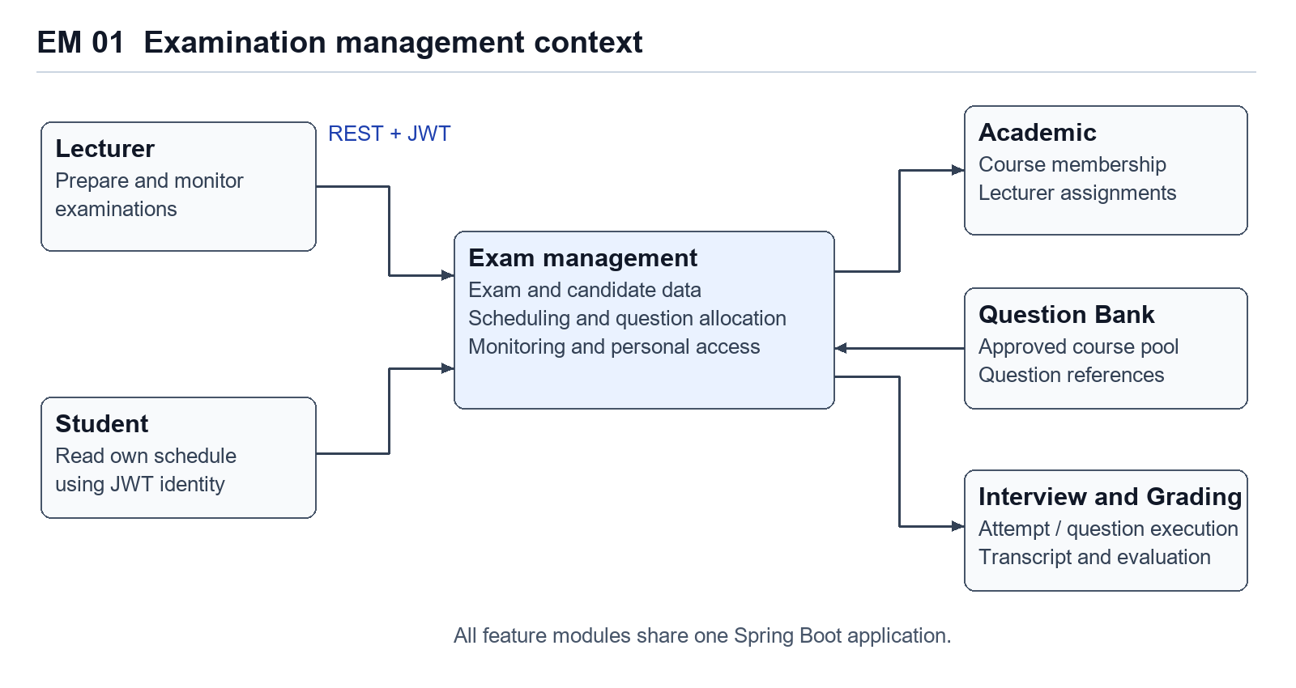
Figure EM 01. Examination management context and its adjacent modules.

I.4 Nonfunctional Requirements
NF-01 Maintainability: layered architecture organised by feature (Controller → Service → Repository), AI and speech providers hidden behind interfaces, schema changes only through Flyway migrations.
NF-02 Performance: the delay between the end of a student's answer and the next AI question should stay short enough for a natural conversation; speech is streamed (PCM 16 kHz over WebSocket).
NF-03 Accuracy: speech recognition is configured for Vietnamese (Deepgram nova-3, language vi).
NF-04 Security and privacy: JWT authentication, role-based access (/api/admin/** only for ADMIN), BCrypt password hashing, recordings and transcripts accessible only to authorised users.
NF-05 Human in the loop: AI results are only suggestions; the lecturer confirms every final score.

Question Bank and Rubric
No approved module-specific NFR target was supplied. The following are Proposed requirement categories with acceptance parameters TBD, rather than claims that the code meets a measured SLA.
NFR | Proposed statement / current evidence / verification
NFR-QBR-01 — Performance | Establish percentile response time and concurrent workload for browsing, import, upload and generation separately; values TBD. Current browse page size is clamped to 1–100; external generation/indexing are synchronous. Measure under agreed data volumes.
NFR-QBR-02 — Availability and recovery | Establish availability, backup RPO/RTO and recovery procedures; values TBD. Database transactions do not reverse external AI or filesystem operations. Exercise provider/file failure recovery.
NFR-QBR-03 — Confidentiality | Establish protection for private teaching sources, logs and provider data retention; policy TBD. JWT and course checks are observed; encryption-at-rest, provider retention and complete sanitisation are not established. Review exports, logs and error responses.
NFR-QBR-04 — Usability/accessibility | Establish supported devices, browsers, accessibility standard and task success targets; values TBD. Frontend was not supplied or inspected. Validate with agreed user tasks.
NFR-QBR-05 — Maintainability | Preserve traceability from FR to UC, controller/service and data. Quantified maintainability target TBD. Current code separates DTO/controller/service/repository/adapter responsibilities.
NFR-QBR-06 — Auditability | Establish recorded events, actor attribution, tamper protection and retention period; TBD. Creator/upload author and timestamps exist; a complete approval/edit/delete audit trail is not observed.
NFR-QBR-07 — Capacity and portability | Establish question/document limits, growth assumptions, file concurrency and supported deployment environments; TBD. Local Compose deployment and Docker build are present; production scaling is unverified.
Configured defaults such as AI timeout, token cap and 25 MiB file size are implementation constraints, not business-approved NFRs. The application's file check may be preceded by framework/proxy multipart limits; the effective deployed limit requires verification.

Exam Management
- Access control. Student schedule reads derive ownership from the JWT subject. The question-configuration service checks course-management authority through CourseAccessService.
- Consistency. Failed automatic scheduling must roll back database changes from that service invocation. A student attempt, its assigned questions and its schedule must remain understandable after retry or interruption.
- Usability. Students select an examination from their own schedule rather than entering a UUID. A configuration screen exposes selected questions, answer duration and follow-up limits in familiar terms.
- Maintainability. Controllers handle HTTP binding, services coordinate business operations, repositories persist entities and mappers produce DTOs. Public responses separate personal schedule summaries from question-bank internals.
- Performance. Student lists are paginated. Indexes support joins and filtering by student, examination, status and schedule. No load-test result or response-time target is asserted in this report.
- Time representation. API dates use offset-aware timestamps. PostgreSQL stores TIMESTAMPTZ values. Presentation converts them to the user's local display time while preserving the underlying instant.

I.5 Functional requirements

Question Bank and Rubric
ID | Observed functional baseline
FR-QBR-01 | The system authenticates requests and restricts course resources to assigned Lecturers or Administrators, except the authenticated template endpoint.
FR-QBR-02 | The system searches course questions by status, Bloom level and case-insensitive content keyword, returns a page ordered by latest update, and retrieves details.
FR-QBR-03 | The system creates manual questions in DRAFT with required course, nonblank content and Bloom level, plus optional same-course rubric.
FR-QBR-04 | The system replaces submitted question details, retaining its creator and resetting status to DRAFT; cross-course movement requires access to both courses.
FR-QBR-05 | The system sets an existing authorized question to APPROVED, including repeated approval; downstream exam selection considers only approved in-course questions.
FR-QBR-06 | The system removes a question only when no question attempt references it.
FR-QBR-07 | The system supplies an XLSX template and validates first-sheet import rows before saving any; any row validation error yields count zero and row feedback.
FR-QBR-08 | The system generates 1–20 draft questions from eligible indexed course sources, defaults missing Bloom selection to UNDERSTAND, and links generated questions to selected source records.
FR-QBR-09 | The system returns course rubric lists and details, including criteria and derived total maximum score.
FR-QBR-10 | The system creates a course rubric with a nonempty criterion collection and validates names and positive minimum maximum-score values.
FR-QBR-11 | The system replaces a rubric's details and full criterion set; it does not implement rubric versioning or a used-rubric edit block.
FR-QBR-12 | The system removes a rubric only when no question references it and cascades removal to owned criteria.
FR-QBR-13 | The system stores and extracts PDF/DOCX/PPTX source uploads within the configured service size limit and records READY or FAILED after synchronous indexing.
FR-QBR-14 | The system lists source document metadata and indexing outcomes without exposing extracted text or provider IDs in DocumentResponse.
FR-QBR-15 | The system blocks deletion of a source referenced by generated questions; otherwise it removes provider file, local file and database record in that order.
FR-QBR-16 | The system returns structured resource/validation/business errors; import row errors and FAILED indexing are carried in otherwise successful HTTP responses.
Business detail and edge conditions are centralised in BR-01–BR-13 in Section I.5.2. Numerical amounts here are observed input bounds, not invented scale or performance targets.

Exam Management
FR EM 01 to FR EM 10 correspond to the use cases in Section I.5.2. These identifiers are report identifiers and provide traceability across requirements, design and verification.
Requirement | Use case | Primary actor
FR EM 01 | UC EM 01 Browse examinations | Lecturer
FR EM 02 | UC EM 02 Create an examination | Lecturer
FR EM 03 | UC EM 03 Revise examination information | Lecturer
FR EM 04 | UC EM 04 Configure a permitted question pool | Lecturer
FR EM 05 | UC EM 05 Assign candidates | Lecturer
FR EM 06 | UC EM 06 Allocate schedules and assigned questions | Lecturer
FR EM 07 | UC EM 07 Reschedule one candidate | Lecturer
FR EM 08 | UC EM 08 Monitor and recover attempts | Lecturer
FR EM 09 | UC EM 09 View a personal schedule | Student
FR EM 10 | UC EM 10 View a personal slot and hand off to interview | Student

I.5.1 Use case diagrams
Based on the user requirements in Section I.1, this report details the functional group NCN7 (System Administration and Authentication) of the Administration Site. Figure I-2 presents the overview use case diagram: managing users, managing courses, assigning lecturers and viewing roles, all of which include the Login use case, and Change Password, which extends Login. Figures I-3 and I-4 are detailed use case diagrams for Manage Users and for Manage Courses / Assign Lecturers.
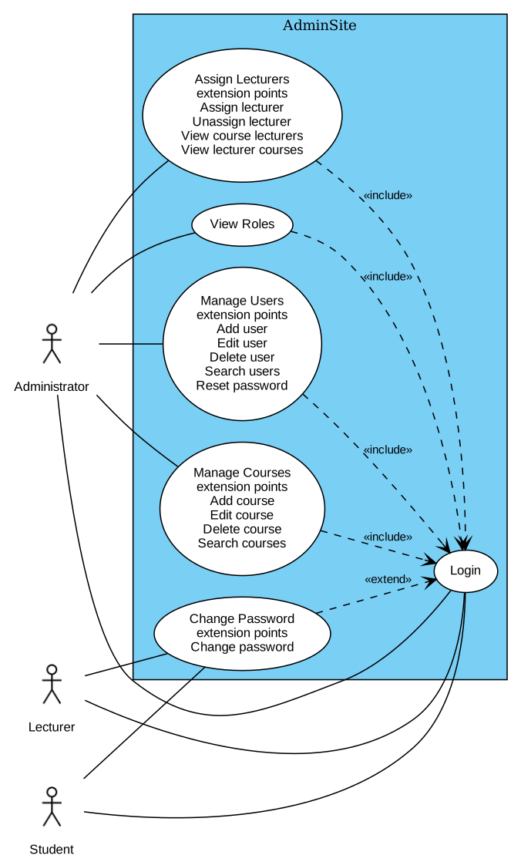
Figure I-2 Overview Use Case Diagram of Admin Site
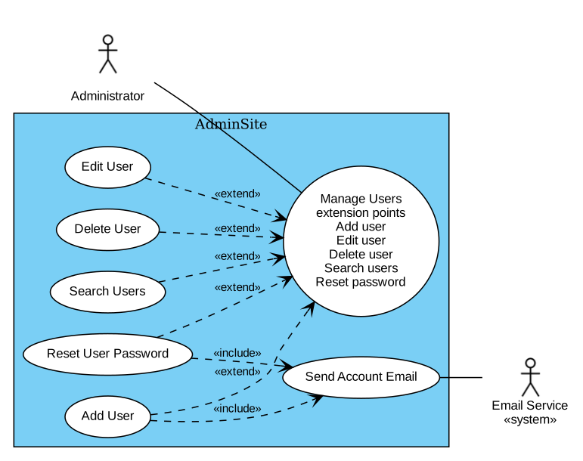
Figure I-3 Detailed Use Case Diagram for Manage Users
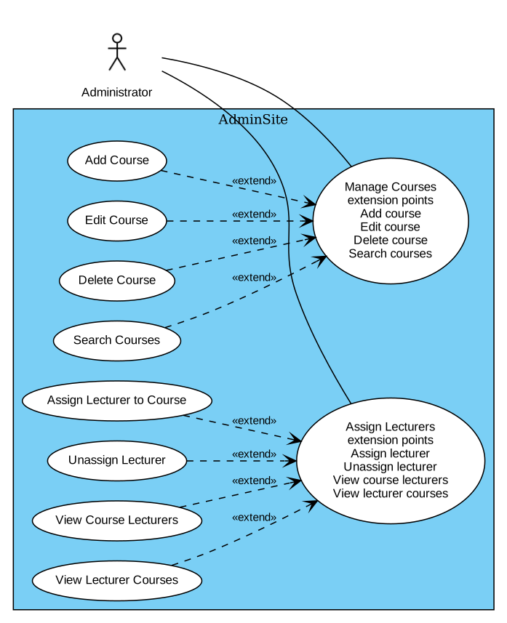
Figure I-4 Detailed Use Case Diagram for Manage Courses and Assign Lecturers

Question Bank and Rubric

Use case diagram
The following is a UML-style use-case overview expressed as a flowchart. Solid associations show participation; dashed ADMIN association represents the same capability set. It does not assert UML actor inheritance or include/extend relations.

UC 01 Use case overview UML style flowchart
Figure UC-01 is included in the diagram appendices.

Detailed diagrams

UC 01 Use case overview UML style flowchart
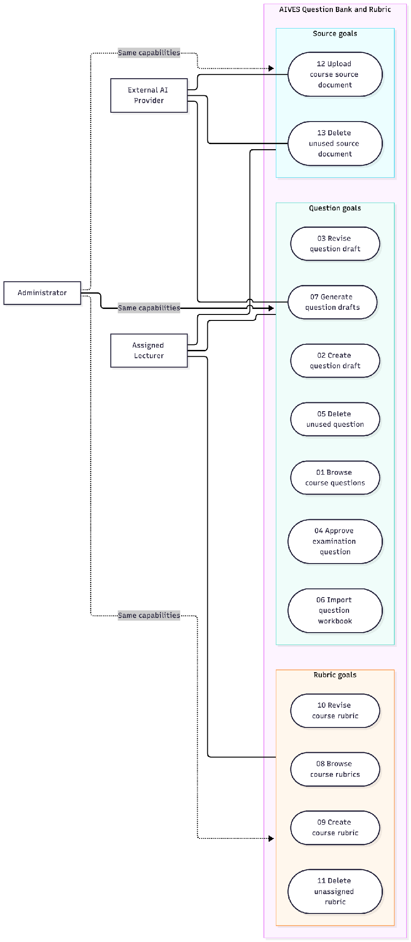

Exam Management

Use case model
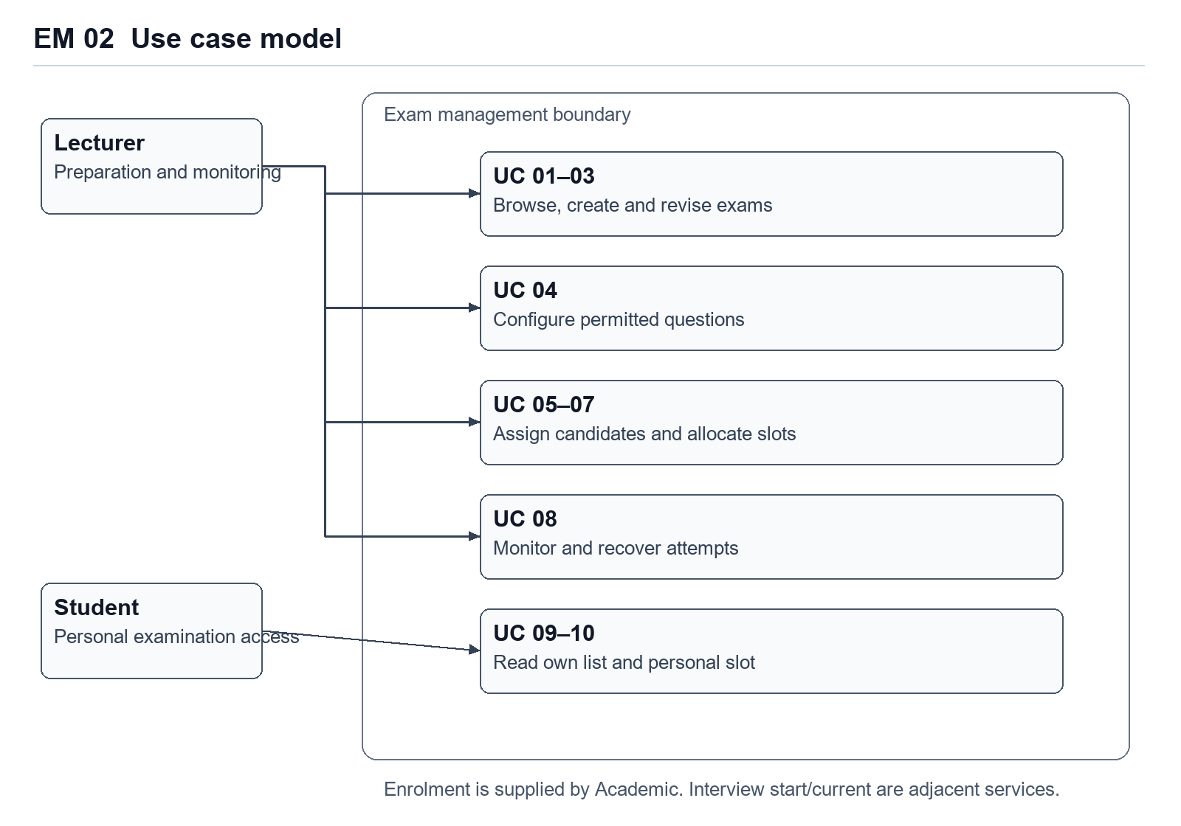
Figure EM 02. Use case relationships. Course enrolment is an academic prerequisite. Starting the interview belongs to the adjacent interview module.

AI Interview Core
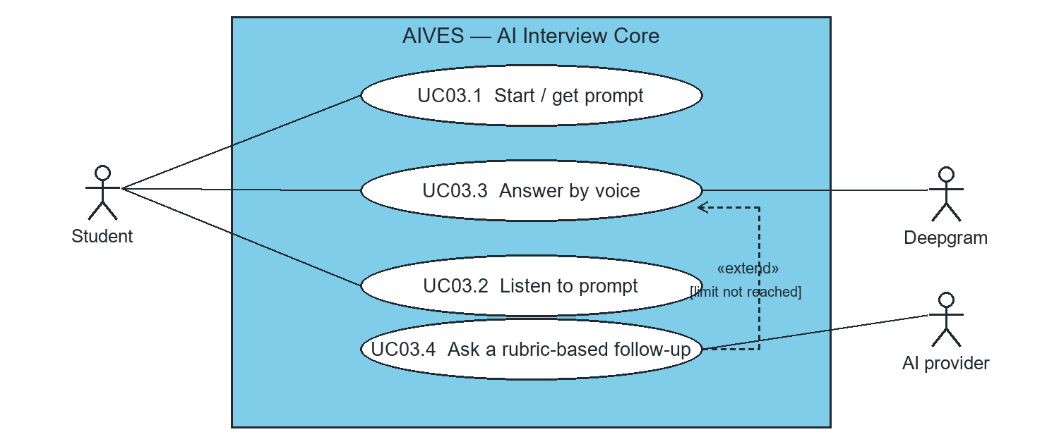
Figure 1. Use cases for the AI Interview Core.

I.5.2 Use case descriptions
Tables I-1 to I-6 describe the use cases Manage Users, Add User, Edit User, Delete User, Assign Lecturer to Course and Change Password. The event flows can be modeled by activity diagrams; Figures I-5 and I-6 model Manage Users and Add User. These descriptions are the input of the analysis models in Section II.
Table I-1 Use case description for Manage Users
ID and Name: | UC-01 Manage users
Created By: | Vinh Date Created: 06/11/2026
Primary Actor: | Administrator (Admin)
Description: | This use case allows the Administrator to manage the user accounts in the system, including adding, editing, deleting and searching users.
Trigger: | The Administrator selects the Manage Users option from the system menu.
Preconditions: | PRE-1. The Administrator is logged into AIVES.  PRE-2. The Administrator is authorized (role ADMIN) and has already changed the temporary password.
Postconditions: | POST-1. The list of users is displayed and the selected management action can be started.
Normal Flow: | 1. The Admin selects the Manage Users option from the system menu.  2. The system retrieves the list of users from the database (filtered by role and keyword, paged).  3. The system displays the Manage Users interface with the list of users.  4. The Admin views the list of users.  5. The Admin can select actions: Add User, Edit User, Delete User, Search User.
Alternative Flows:
Exceptions:
Priority: | High
Business Rules: | BR-1. Only the ADMIN role can access the administration functions.  BR-2. The user list can be filtered by role and keyword and is returned page by page.
Table I-2 Use case description for Add User
ID and Name: | UC-02 Add user
Created By: | Vinh Date Created: 06/11/2026
Primary Actor: | Administrator (Admin) Secondary Actors: Mail service
Description: | This use case allows the Administrator to create a new user account.
Trigger: | The Admin selects the Add User option from the Manage Users section.
Preconditions: | PRE-1. The Administrator is logged into AIVES.  PRE-2. The Administrator is authorized (role ADMIN) and has already changed the temporary password.
Postconditions: | POST-1. Successful addition: the new user is saved, an account e-mail is sent and the user list is updated.  POST-2. Unsuccessful addition: the system shows feedback to the Admin and no user is created.
Normal Flow: | 1. The Admin selects Add User from the Manage Users section.  2. The system displays the add user form.  3. The system retrieves the list of roles and fills the role dropdown.  4. The Admin fills in userCode, fullName, email, initial password and selects a role (See A4.1).  5. The Admin submits "add user".  6. The system validates the input data (See E6.1).  7. The system checks that the e-mail and user code are unique and that the role is valid (See E7.1).  8. The system saves the user with mustChangePassword = true and sends the account e-mail (user code and temporary password) to the user.  9. The system displays a confirmation message that the user was added successfully.
Alternative Flows: | A4.1 Select Cancel (Step 4)  1. The Admin selects the Cancel button.  2. The system closes the Add User screen and returns to the Manage Users screen.
Exceptions: | E6.1 Invalid Data (Step 6): the system returns 400 with the error of each field and prompts the Admin to correct the data.  E7.1 Duplicate or invalid (Step 7): the e-mail or user code already exists (409) or the role is invalid (400); the system displays an error message.
Priority: | High
Business Rules: | BR-1. User code and e-mail must be unique.  BR-2. The role must be ADMIN, LECTURER or STUDENT.  BR-3. A new account must change the password at first login (mustChangePassword = true); the password is stored hashed (BCrypt).
Table I-3 Use case description for Edit User
ID and Name: | UC-03 Edit user
Created By: | Vinh Date Created: 06/11/2026
Primary Actor: | Administrator (Admin)
Description: | This use case allows the Administrator to edit the information of an existing user.
Trigger: | The Admin selects the Edit User option from the Manage Users section.
Preconditions: | PRE-1. The Administrator is logged into AIVES.  PRE-2. The Administrator is authorized (role ADMIN) and has already changed the temporary password.  PRE-3. The user to be edited exists in the system.
Postconditions: | POST-1. Successful edit: the user information is updated.  POST-2. Unsuccessful edit: the system shows feedback and no change is made.
Normal Flow: | 1. The Admin selects Edit User from the Manage Users section.  2. The system displays the edit user form populated with the current user information.  3. The Admin edits the information as needed (See A3.1).  4. The Admin submits the form.  5. The system validates the input data (See E5.1).  6. The system checks the unique constraints and the role-change rule (See E6.1).  7. The system updates the user in the database.  8. The system displays a confirmation message and returns to the Manage Users screen.
Alternative Flows: | A3.1 Select Close (Step 3)  1. The Admin selects the Close button.  2. The system closes the Edit User screen without changes.
Exceptions: | E5.1 Invalid Data (Step 5): the system displays the field errors (400).  E6.1 Business conflict (Step 6): duplicate e-mail / user code, or the role of a lecturer who is teaching a course is being changed (409).
Priority: | High
Business Rules: | BR-1. The role of a lecturer who is currently assigned to a course cannot be changed.  BR-2. E-mail and user code remain unique.
Table I-4 Use case description for Delete User
ID and Name: | UC-04 Delete user
Created By: | Vinh Date Created: 06/11/2026
Primary Actor: | Administrator (Admin)
Description: | This use case allows the Administrator to delete an existing user account.
Trigger: | The Admin selects the Delete User option from the Manage Users section.
Preconditions: | PRE-1. The Administrator is logged into AIVES.  PRE-2. The Administrator is authorized (role ADMIN) and has already changed the temporary password.  PRE-3. The user to be deleted exists in the system.
Postconditions: | POST-1. Successful deletion: the user is removed and the list is refreshed.  POST-2. Unsuccessful deletion: the system shows feedback and no change is made.
Normal Flow: | 1. The Admin selects a user to delete.  2. The system asks the Admin to confirm the deletion (See A2.1).  3. The Admin confirms the deletion.  4. The system deletes the user from the database (See E4.1).  5. The system displays a confirmation message and refreshes the list.
Alternative Flows: | A2.1 Cancel deletion (Step 2)  1. The Admin selects Cancel.  2. The system closes the dialog without changes.
Exceptions: | E4.1 Not found / system error (Step 4): the system displays an error message (404 when the user does not exist).
Priority: | High
Business Rules: | BR-1. Deleting a user is a write operation restricted to the ADMIN role.
Table I-5 Use case description for Assign Lecturer to Course
ID and Name: | UC-05 Assign lecturer to course
Created By: | Vinh Date Created: 06/11/2026
Primary Actor: | Administrator (Admin)
Description: | This use case allows the Administrator to assign a lecturer to a course so that the lecturer can manage that course.
Trigger: | The Admin selects Assign Lecturer from the Manage Courses section.
Preconditions: | PRE-1. The Administrator is logged into AIVES.  PRE-2. The Administrator is authorized (role ADMIN) and has already changed the temporary password.  PRE-3. The course exists in the system.
Postconditions: | POST-1. Successful assignment: the lecturer is linked to the course (course_lecturers).  POST-2. Unsuccessful assignment: the system shows feedback and no change is made.
Normal Flow: | 1. The Admin selects Assign Lecturer for a course.  2. The system displays the assignment form and retrieves the list of lecturers.  3. The Admin selects a lecturer (See A3.1).  4. The Admin submits "assign".  5. The system checks that the course exists and the user is a lecturer (See E5.1).  6. The system saves the assignment.  7. The system displays a confirmation message and refreshes the lecturers of the course.
Alternative Flows: | A3.1 Cancel (Step 3)  1. The Admin selects Cancel.  2. The system closes the form without changes.
Exceptions: | E5.1 Invalid assignment (Step 5): the course does not exist (404) or the selected user is not a lecturer, e.g. a student (400).
Priority: | High
Business Rules: | BR-1. Only users with the LECTURER role can be assigned.  BR-2. Assigning an already assigned lecturer does not create a duplicate.  BR-3. Unassigning a lecturer who is not assigned returns 404.
Table I-6 Use case description for Change Password
ID and Name: | UC-06 Change password
Created By: | Vinh Date Created: 06/11/2026
Primary Actor: | Lecturer, Student, Administrator (User)
Description: | This use case allows a user to change the password; it is mandatory at the first login with a temporary password.
Trigger: | The user logs in with a temporary password, or selects Change Password.
Preconditions: | PRE-1. The user has an account in the system.  PRE-2. The user knows the current (temporary) password.
Postconditions: | POST-1. Successful change: the new password is stored and mustChangePassword = false.  POST-2. Unsuccessful change: the password is not changed.
Normal Flow: | 1. The user enters the account and the temporary password and submits login.  2. The system authenticates the user and returns an access token (mustChangePassword = true); until the password is changed the other APIs answer 428.  3. The system displays the change password form.  4. The user enters the current password and the new password.  5. The user submits "change password".  6. The system validates the current password (See E6.1) and updates the password.  7. The system displays a success message and asks the user to log in again.
Alternative Flows:
Exceptions: | E6.1 Wrong current password or invalid new password (Step 6): the system displays an error message.
Priority: | High
Business Rules: | BR-1. While mustChangePassword = true, all requests except login and change password are rejected with 428.

Question Bank and Rubric
Section I.5.2 lists UC-QBR-01 through UC-QBR-13. Section I.5.2 reproduces their complete 13-field specifications. Priorities remain proposals. The master project register and approved stakeholder requirements were unavailable.

Use case register and business rules
Glossary: Course = subject containing the bank; Question = oral-examination item; Bloom level = REMEMBER, UNDERSTAND, APPLY, ANALYZE, EVALUATE, CREATE; Rubric = course grading standard; Criterion = named component with description and maximum score; DRAFT = awaiting approval; APPROVED = eligible for configured exam selection; READY/FAILED = source indexing outcome.

Use case register
Use case | Goal, actor, and proposed priority
UC-QBR-01 | Browse course questions — Primary: assigned Lecturer; goal: Matching questions, pagination information, and requested question details are available to the Lecturer. Priority: proposed High.
UC-QBR-02 | Create question draft — Primary: assigned Lecturer; goal: A new DRAFT question exists with the submitted course, content, Bloom level, optional rubric and AI flag; the creator is recorded. Priority: proposed High.
UC-QBR-03 | Revise question draft — Primary: assigned Lecturer; goal: The question contains the submitted details; its status is DRAFT; its original creator is retained. Priority: proposed High.
UC-QBR-04 | Approve examination question — Primary: assigned Lecturer; goal: The question status is APPROVED; the question is eligible for selection subject to exam configuration. Priority: proposed High.
UC-QBR-05 | Delete unused question — Primary: assigned Lecturer; goal: The question no longer exists in the bank. Priority: proposed High.
UC-QBR-06 | Import question workbook — Primary: assigned Lecturer; goal: Every accepted nonblank data row is stored as a DRAFT question with AI flag false; the response contains the imported count and no row errors. Priority: proposed High.
UC-QBR-07 | Generate question drafts — Primary: assigned Lecturer; goal: Generated questions exist as DRAFT with AI flag true, optional rubric and linked source documents; generated question details are returned. Priority: proposed High.
UC-QBR-08 | Browse course rubrics — Primary: assigned Lecturer; goal: The course rubric list or requested rubric details are available, including criteria and maximum scores. Priority: proposed High.
UC-QBR-09 | Create course rubric — Primary: assigned Lecturer; goal: A rubric exists in the selected course with its name, optional description, and submitted criteria. Priority: proposed High.
UC-QBR-10 | Revise course rubric — Primary: assigned Lecturer; goal: The rubric name and description match the request; the submitted criteria replace the former set, with newly created criterion identities. Priority: proposed High.
UC-QBR-11 | Delete unassigned rubric — Primary: assigned Lecturer; goal: The rubric and its owned criteria no longer exist. Priority: proposed High.
UC-QBR-12 | Upload course source document — Primary: assigned Lecturer; goal: The document is stored with metadata and extracted text; its final indexing status is READY or FAILED with an indexing error. Priority: proposed High.
UC-QBR-13 | Delete unused source document — Primary: assigned Lecturer; goal: The document record and local file are removed; the provider file is deleted when a provider file identifier exists. Priority: proposed High.
Each document contains history metadata and all 13 requested fields. Source upload/deletion are included because source readiness and retention directly govern generation. Browsing includes list, filter, paging and detail rather than creating one UC per button. Creation, revision, approval and removal remain separate because they produce distinct persisted business outcomes. Rubric assignment is part of question creation/revision/import/generation; there is no separate assignment API.

Business rules and implementation constraints
These rules describe observed code behavior, not newly approved policy.
Rule | Observed behavior and evidence
BR-01 | A course resource requires ADMIN or a LECTURER assigned to that course (CourseAccessService.requireManager). JWT authentication and mandatory-password-change enforcement apply (SecurityConfig, MustChangePasswordFilter). The import-template endpoint itself only requires authentication and does not invoke course access checks.
BR-02 | Questions require a course, nonblank content and a Bloom level; content is trimmed. A rubric is optional but must exist in the same course (QuestionRequest, QuestionService.applyRequest).
BR-03 | New manual, imported and generated questions are DRAFT. The manual create/update payload exposes an aiGenerated boolean; it is not protected provenance (QuestionService, QuestionRequest).
BR-04 | Every question update resets status to DRAFT. Approval directly sets APPROVED, even when already approved; no reject/pending-review state, separate reviewer, or rubric-required approval check is implemented (QuestionService).
BR-05 | Exam selection uses only APPROVED questions in the exam course and applies configured question IDs when supplied (QuestionSelectorServiceImpl). Selection constraints beyond bank eligibility belong to exam management.
BR-06 | A question referenced by a QuestionAttempt cannot be deleted (QuestionService.delete). No archival or soft-delete endpoint was found.
BR-07 | Import accepts nonempty .xlsx, first sheet only, required headers content and bloomLevel; optional rubricId. Headers are trimmed/lowercased; Bloom values are trimmed/uppercased. Blank rows are skipped. A row rubric overrides the default. Any row error returns imported count zero; no row is saved. Header-only files can succeed with count zero (QuestionImportService).
BR-08 | Generation count is 1–20. Empty source selection means all course documents, all of which must be READY and in-course. Missing Bloom selection defaults to UNDERSTAND. Missing topic requires extracted text. Optional rubric must be in-course. Generated drafts link all selected sources, which is not proof of per-question source citation. OpenAI adapter checks output count/nonblank content; generation service checks returned Bloom levels (GenerateQuestionsRequest, QuestionGenerationService, OpenAiAiClient).
BR-09 | Rubric name and criterion names are nonblank and at most 255 characters. Criteria must be nonempty; each maximum score is required and at least 0.01. Total maximum score is the sum of criterion maximum scores (Rubric.getTotalMaxScore). No total-score-equals-10/100, weighting, unique-name or performance-band rule is implemented. Storage uses DECIMAL(5,2); the DTO lacks a matching upper bound/scale restriction (RubricRequest, RubricCriterionRequest, RubricCriterion).
BR-10 | Rubric update clears and replaces all criteria, creating new criterion IDs. No draft/version/approval state or explicit block on editing a used rubric exists (RubricService.applyRequest).
BR-11 | A rubric referenced by any question cannot be deleted. Unassigned rubric deletion cascades to its owned criteria (RubricService.delete, Rubric).
BR-12 | Source uploads accept PDF/DOCX/PPTX based on filename extension, nonempty and within configured app.ai.max-upload-bytes (default 26,214,400 bytes; not an approved fixed requirement). Upload extracts text and indexes synchronously. Indexing failure retains the document as FAILED with an error, despite the generic controller success message (DocumentService, application.yml).
BR-13 | A source linked to an AI question cannot be deleted. Otherwise deletion attempts provider file removal, local file removal, then database deletion; external effects are not transactionally restored (DocumentService.delete).

Detailed use cases

UC QBR 01 Browse course questions
Metadata | Value
Use Case ID | UC-QBR-01
Use Case Name | Browse course questions
Created By | Nguyen Duc Anh
Last Updated By | Nguyen Duc Anh
Date Created | 2026-11-06
Date Last Updated | 2026-11-06
Version | 0.1 — stakeholder review required
Field | Specification
Actor | Primary: Lecturer (assigned to the course). Secondary: None. Administrator has the same course-resource capabilities; see scope note.
Description | To locate reusable examination material, the Lecturer requests the course question bank. The result is a filtered list or the details of a selected question. Trigger: Lecturer requests the question bank for a course.
Preconditions | 1. Lecturer is authenticated and not blocked by mandatory password change.  2. Lecturer is assigned to the relevant course.  3. The selected course exists.
Postconditions | 1. Matching questions, pagination information, and requested question details are available to the Lecturer.
Priority | Proposed High — supports preparation of examination questions or grading standards; stakeholder approval TBD.
Frequency of Use | TBD — no usage volumes supplied; see OI-01 in Section I.5.2.
Normal Course of Events | 1. Lecturer requests the question bank for a course.  2. System returns the first page of questions ordered by latest update.  3. Lecturer supplies a keyword, status, or Bloom-level filter.  4. System returns the matching page.  5. Lecturer requests the details of a selected question.  6. System returns its content, course, rubric reference, author, Bloom level, AI flag, status, and timestamps.
Alternative Courses | UC-QBR-01.AC.1 — At step 3, if the Lecturer changes the page:  3a. Lecturer requests another page. System returns the requested page.  Continue from step 5 of the Normal Course.  UC-QBR-01.AC.2 — At step 4, if no questions match:  4a. System returns an empty page with pagination information. The use case ends successfully.
Exceptions | UC-QBR-01.EX.1 — Trigger: At step 5, the selected question no longer exists.  Response: System reports that the question was not found.  Final state: No question details are returned.  UC-QBR-01.EX.2 — Trigger: The request has a missing, invalid, or expired login token, a required password change is outstanding, or course access is denied.  Response: System rejects the operation with authentication/access feedback.  Final state: This request makes no domain changes.
Includes | None. Authentication and validation are steps/preconditions, not invented included use cases.
Special Requirements | No approved UC-specific measurable NFR targets were found. Performance, availability, accessibility, and audit-retention targets: TBD (OI-02). Configured timeouts and file limits are implementation constraints, not approved SLAs.
Assumptions | 1. User-facing interactions describe logical requests and responses; no frontend screens or button labels have been verified.  2. The current backend is the baseline for this draft, not proof of stakeholder-approved policy.
Notes and Issues | Rules: BR-01, BR-02.  Code evidence: QuestionController.search/findById; QuestionService.search/findById (source index in Section IV.2).  Applicable shared issues: OI-01–OI-08 in Section I.5.2 and OI-09–OI-13 in section VI; owner: TBD; due: TBD; resolution: open. No delivery date or person is inferred.

UC QBR 02 Create question draft
Metadata | Value
Use Case ID | UC-QBR-02
Use Case Name | Create question draft
Created By | Nguyen Duc Anh
Last Updated By | Nguyen Duc Anh
Date Created | 2026-11-06
Date Last Updated | 2026-11-06
Version | 0.1 — stakeholder review required
Field | Specification
Actor | Primary: Lecturer (assigned to the course). Secondary: None. Administrator has the same course-resource capabilities; see scope note.
Description | To add examination material, the Lecturer submits a new question. The result is a saved draft that can be reviewed before approval. Trigger: Lecturer requests creation of a question for a course.
Preconditions | 1. Lecturer is authenticated and not blocked by mandatory password change.  2. Lecturer is assigned to the relevant course.  3. The target course exists.
Postconditions | 1. A new DRAFT question exists with the submitted course, content, Bloom level, optional rubric and AI flag; the creator is recorded.
Priority | Proposed High — supports preparation of examination questions or grading standards; stakeholder approval TBD.
Frequency of Use | TBD — no usage volumes supplied; see OI-01 in Section I.5.2.
Normal Course of Events | 1. Lecturer requests creation of a question for a course.  2. System provides the course rubric choices.  3. Lecturer enters the question content, Bloom level, optional rubric, and AI flag.  4. Lecturer submits the question.  5. System validates the request against BR-02 and BR-03.  6. System saves the question as DRAFT.  7. System returns the saved question.
Alternative Courses | UC-QBR-02.AC.1 — At step 3, if no rubric is selected:  3a. Lecturer leaves the rubric unassigned.  Continue from step 4 of the Normal Course.
Exceptions | UC-QBR-02.EX.1 — Trigger: At step 5, required data is missing, the course or rubric is absent, or the rubric belongs to another course.  Response: System rejects the request with validation or resource feedback.  Final state: No question is created.  UC-QBR-02.EX.2 — Trigger: The request has a missing, invalid, or expired login token, a required password change is outstanding, or course access is denied.  Response: System rejects the operation with authentication/access feedback.  Final state: This request makes no domain changes.
Includes | None. Authentication and validation are steps/preconditions, not invented included use cases.
Special Requirements | No approved UC-specific measurable NFR targets were found. Performance, availability, accessibility, and audit-retention targets: TBD (OI-02). Configured timeouts and file limits are implementation constraints, not approved SLAs.
Assumptions | 1. User-facing interactions describe logical requests and responses; no frontend screens or button labels have been verified.  2. The current backend is the baseline for this draft, not proof of stakeholder-approved policy.
Notes and Issues | Rules: BR-01, BR-02, BR-03.  Code evidence: QuestionController.create; QuestionService.create/applyRequest; QuestionRequest (source index in Section IV.2).  Applicable shared issues: OI-01–OI-08 in Section I.5.2 and OI-09–OI-13 in section VI; owner: TBD; due: TBD; resolution: open. No delivery date or person is inferred.

UC QBR 03 Revise question draft
Metadata | Value
Use Case ID | UC-QBR-03
Use Case Name | Revise question draft
Created By | Nguyen Duc Anh
Last Updated By | Nguyen Duc Anh
Date Created | 2026-11-06
Date Last Updated | 2026-11-06
Version | 0.1 — stakeholder review required
Field | Specification
Actor | Primary: Lecturer (assigned to the course). Secondary: None. Administrator has the same course-resource capabilities; see scope note.
Description | To correct or replace question material, the Lecturer submits revised question details. The result is a saved draft requiring approval before subsequent exam selection. Trigger: Lecturer requests revision of an existing question.
Preconditions | 1. Lecturer is authenticated and not blocked by mandatory password change.  2. Lecturer is assigned to the relevant course.  3. The question and target course exist; the Lecturer has access to both the existing and target courses.
Postconditions | 1. The question contains the submitted details; its status is DRAFT; its original creator is retained.
Priority | Proposed High — supports preparation of examination questions or grading standards; stakeholder approval TBD.
Frequency of Use | TBD — no usage volumes supplied; see OI-01 in Section I.5.2.
Normal Course of Events | 1. Lecturer requests revision of an existing question.  2. System returns the current question details.  3. Lecturer supplies the complete replacement details.  4. Lecturer submits the revision.  5. System validates the revision against BR-02 and BR-03.  6. System saves the revised question as DRAFT.  7. System returns the revised question.
Alternative Courses | UC-QBR-03.AC.1 — At step 3, if the Lecturer moves the question to another authorized course:  3a. Lecturer selects the target course and a rubric belonging to that course, or no rubric.  Continue from step 4 of the Normal Course.
Exceptions | UC-QBR-03.EX.1 — Trigger: At step 5, the question, target course, or rubric is absent, or the rubric is from another course.  Response: System rejects the revision.  Final state: The prior question state remains stored.  UC-QBR-03.EX.2 — Trigger: The request has a missing, invalid, or expired login token, a required password change is outstanding, or course access is denied.  Response: System rejects the operation with authentication/access feedback.  Final state: This request makes no domain changes.
Includes | None. Authentication and validation are steps/preconditions, not invented included use cases.
Special Requirements | No approved UC-specific measurable NFR targets were found. Performance, availability, accessibility, and audit-retention targets: TBD (OI-02). Configured timeouts and file limits are implementation constraints, not approved SLAs.
Assumptions | 1. User-facing interactions describe logical requests and responses; no frontend screens or button labels have been verified.  2. The current backend is the baseline for this draft, not proof of stakeholder-approved policy.
Notes and Issues | Rules: BR-01, BR-02, BR-03, BR-04.  Code evidence: QuestionController.update; QuestionService.update/applyRequest (source index in Section IV.2).  Applicable shared issues: OI-01–OI-08 in Section I.5.2 and OI-09–OI-13 in section VI; owner: TBD; due: TBD; resolution: open. No delivery date or person is inferred.

UC QBR 04 Approve examination question
Metadata | Value
Use Case ID | UC-QBR-04
Use Case Name | Approve examination question
Created By | Nguyen Duc Anh
Last Updated By | Nguyen Duc Anh
Date Created | 2026-11-06
Date Last Updated | 2026-11-06
Version | 0.1 — stakeholder review required
Field | Specification
Actor | Primary: Lecturer (assigned to the course). Secondary: None. Administrator has the same course-resource capabilities; see scope note.
Description | To make a reviewed question eligible for exam selection, the Lecturer requests approval. The result is an APPROVED question. Trigger: Lecturer requests details of the question to review.
Preconditions | 1. Lecturer is authenticated and not blocked by mandatory password change.  2. Lecturer is assigned to the relevant course.  3. The question exists.
Postconditions | 1. The question status is APPROVED; the question is eligible for selection subject to exam configuration.
Priority | Proposed High — supports preparation of examination questions or grading standards; stakeholder approval TBD.
Frequency of Use | TBD — no usage volumes supplied; see OI-01 in Section I.5.2.
Normal Course of Events | 1. Lecturer requests details of the question to review.  2. System returns the question details.  3. Lecturer reviews the question and its rubric reference.  4. Lecturer requests approval.  5. System verifies course-management access.  6. System marks the question APPROVED.  7. System returns the approved question.
Alternative Courses | UC-QBR-04.AC.1 — At step 6, if the question is already APPROVED:  6a. System retains APPROVED and returns the question. The use case ends successfully.
Exceptions | UC-QBR-04.EX.1 — Trigger: At step 5, the question no longer exists.  Response: System reports that the question was not found.  Final state: No approval is recorded.  UC-QBR-04.EX.2 — Trigger: The request has a missing, invalid, or expired login token, a required password change is outstanding, or course access is denied.  Response: System rejects the operation with authentication/access feedback.  Final state: This request makes no domain changes.
Includes | None. Authentication and validation are steps/preconditions, not invented included use cases.
Special Requirements | No approved UC-specific measurable NFR targets were found. Performance, availability, accessibility, and audit-retention targets: TBD (OI-02). Configured timeouts and file limits are implementation constraints, not approved SLAs.
Assumptions | 1. User-facing interactions describe logical requests and responses; no frontend screens or button labels have been verified.  2. The current backend is the baseline for this draft, not proof of stakeholder-approved policy.
Notes and Issues | Rules: BR-01, BR-04, BR-05.  Code evidence: QuestionController.approve; QuestionService.approve; QuestionSelectorServiceImpl.generateQuestionsForAttempt (source index in Section IV.2).  Applicable shared issues: OI-01–OI-08 in Section I.5.2 and OI-09–OI-13 in section VI; owner: TBD; due: TBD; resolution: open. No delivery date or person is inferred.

UC QBR 05 Delete unused question
Metadata | Value
Use Case ID | UC-QBR-05
Use Case Name | Delete unused question
Created By | Nguyen Duc Anh
Last Updated By | Nguyen Duc Anh
Date Created | 2026-11-06
Date Last Updated | 2026-11-06
Version | 0.1 — stakeholder review required
Field | Specification
Actor | Primary: Lecturer (assigned to the course). Secondary: None. Administrator has the same course-resource capabilities; see scope note.
Description | To remove unwanted bank material, the Lecturer requests deletion of a question. The result is removal of a question that has not been allocated to an exam attempt. Trigger: Lecturer selects the question for removal.
Preconditions | 1. Lecturer is authenticated and not blocked by mandatory password change.  2. Lecturer is assigned to the relevant course.  3. The question exists.
Postconditions | 1. The question no longer exists in the bank.
Priority | Proposed High — supports preparation of examination questions or grading standards; stakeholder approval TBD.
Frequency of Use | TBD — no usage volumes supplied; see OI-01 in Section I.5.2.
Normal Course of Events | 1. Lecturer selects the question for removal.  2. System returns the question details.  3. Lecturer submits the deletion request.  4. System checks whether the question has been allocated to an exam attempt.  5. System deletes the unused question.  6. System returns a deletion confirmation.
Alternative Courses | None identified from the current backend for this goal.
Exceptions | UC-QBR-05.EX.1 — Trigger: At step 4, an exam attempt references the question.  Response: System refuses deletion and explains the dependency.  Final state: The question remains stored.  UC-QBR-05.EX.2 — Trigger: At step 5, the question has already been removed.  Response: System reports that the question was not found.  Final state: No further deletion occurs.  UC-QBR-05.EX.3 — Trigger: The request has a missing, invalid, or expired login token, a required password change is outstanding, or course access is denied.  Response: System rejects the operation with authentication/access feedback.  Final state: This request makes no domain changes.
Includes | None. Authentication and validation are steps/preconditions, not invented included use cases.
Special Requirements | No approved UC-specific measurable NFR targets were found. Performance, availability, accessibility, and audit-retention targets: TBD (OI-02). Configured timeouts and file limits are implementation constraints, not approved SLAs.
Assumptions | 1. User-facing interactions describe logical requests and responses; no frontend screens or button labels have been verified.  2. The current backend is the baseline for this draft, not proof of stakeholder-approved policy.
Notes and Issues | Rules: BR-01, BR-06.  Code evidence: QuestionController.delete; QuestionService.delete (source index in Section IV.2).  Applicable shared issues: OI-01–OI-08 in Section I.5.2 and OI-09–OI-13 in section VI; owner: TBD; due: TBD; resolution: open. No delivery date or person is inferred.

UC QBR 06 Import question workbook
Metadata | Value
Use Case ID | UC-QBR-06
Use Case Name | Import question workbook
Created By | Nguyen Duc Anh
Last Updated By | Nguyen Duc Anh
Date Created | 2026-11-06
Date Last Updated | 2026-11-06
Version | 0.1 — stakeholder review required
Field | Specification
Actor | Primary: Lecturer (assigned to the course). Secondary: None. Administrator has the same course-resource capabilities; see scope note.
Description | To add an existing collection in one operation, the Lecturer uploads an Excel workbook. The result is a set of drafts or a row-level report with no imported rows. Trigger: Lecturer requests the question import template.
Preconditions | 1. Lecturer is authenticated and not blocked by mandatory password change.  2. Lecturer is assigned to the relevant course.  3. The selected course exists.
Postconditions | 1. Every accepted nonblank data row is stored as a DRAFT question with AI flag false; the response contains the imported count and no row errors.
Priority | Proposed High — supports preparation of examination questions or grading standards; stakeholder approval TBD.
Frequency of Use | TBD — no usage volumes supplied; see OI-01 in Section I.5.2.
Normal Course of Events | 1. Lecturer requests the question import template.  2. System supplies an XLSX template with content, bloomLevel, and rubricId columns.  3. Lecturer prepares the workbook and optional default rubric.  4. Lecturer submits the workbook for the course.  5. System validates the workbook and all nonblank data rows against BR-07.  6. System saves all accepted rows as question drafts.  7. System returns the imported count.
Alternative Courses | UC-QBR-06.AC.1 — At step 5, if a row specifies its own rubric:  5a. System uses the row rubric instead of the default rubric.  Continue from step 6 of the Normal Course.  UC-QBR-06.AC.2 — At step 5, if the workbook contains headers but no nonblank data rows:  5a. System returns zero imported rows and no row errors. The use case ends successfully.
Exceptions | UC-QBR-06.EX.1 — Trigger: At step 5, one or more data rows are invalid.  Response: System returns row numbers, affected fields, and validation messages with imported count zero.  Final state: No rows are saved.  UC-QBR-06.EX.2 — Trigger: At step 5, the file is empty, not XLSX, unreadable, or lacks required headers.  Response: System rejects the workbook with file or header feedback.  Final state: No rows are saved.  UC-QBR-06.EX.3 — Trigger: The request has a missing, invalid, or expired login token, a required password change is outstanding, or course access is denied.  Response: System rejects the operation with authentication/access feedback.  Final state: This request makes no domain changes.
Includes | None. Authentication and validation are steps/preconditions, not invented included use cases.
Special Requirements | No approved UC-specific measurable NFR targets were found. Performance, availability, accessibility, and audit-retention targets: TBD (OI-02). Configured timeouts and file limits are implementation constraints, not approved SLAs.
Assumptions | 1. User-facing interactions describe logical requests and responses; no frontend screens or button labels have been verified.  2. The current backend is the baseline for this draft, not proof of stakeholder-approved policy.
Notes and Issues | Rules: BR-01, BR-02, BR-07.  Code evidence: QuestionWorkflowController.importFile/template; QuestionImportService.importWorkbook (source index in Section IV.2).  Applicable shared issues: OI-01–OI-08 in Section I.5.2 and OI-09–OI-13 in section VI; owner: TBD; due: TBD; resolution: open. No delivery date or person is inferred.

UC QBR 07 Generate question drafts
Metadata | Value
Use Case ID | UC-QBR-07
Use Case Name | Generate question drafts
Created By | Nguyen Duc Anh
Last Updated By | Nguyen Duc Anh
Date Created | 2026-11-06
Date Last Updated | 2026-11-06
Version | 0.1 — stakeholder review required
Field | Specification
Actor | Primary: Lecturer (assigned to the course). Secondary: AI Provider. Administrator has the same course-resource capabilities; see scope note.
Description | To prepare source-grounded question material, the Lecturer requests AI generation from course documents. The result is saved AI-generated drafts for human review. Trigger: Lecturer requests question generation for a course.
Preconditions | 1. Lecturer is authenticated and not blocked by mandatory password change.  2. Lecturer is assigned to the relevant course.  3. The course exists and has an indexing-store reference; selected source documents belong to the course and have READY status.
Postconditions | 1. Generated questions exist as DRAFT with AI flag true, optional rubric and linked source documents; generated question details are returned.
Priority | Proposed High — supports preparation of examination questions or grading standards; stakeholder approval TBD.
Frequency of Use | TBD — no usage volumes supplied; see OI-01 in Section I.5.2.
Normal Course of Events | 1. Lecturer requests question generation for a course.  2. System returns the course document list and indexing statuses.  3. Lecturer supplies a count, optional topic, Bloom levels, source selection, and rubric.  4. Lecturer submits the generation request.  5. System validates source eligibility and the generation settings against BR-08.  6. System requests questions from the AI Provider.  7. System validates the generated result.  8. System saves the generated questions as drafts linked to the selected sources.  9. System returns the generated drafts.
Alternative Courses | UC-QBR-07.AC.1 — At step 3, if no source documents or Bloom levels are specified:  3a. System selects all course documents and defaults Bloom levels to UNDERSTAND.  Continue from step 4 of the Normal Course.  UC-QBR-07.AC.2 — At step 6, if no topic is supplied:  6a. System supplies sampled extracted text from the selected documents to the AI Provider.  Continue from step 7 of the Normal Course.
Exceptions | UC-QBR-07.EX.1 — Trigger: At step 5, documents are absent, not READY, from another course, or have no extracted text for topic-free generation.  Response: System rejects the request with source feedback.  Final state: No question drafts are created.  UC-QBR-07.EX.2 — Trigger: At step 5, count is outside 1–20 or the rubric is outside the course.  Response: System rejects the request.  Final state: No question drafts are created.  UC-QBR-07.EX.3 — Trigger: At step 6, the AI Provider is unavailable, times out, or is not configured.  Response: System reports generation failure.  Final state: No generated questions are committed.  UC-QBR-07.EX.4 — Trigger: At step 7, the AI result is malformed, has an unexpected count, empty content, or unsupported/request-external Bloom levels.  Response: System rejects the generated result.  Final state: Generated question writes in this request are rolled back.  UC-QBR-07.EX.5 — Trigger: The request has a missing, invalid, or expired login token, a required password change is outstanding, or course access is denied.  Response: System rejects the operation with authentication/access feedback.  Final state: This request makes no domain changes.
Includes | None. Authentication and validation are steps/preconditions, not invented included use cases.
Special Requirements | No approved UC-specific measurable NFR targets were found. Performance, availability, accessibility, and audit-retention targets: TBD (OI-02). Configured timeouts and file limits are implementation constraints, not approved SLAs.
Assumptions | 1. User-facing interactions describe logical requests and responses; no frontend screens or button labels have been verified.  2. The current backend is the baseline for this draft, not proof of stakeholder-approved policy.
Notes and Issues | Rules: BR-01, BR-02, BR-08.  Code evidence: QuestionWorkflowController.generate; QuestionGenerationService.generate; OpenAiAiClient.generateQuestions (source index in Section IV.2).  Applicable shared issues: OI-01–OI-08 in Section I.5.2 and OI-09–OI-13 in section VI; owner: TBD; due: TBD; resolution: open. No delivery date or person is inferred.

UC QBR 08 Browse course rubrics
Metadata | Value
Use Case ID | UC-QBR-08
Use Case Name | Browse course rubrics
Created By | Nguyen Duc Anh
Last Updated By | Nguyen Duc Anh
Date Created | 2026-11-06
Date Last Updated | 2026-11-06
Version | 0.1 — stakeholder review required
Field | Specification
Actor | Primary: Lecturer (assigned to the course). Secondary: None. Administrator has the same course-resource capabilities; see scope note.
Description | To assess available grading standards, the Lecturer requests the course rubrics. The result is rubric information including individual scoring criteria. Trigger: Lecturer requests rubrics for a course.
Preconditions | 1. Lecturer is authenticated and not blocked by mandatory password change.  2. Lecturer is assigned to the relevant course.  3. The selected course exists.
Postconditions | 1. The course rubric list or requested rubric details are available, including criteria and maximum scores.
Priority | Proposed High — supports preparation of examination questions or grading standards; stakeholder approval TBD.
Frequency of Use | TBD — no usage volumes supplied; see OI-01 in Section I.5.2.
Normal Course of Events | 1. Lecturer requests rubrics for a course.  2. System returns the rubric list ordered by creation time descending.  3. Lecturer selects a rubric.  4. System verifies that the rubric belongs to the course.  5. System returns its name, description, criteria, and total maximum score.
Alternative Courses | UC-QBR-08.AC.1 — At step 2, if the course has no rubrics:  2a. System returns an empty list. The use case ends successfully.
Exceptions | UC-QBR-08.EX.1 — Trigger: At step 4, the rubric is absent or belongs to another course.  Response: System reports that the rubric was not found.  Final state: No rubric details are returned.  UC-QBR-08.EX.2 — Trigger: The request has a missing, invalid, or expired login token, a required password change is outstanding, or course access is denied.  Response: System rejects the operation with authentication/access feedback.  Final state: This request makes no domain changes.
Includes | None. Authentication and validation are steps/preconditions, not invented included use cases.
Special Requirements | No approved UC-specific measurable NFR targets were found. Performance, availability, accessibility, and audit-retention targets: TBD (OI-02). Configured timeouts and file limits are implementation constraints, not approved SLAs.
Assumptions | 1. User-facing interactions describe logical requests and responses; no frontend screens or button labels have been verified.  2. The current backend is the baseline for this draft, not proof of stakeholder-approved policy.
Notes and Issues | Rules: BR-01, BR-09.  Code evidence: RubricController.findAll/findById; RubricService.findAll/findById (source index in Section IV.2).  Applicable shared issues: OI-01–OI-08 in Section I.5.2 and OI-09–OI-13 in section VI; owner: TBD; due: TBD; resolution: open. No delivery date or person is inferred.

UC QBR 09 Create course rubric
Metadata | Value
Use Case ID | UC-QBR-09
Use Case Name | Create course rubric
Created By | Nguyen Duc Anh
Last Updated By | Nguyen Duc Anh
Date Created | 2026-11-06
Date Last Updated | 2026-11-06
Version | 0.1 — stakeholder review required
Field | Specification
Actor | Primary: Lecturer (assigned to the course). Secondary: None. Administrator has the same course-resource capabilities; see scope note.
Description | To define a reusable grading standard, the Lecturer submits a rubric and its criteria. The result is a course rubric available for assignment to questions. Trigger: Lecturer requests creation of a course rubric.
Preconditions | 1. Lecturer is authenticated and not blocked by mandatory password change.  2. Lecturer is assigned to the relevant course.  3. The selected course exists.
Postconditions | 1. A rubric exists in the selected course with its name, optional description, and submitted criteria.
Priority | Proposed High — supports preparation of examination questions or grading standards; stakeholder approval TBD.
Frequency of Use | TBD — no usage volumes supplied; see OI-01 in Section I.5.2.
Normal Course of Events | 1. Lecturer requests creation of a course rubric.  2. Lecturer enters a rubric name, optional description, and criteria.  3. Lecturer submits the rubric.  4. System validates the rubric against BR-09.  5. System saves the rubric and criteria.  6. System returns the saved rubric.
Alternative Courses | None identified from the current backend for this goal.
Exceptions | UC-QBR-09.EX.1 — Trigger: At step 4, the name, criterion names, criteria list, or maximum scores violate BR-09.  Response: System rejects the request with validation feedback.  Final state: No rubric or criteria are created.  UC-QBR-09.EX.2 — Trigger: At step 5, a score exceeds database numeric capacity.  Response: System cannot persist the rubric; the shared handler maps data-integrity errors to 409 and unexpected errors to 500; the exact persistence wrapping needs runtime verification.  Final state: The transaction does not commit.  UC-QBR-09.EX.3 — Trigger: The request has a missing, invalid, or expired login token, a required password change is outstanding, or course access is denied.  Response: System rejects the operation with authentication/access feedback.  Final state: This request makes no domain changes.
Includes | None. Authentication and validation are steps/preconditions, not invented included use cases.
Special Requirements | No approved UC-specific measurable NFR targets were found. Performance, availability, accessibility, and audit-retention targets: TBD (OI-02). Configured timeouts and file limits are implementation constraints, not approved SLAs.
Assumptions | 1. User-facing interactions describe logical requests and responses; no frontend screens or button labels have been verified.  2. The current backend is the baseline for this draft, not proof of stakeholder-approved policy.
Notes and Issues | Rules: BR-01, BR-09.  Code evidence: RubricController.create; RubricService.create/applyRequest; RubricRequest; RubricCriterionRequest (source index in Section IV.2).  Applicable shared issues: OI-01–OI-08 in Section I.5.2 and OI-09–OI-13 in section VI; owner: TBD; due: TBD; resolution: open. No delivery date or person is inferred.

UC QBR 10 Revise course rubric
Metadata | Value
Use Case ID | UC-QBR-10
Use Case Name | Revise course rubric
Created By | Nguyen Duc Anh
Last Updated By | Nguyen Duc Anh
Date Created | 2026-11-06
Date Last Updated | 2026-11-06
Version | 0.1 — stakeholder review required
Field | Specification
Actor | Primary: Lecturer (assigned to the course). Secondary: None. Administrator has the same course-resource capabilities; see scope note.
Description | To change the grading standard, the Lecturer submits a replacement rubric definition. The result is the updated rubric with a replacement set of criteria. Trigger: Lecturer requests the current rubric details.
Preconditions | 1. Lecturer is authenticated and not blocked by mandatory password change.  2. Lecturer is assigned to the relevant course.  3. The rubric exists in the selected course.
Postconditions | 1. The rubric name and description match the request; the submitted criteria replace the former set, with newly created criterion identities.
Priority | Proposed High — supports preparation of examination questions or grading standards; stakeholder approval TBD.
Frequency of Use | TBD — no usage volumes supplied; see OI-01 in Section I.5.2.
Normal Course of Events | 1. Lecturer requests the current rubric details.  2. System returns the rubric and criteria.  3. Lecturer supplies the replacement rubric details and complete criteria list.  4. Lecturer submits the revision.  5. System validates the revision against BR-09.  6. System replaces the rubric criteria and details.  7. System returns the revised rubric.
Alternative Courses | None identified from the current backend for this goal.
Exceptions | UC-QBR-10.EX.1 — Trigger: At step 5, the rubric is absent, outside the course, or the request violates BR-09.  Response: System rejects the revision with resource or validation feedback.  Final state: The existing rubric is unchanged.  UC-QBR-10.EX.2 — Trigger: At step 6, replacement criteria cannot be persisted.  Response: System reports persistence failure; the shared handler maps data-integrity errors to 409 and unexpected errors to 500; the exact persistence wrapping needs runtime verification.  Final state: The transaction does not commit.  UC-QBR-10.EX.3 — Trigger: The request has a missing, invalid, or expired login token, a required password change is outstanding, or course access is denied.  Response: System rejects the operation with authentication/access feedback.  Final state: This request makes no domain changes.
Includes | None. Authentication and validation are steps/preconditions, not invented included use cases.
Special Requirements | No approved UC-specific measurable NFR targets were found. Performance, availability, accessibility, and audit-retention targets: TBD (OI-02). Configured timeouts and file limits are implementation constraints, not approved SLAs.
Assumptions | 1. User-facing interactions describe logical requests and responses; no frontend screens or button labels have been verified.  2. The current backend is the baseline for this draft, not proof of stakeholder-approved policy.
Notes and Issues | Rules: BR-01, BR-09, BR-10.  Code evidence: RubricController.update; RubricService.update/applyRequest (source index in Section IV.2).  Applicable shared issues: OI-01–OI-08 in Section I.5.2 and OI-09–OI-13 in section VI; owner: TBD; due: TBD; resolution: open. No delivery date or person is inferred.

UC QBR 11 Delete unassigned rubric
Metadata | Value
Use Case ID | UC-QBR-11
Use Case Name | Delete unassigned rubric
Created By | Nguyen Duc Anh
Last Updated By | Nguyen Duc Anh
Date Created | 2026-11-06
Date Last Updated | 2026-11-06
Version | 0.1 — stakeholder review required
Field | Specification
Actor | Primary: Lecturer (assigned to the course). Secondary: None. Administrator has the same course-resource capabilities; see scope note.
Description | To remove an obsolete grading standard, the Lecturer requests rubric deletion. The result is removal of a rubric unassigned to any question. Trigger: Lecturer selects a course rubric for removal.
Preconditions | 1. Lecturer is authenticated and not blocked by mandatory password change.  2. Lecturer is assigned to the relevant course.  3. The rubric exists in the selected course.
Postconditions | 1. The rubric and its owned criteria no longer exist.
Priority | Proposed High — supports preparation of examination questions or grading standards; stakeholder approval TBD.
Frequency of Use | TBD — no usage volumes supplied; see OI-01 in Section I.5.2.
Normal Course of Events | 1. Lecturer selects a course rubric for removal.  2. System returns its details.  3. Lecturer submits the deletion request.  4. System checks whether any question references the rubric.  5. System deletes the unassigned rubric and its criteria.  6. System returns a deletion confirmation.
Alternative Courses | None identified from the current backend for this goal.
Exceptions | UC-QBR-11.EX.1 — Trigger: At step 4, one or more questions reference the rubric.  Response: System refuses deletion and explains the dependency.  Final state: The rubric and criteria remain stored.  UC-QBR-11.EX.2 — Trigger: At step 4, the rubric is absent or outside the course.  Response: System reports that the rubric was not found.  Final state: No rubric is deleted.  UC-QBR-11.EX.3 — Trigger: The request has a missing, invalid, or expired login token, a required password change is outstanding, or course access is denied.  Response: System rejects the operation with authentication/access feedback.  Final state: This request makes no domain changes.
Includes | None. Authentication and validation are steps/preconditions, not invented included use cases.
Special Requirements | No approved UC-specific measurable NFR targets were found. Performance, availability, accessibility, and audit-retention targets: TBD (OI-02). Configured timeouts and file limits are implementation constraints, not approved SLAs.
Assumptions | 1. User-facing interactions describe logical requests and responses; no frontend screens or button labels have been verified.  2. The current backend is the baseline for this draft, not proof of stakeholder-approved policy.
Notes and Issues | Rules: BR-01, BR-11.  Code evidence: RubricController.delete; RubricService.delete; Rubric entity (source index in Section IV.2).  Applicable shared issues: OI-01–OI-08 in Section I.5.2 and OI-09–OI-13 in section VI; owner: TBD; due: TBD; resolution: open. No delivery date or person is inferred.

UC QBR 12 Upload course source document
Metadata | Value
Use Case ID | UC-QBR-12
Use Case Name | Upload course source document
Created By | Nguyen Duc Anh
Last Updated By | Nguyen Duc Anh
Date Created | 2026-11-06
Date Last Updated | 2026-11-06
Version | 0.1 — stakeholder review required
Field | Specification
Actor | Primary: Lecturer (assigned to the course). Secondary: AI Provider. Administrator has the same course-resource capabilities; see scope note.
Description | To provide material for AI question generation, the Lecturer uploads a course document. The result is a stored document with a reported indexing outcome. Trigger: Lecturer requests the course document list.
Preconditions | 1. Lecturer is authenticated and not blocked by mandatory password change.  2. Lecturer is assigned to the relevant course.  3. The selected course exists.
Postconditions | 1. The document is stored with metadata and extracted text; its final indexing status is READY or FAILED with an indexing error.
Priority | Proposed High — supports preparation of examination questions or grading standards; stakeholder approval TBD.
Frequency of Use | TBD — no usage volumes supplied; see OI-01 in Section I.5.2.
Normal Course of Events | 1. Lecturer requests the course document list.  2. System returns documents with their indexing statuses.  3. Lecturer supplies a PDF, DOCX, or PPTX file and optional title.  4. Lecturer submits the document.  5. System validates the file against BR-12.  6. System stores the document and extracts its text.  7. System requests indexing from the AI Provider.  8. System records READY status.  9. System returns the document metadata and status.
Alternative Courses | UC-QBR-12.AC.1 — At step 3, if no title is supplied:  3a. System uses the original filename as the title.  Continue from step 4 of the Normal Course.  UC-QBR-12.AC.2 — At step 7, if indexing fails or times out:  7a. System records FAILED with the indexing error while retaining the document. System returns the stored document and FAILED status. The upload use case ends successfully; AI generation remains blocked for this document.
Exceptions | UC-QBR-12.EX.1 — Trigger: At step 5, the file is empty, exceeds the configured size, or has an unsupported extension.  Response: System rejects the upload.  Final state: No document is created.  UC-QBR-12.EX.2 — Trigger: At step 6, local storage or text extraction fails.  Response: System rejects the upload and attempts local-file cleanup.  Final state: No document record is committed; failed cleanup may leave an orphan file.  UC-QBR-12.EX.3 — Trigger: The request has a missing, invalid, or expired login token, a required password change is outstanding, or course access is denied.  Response: System rejects the operation with authentication/access feedback.  Final state: This request makes no domain changes.
Includes | None. Authentication and validation are steps/preconditions, not invented included use cases.
Special Requirements | No approved UC-specific measurable NFR targets were found. Performance, availability, accessibility, and audit-retention targets: TBD (OI-02). Configured timeouts and file limits are implementation constraints, not approved SLAs.
Assumptions | 1. User-facing interactions describe logical requests and responses; no frontend screens or button labels have been verified.  2. The current backend is the baseline for this draft, not proof of stakeholder-approved policy.
Notes and Issues | Rules: BR-01, BR-12.  Code evidence: DocumentController.list/upload; DocumentService.list/upload/validate (source index in Section IV.2).  Applicable shared issues: OI-01–OI-08 in Section I.5.2 and OI-09–OI-13 in section VI; owner: TBD; due: TBD; resolution: open. No delivery date or person is inferred.

UC QBR 13 Delete unused source document
Metadata | Value
Use Case ID | UC-QBR-13
Use Case Name | Delete unused source document
Created By | Nguyen Duc Anh
Last Updated By | Nguyen Duc Anh
Date Created | 2026-11-06
Date Last Updated | 2026-11-06
Version | 0.1 — stakeholder review required
Field | Specification
Actor | Primary: Lecturer (assigned to the course). Secondary: AI Provider. Administrator has the same course-resource capabilities; see scope note.
Description | To remove unneeded source material, the Lecturer requests document deletion. The result is removal of an unused document and its stored file. Trigger: Lecturer requests the course document list.
Preconditions | 1. Lecturer is authenticated and not blocked by mandatory password change.  2. Lecturer is assigned to the relevant course.  3. The document exists in the selected course.
Postconditions | 1. The document record and local file are removed; the provider file is deleted when a provider file identifier exists.
Priority | Proposed High — supports preparation of examination questions or grading standards; stakeholder approval TBD.
Frequency of Use | TBD — no usage volumes supplied; see OI-01 in Section I.5.2.
Normal Course of Events | 1. Lecturer requests the course document list.  2. System returns stored documents.  3. Lecturer submits deletion of a selected document.  4. System verifies that no AI question references the document as a source.  5. System deletes the provider file associated with the document.  6. System deletes the local file.  7. System deletes the document record.  8. System returns a deletion confirmation.
Alternative Courses | UC-QBR-13.AC.1 — At step 5, if no provider file identifier exists:  5a. System proceeds without requesting provider deletion.  Continue from step 6 of the Normal Course.
Exceptions | UC-QBR-13.EX.1 — Trigger: At step 4, the document is absent or outside the course.  Response: System reports that the document was not found.  Final state: No document is deleted.  UC-QBR-13.EX.2 — Trigger: At step 4, an AI question references the document.  Response: System refuses deletion and explains the dependency.  Final state: The document remains stored.  UC-QBR-13.EX.3 — Trigger: At step 5, provider deletion fails.  Response: System reports the provider failure.  Final state: The local file and document record remain; provider outcome may require reconciliation.  UC-QBR-13.EX.4 — Trigger: At step 6, local-file deletion fails.  Response: System refuses completion.  Final state: The document record remains; a provider file already deleted is not restored.  UC-QBR-13.EX.5 — Trigger: The request has a missing, invalid, or expired login token, a required password change is outstanding, or course access is denied.  Response: System rejects the operation with authentication/access feedback.  Final state: This request makes no domain changes.
Includes | None. Authentication and validation are steps/preconditions, not invented included use cases.
Special Requirements | No approved UC-specific measurable NFR targets were found. Performance, availability, accessibility, and audit-retention targets: TBD (OI-02). Configured timeouts and file limits are implementation constraints, not approved SLAs.
Assumptions | 1. User-facing interactions describe logical requests and responses; no frontend screens or button labels have been verified.  2. The current backend is the baseline for this draft, not proof of stakeholder-approved policy.
Notes and Issues | Rules: BR-01, BR-13.  Code evidence: DocumentController.delete; DocumentService.delete (source index in Section IV.2).  Applicable shared issues: OI-01–OI-08 in Section I.5.2 and OI-09–OI-13 in section VI; owner: TBD; due: TBD; resolution: open. No delivery date or person is inferred.

Exam Management

Detailed use cases

UC EM 01 Browse examinations
Primary actor. Lecturer.
Trigger. An authenticated actor opens the examination catalogue.
Preconditions. A catalogue page and optional course/status filters are supplied.

Main flow
- The client submits page, size, courseId, status and optional sort settings.
- ExamController builds a Pageable and invokes ExamService.getExams.
- ExamRepository filters records and the mapper returns examination metadata and candidate counts.
- The client displays the page and available navigation.
Alternative and exception flow. An empty query result returns an empty page.
Postconditions. The operation does not modify persistence.
Implementation trace. FR EM 01; ExamController.getExams; ExamServiceImpl.getExams; ExamRepository.searchExams.

UC EM 02 Create an examination
Primary actor. Lecturer.
Trigger. A lecturer requests a new oral examination.
Preconditions. The course exists. The request has a nonblank title, start/end instants and optional configuration.

Main flow
- The client submits courseId, title, startTime, endTime and examConfig.
- Request validation checks required fields and nested configuration minima.
- The service rejects startTime later than endTime and resolves the course.
- It creates an Exam in DRAFT and maps the configuration defaults.
- The repository saves the exam and the controller returns HTTP 201.
Alternative and exception flow. A missing course returns not found. Invalid input is rejected.
Postconditions. A persistent DRAFT examination is available for preparation.
Implementation trace. FR EM 02; ExamServiceImpl.createExam; ExamServiceImplTest.

UC EM 03 Revise examination information
Primary actor. Lecturer.
Trigger. A lecturer saves changes to title, dates or general configuration.
Preconditions. The exam exists and is neither COMPLETED nor CANCELLED under current service checks.

Main flow
- The client submits an update.
- The service resolves the exam and checks status and time ordering.
- It updates title and dates.
- When general examConfig is supplied, it maps the new settings and preserves stored questionIds.
- The service saves and returns the revised exam.
Alternative and exception flow. Missing exams and reversed windows fail.
Postconditions. The existing exam ID and chosen question pool remain associated with the updated definition.
Implementation trace. FR EM 03; ExamServiceImpl.updateExam; ExamMapper.

UC EM 04 Configure a permitted question pool
Primary actor. Lecturer assigned to the course or Administrator.
Trigger. The actor opens or saves the question-configuration screen.
Preconditions. The exam exists. Management authority is verified. Updating requires DRAFT or PUBLISHED.

Main flow
- GET reads questionIds, timeLimitPerTurnSeconds and maxFollowUpQuestions.
- PUT checks that question IDs are unique and every referenced row exists.
- Each question must be APPROVED and in the examination course.
- The service merges the selected settings into the existing JSONB map.
- It saves and returns the configuration.
Alternative and exception flow. A duplicate, missing, cross-course or unapproved ID is rejected. Minimum time is 10 seconds and follow-up count cannot be negative. An empty array means use the approved course pool during allocation.
Postconditions. The permitted pool and turn limits are saved. Existing assigned questions are not automatically rebuilt.
Implementation trace. FR EM 04; ExamServiceImpl.getQuestionConfig/updateQuestionConfig; QuestionConfigDto.

UC EM 05 Assign candidates
Primary actor. Lecturer.
Trigger. The lecturer confirms selected student IDs.
Preconditions. The exam exists and the client supplies a nonempty ID collection.

Main flow
- The service resolves the exam and loads matching account records.
- It checks whether each account already has an attempt in the exam.
- Missing attempts are created with SCHEDULED status and slot numbers.
- Existing attempts are skipped by this endpoint.
- saveAll persists the new rows and returns candidate schedule DTOs.
Alternative and exception flow. The service processes matching account records and skips attempts that already exist for the exam and student.
Postconditions. Candidate attempts exist, but this action does not allocate questions or set scheduled times.
Implementation trace. FR EM 05; ExamScheduleServiceImpl.assignCandidates.

UC EM 06 Allocate schedules and assigned questions
Primary actor. Lecturer.
Trigger. The lecturer requests automatic allocation.
Preconditions. The exam exists. Valid account IDs and a permitted approved question pool are available.

Main flow
- Resolve the exam, matching users and scheduling parameters.
- For each candidate, compute start/end using SIMULTANEOUS or SEQUENTIAL.
- Reject a slot that would finish after the examination end.
- Find or create the candidate attempt and set times, slot number and SCHEDULED.
- If the question collection is empty, invoke QuestionSelectorService and add PENDING children.
- Persist all attempts within the transaction and return the schedules.
Alternative and exception flow. No matching users, invalid configured questions, no approved questions or insufficient window cause failure. The transaction rolls back database writes. A smaller total question pool yields fewer assigned questions than the maximum.
Postconditions. Each scheduled attempt has allocated times and a reusable assigned-question collection.
Implementation trace. FR EM 06; ExamScheduleServiceImpl.autoScheduleSlots; QuestionSelectorServiceImpl.

UC EM 07 Reschedule one candidate
Primary actor. Lecturer.
Trigger. The lecturer saves a different personal slot.
Preconditions. The exam and the student's attempt exist.

Main flow
- The client supplies studentId and newScheduledStartTime/newScheduledEndTime.
- The service resolves the exam and checks that the new interval lies inside its window.
- It finds the attempt by exam and student.
- It changes scheduled times and returns the updated schedule.
Alternative and exception flow. A missing exam or attempt fails. Values outside the parent window fail.
Postconditions. Only the scheduled times of the target attempt are changed.
Implementation trace. FR EM 07; ExamScheduleServiceImpl.rescheduleCandidate.

UC EM 08 Monitor and recover attempts
Primary actor. Lecturer.
Trigger. The lecturer opens monitoring or selects reset/absence.
Preconditions. The examination or attempt exists. Intended policy requires an authorized course manager.

Main flow
- GET monitor loads all attempts and counts each status.
- Reset locks the requested attempt, writes READY and clears actual timing.
- Reset writes PENDING to assigned questions and clears their start/end values.
- Mark-absent locks the attempt and writes ABSENT.
- The endpoint returns monitoring or candidate DTOs.
Alternative and exception flow. An unknown examination or attempt produces a not-found error.
Postconditions. Monitoring reflects stored status. Recovery actions commit a new state without deleting the existing evidence rows.
Implementation trace. FR EM 08; ExamMonitoringServiceImpl.

UC EM 09 View a personal schedule
Primary actor. Student.
Trigger. The student opens My Examinations.
Preconditions. The caller has a STUDENT JWT. The subject identifies the student.

Main flow
- The controller extracts the JWT subject.
- It applies page/size bounds and the optional attempt-status filter.
- The repository projects only that student's attempt and exam/course metadata.
- The controller returns PageResponse with content and pagination fields.
- The client opens the selected exam using examId and attemptId.
Alternative and exception flow. No assigned attempts returns HTTP 200 with an empty content list. Another studentId query does not select a different owner because the endpoint uses the JWT subject.
Postconditions. The student learns the schedule and persistent attempt ID without seeing other students.
Implementation trace. FR EM 09; StudentExamController.getMyExams; ExamAttemptRepository.findStudentExams.

UC EM 10 View a personal slot and hand off to interview
Primary actor. Student.
Trigger. The student selects an examination from the personal schedule.
Preconditions. A STUDENT JWT is present and the selected exam has an attempt for its subject.

Main flow
- The controller obtains studentId from the JWT.
- The service resolves the attempt by examId and studentId.
- The mapper returns the slot, configuration and assigned main-question DTOs.
- The client passes attemptId to interview start/current.
- The interview module creates or returns the actual prompt and questionTurnId.
Alternative and exception flow. A student without an attempt in that exam receives not found. Interview start can reject an attempt without an eligible question set or READY state.
Postconditions. The frontend can restore the student's own slot and use the proper interview entry point.
Implementation trace. FR EM 10; StudentExamController.getMySlot; ExamAttemptMapper.toStudentSlotResponse.

AI Interview Core
UC03.1 — Start the interview and retrieve the current prompt
The student must be signed in, have changed their password, and own the attempt. To start, the attempt must be READY and contain a valid PENDING question.
When the student selects Start, the system moves the attempt and first question to IN_PROGRESS, records a MAIN_QUESTION turn, and returns AWAITING_ANSWER with the prompt text, questionTurnId, and deadlineAt. The client can call current to retrieve the state. Calling start again during the attempt returns its current state.
The system rejects unauthorized requests, attempts that are not ready, and invalid question sets. On success, the prompt is stored and the student can play it and record an answer.
UC03.2 — Listen to the prompt (TTS)
The student can request playback while the current prompt is unanswered and within its deadline. The system validates the prompt and returns text, ttsProvider, and language. The browser reads the text aloud using the configured locale, which defaults to vi-VN. The system rejects stale or expired prompts. The student receives text they can listen to or read on screen.
UC03.3 — Answer by voice (STT)
The student answers during an active attempt with a valid prompt and speech services configured. The client obtains a single-use ticket, opens a WebSocket, sends answer.start, and waits for answer.started. It streams mono linear16 PCM at 16 kHz. Deepgram recognizes the speech, and the server sends transcript.partial and transcript.final per segment. On answer.end or timeout, the server finalizes the stream, saves ANSWER, and sends answer.finalized after persistence. The client can retrieve a missed receipt by answerId. Provider failures, invalid audio, and inactive prompts produce protocol errors. An empty transcript produces no valid answer. On success, the answer is stored once and a receipt is available.
UC03.4 — Ask a follow-up or advance to the next question
After an answer commits, the worker reads the transcript and rubric for the current question. If follow-ups remain, it asks AiClient for a suggestion. A valid question that has not already been asked is recorded as FOLLOW_UP on the same questionAttemptId, with a new questionTurnId and deadline. If the limit is reached, the suggestion is invalid, or the provider fails, is overloaded, or exceeds 10 seconds, the system advances to the next main question or completes the attempt. On expiry, the worker requests speech finalization and allows a 10-second grace period before skipping an unanswered prompt. The client calls current to retrieve the next prompt or COMPLETED.

Viva Interview and AI Grading

Detailed use cases

UC VG 01 Start interview session
- Primary actor: Student.
- Trigger: Candidate clicks 'Start Interview' in an allocated slot.
- Preconditions: Student possesses a valid JWT token; ExamAttempt is in READY or SCHEDULED status.
- Main flow:
- Client sends POST to start the interview attempt.
- Service verifies student ownership and checks examination window validity.
- Service transitions ExamAttempt to IN_PROGRESS and sets start_time.
- Service retrieves the first allocated QuestionAttempt.
- Service creates the initial AI prompt turn and initiates audio synthesis.
- Controller returns session state and active question turn ID.
- Alternative and exception flow: Requests outside the examination window or by non-owners fail with HTTP 403.
- Postconditions: Session is active and initial prompt is waiting.
- Implementation trace: FR VG 01; InterviewController.startInterview; InterviewServiceImpl.startInterview.

UC VG 02 Deliver question prompt
- Primary actor: Student.
- Trigger: Interview session advances to a new question attempt.
- Preconditions: QuestionAttempt is in PENDING status.
- Main flow:
- Service sets QuestionAttempt status to IN_PROGRESS.
- System creates a TranscriptTurn row with speaker AI and turn_type MAIN_QUESTION.
- System calculates deadline_at based on timeLimitPerTurnSeconds.
- System streams synthesized audio to client.
- Controller returns prompt details and turn ID.
- Alternative and exception flow: TTS failure falls back to text prompt delivery.
- Postconditions: Prompt turn is persisted with an active deadline.
- Implementation trace: FR VG 02; InterviewServiceImpl.createPromptTurn.

UC VG 03 Submit spoken answer
- Primary actor: Student.
- Trigger: Candidate finishes speaking into the microphone.
- Preconditions: Active AI turn exists; deadline has not expired.
- Main flow:
- Client streams audio payload with unique answer_id.
- Service validates that answer_id is unique.
- STT service converts audio into text transcript.
- System persists student TranscriptTurn linking response_to_turn_id to the AI prompt turn.
- System triggers adaptive follow-up evaluation.
- Alternative and exception flow: Duplicate answer_id submissions return the existing turn record.
- Postconditions: Spoken answer is transcribed and linked to the prompting turn.
- Implementation trace: FR VG 03; InterviewController.submitAnswer; SpeechServiceImpl.transcribe.

UC VG 04 Generate adaptive follow-up
- Primary actor: AI Subsystem.
- Trigger: Candidate answer transcript is persisted.
- Preconditions: Follow-up question count is less than maxFollowUpQuestions.
- Main flow:
- Service retrieves rubric criteria and prompt history.
- LLM checks candidate transcript against required criteria.
- LLM identifies an ambiguous or omitted point.
- LLM formulates a clarification question.
- System saves a TranscriptTurn with speaker AI and turn_type FOLLOW_UP.
- System streams synthesized question audio to the candidate.
- Alternative and exception flow: If candidate answer is complete, follow-up generation is bypassed and question attempt closes.
- Postconditions: A follow-up turn is created and turn counter increments.
- Implementation trace: FR VG 04; InterviewServiceImpl.evaluateAndGenerateFollowUp.

UC VG 05 Handle turn deadline and timeout
- Primary actor: AI Subsystem.
- Trigger: Clock exceeds deadline_at without receiving candidate speech.
- Preconditions: Active prompt turn in progress.
- Main flow:
- System detects elapsed turn deadline.
- System updates turn with timed_out_at.
- System records an empty candidate turn placeholder.
- System evaluates whether to generate a follow-up or conclude the question attempt.
- Postconditions: Turn is closed without session hanging.
- Implementation trace: FR VG 05; InterviewServiceImpl.handleTurnTimeout.

UC VG 06 Complete question attempt
- Primary actor: Student.
- Trigger: Candidate completes answer turns or follow-up limits are reached.
- Preconditions: QuestionAttempt is IN_PROGRESS.
- Main flow:
- Service sets QuestionAttempt status to COMPLETED and records end_time.
- Service triggers asynchronous rubric evaluation.
- Service advances candidate to next QuestionAttempt or concludes ExamAttempt.
- Postconditions: Question attempt is closed; evaluation pipeline begins.
- Implementation trace: FR VG 06; InterviewServiceImpl.completeQuestionAttempt.

UC VG 07 Compute AI rubric evaluation
- Primary actor: AI Subsystem.
- Trigger: Question attempt completes.
- Preconditions: Chronological transcript turns are persisted.
- Main flow:
- AiEvaluationService gathers rubric criteria and dialogue turns.
- Service queries LLM with structured rubric evaluation instructions.
- LLM returns criteria points, rationales, and suggested overall score.
- Service persists evaluation record with status AI_SUGGESTED.
- Alternative and exception flow: LLM service errors flag evaluation as MANUAL_REVIEW_REQUIRED.
- Postconditions: Preliminary evaluation is saved for lecturer review.
- Implementation trace: FR VG 07; AiEvaluationServiceImpl.evaluateAttempt.

UC VG 08 Review transcript and AI score
- Primary actor: Lecturer.
- Trigger: Lecturer opens evaluation queue.
- Preconditions: Lecturer is assigned to the course; evaluation record exists.
- Main flow:
- Lecturer selects candidate attempt.
- Controller loads candidate transcripts, audio clips, and AI suggested criteria scores.
- Lecturer reviews evidence and plays back speech audio.
- Postconditions: Evaluation evidence is presented without modifying database state.
- Implementation trace: FR VG 08; GradingController.getEvaluationDetails.

UC VG 09 Override and finalize grade
- Primary actor: Lecturer.
- Trigger: Lecturer submits adjusted score or feedback.
- Preconditions: Lecturer possesses course grading permissions; evaluation exists.
- Main flow:
- Lecturer modifies criterion points and qualitative feedback.
- Service updates final_score and overall_feedback.
- Service sets graded_by to lecturer ID and updates status to FINALIZED.
- Controller returns updated evaluation DTO.
- Postconditions: Grade is confirmed; original AI suggested score remains immutable.
- Implementation trace: FR VG 09; GradingController.finalizeEvaluation.

UC VG 10 View published results
- Primary actor: Student.
- Trigger: Student opens examination results.
- Preconditions: Authenticated student owns attempt; published_at is not null.
- Main flow:
- Student requests attempt results.
- Controller verifies student ownership and checks published_at timestamp.
- Service maps final_score, feedback, and criteria summaries to response DTO.
- Client displays official examination result.
- Alternative and exception flow: If published_at is null, endpoint returns 404.
- Postconditions: Student views official grade without exposure to raw AI proposals.
- Implementation trace: FR VG 10; StudentResultController.getMyResult.

I.5.3 Activity diagrams
Figures I-5 and I-6 are activity diagrams modeling the event flows of the use cases Manage Users and Add User.
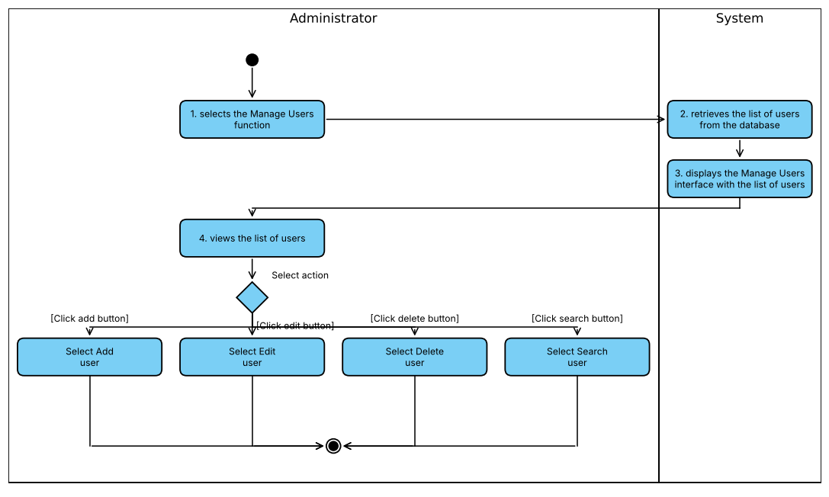
Figure I-5 Activity diagram modeling event flows of use case Manage Users
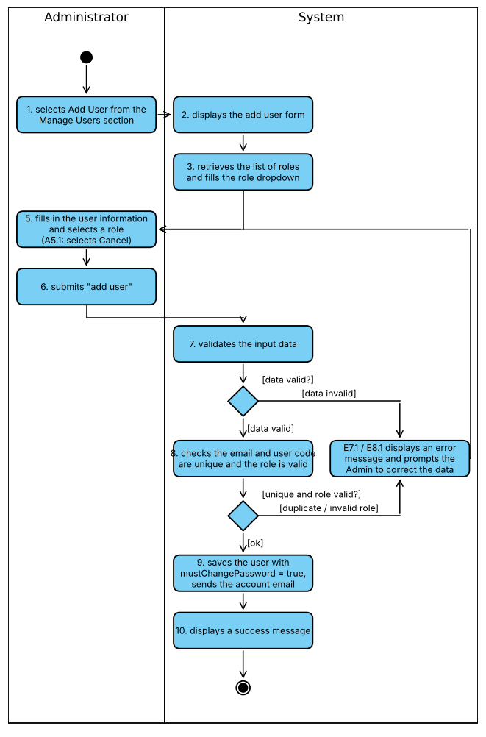
Figure I-6 Activity diagram modeling event flows of use case Add User

Question Bank and Rubric
These UML-style activity flowcharts consolidate related goals while preserving their separate UC specifications. Authentication/course denials terminate before domain mutation. Cancellation before submission has no backend operation and is not claimed as an implemented UI workflow.

ACT 01 Browse questions and rubrics UC 01 08
Figure ACT-01 is included in the diagram appendices.

ACT 02 Prepare question or rubric UC 02 03 09 10
Figure ACT-02 is included in the diagram appendices.

ACT 03 Approve or delete bank resources UC 04 05 11
Figure ACT-03 is included in the diagram appendices.

ACT 04 Import workbook UC 06
Figure ACT-04 is included in the diagram appendices.

ACT 05 Generate drafts UC 07
Figure ACT-05 is included in the diagram appendices.
ACT-05 simplifies adapter internals; the service actually validates each Bloom value while creating drafts in the same transaction. Later invalid output rolls back earlier writes. Topic retrieval uses the course store, without strict selected-file filtering in the inspected adapter requests (OI-07).

ACT 06 Upload and index source UC 12
Figure ACT-06 is included in the diagram appendices.

ACT 07 Delete unused source UC 13
Figure ACT-07 is included in the diagram appendices.

Detailed diagrams

ACT 01 Browse questions and rubrics UC 01 08
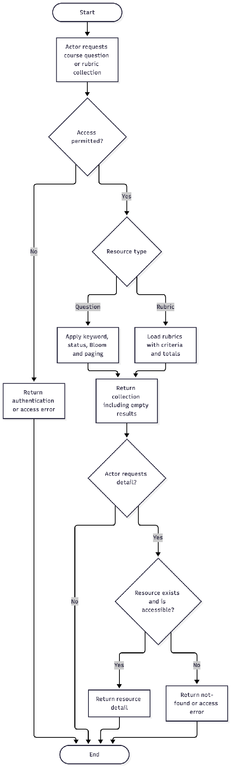

ACT 02 Prepare question or rubric UC 02 03 09 10
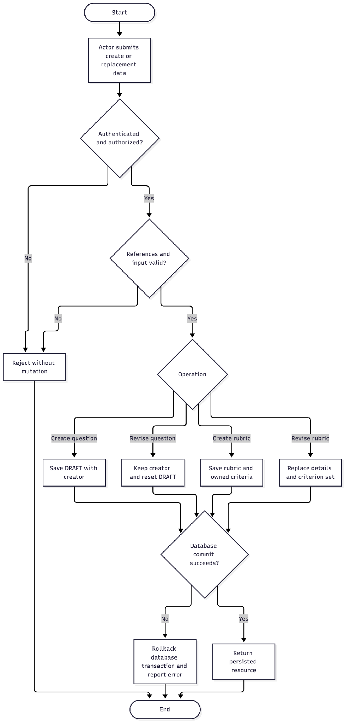

ACT 03 Approve or delete bank resources UC 04 05 11
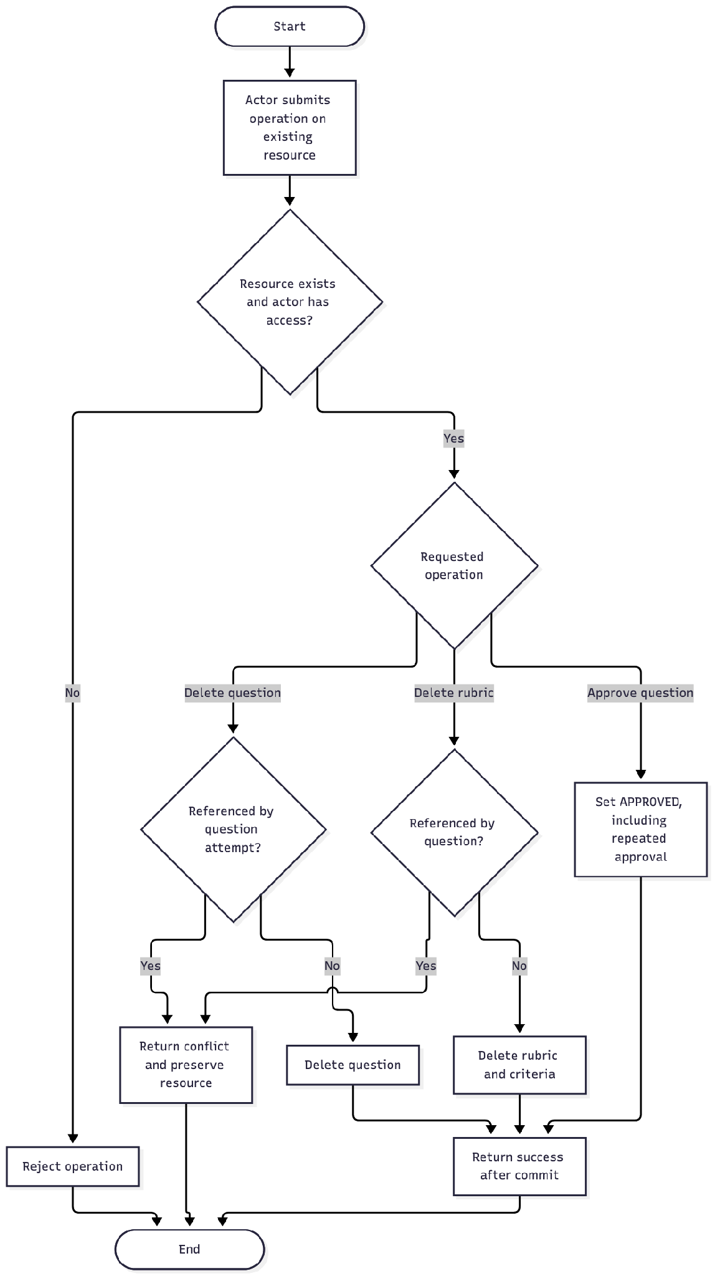

ACT 04 Import workbook UC 06
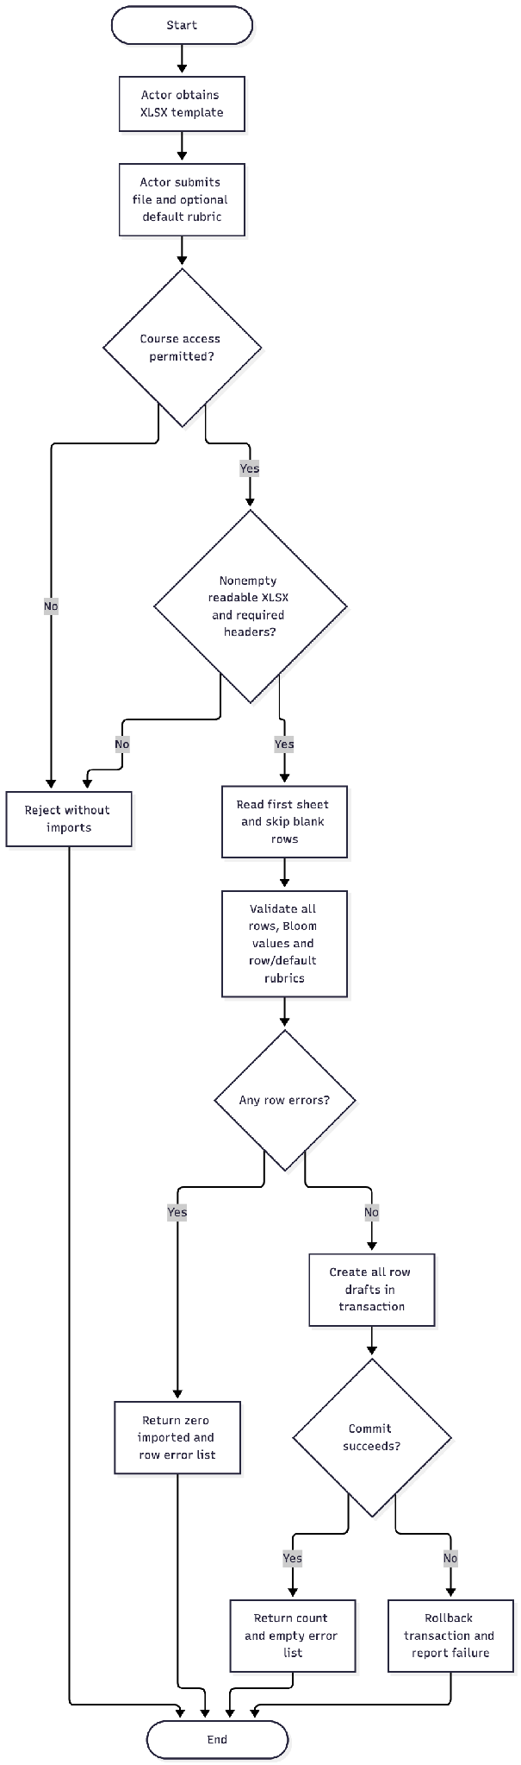

ACT 05 Generate drafts UC 07
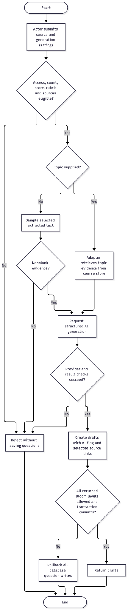

ACT 06 Upload and index source UC 12
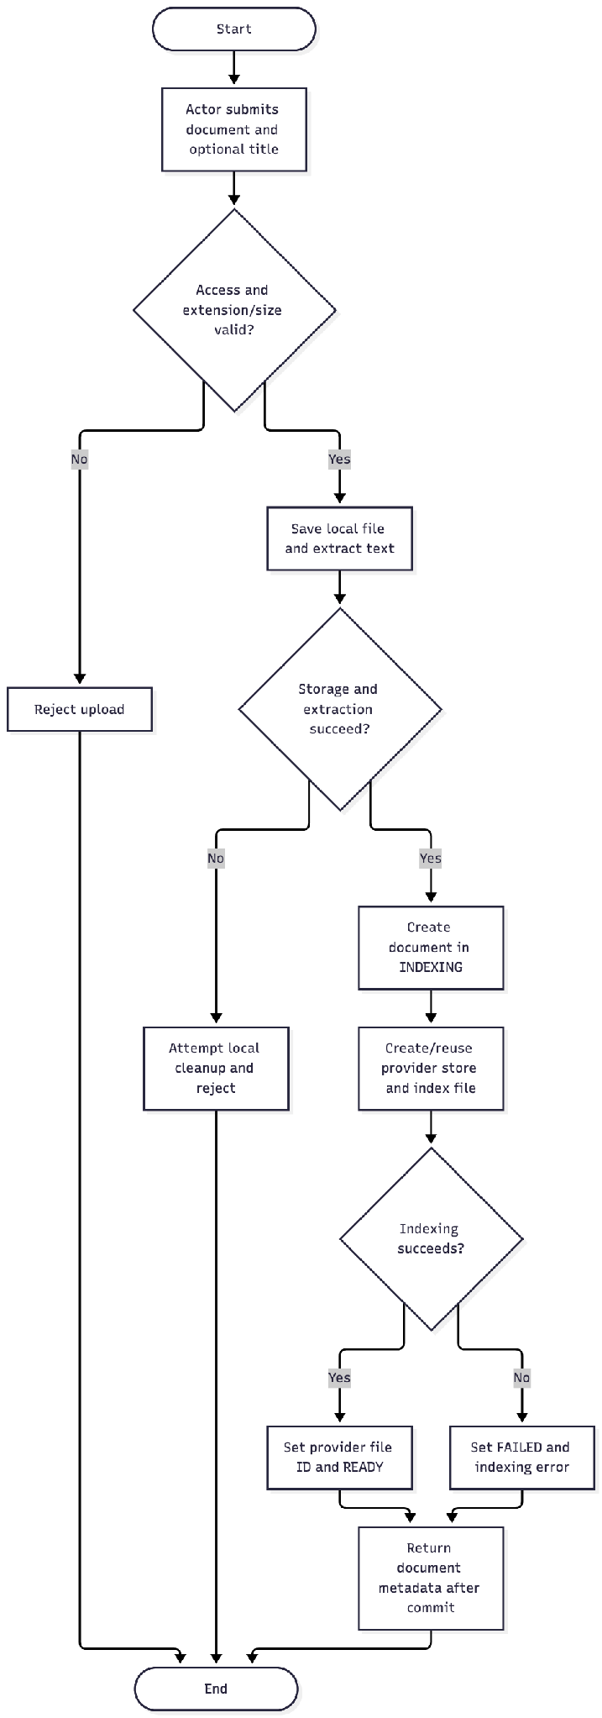

ACT 07 Delete unused source UC 13
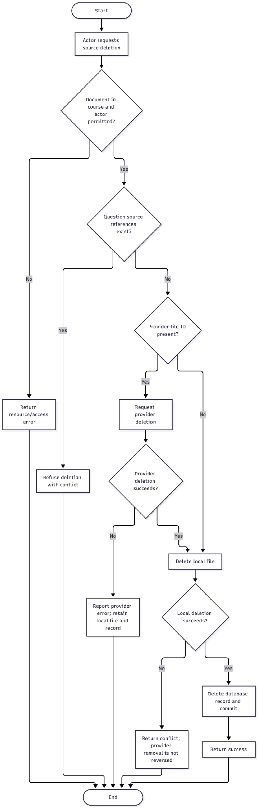

Exam Management

Activity and swimlane model
The preparation workflow begins with a course examination and ends with an allocated student attempt ready for the interview hand-off. Candidate assignment and time allocation are separate actions. The schedule endpoint writes SCHEDULED attempts. In the current workflow, opening an examination does not automatically change every candidate attempt to READY.
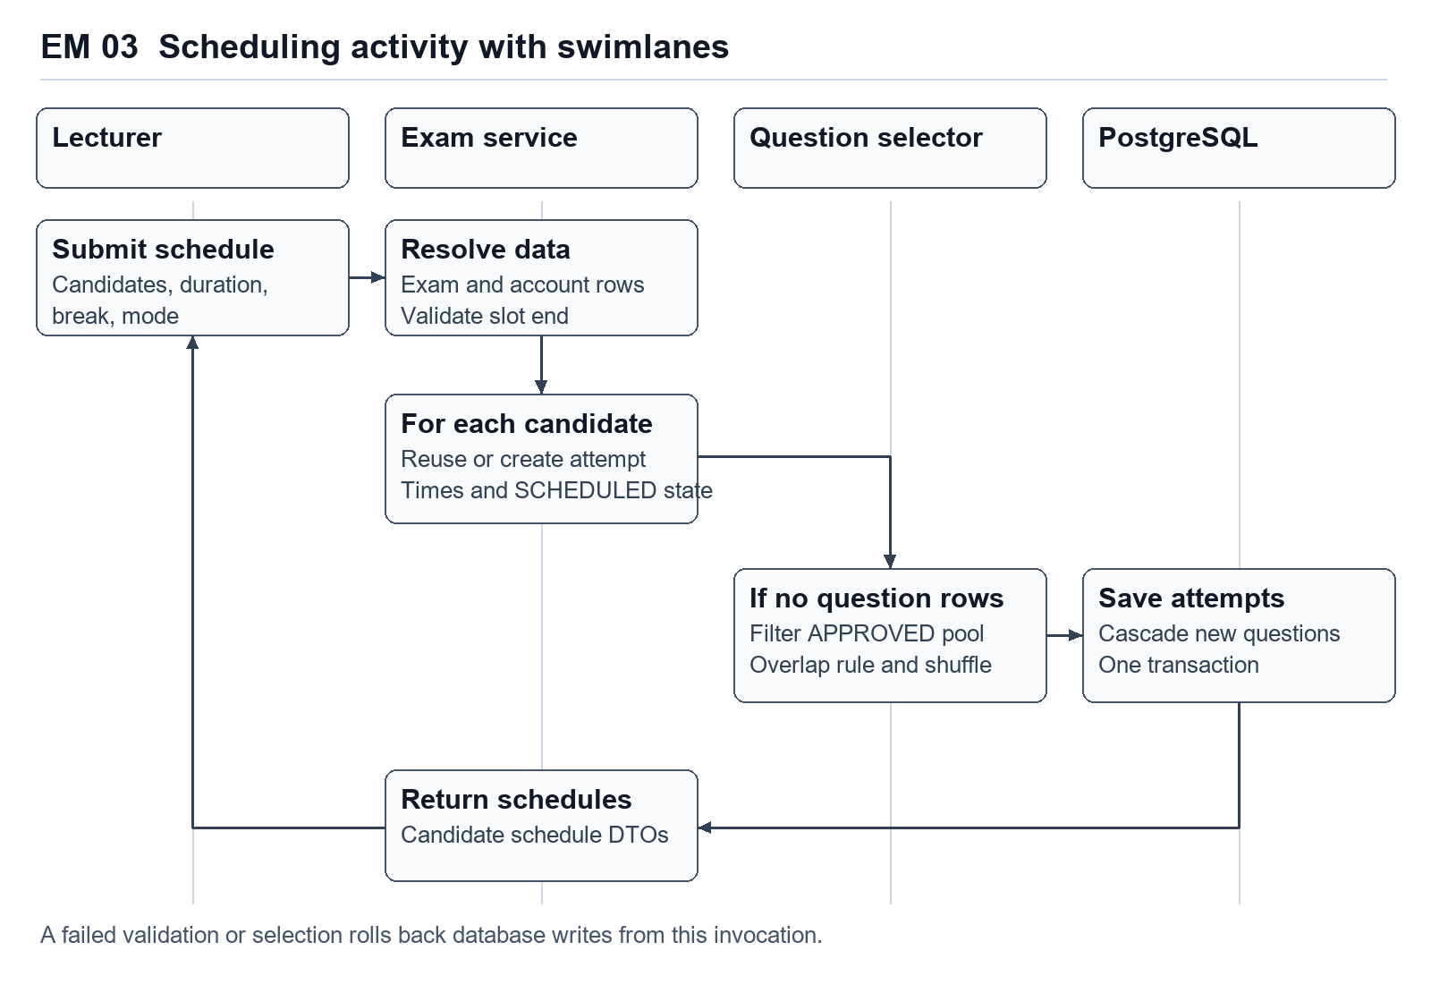
Figure EM 03. Preparation workflow across the lecturer, examination service, question selector and database.

AI Interview Core
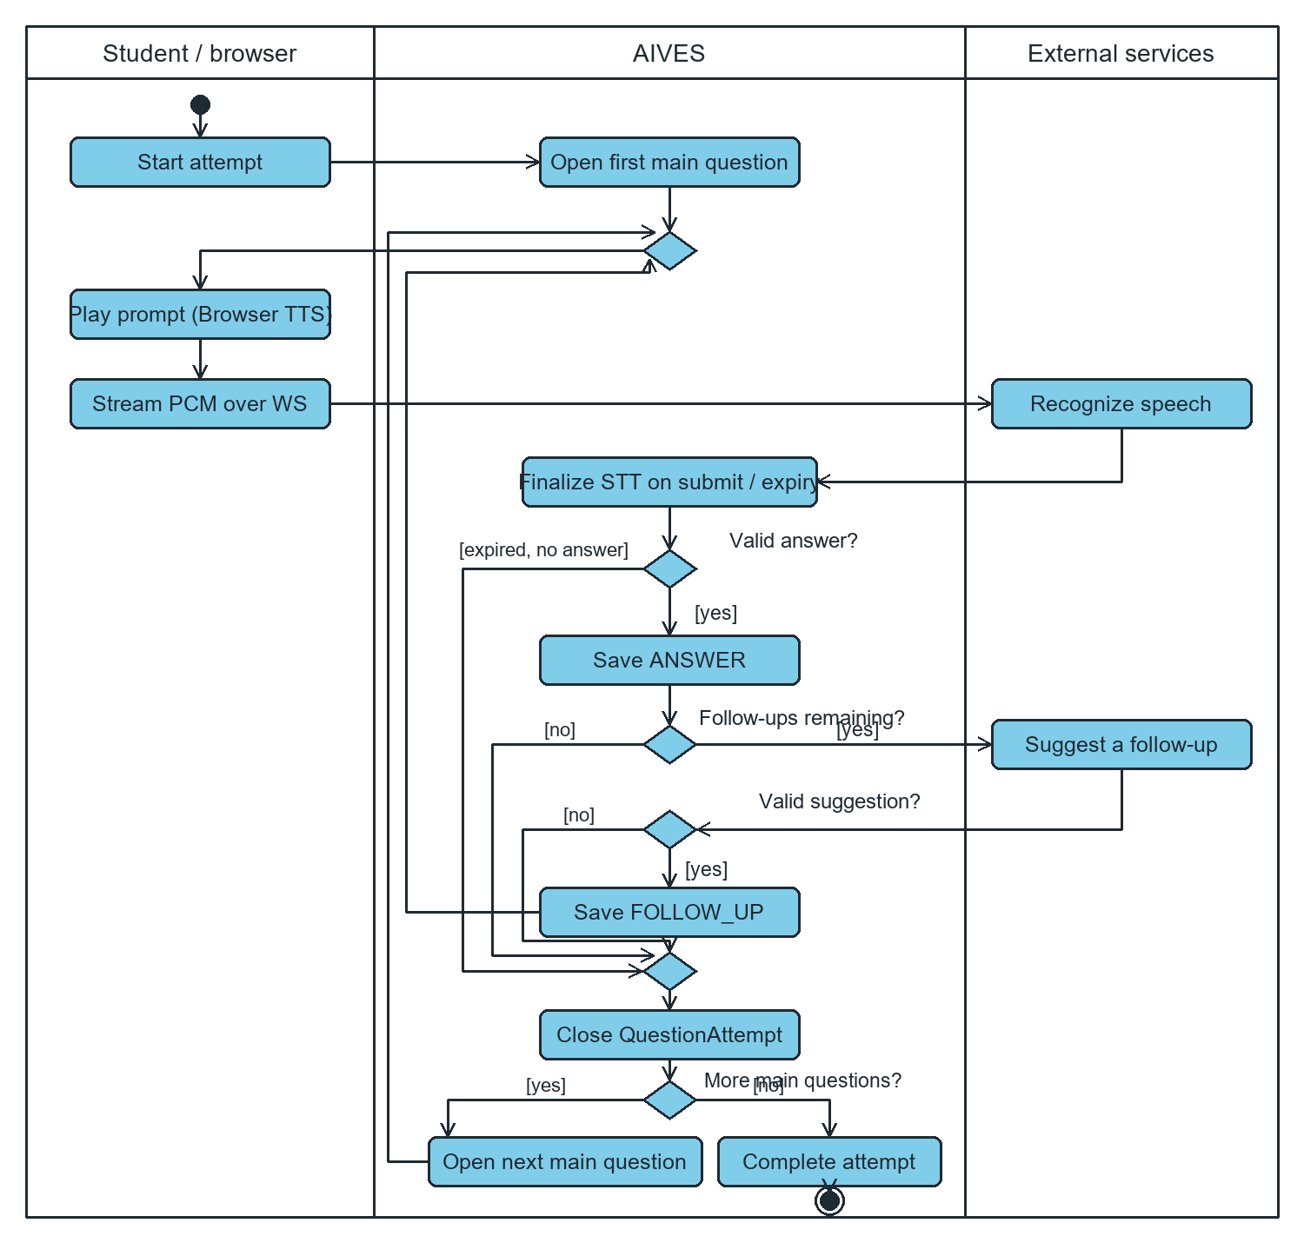
Figure 2. Activity flow from starting an attempt through follow-up, advancement, or completion. The worker checks active attempts roughly once per second to handle deadlines and resume processing from stored transcripts.

I.6 Data Requirements

Question Bank and Rubric
The domain contains Course, Lecturer assignment, Question, Rubric, RubricCriterion and source Document. Each new managed question has one course and creator; zero or one rubric; zero or more source documents. A rubric owns a collection of criteria; each criterion contributes its maximum score to a derived total. Source associations are many-to-many. QuestionAttempt is an adjacent examination entity used as a removal guard.
A source record carries an uploaded filename, internal filename/path, extracted text, provider identifier, size/type, uploader and indexing outcome. These internal fields are not all exposed to clients. A user account and assignment exist in the Academic module. Per-entity field definitions, nullability, PK/FK rules and physical index differences are in Section III.5.
Data-quality expectations derived from application checks: nonblank question text, valid Bloom enum, same-course question/rubric references and positive criterion maximums. The database does not enforce all of these rules; see the schema-gap inventory. No approved retention period, question-version history, criterion-version history, or audit-event store was supplied.

Exam Management
The module requires an existing course, account records, approved course questions and optional course rubric links. Course enrolment determines the list offered by the lecturer interface. Candidate assignment creates ExamAttempt records, whereas automatic scheduling also creates QuestionAttempt records when the attempt has no assigned questions.
Question pool selection is stored as questionIds inside exams.exam_config. This JSON array has application-level reference checks. Each assigned main question becomes a question_attempts row with a real foreign key to questions. Changing the configuration does not automatically rebuild an existing attempt's question collection.

II. Analysis models

II.1 Interaction diagrams
In this section, objects and their interactions that realize the use cases are analyzed with the MVC analysis pattern (View – Controller – Service). The analyzed use cases are Manage Users, Add User, Edit User, Delete User, Assign Lecturer to Course and Change Password. Figures II-1 to II-6 are sequence diagrams and Figures II-7 to II-12 are the corresponding communication diagrams.
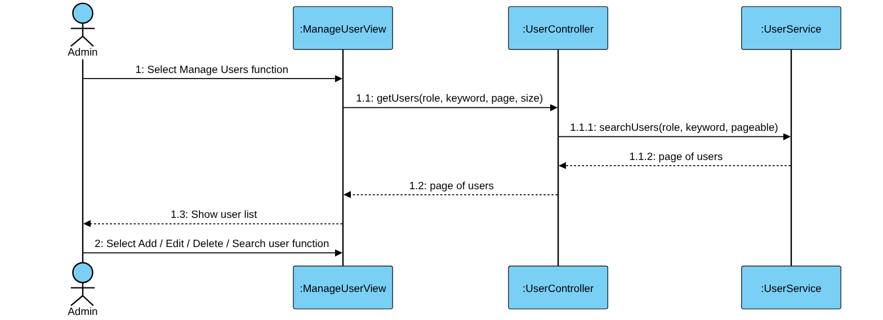
Figure II-1 Sequence Diagram for Manage Users Use Case
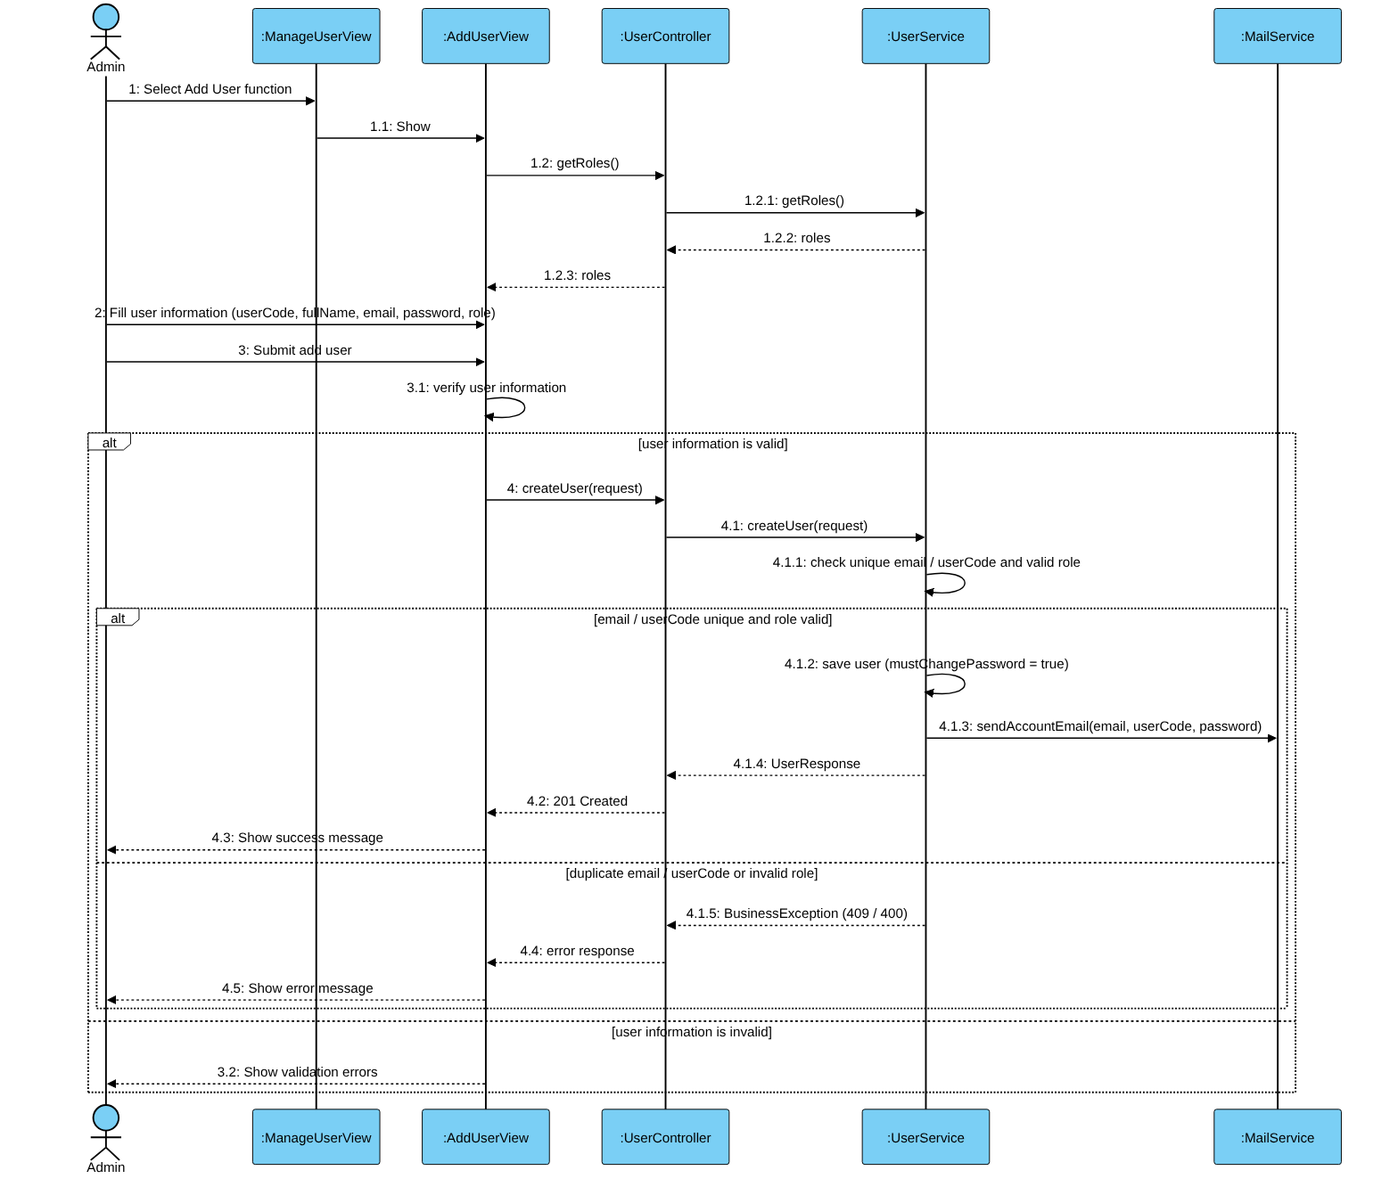
Figure II-2 Sequence Diagram for Add User Use Case
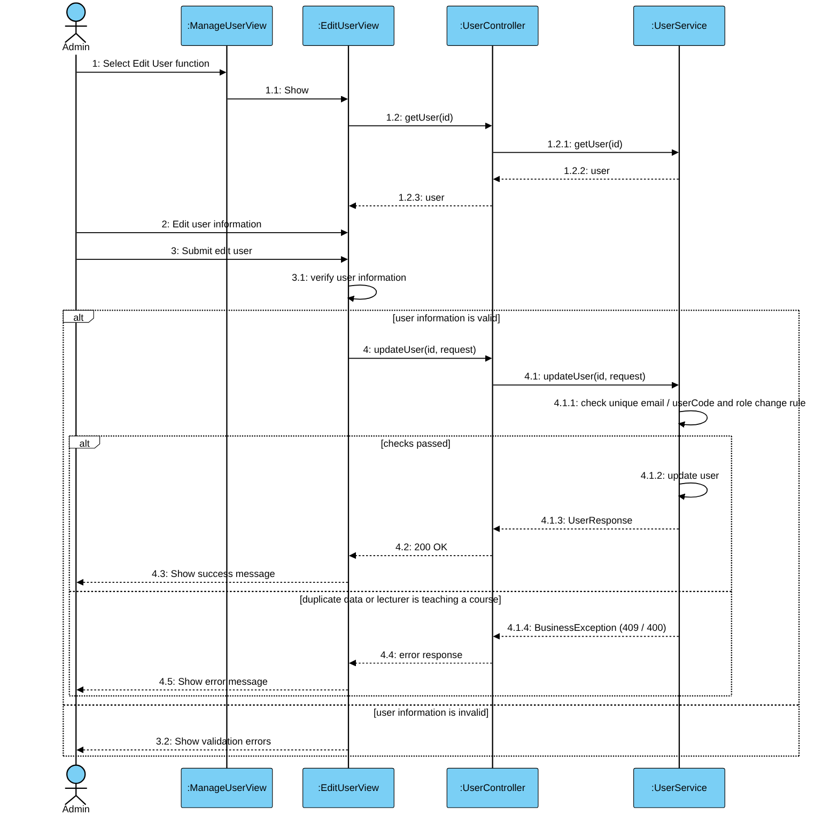
Figure II-3 Sequence Diagram for Edit User Use Case
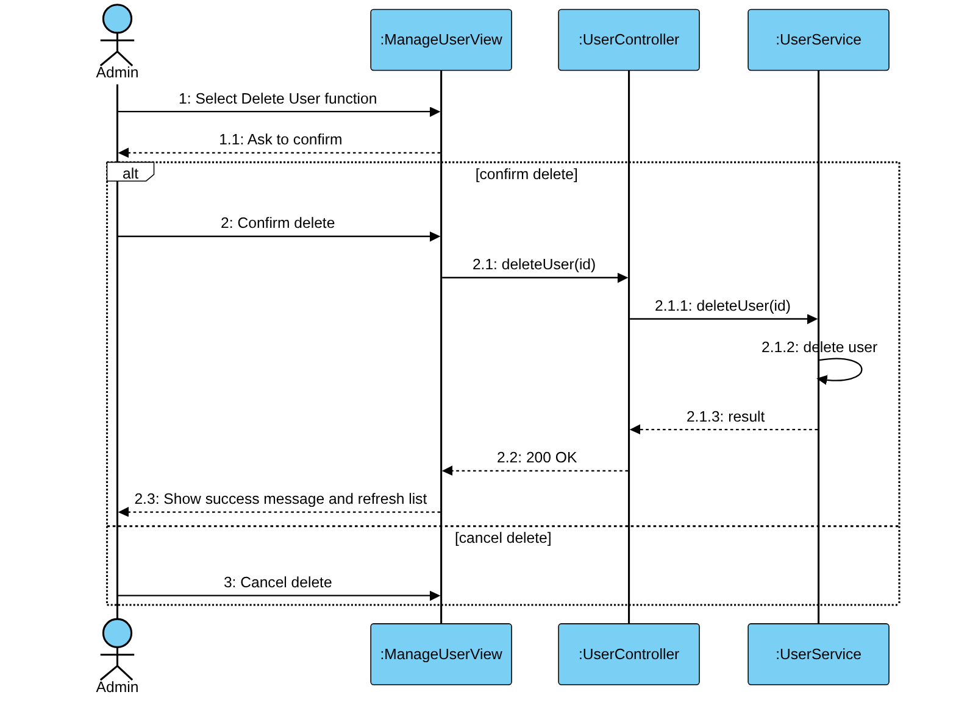
Figure II-4 Sequence Diagram for Delete User Use Case
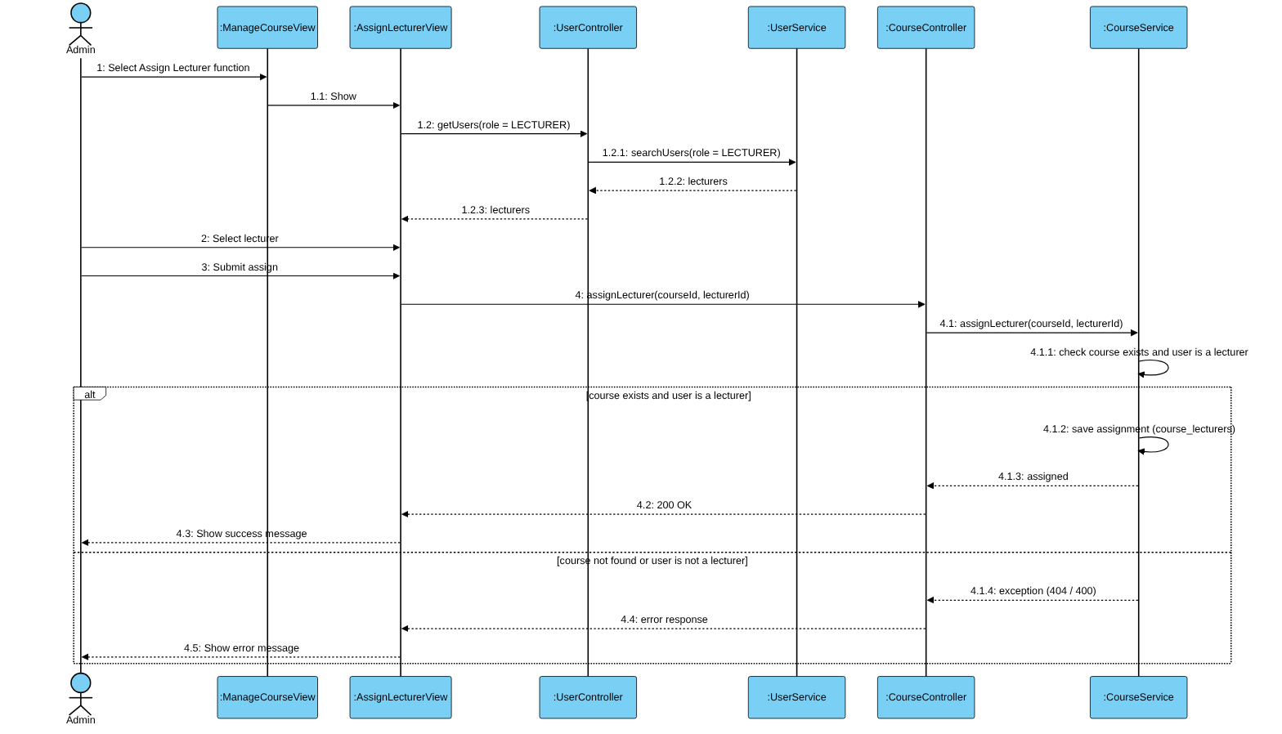
Figure II-5 Sequence Diagram for Assign Lecturer to Course Use Case
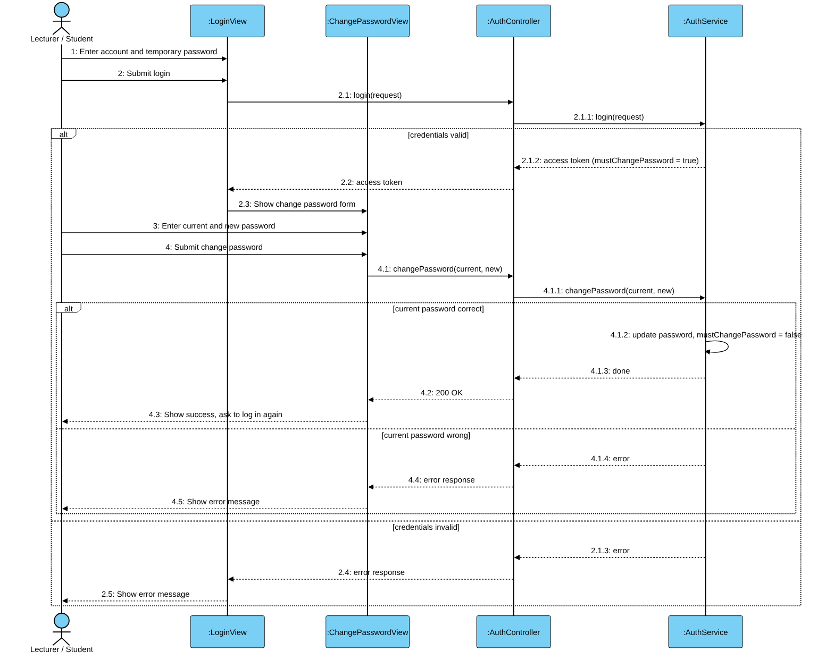
Figure II-6 Sequence Diagram for Change Password Use Case
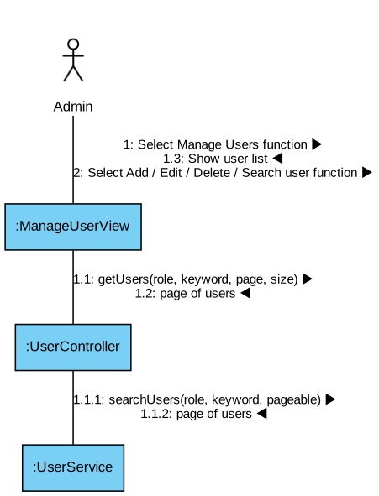
Figure II-7 Communication Diagram for Manage Users Use Case
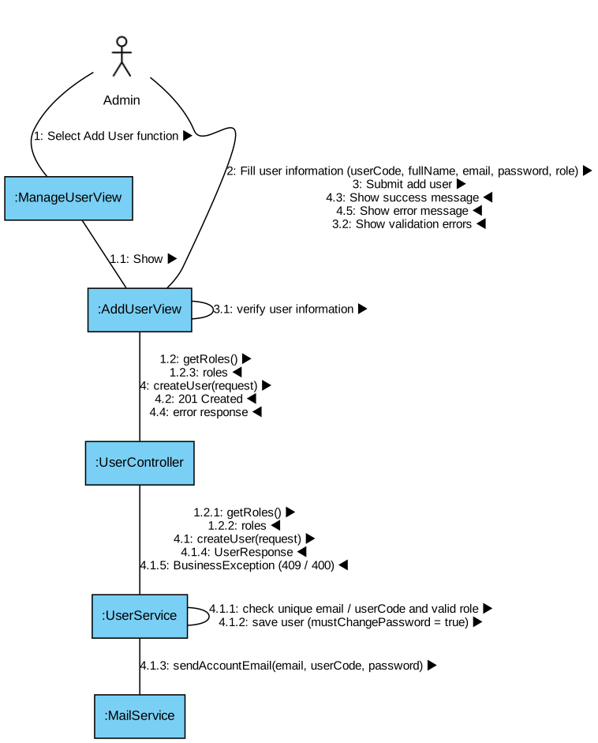
Figure II-8 Communication Diagram for Add User Use Case
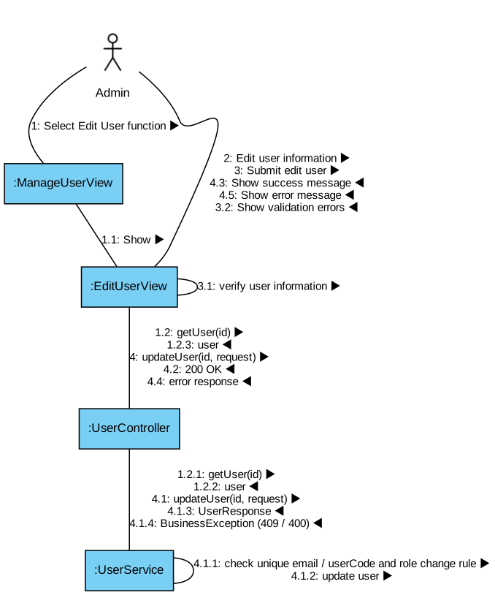
Figure II-9 Communication Diagram for Edit User Use Case
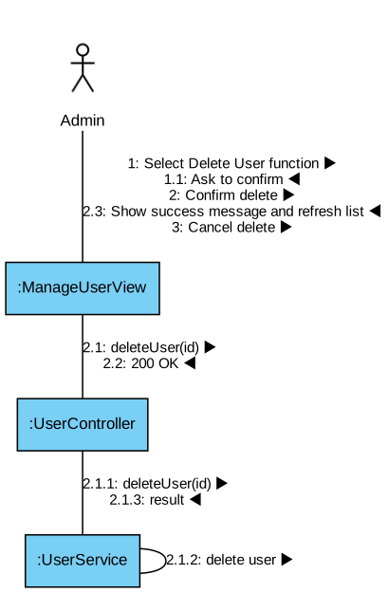
Figure II-10 Communication Diagram for Delete User Use Case
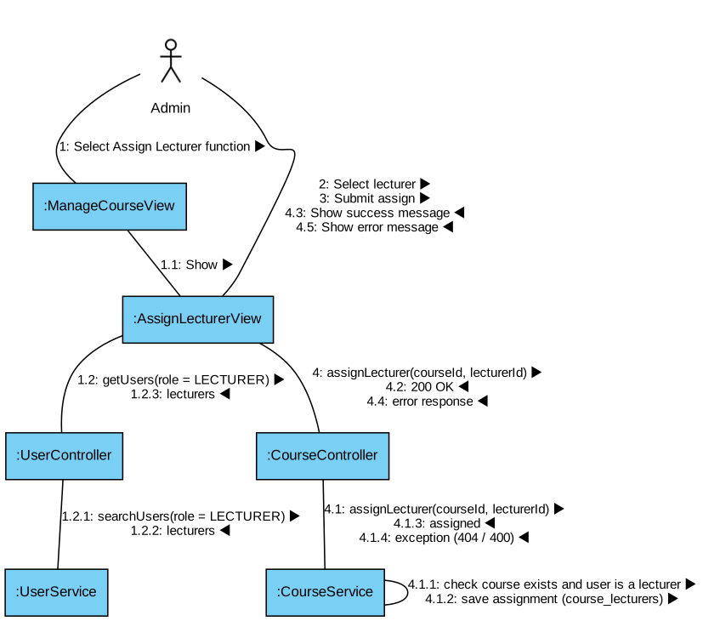
Figure II-11 Communication Diagram for Assign Lecturer to Course Use Case
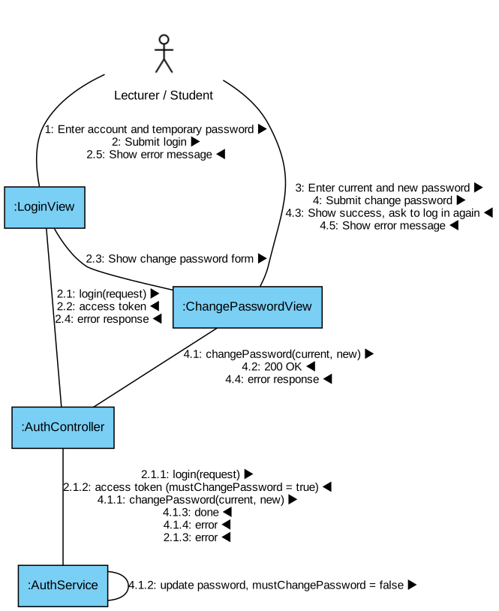
Figure II-12 Communication Diagram for Change Password Use Case

Question Bank and Rubric

Analysis object model
At the analysis level, the boundary accepts a management request and returns results, the control enforces course access and the relevant goal, and entities represent course content. These are responsibility roles, not additional Java classes to implement. The frontend boundary remains conceptual because frontend source was not inspected.

AN 01 Analysis classes and responsibilities
Figure AN-01 is included in the diagram appendices.
Section II.1 contains 13 sequence diagrams, one per UC, with service/repository messages tied to actual methods and relevant rejection branches. Shared Spring authentication and DTO validation precede controller dispatch and are stated once to avoid invented service calls. Database writes occur inside service transactions; a repository call is not a proof of completed commit.
The following numbered collaboration views are UML-style communication diagrams. Each label is an ordered message, not a network service boundary. The detailed sequences remain authoritative for ordering and alternative outcomes.

COM 01 Create or revise question UC 02 03 communication view
Figure COM-01 is included in the diagram appendices.

COM 02 Replace rubric definition UC 10 communication view
Figure COM-02 is included in the diagram appendices.

COM 03 Generate drafts UC 07 communication view
Figure COM-03 is included in the diagram appendices.

Sequence diagrams
These design-level sequence diagrams refine the RDS analysis controls into inspected controller/service/repository calls. Labels use actual Java methods, with grouped resource participants where noted. All are synchronous request flows. No frontend route, UI label or unimplemented notification is assumed.
Shared prelude: Spring Security verifies JWT, then MustChangePasswordFilter can reject with 428. Bean Validation rejects annotated DTOs before invocation. CourseAccessService resolves database user/role and checks assignments, except ADMIN bypasses assignment checks. Authentication errors, resource failures and uncaught service exceptions pass through shared security handlers or GlobalExceptionHandler; abbreviated returns to the actor include this HTTP/controller path.
Transaction convention: repository save/delete or entity mutation may flush later. Service-proxy transaction completion precedes a successful controller response; database rollback cannot undo filesystem/provider actions. No diagram asserts a lock, idempotency key or asynchronous worker.

SEQ 01 UC QBR 01 Browse course questions
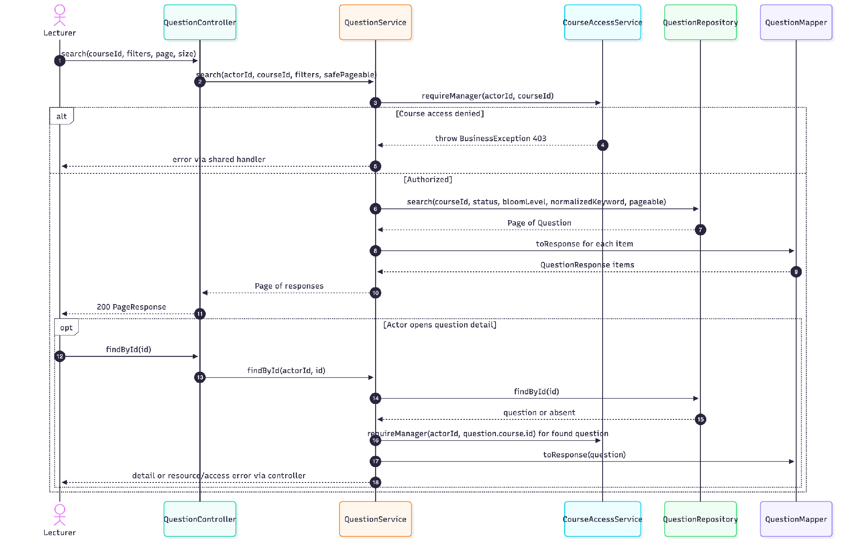
The controller clamps paging through PageableUtils. Detail access is checked after resource lookup. Mapper operations are in-process and do not imply a deployed mapping service.

SEQ 02 UC QBR 02 Create question draft
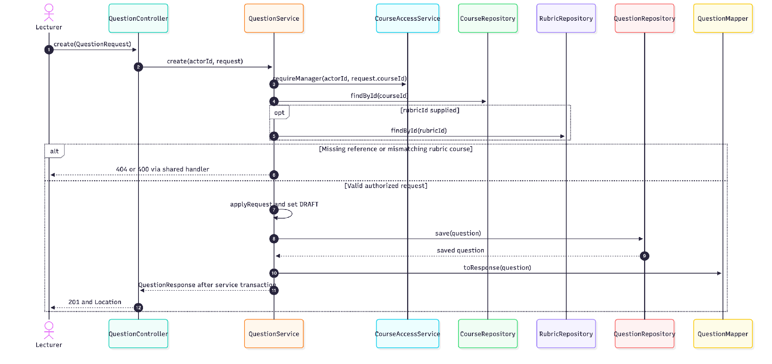
DTO Bean Validation precedes controller dispatch. CourseAccessService returns the creator. The optional rubric is resolved and checked against the course, with content trimmed before storage.

SEQ 03 UC QBR 03 Revise question draft
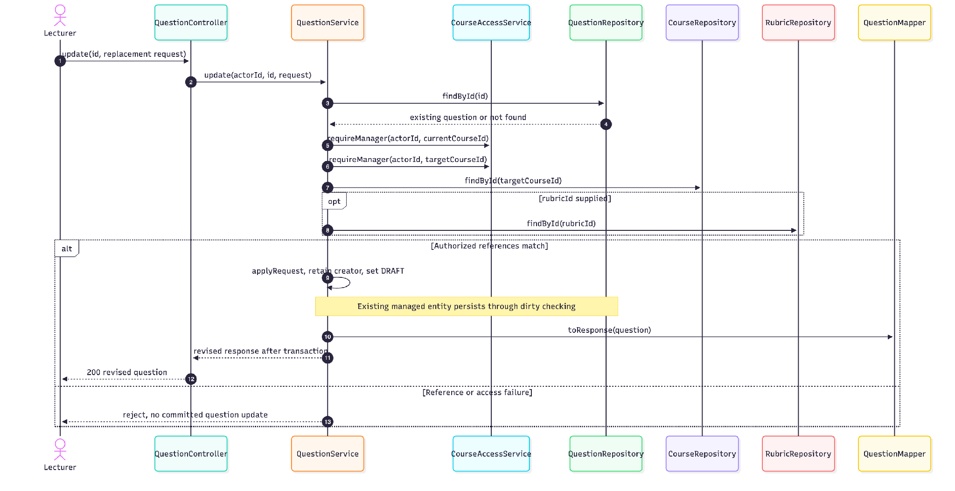
There is no explicit repository save in update. Source associations are untouched by applyRequest; they are not cleared when content, course or AI flag changes. See OI-12.

SEQ 04 UC QBR 04 Approve examination question
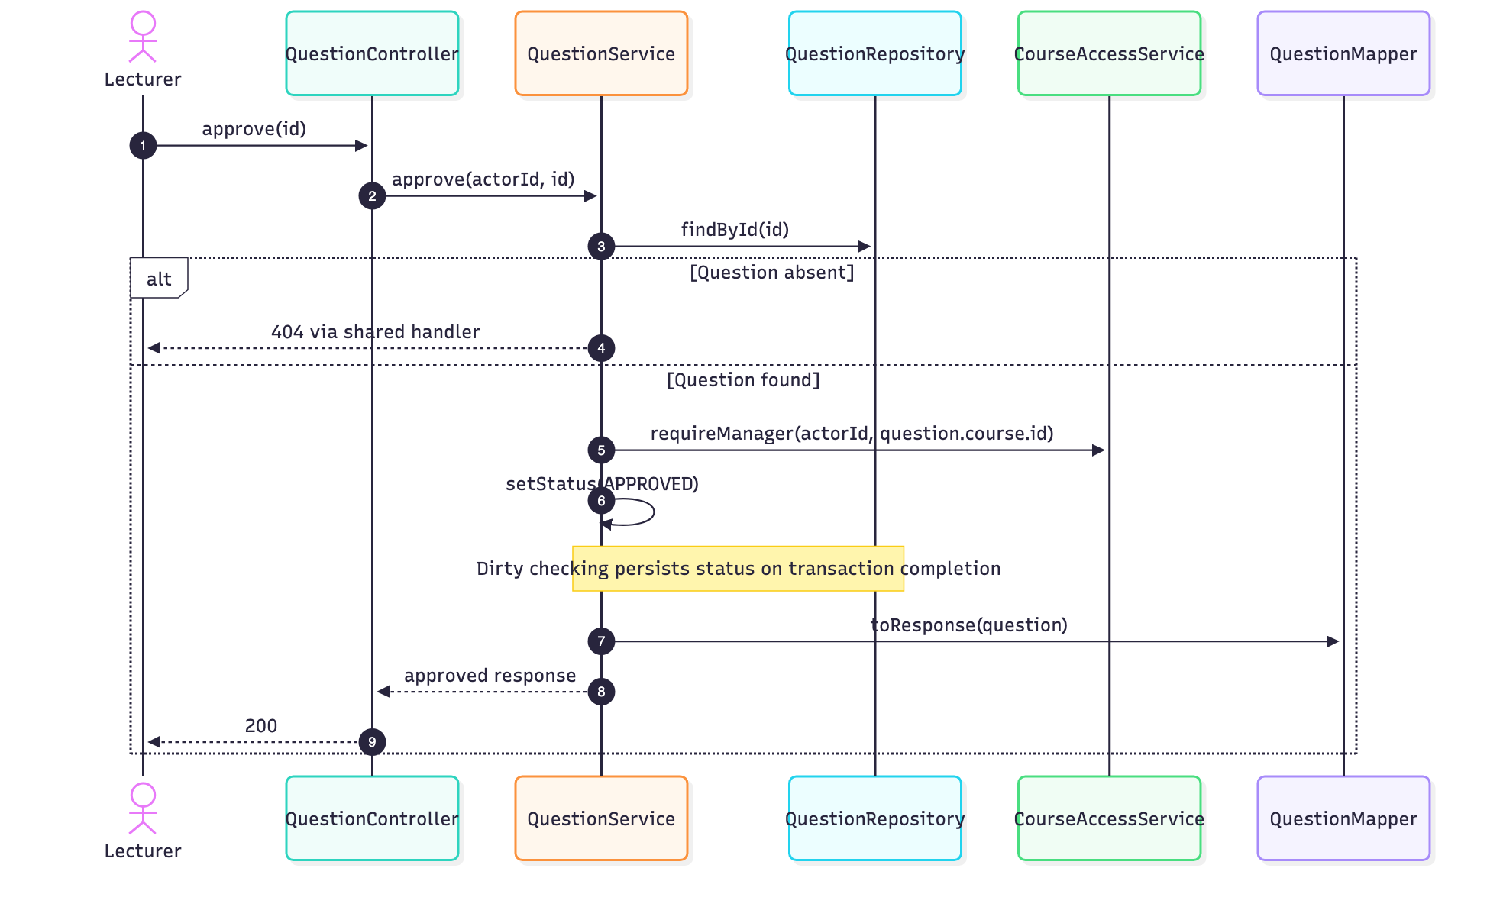
No rubric-required, separate reviewer or current-state guard is implemented. Repeated approval leaves APPROVED. This diagram does not imply automatic exam allocation.

SEQ 05 UC QBR 05 Delete unused question
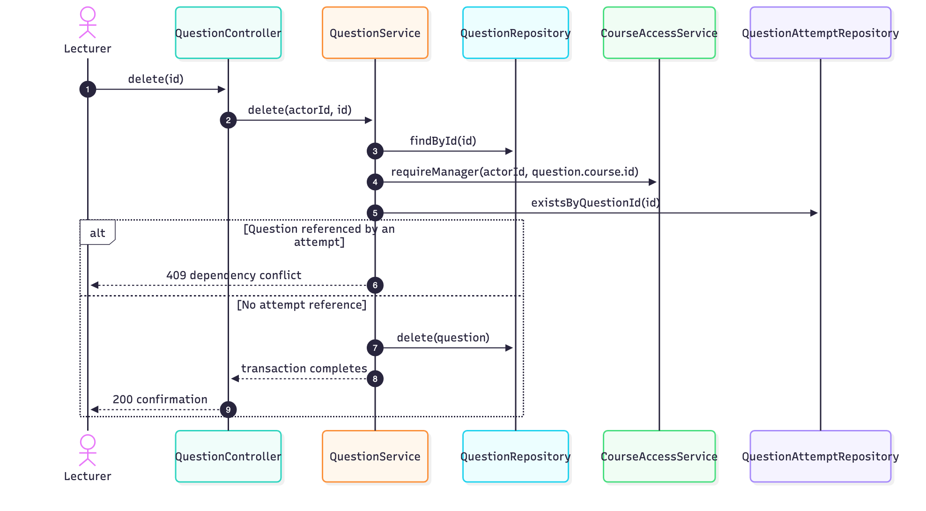
An absent question is 404. The service check is not a locking protocol; the physical attempt FK is CASCADE and direct SQL/racing writes need review (OI-10).

SEQ 06 UC QBR 06 Import question workbook
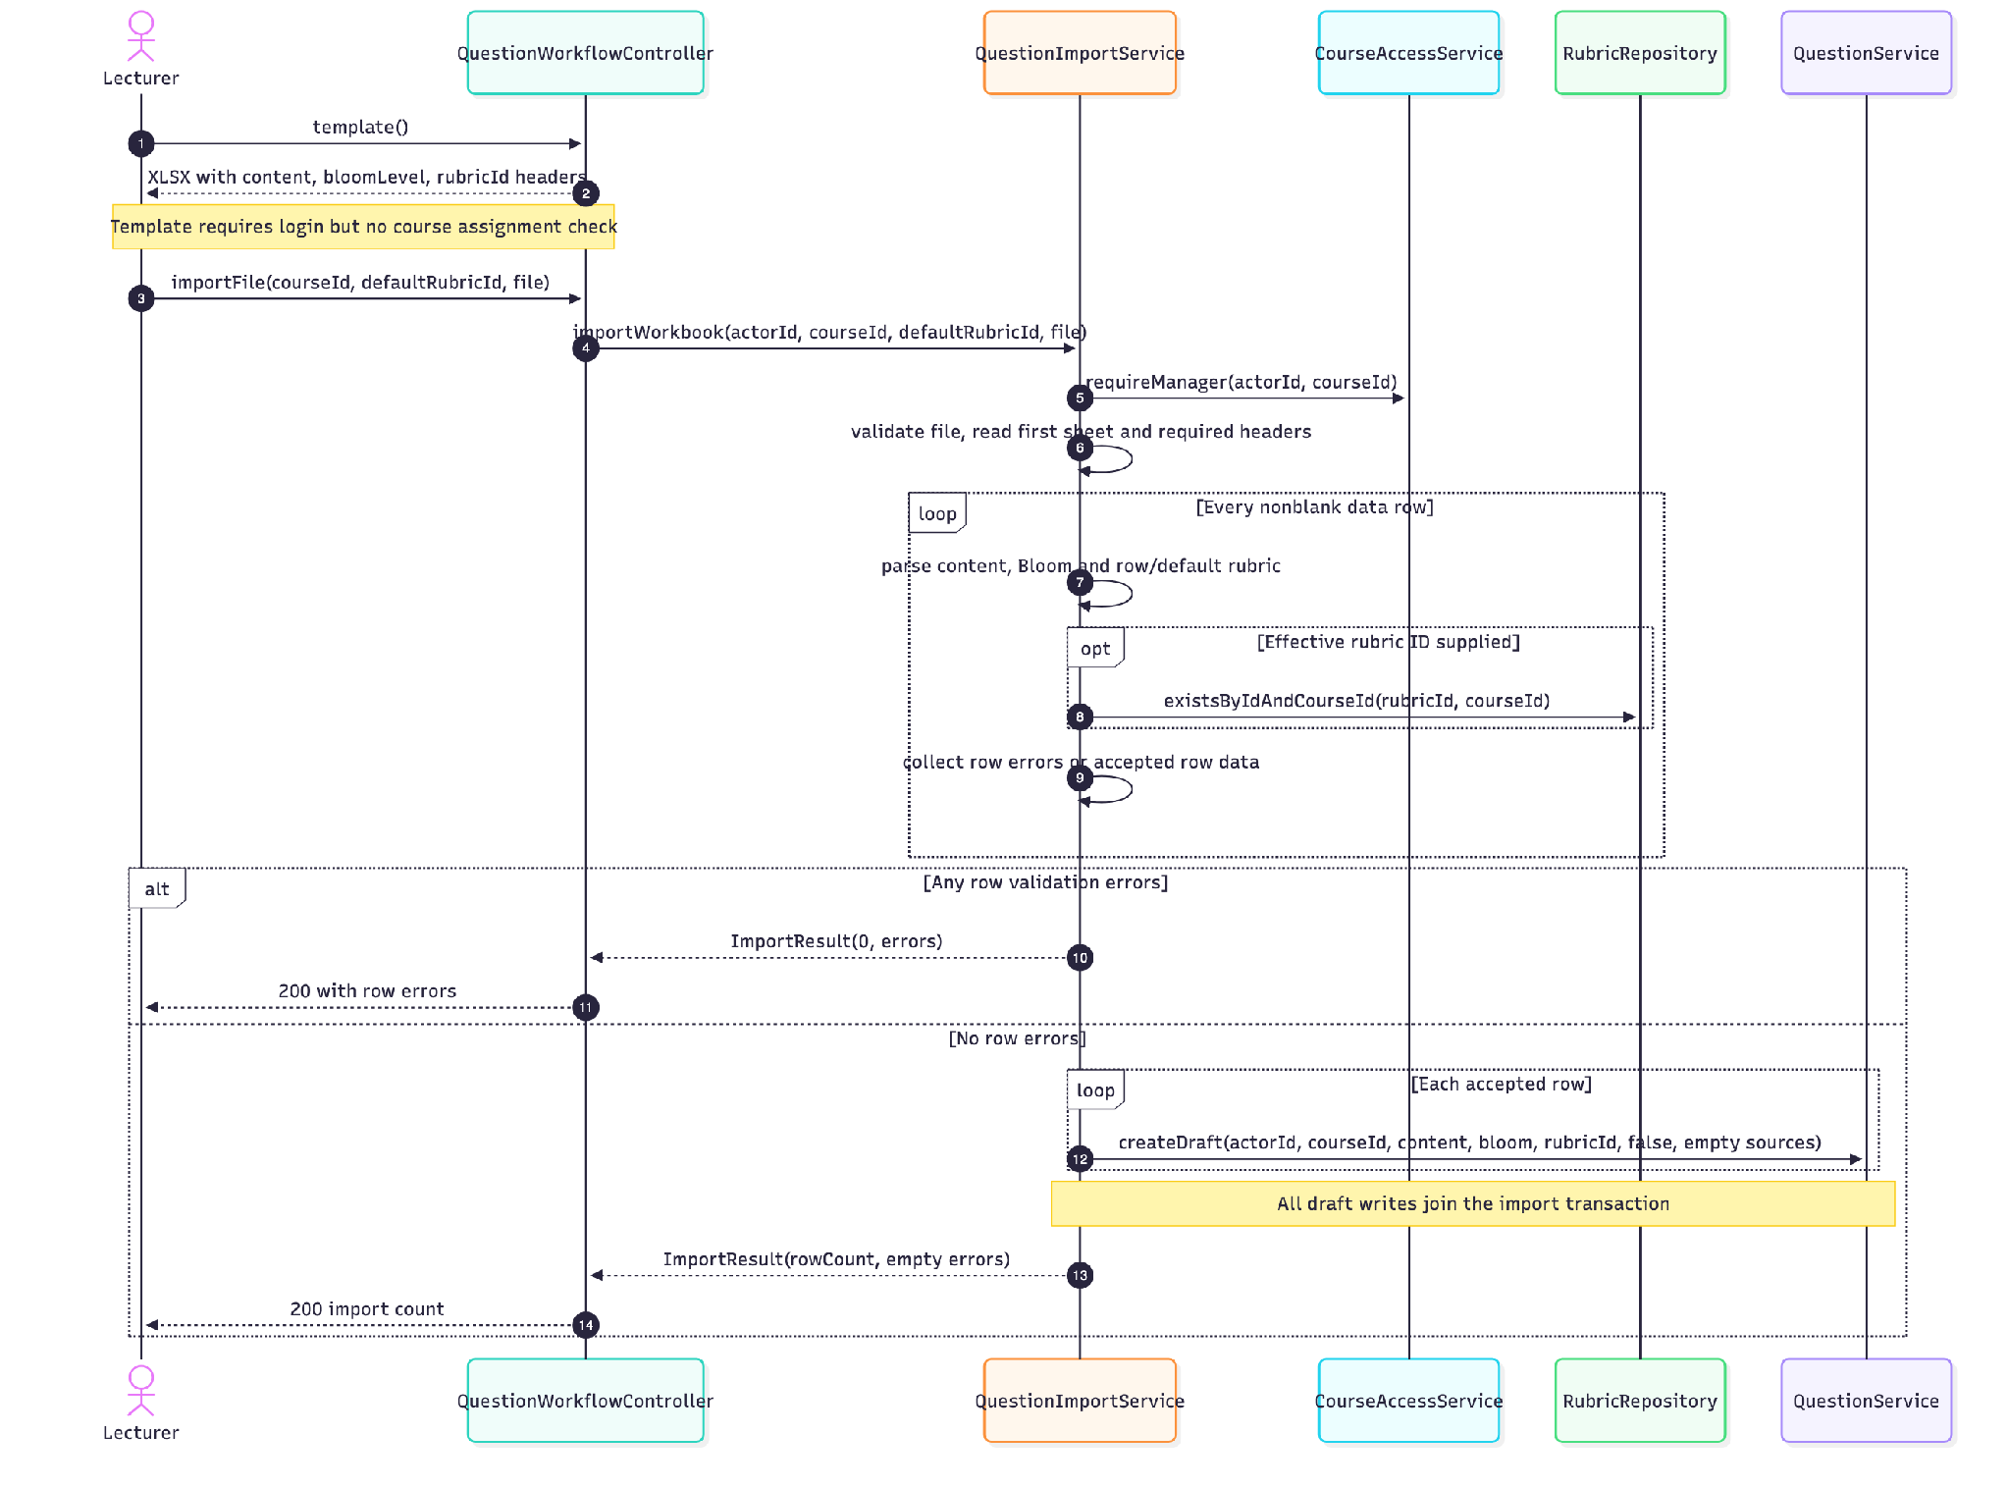
File/header errors throw and are translated to errors instead of row-error results. Header-only workbooks return zero without row errors. Persistence failure rolls back the outer transaction.

SEQ 07 UC QBR 07 Generate question drafts
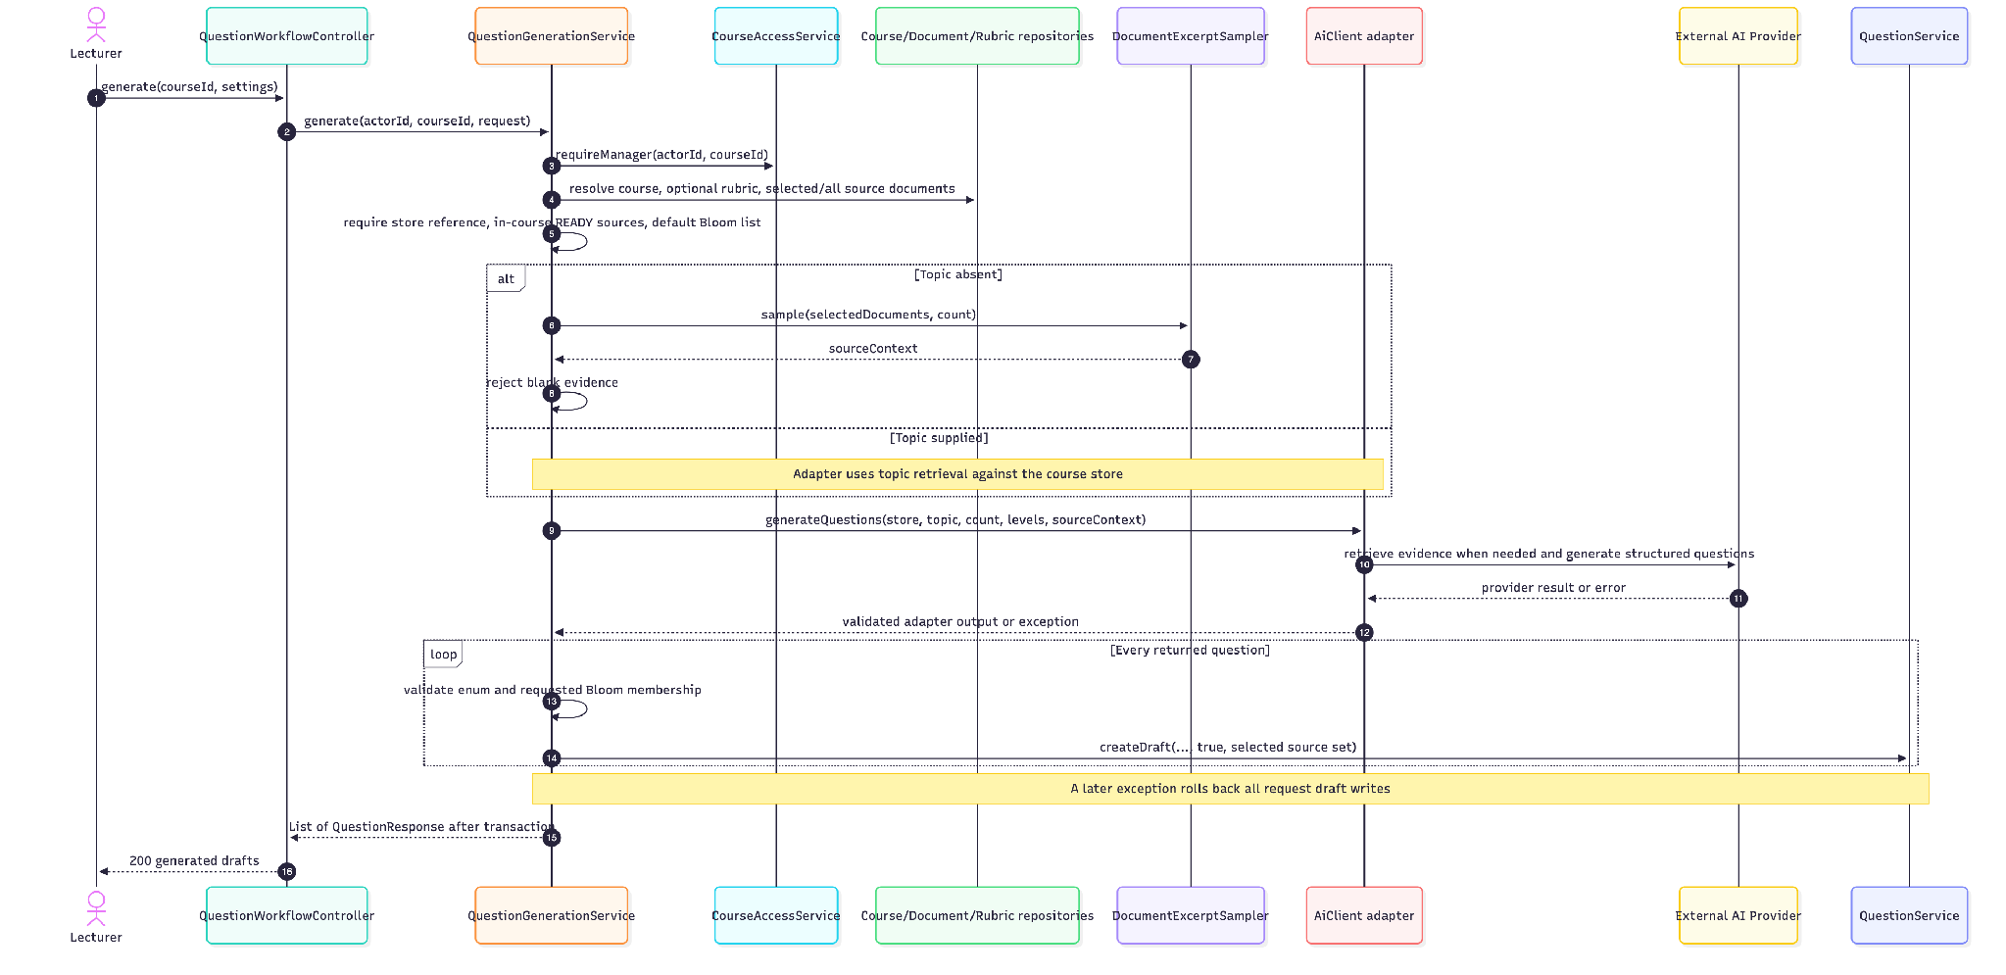
Eligibility, provider or output failure aborts generation. Selected-source association does not guarantee strict selected-file retrieval in topic mode. Adapter protocols and retry/count checks differ; sequence is a business-interface view.

SEQ 08 UC QBR 08 Browse course rubrics
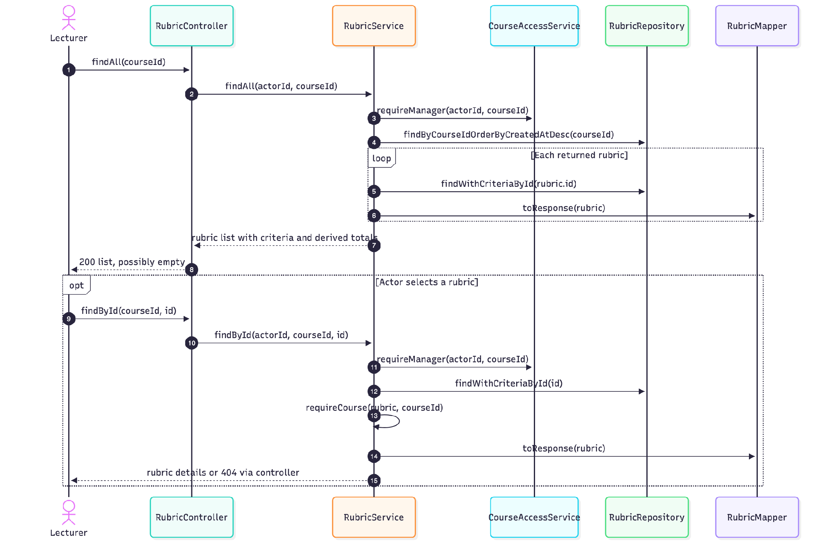
The list implementation re-fetches each rubric with criteria even though the list repository method already declares an EntityGraph. This is observed call structure, not a measured query-performance claim.

SEQ 09 UC QBR 09 Create course rubric
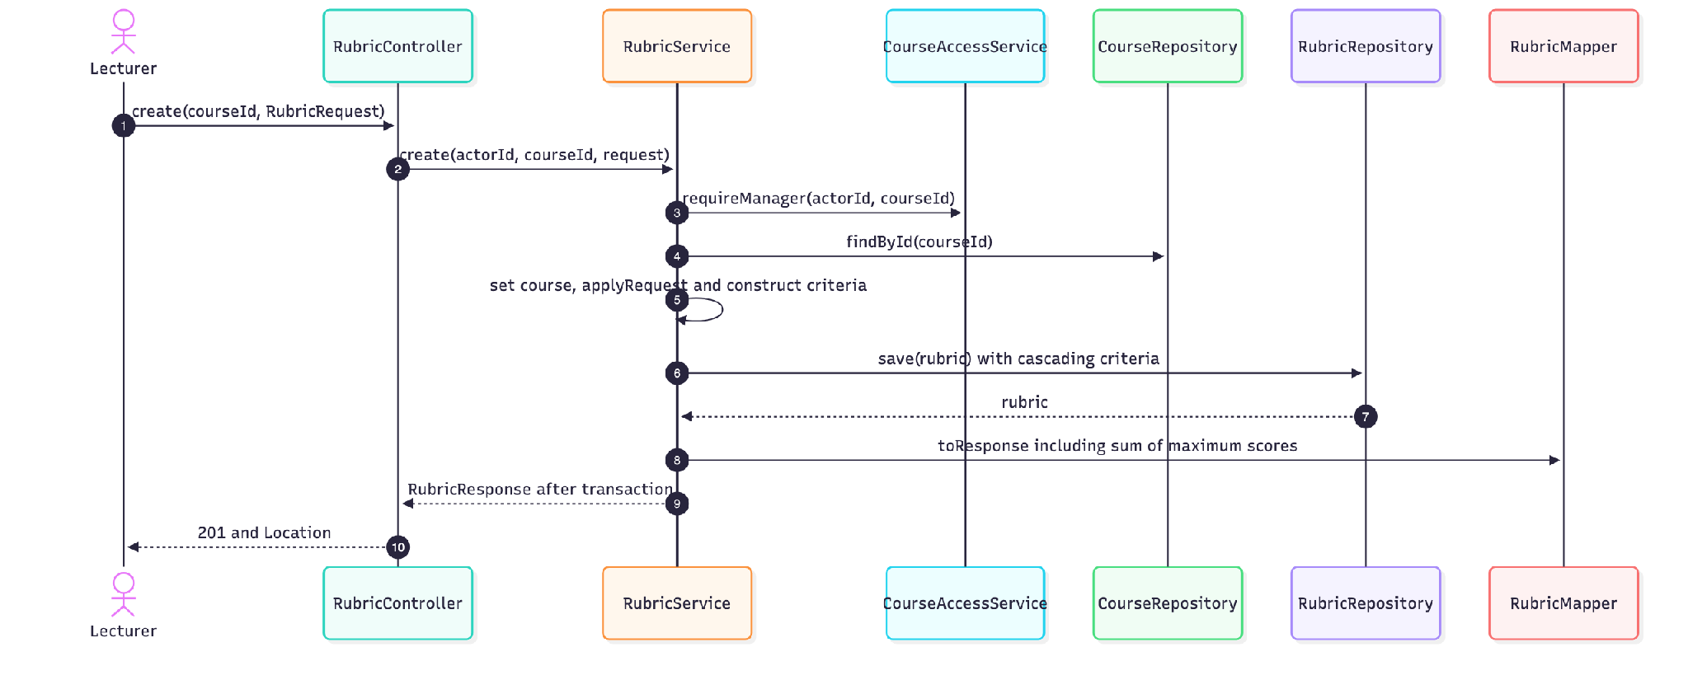
Name/criterion bounds are Bean Validation checks before dispatch. No requirement enforces a fixed rubric total or unique names. Storage errors are translated by the shared handler.

SEQ 10 UC QBR 10 Revise course rubric
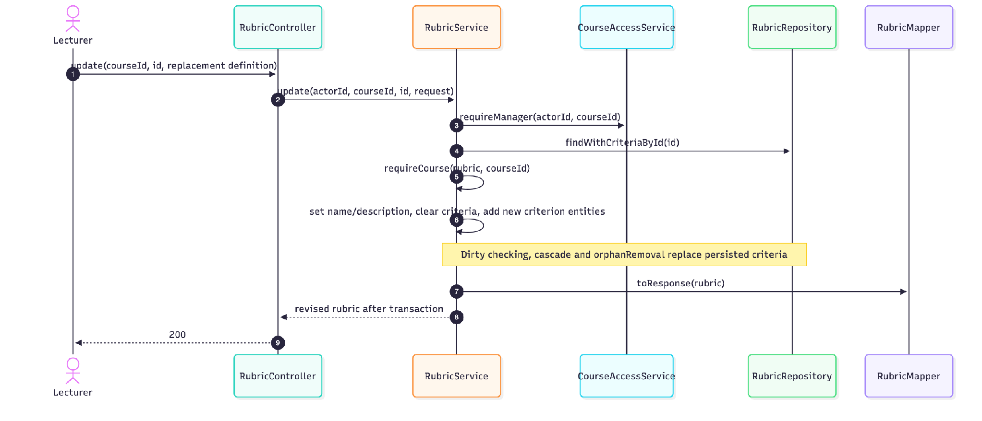
An absent/out-of-course rubric is 404. There is no assigned-question or grading-history guard here. New criterion identities can affect downstream score references; see OI-05.

SEQ 11 UC QBR 11 Delete unassigned rubric
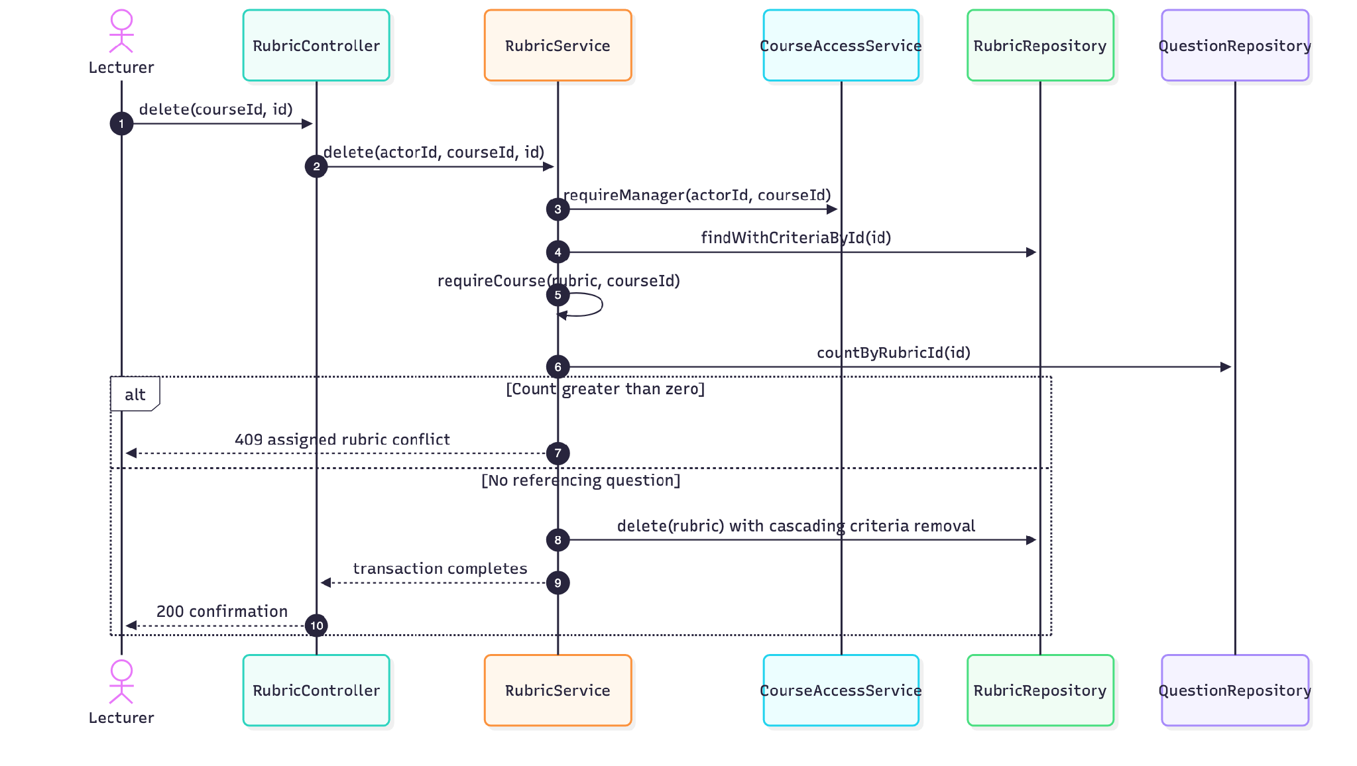
Physical questions.rubric_id has ON DELETE SET NULL. The service blocks assigned rubric deletion, but direct SQL and concurrency can bypass the intent; see OI-10.

SEQ 12 UC QBR 12 Upload course source document
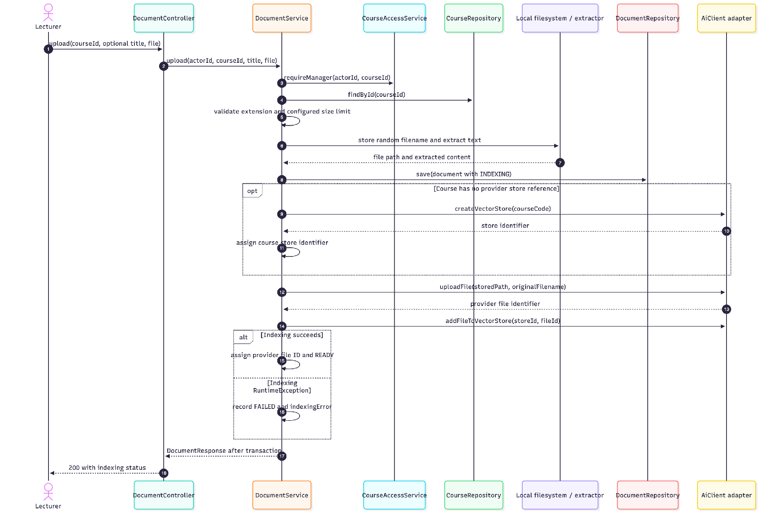
The inner catch covers store creation, upload and indexing. File ID is assigned to the document only after successful indexing; a failure can leave an unrecorded remote file. Local/extraction failures enter the outer cleanup/error path. Transaction-commit failure is outside those method-local catches.

SEQ 13 UC QBR 13 Delete unused source document
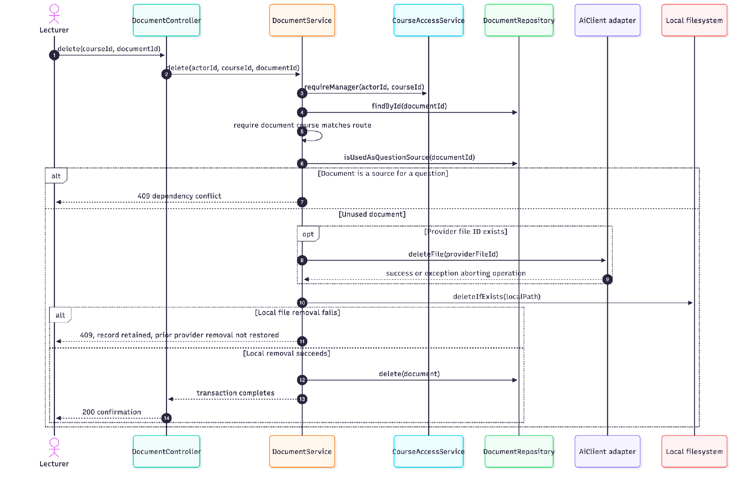
Not-found and out-of-course documents produce 404. Database rollback cannot restore removed external files; provider failure can also have uncertain remote outcome. No distributed transaction or automatic compensation is implemented.

Detailed diagrams

AN 01 Analysis classes and responsibilities
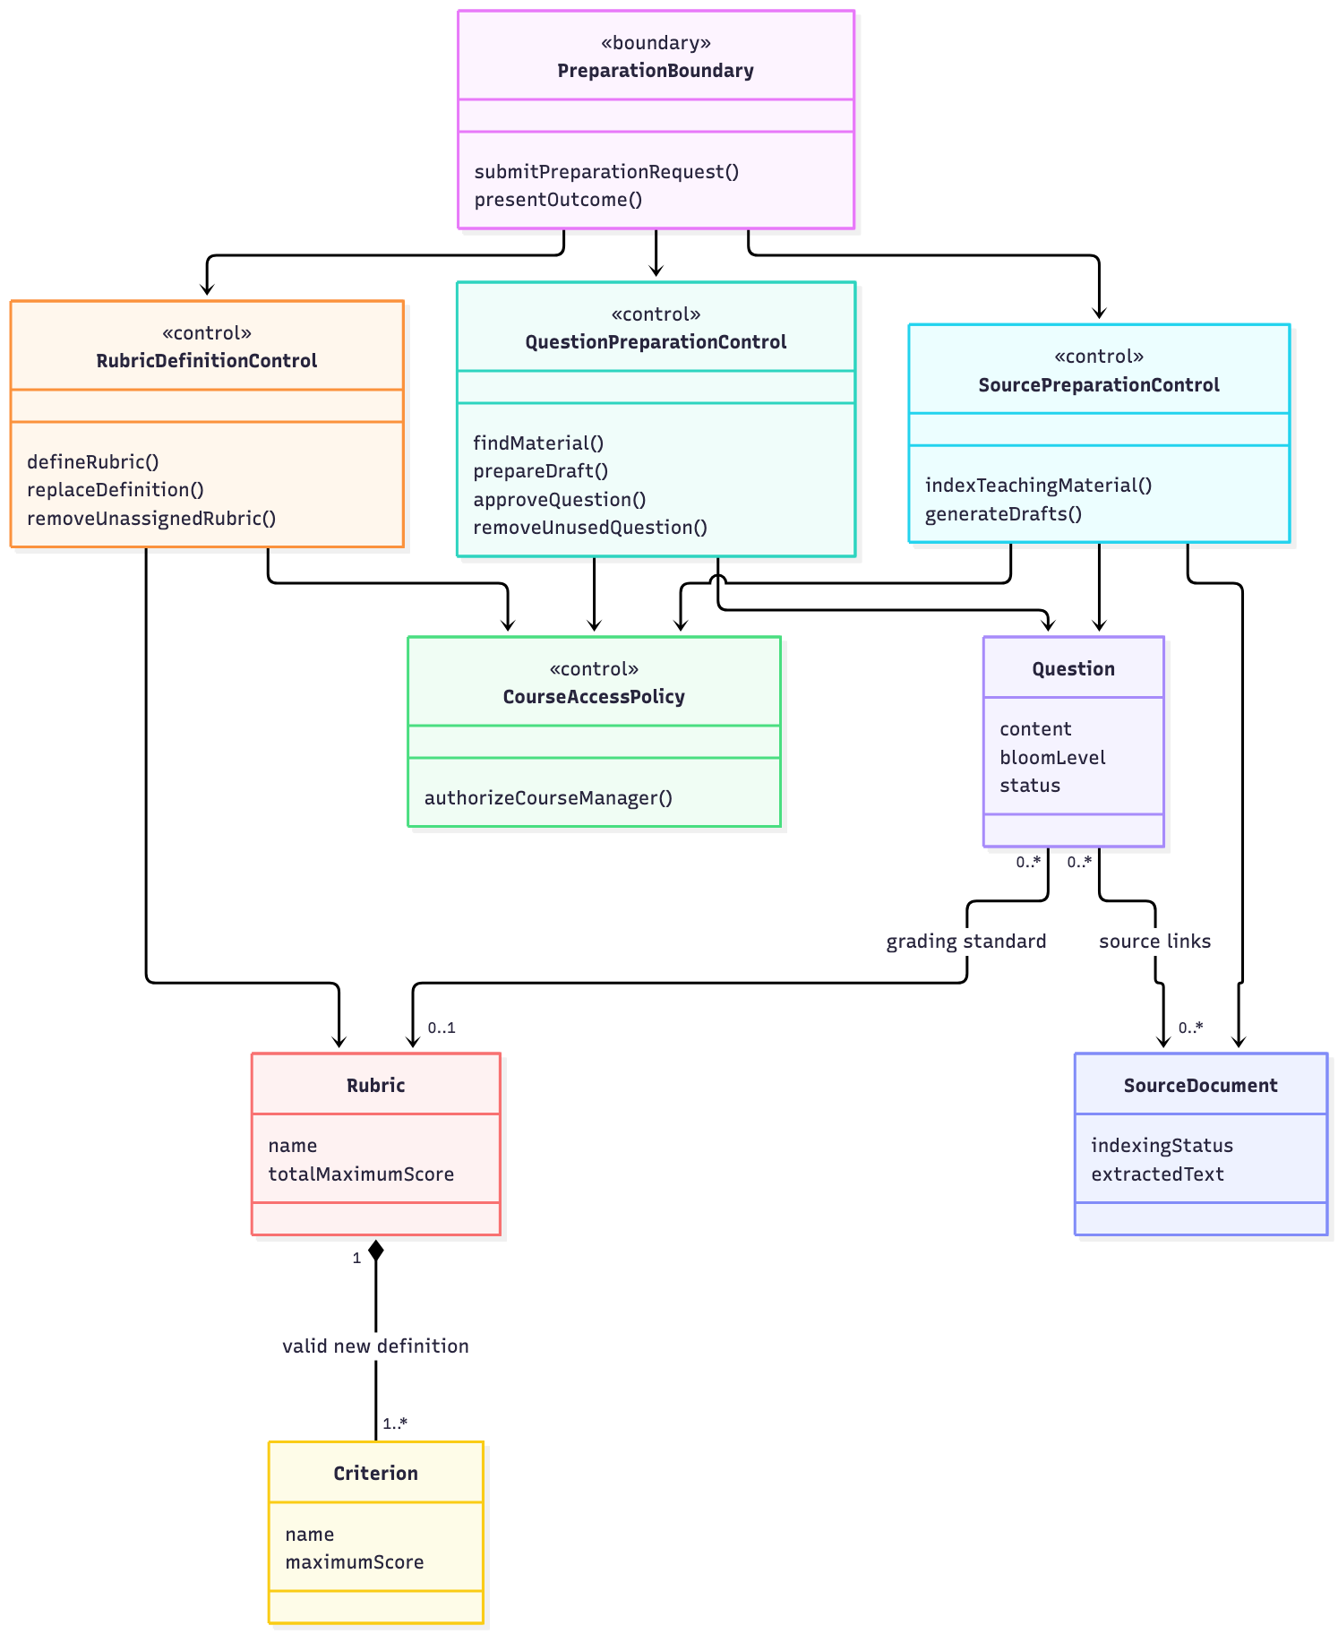

COM 01 Create or revise question UC 02 03 communication view
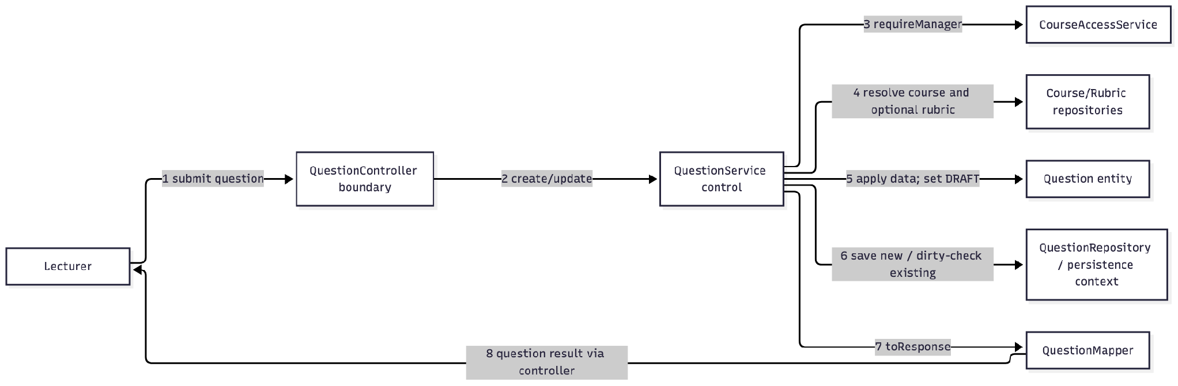

COM 02 Replace rubric definition UC 10 communication view
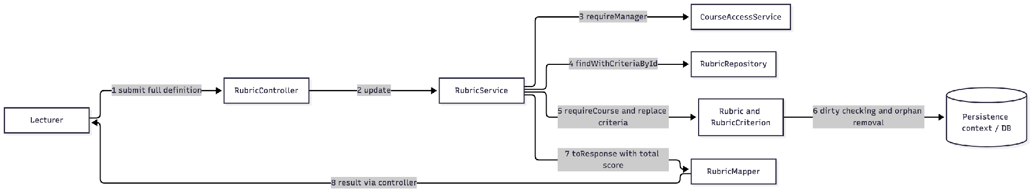

COM 03 Generate drafts UC 07 communication view
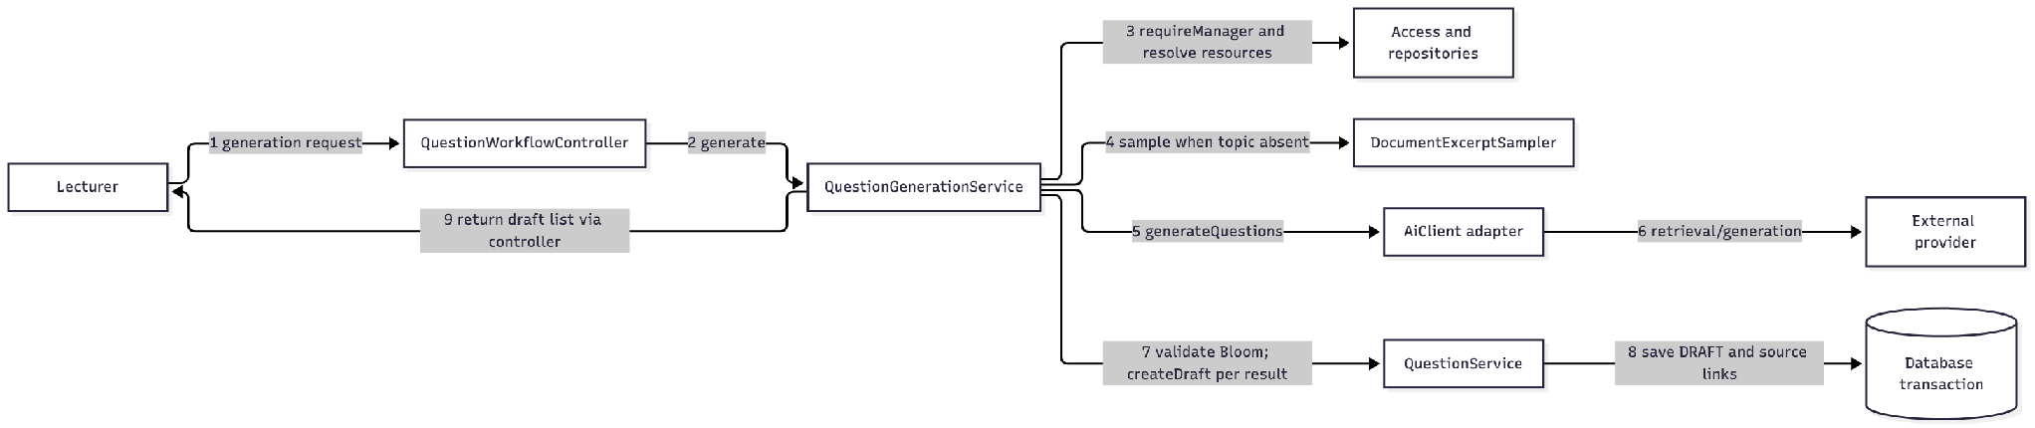

Exam Management

Interaction models

II 4 1 Configure a permitted question pool
ExamController obtains actorId from the JWT and invokes ExamServiceImpl. The service resolves the exam and asks CourseAccessService to validate management authority. It accepts configuration only while the exam is DRAFT or PUBLISHED, rejects duplicate IDs and verifies that every selected question is APPROVED and belongs to the exam course. It merges the three exposed settings into exam_config while retaining other settings.

II 4 2 Allocate slots and questions
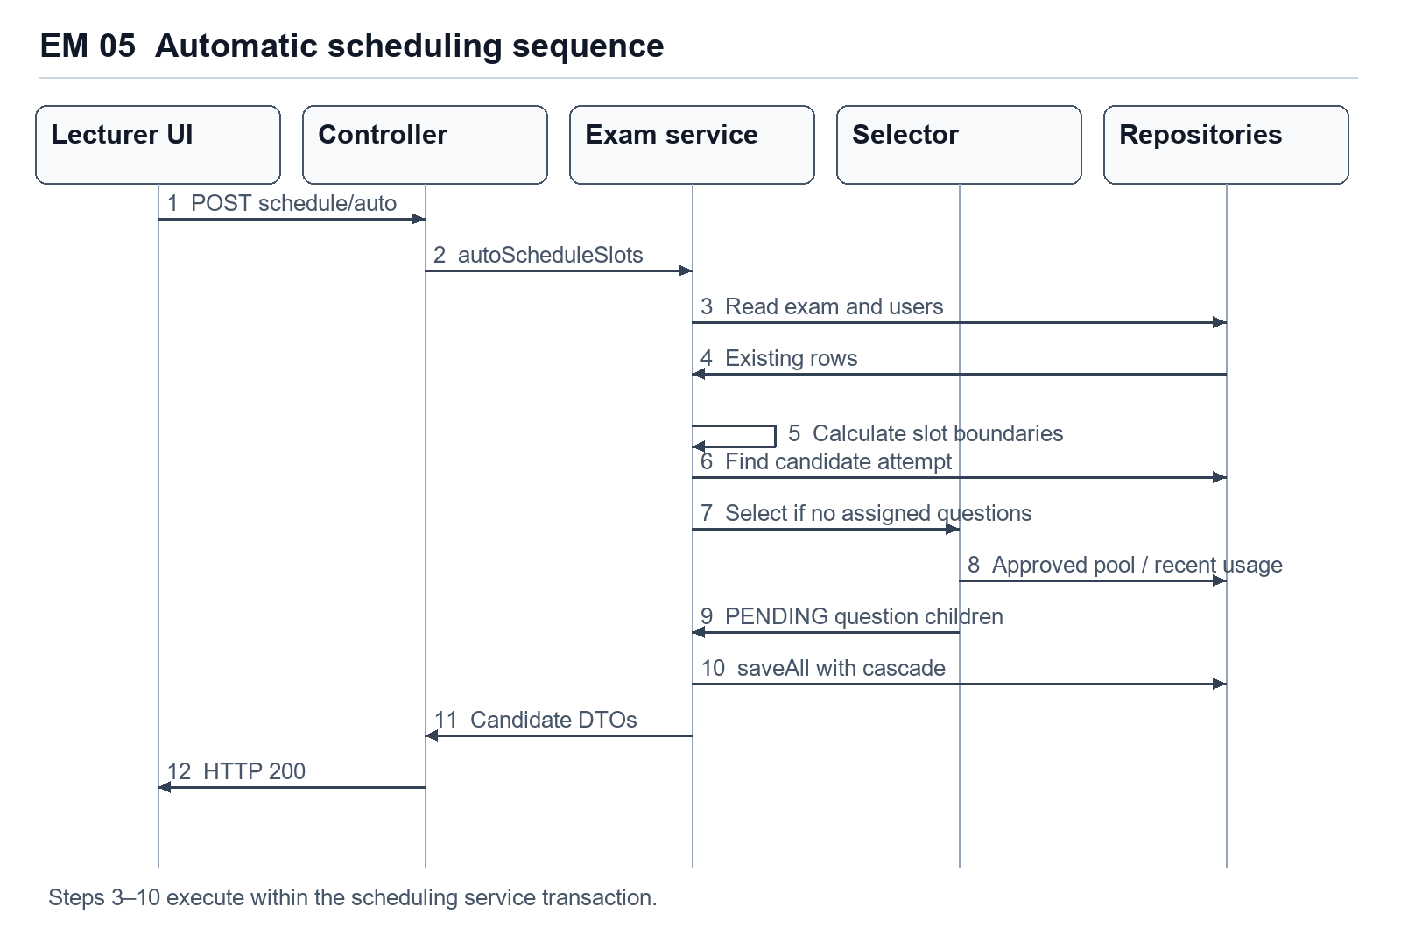
Figure EM 05. Automatic scheduling interaction. The save operation cascades new assigned questions within the same database transaction.
An existing question collection is reused when the attempt is rescheduled automatically. This makes schedule changes preserve an already allocated question set, but it also means a later configuration change will not update those question rows. The response contains candidate schedule DTOs. It is a management response rather than the student's personal summary.

II 4 3 Retrieve a personal schedule
StudentExamController extracts the JWT subject and passes that UUID to ExamScheduleService. ExamAttemptRepository returns a projection joining Exam and Course. An optional attempt-status filter and a bounded page request are applied in the database. The response includes examId and attemptId, course labels, slot number, scheduled times and attempt status. The list omits questions, rubrics and other candidates.

AI Interview Core
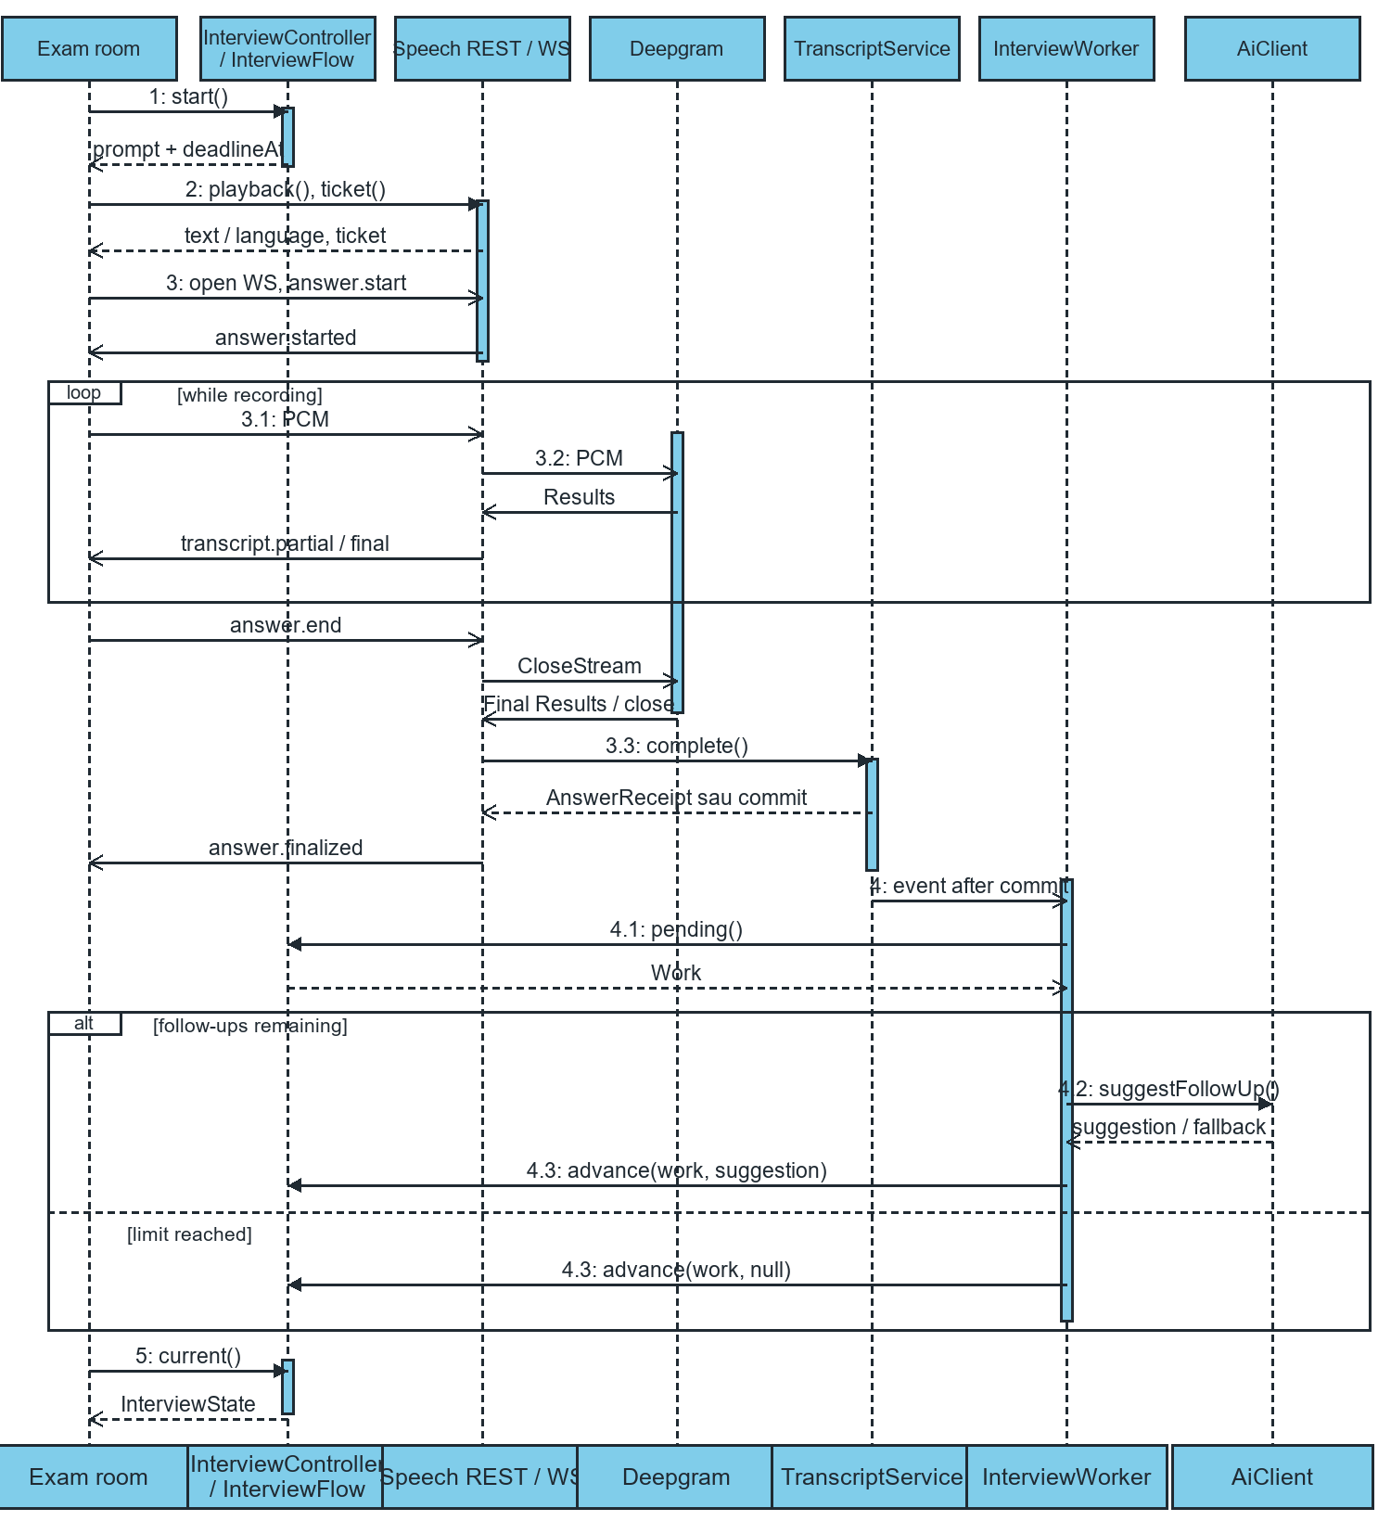
Figure 3. Sequence for a successful answer. Each transcript.final event finalizes one segment. The answer.finalized event confirms that the complete answer has been stored. During processing, current returns PROCESSING. The client can poll again for the next prompt or COMPLETED.

II.2 State diagram
Figure II-13 shows the states and transitions of a User account object. A newly created account is in the state MustChangePassword; the event ChangePassword moves it to Active; DeleteUser removes the account from either state. The events CreateUser, ChangePassword and DeleteUser have the same names as the messages in the sequence diagrams (Figures II-2, II-4 and II-6).
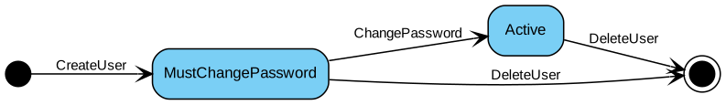
Figure II-13 State diagram model states of a User account object

Question Bank and Rubric

State diagrams
These model implemented states, not proposed approval workflows. No reject/archive state is present. Deletion is a terminal event, not a stored status.

ST 01 Question lifecycle
Figure ST-01 is included in the diagram appendices.

ST 02 Document indexing lifecycle
Figure ST-02 is included in the diagram appendices.

ST 03 Rubric lifecycle derived conceptual states
Figure ST-03 is included in the diagram appendices.

Detailed diagrams

ST 01 Question lifecycle
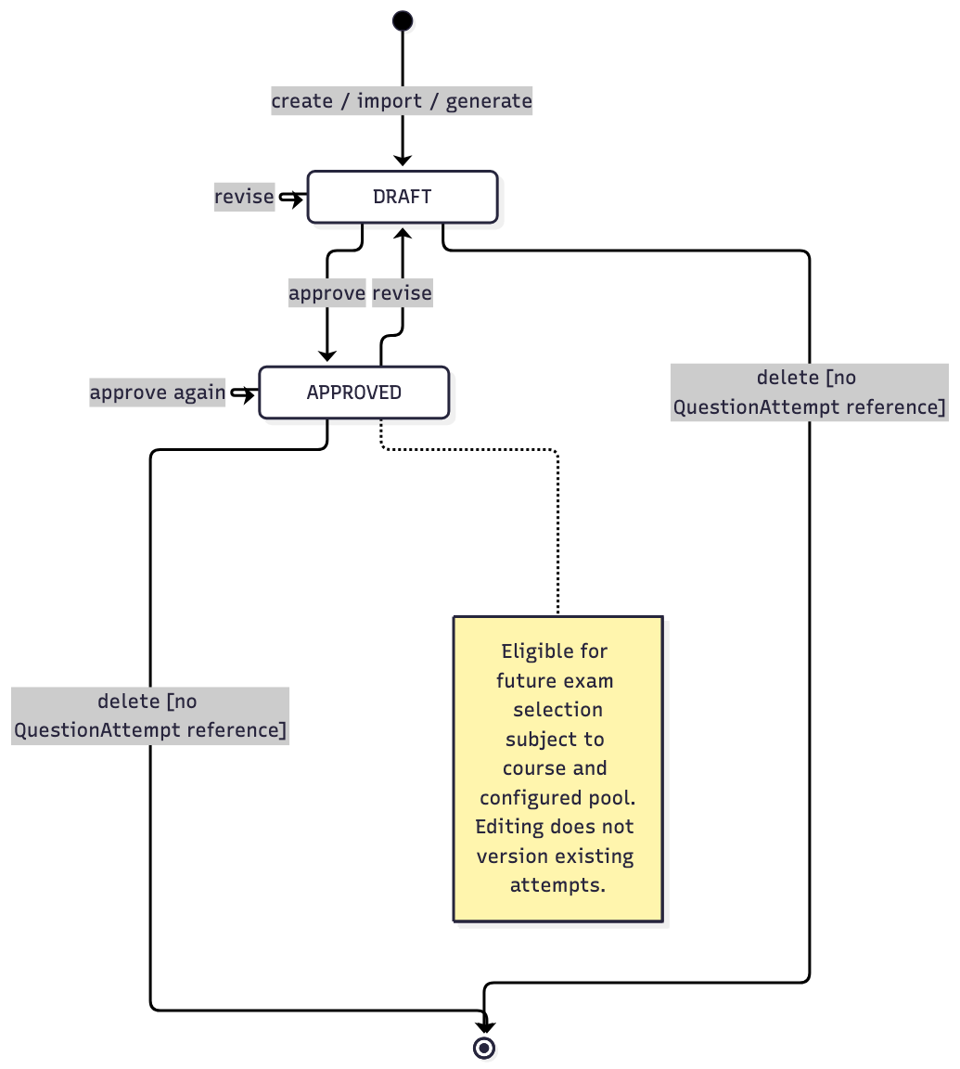

ST 02 Document indexing lifecycle
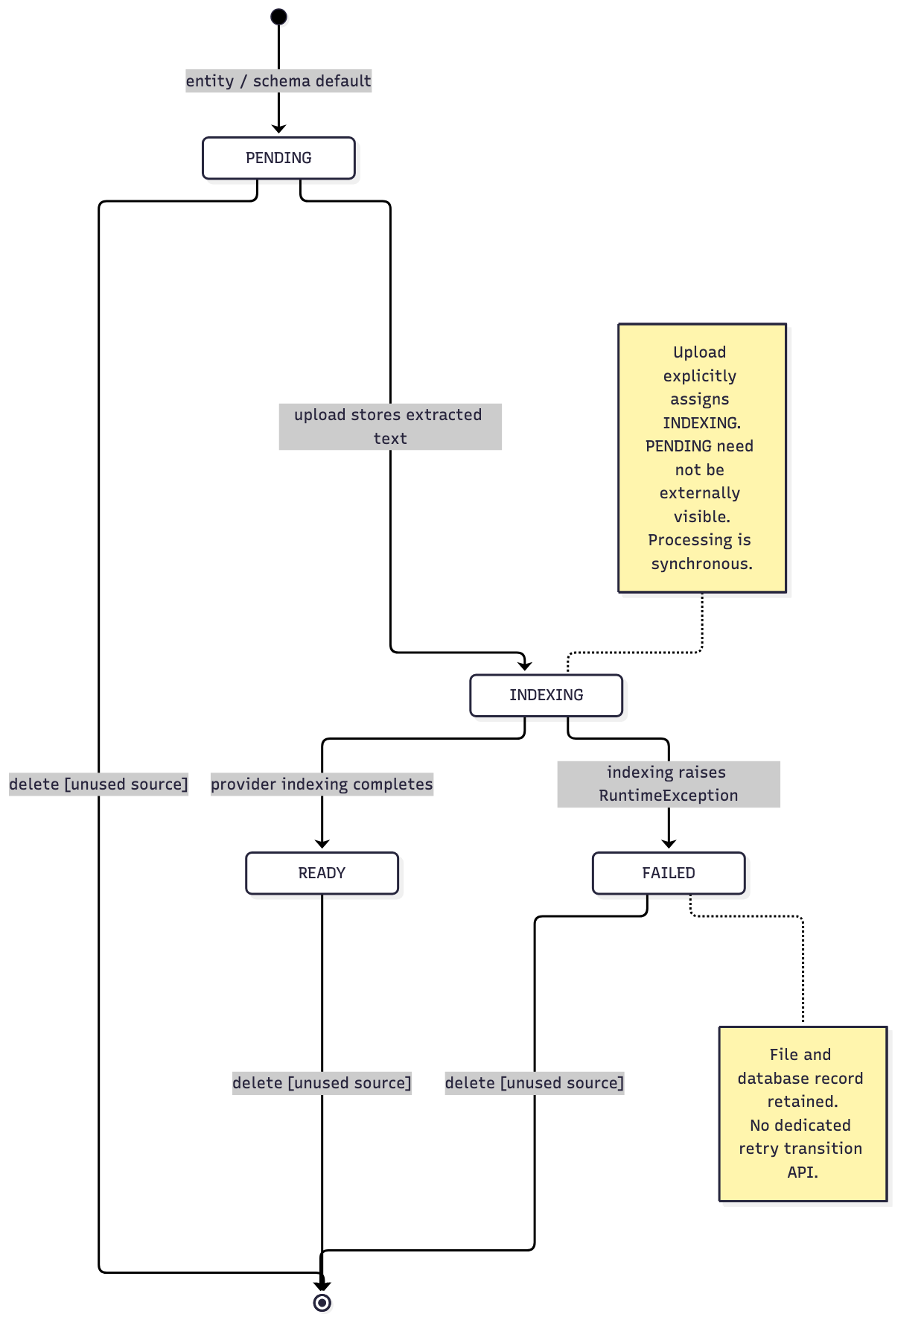

ST 03 Rubric lifecycle derived conceptual states
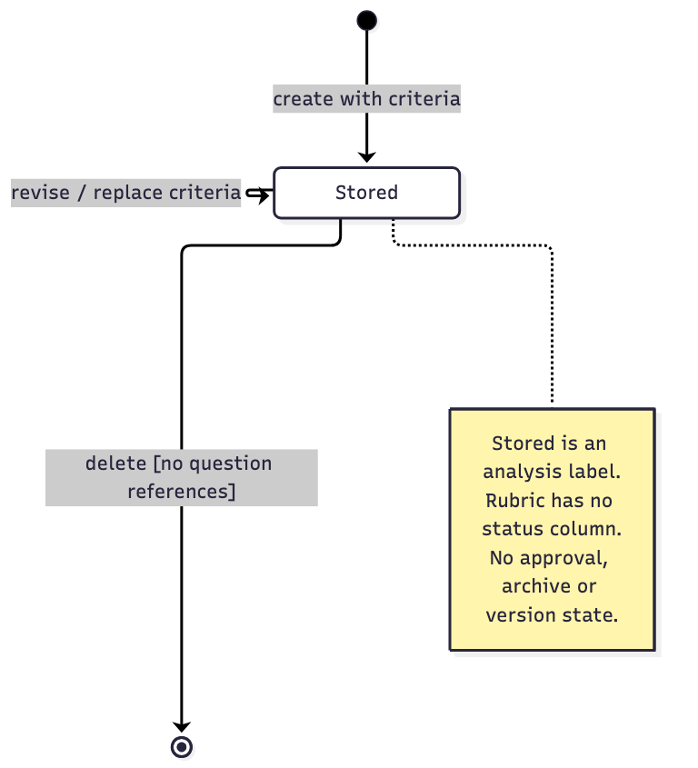

Exam Management

State models
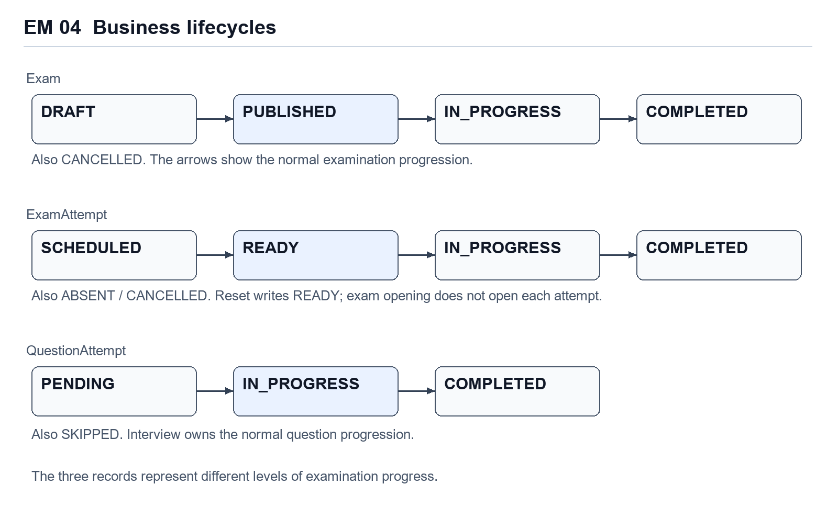
Figure EM 04. Separate examination, student-attempt and assigned-question lifecycles. Arrows describe the normal business progression.
Exam has DRAFT, PUBLISHED, IN_PROGRESS, COMPLETED and CANCELLED values. The intended successful progression is DRAFT to PUBLISHED to IN_PROGRESS to COMPLETED. Candidate operations work on ExamAttempt, whose values are SCHEDULED, READY, IN_PROGRESS, COMPLETED, ABSENT and CANCELLED. QuestionAttempt uses PENDING, IN_PROGRESS, COMPLETED and SKIPPED. The interview service owns the normal transitions through active question and attempt execution.

AI Interview Core
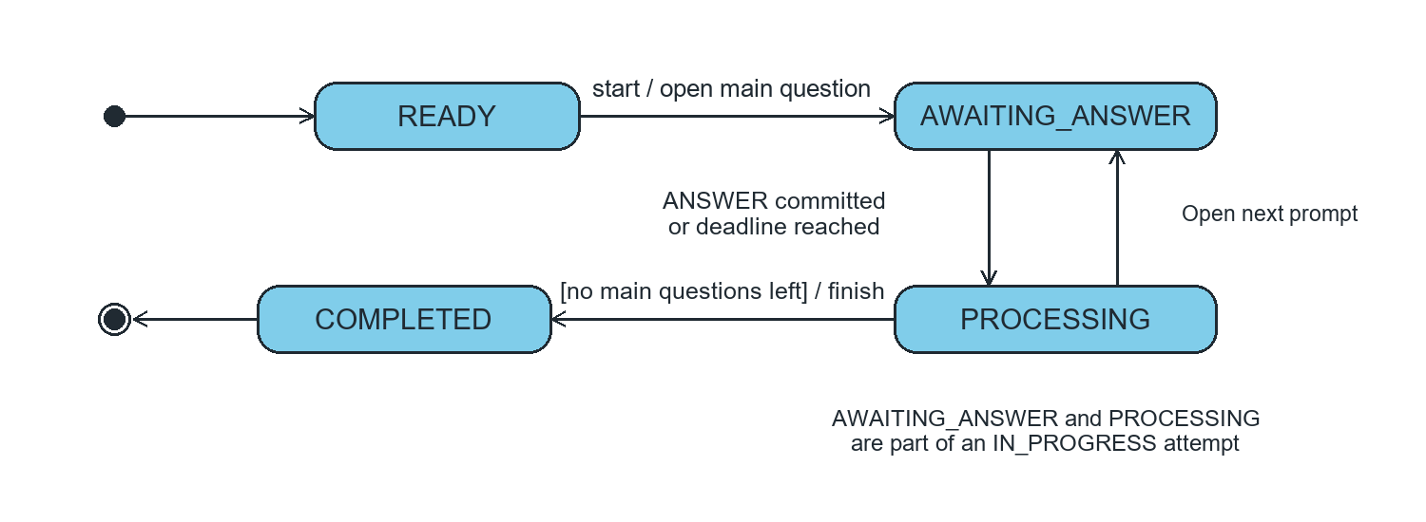
Figure 4. Lifecycle exposed by InterviewState.Status. AWAITING_ANSWER and PROCESSING both correspond to ExamAttemptStatus.IN_PROGRESS. At the deadline, the API can report PROCESSING before the worker finalizes or skips the prompt.

III. Design specification

III.1 Integrated Communication Diagrams
To move from analysis to design, the use-case-based interaction diagrams are integrated. Figure III-1 integrates the communication diagrams of Manage Users, Add User, Edit User and Delete User.
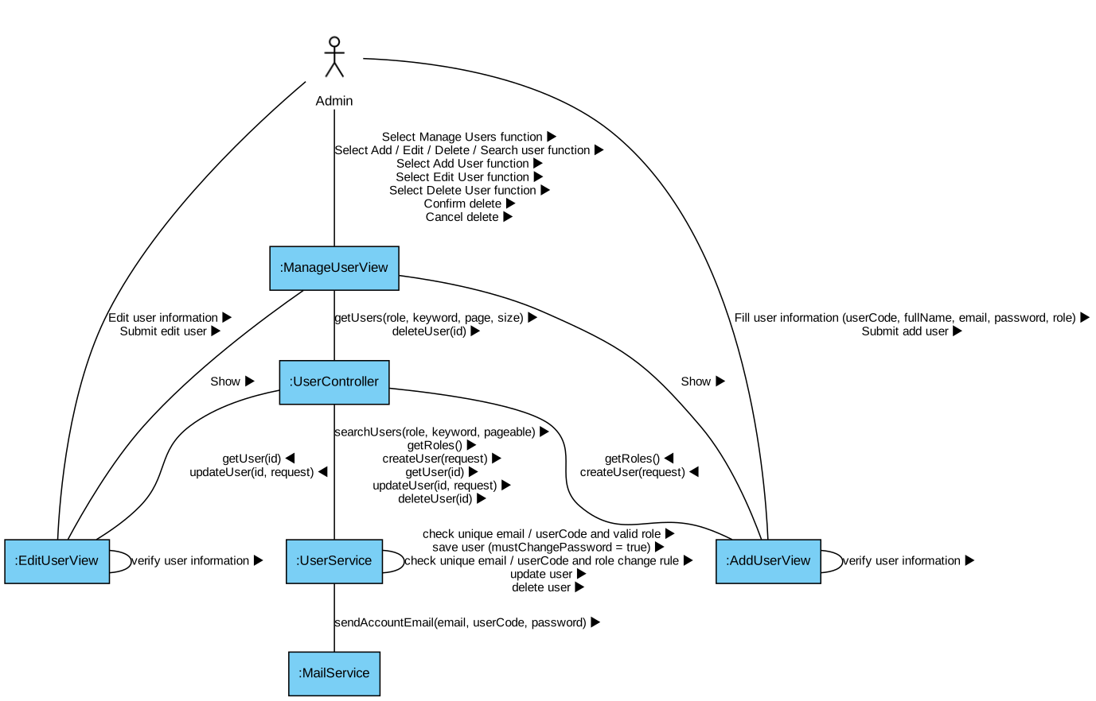
Figure III-1 Integrated communication diagram of Manage Users, Add User, Edit User, Delete User

Question Bank and Rubric

Integrated communication diagram
The module is part of a single Spring application. Services call each other in-process. Shared access policy and repositories are reused; the AI adapter is an external-system boundary, not a separately deployed microservice.

DES 01 Integrated collaboration across module goals
Figure DES-01 is included in the diagram appendices.

Detailed diagrams

DES 01 Integrated collaboration across module goals
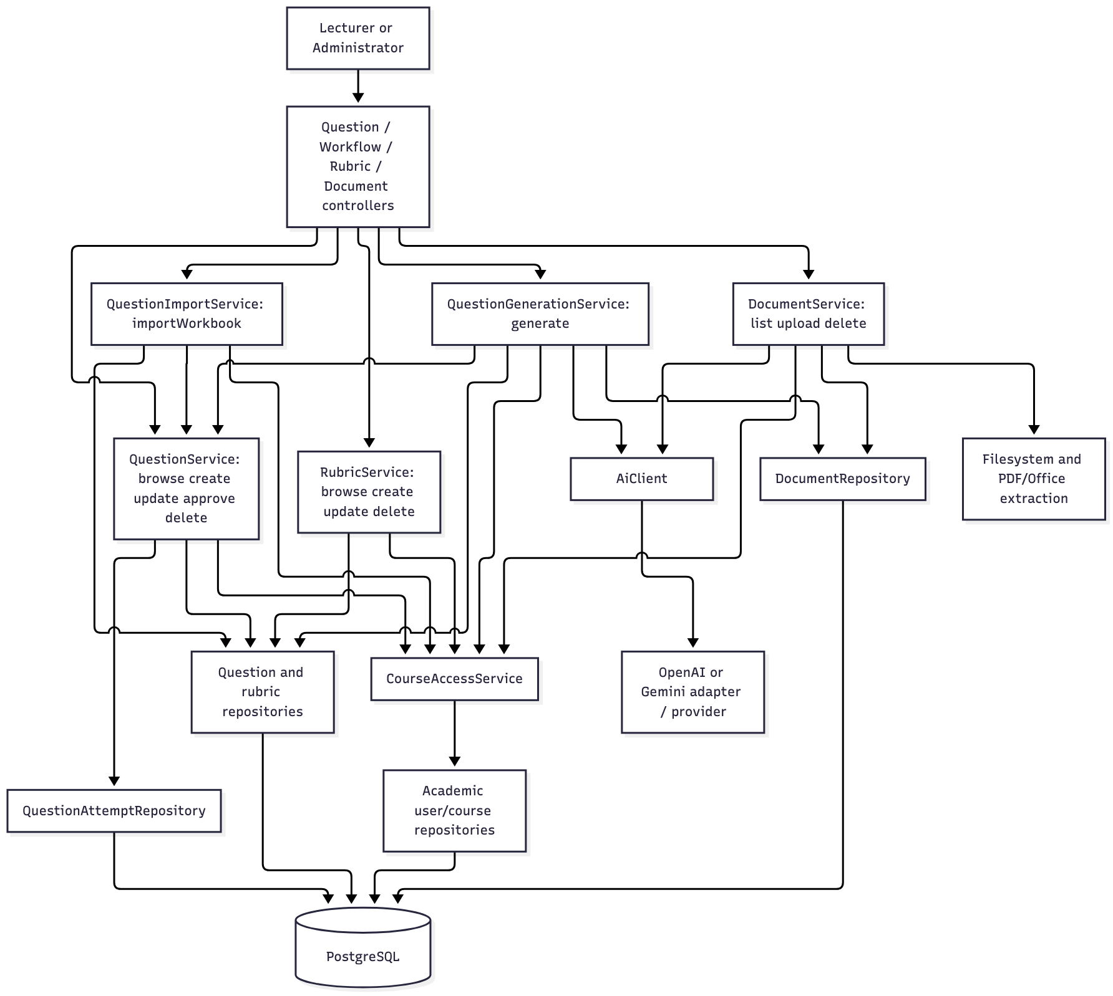

AI Interview Core
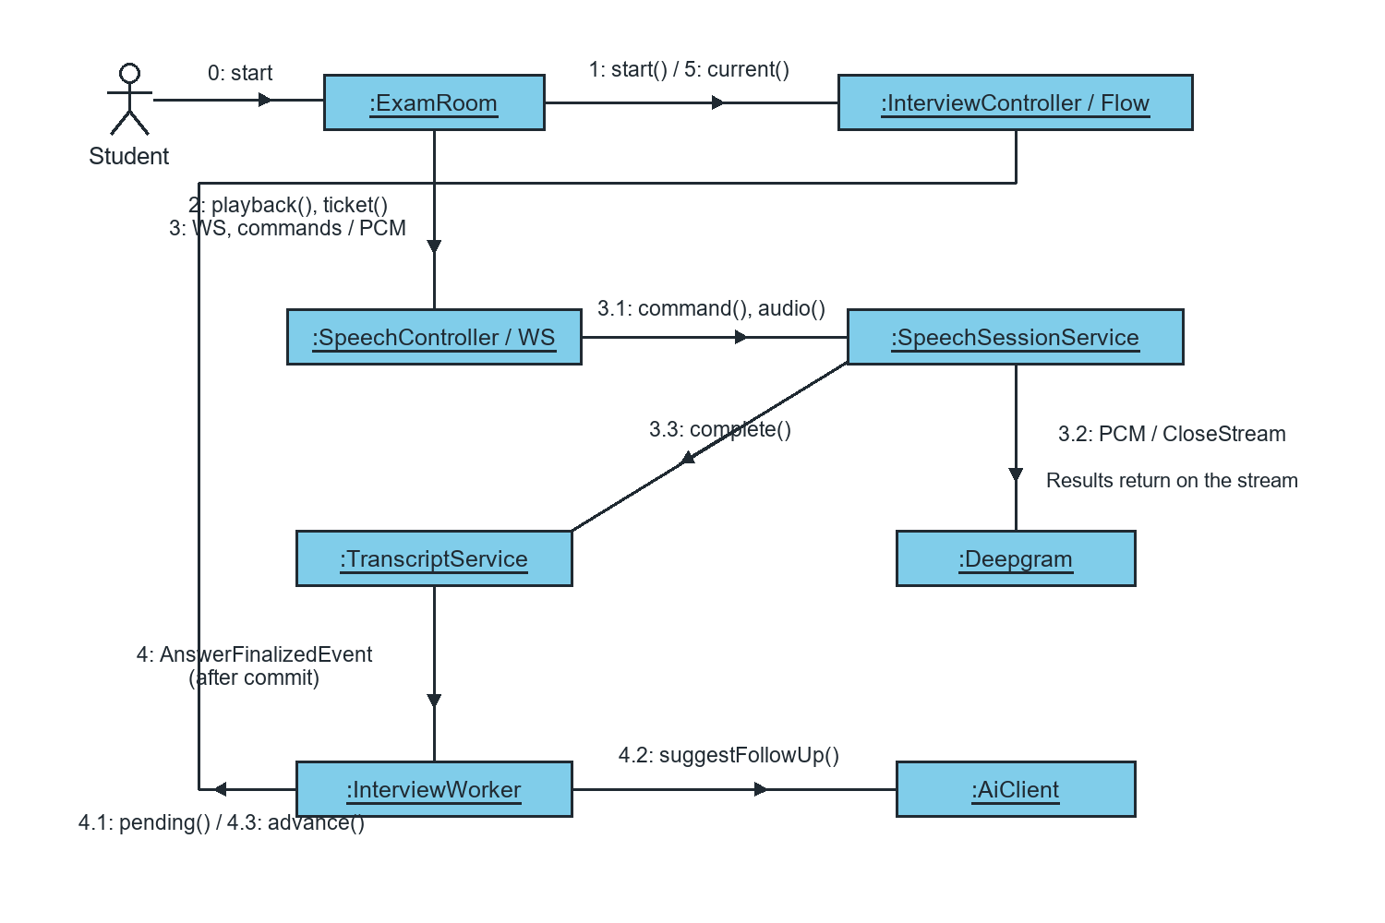
Figure 5. Numbered messages in the integrated interview flow. Messages 3.3 and 4.1–4.3 cover persistence and the follow-up decision.
1 calls InterviewController / InterviewFlow.start. 2 requests playback and a ticket from SpeechController. 3 opens the WebSocket and sends commands and audio to SpeechWebSocketHandler. 3.1 forwards command and audio to SpeechSessionService. 3.2 exchanges PCM, Results, and CloseStream with Deepgram. 3.3 calls TranscriptService.complete.
4 delivers AnswerFinalizedEvent to InterviewWorker after commit. 4.1 calls InterviewFlow.pending. 4.2 calls AiClient.suggestFollowUp if follow-ups remain. 4.3 calls InterviewFlow.advance. 5 retrieves the current state through InterviewController / InterviewFlow.
On timeout, InterviewWorker publishes AnswerDeadlineReachedEvent. SpeechInterviewEventListener passes the event to finishCurrentAnswer(attemptId, questionTurnId).

III.2 System High-Level Design
Based on the functional and non-functional requirements, AIVES uses a layered architecture organised by feature: each feature package contains controller, service, repository, dto, mapper and entity sub-packages, and the layers call each other in the order Controller → Service → Repository → Database. Figure III-2 shows the high-level design of the system.
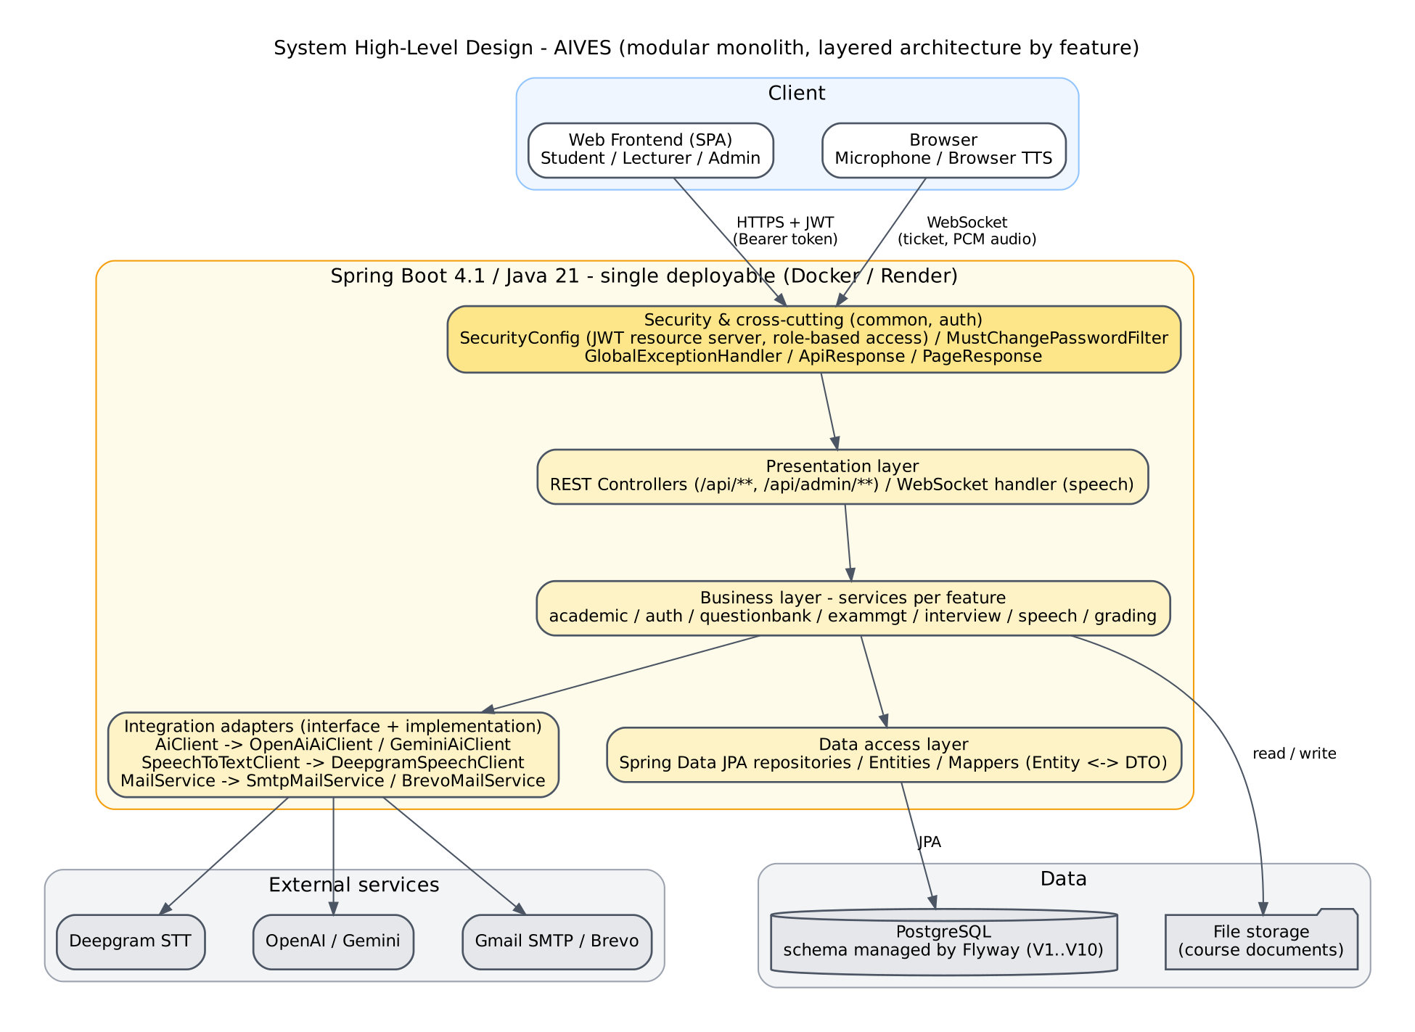
Figure III-2 High-level design of the AIVES system

Question Bank and Rubric

System high level design
Observed architecture: a Java 21 Spring Boot application exposing REST endpoints, JPA persistence and configurable AI adapters. pom.xml declares Spring Boot 4.1.1; that is a repository declaration, not a verified dependency compatibility claim. The application is a layered modular monolith: controller → service → repository/domain, with DTO/mapper and common-security/error infrastructure. Academic, exam and grading packages coexist in the same process and database.
Local deployment evidence: compose.yaml defines a Spring container, PostgreSQL 17 container, database volume and upload volume. Dockerfile has Maven build and Java 21 runtime stages. render.yaml describes a Docker web service using supplied database credentials; it does not establish current production deployment status or persistent upload storage. HTTPS termination, DNS, backups and provider account details are outside verified evidence.

DEP 01 Local deployment Compose evidence deployment style flowchart
Figure DEP-01 is included in the diagram appendices.

CMP 01 Logical components and package dependencies
Figure CMP-01 is included in the diagram appendices.
QuestionService depends on the exam repository for the delete guard while exam selection depends on bank repositories. This is a bidirectional package dependency in the monolith, not a circular constructor dependency claim. It is a consideration for any later extraction into separate services.

Detailed diagrams

DEP 01 Local deployment Compose evidence deployment style flowchart
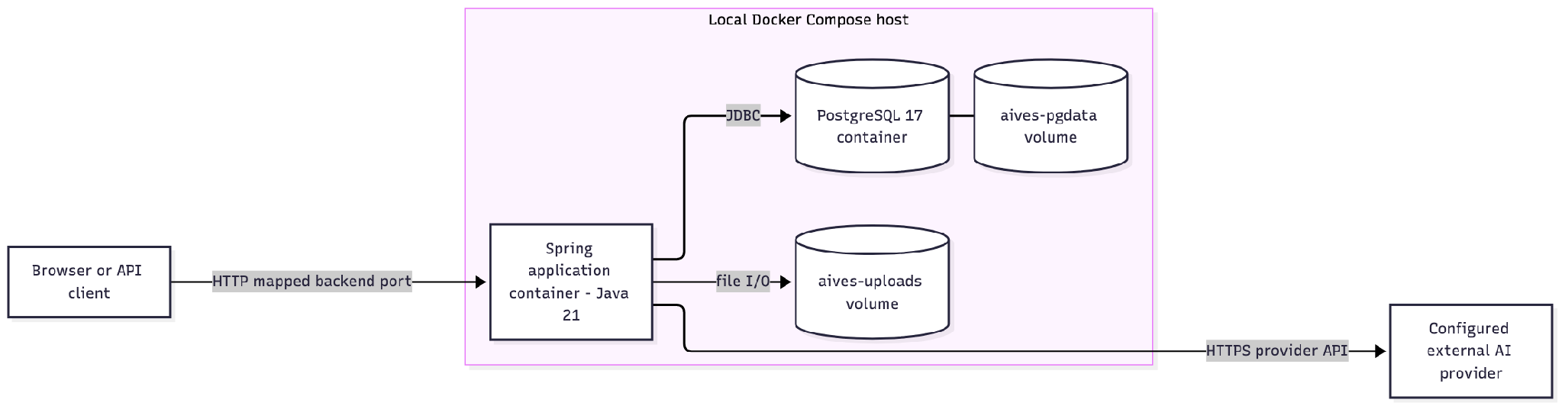

Exam Management

High level and package design
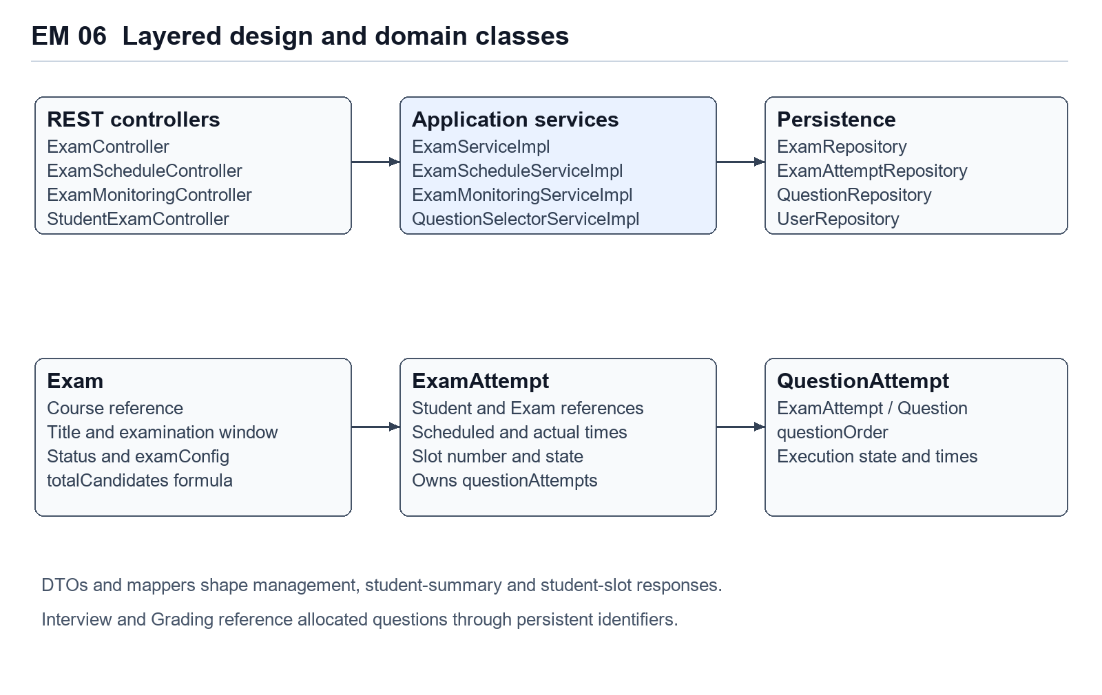
Figure EM 06. Main service, repository and entity responsibilities in the examination module.
ExamController delegates examination CRUD and question configuration to ExamService. ExamScheduleController delegates candidate assignment, automatic allocation and manual rescheduling to ExamScheduleService. ExamMonitoringController delegates status counts and recovery actions to ExamMonitoringService. StudentExamController reads personal data through ExamScheduleService. Concrete implementations are under exammgt.service.impl.
QuestionSelectorService is shared by automatic scheduling. It consumes QuestionRepository and ExamAttemptRepository, and returns new QuestionAttempt entities. ExamMapper maps configuration and exam responses. ExamAttemptMapper maps management schedules, student slots and question-attempt DTOs. The student schedule list uses a dedicated constructor projection to limit returned columns.

III.3 Component and Package Diagram
(Package and component diagrams will be added after the package dependencies are verified against the source code.)

Question Bank and Rubric

Detailed diagrams

CMP 01 Logical components and package dependencies
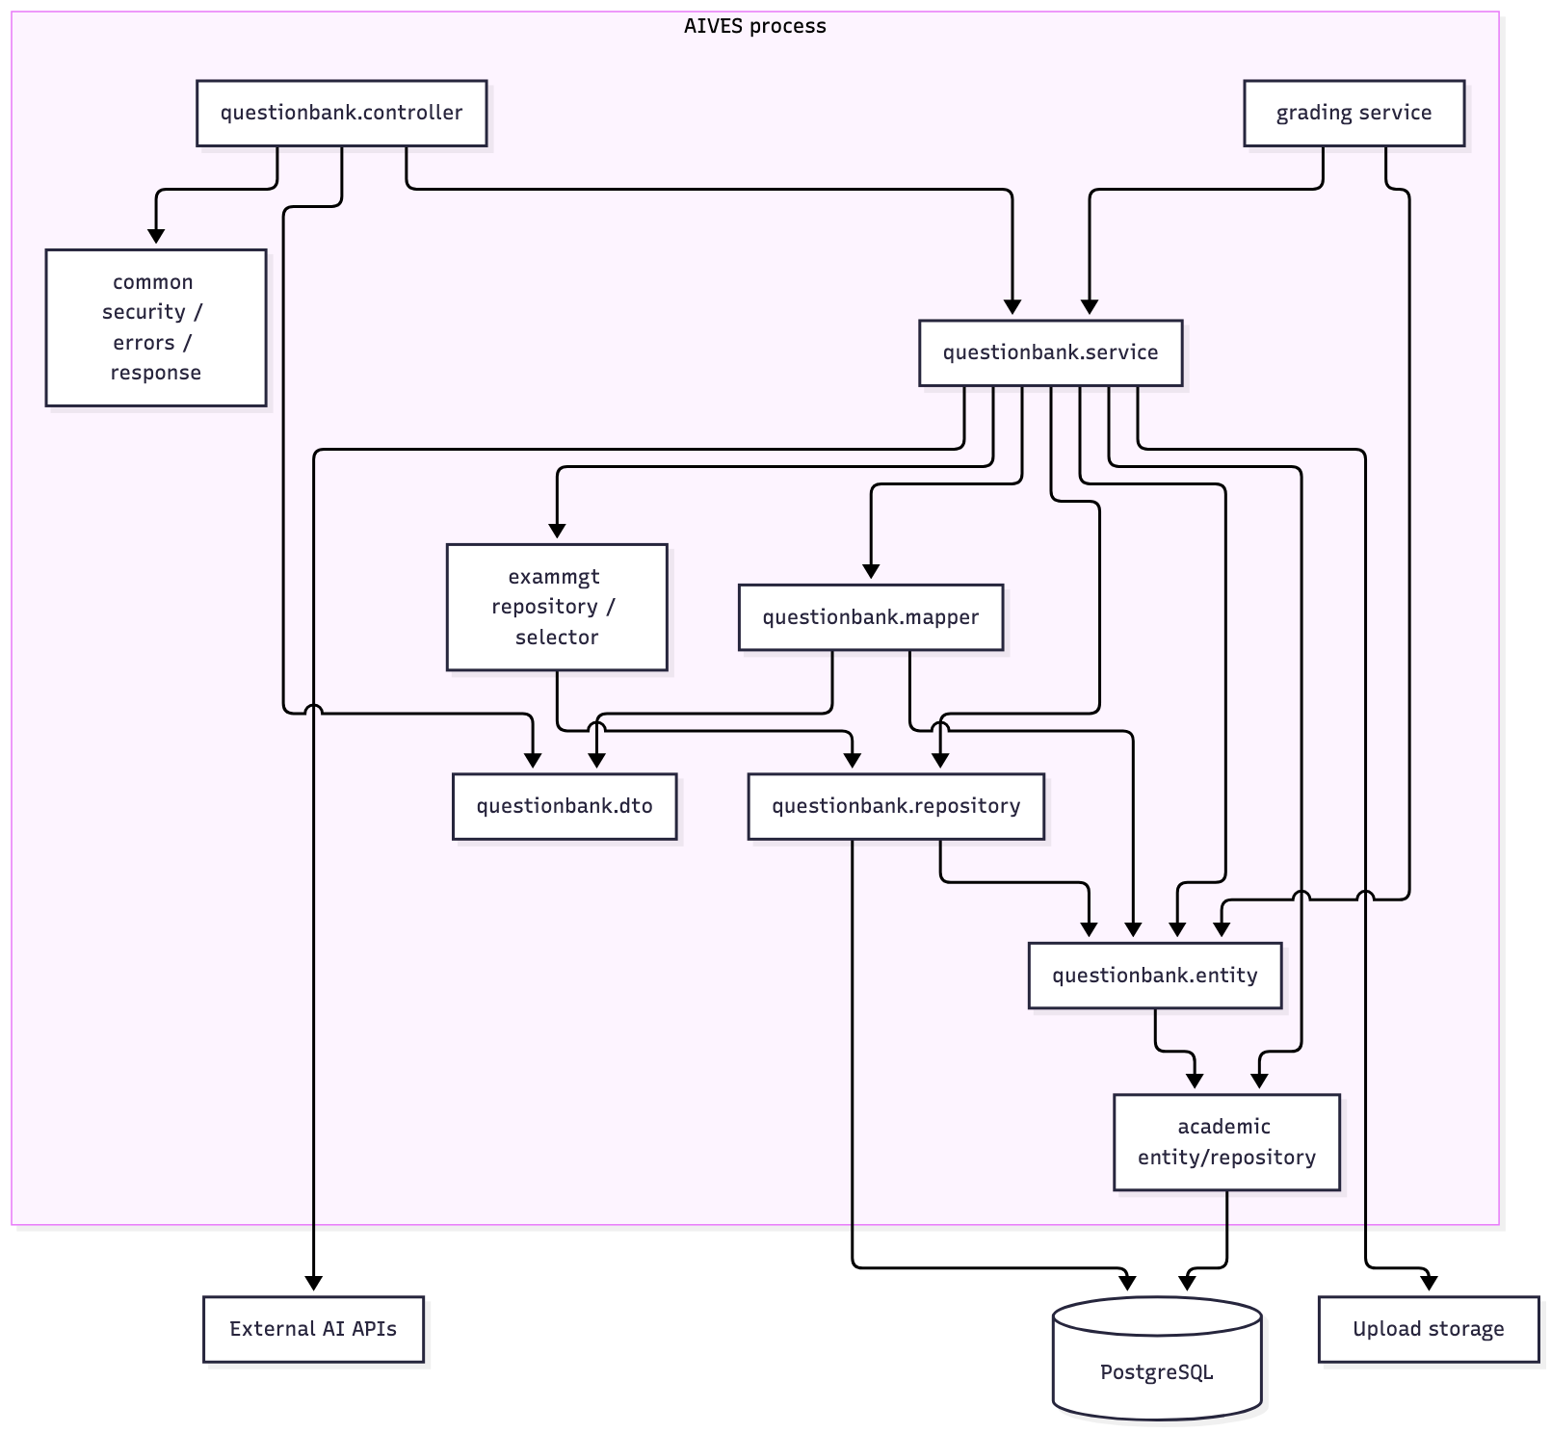

III.4 Detail Design
The classes of the analysis model are mapped to design classes: boundary (view), control (controller), application logic (service, mapper) and entity classes with repositories as the data access wrapper. The operations are derived from the messages in the sequence diagrams of Section II.1. Figure III-3 shows the detailed design classes of NCN7. Operation names are inferred from the API and the database schema and must be checked against the source code.
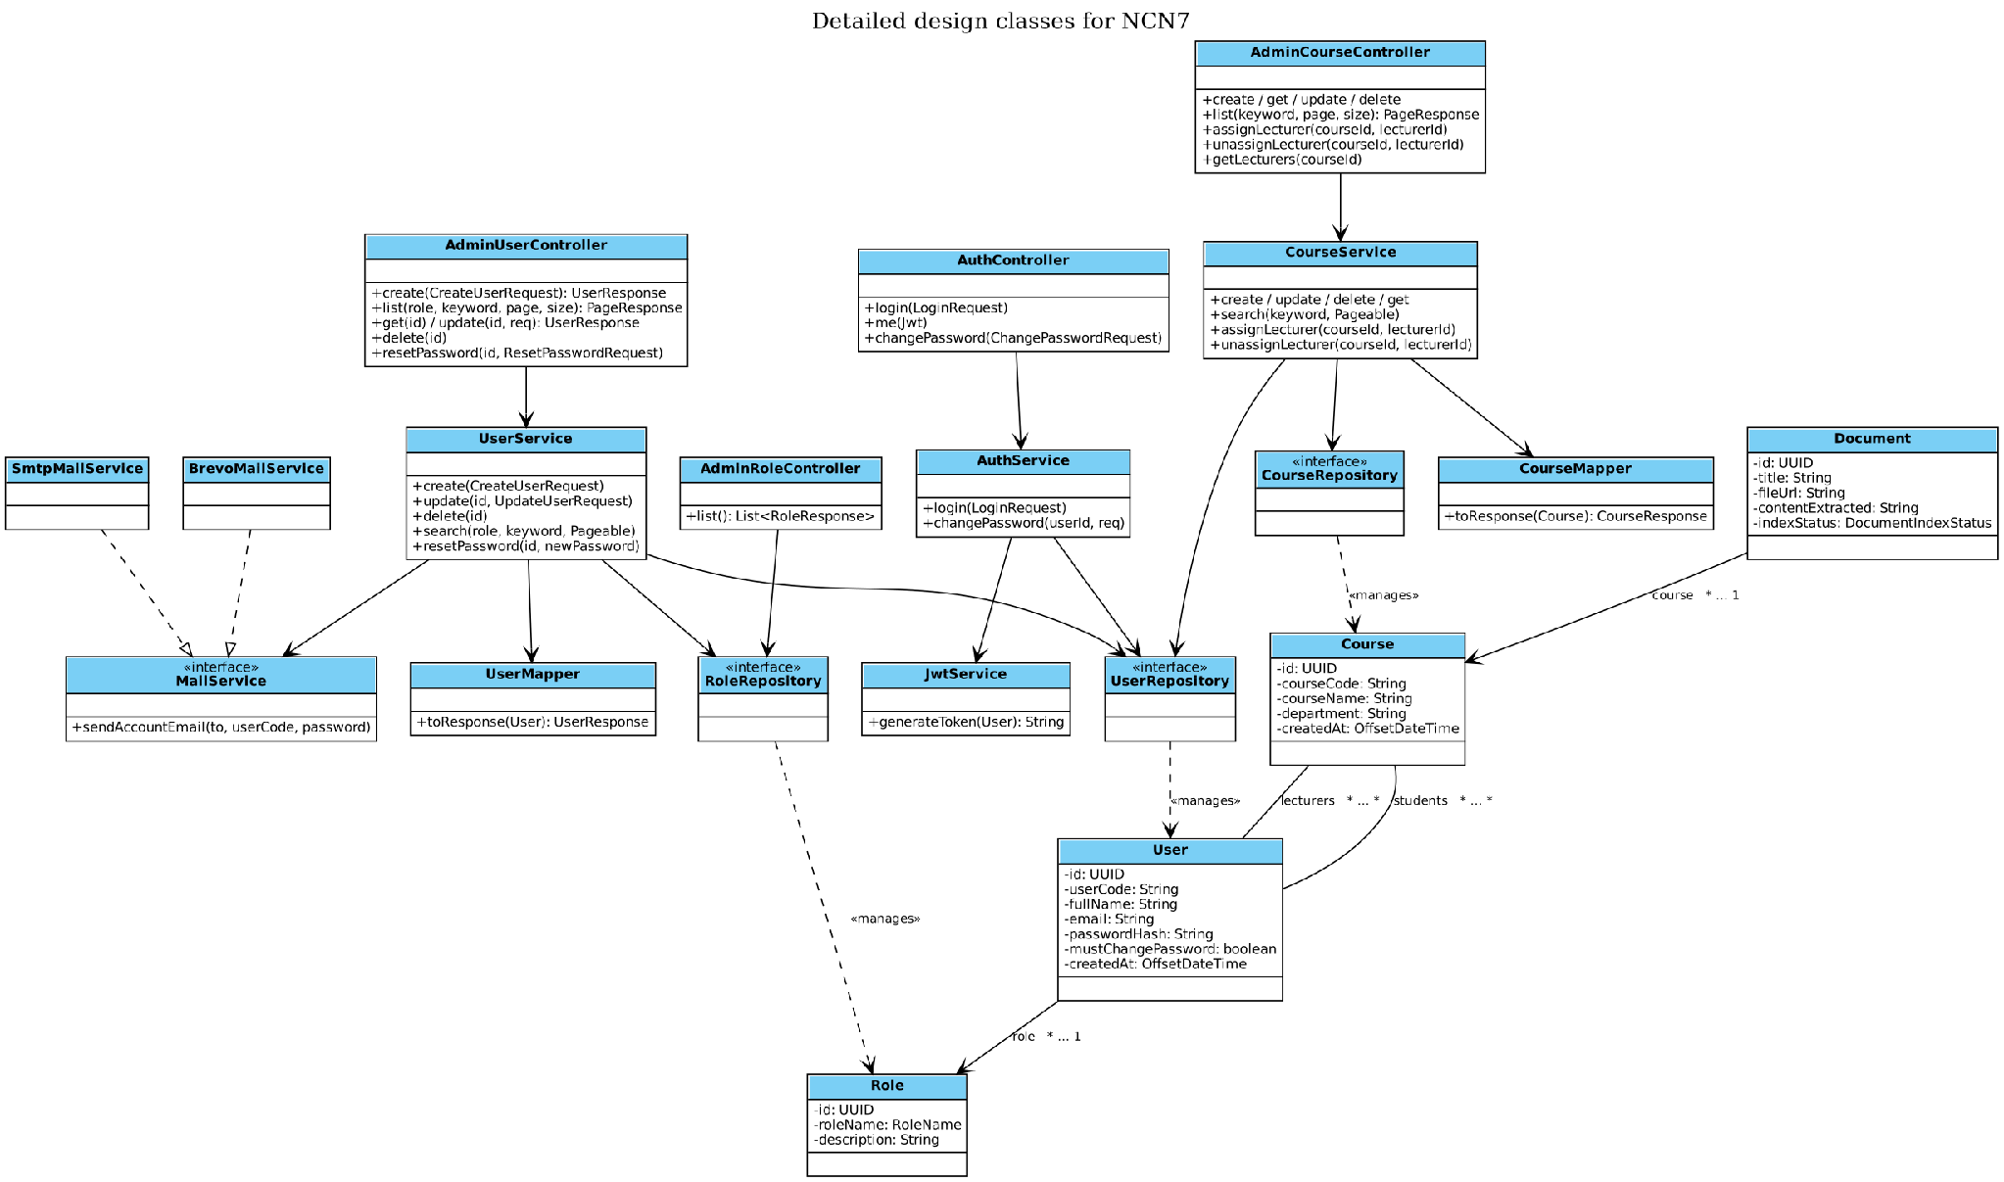
Figure III-3 Detailed Design Classes for System Administration and Authentication

Question Bank and Rubric

Detailed class design
Key operations below use actual Java method names. Repositories are persistence interfaces; entities hide domain state but do not replace repositories. This follows the sample's separation of persistence and data responsibilities without inventing wrapper classes absent from this repository.

CLS 01 Services persistence and provider interface
Figure CLS-01 is included in the diagram appendices.

CLS 02 Domain relationships application level model
Figure CLS-02 is included in the diagram appendices.
CLS-02 models new application-managed rubrics as course-owned. The physical V6 migration leaves rubrics.course_id nullable for legacy data; the database ER model and gap analysis preserve that difference. Criterion multiplicity is 0..* at entity/storage level; the create/update API requires at least one.

Transaction and consistency design
Operation | Observed transaction and external effects
Question/rubric mutation | Service-level transactions; existing managed entities update through dirty checking. Rubric criteria use cascade ALL and orphan removal.
Workbook import | Validate the whole workbook first; createDraft calls join the outer write transaction. Row errors return normally before any create calls. Persistence failure rolls back database writes.
Generation | Provider call occurs within the transaction; draft creations join it. An invalid later Bloom value causes rollback of earlier drafts. Provider processing/cost is not rolled back.
Document upload | Local file creation/extraction and provider indexing occur inside the service method. Indexing RuntimeException is caught, so FAILED document state can commit. Later transaction-commit failure occurs outside the method's local catch and may leave local/provider artifacts.
Document deletion | Provider deletion precedes local-file deletion and database deletion. Database rollback does not restore either external file.
Concurrency | No @Version field or pessimistic lock is present in the inspected bank entities/repositories. Existence/count guards can race with new references. The database FK actions differ from service guards; runtime conflict guarantees require review.

Provider and security boundaries
AiClient separates business services from adapter protocols. OpenAI topic generation uses course-store file search; no-topic generation uses sampled extracted source text. Gemini separates evidence retrieval from structured generation and retries to obtain the requested valid question count. Details are adapter-specific; neither path should be treated as proof that every saved source link is a per-question evidence citation.
JWT validation runs before controllers. CourseAccessService resolves the current database user role and assignment. DTO validation is applied to manual question/rubric creation/update and generation requests; the workbook parser performs its own validation. The template download has no service-level course check. Uploaded filename extensions drive format selection; content-type attestation, malware scanning and OCR are not established by the inspected code.

Detailed diagrams

CLS 01 Services persistence and provider interface
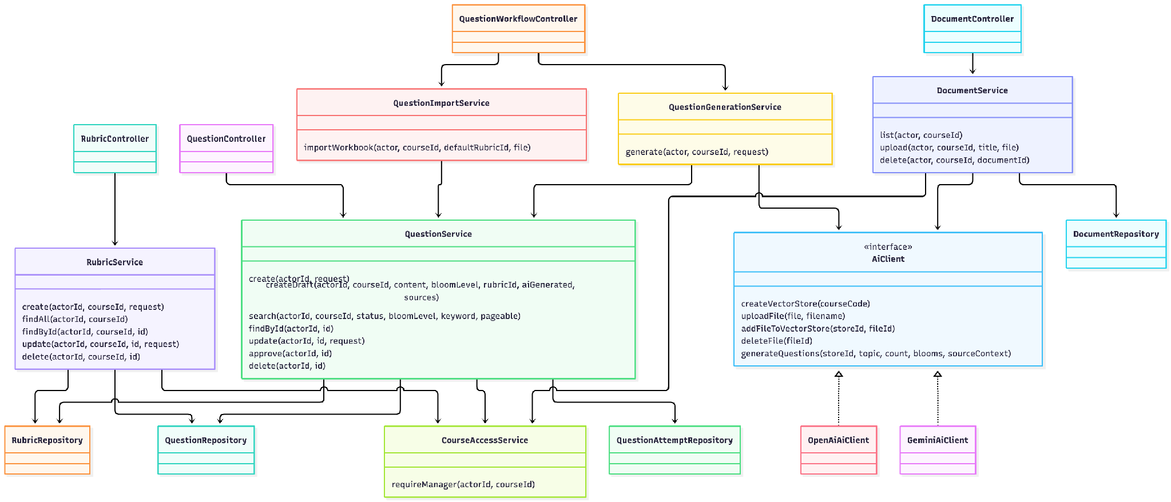

CLS 02 Domain relationships application level model
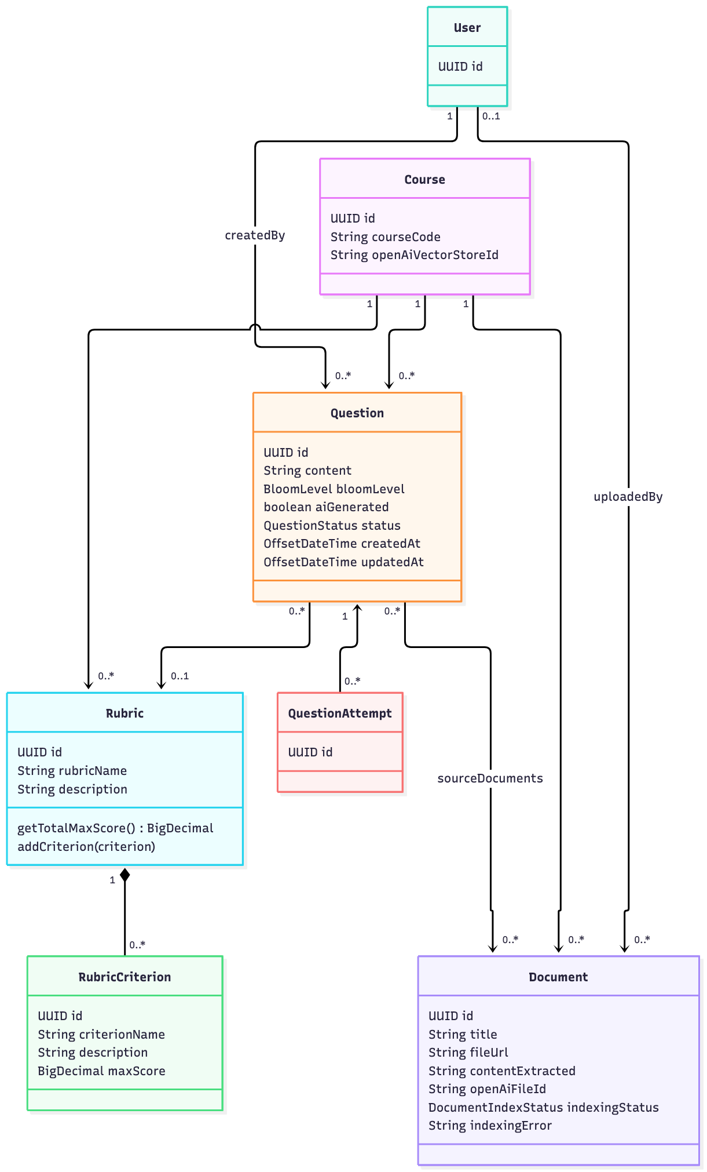

Exam Management

Scheduling design
SIMULTANEOUS is the default mode. Each selected candidate receives the examination start instant and an end instant obtained by adding slotDurationMinutes. The total required examination window is the duration of one slot. Each candidate retains an individual attempt ID and slot number.
SEQUENTIAL advances the next slot start after the prior slot end and breakDurationMinutes. For n candidates, duration d and break b, the required window is n × d + (n − 1) × b. For example, four students with 15-minute slots and 2-minute breaks need 66 minutes. The same four students need a 15-minute examination window in SIMULTANEOUS mode.
The request requires at least one student ID and a slot duration of at least five minutes. Break duration is nonnegative and defaults to two minutes. Each calculated slot end must fit inside the examination end. A failure throws a business exception and rolls back the current transaction.

Question allocation design
The selector starts from APPROVED questions in the examination course. A nonempty configured questionIds array restricts the pool. If any configured ID no longer corresponds to an approved question in that course, allocation fails. An empty questionIds array means that the approved course pool is used.
When antiOverlapEnabled is true and the candidate slot number exceeds one, the selector excludes question IDs used in the previous two slot-number positions. If the remaining pool is smaller than maxMainQuestions, it falls back to the approved pool after configured-ID restriction. It shuffles that pool and selects up to maxMainQuestions entries.
If the available approved pool is smaller than maxMainQuestions, the selector returns the available questions. The overlap fallback can reuse approved questions from the configured pool. The report describes random selection and does not assign a weighted Bloom algorithm to this implementation.

Transaction design
Scheduling and candidate assignment use transactional service methods. Existing attempts are looked up by examination and student, and automatic scheduling creates missing rows before saveAll. Question children cascade from the attempt. This protects a single invocation from partial database persistence when an exception is raised.

AI Interview Core
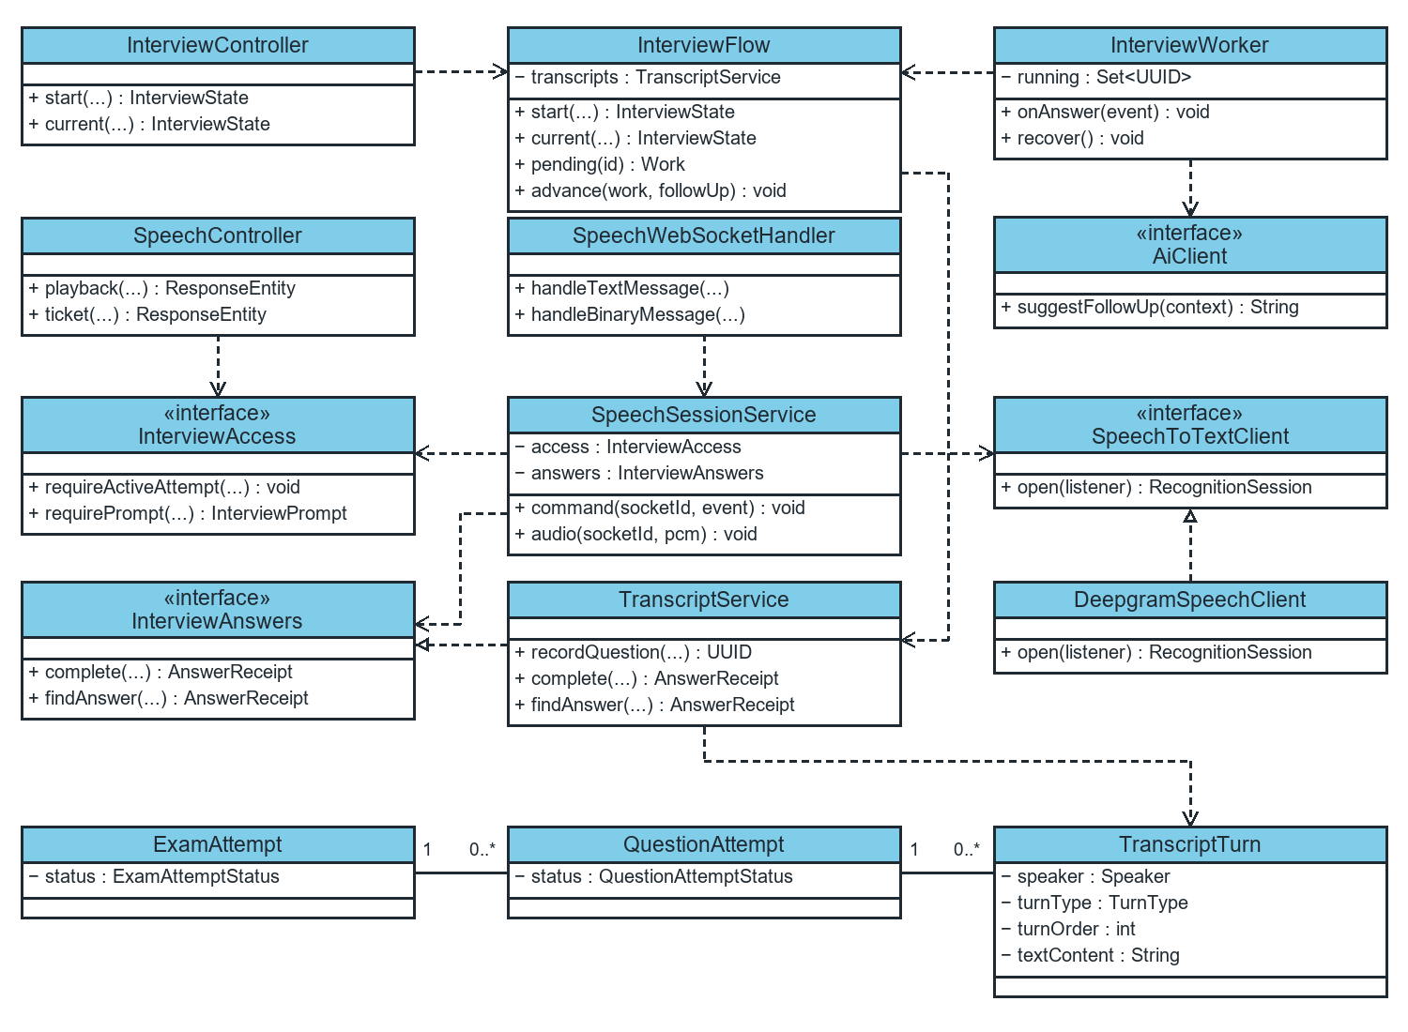
Figure 6. Main classes and interfaces of the AI Interview Core.
InterviewFlow depends on ExamAttemptRepository, QuestionAttemptRepository, TranscriptTurnRepository, TranscriptService, and InterviewAccessService. start opens a main question. pending reads the current question history and creates Work(attemptId, turnId, deadline, context). advance locks the attempt and assigned question, then verifies that turnId is still the latest turn before storing a follow-up or advancing.
InterviewWorker tracks active work by attemptId in running and calls AiClient through an executor. onAnswer runs after commit, and recover scans IN_PROGRESS attempts. The exam configuration sets maxFollowUpQuestions, which defaults to 2. A follow-up must contain usable text after normalization, contain at most 10,000 characters, and differ from previous AI prompts.
SpeechTicketService stores Grant(studentId, attemptId, expiresAt, jwtExpiresAt) in memory. issue checks access, and SpeechHandshakeInterceptor calls consume to redeem the ticket once. SpeechWebSocketHandler forwards JSON and binary frames to SpeechSessionService. The service maintains each connection and buffer, uses InterviewAccess to validate prompts, opens a stream through SpeechToTextClient, and saves answers through InterviewAnswers. TranscriptAccumulator combines recognition results by segment.
TranscriptService implements InterviewAnswers. recordQuestion stores AI turns. complete stores a STUDENT turn, links it to its prompt, and publishes AnswerFinalizedEvent. findAnswer retrieves the receipt. A lock on QuestionAttempt protects turnOrder allocation, and unique constraints on answerId and responseToTurnId prevent duplicate answers.
An ExamAttempt contains multiple QuestionAttempt records, each of which can contain multiple ordered TranscriptTurn records. A turn stores speaker, turnType, textContent, turnOrder, and answer linkage. questionTurnId identifies the AI prompt's TranscriptTurn. questionAttemptId identifies the assigned main question and stays the same across follow-ups.
SpeechController.playback retrieves an InterviewPrompt through InterviewAccess and returns QuestionPlayback. BrowserTextToSpeechClient supports browser TTS. QuestionSpeechService provides create and read operations for server audio when configured.

III.5 Database Design

Question Bank and Rubric
Section III.5 supplies the complete module dictionary and ER diagram, based on V1, V3 and V6 migrations plus entities. It includes adjacent references only where needed. There is no schema change in this documentation task.
Important distinction: ON DELETE CASCADE, SET NULL, RESTRICT and service-level blocking are not interchangeable. Direct SQL deletion can bypass business guards. Same-course rubric matching, role correctness of lecturer assignment, enum membership and several minimum/nonnull checks reside in application code rather than physical constraints.

Database dictionary
Version 0.2 · 2026-11-06 · Observed migration baseline 39dd589.
This describes schema definitions, not an introspection of a running database. Sources: V1__init_schema.sql, V3__course_lecturers.sql (see actual migration filename in the source index), V6__complete_question_bank.sql, relevant entities and repository queries. Physical SQL constraints take precedence in this document over stronger Java/API assumptions. Only module fields and necessary adjacent references are included; this is not the entire AIVES schema.

DB 01 Physical relationship model
Figure DB-01 is included in the diagram appendices.

Relational notation
questions(id PK, course_id FK, rubric_id FK NULL, created_by FK,
content, bloom_level NULL, is_ai_generated NULL, status NULL,
created_at NULL, updated_at NULL)
rubrics(id PK, rubric_name, description NULL, created_at NULL, course_id FK NULL)
rubric_criteria(id PK, rubric_id FK, criterion_name, description NULL,
max_score, created_at NULL)
documents(id PK, course_id FK, title, file_url, content_extracted NULL,
created_at NULL, original_filename NULL, stored_filename NULL,
content_type NULL, file_size NULL, uploaded_by FK NULL,
openai_file_id NULL, indexing_status, indexing_error NULL)
question_source_documents(question_id PK/FK, document_id PK/FK)
course_lecturers(course_id PK/FK, lecturer_id PK/FK, assigned_at NULL)
PK fields are nonnull. A SQL DEFAULT does not imply NOT NULL; omitted values get the default, explicit SQL NULL may still be allowed. Entity defaults and Bean Validation do not rewrite migration constraints.

Field dictionary
All UUID entity PKs use DEFAULT gen_random_uuid() in V1. New entity IDs are also generated through JPA UUID strategy. Timestamps are TIMESTAMP WITH TIME ZONE; JPA exposes OffsetDateTime. Derived totals are not stored columns.

questions
Field | SQL type / constraint / meaning
id | UUID PK; question identity.
course_id | UUID NOT NULL FK → courses.id, ON DELETE CASCADE; owning course.
rubric_id | UUID NULL FK → rubrics.id, ON DELETE SET NULL; optional grading standard. Same-course match is a service rule, not a composite FK.
created_by | UUID NOT NULL FK → users.id; no explicit delete action (default NO ACTION); original creator retained on edits.
content | TEXT NOT NULL; API requires nonblank, service trims.
bloom_level | VARCHAR(50) NULL; Java BloomLevel enum, manual API requires nonnull. No SQL enum/CHECK.
is_ai_generated | BOOLEAN NULL DEFAULT FALSE; Java primitive boolean; manual payload can set it.
status | VARCHAR(50) NULL DEFAULT 'DRAFT'; Java QuestionStatus enum; no SQL enum/CHECK.
created_at | TIMESTAMPTZ NULL DEFAULT CURRENT_TIMESTAMP; entity CreationTimestamp, not updatable.
updated_at | TIMESTAMPTZ NULL DEFAULT CURRENT_TIMESTAMP; entity UpdateTimestamp; no database trigger declared here.

rubrics
Field | SQL type / constraint / meaning
id | UUID PK.
course_id | UUID NULL FK → courses.id, ON DELETE CASCADE, added V6; nullable legacy data despite the entity's required course association.
rubric_name | VARCHAR(255) NOT NULL; API nonblank and maximum 255 characters; service trims. Not unique.
description | TEXT NULL.
created_at | TIMESTAMPTZ NULL DEFAULT CURRENT_TIMESTAMP; no rubric updated_at/version/status field.
totalMaxScore | Not a SQL column; sum of associated criterion maximums returned by the mapper.

rubric criteria
Field | SQL type / constraint / meaning
id | UUID PK; replacement rubric edits create new criterion entities/identities.
rubric_id | UUID NOT NULL FK → rubrics.id, ON DELETE CASCADE.
criterion_name | VARCHAR(255) NOT NULL; API nonblank and maximum 255; service trims. Not unique within rubric.
description | TEXT NULL.
max_score | DECIMAL(5,2) NOT NULL; API minimum 0.01, with no matching upper bound or scale annotation. SQL type allows negative values absent an added CHECK and supports magnitude up to 999.99; rounding/overflow treatment is a persistence concern.
created_at | TIMESTAMPTZ NULL DEFAULT CURRENT_TIMESTAMP.

documents
Field | SQL type / constraint / meaning
id | UUID PK.
course_id | UUID NOT NULL FK → courses.id, ON DELETE CASCADE.
title | VARCHAR(255) NOT NULL; supplied title is trimmed; empty/absent title uses filename. Service has no explicit title-length validation.
file_url | VARCHAR(500) NOT NULL; local stored file path, not necessarily a public HTTP URL.
content_extracted | TEXT NULL; extracted teaching text, internally sampled for topic-free generation. No OCR pipeline is established.
created_at | TIMESTAMPTZ NULL DEFAULT CURRENT_TIMESTAMP.
original_filename | VARCHAR(500) NULL; added V6.
stored_filename | VARCHAR(500) NULL; generated UUID plus extension for new uploads.
content_type | VARCHAR(100) NULL; supplied multipart content type, not an independent content validation guarantee.
file_size | BIGINT NULL; bytes, with no SQL nonnegative CHECK in the inspected migration.
uploaded_by | UUID NULL FK → users.id; default NO ACTION on delete.
openai_file_id | VARCHAR(255) NULL; adapter provider identifier despite OpenAI-specific field naming. Assigned after successful indexing.
indexing_status | VARCHAR(30) NOT NULL DEFAULT 'PENDING'; Java PENDING/INDEXING/READY/FAILED; no SQL enum/CHECK.
indexing_error | TEXT NULL; indexing failure feedback; review sanitisation/provider-detail exposure policy.

question source documents
Field | SQL type / constraint / meaning
question_id | UUID NOT NULL FK → questions.id, ON DELETE CASCADE; first component of composite PK.
document_id | UUID NOT NULL FK → documents.id, ON DELETE RESTRICT; second component of composite PK.
Pair | Composite PK prevents duplicate source association for the same question/document pair. It does not enforce same-course membership.

Adjacent fields used by the module
Entity/field | Definition / role
courses.id | UUID PK; course_code VARCHAR(50) UNIQUE NOT NULL; course_name VARCHAR(255) NOT NULL.
courses.openai_vector_store_id | VARCHAR(255) NULL, V6; per-course provider store reference; name retained for Gemini too.
users.id / role_id | UUID PK; role_id UUID NOT NULL FK → roles.id with RESTRICT; CourseAccessService resolves role before managing resources. Other account fields belong to academic requirements.
course_lecturers.course_id | UUID NOT NULL FK → courses.id with CASCADE, part of composite PK.
course_lecturers.lecturer_id | UUID NOT NULL FK → users.id with CASCADE, part of composite PK; the FK alone does not restrict users to the LECTURER role.
course_lecturers.assigned_at | TIMESTAMPTZ NULL DEFAULT CURRENT_TIMESTAMP.
question_attempts.question_id | UUID NOT NULL FK → questions.id with CASCADE in V1; existsByQuestionId is used as the application-level delete guard. The rest of the attempt schema is outside this module.

Index design
Index / key | Purpose and source
PK on all entity IDs | Unique identity and direct lookup; V1.
idx_questions_course_id | Course lookup/filter; V1.
idx_questions_rubric_id | Rubric-reference count and joins; V1.
idx_questions_created_by | Creator joins; V1.
idx_rubric_criteria_rubric_id | Rubric criteria fetch; V1.
idx_rubrics_course_id | Course rubric listing; V6.
idx_documents_course_id | Course source listing; V1.
idx_documents_course_status | Course and indexing-status lookup; V6.
PK(question_id, document_id) | Duplicate source prevention and question-leading access; V6.
idx_question_source_documents_document | Used-source existence checks and reverse lookup; V6.
PK(course_id, lecturer_id), idx_course_lecturers_lecturer_id | Assignment lookup in either direction; V3.
idx_question_attempts_question_id | Question dependency check; V1.
No composite bank index covering (course_id, status, bloom_level, updated_at) or specialised keyword full-text/trigram index is declared in these migrations. The repository keyword query uses lower-case LIKE with wildcards. Index suitability and additional indexes require real workload and query plans; none are prescribed or added here.

Integrity and mismatch inventory
Concern | Physical versus service behaviour / required review
Legacy rubric course | Nullable physical column versus required entity association and same-course checks. Backfill/NOT NULL policy TBD (OI-09).
Delete protection | Attempt FK CASCADE and rubric FK SET NULL permit outcomes that service methods intentionally refuse; guards are not locked. Define concurrency/direct-SQL policy (OI-10).
Enum domains and blank text | Most domains/nonblank rules are Java/DTO checks only. Direct SQL can insert values that enums cannot map. Constraint policy TBD.
Criterion numeric rules | API minimum is not a SQL CHECK; upper bound/scale not aligned with DECIMAL(5,2). Exact error surface depends on persistence exception translation.
Source course consistency | Join table does not enforce same-course membership. Manual question update preserves prior source links while changing course/content; OI-12.
Historical grading | No rubric/criterion snapshot/version columns in this module. Grading reads the current question rubric and stores criterion-related JSON; change policy TBD (OI-05).
External files | File existence and remote store contents cannot be enforced through relational FKs; reconciliation needed (OI-08/13).
Retention and audit | No soft-delete/archive/complete event history in these entities; policy and retention periods TBD.

Data exposure
QuestionResponse returns identity, course ID/code, optional rubric ID/name, creator ID, text, Bloom level, AI flag, status and timestamps; it omits source-document associations. RubricResponse returns course/name/description/criteria/derived total/created time. DocumentResponse returns identity/title/original filename/type/size/status/error/created time and omits local paths, provider identifiers and extracted text. ImportResult returns importedCount and a list of row/field/message errors. The JSON response envelope is documented in RDS IV.3.
No executable DDL is generated: the migrations remain the source of truth, and this task does not alter them.

Detailed diagrams

DB 01 Physical relationship model
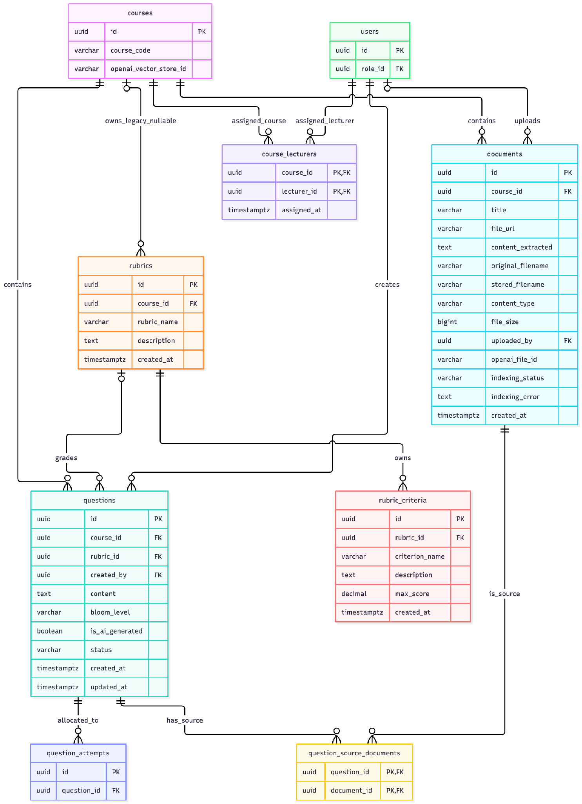

Exam Management

III 5 1 Conceptual model
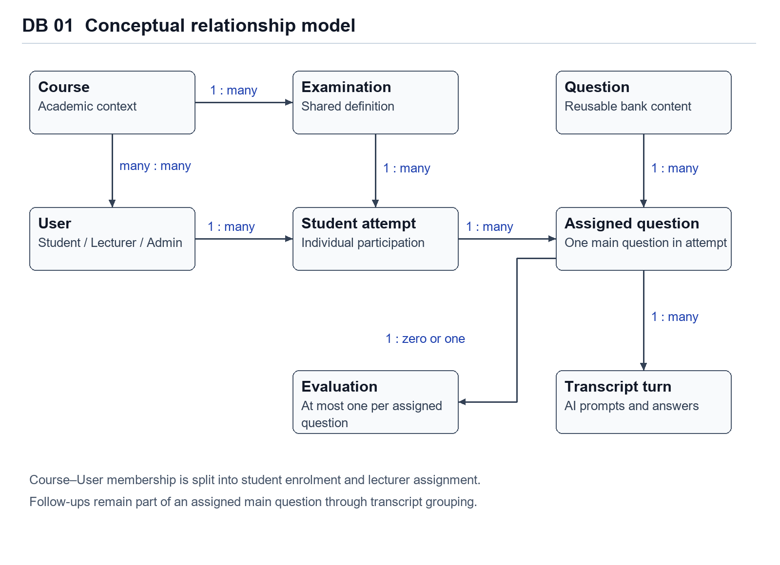
Figure DB 01. Conceptual model spanning course membership, examination preparation, interview evidence and grading.
A course has examinations and question material. Students enrol in courses through course_students, while lecturers are assigned through course_lecturers. An examination has student attempts. Each student attempt owns assigned main questions. The transcript stores both the main prompt and its follow-up conversation under a QuestionAttempt. An evaluation belongs to at most one assigned question.

III 5 2 Physical model
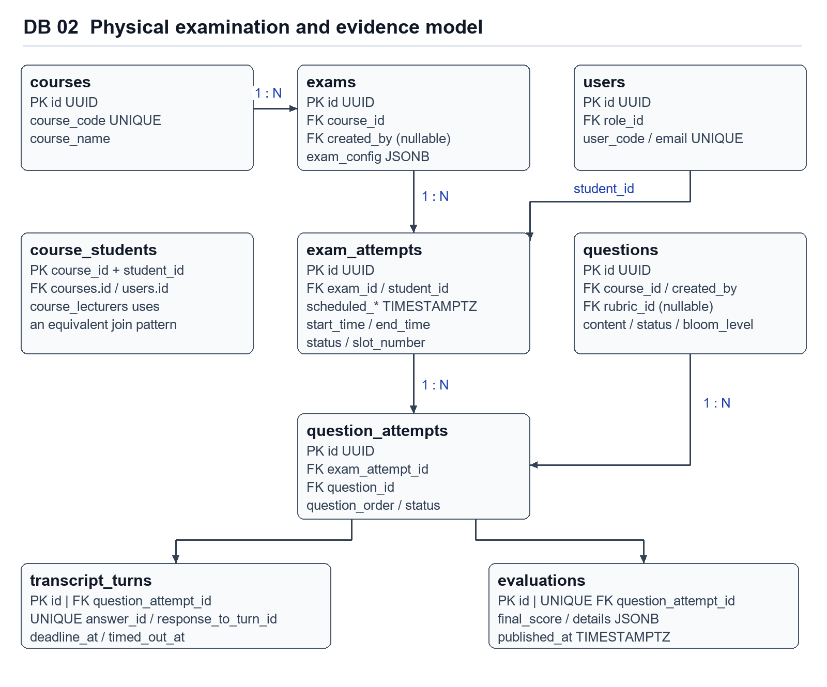
Figure DB 02. Physical tables and foreign-key paths. The configured questionIds JSON array is validated by application code.
UUIDs identify persistent records. The primary tables use gen_random_uuid() defaults in migrations and UUID generation in JPA. TIMESTAMPTZ stores scheduled, actual and audit instants. JSONB is used for flexible exam configuration and grading criterion details. Dedicated foreign keys preserve the identity of each assigned question and its associated evidence.

III 5 3 Relational keys and deletion behaviour
- exams.course_id references courses with ON DELETE CASCADE. exams.created_by is a nullable user reference introduced in V4. Creation service code currently does not populate this field.
- exam_attempts.exam_id and student_id reference exams and users with ON DELETE CASCADE. A shared examination can therefore be removed with its dependent attempts at the database level.
- question_attempts.exam_attempt_id and question_id reference exam_attempts and questions with ON DELETE CASCADE. Application-level protection against removal of referenced questions is consequently important.
- transcript_turns.question_attempt_id references question_attempts. response_to_turn_id is a unique self-reference introduced in V7, with cascading deletion. answer_id is a separate nullable unique idempotency key.
- evaluations.question_attempt_id is a unique foreign key, expressing at most one evaluation per QuestionAttempt. graded_by is a user reference. published_at distinguishes a finalized score from a score released to the student.
- course_students and course_lecturers use composite primary keys. The keys prevent duplicate membership or lecturer assignment for the same course and user. User role eligibility is an application check.

III 5 4 Index and representation design
Foreign-key indexes support joins from examinations to candidates, assigned questions, transcript turns and grading data. V4 adds indexes on exam status, creator, attempt status and scheduled times. idx_exam_attempts_student_exam accelerates lookup but does not enforce uniqueness. V7 adds unique indexes through answer_id and response_to_turn_id constraints.
The Java names actualStartTime and actualEndTime in ExamAttempt map to physical start_time and end_time. The database dictionary distinguishes these mapped fields from the additional actual_start_time and actual_end_time columns introduced by V4.

III 5 5 Schema evolution
Version | Relevant schema change
V1 | Core academic, question, examination, transcript and grading tables and FK indexes.
V2 | ADMIN, LECTURER and STUDENT role seed rows.
V3 | course_lecturers composite key and lecturer lookup index.
V4 | Exam status/creator, scheduled and extra actual timing columns, slot/access fields, question order and indexes.
V5 | Account must_change_password flag.
V6 | Course-scoped rubric/source extensions and question_source_documents.
V7 | Unique answer and response linkage for transcript idempotency.
V8 | Question-turn deadline and timeout instants.
V9 | course_students composite key and student lookup index.
V10 | evaluations.published_at for student result release.

Database dictionary

Section III.5 Database dictionary
The following dictionaries are based on V1–V10 migrations and current JPA mappings. SQL nullability is reported independently from API validation. PK means primary key and FK means foreign key. NULL means the migration permits null.

B 1 Examination definition
Column | SQL definition | Purpose or mapping
id | UUID PRIMARY KEY | Exam identifier. DEFAULT gen_random_uuid().
course_id | UUID NOT NULL FK | courses.id, ON DELETE CASCADE.
title | VARCHAR(255) NOT NULL | Display name. API requires nonblank text.
start_time / end_time | TIMESTAMPTZ NOT NULL | Shared examination window.
exam_config | JSONB NULL | Pool IDs and examination parameters.
status | VARCHAR(50) NULL | V4 DEFAULT 'DRAFT'. Enum values are checked in Java.
created_by | UUID NULL FK | users.id. V4 field currently not populated by createExam.
created_at | TIMESTAMPTZ NULL | DEFAULT CURRENT_TIMESTAMP and JPA creation timestamp.
totalCandidates | Computed Java property | Hibernate formula counts distinct students. Not a physical column.

B 2 Personal attempt
Column | SQL definition | Purpose or mapping
id | UUID PRIMARY KEY | Individual attempt identifier.
exam_id | UUID NOT NULL FK | exams.id, ON DELETE CASCADE.
student_id | UUID NOT NULL FK | users.id, ON DELETE CASCADE.
scheduled_start_time / scheduled_end_time | TIMESTAMPTZ NULL | V4 planned slot boundaries.
start_time / end_time | TIMESTAMPTZ NULL | V1 columns mapped by actualStartTime/actualEndTime.
actual_start_time / actual_end_time | TIMESTAMPTZ NULL | Additional V4 columns. Not mapped by current ExamAttempt entity.
slot_number | INT NULL | V4 allocation sequence. Uniqueness is not declared.
access_code | VARCHAR(50) NULL | V4 optional slot access data.
status | VARCHAR(50) NULL | DEFAULT 'SCHEDULED'. Student and monitoring state.
audio_record_url | VARCHAR(500) NULL | Optional evidence reference.
created_at | TIMESTAMPTZ NULL | DEFAULT CURRENT_TIMESTAMP.

B 3 Assigned main question
Column | SQL definition | Purpose or mapping
id | UUID PRIMARY KEY | Assigned main-question identifier.
exam_attempt_id | UUID NOT NULL FK | exam_attempts.id, ON DELETE CASCADE.
question_id | UUID NOT NULL FK | questions.id, ON DELETE CASCADE.
question_order | INT NULL | V4 DEFAULT 1. In-attempt sequence, with no compound UNIQUE constraint.
start_time / end_time | TIMESTAMPTZ NULL | Execution timestamps of the assigned question.
status | VARCHAR(50) NULL | DEFAULT 'PENDING'. Java enum also includes IN_PROGRESS, COMPLETED and SKIPPED.
created_at | TIMESTAMPTZ NULL | DEFAULT CURRENT_TIMESTAMP.

B 4 Adjacent persistence
users and roles provide account identity and application roles. courses defines course labels. course_students and course_lecturers establish academic relationships. questions references courses, an optional rubric and a creator. rubrics and rubric_criteria define grading criteria. documents and question_source_documents support question provenance in the adjacent question-bank module.
transcript_turns uses UUID id, question_attempt_id, turn_order, speaker, text_content, audio_clip_url, turn_type and created_at. V7 adds nullable UNIQUE answer_id and response_to_turn_id, with the latter referencing another transcript turn. V8 adds nullable deadline_at and timed_out_at. The current interview model groups follow-ups under the same QuestionAttempt.
evaluations uses a UUID primary key, UNIQUE question_attempt_id, optional graded_by, ai_suggested_score and final_score as DECIMAL(5,2), overall_feedback, evaluation_details JSONB, status and audit instants. V10 adds published_at. Student-facing publication DTOs omit AI suggestions and other students' data.

B 5 Configuration dictionary
Key | Default and validation | Stored behaviour
maxMainQuestions | 3; minimum 1 | Upper bound on random question selection.
maxFollowUpQuestions | 2; minimum 0 | Maximum follow-up turns per main question, consumed by interview.
timeLimitPerTurnSeconds | 60; minimum 10 | Per-prompt deadline parameter, consumed by interview.
antiOverlapEnabled | true | Exclude questions from the prior two slot-number positions before fallback.
questionIds | Empty when not configured | UUID strings restricting the approved pool. Validated through question-config API.

Viva Interview and AI Grading

Database dictionary
Section III.5 Database dictionary

B 1 Transcript turn
Column | SQL definition | Purpose or mapping
id |  | Turn identifier. DEFAULT gen_random_uuid().
question_attempt_id |  | question_attempts.id, ON DELETE CASCADE.
turn_order |  | Sequential order of turn in question attempt.
speaker |  | Originator: AI or STUDENT.
text_content |  | Verbatim text transcript or prompt.
audio_clip_url |  | Audio evidence storage link.
turn_type |  | Classification: MAIN_QUESTION, FOLLOW_UP, STUDENT_ANSWER.
answer_id |  | V7 client idempotency token.
response_to_turn_id |  | V7 self-reference to transcript_turns.id.
deadline_at |  | V8 response timeout deadline.
timed_out_at |  | V8 timestamp if turn exceeded deadline.
created_at |  | DEFAULT CURRENT_TIMESTAMP.

B 2 Evaluation definition
Column | SQL definition | Purpose or mapping
id
question_attempt_id
graded_by
ai_suggested_score
final_score
overall_feedback
evaluation_details
status
published_at
created_at
updated_at

B 3 Evaluation details JSONB schema
Key | Type | Purpose
criteria | Array of Objects | List of criterion evaluations containing criterionId, pointsAwarded, maxPoints and aiJustification.
auxiliaryMetrics | Object | Delivery metrics containing averageLatencySeconds, wordsPerMinute and hesitationCount.

B 4 Adjacent persistence
users and roles provide account identity and lecturer audit links. courses defines course labels and access scopes. questions provides approved question prompts. rubrics and rubric_criteria define grading criteria and point weights. exam_attempts defines session status and schedule. question_attempts maintains allocated main questions linked to evaluations and dialogue turns.

B 5 Configuration dictionary
Key | Default and validation | Stored behaviour
maxFollowUpQuestions | 2; minimum 0 | Maximum follow-up prompt turns per question attempt.
timeLimitPerTurnSeconds | 60; minimum 10 | Turn deadline duration in seconds.

IV. Implementation

IV.1 Map architecture to the structure of the project
Figure IV-1 maps the architecture to the package structure of the project.
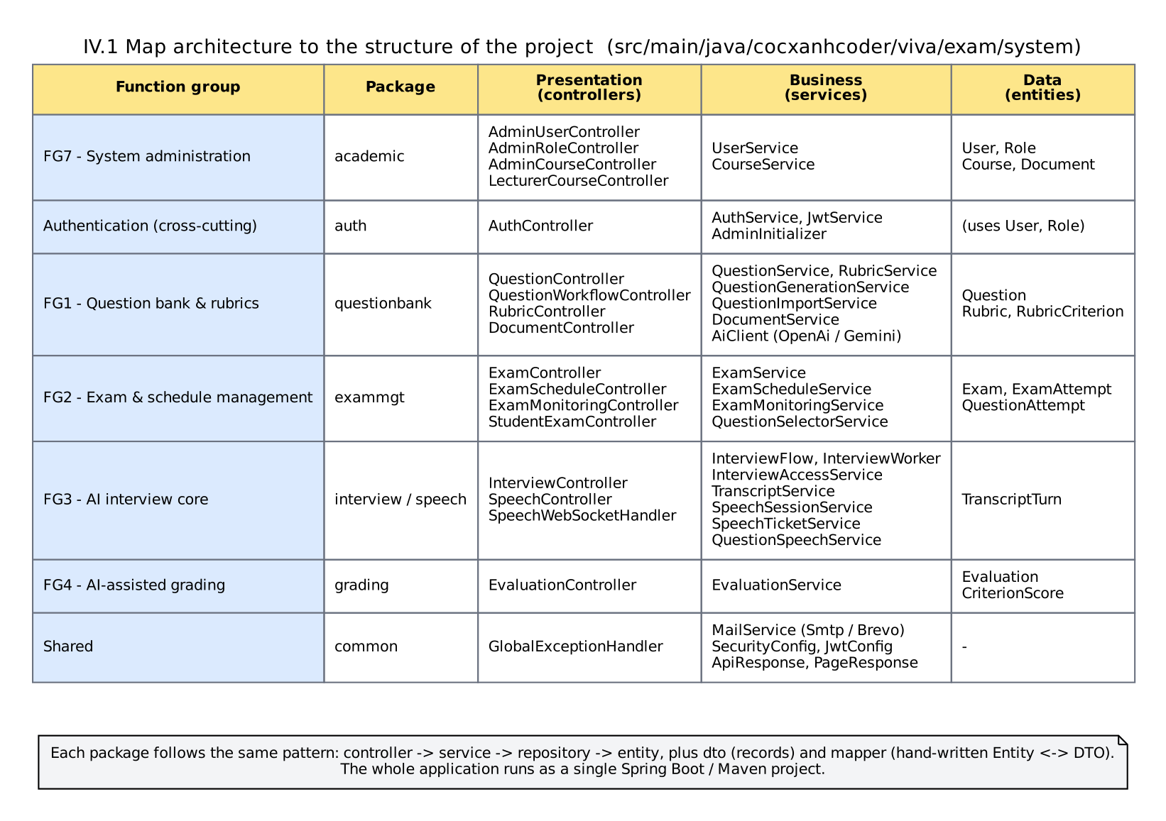
Figure IV-1 The structure of the project

Question Bank and Rubric

Map architecture to project structure
Responsibility | Existing implementation
REST boundary | questionbank/controller/QuestionController.java, QuestionWorkflowController.java, RubricController.java, DocumentController.java.
Request/result contracts | questionbank/dto/ records; common ApiResponse and PageResponse.
Goal orchestration | QuestionService, RubricService, QuestionImportService, QuestionGenerationService, DocumentService.
Shared authorization | CourseAccessService, shared SecurityConfig and MustChangePasswordFilter.
Domain state | questionbank/entity/Question, Rubric, RubricCriterion, enums; academic Document, Course, User.
Persistence | Bank repositories, academic DocumentRepository, CourseRepository, UserRepository; exam QuestionAttemptRepository.
External AI boundary | AiClient, OpenAiAiClient, GeminiAiClient, DocumentExcerptSampler.
Mapping | QuestionMapper, RubricMapper; document mapping is private in DocumentService.
Schema/configuration | src/main/resources/db/migration/; application.yml; compose.yaml; Dockerfile; render.yaml.
Paths in this table are relative to src/main/java/cocxanhcoder/viva/exam/system/ unless fully prefixed. See Section IV.2 for line-linked evidence and UC-to-FR mapping.

Exam Management

Architecture to project structure
The implementation root is src/main/java/cocxanhcoder/viva/exam/system. Examination controllers, DTOs, entities, mappers, repositories and service implementations are grouped under exammgt. academic owns course membership. questionbank owns approved question definitions and rubric material. interview owns prompt turns and progress through the allocated question set. grading owns evaluation, final score and publication.
Database scripts are in src/main/resources/db/migration. Flyway applies ordered schema changes, while JPA uses ddl-auto=validate. Existing migration files should remain immutable after deployment. New database changes require another versioned migration.

IV.2 Map Class Diagram and Interaction Diagram to Code
(To be added after the Java source of UserController / UserService is verified.)

Question Bank and Rubric

Map class and interaction design to code
The 13 sequence diagrams identify real method calls, repository queries, guarded transitions and returned DTOs. Example mappings:
1. Creating a question: QuestionController.create → QuestionService.create → CourseAccessService.requireManager → course/rubric resolution in applyRequest → QuestionRepository.save → QuestionMapper.toResponse.
2. Revising a rubric: RubricController.update → RubricService.update → course check → findWithCriteriaById → applyRequest clears/rebuilds criteria → dirty checking/orphan removal → RubricMapper.toResponse.
3. Generating drafts: QuestionWorkflowController.generate → QuestionGenerationService.generate → source/readiness checks → optional DocumentExcerptSampler.sample → AiClient.generateQuestions → per-result Bloom check → QuestionService.createDraft.
No pseudocode is presented as existing executable code. Full source remains the implementation reference. A service return value is mapped before transaction completion; callers only observe a committed successful request after the proxy/HTTP path completes.

IV 3 API behaviour and integration contract
Contract aspect | Observed behaviour
Success response | JSON envelope: success, status, message, data. Manual question/rubric creation returns 201 with Location; ordinary reads/updates/approvals/deletions return 200. Source upload, import and generation also return 200.
Binary template | XLSX download with attachment header; does not use the JSON success envelope.
Question pagination | Defaults page 0/size 20, size clamped 1–100, page clamped at least 0; latest update first. Keyword is trimmed; empty means no keyword filter.
Client validation | Bean-validation errors produce 400 with field messages; malformed binding/JSON is handled by Spring exception translation.
Access | 401 missing/invalid/expired JWT; 403 insufficient access; 428 required password change outstanding. Missing database user can produce 404 from CourseAccessService.
References | 404 missing question/rubric/document/course in explicit lookups. A rubric outside the rubric-route course is deliberately reported as not found; a question's mismatching rubric is 400.
Business conflict | 409 referenced question/rubric/source and several source-readiness checks. Topic-free generation without extracted evidence returns 422.
Provider failure | OpenAI adapter uses 503 for missing key/model, 502 for many provider/result errors, and 504 for index timeout; upload catches indexing RuntimeException and instead returns stored FAILED status. Gemini details differ.
Persistence/unexpected failure | GlobalExceptionHandler translates DataIntegrityViolationException to generic 409 and other unexpected exceptions to generic 500; exact transaction exception wrapping is not guaranteed by static review.
Semantic success | Import can return HTTP 200 with errors and count 0. Upload can return HTTP 200 with FAILED indexing. Clients must inspect result fields rather than rely on the generic message.
Example JSON shapes (symbolic placeholders, not real identifiers or live results):
{
"success": true,
"status": 200,
"message": "...",
"data": {
"importedCount": 0,
"errors": [
{
"row": 2,
"field": "bloomLevel",
"message": "..."
}
]
}
}
{
"success": true,
"status": 200,
"message": "...",
"data": {
"id": "<document UUID>",
"indexingStatus": "FAILED",
"indexingError": "<provider feedback>",
"title": "<title>",
"originalFilename": "<filename>",
"contentType": "<type>",
"fileSize": 123,
"createdAt": "<timestamp>"
}
}
These are contract illustrations, not runnable request payloads. No real course material or secrets are embedded.

IV 4 Verification evidence and acceptance outline
This task changes documentation only. Existing test sources provide evidence for selected access, sampling and AI-adapter paths; they do not prove complete CRUD, workbook, upload, concurrency or deployment coverage. Test files were inspected, not executed for this documentation change. The traceability report states existing test evidence and proposed acceptance checks separately.
Artifact verification checks link targets, source references, all 13 UC fields, FR/UC coverage and Mermaid compilation. Successful diagram rendering checks syntax/layout generation, not business correctness or implementation correctness.

V Alternative architecture patterns
This section adapts the sample's architecture discussion as Proposed options only. No requirement for a new service, mobile app, message broker, discovery system or horizontal scaling has been supplied. The current modular monolith remains the observed design.

Requirements traceability

Requirements use cases implementation
Each FR is an observed baseline, pending business approval. Linked line numbers were resolved against the inspected workspace at the recorded commit. These are local file links; source filenames and method names remain portable reference labels when sharing the document.
Requirement / UC / business rules | Source evidence / verification reference
FR-QBR-01; UC-QBR-01–13; BR-01 | SecurityConfig.java; CourseAccessServiceTest; role/assignment paths.
FR-QBR-02; UC-QBR-01; BR-02 | QuestionService.java; Proposed acceptance A-02.
FR-QBR-03; UC-QBR-02; BR-02/03 | QuestionService.java; Proposed acceptance A-03.
FR-QBR-04; UC-QBR-03; BR-04 | QuestionService.java; Proposed acceptance A-04.
FR-QBR-05; UC-QBR-04; BR-04/05 | QuestionService.java; Exam selector unit source; proposed A-05.
FR-QBR-06; UC-QBR-05; BR-06 | QuestionService.java; Proposed acceptance A-06.
FR-QBR-07; UC-QBR-06; BR-07 | QuestionImportService.java; Proposed acceptance A-07.
FR-QBR-08; UC-QBR-07; BR-08 | QuestionGenerationService.java; QuestionGenerationServiceTest; adapter/sampler tests.
FR-QBR-09; UC-QBR-08; BR-09 | RubricService.java; Proposed acceptance A-09.
FR-QBR-10; UC-QBR-09; BR-09 | RubricService.java; Proposed acceptance A-10.
FR-QBR-11; UC-QBR-10; BR-10 | RubricService.java; Proposed acceptance A-11.
FR-QBR-12; UC-QBR-11; BR-11 | RubricService.java; Proposed acceptance A-12.
FR-QBR-13; UC-QBR-12; BR-12 | DocumentService.java; OpenAI indexing adapter source; proposed A-13.
FR-QBR-14; UC-QBR-12/13; BR-12 | DocumentService.java; Proposed acceptance A-14.
FR-QBR-15; UC-QBR-13; BR-13 | DocumentService.java; Proposed acceptance A-15.
FR-QBR-16; UC-QBR-01–13; BR-01/07/12 | GlobalExceptionHandler.java; Proposed acceptance A-16.
The import-template endpoint is an explicit FR-01 exception. Browse UCs include both list and detail; source listing supports UC-07/12/13. Every UC has a sequence diagram SEQ-01–13; ACT-01 covers UC-01/08, ACT-02 covers UC-02/03/09/10, ACT-03 covers UC-04/05/11, and ACT-04–07 cover UC-06/07/12/13 respectively.

Source evidence and acceptance checks

Source index
Paths without repository prefix are under src/main/java/cocxanhcoder/viva/exam/system/.
Responsibility | Verified source
Access | CourseAccessService.java
Question endpoints | QuestionController.java
Workflow endpoints | QuestionWorkflowController.java
Rubric endpoints | RubricController.java
Document endpoints | DocumentController.java
Question input | QuestionRequest.java
Generation input | GenerateQuestionsRequest.java
Rubric validation | RubricRequest.java
Criterion validation | RubricCriterionRequest.java
Question state/source model | Question.java
Rubric ownership/total | Rubric.java
Criterion numeric storage | RubricCriterion.java
Document state | Document.java
Question search | QuestionRepository.java
Source-use guard | DocumentRepository.java
Provider contract | AiClient.java
OpenAI adapter | OpenAiAiClient.java
Gemini adapter | GeminiAiClient.java
Excerpt selection | DocumentExcerptSampler.java
Question mapper | QuestionMapper.java
Rubric mapper | RubricMapper.java
Future exam eligibility | QuestionSelectorServiceImpl.java
Current rubric consumption in grading | EvaluationService.java
Pagination bound | PageableUtils.java
Mandatory password change | MustChangePasswordFilter.java
Shared HTTP response | ApiResponse.java
Error translation | GlobalExceptionHandler.java
Schema / build / deployment definition | V1__init_schema.sql
Schema / build / deployment definition | V3__course_lecturers.sql
Schema / build / deployment definition | V6__complete_question_bank.sql
Schema / build / deployment definition | application.yml
Schema / build / deployment definition | compose.yaml
Schema / build / deployment definition | Dockerfile
Schema / build / deployment definition | render.yaml
Schema / build / deployment definition | pom.xml

Existing test source evidence
These are inspected test definitions, not test execution results. This documentation change did not run the application, database migrations, provider calls or backend test suite. Existing assertions provide only the stated source-level coverage.
Test source | Inspected intent
CourseAccessServiceTest.java | ADMIN can manage any course; unassigned Lecturer is rejected.
QuestionGenerationServiceTest.java | Topic-free generation uses selected READY source text; no extracted text blocks the AI call.
DocumentExcerptSamplerTest.java | Samples selected documents; rejects unavailable extractable text.
OpenAiAiClientTest.java | Configured model/token cap, sampled-text path, indexing polling, incomplete output and missing key.
GeminiAiClientTest.java | JSON response handling, polling, exhausted quota handling, insufficient evidence, unsuitable generated questions and filling missing valid results.
No direct QuestionService, RubricService, QuestionImportService or DocumentService test class was found in the inspected questionbank test package. This is not a claim that no other project integration test touches them. Postman collections exist but were not executed and are not proof of current API conformance.

Proposed acceptance checks
These are reviewable validation scenarios, not newly written automated tests or completed execution results. Use an isolated fixture/database and mocked provider where appropriate. All execution statuses: Not run.
Check / FR | Expected observable result
A-01 / FR-01 | Assigned Lecturer and ADMIN can access applicable resources; another Lecturer/Student is refused; invalid JWT gives 401 and mandatory change gives 428. Test template exception separately.
A-02 / FR-02 | Filter a known course by keyword/status/Bloom; inspect detail, empty page, latest-update order and page-size clamping. No cross-course leak.
A-03 / FR-03 | Create without rubric and with same-course rubric; both DRAFT. Missing content/Bloom and mismatching rubric fail without insertion.
A-04 / FR-04 | Revise approved question: status becomes DRAFT and creator stays. Moving course needs both accesses. Inspect unchanged old source links as OI-12, not desired provenance.
A-05 / FR-05 | Approve DRAFT and already-APPROVED question. Confirm self-approval and missing rubric remain permitted; exam candidate selection excludes DRAFT.
A-06 / FR-06 | Remove an unused question, then attempt a referenced one: first removed, second 409 and retained. Concurrency protection is not assumed.
A-07 / FR-07 | Valid XLSX imports every nonblank row as non-AI DRAFT; one invalid row imports none with row errors; row rubric overrides default; blank workbook returns zero.
A-08 / FR-08 | Generate with selected READY sources and omitted Bloom list; defaults UNDERSTAND and saves AI DRAFT source associations. Fail invalid sources/output and verify rollback, including invalid later Bloom.
A-09 / FR-09 | List/read rubrics with criterion max-score sum; reject out-of-course detail. Empty course list returns empty.
A-10 / FR-10 | Create nonempty criteria; reject blank names, empty list and maximum score below 0.01. Probe numeric type bounds separately.
A-11 / FR-11 | Replace a rubric's definition; inspect removed old criteria and new criterion IDs. Confirm behaviour of prior grading references through separate policy review.
A-12 / FR-12 | Delete unassigned rubric including criteria; referenced rubric returns 409 and remains.
A-13 / FR-13 | Upload supported file, verify extracted text and READY. Simulate indexing failure: retained document/file, FAILED status. Simulate extraction failure: rollback with attempted file cleanup.
A-14 / FR-14 | Source list returns metadata/status/error and omits local path/provider ID/extracted text. Verify privacy expectations before adopting exact error exposure.
A-15 / FR-15 | Used source refuses deletion; unused source removes files/record. Inject provider, filesystem and DB commit failures; record actual external side effects for reconciliation review.
A-16 / FR-16 | Verify 201/200 envelopes, template binary response, 400/403/404/409/422/428 and provider error paths; inspect semantic errors in 200 import/upload results.

Open design decisions
The existing OI-01–OI-08 register remains applicable. Additional findings from completing the physical design are:
Issue | Finding / decision needed
OI-09 | V6 leaves rubric course_id nullable while entity/app expects a course. Define legacy backfill and constraint policy; no migration performed. Owner/due/resolution TBD.
OI-10 | DB question_attempts FK uses ON DELETE CASCADE while QuestionService blocks deletion of referenced questions; DB question rubric FK uses SET NULL while RubricService blocks deletion of assigned rubrics. Decide protection against races and direct SQL bypass. Owner/due/resolution TBD.
OI-11 | Effective request size includes framework/proxy multipart settings, not only service maxBytes. Verify deployed upload acceptance and persistent storage/backup. Owner/due/resolution TBD.
OI-12 | Manual revision does not clear or recompute sourceDocuments, including when moving to another course or changing AI flag. Define provenance policy; current links may no longer describe current content/course. Owner/due/resolution TBD.
OI-13 | If provider upload succeeds but indexing fails before openAiFileId assignment, a remote file may remain without a recorded identifier. Define provider/local reconciliation and cleanup. Owner/due/resolution TBD.

Open issues and gaps

Open issues and gaps
All owners and due dates are TBD. These are review questions, not authorized implementation changes.
Issue | Question / resolution state
OI-01 | Frequency and peak usage per UC are unavailable. Supply usage estimates or analytics. Open.
OI-02 | No approved AIVES-specific response-time, capacity, accessibility, availability or audit-retention targets supplied. Do not copy FreshFood NFR figures. Open.
OI-03 | Confirm proposed High priorities, primary teaching role, ADMIN substitution, and project-wide UC IDs against the master register. Open.
OI-04 | Confirm whether a lecturer can approve their own questions and approve questions without rubrics. Code currently permits both. No rejection workflow or rubric approval/versioning exists. Open.
OI-05 | Define the policy for changing questions already allocated to attempts and replacing criteria already used in grading. Code does not explicitly block these updates or provide version snapshots here. Review impact with grading/exam modules. Open.
OI-06 | Define lost-update/conflict handling, duplicate prevention, bulk-import limits and client retries after uncertain network outcomes. No entity version field or idempotency key was found in inspected bank entities/controllers. Do not promise conflict detection or retry safety. Open.
OI-07 | Verify document-selection isolation in topic-based generation: the OpenAI adapter searches the course vector store, while the service links selected documents. The request does not constrain file_search to selected document IDs. Decide whether strict selected-file grounding and per-question citations are required. Open.
OI-08 | Define indexing retry, provider/local/database reconciliation, numeric score validation and sanitised persistence errors. FAILED uploads have no dedicated reindex endpoint; document deletion can leave partial external effects. Source provenance is not exposed in QuestionResponse, and the manual AI flag is caller-controlled. Open.

Exam Management

Public API behaviour
Section IV.2 lists verified examination endpoints. Management endpoints mostly return plain DTOs or lists. The management list exposes Spring Page<ExamResponse>. The student's personal list returns PageResponse directly with content, page, size, totalElements and totalPages. These contracts should be documented explicitly because several adjacent academic and grading APIs use an ApiResponse envelope.
GET /api/v1/student/exams defaults to page 0 and size 20, clamps size to 1–100, permits an optional ExamAttemptStatus filter and sorts scheduled start descending with nulls last, then ID ascending. Students with no assigned attempts receive a successful empty page. GET /api/v1/student/exams/{examId}/my-slot uses the same JWT-derived student identity.
The slot response includes assigned main-question text and configuration. During an active interview, the authoritative prompt comes from /api/interviews/{attemptId}/current and its questionTurnId. The frontend uses that actual turn identifier for speech.

Verification evidence
ExamServiceImplTest contains creation, invalid-time, missing-course, question-configuration and candidate-count tests. ExamScheduleServiceImplTest covers common-time allocation and insufficient sequential time. QuestionSelectorServiceImplTest covers overlap filtering, missing approved questions and configured-pool fallback. InterviewPostgresTest contains integration scenarios for student schedule ownership and course roster behaviour.
Check | Expected observation | Evidence status
A EM 01 Create exam | DRAFT row and defaults saved. Reversed dates and unknown course rejected. | Existing unit test source.
A EM 02 Configure pool | Only distinct approved same-course IDs accepted. Other config keys retained. | Existing unit test source.
A EM 03 Simultaneous schedule | All selected candidates share start/end with distinct attempt IDs. | Existing scheduling test source.
A EM 04 Sequential capacity | Insufficient parent window fails. No partial allocation commits. | Existing scheduling test source.
A EM 05 Selector fallback | Configured approved pool retained when overlap exclusion leaves too few entries. | Existing selector test source.
A EM 06 Personal ownership | Another studentId parameter cannot switch the JWT owner. | Existing PostgreSQL integration test source.

Demonstration workflow
Use a test course with an assigned lecturer, enrolled student accounts and approved questions. Create an examination, choose a question pool and answer limits, add candidates and allocate slots. Show how SIMULTANEOUS gives several candidates the same start instant while each retains a distinct attemptId. Open an attempt and let the student read its personal schedule.
For the module boundary demonstration, pass that attemptId to interview start/current. Show that the live prompt has a questionTurnId different from questionId and questionAttemptId. Conclude with the monitoring view and explain how exam-level status differs from an individual's attempt status. Demonstrate recovery only on disposable test data.

API contract and traceability

Section IV.2 API contract and traceability
The API table lists the verified examination endpoints and their successful response contracts. Student reads use JWT ownership. Question configuration uses the course-management access check.
Method | Path | Success response
POST | /api/v1/exams | 201 ExamResponse
GET | /api/v1/exams | 200 Spring Page<ExamResponse>
GET | /api/v1/exams/{id} | 200 ExamDetailResponse
PUT | /api/v1/exams/{id} | 200 ExamResponse
PATCH | /api/v1/exams/{id}/status | 200 ExamResponse
DELETE | /api/v1/exams/{id} | 204 with no body
GET / PUT | /api/v1/exams/{examId}/question-config | 200 QuestionConfigDto
POST | /api/v1/exams/{examId}/candidates | 200 List<CandidateScheduleResponse>
POST | /api/v1/exams/{examId}/schedule/auto | 200 List<CandidateScheduleResponse>
PUT | /api/v1/exams/{examId}/schedule/reschedule | 200 CandidateScheduleResponse
GET | /api/v1/exams/{examId}/schedule | 200 List<CandidateScheduleResponse>
GET | /api/v1/exams/{examId}/monitor | 200 ExamMonitoringResponse
POST | /api/v1/exams/{examId}/attempts/{attemptId}/reset | 200 CandidateScheduleResponse
POST | /api/v1/exams/{examId}/attempts/{attemptId}/absent | 200 CandidateScheduleResponse
GET | /api/v1/student/exams | 200 PageResponse<StudentExamSummary>
GET | /api/v1/student/exams/{examId}/my-slot | 200 StudentExamSlotResponse

C 1 Requirements to implementation
Requirement | Main implementation | Verification reference
FR EM 01 Browse | ExamController / ExamServiceImpl / ExamRepository | Filter and pagination acceptance checks.
FR EM 02 Create | ExamServiceImpl.createExam | ExamServiceImplTest creation/error cases.
FR EM 03 Revise | ExamServiceImpl.updateExam | Update and retained-pool acceptance checks.
FR EM 04 Configure | getQuestionConfig/updateQuestionConfig | Round-trip and cross-course rejection unit tests.
FR EM 05 Candidates | ExamScheduleServiceImpl.assignCandidates | Duplicate and identity acceptance checks.
FR EM 06 Allocate | autoScheduleSlots / QuestionSelectorServiceImpl | Scheduling and selector unit tests.
FR EM 07 Reschedule | rescheduleCandidate | Boundary and reversed-interval acceptance checks.
FR EM 08 Monitor | ExamMonitoringServiceImpl | Status counts and association acceptance checks.
FR EM 09 Personal list | StudentExamController.getMyExams | InterviewPostgresTest ownership scenario.
FR EM 10 Personal slot | getMySlot / ExamAttemptMapper | InterviewPostgresTest legacy-query isolation.

C 2 Identifier guide
examId identifies the shared Exam. attemptId or examAttemptId identifies one student's ExamAttempt. questionId identifies reusable question-bank content. questionAttemptId identifies an allocated main question in an attempt. questionTurnId identifies an actual AI TranscriptTurn in the interview. answerId identifies one speech submission and is an idempotency key. These identifiers represent different entities and should not be substituted for each other.

References

the references in Section IV.2 References
R1. AIVES_Report, adjacent Question Bank and Rubric tab. Used as the structure and terminology reference for this module contribution.
R2. SWD302 Manage milestone sheet. Lists use case, conceptual and physical ERD, swimlane, class, state and sequence deliverables.
R3. Backend package exammgt, source baseline 8b489db, inspected 6 November 2026. Includes ExamController, ExamScheduleController, ExamMonitoringController, StudentExamController and their services, repositories, DTOs and mappers.
R4. Flyway migrations V1–V10 under src/main/resources/db/migration. Used as the source of physical column types, constraints and deletion behaviour.
R5. ExamServiceImplTest, ExamScheduleServiceImplTest, QuestionSelectorServiceImplTest and InterviewPostgresTest. Referenced as existing test source evidence. No fresh pass count is asserted.
R6. MODULE2_EXAM_MANAGEMENT.md. Used for background and checked against current code where older descriptions differ.

AI Interview Core
The Java paths below are relative to src/main/java/cocxanhcoder/viva/exam/system/.
M1 — Start and retrieve state. interview/controller/InterviewController.java → interview/service/InterviewFlow.java (start, current). Endpoints are POST /api/interviews/{attemptId}/start and GET /api/interviews/{attemptId}/current. DTO: interview/dto/InterviewState.java.
M2 — Play the prompt and issue a ticket. speech/controller/SpeechController.java (playback, ticket) → interview/service/InterviewAccessService.java (requirePrompt) or speech/service/SpeechTicketService.java (issue). Endpoints are GET /api/interview/attempts/{attemptId}/speech/questions/{questionTurnId}/playback and POST /api/interview/attempts/{attemptId}/speech-ticket.
M3 — Authenticate the WebSocket and stream audio. speech/websocket/SpeechHandshakeInterceptor.java → SpeechTicketService.consume. speech/websocket/SpeechWebSocketHandler.java → speech/service/SpeechSessionService.java (connect, command, audio, disconnect) → speech/provider/DeepgramSpeechClient.java through SpeechToTextClient. speech/dto/SpeechProtocol.java defines the events.
M4 — Finalize and recover answers. SpeechSessionService → interview/service/TranscriptService.java (complete) → interview/repository/TranscriptTurnRepository.java. SpeechController.answer calls TranscriptService.findAnswer through InterviewAnswers. Endpoint: GET /api/interview/attempts/{attemptId}/speech/answers/{answerId}. Database constraints: src/main/resources/db/migration/V7__speech_answer_idempotency.sql.
M5 — Handle follow-ups and timeouts. interview/service/InterviewWorker.java (onAnswer, recover) → InterviewFlow.pending → questionbank/service/AiClient.java (suggestFollowUp) → InterviewFlow.advance → TranscriptService.recordQuestion. interview/service/InterviewTiming.java determines the deadline and finalization grace period. speech/service/SpeechInterviewEventListener.java (onAnswerDeadline) calls finishCurrentAnswer.
M6 — Persist state and conversation. The entities are exammgt/entity/ExamAttempt.java, exammgt/entity/QuestionAttempt.java, and interview/entity/TranscriptTurn.java. src/main/resources/db/migration/V8__interview_deadlines.sql stores deadline and timeout timestamps.
Integration reference: postman_collection_interview_e2e.json and doc/INTERVIEW_E2E_POSTMAN.md describe the test flow from start through PCM streaming, follow-up, and COMPLETED.

Viva Interview and AI Grading

API contract and traceability
Section IV.2 API contract and traceability
Method | Path | Success response
 | /api/v1/interviews/{attemptId}/start
 | /api/v1/interviews/{attemptId}/current
 | /api/v1/interviews/{attemptId}/turns/{turnId}/answer
 | /api/v1/interviews/{attemptId}/turns/{turnId}/timeout
 | /api/v1/interviews/{attemptId}/complete
 | /api/v1/grading/attempts/{attemptId}/evaluation
 | /api/v1/grading/evaluations/{evaluationId}
 | /api/v1/grading/evaluations/{evaluationId}/publish
 | /api/v1/student/results/{attemptId}

C 1 Requirements to implementation
Requirement | Main implementation | Verification reference
FR VG 01 Start session | InterviewServiceImpl.startInterview | Session initialization acceptance checks.
FR VG 02 Deliver prompt | InterviewServiceImpl.createPromptTurn | Turn order and synthesis checks.
FR VG 03 Submit answer | InterviewController.submitAnswer | STT turn creation acceptance checks.
FR VG 04 Adaptive follow-up | InterviewServiceImpl.generateFollowUp | LLM follow-up boundary unit tests.
FR VG 05 Handle timeout | InterviewServiceImpl.handleTurnTimeout | Deadline boundary tests.
FR VG 06 Complete question | InterviewServiceImpl.completeQuestion | Question transition tests.
FR VG 07 Rubric evaluation | AiEvaluationServiceImpl.evaluateAttempt | Evaluation JSON mapping tests.
FR VG 08 Review transcript | GradingController.getEvaluationDetails | Evidence retrieval tests.
FR VG 09 Finalize grade | GradingServiceImpl.finalizeEvaluation | Lecturer override audit tests.
FR VG 10 Student result | StudentResultController.getMyResult | Publication gating acceptance checks.

C 2 Identifier guide
examId identifies the shared Exam. attemptId or examAttemptId identifies one candidate's ExamAttempt. questionAttemptId identifies an allocated main question in an attempt. turnId identifies an individual dialogue turn (TranscriptTurn). answerId identifies one speech submission and acts as an idempotency key. evaluationId identifies the rubric evaluation entity. These identifiers represent distinct database records and must not be used interchangeably.

References
the references in Section IV.2 References
- R1. AIVES Requirement and Design Specification: Exam Management and Database Design, Version 1.0, 6 November 2026, Backend baseline 8b489db. Used as structural and stylistic baseline.
- R2. AIVES Requirement and Design Specification: Question Bank and Rubric Management.
- R3. Backend packages interview and grading, source baseline 8b489db, inspected 6 November 2026.
- R4. Flyway migrations V1–V10 under src/main/resources/db/migration.
- R5. InterviewServiceImplTest, AiEvaluationServiceImplTest, GradingServiceImplTest, and InterviewPostgresTest.

V. Applying Alternative Architecture Patterns

V.1 Applying the service-oriented architecture
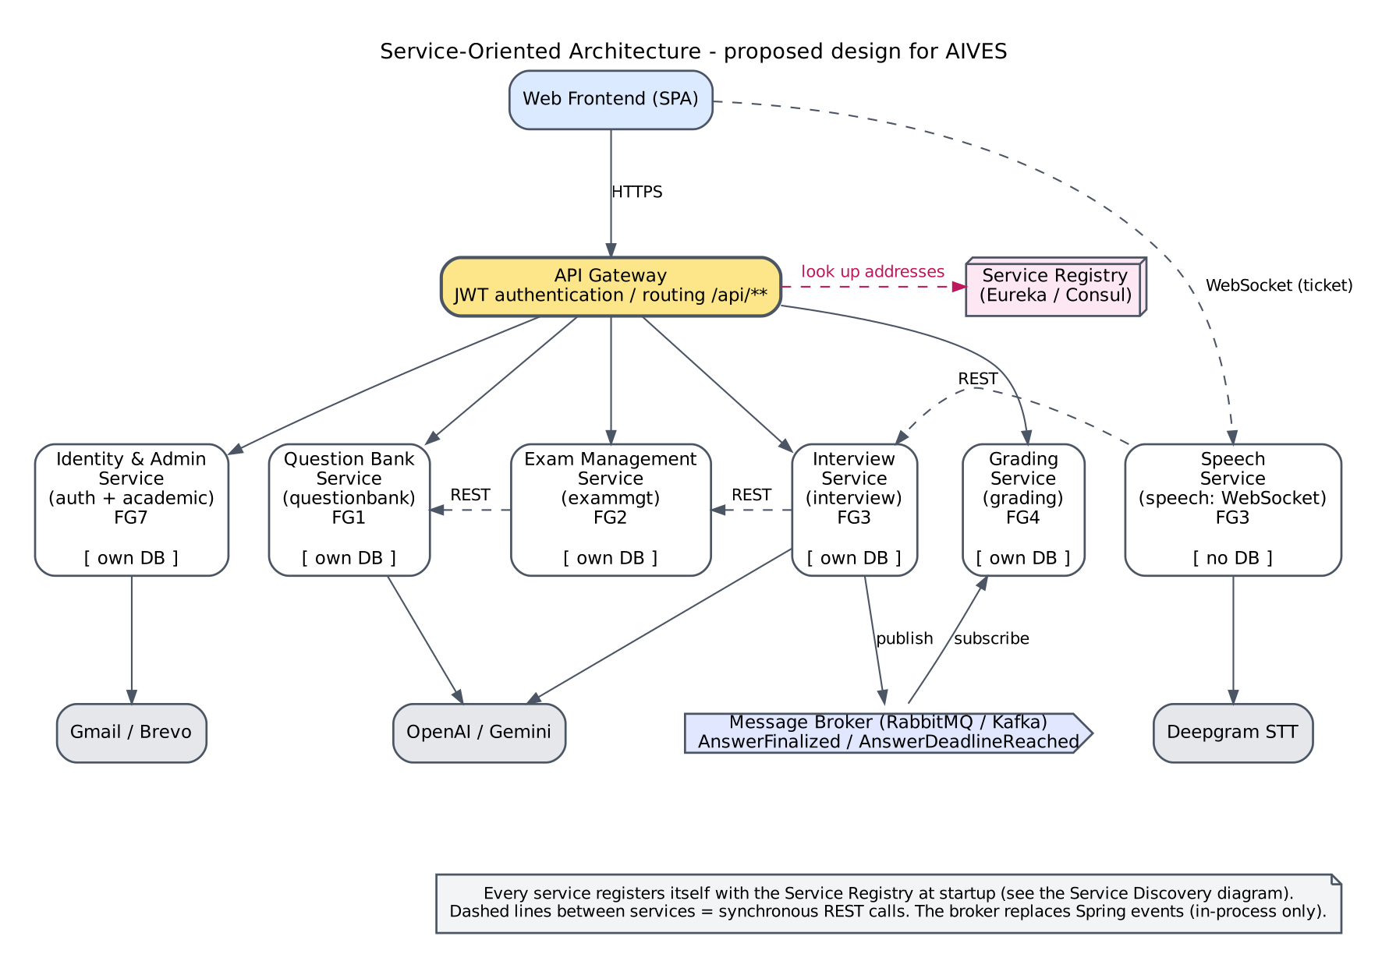
Figure V-1 Service-oriented architecture of AIVES

Question Bank and Rubric

Reuse through an application API
The existing REST API already separates clients from backend business logic. A future additional client could reuse it, subject to supported authentication, CORS, versioning and DTO contracts. This does not require splitting repositories into an independently deployed service merely to reproduce the sample's SOA example.
If cross-team release independence or external integrations become a confirmed requirement, define stable application interfaces and API compatibility tests first. Owners, consumers, workload and compatibility windows are TBD. Keep shared access decisions explicit; do not permit clients to bypass CourseAccessService.

Asynchronous document and generation processing
A confirmed requirement for long-running operations or retryable recovery could justify jobs and a worker. This would change UC-07/12 from one synchronous completion to submit/status/result interactions. Proposed design work would include a job identity, idempotency, retained source snapshot, cancellation policy, retry budget, provider reconciliation and access checks at submission and retrieval. None exists as a job subsystem in the inspected code.

ALT 01 Proposed asynchronous extension not implemented
Figure ALT-01 is included in the diagram appendices.

Detailed diagrams

ALT 01 Proposed asynchronous extension not implemented

V.2 Applying Service Discovery Pattern in the service-oriented architecture
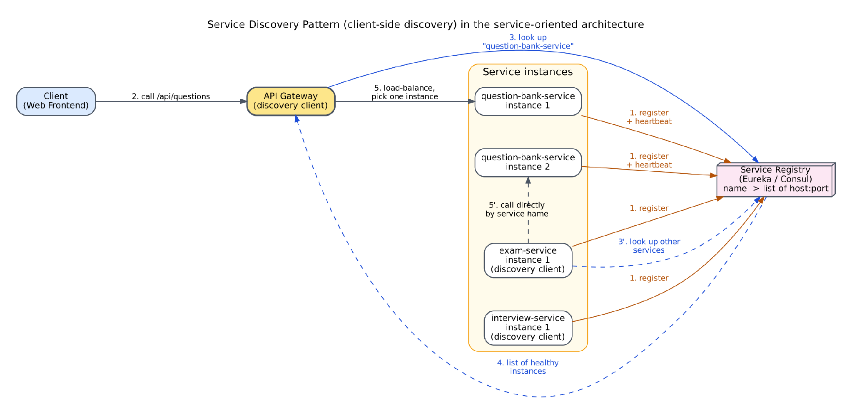
Figure V-2 Service discovery pattern in AIVES

Question Bank and Rubric

Service discovery and microservice extraction
Service discovery is unnecessary for the current single backend process. Consider independent services only after evidence supports separate scaling, ownership or isolation. Extracting this module would first require resolving its dependencies on Academic access, QuestionAttempt deletion guards and Grading rubric reads. A network split introduces consistency and authorization problems that in-process calls currently avoid; the choice of discovery mechanism is deployment-dependent and TBD.
Option | Benefit / prerequisite / unresolved cost
Retain modular monolith | Lowest architectural change; improve internal interfaces and measured bottlenecks. No new operational platform required.
Add background worker | Separates slow provider work from request latency; requires durable jobs, idempotency, progress contract and reconciliation.
External object storage | Could support multi-instance source access; requires data migration, scoped access, lifecycle policy and external-effect recovery. Current code stores local paths.
Extract independent bank service | Could support separate team release/scaling; requires API boundaries for assignments, attempts and grading, data ownership and consistency policy.
Discovery/load balancing | Relevant after multiple independently addressed instances/services exist; topology, service registry and capacity evidence TBD.
No speculative technologies, cost numbers or performance improvements are asserted as facts.

