1. Public Room Viewing

1.1 Public room listing without login
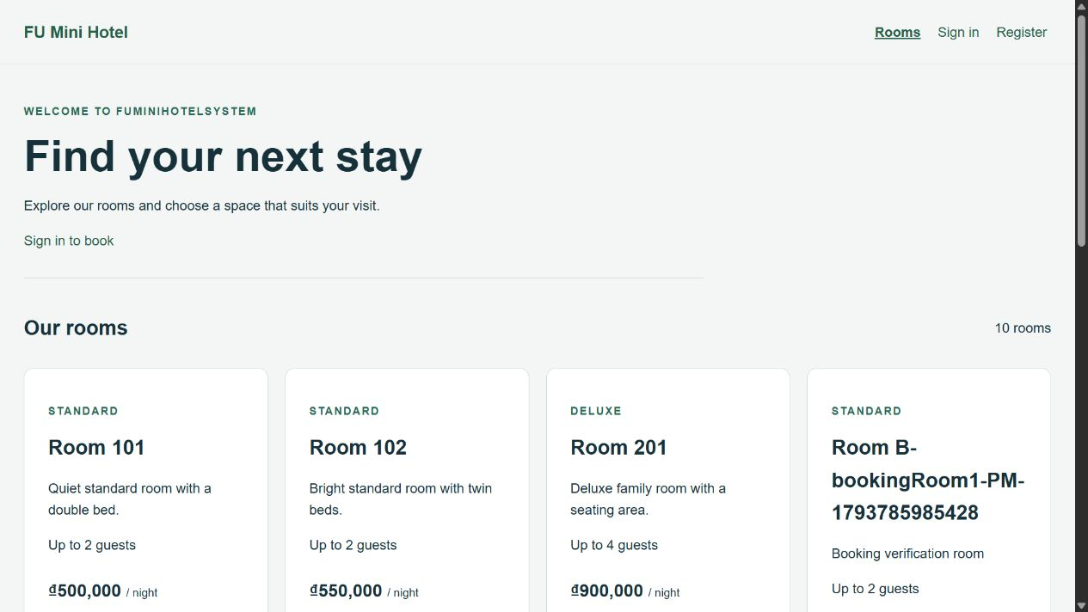
Figure 1. Public room listing without login

1.2 Room details and nightly price
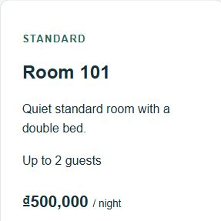
Figure 2. Room details and nightly price

2. Customer Registration

2.1 Registration form
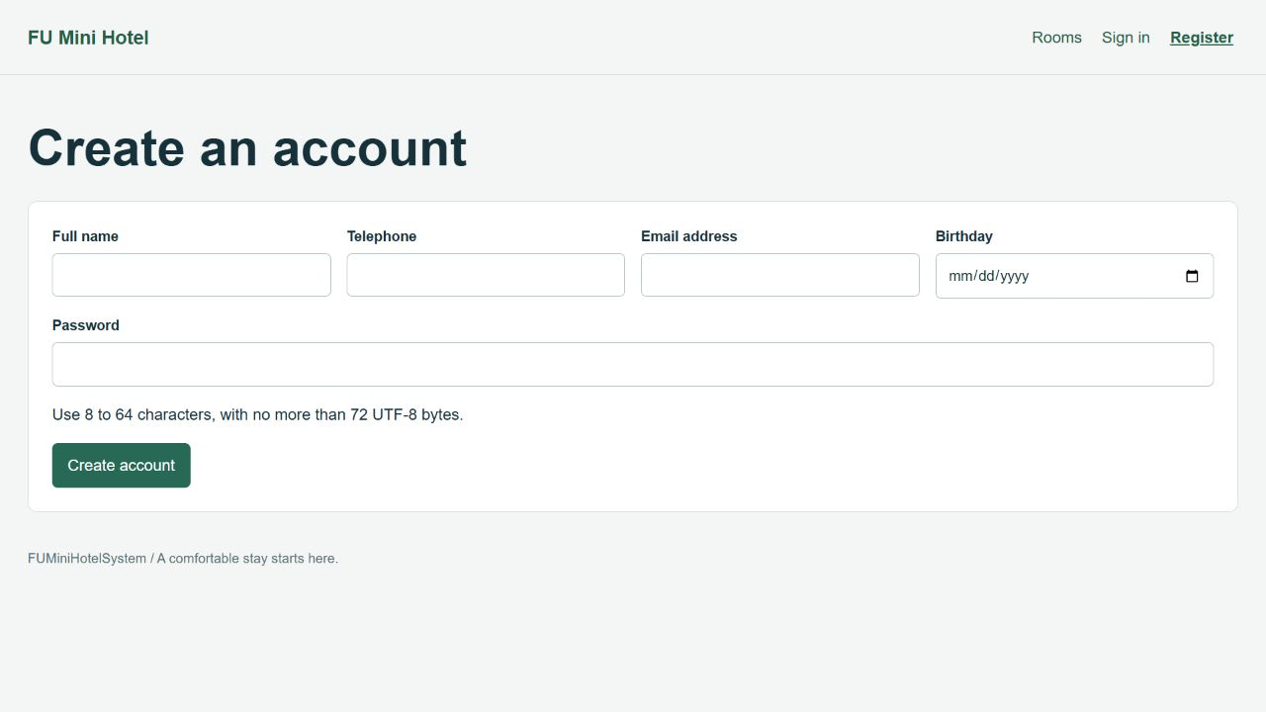
Figure 3. Registration form

2.2 Account registered successfully
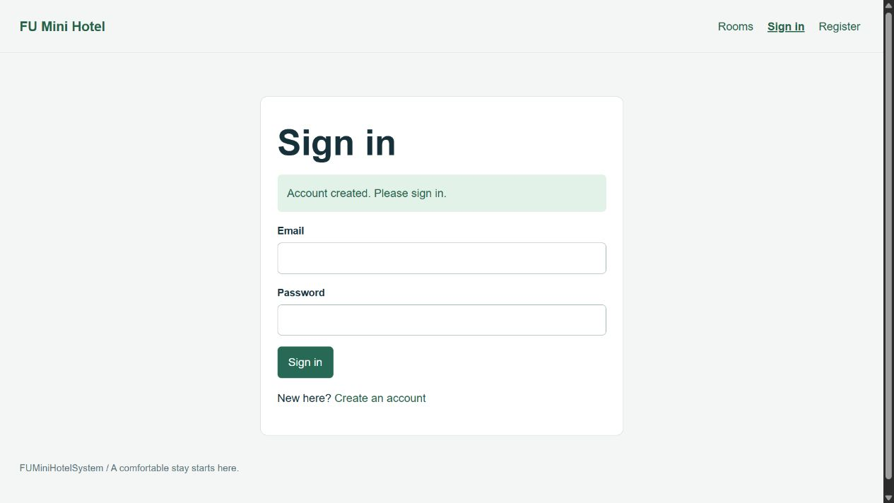
Figure 4. Account registered successfully

2.3 Registration validation errors
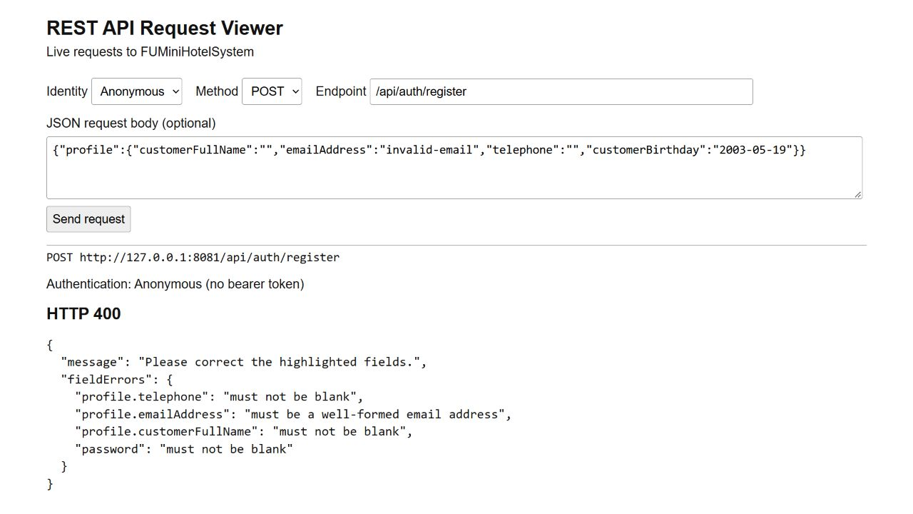
Figure 5. Registration validation errors

3. Customer Authentication — JWT

3.1 Customer sign-in form
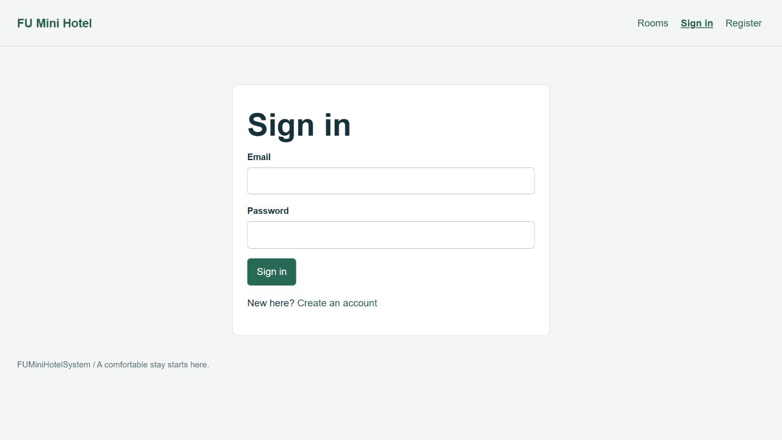
Figure 6. Customer sign-in form

3.2 Customer signed in successfully
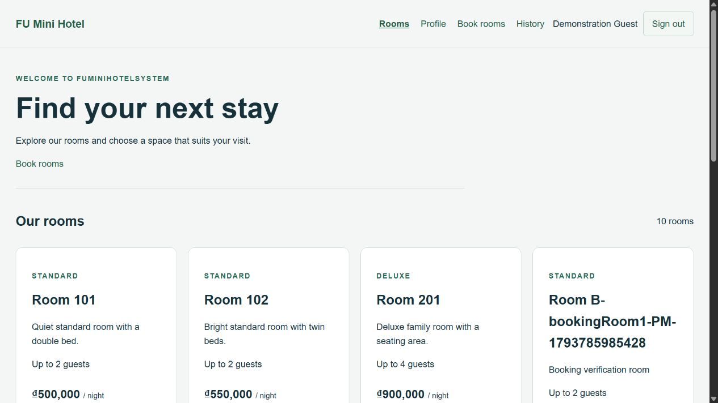
Figure 7. Customer signed in successfully

3.3 Invalid credentials rejected
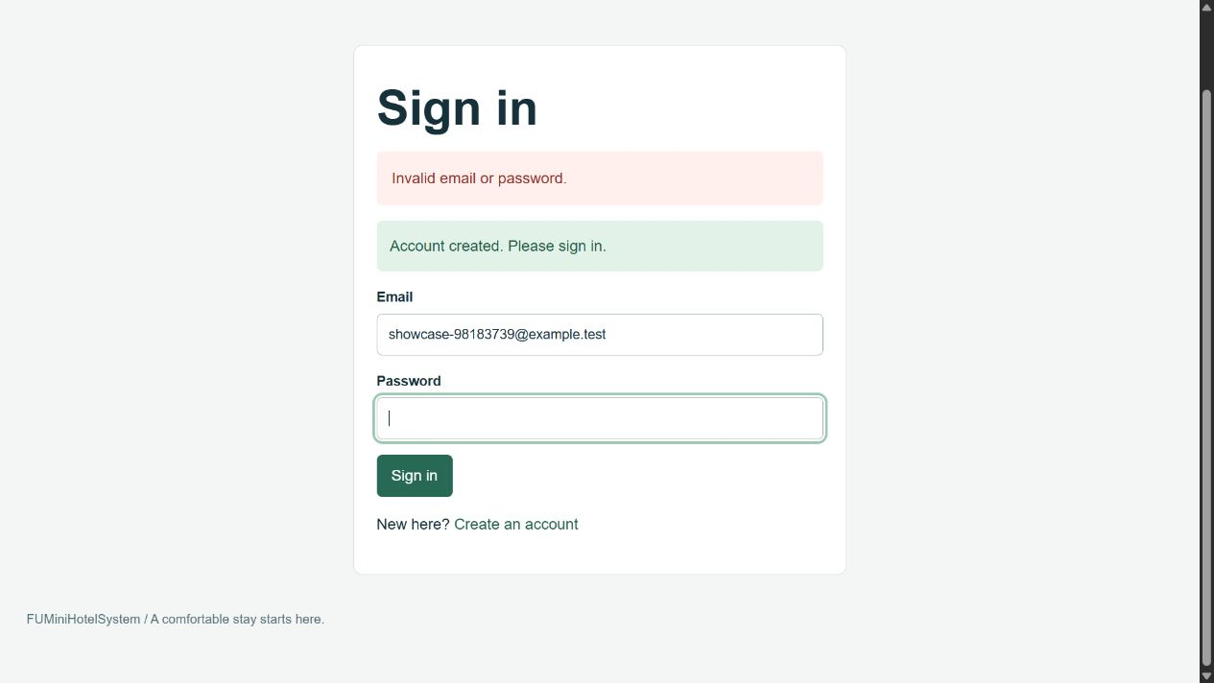
Figure 8. Invalid credentials rejected

3.4 Protected profile requires authentication
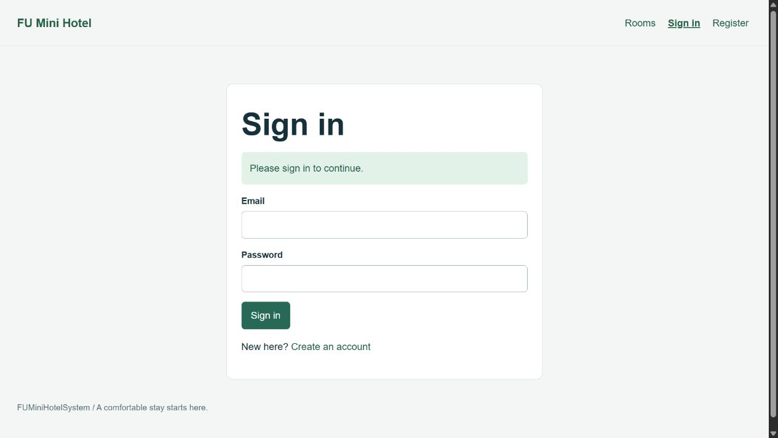
Figure 9. Protected profile requires authentication

4. Staff Authentication and Role-Based Access

4.1 Configured staff login and management interface
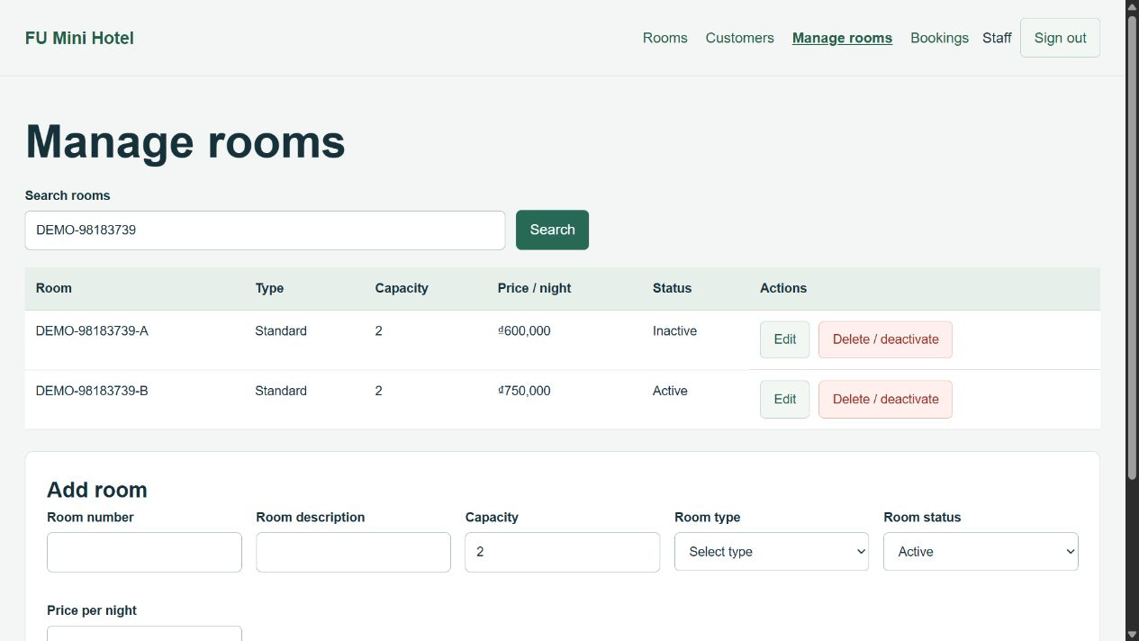
Figure 10. Configured staff login and management interface

4.2 Customer access to staff management rejected
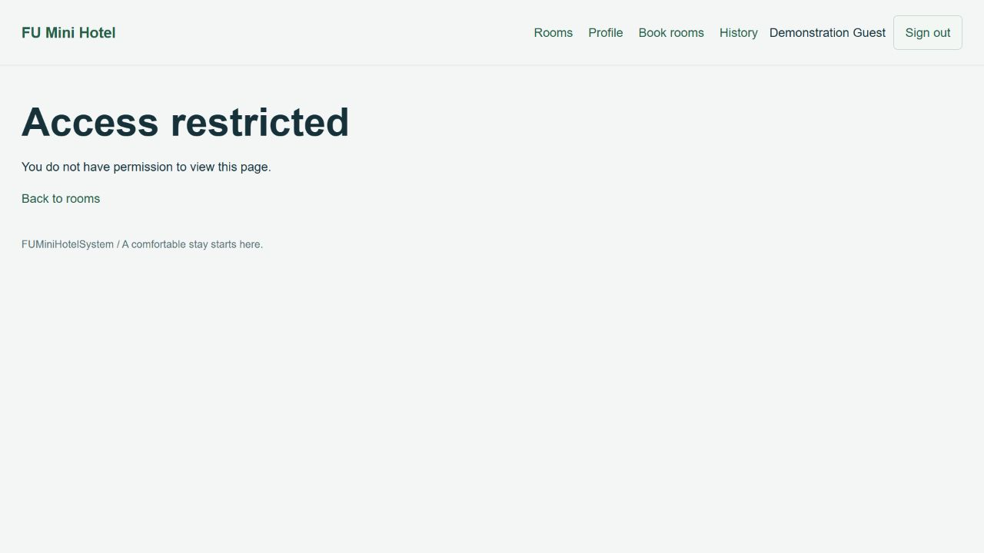
Figure 11. Customer access to staff management rejected

5. Staff — Customer Management

5.1 Customer list
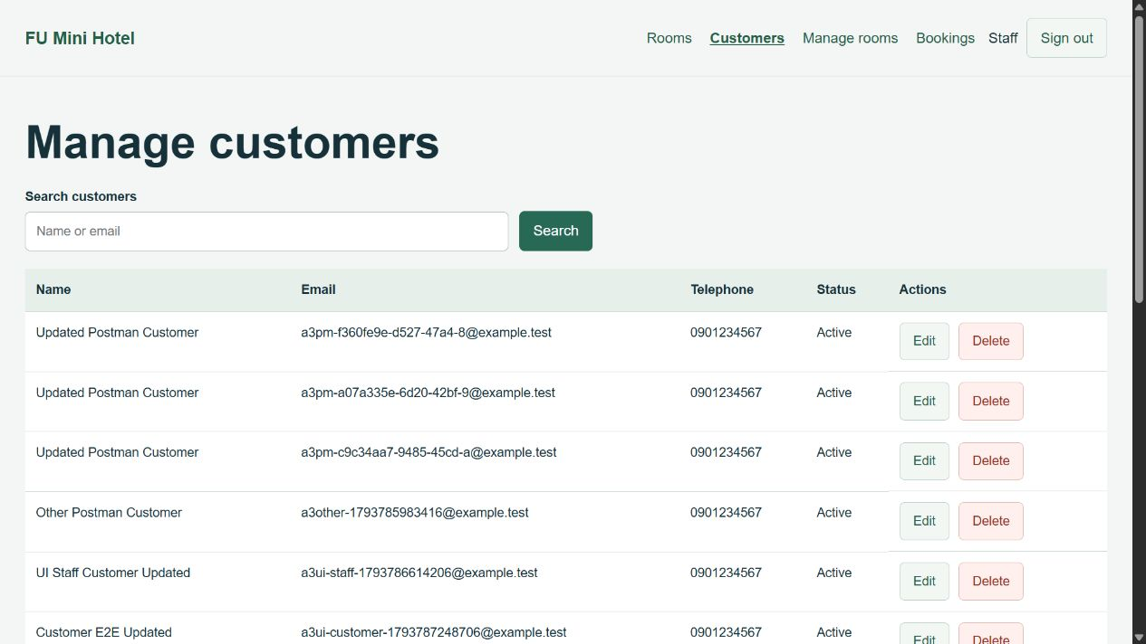
Figure 12. Customer list

5.2 Create customer
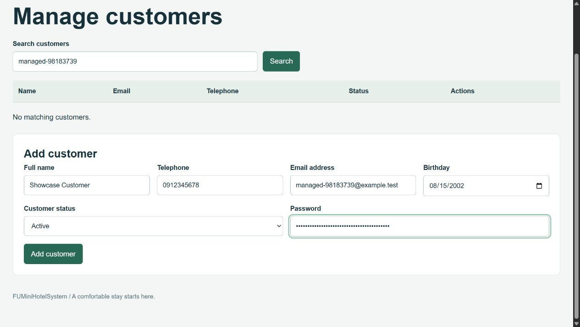
Figure 13. Create customer

5.3 Customer created and found by email
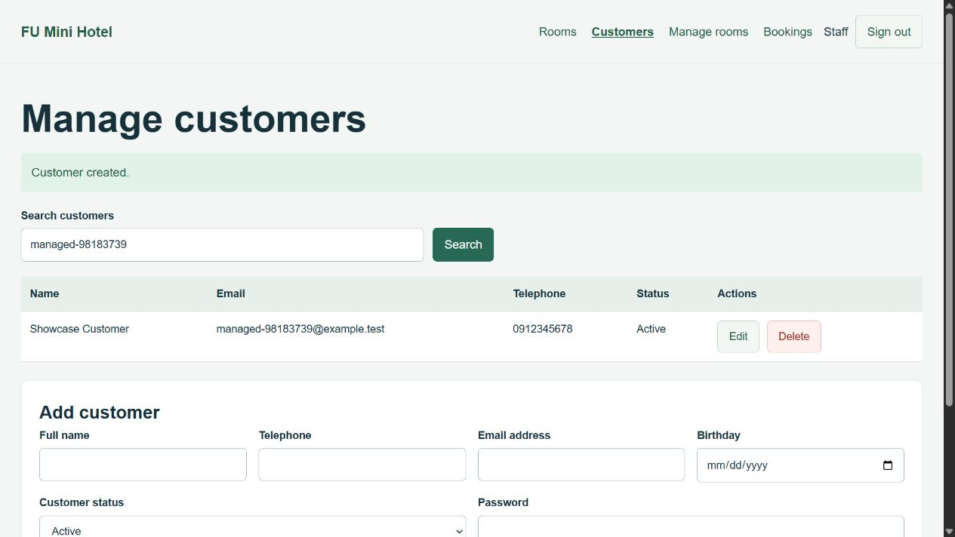
Figure 14. Customer created and found by email

5.4 Edit customer profile
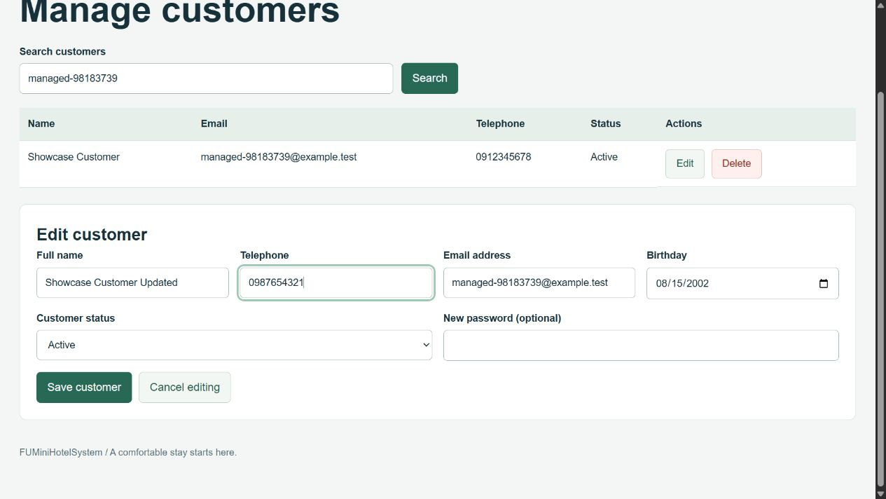
Figure 15. Edit customer profile

5.5 Customer update saved
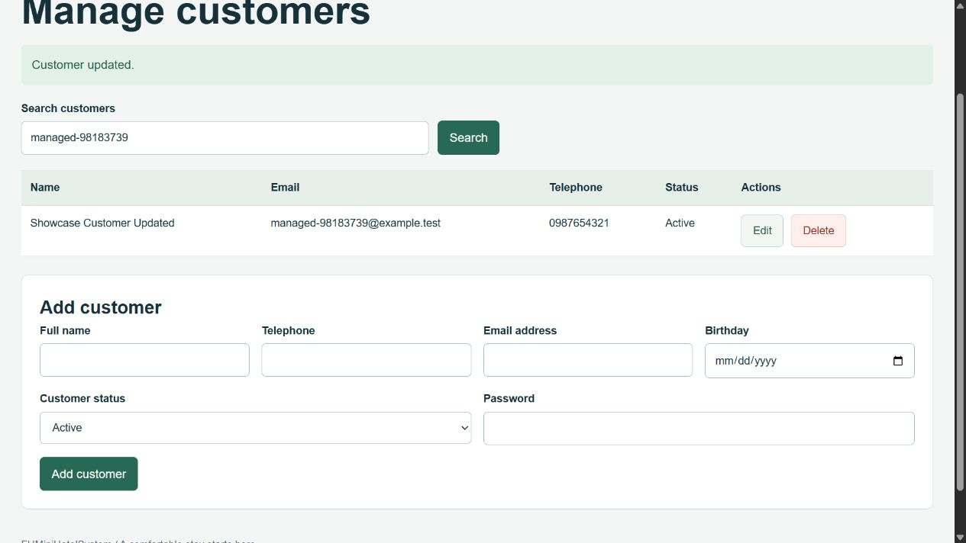
Figure 16. Customer update saved

5.6 Delete customer confirmation
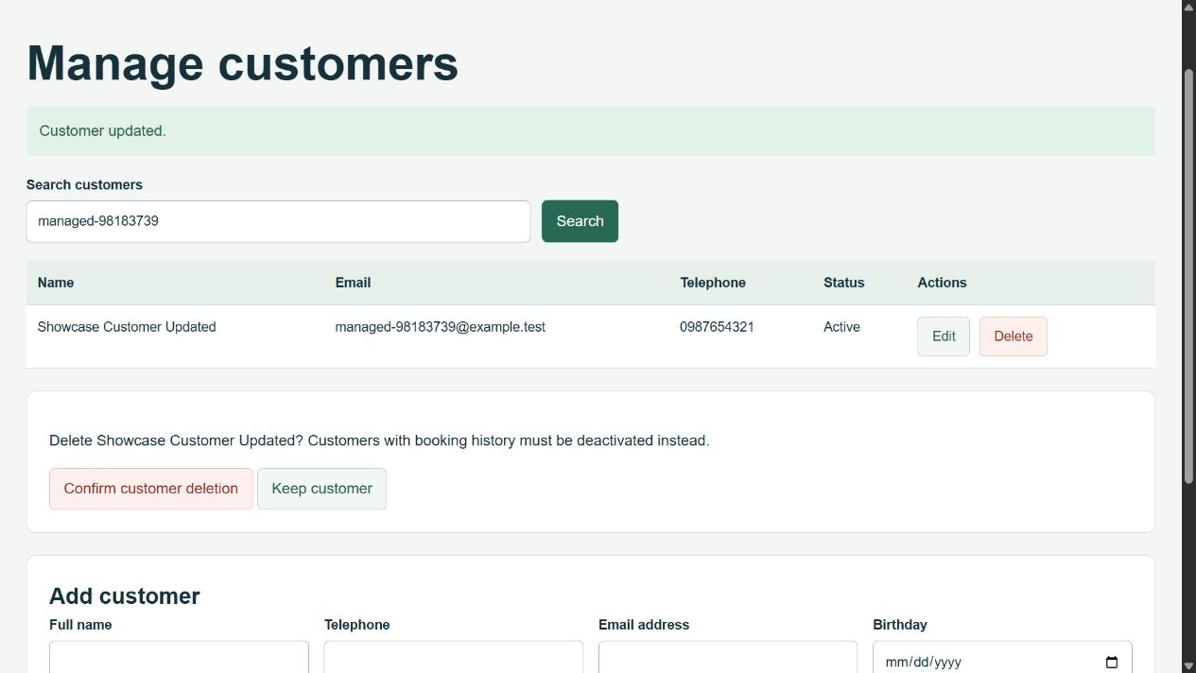
Figure 17. Delete customer confirmation

5.7 Deleted customer removed from search
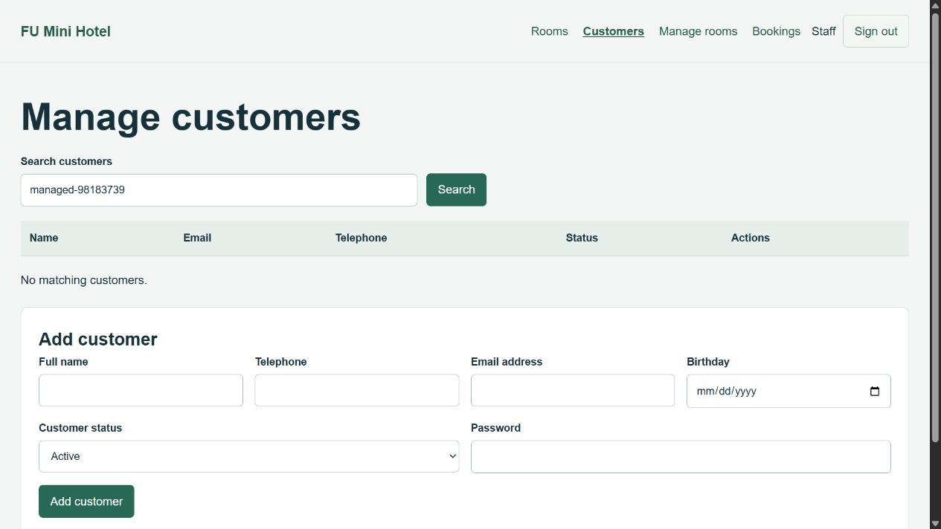
Figure 18. Deleted customer removed from search

6. Staff — Room Management

6.1 Room list
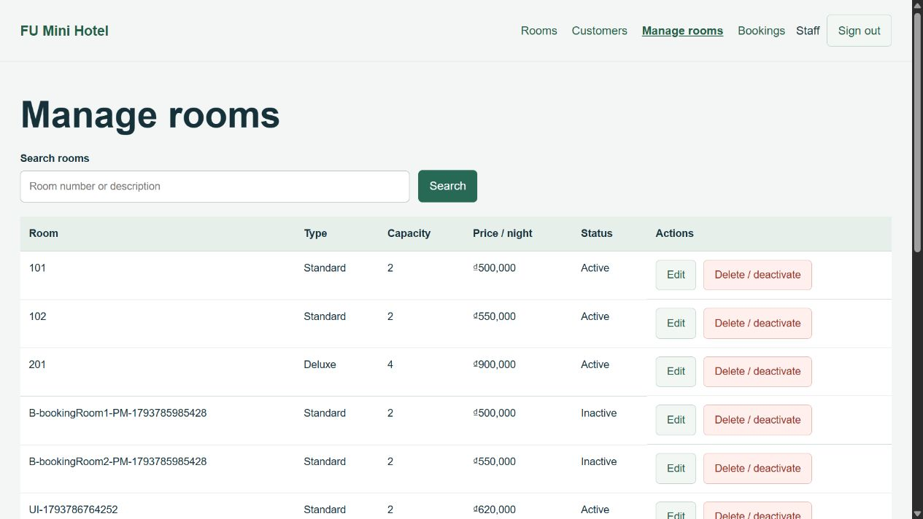
Figure 19. Room list

6.2 Create an active room
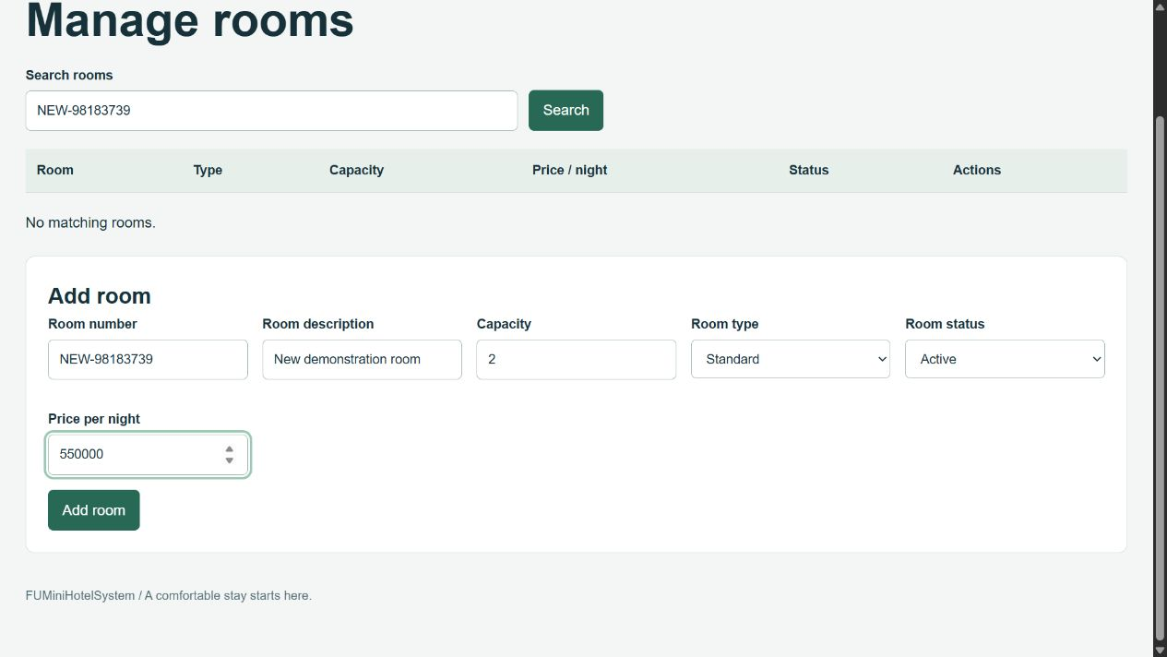
Figure 20. Create an active room

6.3 Room created and found by number
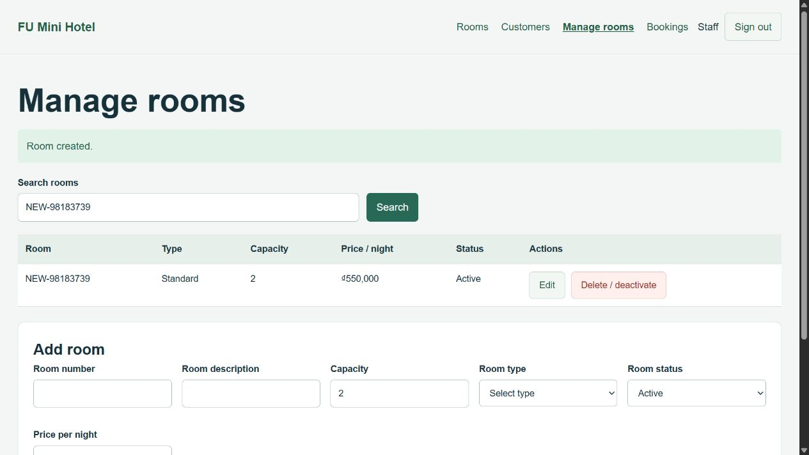
Figure 21. Room created and found by number

6.4 Edit room description and price
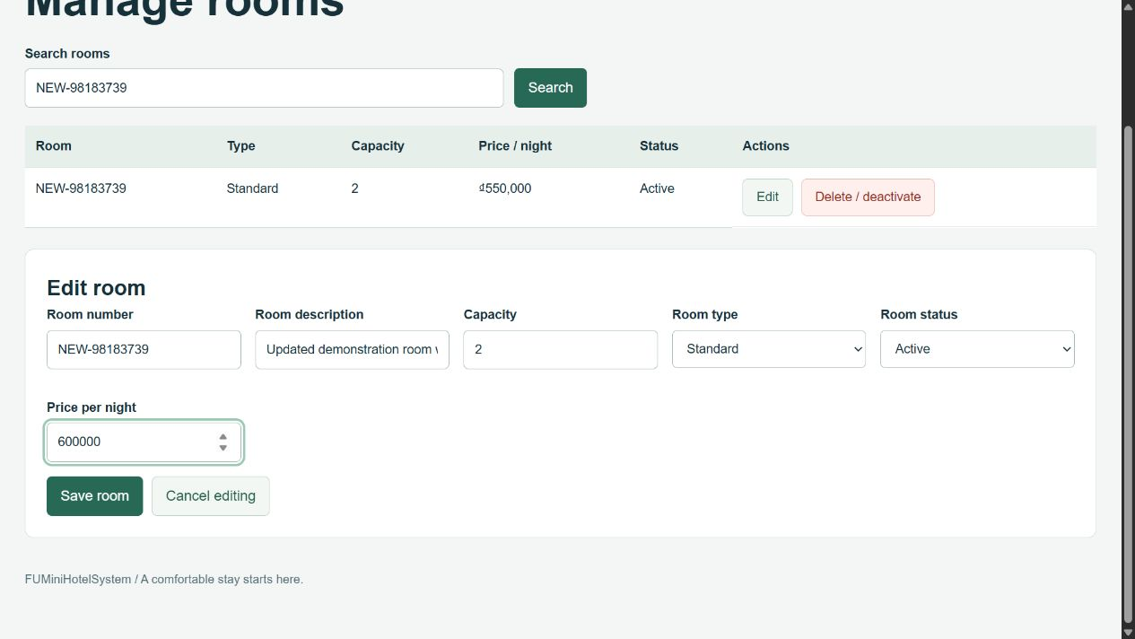
Figure 22. Edit room description and price

6.5 Room update saved
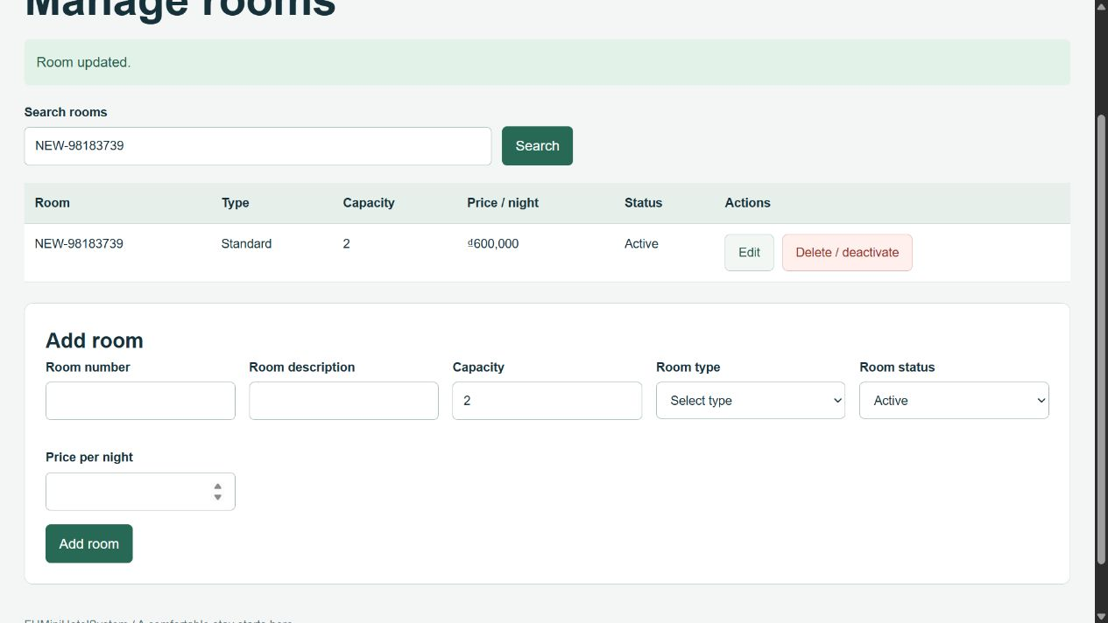
Figure 23. Room update saved

6.6 Delete an unused room
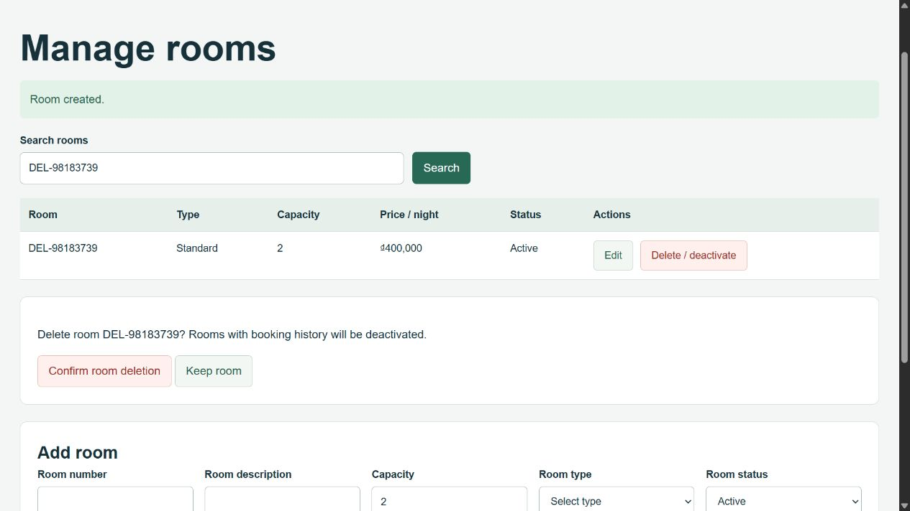
Figure 24. Delete an unused room

6.7 Unused room physically removed
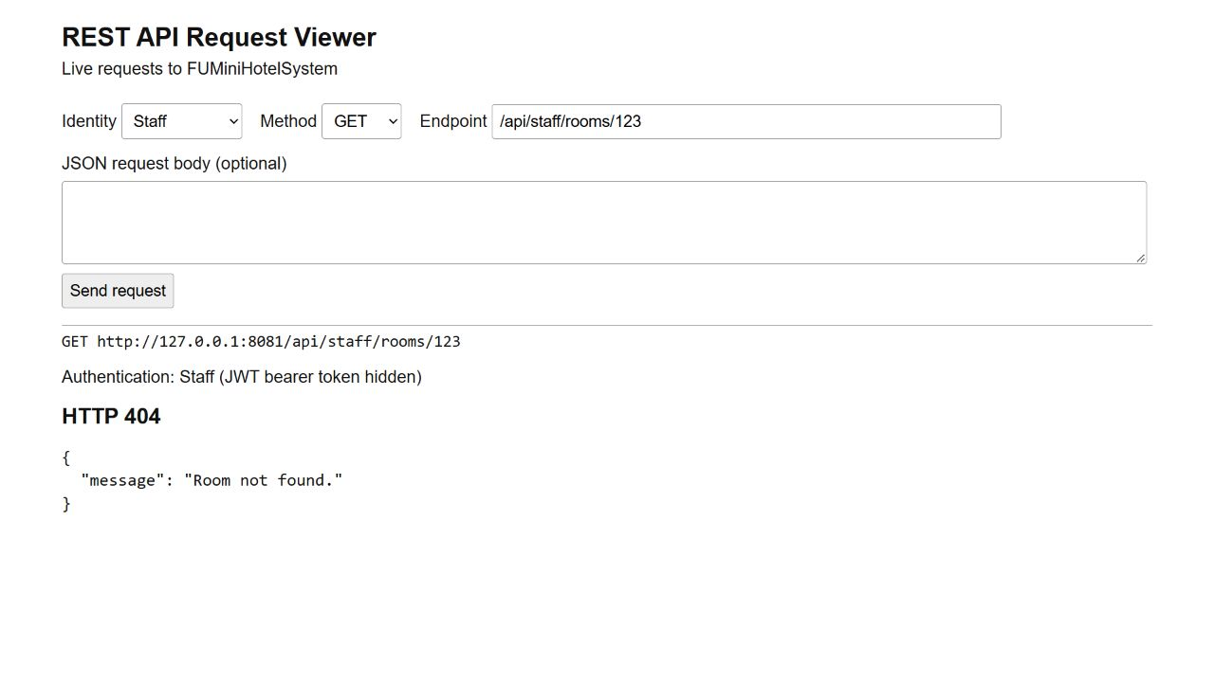
Figure 25. Unused room physically removed

6.8 Delete a room with booking references
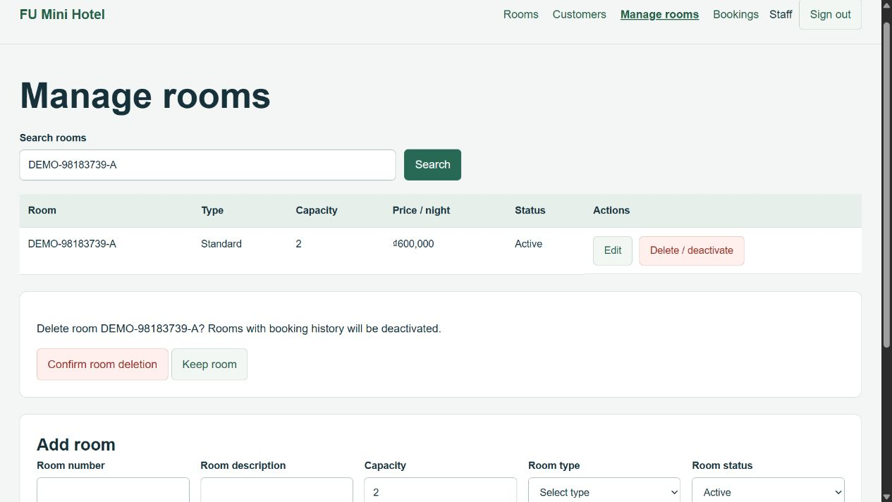
Figure 26. Delete a room with booking references

6.9 Referenced room retained as inactive
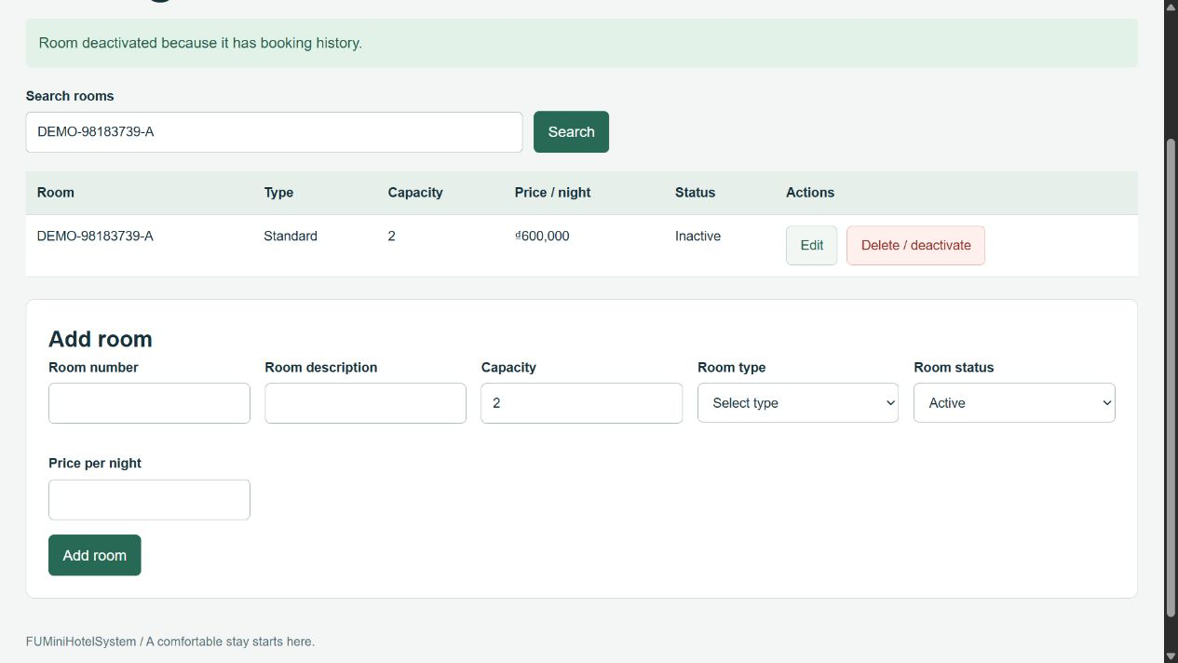
Figure 27. Referenced room retained as inactive

7. Staff — Booking Reservation Management

7.1 Booking reservation list
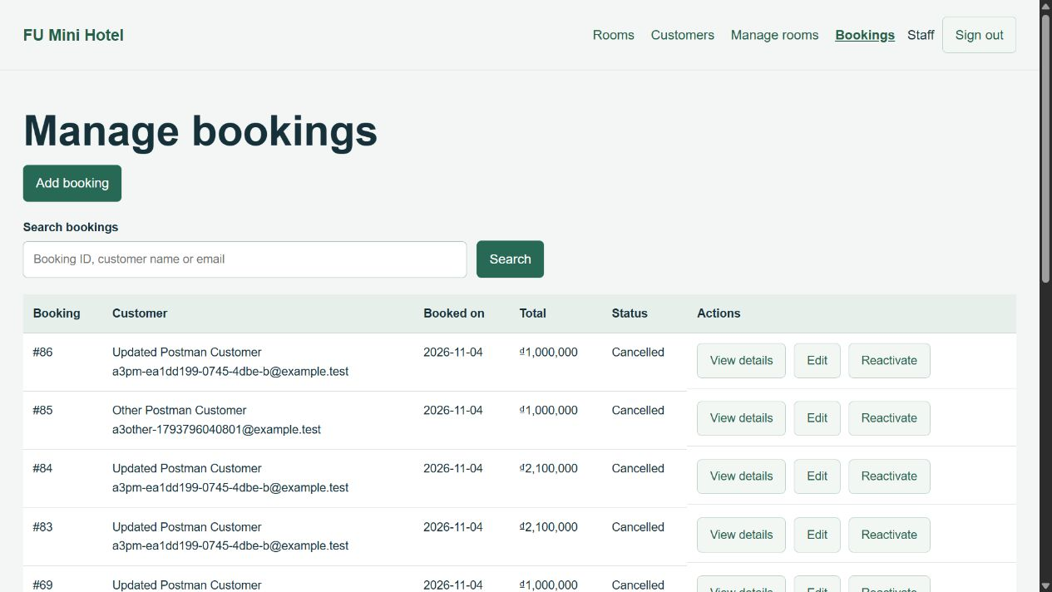
Figure 28. Booking reservation list

7.2 Select customer, room, and booking dates
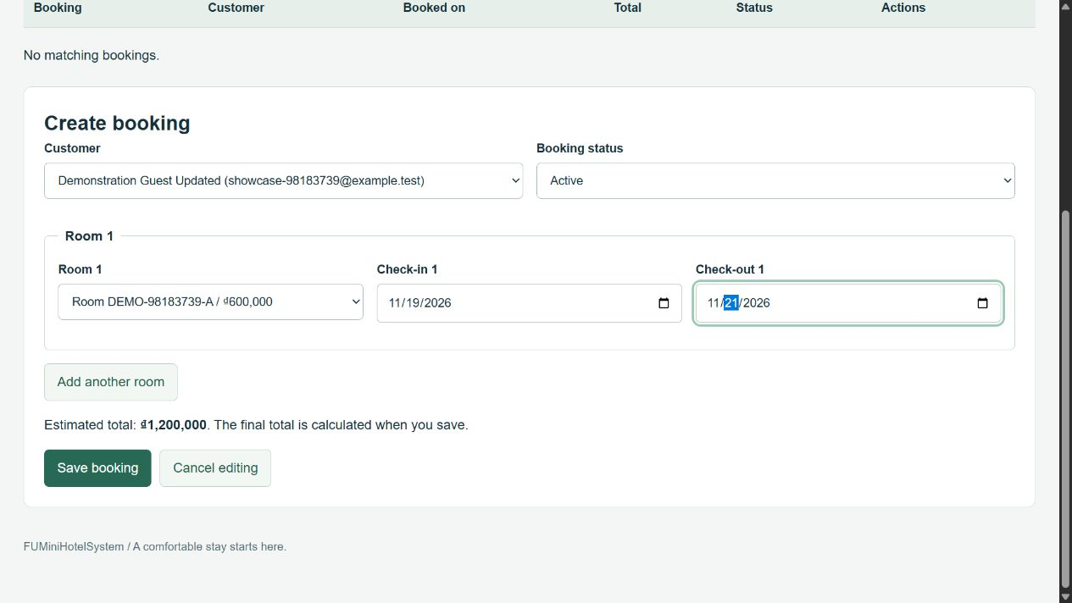
Figure 29. Select customer, room, and booking dates

7.3 Reservation created with room details
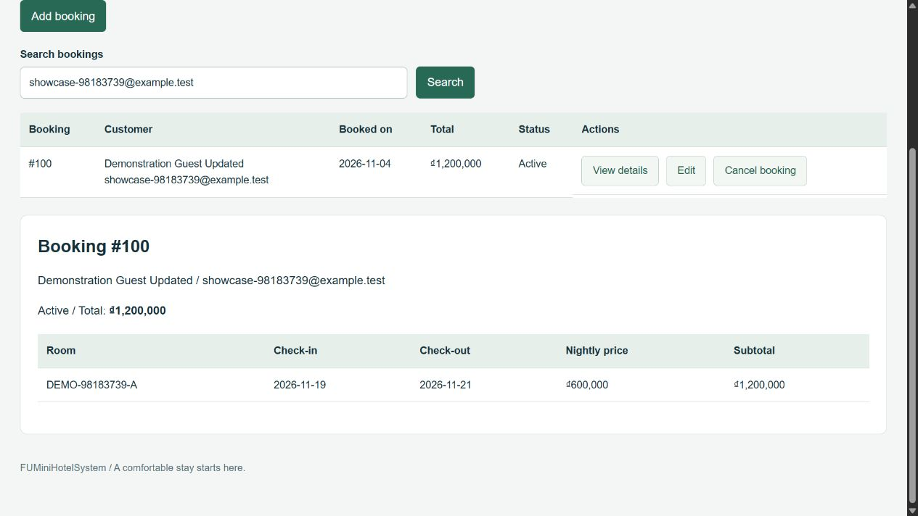
Figure 30. Reservation created with room details

7.4 Search reservation by booking number
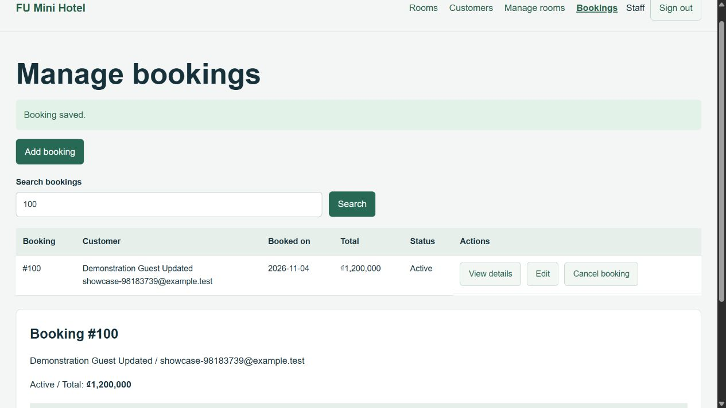
Figure 31. Search reservation by booking number

7.5 Edit reservation dates
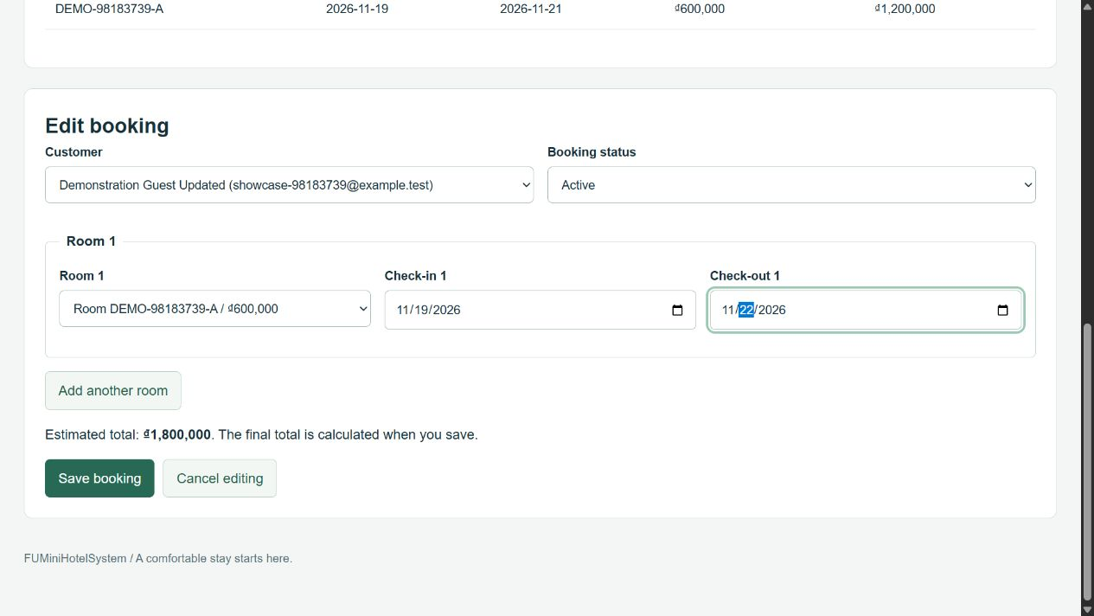
Figure 32. Edit reservation dates

7.6 Reservation updated with recalculated total
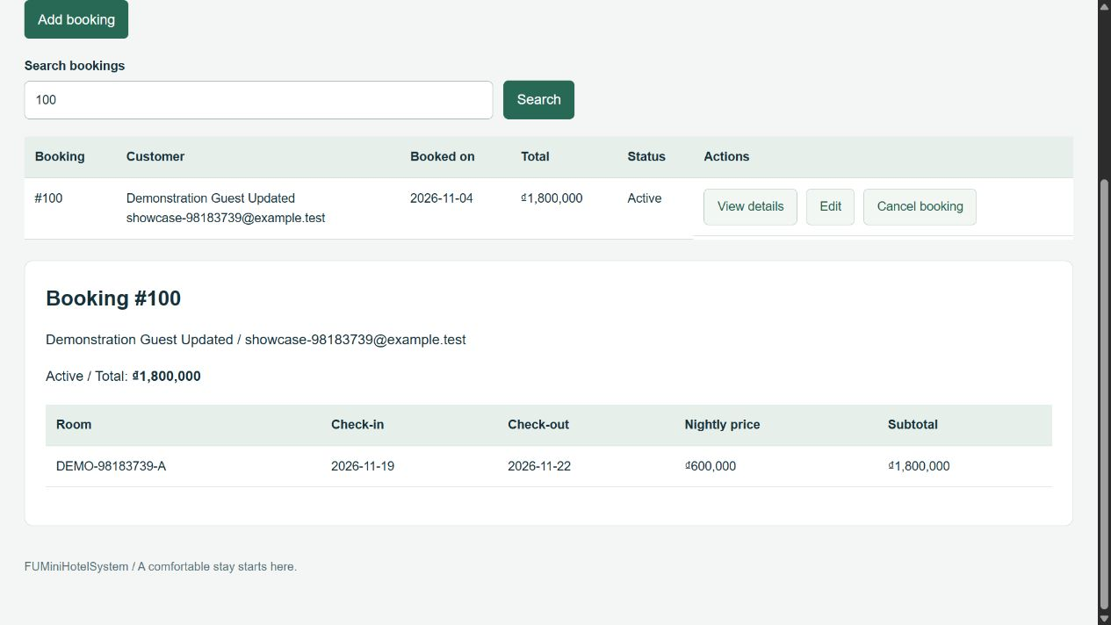
Figure 33. Reservation updated with recalculated total

7.7 Cancel reservation and preserve details
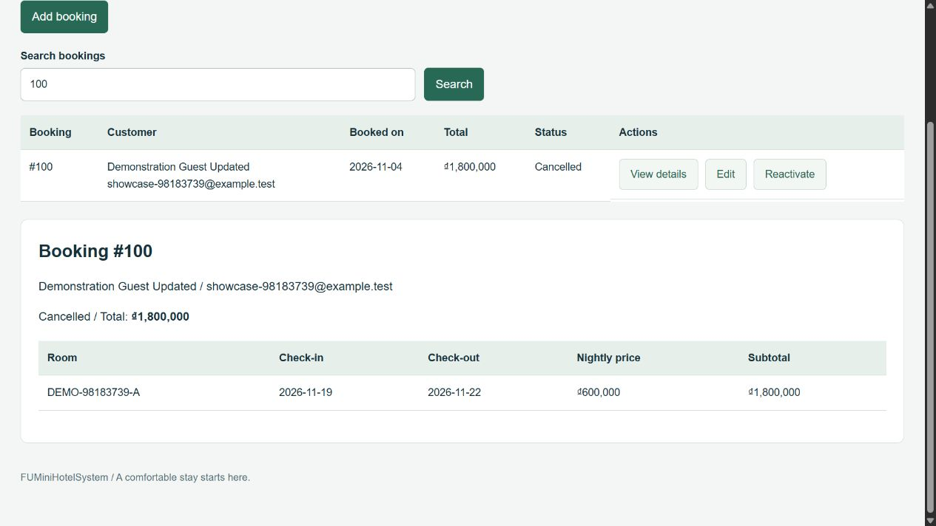
Figure 34. Cancel reservation and preserve details

8. Customer — Online Booking

8.1 Select one room and stay dates
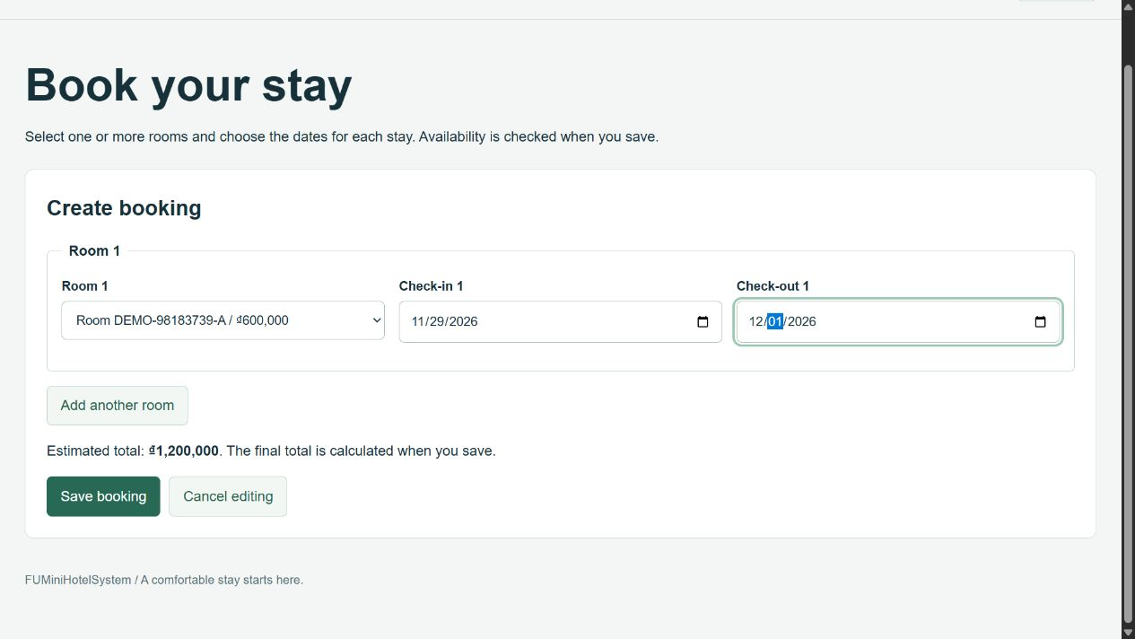
Figure 35. Select one room and stay dates

8.2 Single-room reservation confirmed
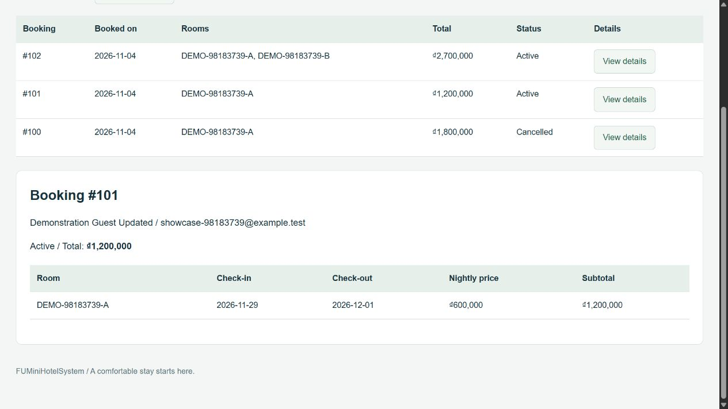
Figure 36. Single-room reservation confirmed

8.3 Select two rooms and review the booking total
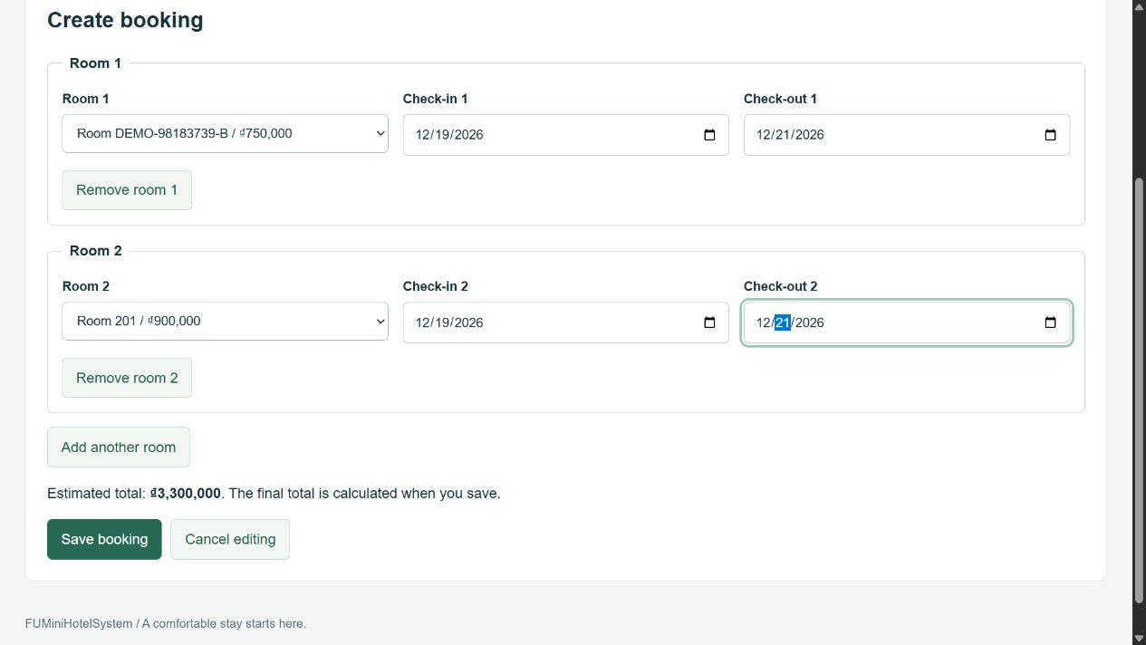
Figure 37. Select two rooms and review the booking total

8.4 Two rooms confirmed in one reservation
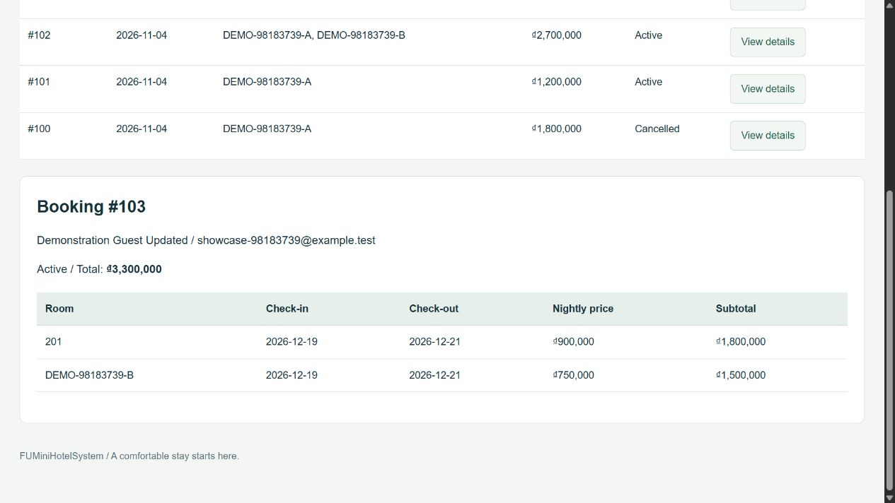
Figure 38. Two rooms confirmed in one reservation

9. Customer — Profile Management

9.1 View personal profile
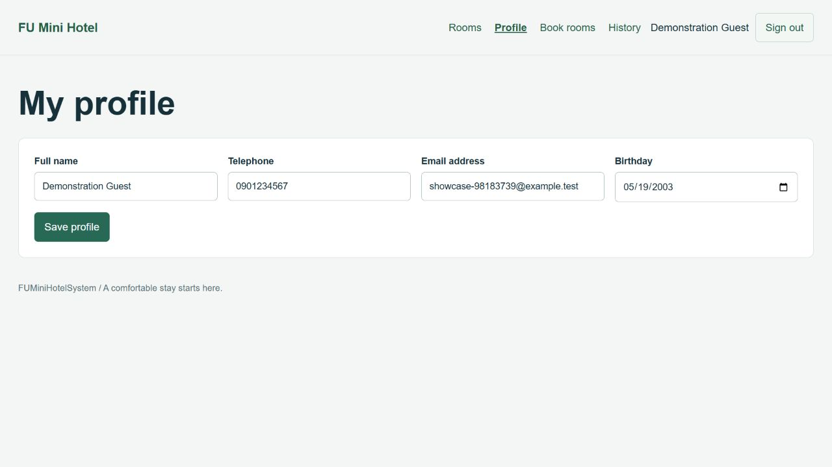
Figure 39. View personal profile

9.2 Edit profile information
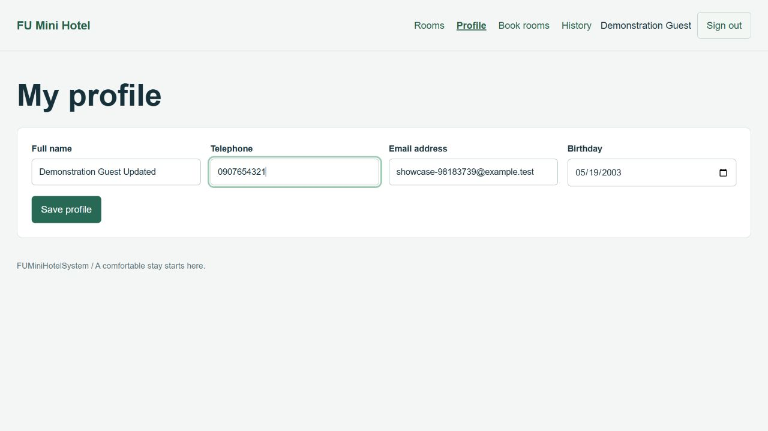
Figure 40. Edit profile information

9.3 Profile updated successfully
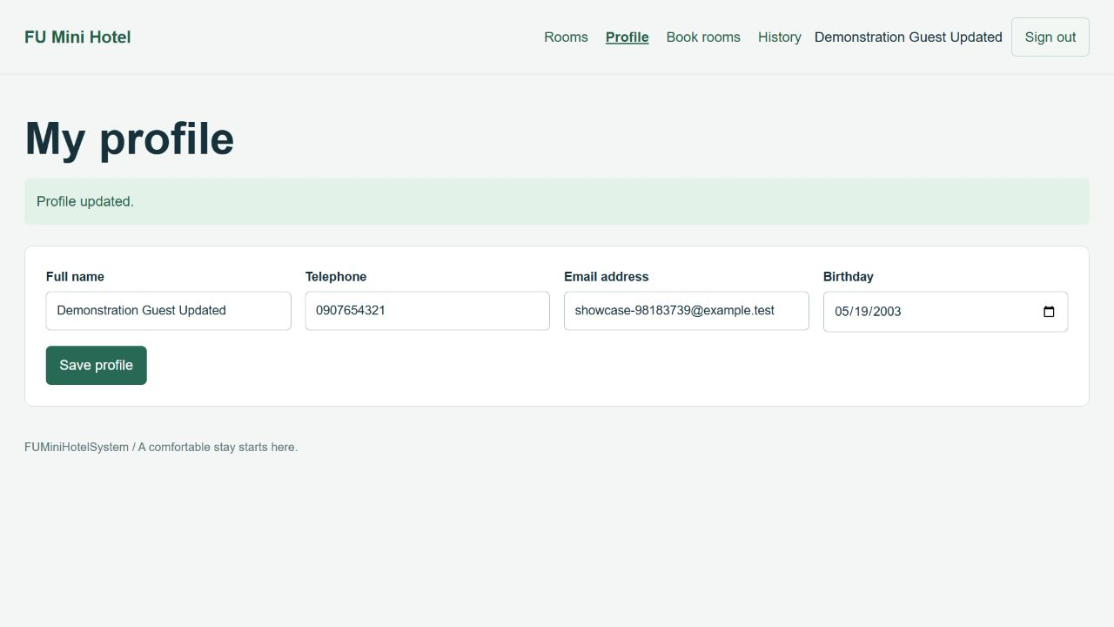
Figure 41. Profile updated successfully

10. Customer — Booking History

10.1 Personal booking history and reservation list
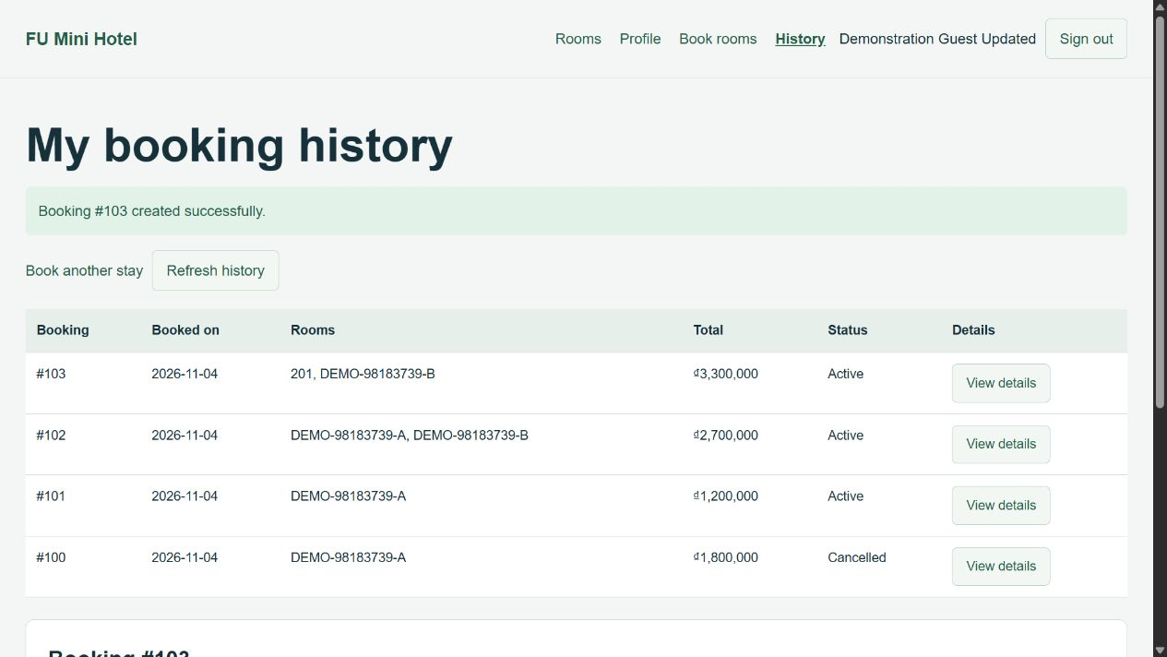
Figure 42. Personal booking history and reservation list

10.2 Reservation details with rooms, dates, and prices
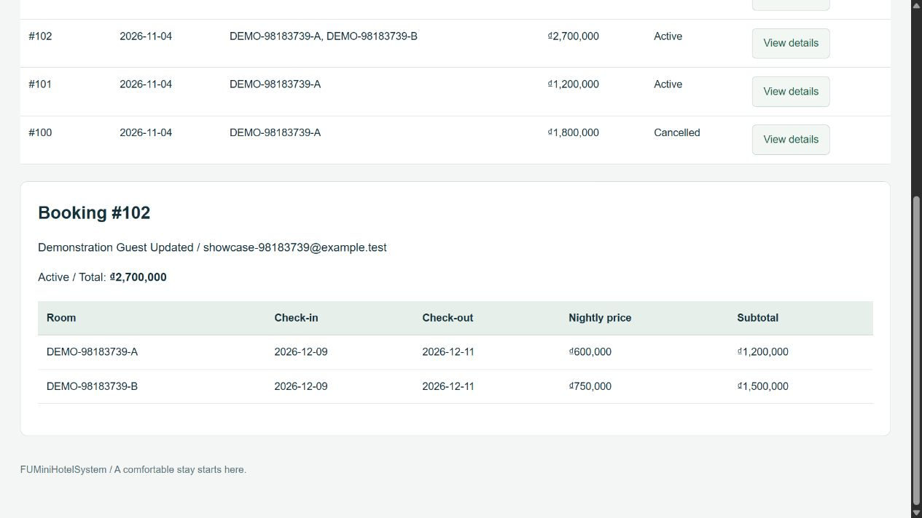
Figure 43. Reservation details with rooms, dates, and prices

11. Form Validation

11.1 Required registration fields
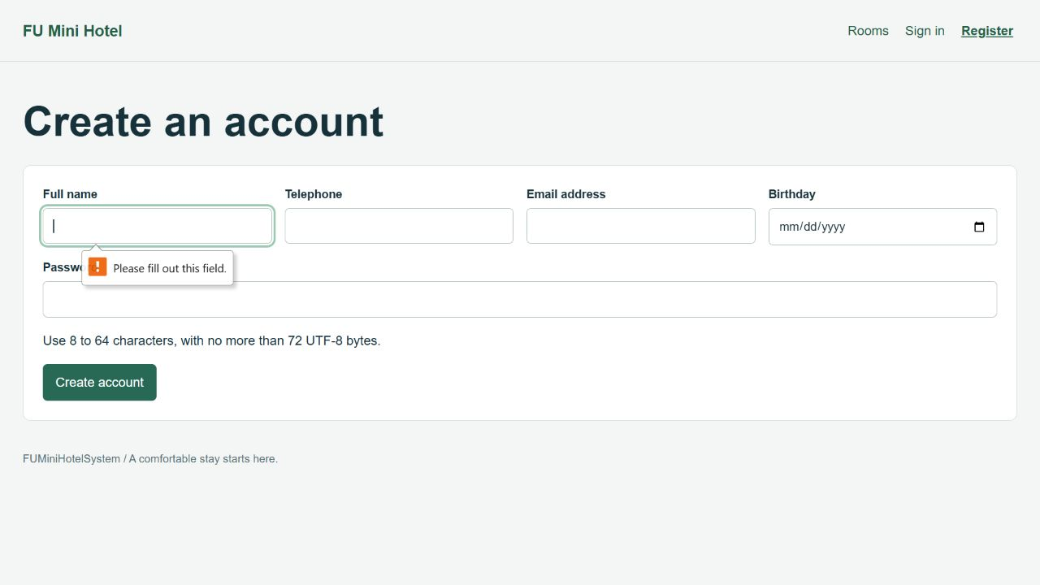
Figure 44. Required registration fields

11.2 Invalid email address rejected
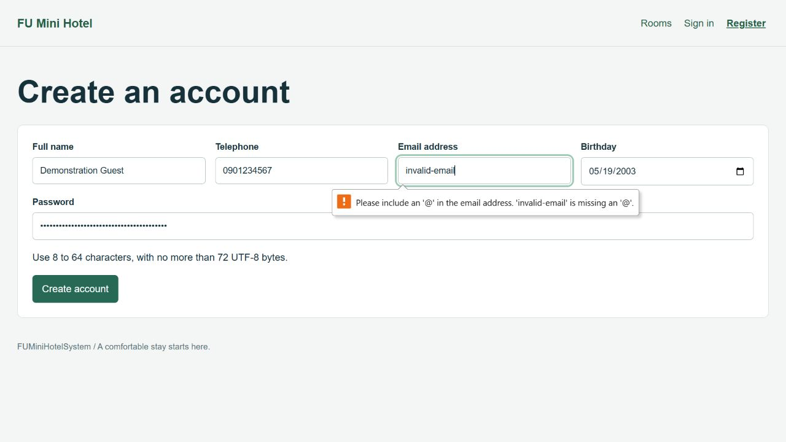
Figure 45. Invalid email address rejected

11.3 Duplicate room selection rejected
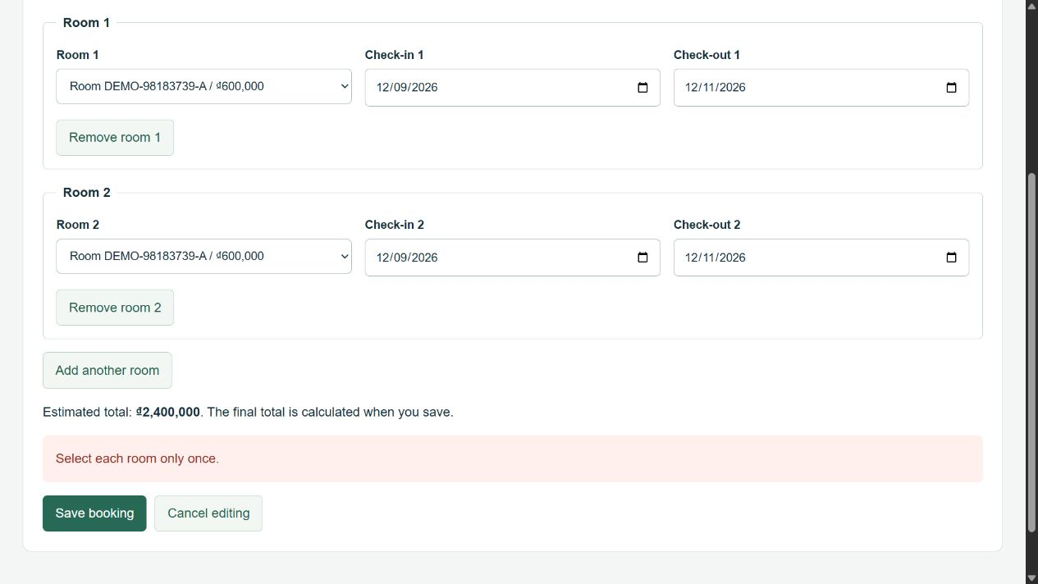
Figure 46. Duplicate room selection rejected

11.4 Invalid checkout date rejected
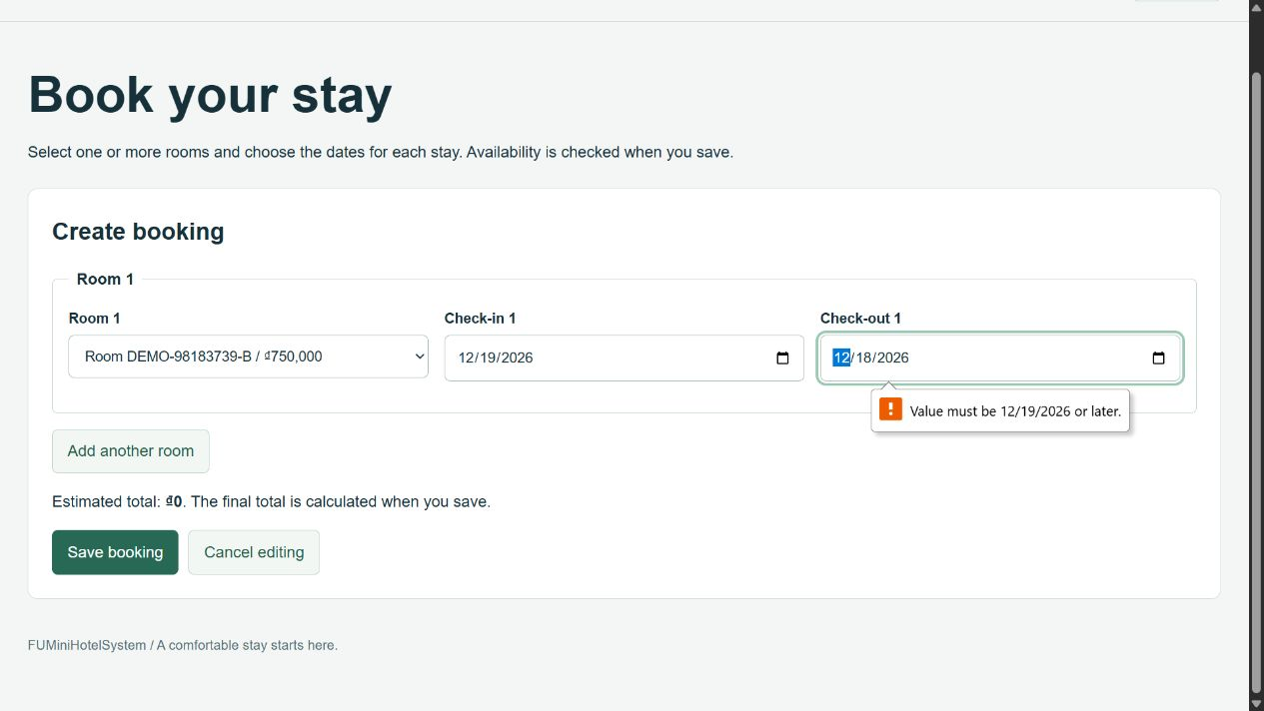
Figure 47. Invalid checkout date rejected

12. REST API Security and Integration

12.1 Authenticated customer request — HTTP 200
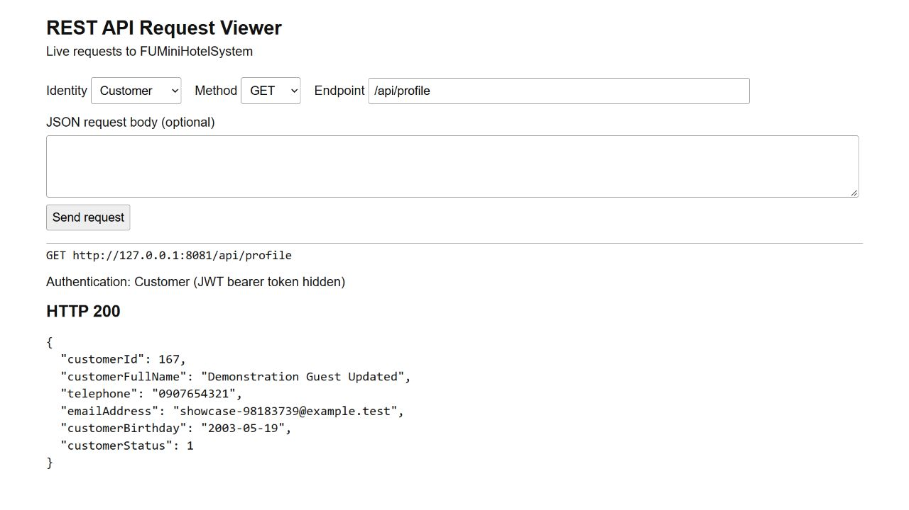
Figure 48. Authenticated customer request — HTTP 200

12.2 Missing bearer token — HTTP 401
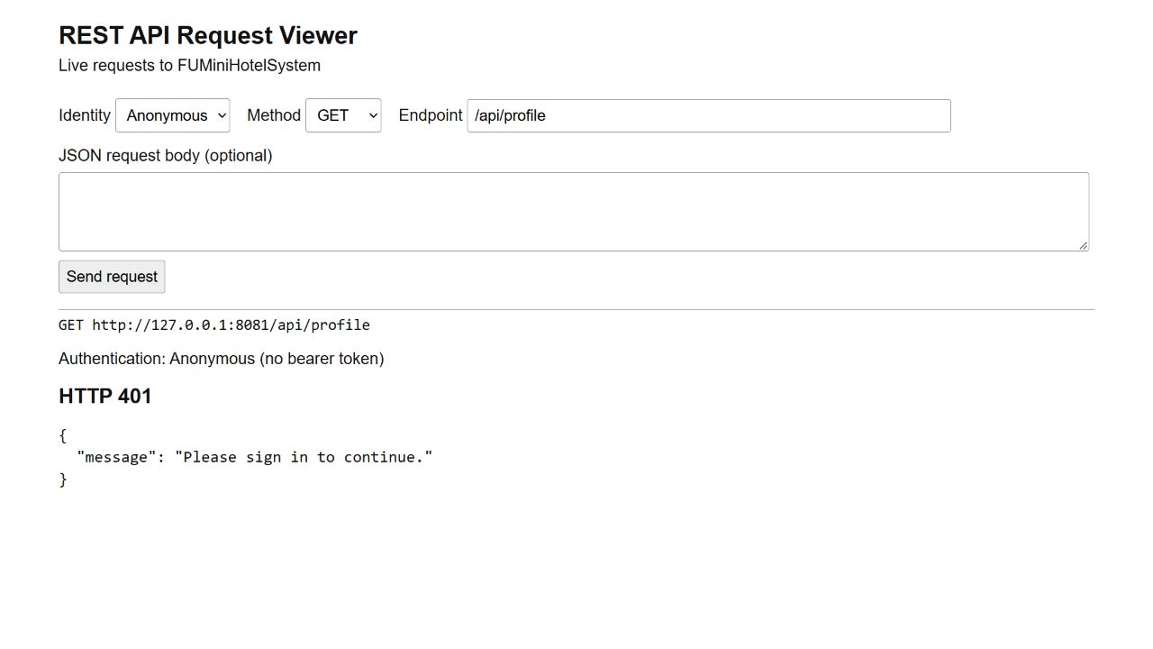
Figure 49. Missing bearer token — HTTP 401

12.3 Insufficient role — HTTP 403
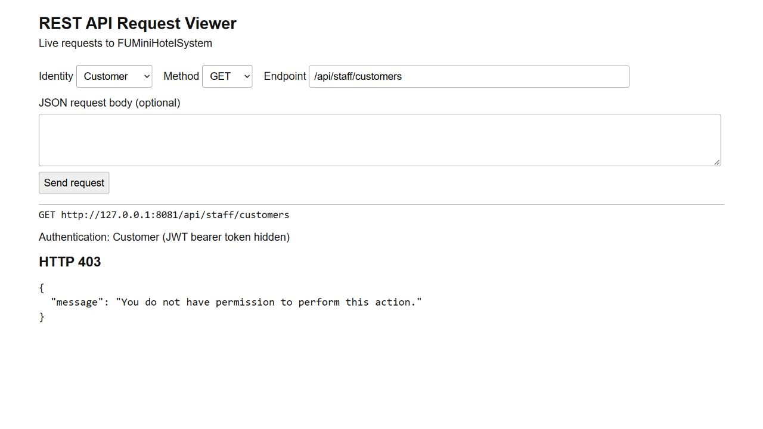
Figure 50. Insufficient role — HTTP 403

12.4 Invalid room capacity and price — HTTP 400
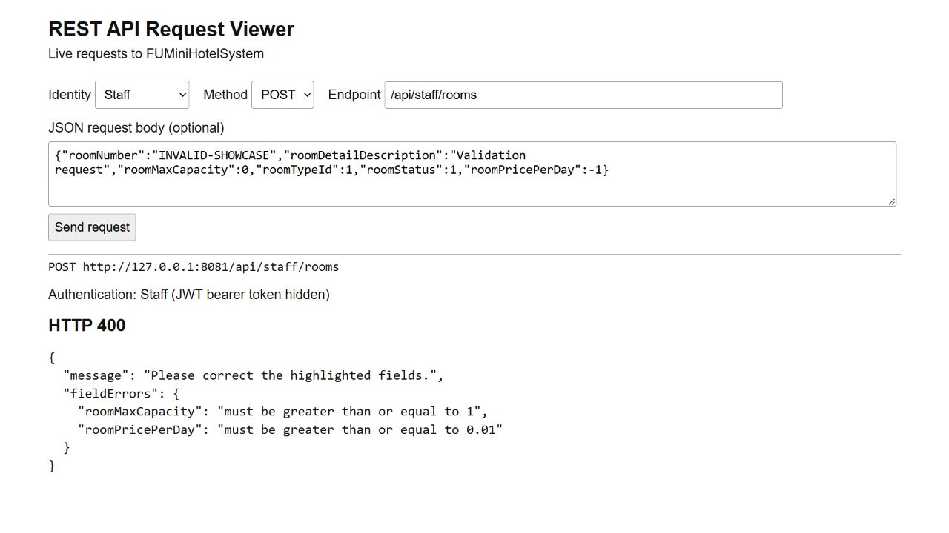
Figure 51. Invalid room capacity and price — HTTP 400

12.5 API returns the reservation created in React
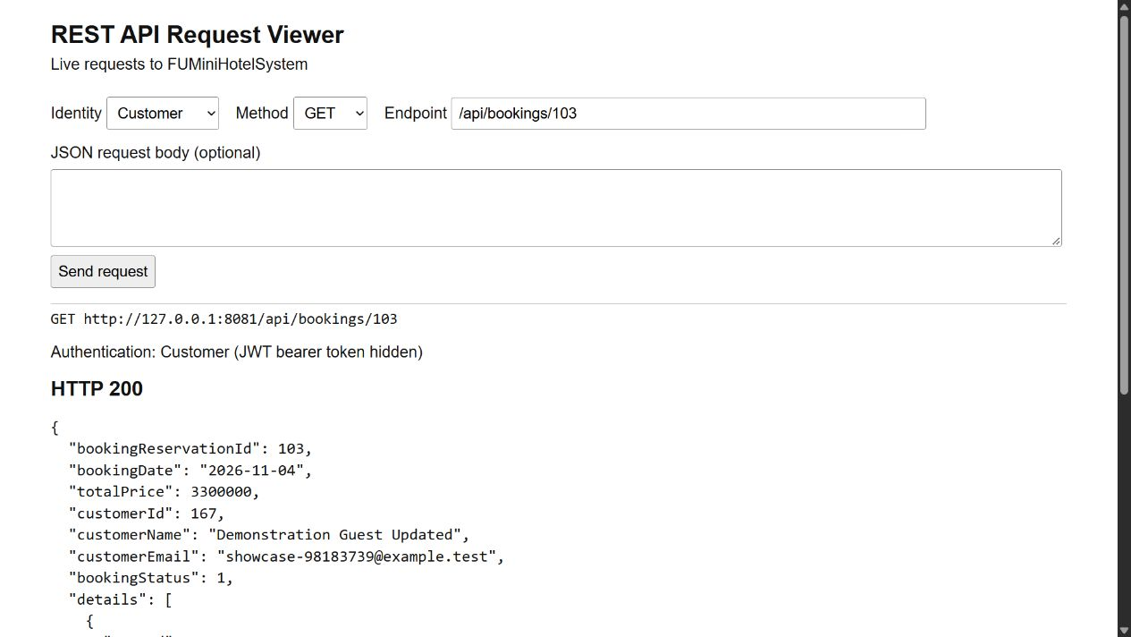
Figure 52. API returns the reservation created in React

