

**SNEAKER ONLINE SHOP SYSTEM**

**Software Requirement Specification**

– Hanoi, April 2023 –

**Table of Contents**

I. Overview 3

1. Introduction 3

2. System Functions 4

3. Common Requirements 5

*a. Actors 5*

II. Functional Requirements 7

1. Public Feature 7

a. Home Page 7

2. Common Feature 7

a. Login 7

b. Forgot Password 8

c. Order 9

d. Sign Up 10

3. Customer Feature 11

a. Profile 11

b. Change Password 12

c. Edit Profile 13

D. My Order 14

4. Employee Feature 15

a. Product List Employee 15

b. Check All Order Status 16

5. Admin Feature 17

a. Order List 17

b. Product List Admin 18

c. Edit Product 19

d. Create Product 20

e. Customer Lists 21

f. Dash Boards 22

g. Category Lists 23

# I. Overview

## 1. Introduction

* The project of a sales website with products such as shoes with the purpose of providing customers with high quality products. and full of utility features, helping customers easily search, compare, select and purchase necessary products.

* This document will be used to develop the software requirements specification document, helping to ensure that the software developed meets the product's specification and feature requirements. In addition, the document provides the necessary information to develop new features and enhance the customer experience on this sales site.

## 2. System Functions

#### a. Software usage activity chart

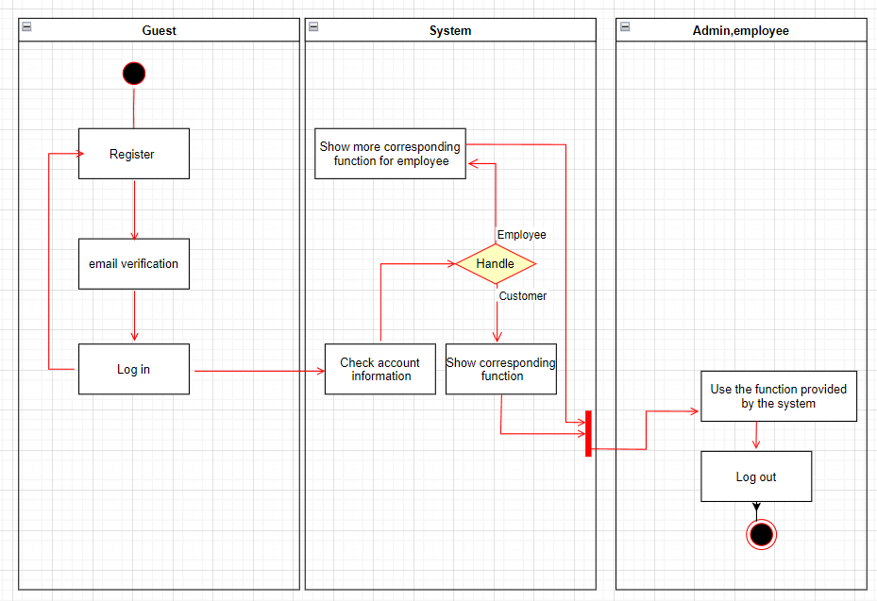

#### b. Screen Details

| **#** | **Feature** | **Screen** | **Description** |
| --- | --- | --- | --- |
| 1 | Public | Home Page | the starting page of the system |
| 2 | Public | Product Detail | detail of product information |
| 3 | Common | Login | authenticate the user to give him/her to access authorised features later on |
| 4 | Common | Forgot Password | use in case the user forgot his/her password |
| 5 | Common | Order | user order |
| 6 | Common | Signup | register a new user into the system, verified by the registered email |
| 7 | Customer | Profile | view user profile |
| 8 | Customer | Change Password | change user’s login password |
| 9 | Customer | Edit Profile | edit/update user profile |
| 10 | Customer | My Order | user order history |
| 11 | Employee | Product List Employee | staff see the number of products in stock |
| 12 | Employee | Check All Order Status | check & filter by date order status |
| 13 | Admin | Order List | list all orders by customer |
| 14 | Admin | Product Lists Admin | view all products |
| 15 | Admin | Edit Product | edit, update products |
| 16 | Admin | Create Product | create new products |
| 17 | Admin | Customer Lists | list all account by customer |
| 18 | Admin | Dash Board | view general statistics & trends about the management-related data |
| 19 | Admin | Category Lists | list all category |

#### c. User Authorization

| **Screen** | **Guest** | **Customer** | **Employee** | **Admin** |
| --- | --- | --- | --- | --- |
| Home Page | X | X | X | X |
| Product Detail | X | X | X | X |
| Login |  | X | X | X |
| Forgot Password |  | X | X | X |
| Order | X | X |  |  |
| Signup | X | X | X |  |
| Profile |  | X |  |  |
| Change Password |  | X |  |  |
| Edit Profile |  | X |  |  |
| My Order |  | X |  |  |
| Product Lists Employee |  |  | X |  |
| Check All Order Status |  |  | X |  |
| Order List |  |  |  | X |
| Product Lists Admin |  |  |  | X |
| Edit Product |  |  |  | X |
| Create Product |  |  |  | X |
| Customer Lists |  |  |  | X |
| Dash Board |  |  |  | X |
| Category List |  |  |  | X |

## 3. Common Requirements

## *a. Actors*

| **#** | **Actor** | **Description** |
| --- | --- | --- |
| 1 | Guest | Users who do not have an account can still view product and place orders |
| 2 | Customer | Customers have an account in the system, Customers can place orders, view their purchase history and account information |
| 3 | Employee | Employee manage product quantity and view order st atus |
| 4 | Admin | Admin is a role that manage all Product, Order, Customer and Employee |

#### b. Use cases

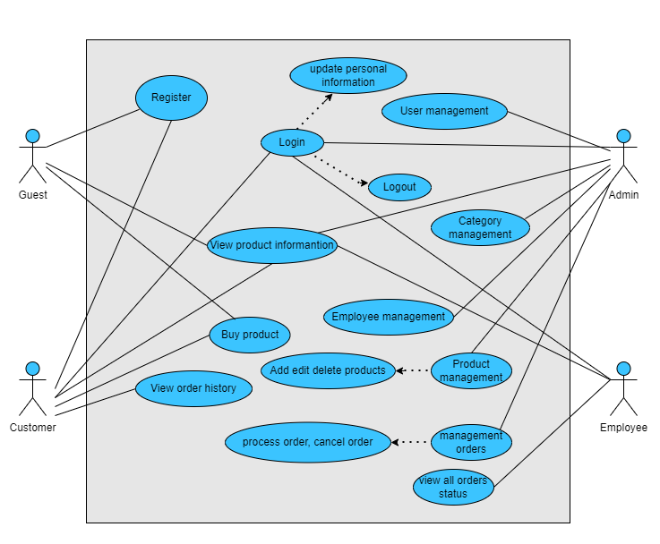

# II. Functional Requirements

## 1. Public Feature

### a. Home Page

● Function trigger: This function is triggered when the user visits the website or the system homepage

● Function description: Users see briefs about introduction, view all products , search and filter by color, size, price, category.

● Screen layout: simulated prototype of the screen, the sample below is for the home screen

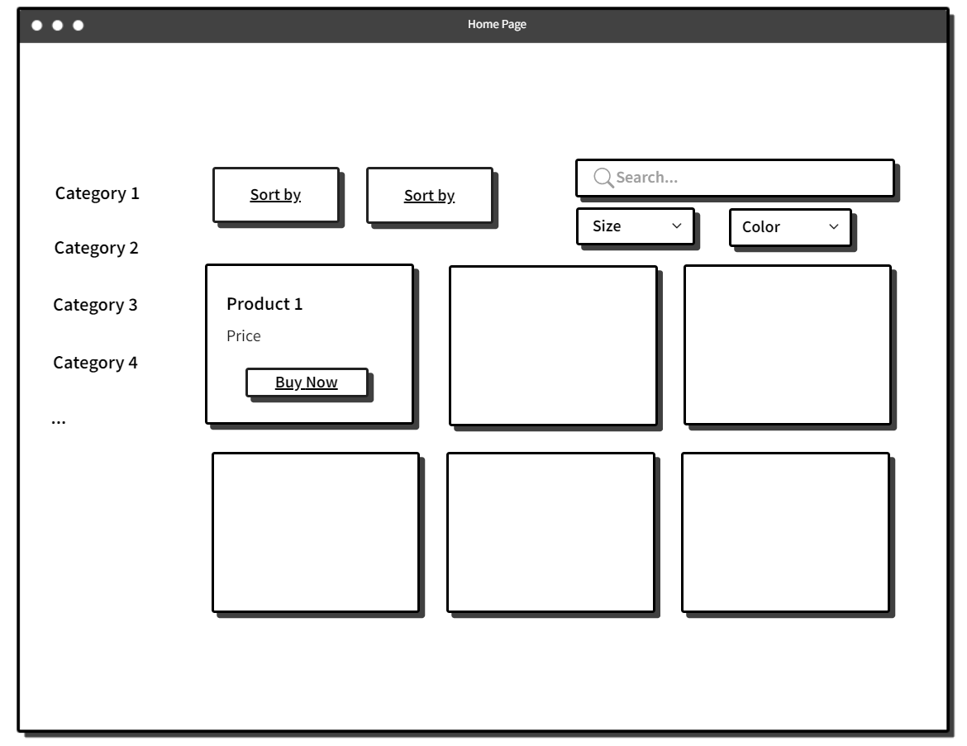

● Function Details: When users access the system, the homepage will appear and show information about the system

## 2. Common Feature

### a. Login

● Function trigger: This function is triggered when the user clicks Sign in from Homepage

● Function description: User sign in into the system.

● Screen layout: mock-up prototype of the screen, sample below is for the Sign in screen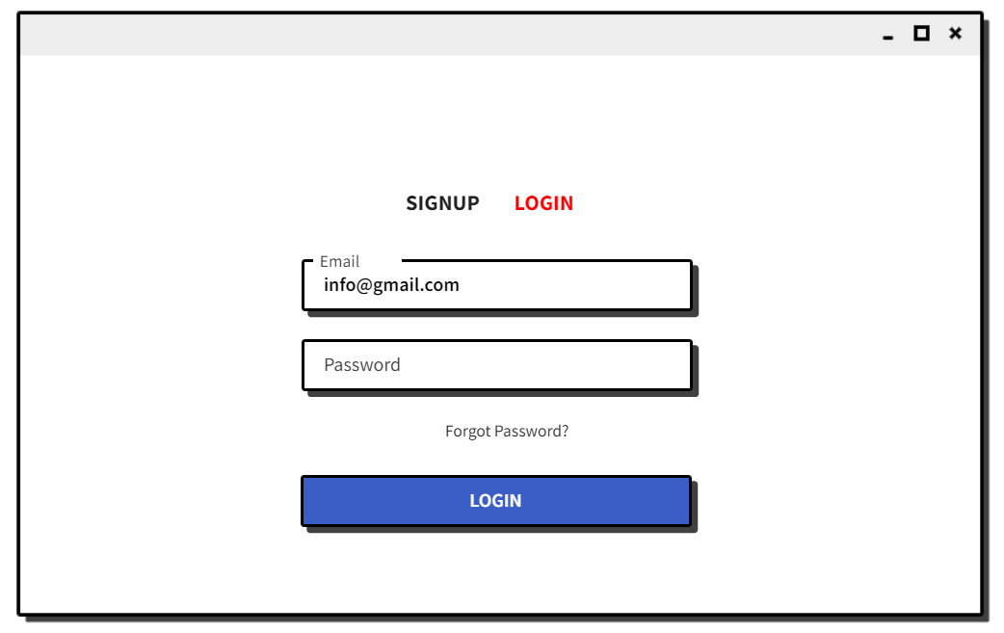

● Function Details: When the user is in the state not logged in, at the home page there will be a Sign in button after signing in into the system, the Sign in button will become Sign out.

### b. Forgot Password

* Function trigger: This function is triggered when the user clicks “Forgot Password” from Login
* Function description: The user can Forgot Password to an account.
* Screen layout: simulated prototype of screen, below sample is for Forgot Password screen

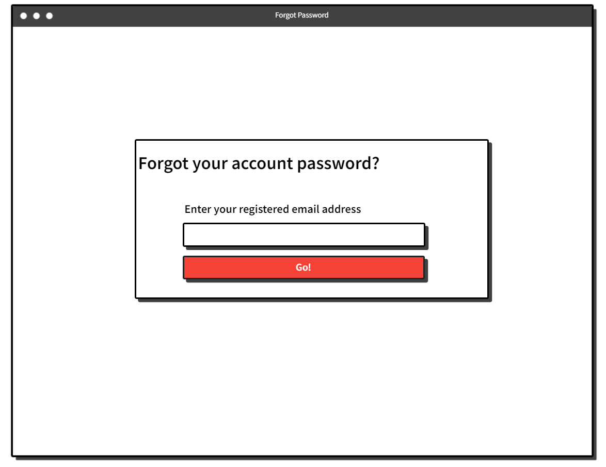

● Function Details: The user can input his/her email to receive the reset password link.

### c. Order

● Function trigger: This function is triggered when the user clicks “Buy now” from Product on home.

● Function description: The user can edit quantity, remove Products ands user input information to order .

● Screen layout: simulated prototype of screen, below sample is for Cart screen

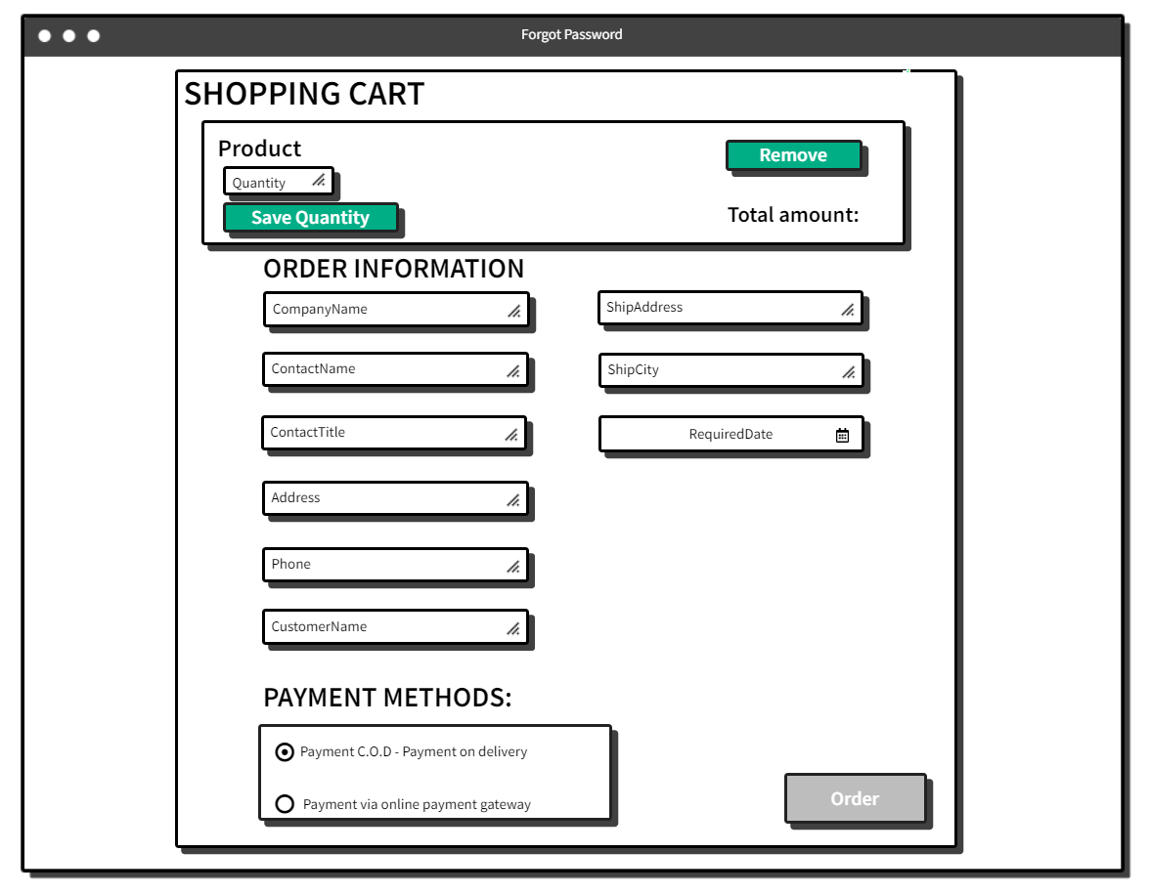

● Function Details: User enters complete information to place an order.

### d. Sign Up

● Function trigger: This function is triggered when the guest goes to login and choose to register

● Function description: The guest can create an account.

● Screen layout: mock-up prototype of the screen, sample below is for the Register.

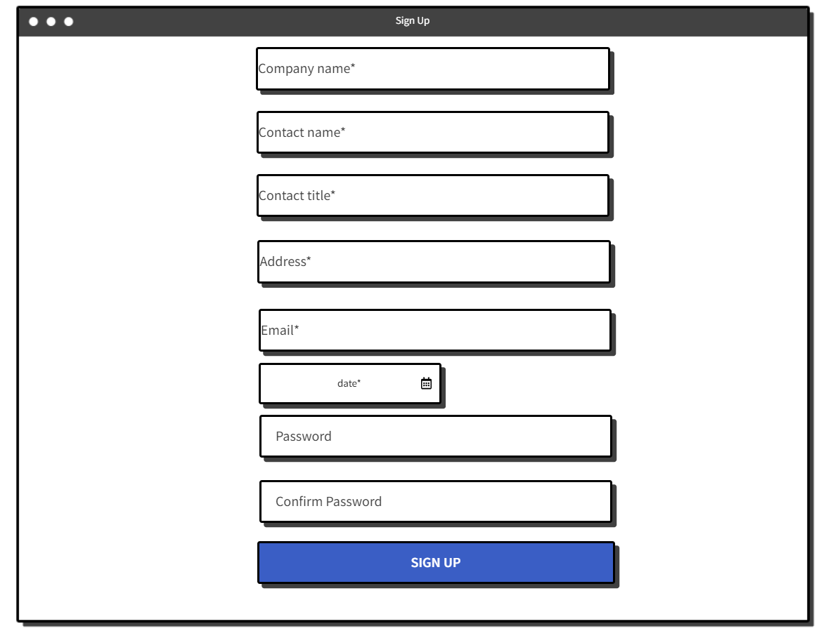

● Function Details: After going to the login, the guest can create an account.

## 3. Customer Feature

### a. Profile

● Function trigger: This function is triggered when the user clicks “Profile” from Home

● Function description: The user can view his/her profile information, including the registered user information .

● Screen layout: simulated prototype of screen, below sample is for User profile screen

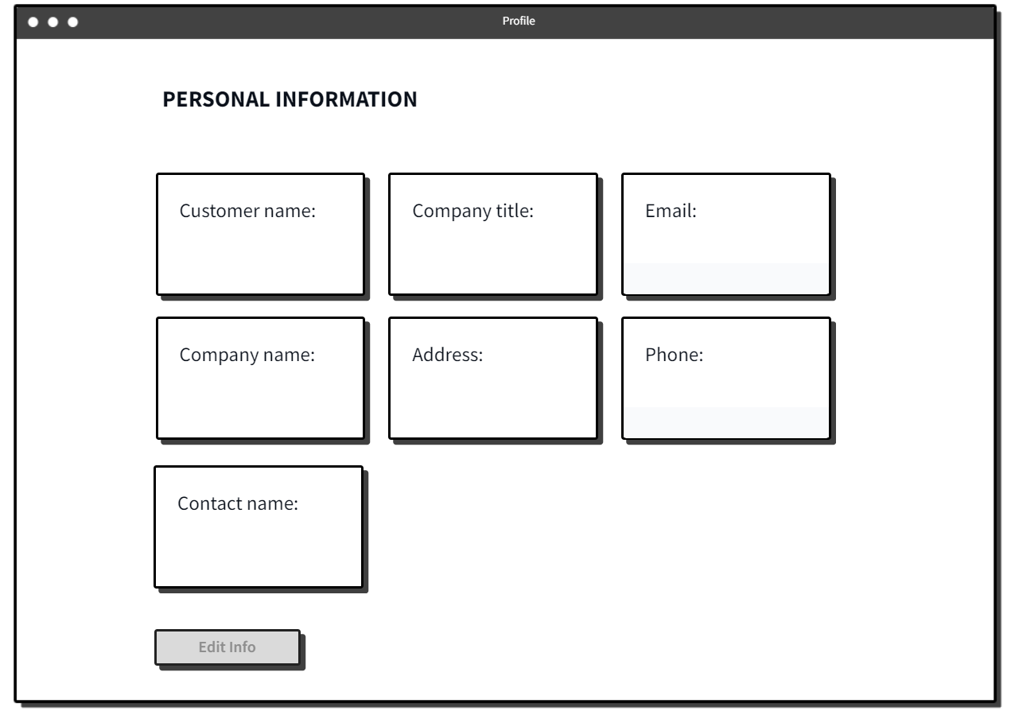

● Function Details: The user view his/her profile information.

### b. Change Password

● Function trigger: This function is triggered when the user clicks “Profile” from in Homepage

● Function description: Show profile

● Screen layout: simulated prototype of screen, below sample is for Change Password screen

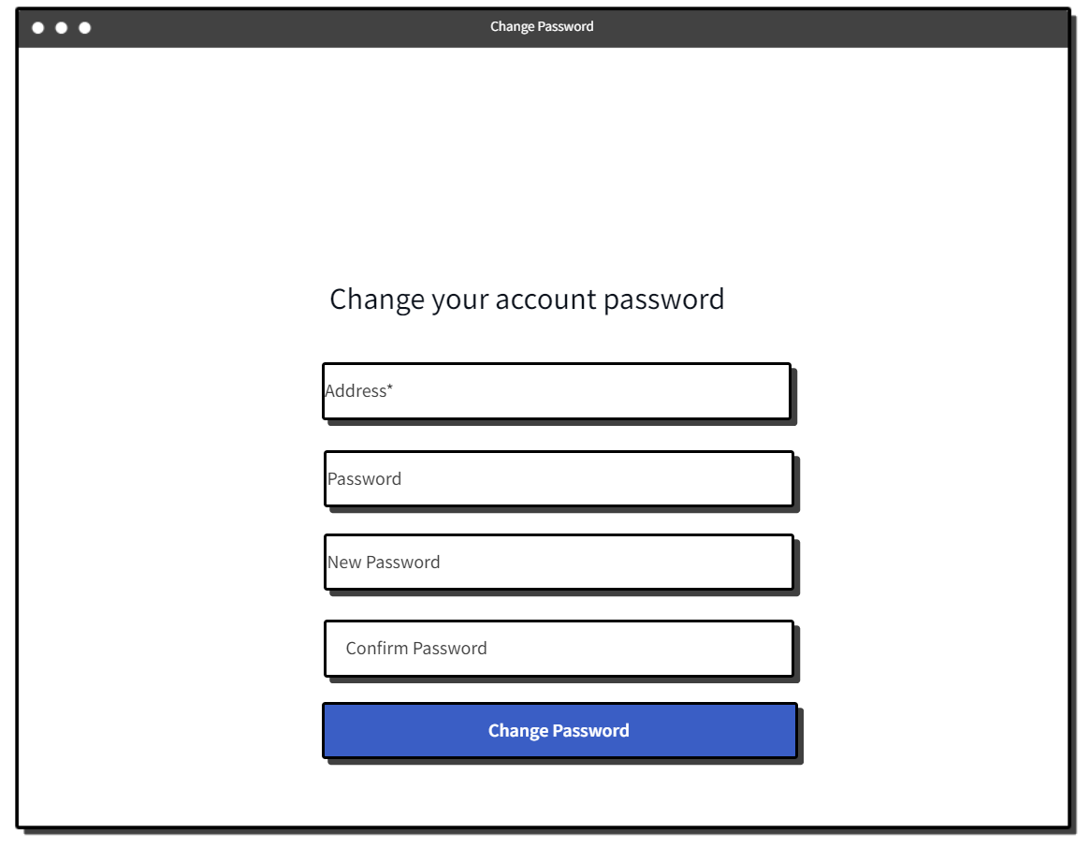

● Function Details*:* Allows the user to change his/her password by inputting his current password as well as new password (twice)

### c. Edit Profile

● Function trigger: This function is triggered when the user clicks “Profile” from Home

● Function description: The user can edit his/her profile information, including the registered user information .

● Screen layout: simulated prototype of screen, below sample is for User profile screen

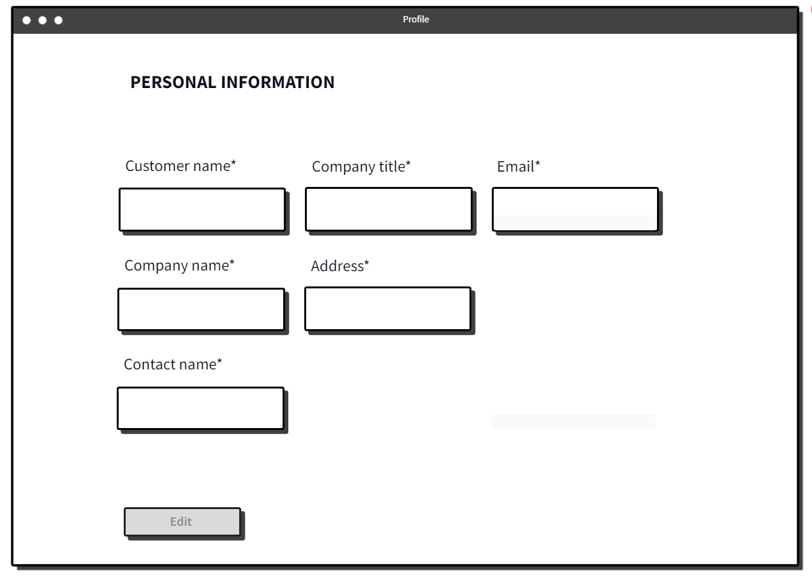

● Function Details: The user view edit his/her profile information.

### D. My Order

● Function trigger: This function is triggered when the user clicks “Profile” from Home and choose My Order

● Function description: Users can view and filter the information list of their orders.

● Screen layout: simulated prototype of screen, below sample is for User profile screen

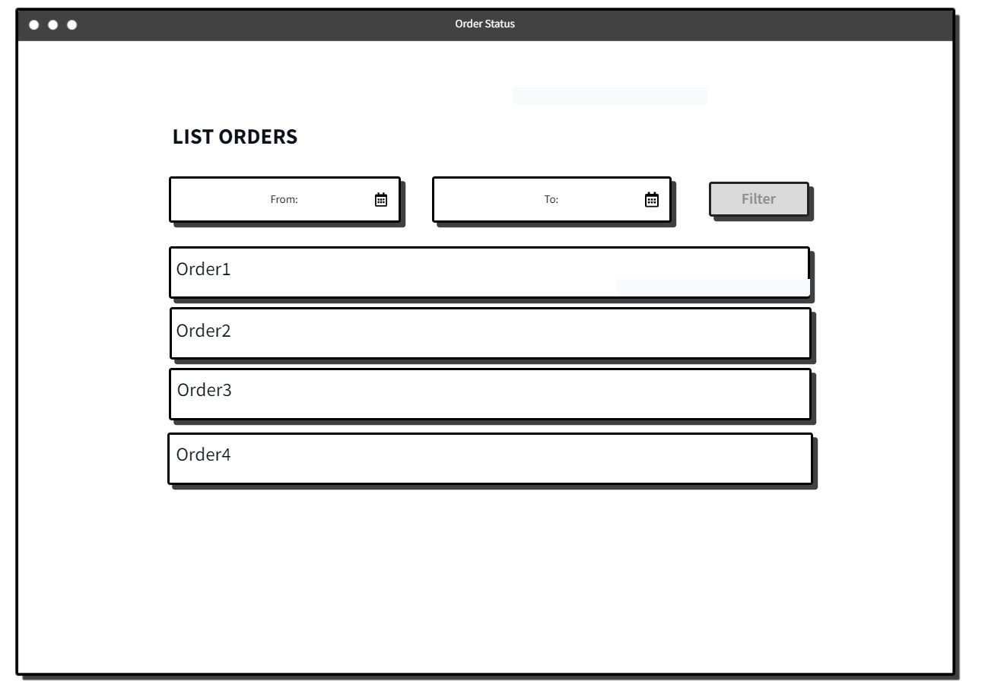

● Function Details: The user view filter his/her Orders information*.*

### 

### 

### 4. Employee Feature

### a. Product List Employee

● Function trigger: When a user logs in as Employee, the user chooses “Products List” feature

● Function description: Products list feature displays a list of all Products created on the system, Employee can search and filter product by name, color ...

● Screen layout: simulated prototype of screen, below sample is for employee setting screen.

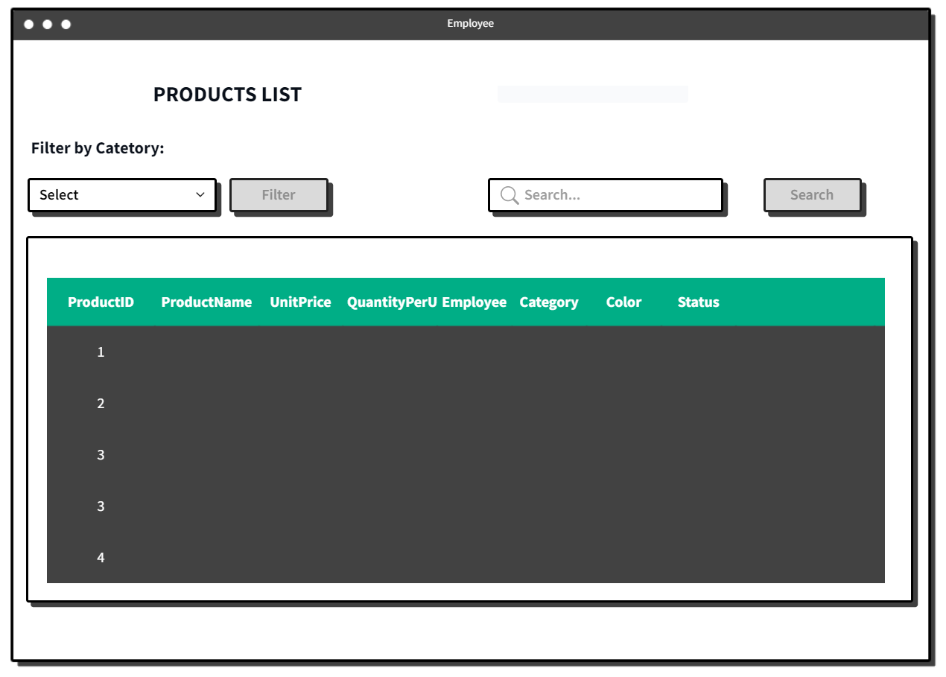

● Function Details: Allow the employee to search account name, display list product.

### b. Check All Order Status

● Function trigger: When a user logs in as Employee, the user chooses “List Orders” feature

● Function description: Orders list feature displays a list of all Orders, Employee filter Orders form date to date

● Screen layout: simulated prototype of screen, below sample is for Employee setting screen.

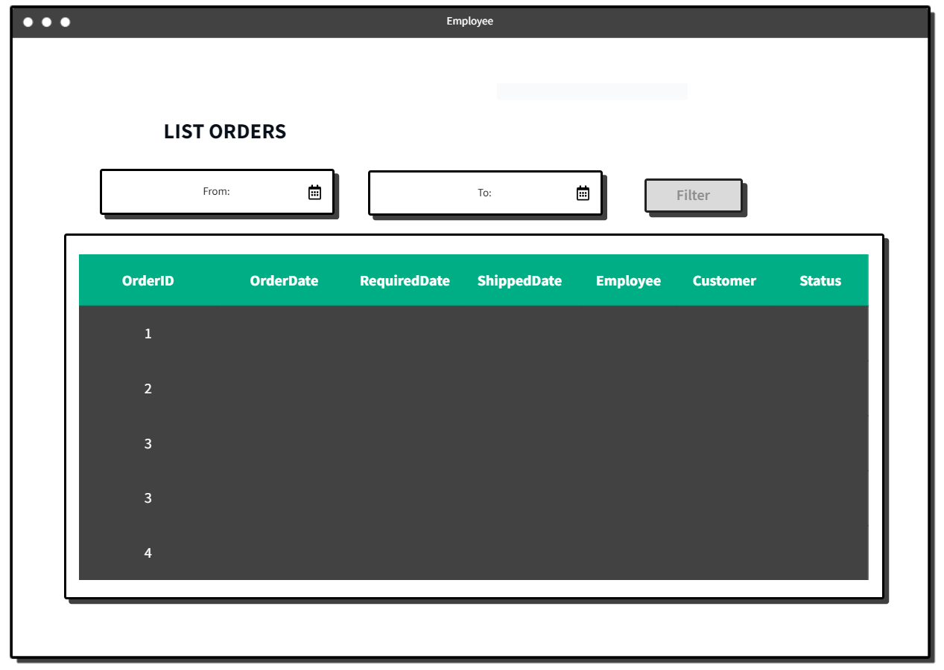

● Function Details: Allow the Employee to filter Orders, display list Orders.

## 5. Admin Feature

### a. Order List

● Function trigger: When a user logs in as Admin, the user chooses “List Orders” feature

● Function description: Orders list feature displays a list of all Orders, Admin filter Orders form date to date

● Screen layout: simulated prototype of screen, below sample is for Admin setting screen.

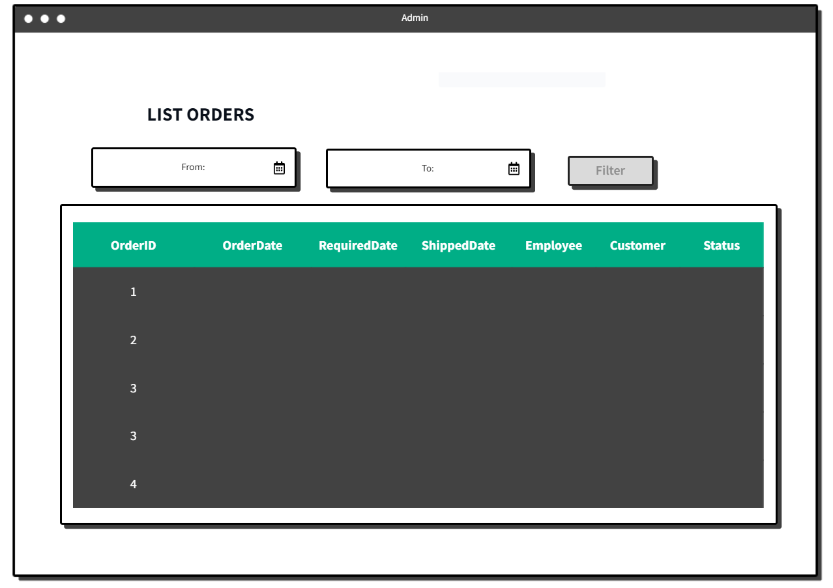

● Function Details: Allow the Admin to filter Orders, display list Orders.

### b. Product List Admin

● Function trigger: When a user logs in as Admin, the user chooses “Products List” feature

● Function description: Products list feature displays a list of all Products created on the system, Admin can search, delete and filter product by name, color ...

● Screen layout: simulated prototype of screen, below sample is for Admin setting screen.

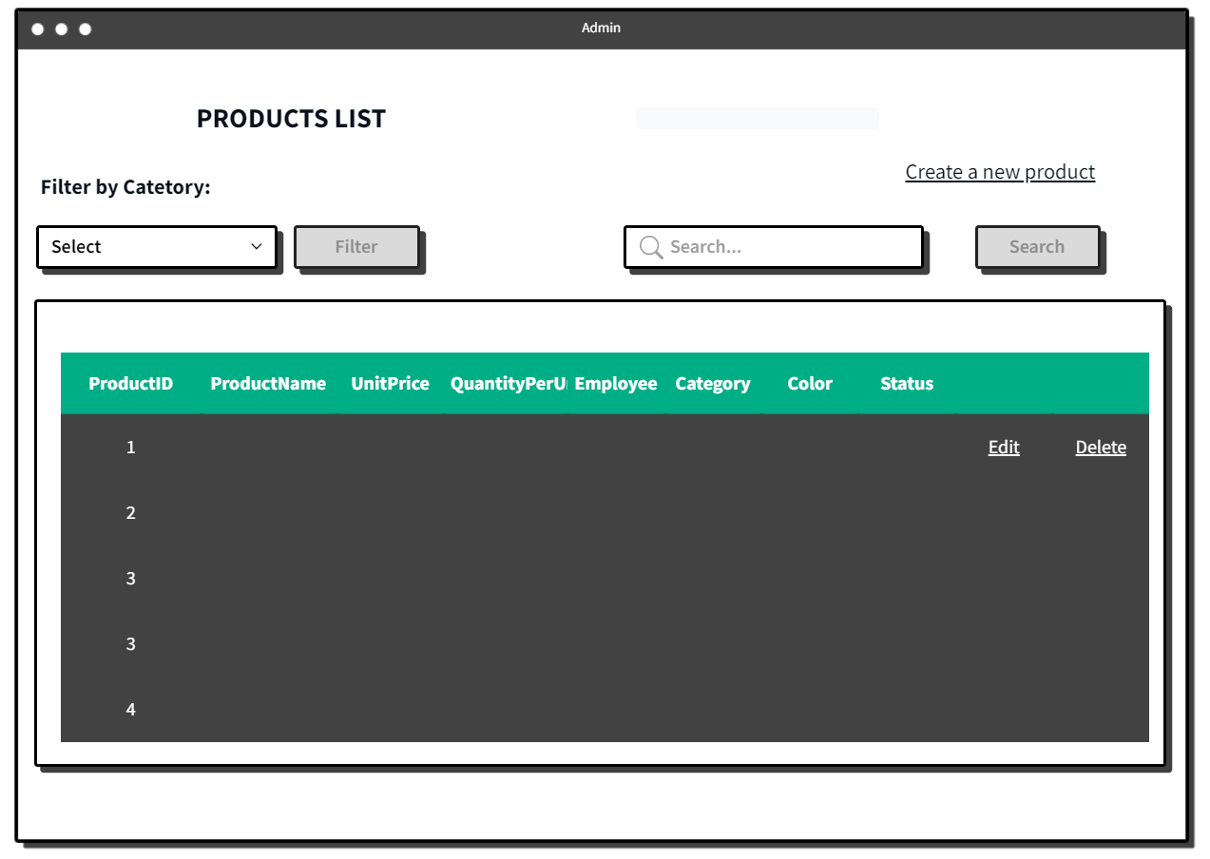

● Function Details: Allow the Admin to search account name, display list product.

### c. Edit Product

● Function trigger: When a user logs in as Admin, the user chooses “Products List” feature and click edit

● Function description: Products list feature displays a list of all Products created on the system, Admin can edit product.

● Screen layout: simulated prototype of screen, below sample is for Admin setting screen.

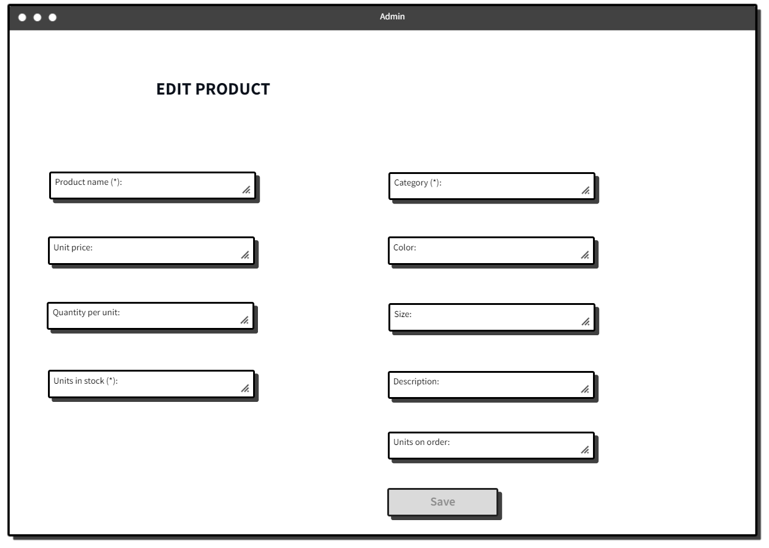

● Function Details: Allow the admin to display product and edit product.

### d. Create Product

● Function trigger: When a user logs in as Admin, the user chooses “Products List” feature and click Create a new Product

● Function description: Admin input product information.

● Screen layout: simulated prototype of screen, below sample is for dashboard screen.

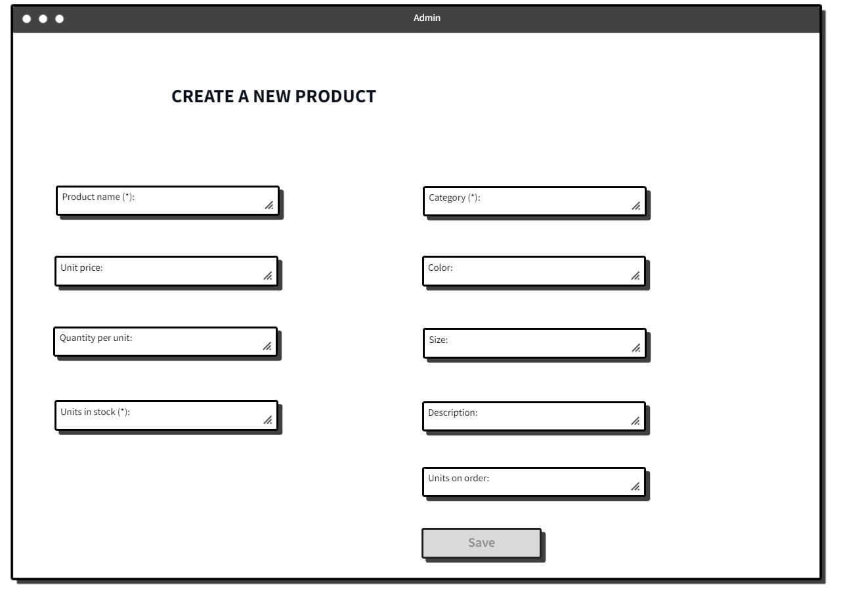

● Function Details: Allow the Admin create a new product.

### e. Customer Lists

● Function trigger: When a user logs in as Admin, the user chooses “Customers List” feature.

● Function description: Customers list feature displays a list of all Customers created on the system, Admin can search Customers by name.

● Screen layout: simulated prototype of screen, below sample is for dashboard screen.

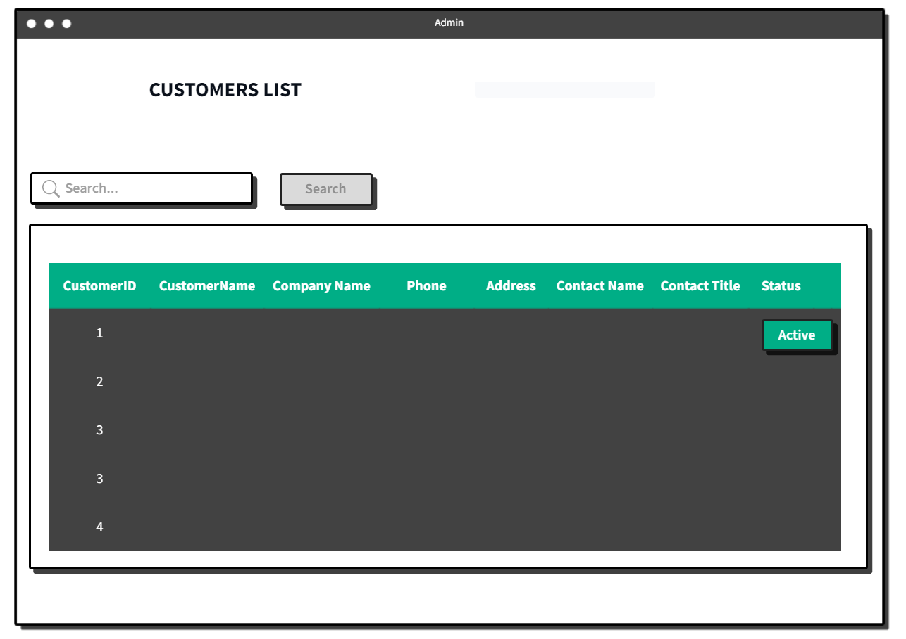

● Function Details: List of Customers in the system:

- Shown columns: Id, name, company name, phone, address...

- The Admin can search the Customers by name.

### f. Dash Boards

● Function trigger: When a user logs in as admin, the user chooses “Dash Board” . ● Function description: Show dashboard.

● Screen layout: simulated prototype of screen, below sample is for dashboard screen.

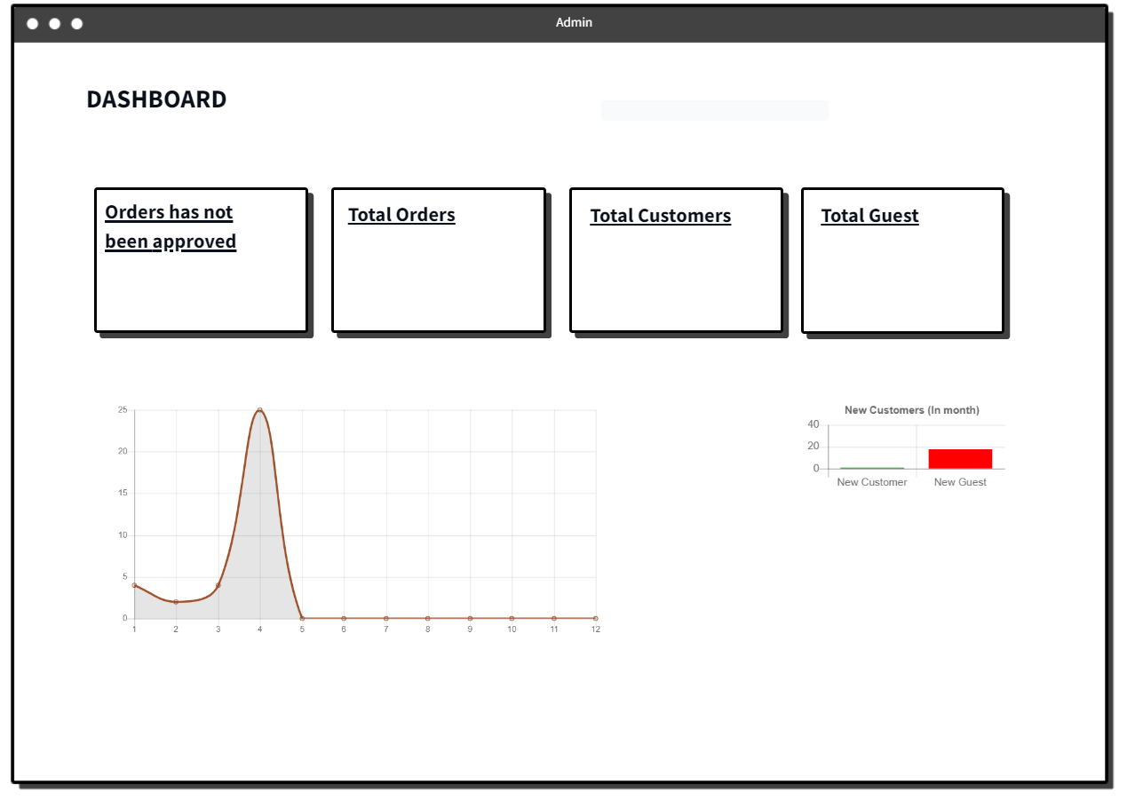

● Function Details:

- Graphs & Statistics of Customer and Guest

- Total Orders, Total Customers, Total Guest

### g. Category Lists

● Function trigger: When a user logs in as Admin, the user chooses “Category List” feature.

● Function description: Category list feature displays a list of all Category created on the system, Admin can search Category by name.

● Screen layout: simulated prototype of screen, below sample is for dashboard screen.

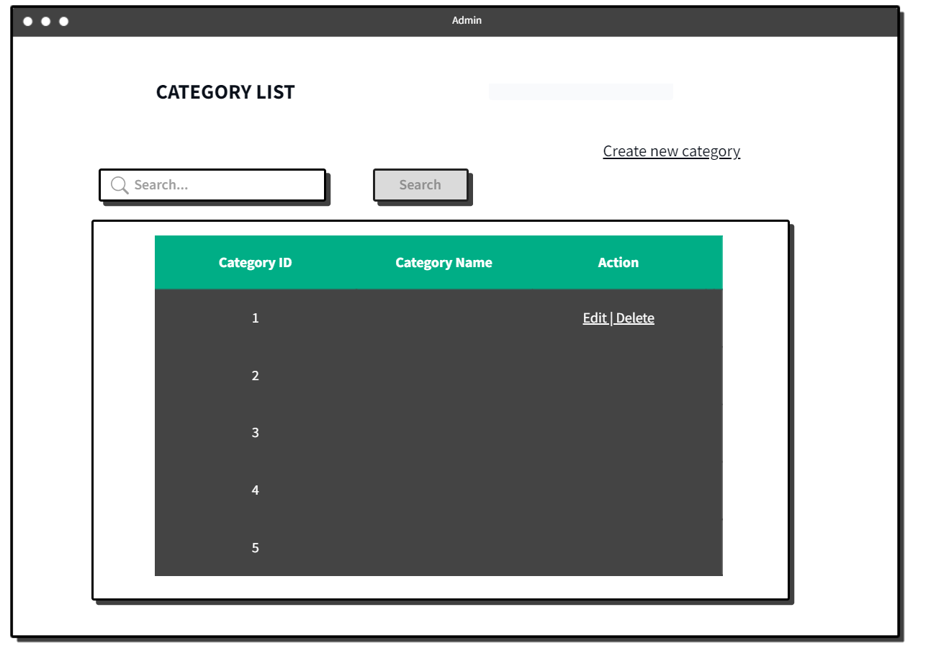

● Function Details: List of Category in the system:

- Shown columns: Id, name, action,

- The Admin can search the Category by name.