Contents
Report For Assignment 1 1
1. Introduction 1
2. Project Description 1
3. Implementation Details 1
4. Conclusion 1
5. References 2

Report For Assignment 1
Ho Minh Duc ( s3994277 )

Introduction
The Manga Store website is designed to provide a platform for manga enthusiasts to buy and sell manga as well as make special book requests. The primary objective is to create a user-friendly and engaging platform that caters to the needs of manga lovers. This report outlines the project's purpose, scope, objectives, features, implementation details, and future plans.

Project Description
The website offers the following features:
- Product listings with “Add to cart” icon price, names, the author and the gerne of those product
- Detailed product pages with price and description
- People can contact us for selling used manga and requesting specific titles
- Contact options for querries and requests
- We also have a different view for people who use phone or ipad

Implementation Details
To justify design decisions, we chose a clean and intuitive layout to enhance user experience. Requirements/features implemented:
- Shopping cart functionality: User can add products to their cart and view the cart’s content, but I haven’t created the shopping cart page, just created the add the shopping cart icon
- Product details page: Clicking on a product reveals its details, such as price and description
- Selling and Requesting Books: You can tick on the box in contact page for the reason contact like selling or want us to find the book you want

Some picture of website features:

You point at Home or anything in the picture, the will be a red line under it

When you press into the logo, you will be return back to the homepage
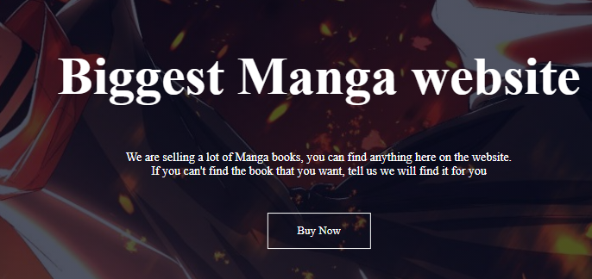
When you point or press buy now, it will turn red
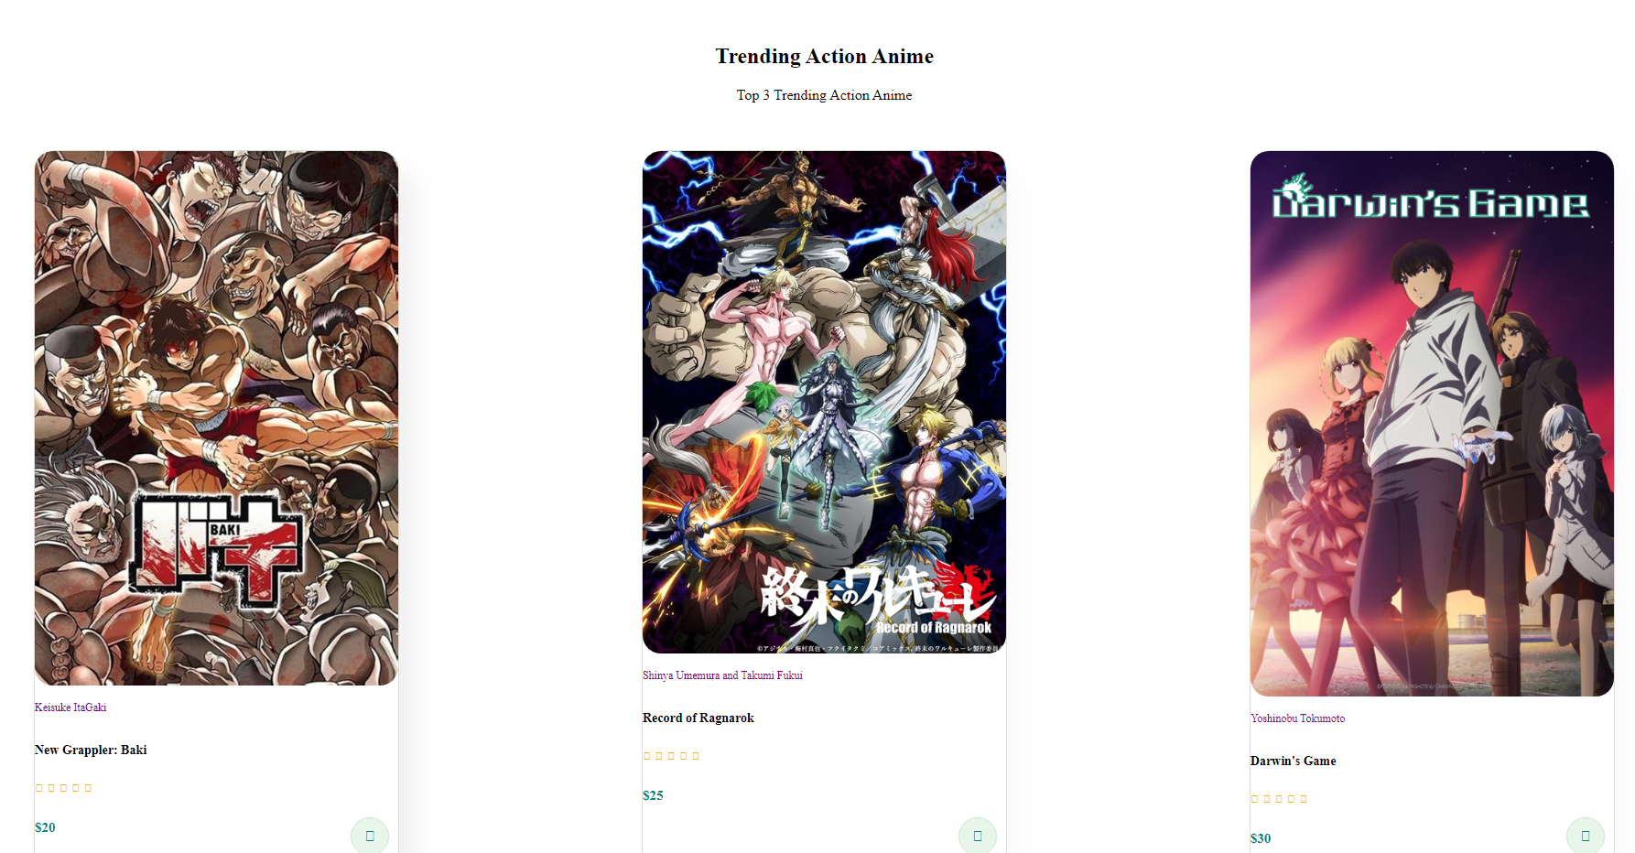
When you press into the manga, it will be direct to the detail page

When you press action manga or romance manga, it will be direct to the action manga or romance manga with different book from the first page
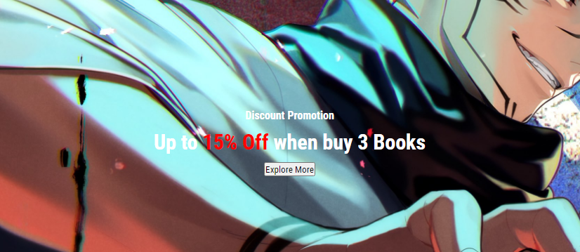
This is the banner of the website when you point at it it will turn green
You can enter email and sign up for upcoming news about manga and our shop

You can press contact us or the icons for my information

This is a video about my favourite manga and anime

When you in book details page, you can press home to go back to homepage, press action manga to go back to the subcategory page

Conclusion
While the website achieved its initial goal, there are some drawbacks. Limited testing may have led to unresolved bugs. Future enhancements include refining the user interface, enhacing the product search feature, and implementing user reviews
Inconclusion, the manga store website serves as a platform for manga enthusiasts to buy, sell, and request their favourite titles. The project aimed to demonstrate learned skills in web development while fullfilling the objectives of creating a user-friendly and engaging manga-oriented e-commerce site. With future improvements, the website can continue to evolve and cater to the needs of manga lovers

References
https://www.w3schools.com/
https://fontawesome.com/icons
https://fonts.google.com/noto/specimen/Noto+Sans+JP
https://stackoverflow.com/questions/885691/how-to-make-a-ul-display-in-a-horizontal-row

