Restaurant Automation

Restaurant Automation
Software Requirement Specification

Project Code: RA001
Document Code: RA001– v1.0

Ho Chi Minh, July 17, 2017

Record of change

*A - Added M - Modified D - Deleted
Effective Date | Changed Items | A*  M, D | Change Description | New Version
17/07/2017 | Initial | a | Add project over view

SIGNATURE PAGE

ORIGINATOR: Dương Anh Tuấn July 18, 2017

REVIEWERS: <Name> <Date>
<Position>

<Name, if it’s needed> <Date>
<Position>

APPROVAL: <Name> <Date>
<Position>
TABLE OF CONTENTS
1 Introduction 6
1.1 Purpose 6
1.2 Scope 6
1.3 Definitions, Acronyms, and Abbreviations 6
1.4 References 6
1.5 Overview 7
2 Overall Description 8
3 FUNCTIONAL Requirements 9
3.1 <The actors> 9
3.2 <The use cases> 9
3.3 <Use Cases Diagram> 9
3.3.1 <Functional Requirement one> 10
4 NON-FUNCTIONAL Requirements 11
4.1 Usability 11
4.2 Reliability 11
4.3 Performance 12
4.4 Supportability 12
4.5 Design Constraints 12
4.6 On-line User Documentation and Help System Requirements 12
4.7 Purchased Components 13
4.8 Interfaces 13
4.9 Licensing Requirements 13
4.10 Legal, Copyright, and Other Notices 13
4.11 Applicable Standards 14
5 Supporting Information 15

Introduction
[The introduction of the Software Requirements Specification (SRS) provides an overview of the entire SRS. It includes the purpose, scope, definitions, acronyms, abbreviations, references, and overview of the SRS.]
[Note: The SRS document captures the complete software requirements for the system, or a portion of the system. Following is a typical SRS outline for a project using only traditional, natural-language style requirements—with no use-case modeling. It captures all requirements in a single document, with applicable sections inserted from the Supplementary Specifications (which would no longer be needed). For a template of an SRS using use-case modeling, which consists of a package containing Use Cases of the use-case model and applicable Supplementary Specifications and other supporting information, see rup_srsuc.dot.]
[Many different arrangements of an SRS are possible. Refer to [IEEE830-1998] for further elaboration of these explanations, as well as other options for SRS organization.]

Purpose
[Specify the purpose of this SRS. The SRS fully describes the external behavior of the application or subsystem identified. It also describes nonfunctional requirements, design constraints, and other factors necessary to provide a complete and comprehensive description of the requirements for the software.]

Scope
[A brief description of the software application that the SRS applies to, the feature or other subsystem grouping, what Use-Case model(s) it is associated with, and anything else that is affected or influenced by this document.]

Definitions, Acronyms, and Abbreviations
[This subsection provides the definitions of all terms, acronyms, and abbreviations required to properly interpret the SRS. This information may be provided by reference to the project’s Glossary.]

References
[This subsection provides a complete list of all documents referenced elsewhere in the SRS. Identify each document by title, report number if applicable, date, and publishing organization. Specify the sources from which the references can be obtained. This information may be provided by reference to an appendix or to another document.]

Overview
[This subsection describes what the rest of the SRS contains and explains how the document is organized.]

Overall Description
[This section of the SRS describes the general factors that affect the product and its requirements. This section does not state specific requirements. Instead, it provides a background for those requirements, which are defined in detail in Section 3, and makes them easier to understand. Include such items as:
• product perspective
• product functions
• user characteristics
• constraints
• assumptions and dependencies
• requirements subsets]

FUNCTIONAL Requirements

<The actors>
[An Actor is someone outside the system that communicates directly with the system]
[List the actors of the system with their permissions, privileges…]
# | Main functions | Host | Busboy | Waiter | Chef | Manager
1 | View status of tables | x | x | x
2 | Change status of tables | x | x | x
3 | View available foods |  |  | x
4 | Create order |  |  | x
5 | View orders |  |  | x |  | x
6 | Add order detail |  |  | x
7 | Remove order details |  |  | x
8 | View order details |  |  | x | x | x
9 | Change status order detail |  |  | x | x
10 | Make bill |  |  | x
11 | Analysis information |  |  |  |  | x

<The use cases>
[A Use Case is a description of a complete flow of events that results in something of value to an Actor.]

System Functions | Main Use Cases | Use Case #
Functional Requirement One
 | Change table status | UC_1.1
 | Use Case Name 2 | UC_1.2
 | ……… | …….
………………………
 | ………. | …...

<Use Cases Diagram>
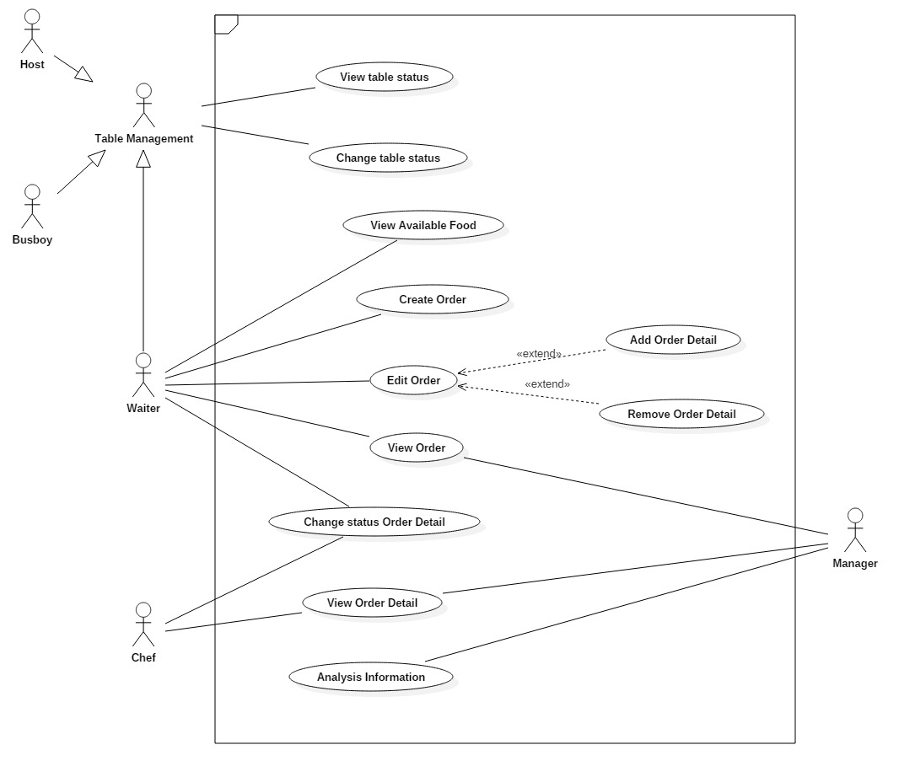
Figure 1 Overal Usecase Diagram

<Functional Requirement one>

Change table status
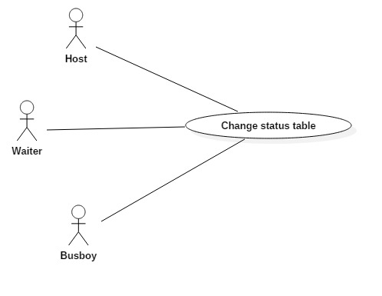
User Case ID | UC_1.1
Name | Change table status
Goal | Want to change table status
Actors | Host, busboy, waiter
Pre-conditions | User must login with role “Host” or “Bus boy” or “Waiter”
Post-conditions
Main Flow | 1. Change table status. | - Change table status in server context, database.  - Insert log change table status into database.  - Update View
Exception | 1A: if role is not correct, show error message and ask to log in again.
Open Issues | N/A

<Use Case Name 2>
…………………

NON-FUNCTIONAL Requirements
[This section describes the non-functional requirements of the system. Some examples are listed as below]

Usability
Interface elements easy to understand.
Require quick training: 15 minutes.

Reliability
System provide right tools for waiter, host, busboy and chef to work.
System provide analysis for manager.
With total production time (up and down time): 100 hours, total down time: 1 hour, number of breakdowns: 1.
Percentage of time available: 99%.
Mean time between Failures (MTBF): 99 hours
Mean time to repair (MTTR): 1 hours

Performance
- For host, busboy, waiter, and chef.
System is a real-time system with maximum delay update is 2 seconds.
Response time for a transaction: average is 15 millisecond, and maximum is 300 millisecond. It’s depend on WLAN speed and hardware of internal-server computer.
Capacity: depend on how many devices can connect to WLAN.
- For manager.
Response time for a transaction: average is 50 millisecond, and maximum is 1 second.

Supportability
The source code developed for this system is maintain in Configuration management tool.

Design Constraints
Each device of host, busboy, waiter, chef, and manager have to install a browser.
Restaurant must have a internal-server computer to run server, storage database.
Restaurant require to equiped routers to make system available.

On-line User Documentation and Help System Requirements
Not applicable.

Purchased Components
Not applicable.

Interfaces

User Interfaces
Compatible with any browser such as Google Chrome, Internet Explorer, Mozilla,…

Hardware Interfaces
Since this system need to connect to WLAN, it require user’s devices must have WIFI.
Compatible with any smart phone, tablet, and computer.

Software Interfaces
Host and Bus boy can communicate with server to get, change tables’ status.
Waiter can communicate with server to get notification.
Waiter can communicate with server to create order.
Waiter can communicate with server to add, delete order details.
Waiter can communicate wirh server to get bill.
Chef can communicate with server to get notification.
Chef can communicate with server to change status order detail.
Manager can communicate with server to get analysis about host, bus boy, waiter, chef, income, orders in a period time

Communications Interfaces
Protocol using by system is HTTP 1.0.
Port using by system is 8080.
Logical address of system is in IPv4 format.

Licensing Requirements
No licensing requirement.

Legal, Copyright, and Other Notices
Restaurant automation website must display copyright by F-soft.

Applicable Standards
Industry standards.

Supporting Information
[The supporting information makes the SRS easier to use. It includes:
Table of contents
Index
Appendices
These may include use-case storyboards or user-interface prototypes. When appendices are included, the SRS should explicitly state whether or not the appendices are to be considered part of the requirements.]

