

Zola

* **Faculty: Ho Hoan Kiem**
* **Batch:**
* **Team Member:**
  + - * **Duong Anh Tuan**

**Ho Chi Minh City, Oct 12 2017**

Table of Contents

1. Review 1

* **Problem Definition..…………………………………………………………………………………01**
* **Customer Request Specification……………………………………………………………… 02**

1. Review 2

* ***Use Case Diagram* 04**
* ***Class Diagram* 15**
* ***Sequence Diagram* 16**
* ***ERD* 18**
* ***Entity Description* 19**
* ***Table Relationship Diagram* 26**

1. Review 3

* Interface Design………………………………………………………………………………..... 27
* Site Map……………………………………………………………………………………………… 51
* Report ………………………………………………………………………………………………..53
* Tasksheet……………………………………………………………………………………………. 56

REVIEW 1

Problem Definition

1. **The Object Of The Project**

This project will aim at creation of a chatting system. It alllow you to communicate with your friends. This will be accessible to all users who have a valid Username and Password. This system provides the following facilities:

* Server side for hosting.
* Database side for storing data.
* Client side for users communicate with each orther.

Customer Request   
 Specification

1. **Functional Requirements**

Following is a list of functionalities of the system. More functionalities that you find appropriate can be added to this list.

* User must provide Username, Password, Name to create an account.
* User must provide Username, Password to login.
* User can update thei own account’s information.
* User can search orther accounts by account’s username.
* User can make friend with orther accounts after searching accounts.
* User can respone “Make friend” request.
* Notify result “make friend” request for requested account.
* User can see friend list.
* User can chat with friends.
* User can logout.

# Hardware/ Software Requirements

By adding new technologies such as ASP.NET 4.6.1, WCF, WPF and 3-layers architecture, the application becomes more interactive with users, security and easily updated.

1. **System Requirement**

* **For Users**
  + **Hardware**
    - CPU: Pentium IV 2.0 GHz or higher
    - RAM: 512 MB or higher
  + **Software**
    - OS: Windows 10
    - Environment: Microsoft .NET Framwork 4.6.1
* **For Software Developers**
  + **Hardware**
    - CPU: Pentium IV 2.0 GHz or higher
    - RAM: 512 MB or higher
  + **Software**
    - OS: Windows 10
    - Environment: Microsoft .NET Framework 4.6.1
    - Database Management System: Microsoft SQL Server 2017
    - IDE: Microsoft Visual Studio 2017

|  |  |  |
| --- | --- | --- |
| **Date: Oct 12, 2017** | **Prepared by Project Group 4**  **Team Leader: Duong Anh Tuan** | **Approved by**  **Mr Ho Hoan Kiem** |
| **Signature** |  |  |

REVIEW 2

**USE CASE DIAGRAM**



**USE CASE DESCRIPTION**

1. **Actor:**

* **Guest :** All the visitors that using application without login.
* **User:** All the persons that logined into application.

1. **Usecase:**

|  |  |
| --- | --- |
| **Usecase** | Register |
| **Short Description** | Register account to become a member of the application. |
| **Pre-Conditions** |  |
| **Post-Conditions** |  |
| **Main flow** | _Guest must provide mandatory information :   * Username. * Password. * Confirm Password. * Name.   _Guest clicks on Register button.  _System checks the information which guest provided  _System create new account for guest that registers to this application.  _Application forward to login form. |
| **Alternative flow(s)** | _If the mandatory information that guest provided, is missed or not exactly, system notifys the error. All cases are :   * Username has existed in Database. * Username is less than 3 characters. * Password is less than 5 characters. * Confirm Password and Password are not the same. * Name is blank.   _If the suplementary information that guest provided, is invalid form, system notifys the error. |

|  |  |
| --- | --- |
| **Usecase** | Login |
| **Short Description** | Guest login to become a User of the application. |
| **Pre-Conditions** |  |
| **Post-Conditions** |  |
| **Main flow** | _Guest must provide mandatory information :   * Username. * Password.   _Guest clicks on Login button.  _System checks the information which guest provided.  _System notifys User’s friend that user is online.  _Application forward to Chat form containts:  +User’s avatar.  +User’s username.  +User’s name.  +User’s list friend.  +User’s list sent make friend request.  +User’s list received make friend request.  +User’s unreaded messages. |
| **Alternative flow(s)** | _If the username and password are not correct, application show notify Login Failed. |

|  |  |
| --- | --- |
| **Usecase** | Update Informations |
| **Short Description** | User can update his/her’s informations |
| **Pre-Conditions** | Logined |
| **Post-Conditions** |  |
| **Main flow** | _User input new Name.  _User choose a gender (Male, Female).  _User Press “Update Information” Button.  _System update user’s new information.  _System notifys all user’s friend. |
| **Alternative flow(s)** | _If the mandatory information that guest provided, is missed or not exactly, application notifys the error. All cases are :   * Name is blank. * Gender is not choosed. |

|  |  |
| --- | --- |
| **Usecase** | Update Password |
| **Short Description** | User can update new password for user’s account. |
| **Pre-Conditions** | Logined |
| **Post-Conditions** |  |
| **Main flow** | _User must provide mandatory information :   * Old Password. * New Password. * Confirm Password.   _User clicks on “Update Password” button.  _System checks Old Password which guest provided.  _System update password for guest that registers to this application. |
| **Alternative flow(s)** | _If the mandatory information that guest provided, is missed or not exactly, system notifys the error. All cases are :   * New Password is less than 5 characters. * Confirm Password and Password are not the same. * Old Password is not match in database. |

|  |  |
| --- | --- |
| **Usecase** | Update Avatar |
| **Short Description** | User can update his/her’s avatar. |
| **Pre-Conditions** | Logined |
| **Post-Conditions** |  |
| **Main flow** | _User press “Browse” Button.  _Application show Open file form allow user choose an image (*.png, *.jpg, *.jpeg).  _User chooses an image and presses “Open” Button.  _Application close Open file form.  _User presses “Update Avatar” Button.  _Application transfer file into system.  _System save image and notify all user’s friend to update avatar. |
| **Alternative flow(s)** |  |

|  |  |
| --- | --- |
| **Usecase** | Search strangers |
| **Short Description** | User can search stranger’s account by it’s username. |
| **Pre-Conditions** | Logined |
| **Post-Conditions** |  |
| **Main flow** | _User press “Explore Friend” Button.  _Application show a search form.  _User type in textbox.  _System find account list that is not user’s friend, sent make friend request, received make friend request.  _Application show list account that system found contain:  +Avatar.  +Username.  +Name.  +”Make friend” button. |
| **Alternative flow(s)** |  |

|  |  |
| --- | --- |
| **Usecase** | Send make friend request |
| **Short Description** | User makes friend with orther account by send make friend request. |
| **Pre-Conditions** | Logined, Found stranger |
| **Post-Conditions** |  |
| **Main flow** | _User Press “Make friend” button.  _System updates relation in database, notifys account received make friend request. |
| **Alternative flow(s)** |  |

|  |  |
| --- | --- |
| **Usecase** | Accept Friend Request |
| **Short Description** | User can accept friend request. |
| **Pre-Conditions** | Logined, received a friend request. |
| **Post-Conditions** |  |
| **Main flow** | _Application show a form that have friend request.  _User choose a friend request and press “Accept” button.  _System updates relationship and notify sender. |
| **Alternative flow(s)** |  |

|  |  |
| --- | --- |
| **Usecase** | Chat |
| **Short Description** | User can chat with user’s friends. |
| **Pre-Conditions** | Logined |
| **Post-Conditions** |  |
| **Main flow** | _User choose an item in Friend List.  _Application show chat form for this conversation.  _User type in textbox.  _System notify choosen friend that User is typing.  _User press “Send” button.  _System saves message into database and notifys friend that received a message.  _Friend’s application show message that user sent. |
| **Alternative flow(s)** | _If friend is not online, system saves message into unreceived messages.  _If friend is online, but not chatting with User, Application show unread message number in List Friend. |

|  |  |
| --- | --- |
| **Usecase** | Logout |
| **Short Description** | User logout system. |
| **Pre-Conditions** | Logined |
| **Post-Conditions** |  |
| **Main flow** | _User close Chat form.  _System log user out, notify user’s friend that user is offline.  _Application show login form. |
| **Alternative flow(s)** |  |

**CLASS DIAGRAM**

* Host application

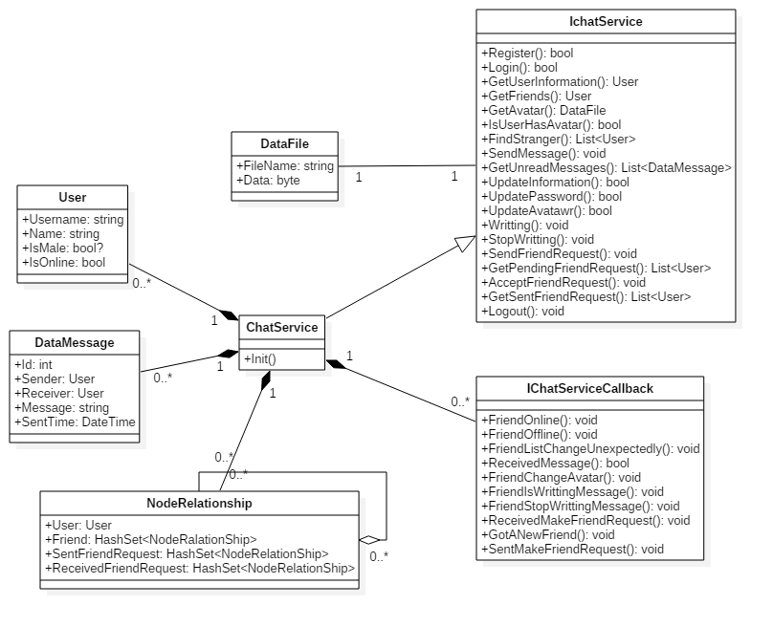

* Client Application

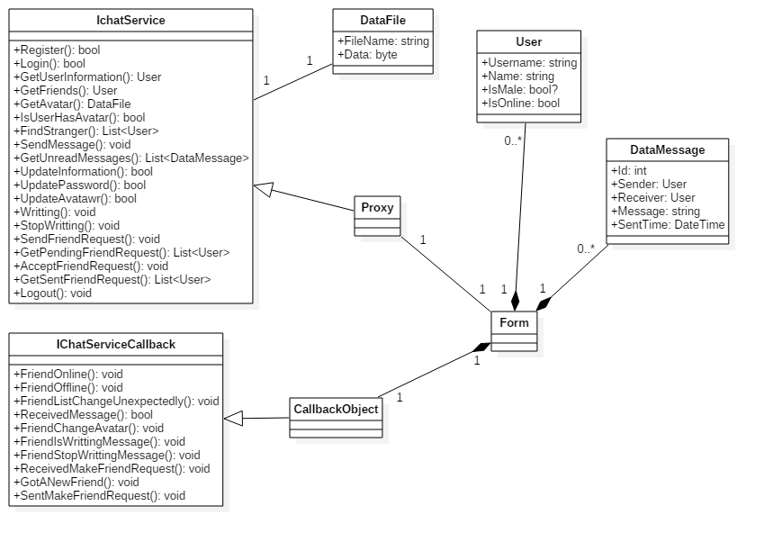

**ENTITY RELATIONSHIP DIAGRAM (ERD)**

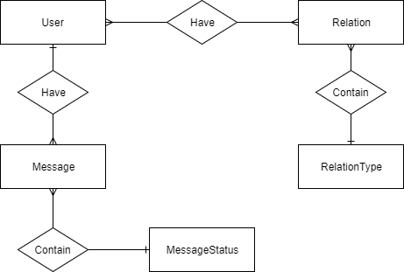

**ENTITY DESCRIPTION**

1. **User:**

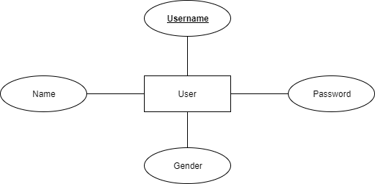

1. **Relation  
   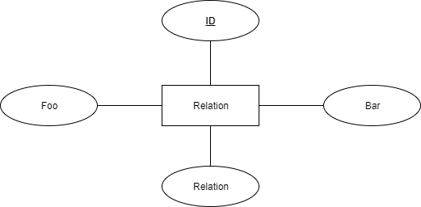**
2. **Relation Type  
   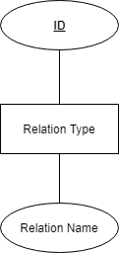**
3. **Message  
   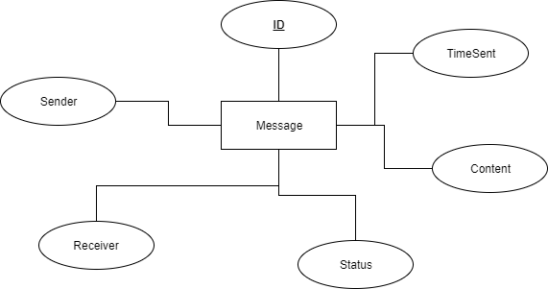**
4. **Message Status  
   MessageStatusERD**

**TABLE DESIGN**

1. **User :**

|  |  |  |  |  |  |
| --- | --- | --- | --- | --- | --- |
| **No** | **Column Name** | **Data Type** | **Size** | **Check** | **Description** |
| 1 | **🗝**Username | Varchar | 50 | Not Null | User’s Username |
| 2 | Password | Varchar | 50 | Not Null | User’s password |
| 3 | Name | Nvarchar | 100 | Not Null | User’s Name |
| 4 | Gender | Bit |  |  | User’s Gender |

1. **Relation:**

|  |  |  |  |  |  |
| --- | --- | --- | --- | --- | --- |
| **No** | **Column Name** | **Data Type** | **Size** | **Check** | **Description** |
| 1 | **🗝**Id | Bigint |  | Not Null | Relation’s Id |
| 2 | Foo | Varchar | 50 | Not Null | Username of user sent make friend request |
| 3 | Bar | Varchar | 50 | Not Null | Username of user received make friend request |
| 4 | Relation | Int |  | Not Null | Relation type id |

1. **Relation Type:**

|  |  |  |  |  |  |
| --- | --- | --- | --- | --- | --- |
| **No** | **Column Name** | **Data Type** | **Size** | **Check** | **Description** |
| 1 | **🗝**Id | Int |  | Not Null | Relation Type’s id |
| 2 | Relation_Name | Varchar | 50 | Not Null | Name of relation’s type |

1. **Messages:**

|  |  |  |  |  |  |
| --- | --- | --- | --- | --- | --- |
| **No** | **Column Name** | **Data Type** | **Size** | **Check** | **Description** |
| 1 | **🗝**Id | Bigint |  | Not Null | Message’s Id |
| 2 | Sender | Varchar | 50 | Not Null | Username of sender |
| 3 | Receiver | Varchar | 50 | Not Null | Username of receiver |
| 4 | Time_Sent | DateTime |  | Not Null | Time message is created |
| 5 | Message | Nvarchar | MAX | Not Null | Message content |
| 6 | Status | Int |  | Not Null | Message status id |

1. **Message Status:**

|  |  |  |  |  |  |
| --- | --- | --- | --- | --- | --- |
| **No** | **Column Name** | **Data Type** | **Size** | **Check** | **Description** |
| 1 | **🗝**Id | Int |  | Not Null | Message Status’s id |
| 2 | Status | Varchar | 50 | Not Null | Status name |

**Note**

**🗝** Primary key

✓ Unique constraint

**TABLE RELATIONSHIP DIAGRAM**

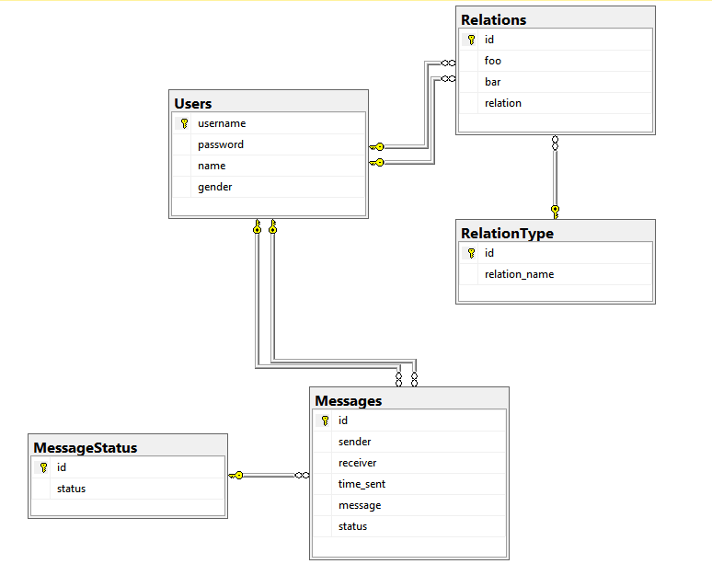

|  |  |  |
| --- | --- | --- |
| **Date: Sep 20, 2012** | **Prepared by Project Group 4**  **Team Leader:** | **Approved by**  **Mr. Ho Hoan Kiem** |
| **Signature** |  |  |

REVIEW 3

**INTERFACE DESIGN**

1. **Login Form:**

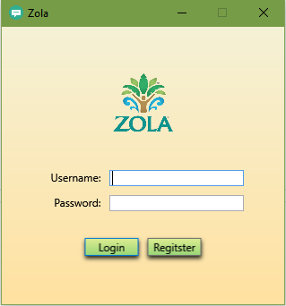

|  |  |  |  |  |  |
| --- | --- | --- | --- | --- | --- |
| **Name** | **Type** | **Event** | **Validation** | **Description** | **Status** |
| txtUsername | TextBox |  | String, not null | Input Guest’s username |  |
| txtPassword | PasswordBox |  | String, not null, | Input Guest’s password |  |
| btnLogin | Button | Click |  | Login |  |
| btnRegister | Button | Click |  | Open Register form |  |
| IP Config | ContextMenu | Right Click |  | Open Config IP dialog for server |  |

1. **Login Form:**

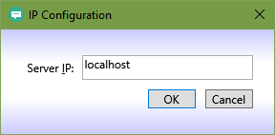

|  |  |  |  |  |  |
| --- | --- | --- | --- | --- | --- |
| **Name** | **Type** | **Event** | **Validation** | **Description** | **Status** |
| txtNewIP | TextBox |  | String, not null | Ip of server |  |
| btnOK | Button | Click |  | Save new IP |  |
| btnCancel | Button | Click |  | Canel, close form |  |

1. **Register Form:**

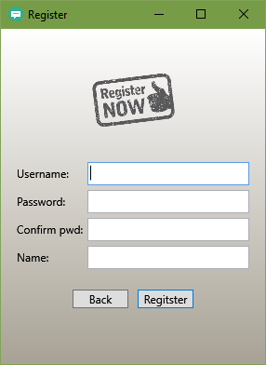

|  |  |  |  |  |  |
| --- | --- | --- | --- | --- | --- |
| **Name** | **Type** | **Event** | **Validation** | **Description** | **Status** |
| txtUsername | TextBox |  | String, not null, length > 2 | User’s Username |  |
| txtPassword | PasswordBox |  | String, not null, length > 4 | User’s Password |  |
| txtConfirmPassword | PasswordBox |  | String, not null, equal txtPassword | Confirm password |  |
| txtName | TextBox |  | String, not null | User’s Name |  |
| btnBack | Button | Click |  | Cancel, close form |  |
| btnRegister | Button | Click |  | Register, close form |  |

1. **Welcome Form:**

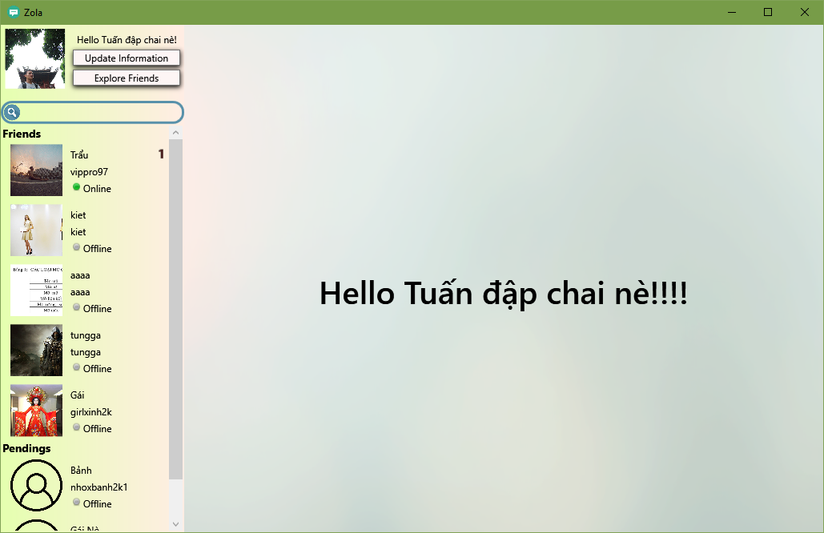

|  |  |  |  |  |  |
| --- | --- | --- | --- | --- | --- |
| **Name** | **Type** | **Event** | **Validation** | **Description** | **Status** |
| btnUpdate | Button | Click |  | Update Informations |  |
| btnExploreFriend | Button | Click |  | Find Friends |  |
| lvUsers | ListView | Click |  | Friend List, Sent request list, Received request List. |  |
| txtSearch | Textbox | Change |  | Filter List user |  |

1. **Chat Form:**

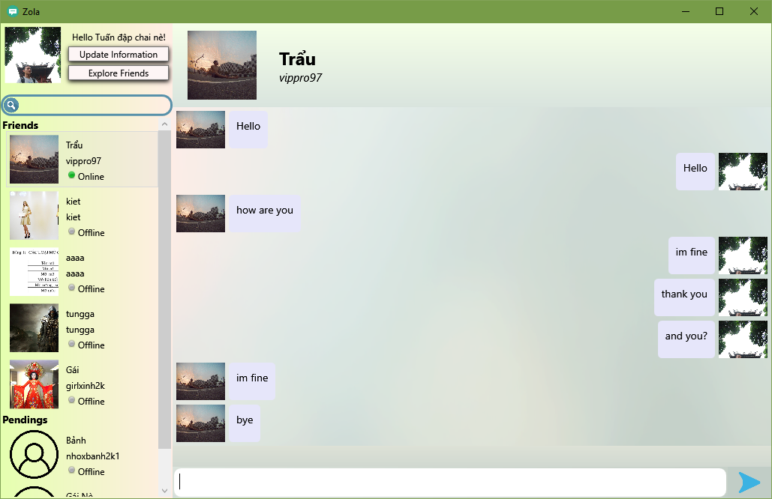

|  |  |  |  |  |  |
| --- | --- | --- | --- | --- | --- |
| **Name** | **Type** | **Event** | **Validation** | **Description** | **Status** |
| txtMessage | TextBox | TextChange | String, not null | Message content to be sent |  |
| btnSend | Button | Click |  | Send message |  |

1. **Received Message Form:**

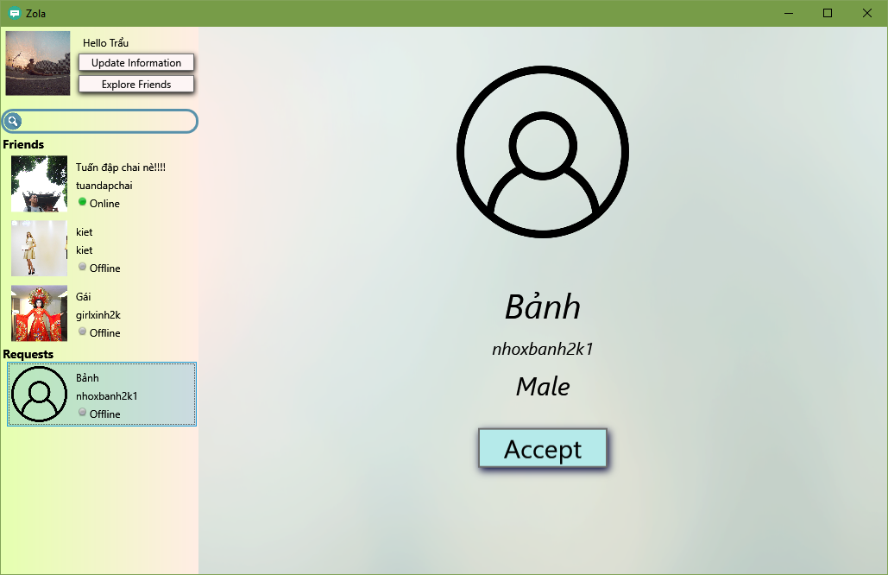

|  |  |  |  |  |  |
| --- | --- | --- | --- | --- | --- |
| **Name** | **Type** | **Event** | **Validation** | **Description** | **Status** |
| btnAccept | Button | Click |  | Accept Friend Request |  |

1. **Update Form:**

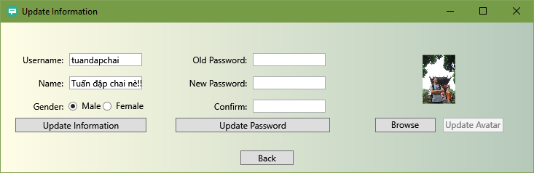

|  |  |  |  |  |  |
| --- | --- | --- | --- | --- | --- |
| **Name** | **Type** | **Event** | **Validation** | **Description** | **Status** |
| txtUsername | TextBox |  |  | Read only, user’s username |  |
| txtName | Textbox |  | String, not null | User’s name |  |
| rbMale | RadioButton |  |  | Choose gender is male |  |
| rbFemale | RadioButton |  |  | Choose gender is female |  |
| btnUpdateInformation | Button | Click |  | Update new information |  |
| txtOldPass | PasswordBox |  | String | Old Password |  |
| txtNewPass | PasswordBox |  | String, length > 4 | New Password |  |
| txtConfirmPass | PasswordBox |  | String, equal txtNewPassword | Confirm new password |  |
| btnUpdatePassword | Button | Click |  | Update Password |  |
| btnBrowse | Button | Click |  | Show open file dialog to choose image |  |
| btnUpdateAvatar | Button | Click |  | UpdateAvatar |  |
| btnBack | Button | Click |  | Close Update form |  |

1. **Find Strangers Form:**

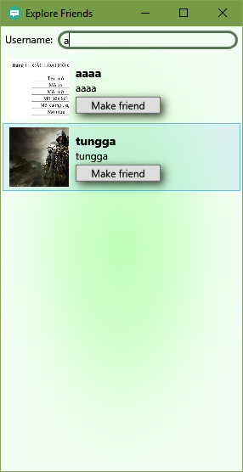

|  |  |  |  |  |  |
| --- | --- | --- | --- | --- | --- |
| **Name** | **Type** | **Event** | **Validation** | **Description** | **Status** |
| txtUsername | Textbox |  |  | Username of stranger’s account to find |  |
| btnMakeFriend | Button | Click |  | Button for each item List view to send friend request |  |

1. **Notification Error:**

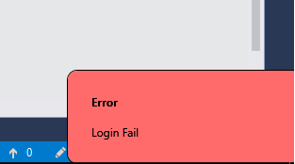

1. **Notification Info:**

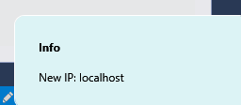

**TASK SHEET**

|  |  |  |  |  |  |  |
| --- | --- | --- | --- | --- | --- | --- |
| **Project** | | **Project Title**  **Zola Projeck** | | **Date of Preparation** | | **Activity Plan Prepared by Duong Anh Tuan** |
| **No** | **Task Title** | | **Planned Start Date** | **Planned Completed Date** | **Team Mate Names** | **Status** |
| 1 | Review 1 | | Oct 12, 2017 | Oct 12,2017 | **Duong Anh Tuan** | Completed |
| 2 | Review 2 | | Oct 25, 2017 | Oct 25, 2017 | **Duong Anh Tuan** | Completed |
| 3 | Review 3 | | Oct 20, 2017 | Nov 5,2017 | **Duong Anh Tuan** | Completed |

|  |  |  |
| --- | --- | --- |
| **Date: Nov 5, 2017** | **Prepared by Project Group 4**  **Team Leader:** | **Approved by**  **Mr. Ho Hoan Kiem** |
| **Signature** | **Duong Anh Tuan** |  |