PROFESSIONAL PROFILE

1. Professional Profile

1.1. Teacher Identity
My name is Nguyen Thi Lan Nhi, and I am about to graduate in the next few months and currently preparing for my professional career as an English teacher. Although this is just the beginning of my teaching journey, my experiences as both a tutor and a teaching assistant have allowed me to recognize my teaching philosophy and preferences.
Last year, I tutored a ninth-grade student to consolidate her English and help her prepare for the High School Entrance Exam. To support her, I prepared personalized lesson plans and exercises based on her weaknesses and learning needs. After one month, she eventually gained admission to her dream high school. This experience became a source of motivation for me because I realized I had effectively delivered essential knowledge for my student. After that, I worked as a Teaching Assistant at an English Center for seven months. This was a useful experience for me as it allowed me to develop my teaching skills, including classroom management, interaction with students, and understanding different learning styles. More importantly, it helped me recognize my teaching philosophy: “Ensuring understanding for all.” I strongly believe that every student has different learning speeds and abilities, so the role of a teacher is to provide appropriate support and guidance for all students so that no one falls behind in the learning process. My teaching philosophy was reflected by the fact that I often spent break time re-explaining lessons to students, especially those who needed extra support. I also provided additional exercises and communicated with parents to seek cooperation to ensure the best effective learning experience for the students. As a result, my students made considerable progress and that I consistently received positive feedback from the parents fostered me to try harder.

1.2. Goal for Development
In the future, my goal is to open a small-scale English center, aiming at IELTS, with around four to eight students each class because I desire to carefully monitor my students’ learning progress. I am particularly interested in teaching IELTS because I enjoy exam-oriented teaching and academic learner development. I find it greatly motivating when my students make gradual progress, and especially when they achieve their target scores. In addition, I believe I work more effectively with adolescent and young adult learners because they are generally more aware of their learning responsibilities. As a result, I can focus deeply on delivering academic knowledge and giving feedback for improvements rather than wasting a significant amount of time on behavioral and classroom management. I believe this teaching environment is particularly suitable for my teaching philosophy and preferences.
To achieve this ultimate goal, I believe I need to improve several professional development areas, including subject-matter knowledge, pedagogical expertise, and career advancement. Firstly, my current priority is to strengthen my subject-matter knowledge by achieving an overall IELTS score of 8.0, which is an obligatory professional requirement for an IELTS teacher. Therefore, I am currently studying IELTS at an English center and spending a significant amount of time analyzing different IELTS question types and effective ways to approach them.
At the same time, I also want to develop my pedagogical expertise by applying to become an IELTS Teaching Assistant. Through this experience, I believe that I can observe IELTS teaching procedures, observe teacher feedback techniques, understand common learner difficulties, and become more familiar with IELTS classroom practices. This practical experience will help me gradually develop more effective teaching strategies, classroom management skills, and learner support techniques which are extremely important to operate an effective classroom.
After gaining sufficient teaching skills and subject-matter knowledge, I desire to apply for an IELTS teaching position in order to better strengthen my teaching expertise and become more accustomed to managing IELTS classes. In the long term, as I know that operating an IELTS-oriented English center also requires the ability to design logical and systematic lesson plans, syllabi, and teaching materials, I hope to pursue a master’s degree related to this field to further develop my professional knowledge and support my future career advancement.

DEVELOPMENT PROCESS

2. Development Process

2.1. Observation Report
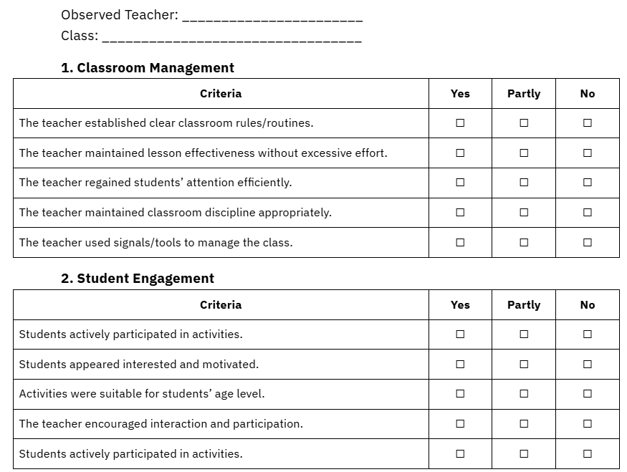
One of the most significant insights that I gained while working as a Teaching Assistant at an English center was related to teacher sustainability. The first class that I was assigned to as a Teaching Assistant was a kid class whose students ranged from age three to five. Initially, the first lead teacher was extremely friendly and committed to creating a comfortable and enjoyable learning environment for the students. She treated them with great care and often adjusted activities according to their preferences in order to maintain their engagement and participation during the lesson. As a result, many students actively enjoyed attending her classes.
However, after several sessions of observation, I gradually noticed some limitations of this teaching approach. I noticed that consistently drawing students’ engagement through continuous interaction required a significant amount of physical and emotional energy from the teacher, which may lead to burnout. In some situations, students became overly excited and paid less attention to the learning objectives of the lesson. Hence, it became difficult for the teacher to manage the classroom, which reduced the effectiveness of lesson delivery.
One month later, another lead teacher took over the class, and her teaching approach was greatly different from the former one. Instead of relying heavily on constant interaction and entertainment, she focused strongly on establishing classroom disciplines and behavioral expectations from the very beginning. During the first lesson, she spent time training students to follow instructions, and remain attentive. She also used simple but effective classroom management techniques, such as counting signals from one to ten and a small bell, to manage students’ attention and conduct activities efficiently without putting excessive effort in the long term. As a result, she was able to maintain her energy throughout the day. More importantly, students were able to participate more actively and consistently in learning activities, which improved the overall effectiveness of the lesson.

2.2. Reflection
Through this observation, I began reflecting on my own understanding of effective teaching. Before this experience, I used to believe that a good teacher should always try to make all the students happy and like them. In order to achieve this, I believed that teachers should create, similar to the first teacher, a highly comfortable, entertaining, engaging, and emotionally supportive learning atmosphere. Previously, since I had received feedback that I did not seem approachable or naturally likable enough, I attempted to make a consistent effort to look more friendly, amiable, and emotionally available to students during lessons so that they could feel comfortable reaching out to me whenever they needed to.
However, in reality, this approach did not make me feel comfortable. I was under pressure to continuously adjust my personality and devote a lot of physical and emotional energy in order to maintain students’ engagement and satisfaction. As time passed, I gradually became emotionally exhausted and even started losing interest in the teaching profession because I felt under continual pressure to not only satisfy students but also to ensure lesson effectiveness. Because of this belief, I considered my personality as a weakness in the teaching career and believed that an effective teacher should always be emotionally engaging and highly energetic in the classroom.
However, after a long period of time observing the second teacher, my perspective about this matter gradually changed. Although she was stricter and received some negative feedback from students who felt her classes were less enjoyable, or who were afraid of her, she was able to maintain her energy, lesson effectiveness, and enthusiasm throughout her years of teaching. More importantly, I realized that she was not unfriendly or uncaring toward students. Instead, she created clear professional boundaries between teachers and learners, which enabled her to manage the classroom effectively without experiencing emotional overload. Rather than having friendly conversations with students, she spent more time providing personalized feedback and practical suggestions for improvement. which were extremely beneficial to their learning progress.
This observation helped me realize that it is extremely challenging, or even impossible, to satisfy every student emotionally. As it takes an unrealistic amount of effort and energy to maintain constant entertainment, emotional engagement, as well as lesson effectiveness, and teaching sustainability, a teacher cannot handle every aspect of teaching at the same time. As a result, I eventually understood that effective teaching is more than simply making the lessons engaging or trying to make students like the teacher. Rather, it also involves creating sustainable teaching practices that allow teachers to maintain their effectiveness and mental well-being over time.
As a result of this experience, I now have a much clearer understanding of the kind of teacher that I hope to become in the future. Even though supportive interaction with learners and a positive learning environment are still emphasized, I no longer think that a teacher must sacrifice their emotional energy in order to satisfy every student. Instead, I hope to gradually develop a teaching style similar to the second teacher’s approach by setting clearer classroom rules which can help to reduce unnecessary energy while still providing support for learners. I now understand that, just like students do, different teachers have different personalities and teaching styles. Therefore, instead of forcing myself to become a teacher whose personality does not make me feel comfortable, I hope to develop a teaching approach that feels more natural for my personality while still enabling me to effectively deliver knowledge to the students and maintain my energy and enthusiasm. In the long term, I believe this balance will help me become a more effective and emotionally stable educator.
Although I later realized that teaching young learners did not suit closely with my long-term teaching preference, this observation still provided me with valuable insights into classroom management, emotional involvement, and sustainable teaching practices.

WORKSHOP EVALUATION

3. Workshop
Overall, the workshop was highly practical and engaging because it introduced a variety of classroom activities that can be directly applied in English language teaching contexts. Also, it met nearly all the criteria for a successful workshop, including being short-term, intensive, practical, and collaborative. The workshop was conducted within four hours, an ideal time allocation. Furthermore, all the necessary information was delivered clearly, and attendees were not required to seek additional information before or after participating in the workshop. The topic was focused enough for all attendees to have opportunities to experience the activities introduced in the workshop. It was also highly relevant because it addressed one of the common concerns faced by students at this stage, especially those preparing to enter the teaching profession. More importantly, the workshop involved consistent interactions between the host and attendees and also between attendees themselves which made it more engaging for participants.
Regarding the design of the workshop, the session was logically organized and covered a wide range of classroom activities. There were six activities introduced in total, and each was useful for different language skills and aspects. It was also useful that a teacher can apply for various learning styles and ages. For example, for the warm-up stage, a teacher can use a variety of icebreakers such as “Line Up,” “Two Truths and a Lie,” and “What is Your Strangest Talent?” which effectively created a comfortable and energetic learning atmosphere. These activities also demonstrated how teachers can encourage communication and reduce learners’ anxiety at the beginning of lessons. After that, the presenter gradually moved to activities focusing on different language skills, including listening, grammar, reading, writing, and speaking. This order allowed participants to follow the workshop effectively and observe how different activities can be applied in English language classrooms. For each activity, the presenter acted as the teacher while the attendees took the role of students so that participants could better understand how the activities worked in the actual classroom and how to give clear instructions effectively.
In terms of the presenter, Dr. Võ Thị Nữ Anh showed strong professionalism and practical teaching experience throughout the workshop. The instructions for each activity were generally clear and easy to follow. As a result, participants could follow the workshop easily and also learn effective ways of giving classroom instructions through observing how she conducted the activities. In addition, she was highly supportive in providing feedback and answering participants’ questions whenever difficulties or confusion appeared during the activities.
Concerning resources, the workshop provided various useful and adaptable classroom activities that can be applied to different learner groups and teaching contexts. For example, the jigsaw reading activity successfully integrated reading, listening, and speaking skills, while the strip story activity effectively developed students’ understanding of coherence and paragraph organization in writing. Similarly, the Inside-Outside Circles activity was particularly useful for promoting learner interaction and maximizing speaking opportunities in large classrooms. These activities were practical because they required relatively simple materials while still creating meaningful learner engagement.
Most importantly, the workshop was particularly meaningful for me because it addressed one of the most challenging parts that I am currently worrying about as a beginning teacher. Since I still lack practical teaching experience, I often struggle to find suitable classroom activities and effective ways to maintain students’ engagement during lessons. Therefore, the workshop provided me with many practical activity ideas that I may use in my future classrooms to create a more active and communicative learning environment. Most activities can be adapted to different age groups, proficiency levels, and lesson objectives.
Therefore, I found the workshop particularly valuable because it provided practical ideas that I may apply in my future classrooms to increase learner participation and interaction in the EFL classroom.

REFLECTION

4. Reflection
The subject Professional Development for Language Teachers has had a significant impact on me, including personal and professional respects. Rather than simply providing theoretical knowledge about teaching practice as other previous subjects, this course serves as a valuable opportunity for me to pause and reflect deeply on myself, including my past experiences, present situation, and future professional direction. Before taking this course, although I already had some teaching and teaching assistant experience, I was still extremely bewildered about what kind of teacher I truly wanted to become and what exactly area of teaching that I wanted to pursue.
Through the portfolio-building process, I could step back and carefully analyze what I had gone through during the time working as a tutor and teaching assistant. By doing this, I can better understand what my teaching philosophy and preferences are, what I enjoy in teaching, and what I feel comfortable and uncomfortable with. And more importantly, one of the most impressive parts that I have obtained through the course was the lecturer’s statement that no working environment is completely relaxing, the key point here is which area you can suffer from. It served as a wake-up call for me, since I had kept looking for a workplace with as little workload as possible, and the only requirement for me while teaching is just to teach and go home which is not realistic at all. I now realize that part of the problem came from my tendency to remain in my comfort zone and do not dare to challenge myself. For example, I realized that I highly value learner understanding, close learner support, and meaningful academic progress rather than simply maintaining entertainment or emotional satisfaction in the classroom. At the same time, I also became more aware of the teaching contexts that may emotionally exhaust me in the long run and the importance of establishing sustainable teaching practices and professional boundaries.
In addition, this course also helped me recognize both my strengths and weaknesses more clearly. I realized that one of my strengths is my strong sense of responsibility and commitment to supporting students’ learning progress. However, I also recognized that I sometimes become overly emotionally invested in students’ learning outcomes, which may eventually lead to emotional exhaustion if I do not learn how to manage my energy and expectations more effectively. Therefore, the course encouraged me to think more critically about the type of teacher I hope to become and the professional skills that I still need to develop in the future. I now better understand the importance of managing my energy appropriately in teaching.
Most importantly, this subject helped me establish a clearer long-term professional goal and a more realistic developmental pathway to achieve it. Previously, I often felt confused and uncertain about my future career direction. I had not clearly identified the career path that I genuinely wanted to pursue. My thoughts were wandering around numerous options, including a tour guide, an English teacher, or a hotel receptionist. However, through the process of reflection and professional development planning, I realized that it was my weakness that I did not dare to confront the real situation, and I gradually identified my long-term goal of becoming an IELTS teacher and eventually opening a small-scale IELTS-oriented English center. At the same time, I also became more aware of the areas that I need to improve, including subject-matter knowledge, pedagogical expertise, and career advancement.
Overall, I believe this course was particularly important as it helped me better understand myself as a future educator. Rather than providing knowledge about teaching fields, these sessions functioned as a period of reflection during which I was able to listen to myself more carefully, helping me sharpen my own teaching identity, values, strengths, limitations, and long-term professional orientation.

Tab 5

Observed Teacher: _______________________
Class: _________________________________

1. Classroom Management
Criteria | Yes | Partly | No
The teacher established clear classroom rules/routines. | ☐ | ☐ | ☐
The teacher maintained lesson effectiveness without excessive effort. | ☐ | ☐ | ☐
The teacher regained students’ attention efficiently. | ☐ | ☐ | ☐
The teacher maintained classroom discipline appropriately. | ☐ | ☐ | ☐
The teacher used signals/tools to manage the class. | ☐ | ☐ | ☐

2. Student Engagement
Criteria | Yes | Partly | No
Students actively participated in activities. | ☐ | ☐ | ☐
Students appeared interested and motivated. | ☐ | ☐ | ☐
Activities were suitable for students’ age level. | ☐ | ☐ | ☐
The teacher encouraged interaction and participation. | ☐ | ☐ | ☐
Students actively participated in activities. | ☐ | ☐ | ☐

