GLAMPRO ENHANCEMENT SPECIFICATION
Package Commission – Sale & Redemption Tracking
Research, business rules, workflow diagrams, data model and screen changes for verification
Item | Detail
Document version | v0.9 – DRAFT FOR VERIFICATION
Date | 26 October 2026
Product | Glampro Suite (glampro.tusphere.com)
Reference salon | Eurosense Hair Studio Pte Ltd – September 2026 salary sheets (Alvin / Chang Kah Weng, Stella)
Prepared for | Kenny Eng (owner) · Glampro project team (Aridient)
Status | Workflow & rules to be confirmed by owner before development (see Section 13)

Contents

Right-click the table and choose “Update field” in Word if page numbers are not shown.

1. Executive summary
Eurosense pays commission on packages twice: once to the consultant who sells the package, and again to the therapist who performs each session when the customer comes back (“course service” / “on course service” in the salary sheets). Rates differ per staff and per commission type, and are worked out manually in Excel every month.
Glampro already has a solid commission rule engine (effective-dated rules, item → department → staff → company precedence, change reasons) but it only covers Services and Products. Packages are sold and redeemed, yet no commission is attributed to either the seller or the performing therapist.
This specification extends Glampro so that:
- Package sale commission is credited to the “Sold by” staff (with optional split) on the amount collected – including deposits and instalments.
- Package redemption commission is credited to the “Performed by” therapist every time a session is used, on a session value snapshot (net price paid ÷ sessions) taken when the package was bought.
- Admins change % rates in one Commission matrix screen (staff × commission type) with an effective date and reason – no code or spreadsheet changes. A package can override the rate when needed.
- Every commission event is written to an auditable Commission ledger, which feeds a month-end Commission & payroll report that reproduces the current Excel salary sheet, including the Payroll/Sales ratio.
- Refunds, transfers, family sharing, expiry and value (stored-credit) packages are handled by explicit rules.

Recommended model (industry practice): Seller earns on the package sale; therapist earns per session redeemed, valued at the discounted session value. This is how Zenoti, Meevo and Pabau support it and matches Eurosense’s current practice.
Key decisions needed from owner: Section 13 (e.g. sale commission on amount collected vs. full package value, clawback policy, redemption before full payment).

2. Current practice – analysis of September 2026 salary sheets
The two sheets supplied were re-calculated to confirm how commission is computed today. All figures reconcile to the cent.

2.1 Alvin (Chang Kah Weng) – 1 to 30 Sep 2026
Commission line (sheet label) | Base (S$) | Rate | Commission (S$) | Glampro commission type
Packages | 6,671.00 | 8% | 533.68 | Package sale
Cash Service | 159.00 | 8% | 12.72 | Service
(sheet shows Packages + Cash Service merged) | 6,830.00 | 8% | 546.40
On course Service | 8,985.50 | 7% | 628.99 (628.985) | Package redemption
Product | – | 10% | 0.00 | Product
F.O.C | 492.00 | 5% | 24.60 | FOC service
Total | 16,307.50 |  | 1,199.99

Salary component | S$
Basic salary | 2,000.00
Minus 2 days unpaid leave | not deducted on sheet (0.00)
Total commission | 1,199.99
Overtime | 0.00
Total take-home salary | 3,199.99
FWL borne by company | 800.00
Total collection (6,330.00 + deposit 300.00) | 6,630.00
Payroll/Sales = (3,199.99 + 800.00) ÷ 6,630.00 | 60.3% (sheet: 60%)

2.2 Stella – September 2026
Commission line (sheet label) | Base (S$) | Rate | Commission (S$) | Glampro commission type
Cash Service | 1,087.00 | 10% | 108.70 | Service
Course Service | 12,071.84 | 10% | 1,207.18 | Package redemption
Products | 78.00 | 10% | 7.80 | Product
Others – FOC | – | 5% | 0.00 | FOC service
Package | 9,256.31 | 7% | 647.94 | Package sale
Total commission |  |  | 1,971.62

Salary component | S$
Salary (incl. fixed OT line) | 2,200.00
Total commission | 1,971.62
Incentive | 50.00
Total take-home salary | 4,221.62
FWL borne by company | 400.00
Total cash collection (package 8,688.00 + service 1,087.00 + product 78.00) | 9,853.00
Payroll/Sales = (4,221.62 + 400.00) ÷ 9,853.00 | 46.9% (sheet: 47%)

2.3 Findings that shape the design
- Hybrid model is in use: package sale commission (7–8%) to the seller plus redemption (“course service”) commission (7–10%) to the performing therapist.
- Rates are per staff and per type: Alvin earns 8% on package sales but 7% on redemptions; Stella is the reverse (7% sale, 10% redemption). The system must therefore support a different rate per staff × commission type – a grid is the natural UI.
- Sale commission base is the package sales value, not cash collected: Alvin’s package base (6,671.00) ≠ his collection (6,630.00); Stella’s package base (9,256.31) ≠ package cash collected (8,688.00). Owner to confirm which basis to adopt in Glampro (Section 13).
- Redemption base is the value of sessions used (8,985.50 / 12,071.84) – this requires a per-session value stored on each package holding.
- FOC services earn 5% of their value – needs its own commission type.
- Payroll/Sales ratio = (take-home + FWL levy) ÷ total collection is the KPI the owner tracks; the report should compute it automatically.
- Rounding: 8,985.50 × 7% = 628.985 → 628.99 – rounding is applied on the category subtotal (half-up), not per line.
Data quality notes on the supplied sheets (for owner’s attention):
• Stella’s sheet header says September but the date cell shows 31-Aug-26 and the OT period says 1–31 August 2026.
• Alvin’s sheet lists “Minus 2 days unpaid leave” but the salary stays at 2,000.00 – no deduction was applied.
• Stella’s “checking” cell (2,021.62) = commission 1,971.62 + incentive 50.00.
These are the kinds of manual errors that system-generated statements remove.

3. Market research – how leading salon systems handle package commission
System | When package commission is paid | Value used for redemption | Admin configuration
Zenoti | Separate rules for package sale and for redemption; commission also on recurring payments of series packages and on free (loyalty) services. | Choice of original or discounted price. | Item, employee and job (role) level rules; flat / % / tiered; rates versioned by effective date so past periods keep original rates; splits (e.g. 70/30) set at payment; cost deductions.
Meevo | On redemption of package items. | Each service’s share of the original package price, applied to price paid (e.g. $60 package of four $20 services → $15 each). Option “Award full commission on redemption” uses list price instead. | Package redemption priority FIFO/LIFO; unlimited packages use service price.
Pabau | “Pay commission on” setting: Sale or Redemption (POS only; not online bookings). | Package price × qty, adjusted by deduction settings. | Default fixed or tiered; per-package override (higher/lower/zero); deduct discounts, tax, consumables.
Fresha | Every sale of service, product, membership or package tracked automatically. | Not specified publicly. | Workspace or individual level; fixed or tiered; progressive vs retroactive tiers; day/location-based rates; multi-staff split by service value.
Phorest | Full course value recorded as sales on the day bought; redeeming a session does not change that day’s sales. | – | Staff commission set-up and overview reports.

3.1 Best practices adopted in this spec
- Treat sale and redemption as two separate commission types, each switchable on/off and with its own rate.
- Value each redeemed session at the discounted (net) price actually paid, snapshotted at purchase – so later price changes or promotions never change commission on existing packages (Meevo / Zenoti “discounted price” option). Offer list price as an option.
- Rate precedence from most to least specific with effective-dated versions (Zenoti, and Glampro already does this).
- Per-package override for promotional or low-margin packages (Pabau).
- Splits between staff at the till; each share uses that staff member’s own rate (Zenoti).
- Commission on deductions-aware base: after discount, excluding GST (Glampro’s existing convention).
- Commission ledger with approval and period lock before payroll (needed for audit and clawbacks).

4. Glampro today (AS-IS) and gaps
Reviewed live on glampro.tusphere.com on 26 Oct 2026 (Eurosense salon).
Area | What exists today | Gap for package commission
Settings › Team & commissions | Company commission defaults; publish rule (item type Services/Products, %, effective-from, reason); publication history. Rule note: “After discounts, excluding tax. Item → department → staff → company. Rates never stack.” | No package / redemption / FOC types. One rule at a time – no overview of all staff rates.
Staff › Edit staff › Advanced commissions | Per-staff rules: item type, rule scope (staff default, department override, specific item override), rate behaviour (custom / inherit), preview. | Same item types only. No salary, OT, FWL levy data for payroll.
Products › Packages | Name, member/non-member price, sessions, status, validity days, description, session redemption mode, covered services. New purchases snapshot the rules. | No commission settings; no session-value snapshot.
Sale (POS) | Tabs: Services, Products, Packages, Value packages, Gift cards; Switch staff; held carts. | No “Sold by” / “Performed by” per line; no split; no deposit/instalment for packages.
Customer profile | Package & credit balances, transfers, family sharing, balance audit, visit & purchase history. | No per-session usage log showing who performed it and commission earned.
Reports | Overview, Staff & payments (“Only sale lines explicitly credited to a staff member”), Customer balances, Daily close. | No commission report, no payroll statement, no Payroll/Sales ratio.

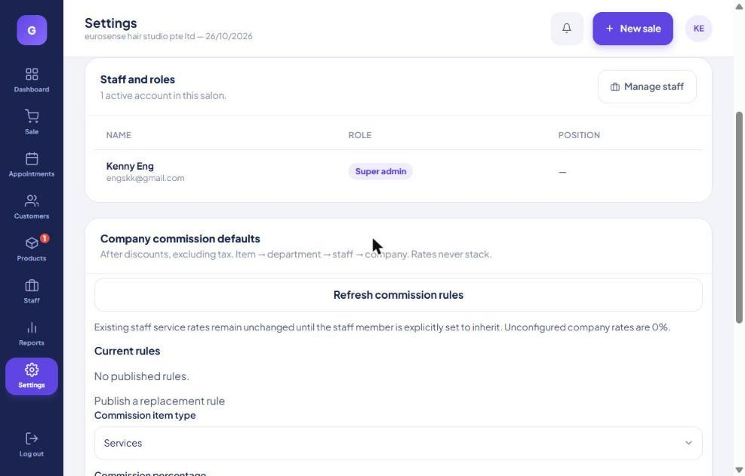
Figure 4.1 – AS-IS: Settings › Team & commissions › Company commission defaults
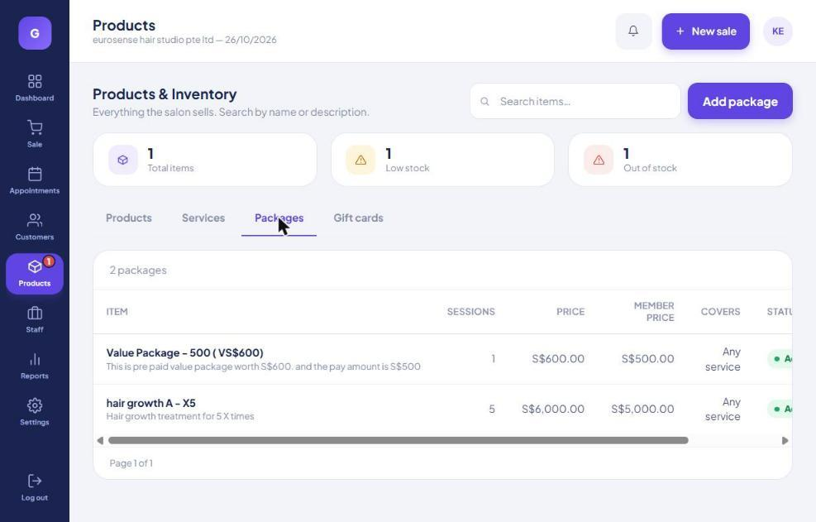
Figure 4.2 – AS-IS: Products › Packages

5. Design principles
- Easy for salon admin: all rates for all staff on one grid; change a cell, set the effective date, publish. Templates (“Copy rates from…”) for new staff.
- No surprises: rates and session values are snapshotted on each event; changing a rate never rewrites history.
- Attribute at the till: the cashier must pick Sold by / Performed by on each package or redemption line (defaults: logged-in staff / appointment therapist). The sale cannot be completed with an unattributed commissionable line if the setting “Require staff on commissionable lines” is on.
- One source of truth: a Commission ledger line for every commission event; reports are sums of the ledger.
- Reuse the existing engine: extend the item-type list and precedence rather than build a parallel system.
- Audit: every manual change (rate, attribution correction, adjustment) needs a reason and is logged with user and time.

6. Commission business rules

6.1 Commission types
Code | Commission type | Earned when | Base amount | Earned by
SVC | Service | Service paid at POS (cash/card) | Net line amount (after discount, excl. GST) | Performed by
PRD | Product | Product sold | Net line amount | Sold by
PKG_SALE | Package sale | Each payment collected for a package (or at sale – see 6.5) | Amount collected for the package, excl. GST | Sold by (split)
PKG_RED | Package redemption | Each session redeemed | Holding’s session value (or list price / fixed $ per policy) | Performed by (split)
VP_SALE | Value package sale | Value (credit) package paid | Amount paid (e.g. $500), not credit ($600) | Sold by
VP_SPEND | Value package spend | Service paid with stored credit | Credit spent × paid/credit ratio | Performed by
FOC | FOC / complimentary service | FOC service performed | Service list price (or fixed $) | Performed by
GC_SALE | Gift card sale (optional) | Gift card sold | Amount paid | Sold by
ADJ | Manual adjustment | Manager posts adjustment | Entered amount + reason | Selected staff
CLAWBACK | Clawback | Refund of a package after period lock | Negative of reversed commission | Original earner

6.2 Session value (the redemption base)
When a package is bought, Glampro stores on the customer holding:
session_value = net package price paid (after discount, excl. GST) ÷ number of sessions
Example: hair growth A - X5, member price S$5,000.00, 5 sessions → session value S$1,000.00. Non-member price S$6,000.00 → S$1,200.00.
For “one session per complete service set” packages the same formula applies per set. If a package covers services with different list prices, the session value is weighted by list price share (Meevo method): value_i = net price × (list_i ÷ Σ list).

Policy options (Settings › Package commission policy): Session value (recommended, default) · Service list price (pays full commission even if package was discounted) · Fixed S$ per session (set per package).
Value packages (pay S$500, receive S$600 credit): spend base = credit spent × 500/600. Example: S$100 service paid by credit → base S$83.33.

6.3 Rate resolution and effective dates
For each staff member S, commission type T and item I, the first match wins (rates never stack):
- Staff S’s specific-item override for I (existing Glampro scope).
- Package override set on the package (new – applies to all staff).
- Staff S’s department override (existing).
- Staff S’s default rate for type T – a cell in the Commission matrix (existing “staff default”).
- Company default for type T (existing).
- Otherwise 0%.
Among versions of the matched rule, the one with the latest effective_from ≤ event time is used. The rule id, rate and base are copied onto the ledger line (snapshot).
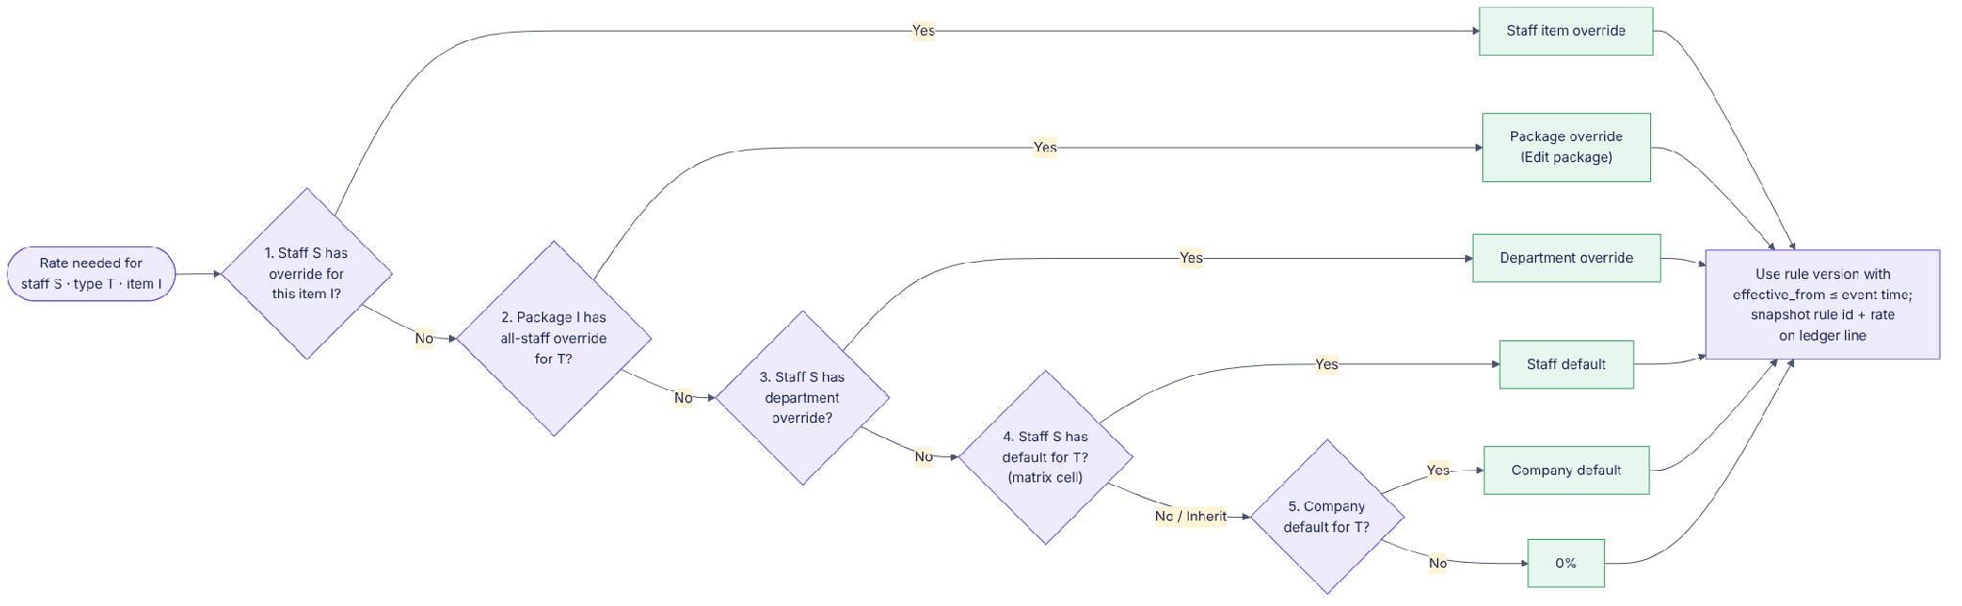
Figure 6.1 – Rate resolution

6.4 Splits
- A package sale line or redemption line can be credited to up to 4 staff; split % must total 100% (default 100% to one staff).
- Each staff’s share = base × split % × that staff’s own rate.
- Example: S$2,000 deposit, Stella 50% (7%) / Alvin 50% (8%) → Stella S$70.00, Alvin S$80.00.

6.5 Deposits and instalments
- Collected basis (recommended): sale commission is earned on each amount actually collected, in the period it is collected. Avoids paying commission on money never received.
- Sale-value basis (current Excel practice): full commission at the moment of sale on the full package value; any unpaid balance written off later is clawed back.
- Redemption before full payment: allowed up to the number of sessions covered by the amount paid (floor(paid ÷ session value)); a manager PIN can override.

6.6 Refunds, cancellations, transfers, expiry
Event | Sale commission | Redemption commission
Package refunded (open period) | Reversed on the refunded amount (prorated) – lines marked REVERSED | Already earned – kept
Package refunded (period locked/paid) | Negative CLAWBACK line in current open period | Kept
Clawback policy = “Full within N days” | All sale commission reversed if refund within N days of sale | Kept
Session redemption voided (wrong entry) | No change | Ledger line reversed; session returned to holding
Wrong therapist recorded | No change | Manager “Correct staff” (reason) → reverse + re-post to correct staff
Holding transferred / family-shared | No change (stays with original seller) | Paid to therapist who performs; session value stays from original holding
Sessions expire unused | No change | No redemption commission (breakage)
No-show / late cancel with session forfeited | No change | Optional: % of session value to booked therapist (policy setting, default off)
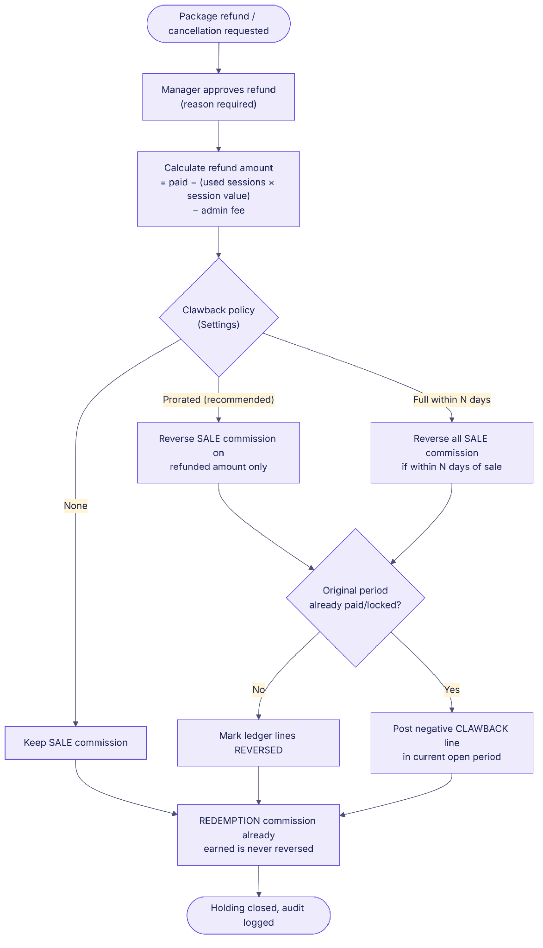
Figure 6.2 – Refund / clawback flow

6.7 Rounding and period
- Ledger lines are stored to 4 decimal places; statements round each staff × commission-type subtotal to 2 dp (half-up). This reproduces 8,985.50 × 7% = 628.99.
- Commission period = calendar month (configurable start day). Events belong to the period of their business date in the salon time zone (Asia/Singapore).

7. Workflow diagrams

7.1 End-to-end package lifecycle
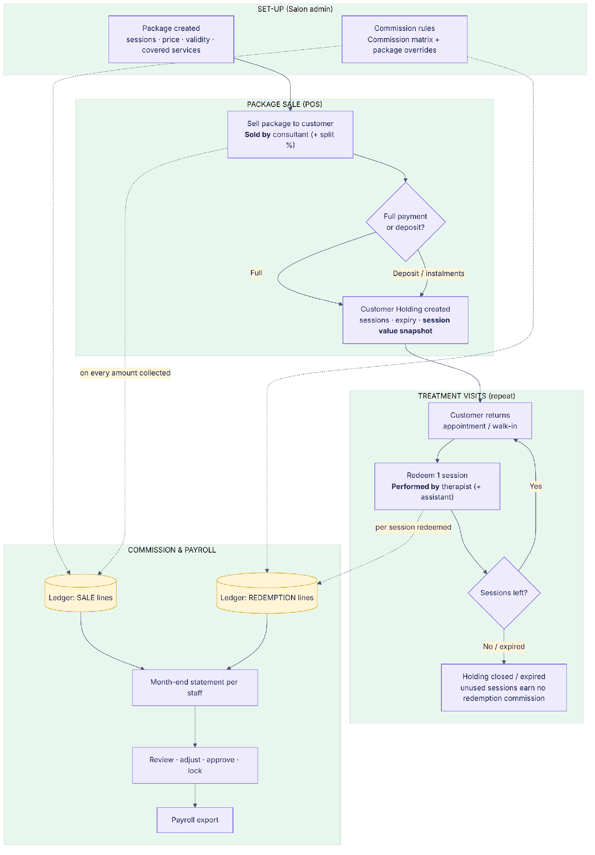
Figure 7.1 – From set-up to payroll

7.2 Package sale workflow (POS)
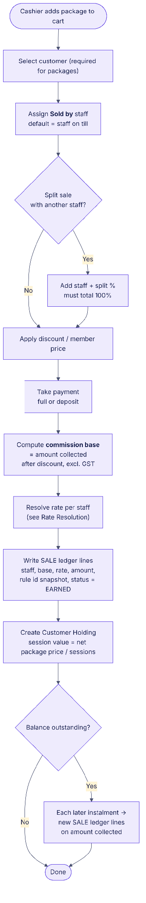
Figure 7.2 – Selling a package and crediting the seller

7.3 Treatment visit / redemption workflow
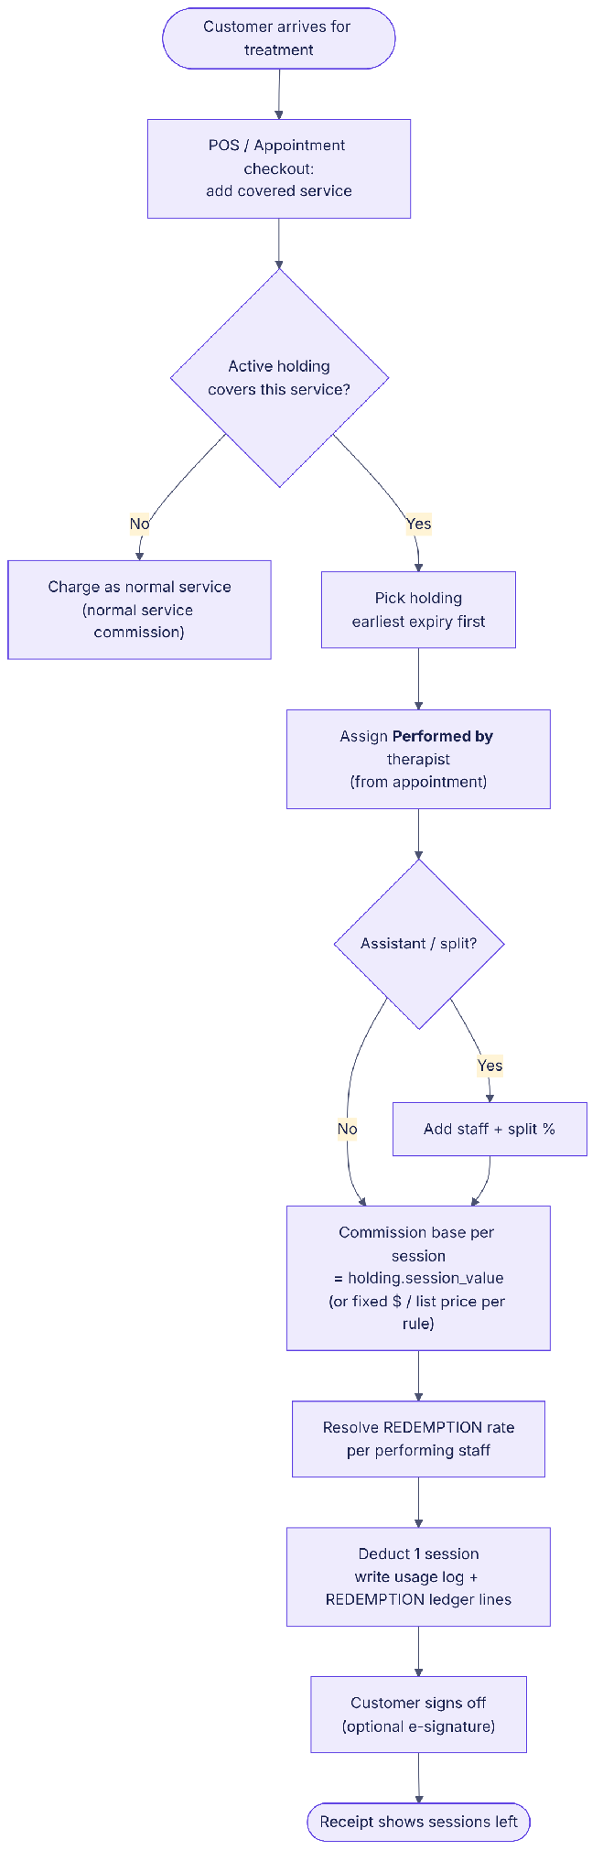
Figure 7.3 – Redeeming a session and crediting the therapist

7.4 Month-end commission and payroll
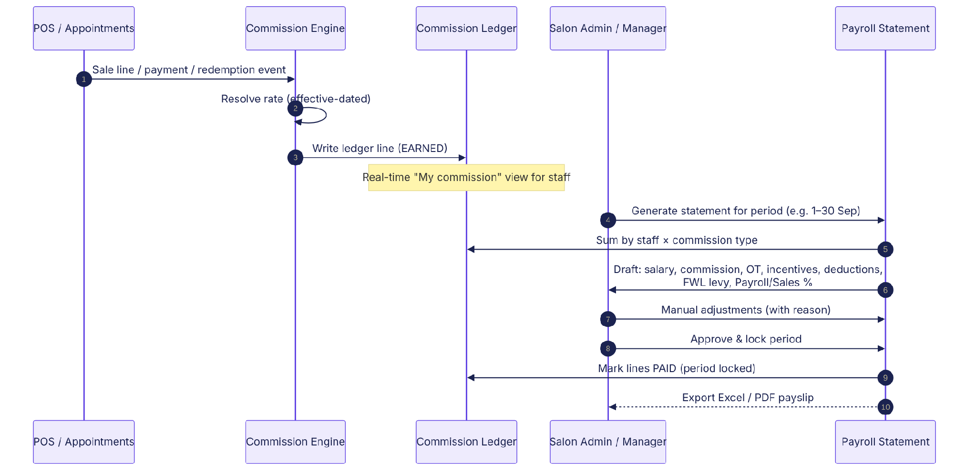
Figure 7.4 – Ledger to approved payroll statement
Steps for the salon admin at month end:
- Reports › Commission & payroll › select period (e.g. 1–30 Sep 2026).
- Review the draft per staff; drill into any figure to see receipts / sessions.
- Enter unpaid leave, overtime, incentives (each with reason).
- Approve & lock → ledger lines marked PAID; later changes go to the next period as adjustments/clawbacks.
- Export Excel / payslip PDF for payroll.

8. Data model
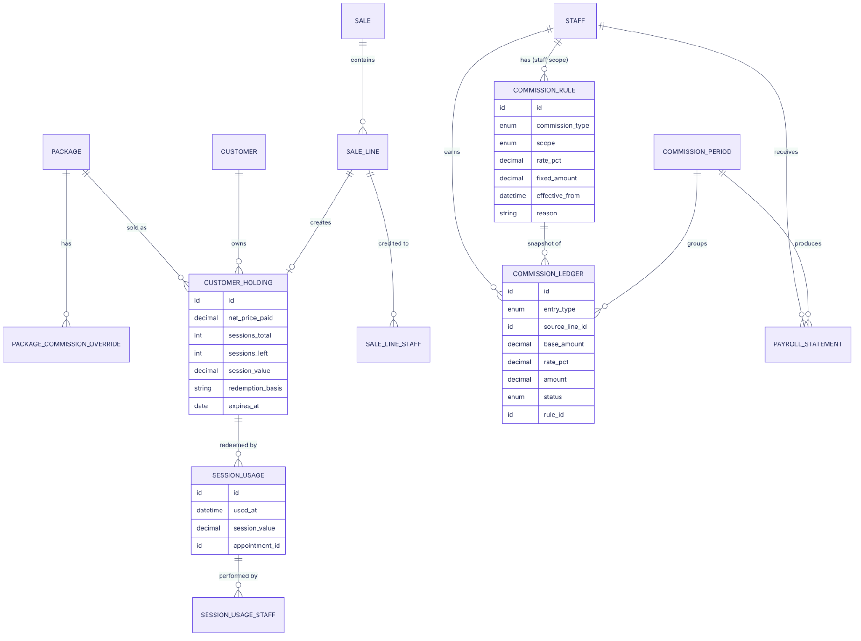
Figure 8.1 – New and changed entities

8.1 New / changed fields
Entity | Field | Type | Notes
commission_rule (existing) | item_type | enum | ADD: PKG_SALE, PKG_RED, VP_SALE, VP_SPEND, FOC, GC_SALE
commission_rule | calc_method | enum | PERCENT (default) | FIXED_AMOUNT
commission_rule | fixed_amount | decimal(12,2) | Used when FIXED_AMOUNT
commission_rule | scope | enum | ADD: PACKAGE_OVERRIDE (all staff, item = package)
package (existing) | sale_commission_mode | enum | STAFF_RATES | OVERRIDE_PCT | FIXED
package | redemption_commission_mode | enum | STAFF_RATES | OVERRIDE_PCT | FIXED
package | redemption_basis | enum | SESSION_VALUE | LIST_PRICE | FIXED (default from policy)
customer_holding (existing) | net_price_paid | decimal(12,2) | After discount, excl. GST – snapshot
customer_holding | session_value | decimal(12,4) | net_price_paid ÷ sessions – snapshot
customer_holding | amount_collected / balance_due | decimal(12,2) | Supports deposits & instalments
customer_holding | commission_snapshot | json | Package commission modes & basis at purchase
sale_line_staff (new) | sale_line_id, staff_id, role, split_pct |  | role = SOLD_BY | PERFORMED_BY | ASSISTANT; Σ split_pct = 100
session_usage (new) | holding_id, used_at, service_id, appointment_id, session_value, signature_ref, voided_at, void_reason |  | One row per session redeemed
session_usage_staff (new) | session_usage_id, staff_id, split_pct |  | Performed by / assistant
commission_ledger (new) | id, staff_id, entry_type, commission_type, source_type, source_id, business_date, base_amount, split_pct, rate_pct, fixed_amount, amount, rule_id, period_id, status, reversed_by_id, reason, created_by, created_at |  | status = EARNED | REVERSED | PAID; append-only
commission_period (new) | id, start_date, end_date, status, approved_by, approved_at |  | status = OPEN | APPROVED | LOCKED
staff_payroll_profile (new) | staff_id, basic_salary, fixed_ot, fwl_levy, commission_template_id, payroll_sales_alert_pct, effective_from |  | Effective-dated
payroll_statement (new) | period_id, staff_id, basic, unpaid_leave, commission_total, ot, incentive, other, take_home, fwl, collection, payroll_sales_pct |  | Generated; adjustments carry reason
salon_commission_policy (new) | pkg_sale_basis, redemption_basis, vp_spend_basis, foc_basis, clawback_mode, clawback_days, rounding, deduct_gst, deduct_discount, period_start_day, require_staff_on_lines, allow_redeem_before_paid |  | One row per salon

9. Screen changes (where the new fields go)
Each change is numbered N1–N14. For each screen the AS-IS screenshot shows where the change is inserted (orange dashed box) and the TO-BE mockup shows the new design. Mockups use Eurosense’s September figures.

9.1 Settings › Team & commissions – Commission matrix (N1, N2)
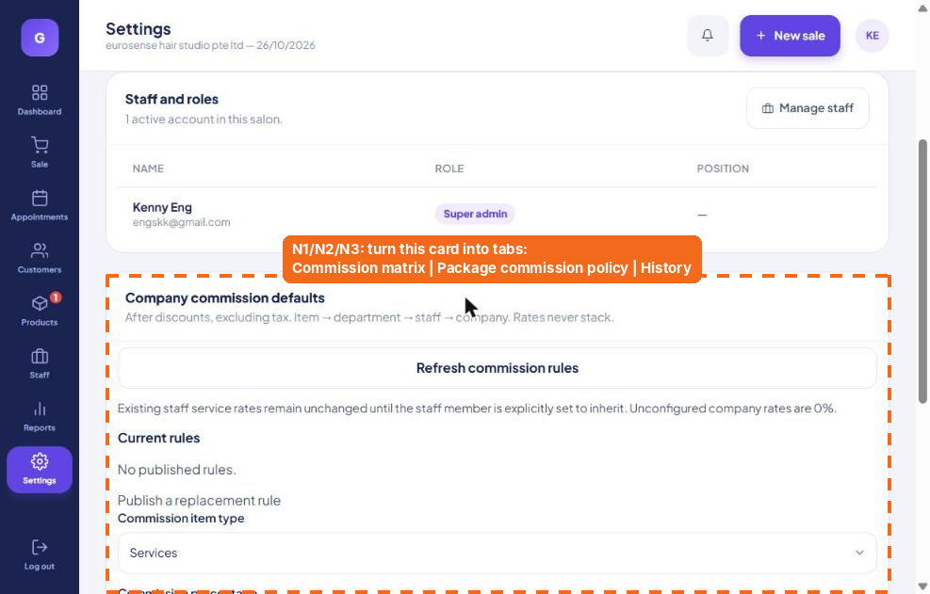
AS-IS – insertion point
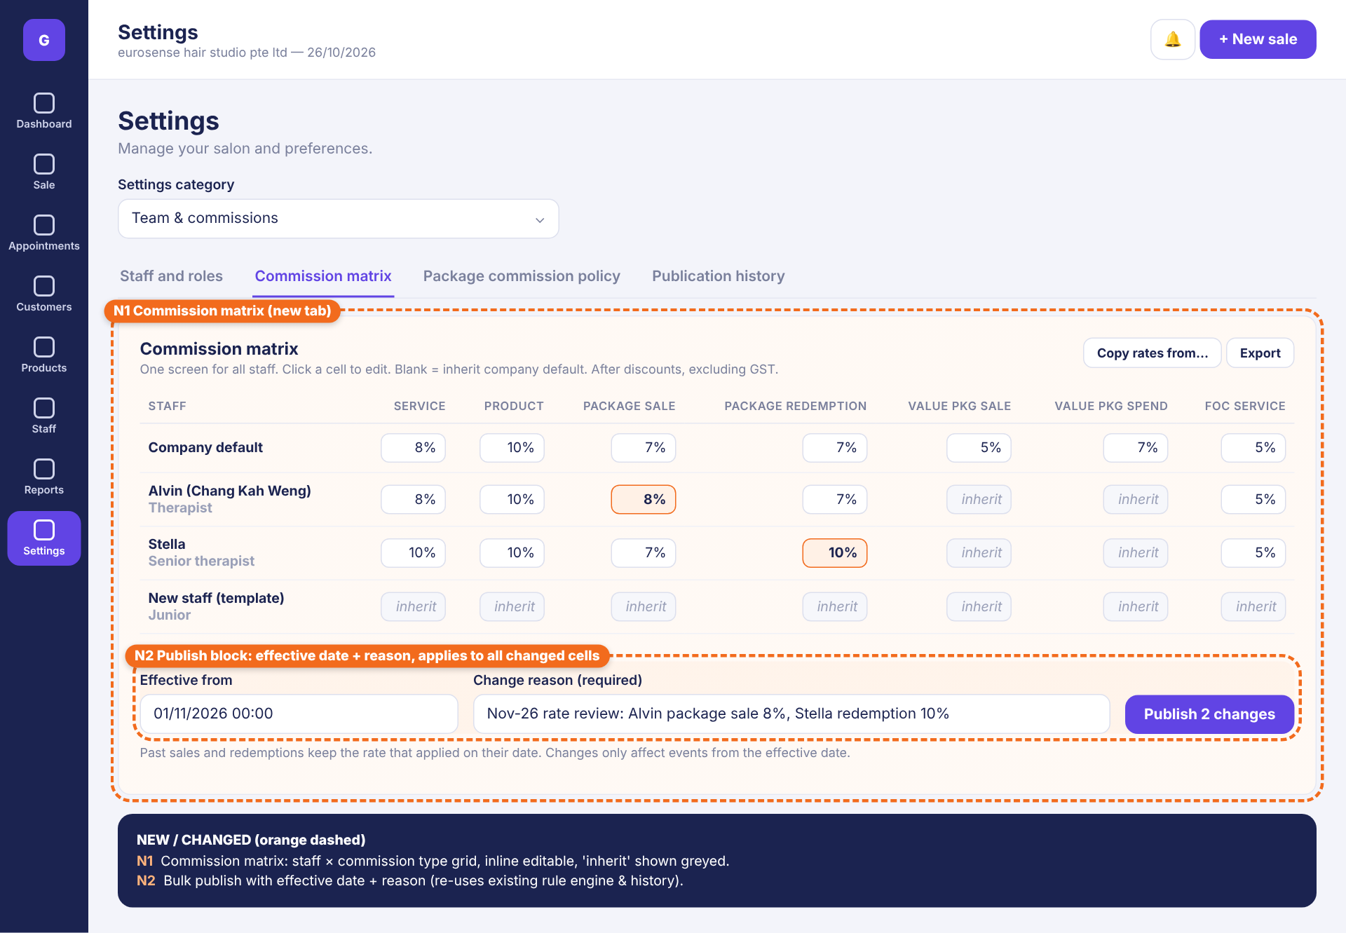
TO-BE – mockup
# | Element | Specification
N1 | Commission matrix tab | Grid: rows = Company default + each active staff; columns = commission types. Cell = % (or $ if fixed). Empty cell = inherit (shown grey italic). Changed cells highlighted orange until published. “Copy rates from…” copies a staff row to another / a template. Export to Excel.
N2 | Publish block | Effective from (datetime, default now), Change reason (required). “Publish N changes” creates one effective-dated rule version per changed cell using the existing rule engine; listed in Publication history.

9.2 Settings › Team & commissions – Package commission policy (N3)
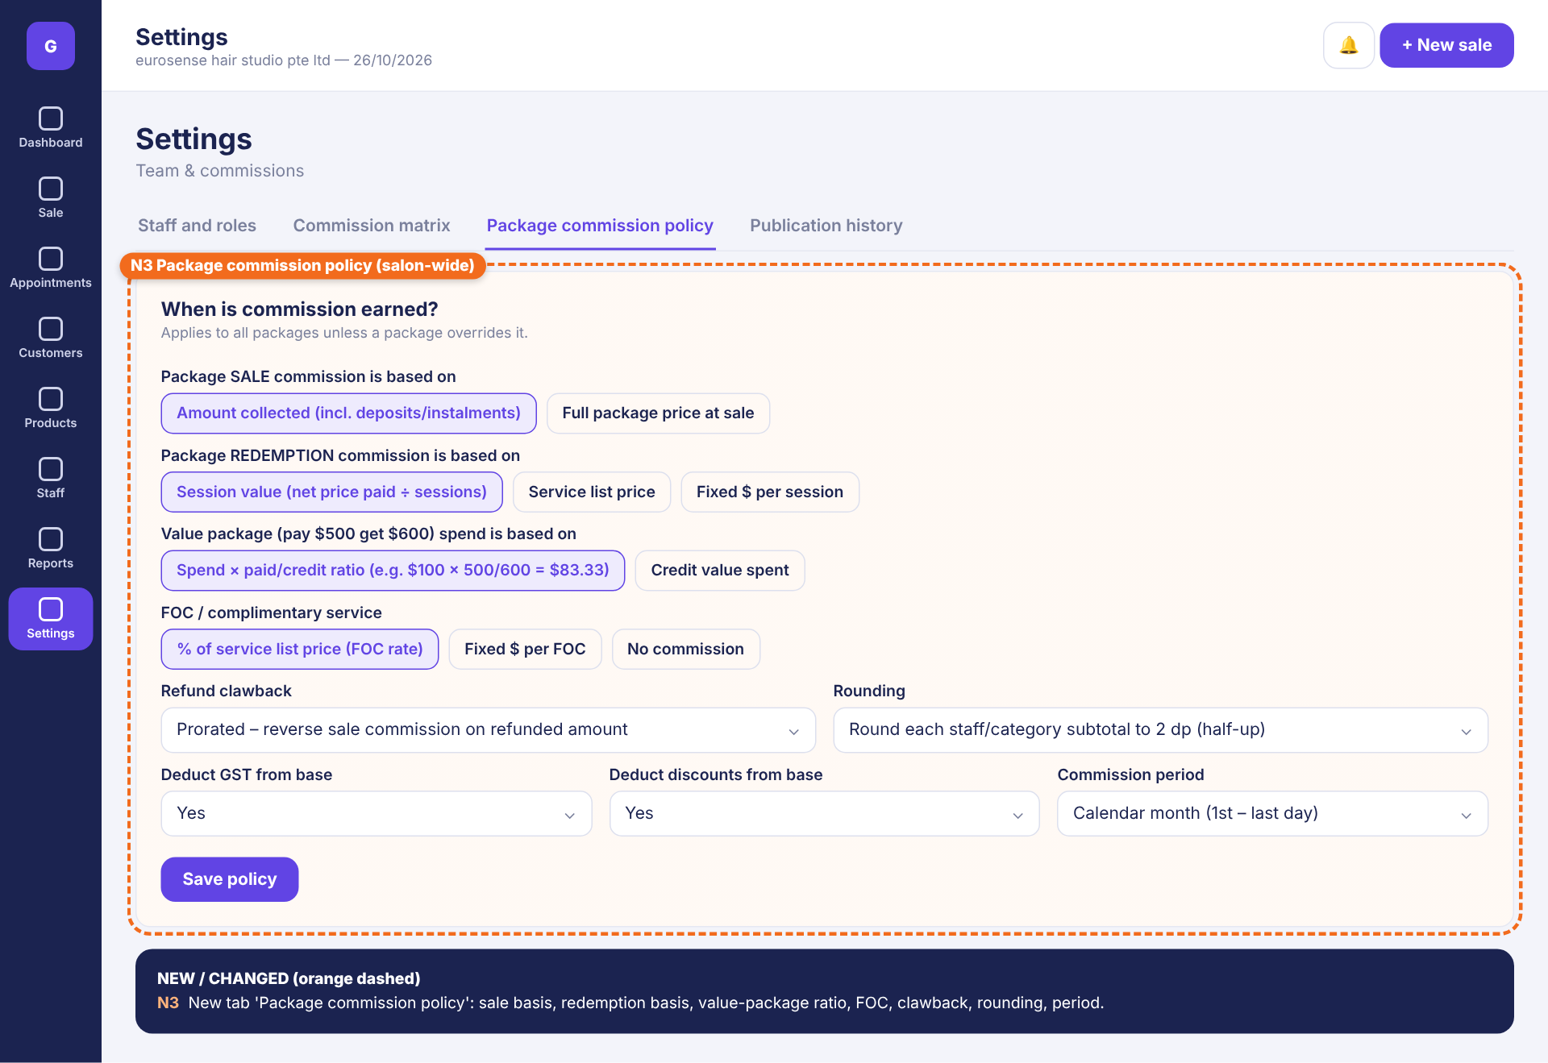
TO-BE – mockup
# | Element | Specification
N3 | Package commission policy tab | Package SALE basis (Amount collected | Full price at sale); REDEMPTION basis (Session value | Service list price | Fixed $); Value package spend basis (ratio | credit value); FOC basis (% of list | fixed $ | none); Refund clawback (Prorated | Full within N days | None); Rounding; Deduct GST; Deduct discounts; Commission period; Require staff on commissionable lines; Allow redemption before fully paid.

9.3 Products › Packages › Edit package – Commission section (N4, N5)
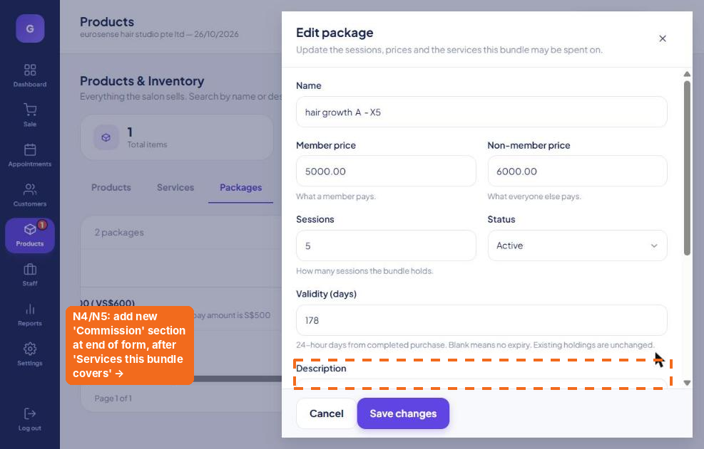
AS-IS – insertion point
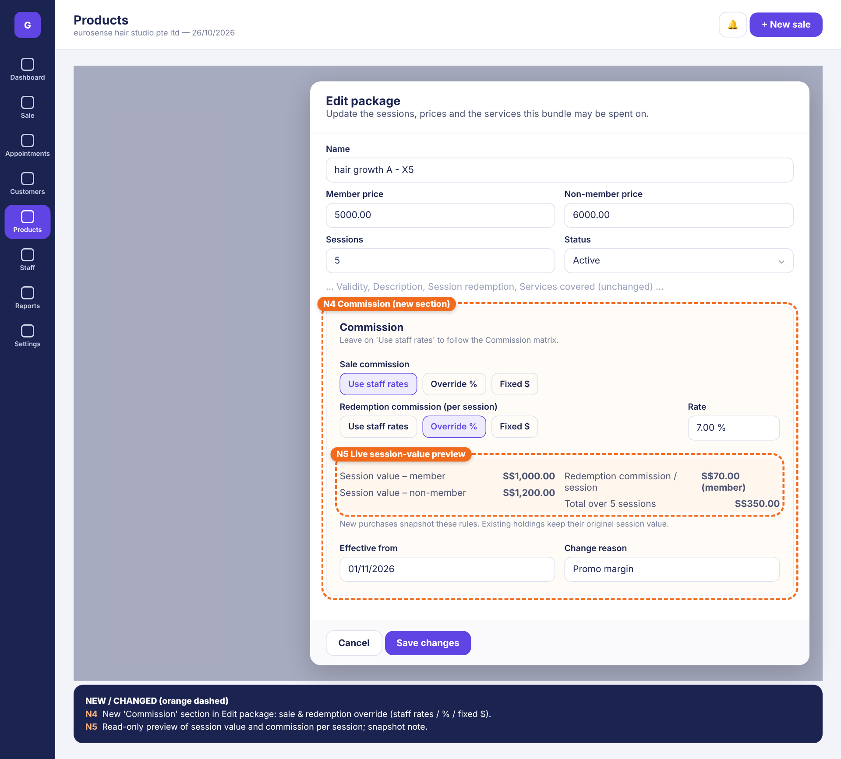
TO-BE – mockup
# | Element | Specification
N4 | Commission section | Sale commission: Use staff rates (default) | Override % | Fixed $. Redemption commission per session: Use staff rates | Override % | Fixed $ + Rate field. Effective from + Change reason when an override is set.
N5 | Session value preview | Read-only: session value (member / non-member), commission per session and total over all sessions at the override or a sample staff rate. Note: new purchases snapshot these rules.

9.4 Sale (POS) – Sold by, Performed by, redeem, deposit (N6–N9)
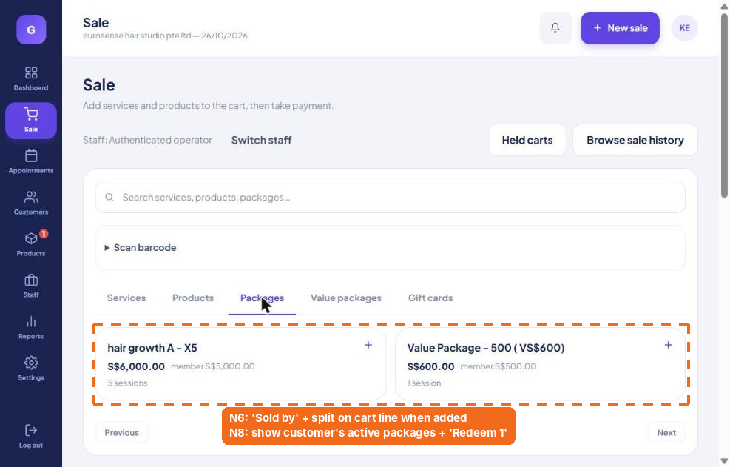
AS-IS – insertion point
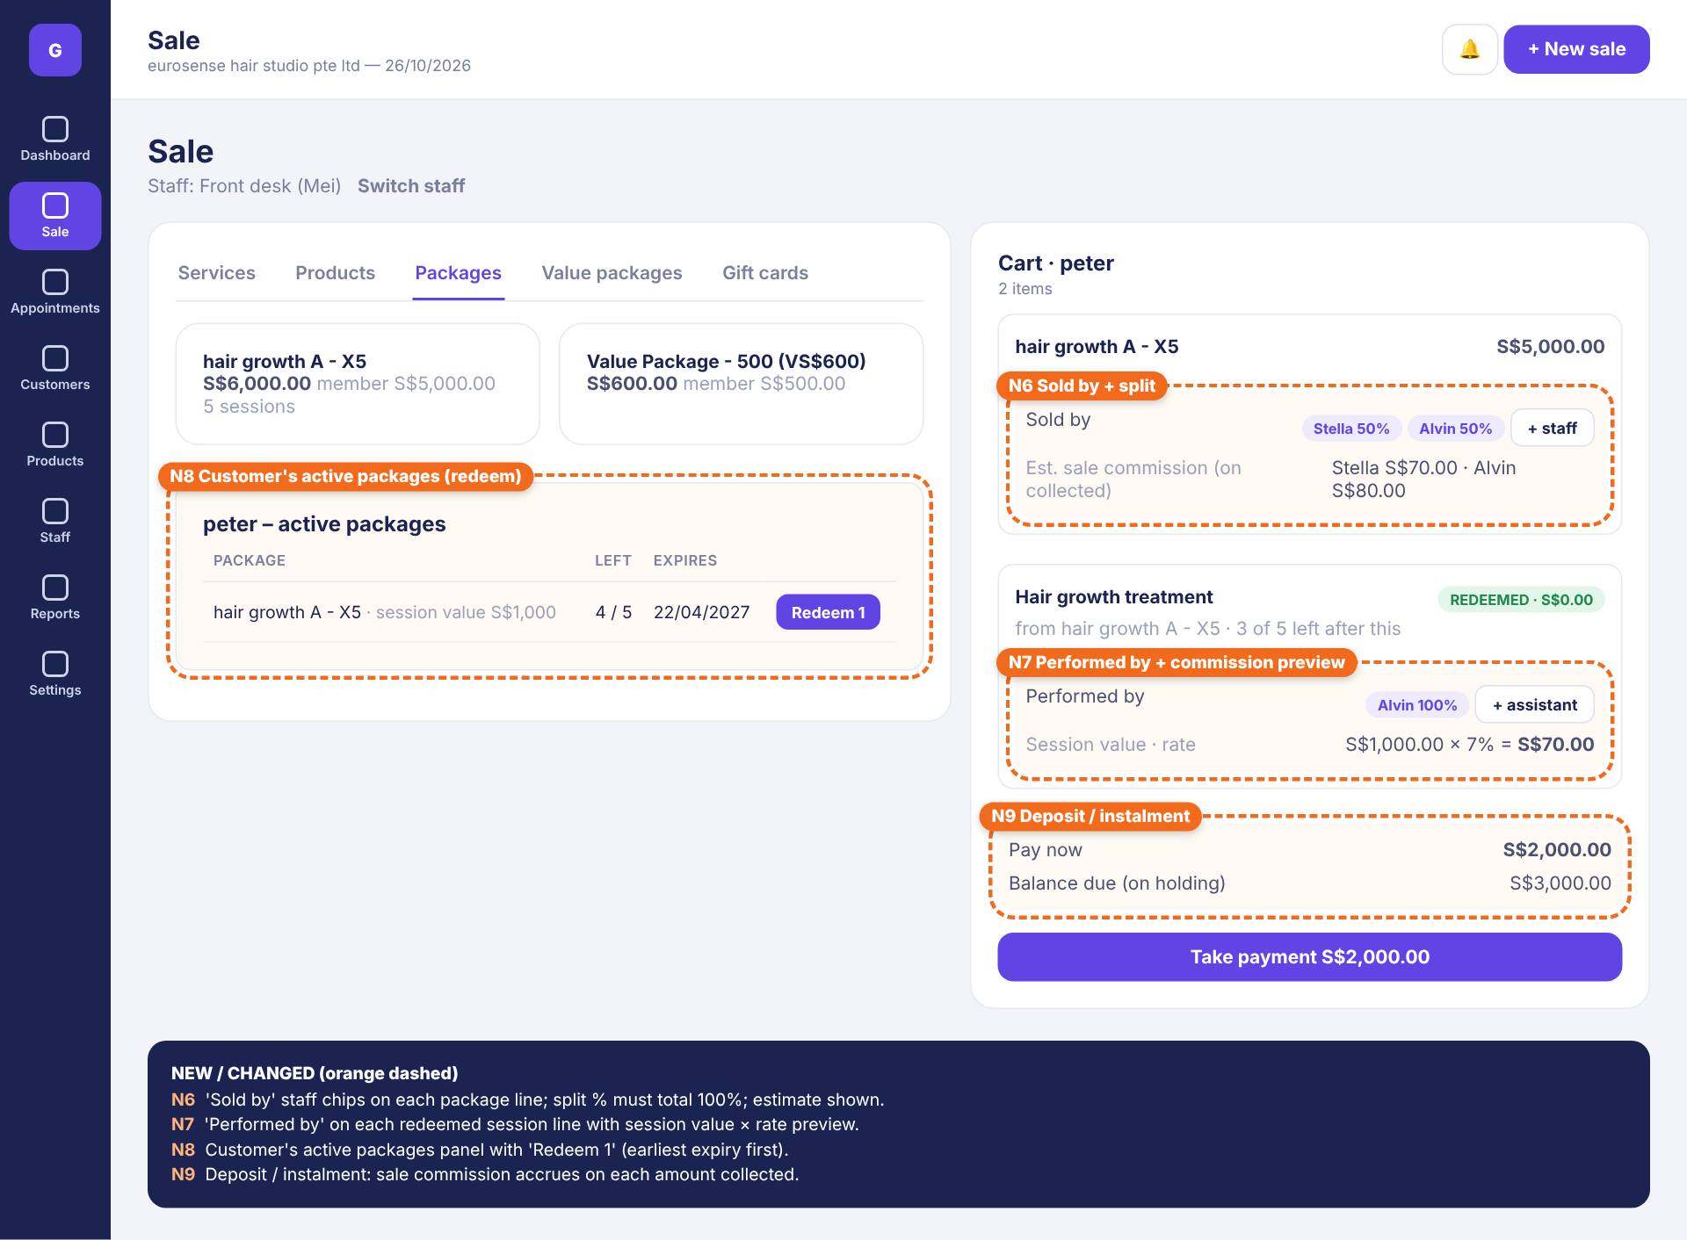
TO-BE – mockup
# | Element | Specification
N6 | Sold by (package line) | Staff chips with split %; default = staff on till; “+ staff” adds a split; must total 100%. Shows estimated commission.
N7 | Performed by (redeemed line) | Default = appointment therapist; “+ assistant” to split. Shows session value × rate = commission.
N8 | Customer’s active packages | When a customer is selected: list holdings with sessions left, expiry, session value and a “Redeem 1” button (earliest expiry first; covered services only).
N9 | Deposit / instalment | Pay now amount (≥ minimum deposit %); balance due stored on the holding; later payments taken from Customer › Balances or POS “Collect balance”.

9.5 Customer profile – session usage & commission log (N10)
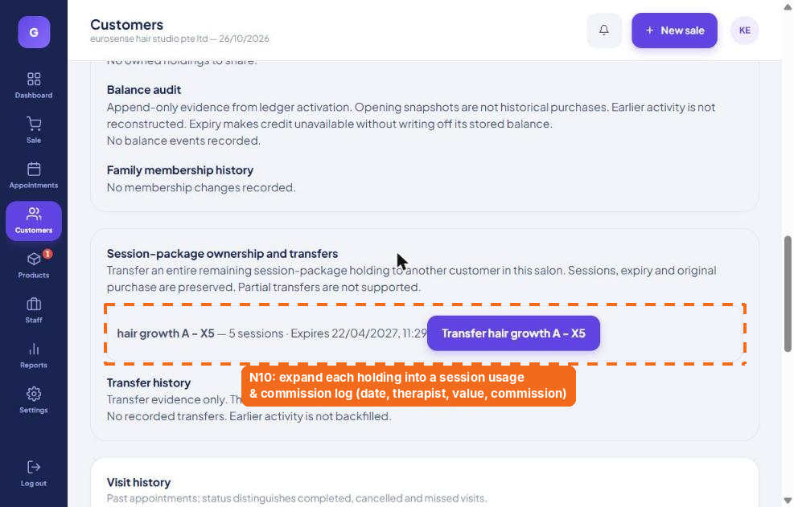
AS-IS – insertion point
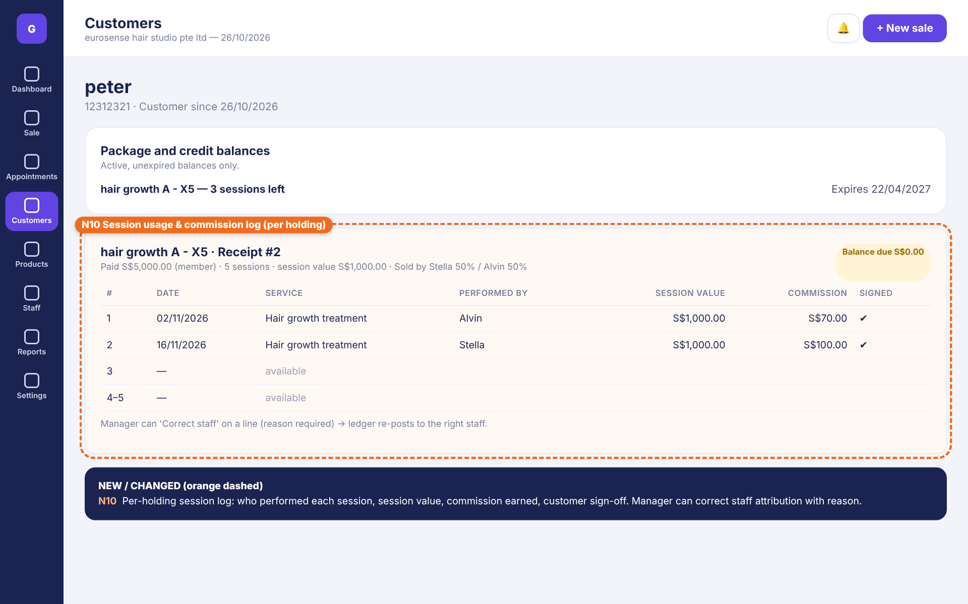
TO-BE – mockup
# | Element | Specification
N10 | Session usage log per holding | Header: paid amount, sessions, session value, sold by, balance due. Rows: #, date, service, performed by, session value, commission, customer signed. Manager action “Correct staff” (reason) and “Void session” (reason).

9.6 Reports › Commission & payroll (N11, N12)
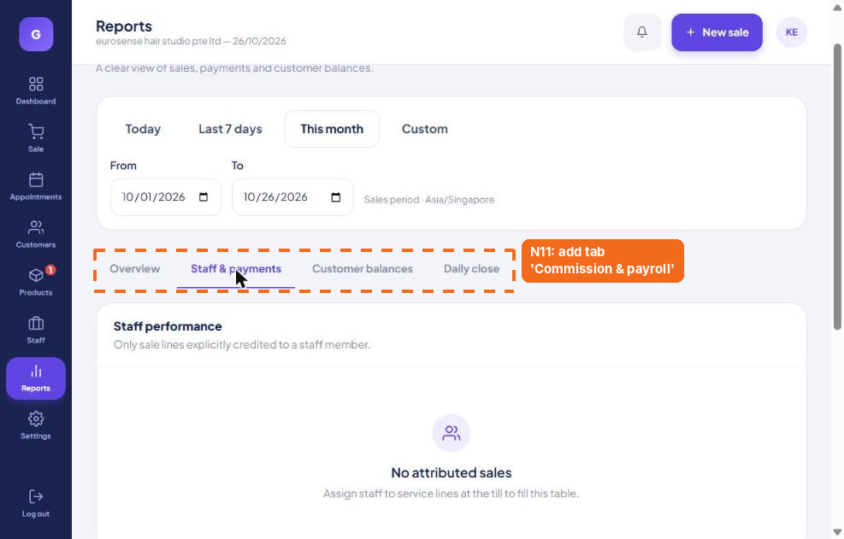
AS-IS – insertion point
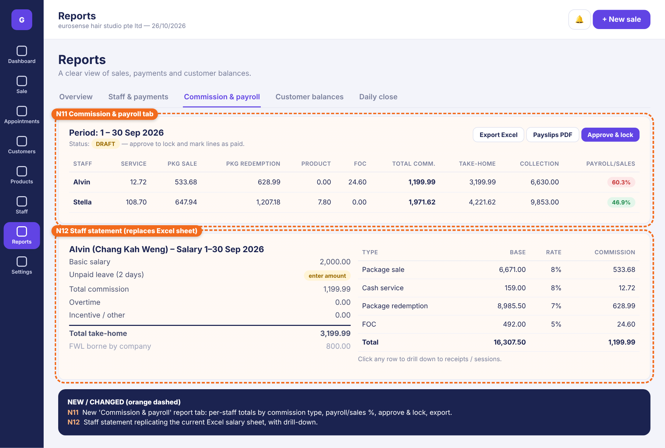
TO-BE – mockup
# | Element | Specification
N11 | Commission & payroll tab | Period selector; status (Draft / Approved / Locked); table per staff: Service, Pkg sale, Pkg redemption, Product, FOC, VP, Adjustments, Total commission, Take-home, Collection, Payroll/Sales % (red when above alert). Buttons: Export Excel, Payslips PDF, Approve & lock.
N12 | Staff statement | Replicates the Excel salary sheet: basic, unpaid leave, commission, OT, incentive/other, take-home, FWL; commission table by type with base, rate and amount; drill-down to receipts and sessions.

9.7 Staff › Edit staff – Payroll profile & item types (N13, N14)
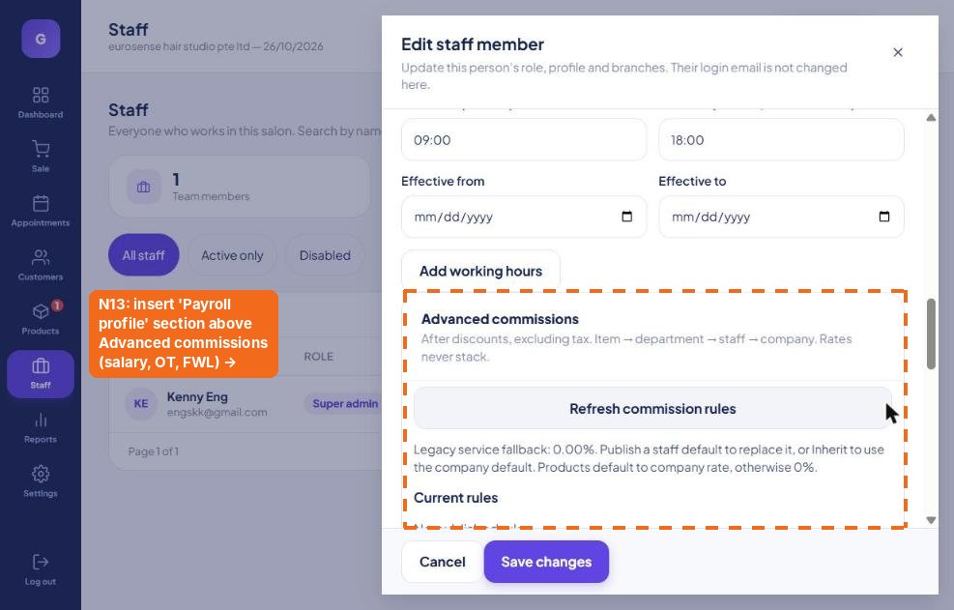
AS-IS – insertion point
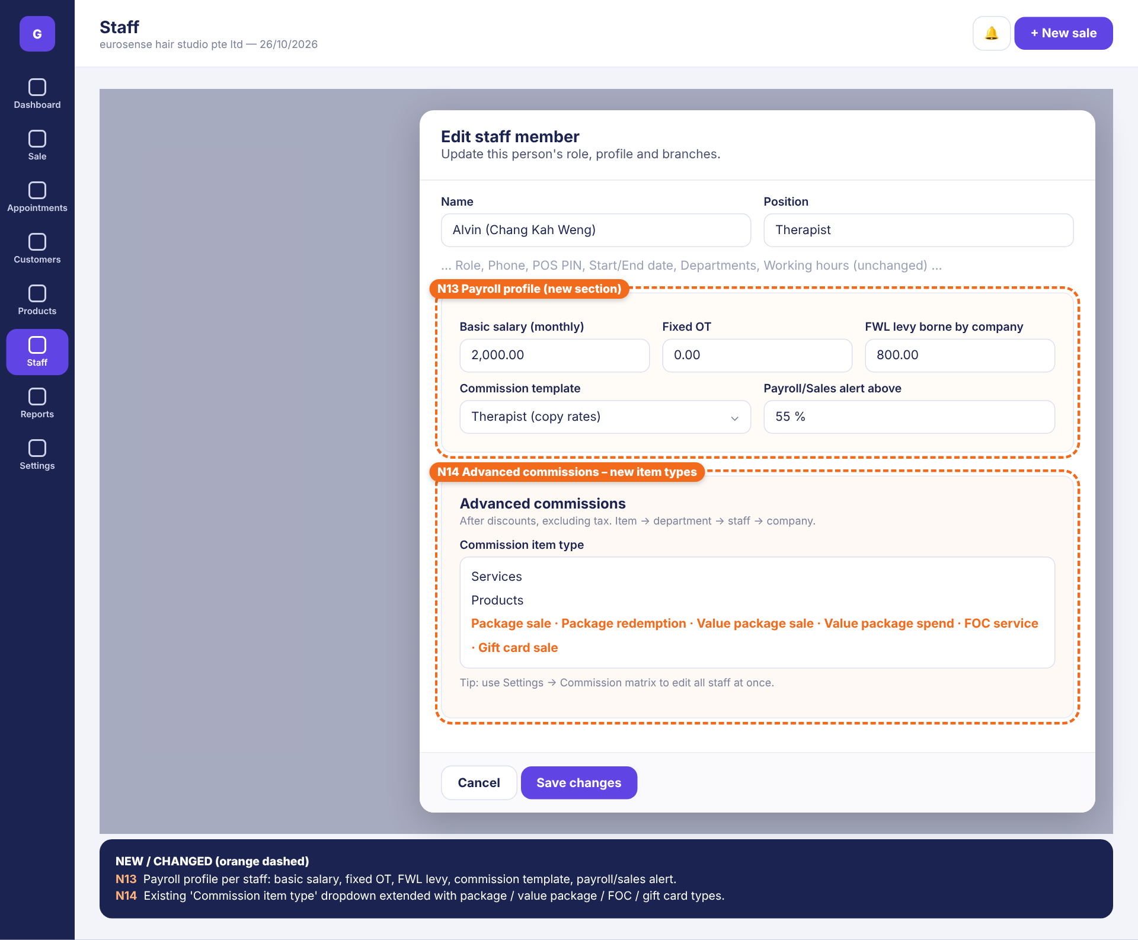
TO-BE – mockup
# | Element | Specification
N13 | Payroll profile section | Basic salary (monthly), Fixed OT, FWL levy borne by company, Commission template (copy rates), Payroll/Sales alert %. Effective-dated.
N14 | Commission item type list | Add Package sale, Package redemption, Value package sale, Value package spend, FOC service, Gift card sale to the existing dropdown (also in Settings › Publish a replacement rule).

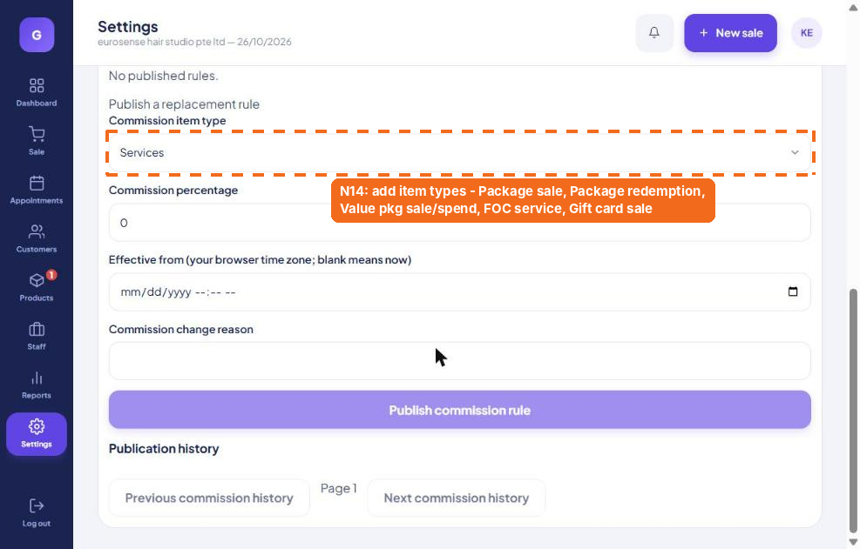
AS-IS – N14 applies to the existing “Commission item type” dropdown

10. Worked examples and acceptance tests

10.1 Scenario A – package sold with split and deposit, then redeemed
Package “hair growth A - X5”, member S$5,000.00, 5 sessions (session value S$1,000.00). Sold by Stella 50% / Alvin 50%. Policy: sale commission on amount collected. Rates per matrix: Stella PKG_SALE 7%, PKG_RED 10%; Alvin PKG_SALE 8%, PKG_RED 7%.
Date | Event | Staff | Base (S$) | Rate | Commission (S$)
01 Nov | Deposit 2,000 collected | Stella (50%) | 1,000.00 | 7% | 70.00
01 Nov | Deposit 2,000 collected | Alvin (50%) | 1,000.00 | 8% | 80.00
02 Nov | Session 1 redeemed | Alvin | 1,000.00 | 7% | 70.00
15 Nov | Balance 3,000 collected | Stella (50%) | 1,500.00 | 7% | 105.00
15 Nov | Balance 3,000 collected | Alvin (50%) | 1,500.00 | 8% | 120.00
16 Nov | Session 2 redeemed | Stella | 1,000.00 | 10% | 100.00
 | November totals | Stella |  |  | 275.00
 |  | Alvin |  |  | 270.00
Check: session 3 cannot be redeemed on 05 Nov if only the S$2,000 deposit is paid unless a manager overrides (2,000 ÷ 1,000 = 2 sessions covered).

10.2 Scenario B – refund after 2 sessions (prorated clawback)
Customer cancels on 20 Nov. Refund = 5,000 − (2 × 1,000) − admin fee 100 = S$2,900.00 (58% of package price). Sale commission reversed: Stella 175.00 × 58% = 101.50; Alvin 200.00 × 58% = 116.00. Redemption commission (70.00 + 100.00) kept. If November is still open, lines are marked REVERSED; if locked, CLAWBACK lines are posted in December.

10.3 Scenario C – value package
Value Package – 500 (VS$600) sold by Stella: VP_SALE base S$500.00 × 5% (company default) = S$25.00. Later a S$100.00 service paid by credit, performed by Alvin: VP_SPEND base = 100 × 500/600 = S$83.33 × 7% = S$5.83.

10.4 Scenario D – mid-month rate change
Alvin’s PKG_SALE rate is changed from 7% to 8% effective 01 Nov 2026 00:00. A package collected 31 Oct 23:50 uses 7%; one collected 01 Nov 10:00 uses 8%. The October statement is unchanged.

10.5 Regression – reproduce September 2026 sheets
Loading Alvin’s and Stella’s September transactions with the matrix rates in Figure 9.1 and policy “sale value basis” must produce exactly: Alvin total commission 1,199.99, take-home 3,199.99, Payroll/Sales 60.3%; Stella total commission 1,971.62, take-home 4,221.62 (with S$50 incentive), Payroll/Sales 46.9%.

10.6 Acceptance checklist
- Admin can change any staff × type rate in the matrix and publish with effective date + reason in under 1 minute.
- Package override overrides staff default but not a staff-specific item override.
- Cannot complete a sale with a package or redeemed line that has no Sold by / Performed by when the policy requires it.
- Split % validation (must total 100%).
- Session value stored on holding at purchase and unchanged after package price edit.
- Redemption commission posts immediately and appears on the customer session log and staff report.
- Refund triggers correct reversal/clawback per policy; redemption commission untouched.
- Transferred / family-shared holding redemptions credit the performing therapist at the original session value.
- Approve & lock prevents edits; later corrections post to the open period.
- Excel export matches on-screen totals to the cent.

11. Roles, permissions and audit
Action | Super admin | Manager | Staff | Cashier
Edit commission matrix / policy / package override | ✔ | ✔ (if allowed) | – | –
Set Sold by / Performed by at POS | ✔ | ✔ | ✔ | ✔
Correct staff on a past session / void session | ✔ | ✔ (reason) | – | –
Post manual adjustment | ✔ | ✔ (reason) | – | –
Approve & lock period, export payroll | ✔ | – | – | –
View own commission (My commission) | ✔ | ✔ | ✔ own only | –
View all staff commission & payroll | ✔ | ✔ | – | –
Every rule change, override, correction, adjustment and approval is logged with user, timestamp, before/after values and reason (extends existing Publication history).

12. Reports and exports
- Commission & payroll (period) – per staff totals by type, take-home, collection, Payroll/Sales %; Excel & PDF payslips.
- Commission detail (ledger) – every line with filters (staff, type, date, package, customer); Excel export.
- Package liability – outstanding sessions × session value per holding (unearned revenue and future redemption commission exposure).
- My commission – staff self-service view in POS/mobile: month-to-date earned by type, list of sessions performed.
- Package utilisation – sold vs redeemed vs expired sessions per package.

13. Decisions for owner verification
Please tick the preferred option (recommended option listed first):
☐ Package SALE commission basis: (a) amount collected incl. deposits/instalments [recommended] · (b) full package value at sale (current Excel practice).
☐ Package REDEMPTION base: (a) session value = net price ÷ sessions [recommended] · (b) service list price · (c) fixed $ per session.
☐ Clawback on refund: (a) prorated on refunded amount [recommended] · (b) full reversal if within N days · (c) none.
☐ Allow redemption before package fully paid: (a) up to sessions covered by amount paid [recommended] · (b) always · (c) never.
☐ FOC commission: (a) 5% of service list price (current) · (b) fixed $ · (c) none.
☐ Should the seller and the therapist both earn when they are the same person? (a) yes – both types [current practice] · (b) only one.
☐ Payroll/Sales formula: (take-home + FWL levy) ÷ total collection – confirm, and confirm alert threshold (e.g. 55%).
☐ Payroll fields in Glampro (salary, OT, FWL, unpaid leave) – (a) include in Phase 2 [recommended] · (b) commission only, payroll stays in Excel.
☐ Tiered commission (higher % above a monthly target) – needed now or later?

14. Implementation phases
Phase | Scope | Screens
1 – Attribution & ledger | New commission types; session-value snapshot; Sold by / Performed by + split at POS; redemption flow; commission ledger; package override; rate resolution; effective dates. | N4, N5, N6, N7, N8, N14
2 – Admin ease & reporting | Commission matrix with bulk publish; package commission policy; Commission & payroll report; staff statement; Excel export; customer session log. | N1, N2, N3, N10, N11, N12
3 – Payroll & advanced | Payroll profile; approve & lock periods; clawbacks; deposits/instalments; payslip PDF; My commission view; tiers (optional). | N9, N13

Appendix – Research sources
- Zenoti – Commission Management: https://www.zenoti.com/platform/commission-management
- Meevo – Redeeming Items from a Package: https://docs.meevo.com/multi-location/Register/RedeemingItemsPackage.htm
- Pabau – How to Set Up a Commission Structure for Packages: https://support.pabau.com/en/pabau2/commission-structure-for-packages
- Fresha – Commissions update (Apr 2026): https://www.fresha.com/blog/fresha-commissions-update
- Phorest – Courses: https://phorest.helpjuice.com/44038-category-2-GB/321698-courses
- Glampro Suite – live review of glampro.tusphere.com, 26 Oct 2026
- Eurosense Hair Studio – September 2026 salary sheets (Alvin / Chang Kah Weng, Stella)

