DEVELOPER INSTRUCTIONS
Glampro Staff Commission Module – Setup, Integration and Working with ChatGPT
For the Glampro developer. Read together with SRS v1.2 (Glampro_SRS_Commission_Plans_v1.2.docx) and the source code package glampro-commission-module.zip.
Item | Detail
Package | glampro-commission-module.zip (shared engine, Node/TypeScript backend, React/TypeScript frontend, docs)
Stack | Node.js 20+, TypeScript, Express, Prisma + PostgreSQL, React 18 + Vite
Status | 33 automated tests passing; typecheck and production build passing; demo mode runs without a database
Not yet done | Real Glampro login, link to Glampro staff table, POS hook calls, backfill of existing packages, test on real PostgreSQL
Business owner | Kenny Eng
Date | 27 October 2026

Contents

In Word: right-click → Update field to show page numbers.

1. What this module does
The module calculates staff commission for Glampro salons automatically, replacing the monthly Excel salary sheets. During the month the POS records what happened (base lines, no rates). At month end the commission plan of each staff member decides how much is paid.
Code | Commission type | Earned when | Base amount | Earned by
SVC | Cash service | Service paid normally | Net line amount (after discount, excl. GST) | Performed by
PRD | Product | Product sold | Net line amount (+ category, e.g. Beauty) | Sold by
PKG_SALE | Package sale | Each payment collected (deposit / instalment / full) | Cash collected; negative on refund | Sold by (split)
PKG_RED | On course (redemption) | Each session used | Session value = net price ÷ sessions (snapshot) | Performed by (split)
FOC | Complimentary service | FOC service performed | Service list price (plan applies base %, e.g. 50%) | Performed by
VP_SALE / VP_SPEND | Value package | Sold / credit spent | Cash paid / credit × paid ÷ credit | Sold by / Performed by

A plan (e.g. Hair Commission Scheme 2022, TP Mani & Pedi Scheme) has components, stages by tenure (e.g. New staff months 1–3) and incentives. Each component pools the month’s base of chosen commission types and applies one method:
Method | Rule | Example: bands 0–7,000 @5%, 7,000–15,000 @7%, base 8,985.50
FLAT | base × rate | –
TIER_WHOLE | rate of band reached × whole base (retroactive) | 8,985.50 × 7% = 628.99
TIER_SLICE | each band’s rate on its own slice (progressive) | 7,000 × 5% + 1,985.50 × 7% = 488.99
TIER_MIXED | per band: from $1 (WHOLE) or SLICE | depends on band settings
FIXED_PER_UNIT | fixed S$ × number of items | –

1.1 Owner decisions (do not change without the owner)
- D-1 Package sale commission base = cash collected (deposit/instalment counted in the month received).
- D-2 Each staff member gets a plan when they join; rates vary by stage and tier.
- D-4 Calculation method is a setting per component (admin chooses in Commission settings).
- D-5 The plan and plan version in force on the last day of the month apply to the whole month.
- D-7 Refund takes back only the sale commission on the refunded part; redemption commission stays.
- D-8 Customers can redeem only sessions they have paid for; manager PIN override allowed and logged.

2. Package contents
glampro-commission/
├─ AI_HANDOFF.md <- give this to ChatGPT first
├─ README.md
├─ shared/ pure TypeScript commission engine (used by backend AND frontend)
├─ backend/ Node + Express API, services, Prisma schema, SQL DDL, tests
├─ frontend/ React + TypeScript screens (Vite), demo mode without a server
├─ scripts/bundle-code.mjs builds docs/ALL_CODE.md
└─ docs/ SRS v1.2, screenshots, offline demo, ALL_CODE.md

2.1 Architecture
React screens ──(CommissionApi)──► HttpApi ──REST──► Express router ──► Services
DemoApi ── runs the same Services in the browser
Glampro POS checkout ──hooks──► REST /holdings, /lines ... │
▼
Repository interface ── MemoryRepo (tests/demo)
└─ PrismaRepo (PostgreSQL)
shared/ engine (pure functions) ◄── used by services AND the settings calculator
- shared/ – pure functions, no I/O. If a commission number is wrong, the bug is almost always here.
- backend/services – workflows: permissions, validation, writing ledger lines, periods.
- backend/repo – storage only; changing the database means changing prismaRepo.ts only.
- frontend – screens only call useApp().api.* (interface in frontend/src/api/client.ts).

3. Setup

3.1 Quick start (no database)
npm install # installs shared, backend, frontend
npm test # 33 tests (engine + API)
npm run dev:web # UI demo http://localhost:5173 (services run in the browser)
npm run dev:api # API http://localhost:4100/api/commission (in-memory demo data)
To make the UI call the API instead of demo mode, create frontend/.env with VITE_API_URL=http://localhost:4100/api/commission.

3.2 With PostgreSQL
cd backend
cp .env.example .env # set DATABASE_URL
npx prisma generate
npx prisma migrate dev --name commission_module # OR: psql -f sql/001_commission_module.sql
npm run seed # optional Eurosense demo data
npm run dev
npm run typecheck # runs prisma generate, then tsc
All tables are prefixed comm_ so they sit beside Glampro’s existing tables. Money columns are DECIMAL – never float.

4. Integration into Glampro (to-do list)
# | Task | Where | Done
1 | Create the comm_ tables (Prisma migrate or SQL file) | backend/prisma, backend/sql | ☐
2 | Link staff: keep comm_staff in sync with Glampro staff, or change PrismaRepo staff methods to read Glampro’s staff table | backend/src/repo/prismaRepo.ts | ☐
3 | Mount the router with Glampro auth; replace actorFrom() demo headers with the real session (salonId, userId, role) | backend/src/api/app.ts (TODO) | ☐
4 | Call the POS hooks from Glampro checkout after payment succeeds (table 4.1) | Glampro POS code | ☐
5 | Copy the React screens into Glampro’s frontend and mount on Glampro routes; use HttpApi with real auth | frontend/src (App.tsx comments, AppContext.tsx TODO) | ☐
6 | Backfill comm_holding for existing packages (session value = net price ÷ sessions; cash collected = paid so far) | one-off script | ☐
7 | Assign a plan and join date to every staff member (Alvin → Hair; Stella → TP; others per owner) | Staff › Commission plan screen | ☐
8 | Run September 2026 on a test salon and compare with the salary sheets (SRS §8 E1/E2) | Reports › Commission & payroll | ☐
9 | Test on real PostgreSQL (not yet tested – only in-memory and SQL syntax were tested) | staging | ☐

import { createCommissionRouter } from './commission/backend/src/api/app';
import { PrismaRepo } from './commission/backend/src/repo/prismaRepo';
app.use('/api/commission', authMiddleware, createCommissionRouter(new PrismaRepo(prisma)));

4.1 POS hooks – call after Glampro payment succeeds
Glampro event | API call | Notes
Package sold (full or deposit) | POST /holdings | Glampro holding id, net price, sessions, sellers split, payNow, paymentId
Balance / instalment paid | POST /holdings/:id/payments | Credits sellers in the month received
Session used | POST /holdings/:id/redeem | 409 SESSION_NOT_PAID → ask manager override (managerId + reason)
Cash service line / FOC | POST /lines/service | foc: true for complimentary
Product line | POST /lines/product | Send productCategory (e.g. Beauty)
Value package sold / spent | POST /lines/value-package | kind SALE or SPEND
Package refund | POST /holdings/:id/refund | Manager; reason required
Void session / correct staff | POST /sessions/:id/void · /lines/:id/correct-staff | Manager; reason required

4.2 Other API routes
GET /overview?period=YYYY-MM dashboard cards + staff month-to-date
GET /plans POST /plans GET|PATCH /plans/:id
PUT /plans/:id/draft save draft definition
POST /versions/:id/publish { effectiveFrom, reason }
POST /simulate test calculator
POST /plans/:id/impact { definition, periodKey }
GET /staff/:id POST /staff/:id/assignments PUT /staff/:id/stage-override | payroll-profile
POST /periods/:p/calculate GET /periods/:p GET /periods/:p/staff/:id
POST /periods/:p/adjustments POST /periods/:p/approve GET /periods/:p/export.csv
GET|PUT /settings

5. Golden rules (also for ChatGPT)
- Money is never a JS number. Use Decimal via D() from shared/src/money.ts. API/DB values are strings like "1234.50"; rates are strings like "7" (= 7%). Round with money2() (2 dp half-up) only for final amounts; ledger lines use money4().
- The engine stays pure. Nothing in shared/ may import Node, Express, Prisma or React.
- The ledger is append-only. Never update baseAmount. To correct: mark REVERSED (open period) or post a negative line in the next open period (approved period).
- Approved periods are locked. Changes that touch a locked month post to the next open month.
- Snapshots. Session value is fixed at purchase; period results store plan version, stage and band reached. Publishing a new plan version never changes past months.
- Effective dating. Plan versions have effectiveFrom; assignments have fromDate / toDate.
- Every manual change needs a reason and writes repo.audit(...).
- Permissions: only Super admin creates/publishes plans, approves periods, edits salaries; Manager refunds, voids, corrects staff, overrides, adjusts; Staff sees only own data.
- Keep interfaces in sync: CommissionRepo (MemoryRepo + PrismaRepo) and CommissionApi (HttpApi + DemoApi).
- Add or adjust tests for every change (shared/tests or backend/tests) and run npm test.

6. Working with ChatGPT

6.1 How to start each session
- Upload AI_HANDOFF.md (rules and architecture) – always first.
- Upload docs/ALL_CODE.md (whole codebase in one file) or only the files to change.
- Describe the task and ask ChatGPT to follow the golden rules and add tests.
- Paste the changed files back, run npm test and npm run typecheck, then npm run bundle to refresh ALL_CODE.md.

6.2 Prompt templates
"You are working on the Glampro commission module. Follow the rules in AI_HANDOFF.md.
Here are files X and Y. Task: ... . Keep money as Decimal strings, keep shared/ pure,
update both MemoryRepo and PrismaRepo, and add a test."

"Glampro's staff table is Staff(id, salonId, fullName, startDate, isActive).
Change PrismaRepo staff methods to read from it instead of comm_staff."

"Add a monthly minimum guarantee per staff (e.g. commission at least S$300).
Put the rule in the plan definition (shared types + validate + period.ts),
show it in CommissionSettingsPage, and add tests."

6.3 Common extensions
Change | Steps
New calculation method | 1) CalcMethod + labels in shared/src/types.ts 2) implement in calcComponent() (engine/tier.ts) with working lines 3) validate.ts, api/schemas.ts enum, method picker in CommissionSettingsPage.tsx 4) tests
New commission type (e.g. MEMBERSHIP_SALE) | 1) CommissionType + labels; schemas.ts enum 2) LedgerService method + API route + HttpApi/DemoApi method 3) admins tick it under “Sales that count” – no engine change
Rounding / period / tenure rules | money.ts · services/util.ts periodRange() · engine/stage.ts
Excel (.xlsx) export | add exceljs in backend and a route next to export.csv

7. Tests and acceptance
npm test runs 33 automated tests that reproduce the SRS cases:
Case | Expected
Alvin Sept 2026, Hair plan (FOC at 50% rule) | Commission 1,187.69
Stella Sept 2026, TP plan | 1,971.62 + S$50 personal target
On course 8,985.50 – whole amount / by slice | 628.99 / 488.99
Hair component 1 at 12,000 – whole / slice / mixed | 1,200 / 600 / 1,000
Band edges 4,000 / 4,000.01 / 6,000 / 6,000.01 | 0 / 160 / 240 / 480
New staff (joined 10 Sep), Oct base 3,600 / Dec base 3,600 | 144.00 / 0.00
Deposit 2,000 on S$5,000 package, 5 sessions | 2 sessions redeemable; 3rd blocked (409) unless manager override
Refund after 2 sessions | 2,900 refunded; sellers −1,450 each; redemption kept
Switch On course to by slice (impact preview) | Alvin −140.00
Approve period, then change | Period locked; change posts to next month

8. Screens
All screens follow Glampro’s look (Plus Jakarta Sans, navy sidebar, purple primary). Mount them on Glampro routes as noted in frontend/src/App.tsx.
Screen | Component | SRS ref
Settings › Commission settings (editor, calculator, chart, impact, publish) | pages/CommissionSettingsPage.tsx | C3–C5, C17–C20
Commission plans + staff month-to-date | pages/PlansOverviewPage.tsx | C1, C2
Staff › Commission plan & payroll profile | pages/StaffCommissionPanel.tsx | C6, C7
POS – sell package (Sold by, deposit), redeem (Performed by), collect balance | pos/PosDemoPage.tsx | C8–C11
Customer › package payments & sessions, void, correct staff, refund | customer/HoldingDetail.tsx | C16
Reports › Commission & payroll | pages/CommissionReportPage.tsx | C14, C15

Commission settings
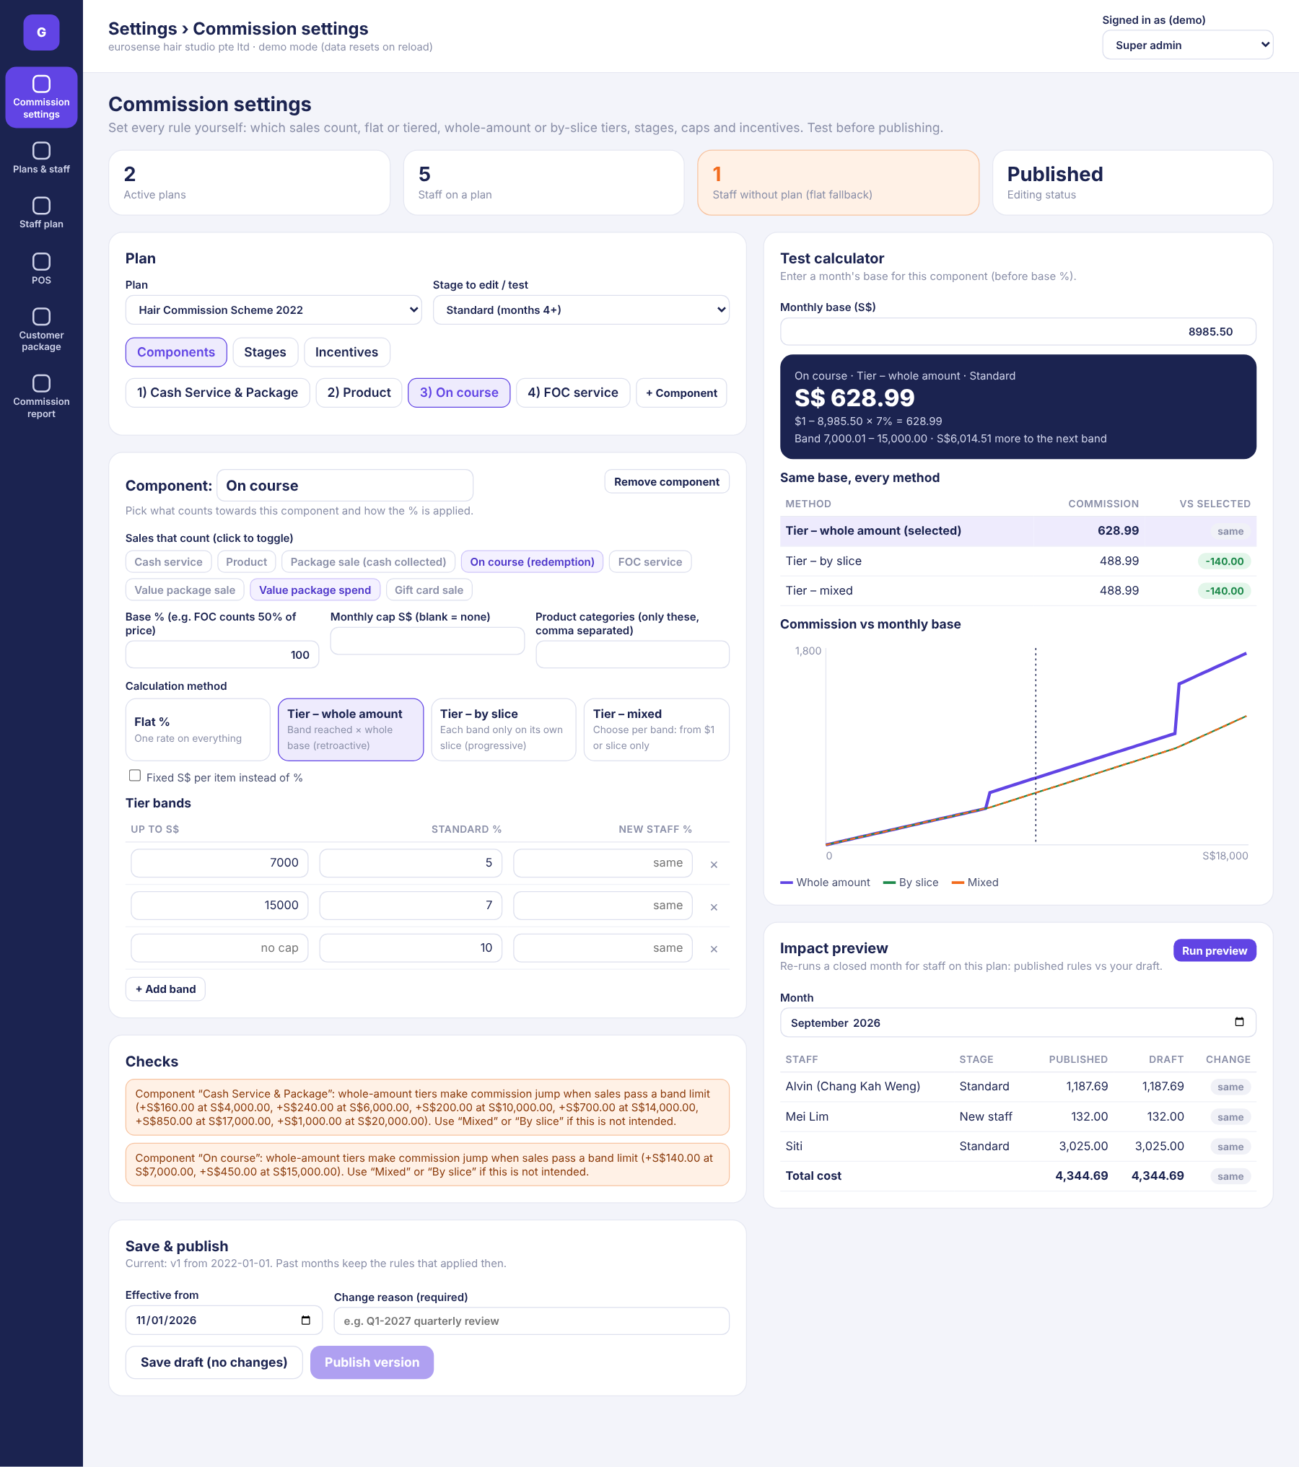

POS – sell & redeem
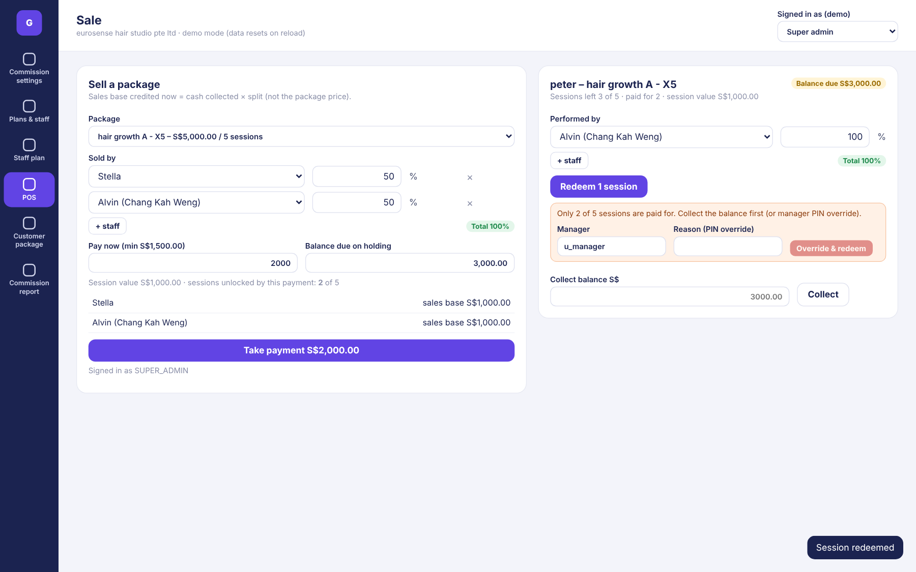

Commission & payroll report
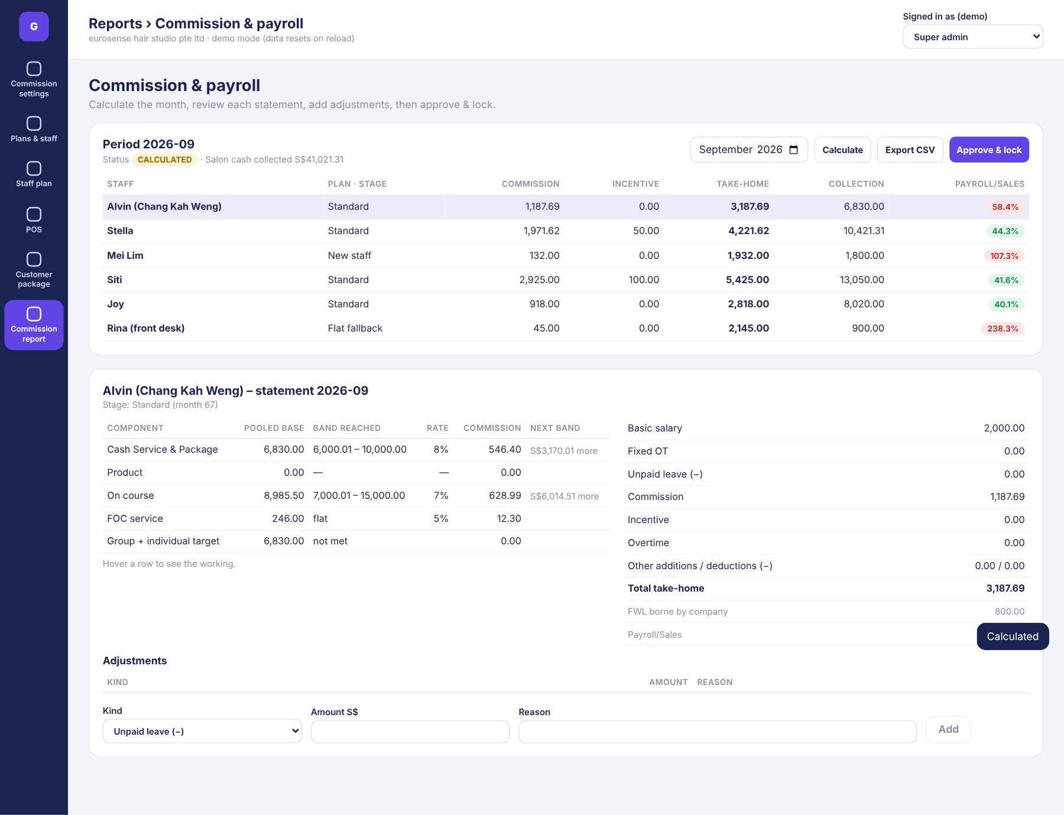

Staff commission plan
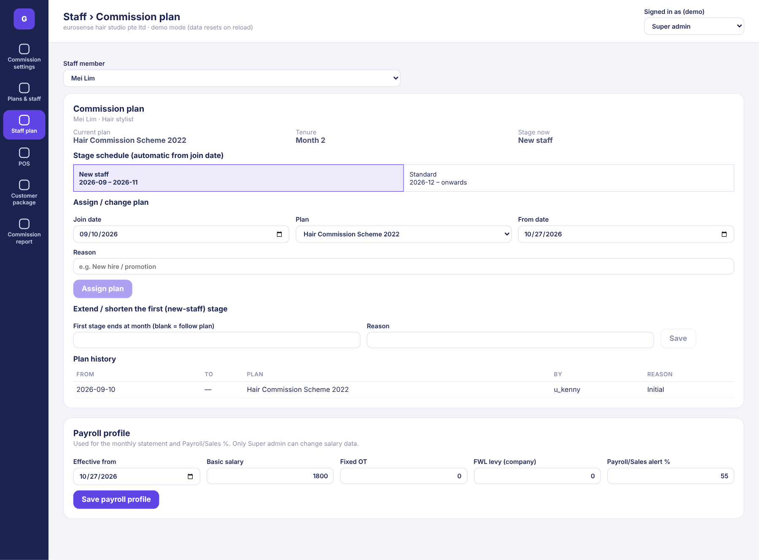

9. File map
shared/src/types.ts domain types (read first)
shared/src/money.ts Decimal helpers, split allocation
shared/src/engine/tier.ts component calculator (all methods)
shared/src/engine/period.ts month-end per staff, flat fallback
shared/src/engine/stage.ts tenure month, stage, schedule
shared/src/engine/incentive.ts incentives
shared/src/engine/package.ts session value, paid sessions (D-8), refund (D-7)
shared/src/engine/validate.ts plan validation, jump warnings
shared/src/engine/impact.ts impact preview
shared/src/seed.ts Eurosense Hair 2022 and TP Mani & Pedi plans
backend/src/repo/* storage interface + memory + Prisma
backend/src/services/* plan, ledger, period, staff services
backend/src/api/* Express routes + zod validation
backend/src/seed/demo.ts demo data (Sep/Oct 2026)
backend/prisma/schema.prisma database schema (sql/001_commission_module.sql = same in SQL)
frontend/src/api/* CommissionApi, HttpApi, DemoApi
frontend/src/pages|pos|customer screens; components/ UI kit, SplitEditor, Chart

10. Open points with the owner
# | Question | Default in code
OP-1 | On course method at go-live: whole amount (628.99) or by slice (488.99) for Alvin’s Sept | Whole amount (changeable in settings)
OP-2 | FOC “50% of price”: was S$492 the full price (→ 12.30) or already 50% (→ 24.60)? | Base 50% of list price
OP-3 | Hair component 1 above S$25,000 | 25%, no cap
OP-5 | Personal/individual target metric = cash service + package cash + product | Yes
OP-9 | Minimum deposit % and refund admin fee | 30% · S$100 (Settings)

