SYSTEM REQUIREMENT SPECIFICATION
Glampro – Staff Commission Plans, Package Sale & Redemption Commission
Tiered commission plans with new-staff stages, cash-collected package sales, per-session redemption, incentives and month-end payroll statements
Item | Detail
Document | SRS-GLAMPRO-COMM
Version | v1.2 – for developer hand-over (supersedes v1.1, v1.0, v0.9)
Date | 27 October 2026
Product | Glampro Suite (glampro.tusphere.com)
Business owner | Kenny Eng
Reference salon | Eurosense Hair Studio Pte Ltd
Source documents | Hair Commission Scheme (2022) · TP Mani & Pedi Commission Scheme (May 2019) · September 2026 salary sheets (Alvin / Chang Kah Weng, Stella)

Document history
Version | Date | Change
0.9 | 26 Oct 2026 | First draft: package sale & redemption commission, flat % per staff (commission matrix), workflows, screens.
1.2 | 27 Oct 2026 | Owner confirmed: (D-7) refunds take back only the sale commission on the refunded part, redemption commission already earned stays; (D-8) customers can redeem only as many sessions as they have paid for (manager PIN override, logged).
1.1 | 27 Oct 2026 | Commission settings dashboard: every rule is admin-configurable – calculation method per component (Flat, Tier – whole amount, Tier – by slice, Tier – mixed per band), included sales types, base %, monthly cap, stage rates; test calculator, method comparison chart and last-month impact preview before publishing. On-course method is now a setting (OP-1 closed). Interactive prototype supplied.
1.0 | 27 Oct 2026 | Commission plans assigned to staff on joining; tiered rates (retroactive / progressive); stages by tenure (e.g. first 3 months); incentives (group + individual / personal target); package sale commission base fixed to cash collected; base ledger + month-end calculation engine; requirement IDs, algorithms, seed data and test cases added.

Contents

In Word: right-click the table → Update field to refresh page numbers.

1. Introduction

1.1 Purpose
This document specifies what the Glampro development team must build so that staff commission at Eurosense (and any other Glampro salon) is calculated by the system instead of manual Excel salary sheets. It is written for developers, testers and the business owner who signs off.

1.2 Scope
In scope | Out of scope (this release)
Commission plans with components, tier bands, stages, incentives and versions  Staff plan assignment at joining, automatic stage progression  Capture of commission base at POS: cash services, products, package sales (cash collected), package redemptions, FOC, value packages  Sold by / Performed by attribution and splits  Deposits and instalments for packages  Month-end calculation engine, adjustments, refunds and clawbacks  Commission & payroll report, staff statement, Excel / PDF export, approve & lock  Audit trail and permissions | Statutory payroll (CPF, IR8A, bank GIRO files)  Leave management (unpaid leave amount is entered manually)  Online-booking prepayment commission  Multi-currency  Tips / gratuities

1.3 Definitions
Term | Meaning
Commission type | Category of a commissionable event: SVC (cash service), PRD (product), PKG_SALE (package sale – cash collected), PKG_RED (package redemption / “on course”), FOC (complimentary service), VP_SALE, VP_SPEND (value / stored-credit package), GC_SALE (gift card).
Base line | One row in the Commission Base Ledger: staff, commission type, base amount, business date, source. It carries no rate – the rate is decided at month end by the plan.
Commission plan | A named scheme (e.g. “Hair Commission Scheme 2022”) holding components, stages and incentives. Versioned by effective date.
Component | A part of a plan that pools one or more commission types and applies a flat rate or a tier table (e.g. “Cash Service & Package Commission”).
Tier band | A row of a tier table: upper limit of monthly base and the rate for that band.
Tier – whole amount (retroactive) | When the monthly base reaches a band, that band’s rate applies to the whole base from $1. (Eurosense’s September practice.)
Tier – by slice (progressive) | Each band’s rate applies only to the slice of base inside that band (like income tax).
Tier – mixed | Each band is marked “from $1 (whole)” or “slice only”. Bands marked whole cover $1 up to their limit; bands above them are added slice by slice. Lets the admin model wording such as Hair scheme “(1-$10,000)” then “($10,001-$14,000)”.
Stage | A period of a staff member’s tenure with its own band overrides, e.g. Stage 1 “New staff” = months 1–3.
Tenure month | Month number since join date; the join month is month 1.
Session value | Net package price paid ÷ number of sessions, snapshotted on the customer holding at purchase.
Cash collected | Money actually received for a package in the period (full payment, deposit or instalment), after discount, excluding GST, net of refunds.
Period | Commission period – a calendar month (1st to last day, Asia/Singapore).

2. Business context

2.1 Eurosense commission schemes (source of truth)

A. Hair Commission Scheme (2022) – hair stylists / therapists
Component | Monthly base (S$) | Rate | Notes
1) Cash Service & Package | 0 – 4,000 | 0% | 4% in first 3 months (new-staff stage)
 | 4,001 – 6,000 | 4% | written “(1-$6,000)” → applies from $1
 | 6,001 – 10,000 | 8% | written “(1-$10,000)” → applies from $1
 | 10,001 – 14,000 | 10%
 | 14,001 – 17,000 | 15%
 | 17,001 – 20,000 | 20%
 | 20,001 – 25,000 | 25% | above 25,000 not defined → assume 25% (open point)
2) Product | any | 10% | flat
3 i) On course (100%) | 0 – 7,000 | 5% | “1st 7K”
 | 7,001 – 15,000 | 7% | “next 8K”
 | 15,001 and above | 10%
3 ii) FOC service | 50% of price | 5% | base = 50% of service price
4) Additional incentive | Group 30,000 / Individual 12,000 | S$100 | both targets must be met
 | Group 40,000 / Individual 15,000 | S$200
 | Group 50,000 / Individual 17,000 | S$300
Scheme note: “reviewed every quarter; the company has sole discretion to make changes” → plans must be versioned with effective dates.

B. TP Mani & Pedi Commission Scheme (from May 2019) – nail technicians
Component | Monthly base (S$) | Rate
1) Cash & Course Services | any | 10% flat
2) Product | any | 10% flat
3) Package | 0 – 4,000 / 4,001 – 6,000 / 6,001 – 8,000 / 8,001 & above | 2% / 4% / 5% / 7%
4) Other – Beauty product | any | 5% flat
5) Personal target | 10,000 / 13,000 / 16,000 | S$50 / S$100 / S$150

2.2 Reconciliation with September 2026 salary sheets
Both sheets were recalculated against the schemes to establish how rules are applied in practice.
Staff / plan | Component | Base (S$) | Band | Rate | Sheet (S$) | Match
Alvin – Hair | 1) Cash svc 159.00 + Package 6,671.00 | 6,830.00 | 6,001–10,000 | 8% on whole | 546.40 | ✔ retroactive
 | 3 i) On course | 8,985.50 | 7,001–15,000 | 7% on whole | 628.99 | ✔ retroactive *
 | 3 ii) FOC | 492.00 | flat | 5% | 24.60 | ? see 2.3
 | Total commission |  |  |  | 1,199.99
Stella – TP | 1) Cash svc 1,087.00 + Course 12,071.84 | 13,158.84 | flat | 10% | 1,315.88 | ✔
 | 2) Product | 78.00 | flat | 10% | 7.80 | ✔
 | 3) Package | 9,256.31 | 8,001+ | 7% on whole | 647.94 | ✔ retroactive
 | Total commission |  |  |  | 1,971.62 | ✔
 | 5) Personal target | 10,421.31 (pkg + svc + product) | ≥ 10,000 |  | 50.00 | ✔

2.3 Findings that drive the requirements
- Tiers are applied retroactively in practice (rate of the band reached × whole monthly base) – both sheets confirm this. Because practice and wording differ, the method must be a setting the admin chooses per component (section 4.3), not hard-coded.
- * On-course discrepancy: the Hair scheme wording (“1st 7K 5%, next 8K 7%”) reads as progressive, which would give 7,000×5% + 1,985.50×7% = 488.99, but Alvin was paid 628.99 (7% on the whole). Owner to confirm which is intended (open point OP-1).
- FOC “50% of price”: if S$492.00 is the full service price, the scheme gives 492 × 50% × 5% = 12.30, not 24.60. Owner to confirm whether 492.00 was already the 50% figure (OP-2).
- Package sale base changes to cash collected (owner decision, 27 Oct). The sheets used package sales value (Alvin 6,671.00 vs cash; Stella 9,256.31 vs package cash 8,688.00). Under the new rule Stella’s package base would be 8,688.00 → still 7% band → 608.16 (−39.78), and her personal-target base 9,853.00 would fall below 10,000 → no S$50 incentive. Owner should be aware of this impact (OP-5).
- New-staff stage: the Hair scheme pays 4% on the 0–4,000 band during the first 3 months (0% afterwards). Stages must be driven automatically from the join date.
- Different staff are on different plans (Alvin – Hair; Stella – TP). Rates are therefore a property of the plan, not hard-coded per staff.
- Payroll/Sales ratio = (take-home + FWL levy) ÷ total collection is the KPI tracked on the sheets (Alvin 60%, Stella 47%).

2.4 Glampro today and gaps
Area (AS-IS) | What exists | Gap
Settings › Team & commissions | Company commission defaults; rules for Services / Products: %, effective-from, reason; precedence item → department → staff → company. | Flat % only; no tiers, stages, plans, incentives; no package types.
Staff › Edit staff | Role, POS PIN, start/end date, departments, working hours, advanced (flat) commission rules. | No plan assignment; no payroll profile.
Products › Packages | Member / non-member price, sessions, validity, redemption mode, covered services. | No session-value snapshot, deposit or commission settings.
Sale (POS) | Services, Products, Packages, Value packages, Gift cards tabs; switch staff. | No Sold by / Performed by per line, no split, no deposit / balance collection.
Customer profile | Balances, transfers, family sharing, histories. | No payment and session log per holding.
Reports | Overview, Staff & payments, Customer balances, Daily close. | No commission calculation, statement or payroll export.

2.5 Industry practice (summary)
System | Relevant practice adopted
Zenoti | Separate rules for package sale and redemption; tiers (cumulative or highest-qualified); rates versioned by effective date; splits at payment.
Fresha | Tiers either progressive (higher rate only above threshold) or retroactive (higher rate on all sales once threshold met); workspace or individual level.
Meevo | Redemption valued at each service’s share of the price actually paid, or optionally full list price.
Pabau | Per-package commission override; choose to pay on sale or on redemption; deduct discounts / tax.

3. Solution overview
The design separates what happened (base lines written in real time at the POS) from how much is paid (decided once a month by the staff member’s plan). This is required because tier rates depend on the monthly total, which is only known at month end.
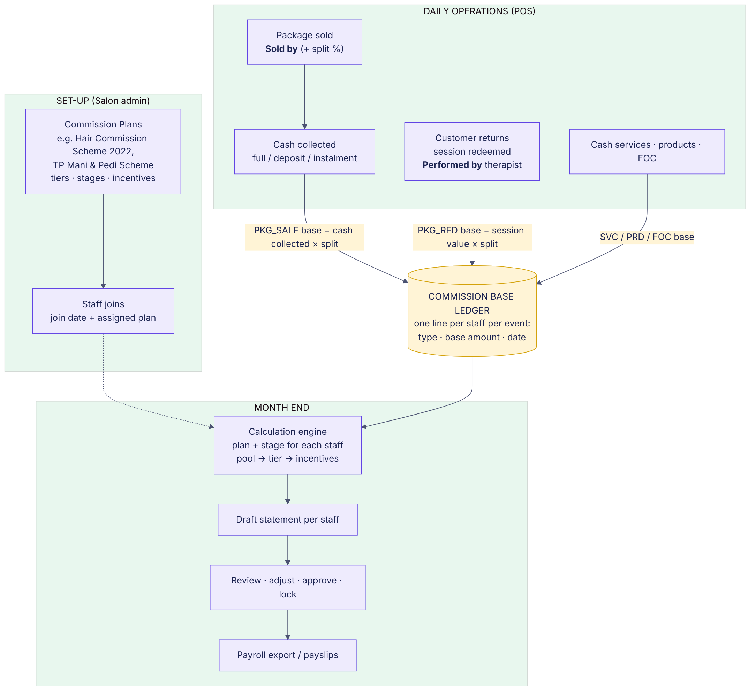
Figure 3.1 – End-to-end flow

3.1 Decisions confirmed by the owner
# | Decision
D-1 | Package SALE commission base = cash collected (deposits and instalments count in the month received; refunds are negative).
D-2 | Each staff member is given a commission plan when they join; % for sales and redemption vary by stage and by monthly tier.
D-3 | Package REDEMPTION (“on course”) base = session value snapshotted at purchase.
D-4 | The calculation method is a setting per plan component, chosen by the salon admin in Commission settings: Flat, Tier – whole amount, Tier – by slice, or Tier – mixed (per band). Seed default = whole amount (September practice); the admin can switch any component (e.g. On course) from an effective date, after checking the impact preview.
D-5 | Commission period = calendar month; the plan version and assignment in force on the last day of the month apply to the whole month.
D-6 | Existing flat rules remain as fallback for staff without a plan.
D-7 | Refunds: only the sale commission on the refunded part is taken back (negative package-sale base on the refund date, split to the original sellers). Redemption commission already earned stays. (FR-ADJ-01, FR-ADJ-02)
D-8 | Unpaid packages: a customer may redeem only as many sessions as they have paid for – floor(cash collected ÷ session value). Further sessions are blocked until the balance is collected; a manager PIN override is allowed and logged. (FR-POS-08)

4. Functional requirements
Priority: M = must have for go-live, S = should have, C = could have.

4.1 Commission base capture (ledger)
ID | Requirement | Pri.
FR-BAS-01 | The system shall write one Commission Base Line per credited staff member for every commissionable event, with: staff, commission type, base amount (4 dp), split %, business date (salon time zone), source (sale, payment, session usage, refund, adjustment), outlet, created by/at. | M
FR-BAS-02 | SVC: when a service is paid other than from a package, base = net line amount (after discount, excl. GST) credited to Performed by staff × split. | M
FR-BAS-03 | PRD: base = net product line amount credited to Sold by staff. Product category shall be stored so plan components can filter (e.g. “Beauty product”). | M
FR-BAS-04 | PKG_SALE: base = cash collected for a package in each payment (full, deposit, instalment), excl. GST, credited to the package line’s Sold by staff × split. Base is written on the payment date – not on the sale date. | M
FR-BAS-05 | PKG_RED: on each session redeemed, base = holding.session_value (× split) credited to Performed by staff. Session value is never recalculated after purchase. | M
FR-BAS-06 | FOC: when a complimentary service is performed, base = service list price; the plan component applies its base % (e.g. 50%). | M
FR-BAS-07 | VP_SALE: base = cash paid for a value package (e.g. S$500, not the S$600 credit). VP_SPEND: base = credit spent × paid ÷ credit (S$100 × 500/600 = S$83.33). | S
FR-BAS-08 | Refund of a package or value package writes NEGATIVE PKG_SALE / VP_SALE lines to the original sellers × split on the refund date. | M
FR-BAS-09 | Base lines are append-only. Corrections are made by reversing lines (status REVERSED) and writing new ones, with user and reason. | M
FR-BAS-10 | Gift card sales (GC_SALE) are recorded but excluded from all seed plans by default. | C

4.2 Commission plans
ID | Requirement | Pri.
FR-PLN-01 | Admin can create, duplicate, edit, archive commission plans: name, description, intended position(s), outlet(s). | M
FR-PLN-02 | A plan has one or more versions. Each version has effective-from date, change reason (required), status Draft / Published. Only one published version is effective at any date. | M
FR-PLN-03 | A version has one or more components. Component fields: name, included commission types (multi-select), optional product/service category filter, base % (default 100%), method (FLAT | TIER_WHOLE | TIER_SLICE | TIER_MIXED | FIXED_PER_UNIT), flat rate %, monthly cap S$ (optional), display order. | M
FR-PLN-04 | A TIER component has ordered tier bands: upper limit (S$, blank = no cap), rate %, and – for TIER_MIXED – apply mode WHOLE (from $1) or SLICE. Band i covers base > upper(i−1) and ≤ upper(i). | M
FR-PLN-05 | Band rates can be overridden per stage (blank = same as Standard). | M
FR-PLN-06 | A version can hold incentive rules (see 4.6). | M
FR-PLN-07 | Publishing a version validates: bands ascending, no overlaps, rates 0–100, at least one component, effective date not inside a locked period. | M
FR-PLN-08 | Preview calculator: admin enters sample monthly bases and sees the commission per component and total, for each stage. | S
FR-PLN-09 | Plan list shows number of staff on each plan and current version; plan editor shows version history with who/when/why. | M
FR-PLN-10 | Optional fixed amount per unit component (e.g. S$5 per FOC) – method FIXED_PER_UNIT. | C

4.3 Commission settings dashboard (admin configuration)
The salon admin must be able to change every commission rule without a developer. All settings live in Settings › Commission settings (prototype: commission_settings_prototype.html, screens 7.2).
ID | Requirement | Pri.
FR-SET-01 | Dashboard header cards: active plans, staff on a plan, staff without a plan (warning – they use the flat fallback), status of the version being edited (Published / Draft / Scheduled). | M
FR-SET-02 | Plan selector and component tabs; components can be added, renamed, re-ordered, duplicated and removed in a draft. | M
FR-SET-03 | “Sales that count” chips per component to include / exclude commission types (cash service, package sale cash, on course, product, FOC, value package sale / spend) plus optional category filter. | M
FR-SET-04 | Calculation method picker per component with plain-language explanation: Flat % · Tier – whole amount · Tier – by slice · Tier – mixed. Switching method keeps the band table. | M
FR-SET-05 | Editable band table: Up to S$, Standard %, one column per extra stage (blank = same as Standard), Applies (From $1 / Slice only) shown for Mixed; add / remove band; validation (ascending limits, only last band uncapped, 0–100%). | M
FR-SET-06 | Base % and monthly cap per component (e.g. FOC counts 50% of price; cap S$ x per month). | M
FR-SET-07 | Test calculator: enter a monthly base and stage → shows commission and the line-by-line working (bands, slices, rates, cap). | M
FR-SET-08 | Method comparison: for the same base shows the result under whole amount, by slice and mixed, and the difference vs the selected method; chart of commission vs monthly base for each method with the test base marked. | S
FR-SET-09 | Jump warning: for whole-amount tiers the system shows the jump in commission when a band limit is crossed (e.g. On course: +S$140.00 at S$7,000) so the admin can decide if that is intended. | S
FR-SET-10 | Impact preview: re-runs the last closed month for every staff member on the plan with the published rules vs the draft; shows per staff and total cost change before publishing. | M
FR-SET-11 | Publish with effective date (today or future = Scheduled) and required reason; past periods keep their rules. Version compare view shows what changed. | M
FR-SET-12 | Export / import plan as JSON (backup, copy between outlets or salons). | C

4.3a Stages (tenure-based)
ID | Requirement | Pri.
FR-STG-01 | A plan version defines stages with name, from-month and to-month (blank = open-ended), e.g. Stage 1 “New staff” months 1–3, Stage 2 “Standard” month 4+. If none defined, a single Standard stage applies. | M
FR-STG-02 | Tenure month for period P = (year(P) − year(join)) × 12 + month(P) − month(join) + 1. | M
FR-STG-03 | Stage for staff S in period P = stage whose month range contains the tenure month. Progression is automatic; no manual action. | M
FR-STG-04 | Admin can override a staff member’s stage end (extend / shorten the new-staff stage) with reason; logged. | S
FR-STG-05 | Salon setting “Join after day N counts from next month” (default off). | C

4.4 Staff plan assignment
ID | Requirement | Pri.
FR-ASN-01 | Add / Edit staff requires join date and (for commission-earning roles) a commission plan. | M
FR-ASN-02 | Assignments are effective-dated (from / to). Changing plan creates a new assignment; history is kept and shown. | M
FR-ASN-03 | The assignment in force on the last day of the period applies to the whole period (D-5). | M
FR-ASN-04 | Edit staff shows the auto stage schedule (e.g. Stage 1 Sep–Nov 2026, Standard from Dec 2026) and current tenure month. | M
FR-ASN-05 | Staff with no plan fall back to the existing flat rules (item → department → staff → company). | M
FR-ASN-06 | Bulk assign: select several staff → assign plan from date. | S

4.5 POS attribution, deposits and redemption
ID | Requirement | Pri.
FR-POS-01 | Every commissionable cart line has staff attribution: Sold by (packages, products, value packages) or Performed by (services, redemptions, FOC). Default = staff on till / appointment therapist. | M
FR-POS-02 | Split: up to 4 staff per line; split % must total 100%. | M
FR-POS-03 | Salon setting “Require staff on commissionable lines” blocks checkout when missing (default on). | M
FR-POS-04 | Packages can be paid in part: pay-now amount ≥ package minimum deposit %; balance due stored on the holding. | M
FR-POS-05 | “Collect balance” on POS and customer profile: takes payment against a holding, writes PKG_SALE base lines to the original sellers and split. | M
FR-POS-06 | On purchase the holding stores: net price paid (excl. GST), sessions, session value, sellers & split, commission settings snapshot. | M
FR-POS-07 | With a customer selected, POS lists active holdings with sessions left, balance due and a “Redeem 1” action (earliest expiry first, covered services only). | M
FR-POS-08 | Redemption allowed only for sessions already paid: floor(cash collected ÷ session value) > sessions used, unless a manager PIN override is entered (logged). | M
FR-POS-09 | Line shows base being credited and, for the staff member, month-to-date base, current band and gap to next band (informational). | S
FR-POS-10 | Package edit form has commission settings: Package sale – Follow plan | Exclude | Fixed $ per sale; Redemption – Follow plan | Exclude | Fixed $ per session; Minimum deposit %. (Redemption before full payment is not a per-package option – the D-8 rule always applies.) | M

4.6 Incentives
ID | Requirement | Pri.
FR-INC-01 | Incentive rule types: INDIVIDUAL_TARGET (table of individual target → amount) and GROUP_AND_INDIVIDUAL (table of group target + individual target → amount). | M
FR-INC-02 | Pay the amount of the highest row whose conditions are all met; rows are not cumulative. | M
FR-INC-03 | Individual metric is configurable as a set of commission types (seed: SVC + PKG_SALE + PRD, i.e. sales excluding redemption). | M
FR-INC-04 | Group metric is configurable: salon total cash collected (default) or total of all staff individual metrics; scope = outlet or whole salon. | M
FR-INC-05 | Incentives appear as a separate line on the statement and may be adjusted with reason. | M

4.7 Month-end calculation engine
ID | Requirement | Pri.
FR-CAL-01 | Admin can run (and re-run) the calculation for any OPEN period; it produces a draft Period Result per staff. Re-run replaces drafts and keeps manual adjustments. | M
FR-CAL-02 | For each staff: resolve assignment and plan version effective on the period’s last day; compute tenure month and stage. | M
FR-CAL-03 | For each component: pooled base = Σ base lines (types in component, optional category filter, business date in period) × base %. | M
FR-CAL-04 | Let k = band containing the pooled base. FLAT: base × rate. TIER_WHOLE: rate(k) × base. TIER_SLICE: Σ over bands ≤ k of slice × band rate. TIER_MIXED: j = highest band ≤ k marked WHOLE; amount = rate(j) × min(base, upper(j)) + Σ slices of bands j+1..k × their rates (if no WHOLE band reached, same as by slice). Stage overrides replace band rates; the monthly cap is applied last. | M
FR-CAL-05 | Pooled base ≤ 0: amount = 0; the negative amount is carried to the same component in the next period (setting: carry forward | write off; default carry forward). | M
FR-CAL-06 | Rounding: each component amount rounded to 2 dp half-up (reproduces 8,985.50 × 7% = 628.99). | M
FR-CAL-07 | Store snapshot per result line: plan, version, stage, component, pooled base, band reached, rate, amount, next band threshold. | M
FR-CAL-08 | Package-level “Fixed $” or “Exclude” settings bypass the plan: fixed amounts are added as their own result line; excluded lines are not pooled. | M
FR-CAL-09 | Staff without a plan: amount = Σ base × flat rule rate (existing engine), shown as component “Flat rules”. | M
FR-CAL-10 | Live month-to-date estimate (same algorithm on period-to-date data) for POS, staff overview and “My commission”. | S
Reference algorithm (developer guidance):
function calculatePeriod(P):
for staff S in activeStaff(P):
a = assignment(S, P.end) // null -> flat-rule fallback
v = publishedVersion(a.plan, P.end)
m = (P.year-S.join.year)*12 + P.month - S.join.month + 1
stg = v.stages.find(s => s.from <= m && (s.to==null || m <= s.to))
for comp in v.components:
base = sum(lines(S,P).where(type in comp.types && catOk(comp))) * comp.basePct
base += carryForward(S, comp, P.prev)
if base <= 0: amount = 0; carry(S, comp, P, base); continue
bands = comp.bands.withStageOverrides(stg)
switch comp.method:
FLAT: amount = base * comp.rate
TIER_WHOLE: b = bands.first(x => x.upper==null || base <= x.upper)
amount = base * b.rate
TIER_MIXED: j = lastWholeBandUpTo(k); amount = rate(j)*min(base,upper(j))
+ sum(slice(i)*rate(i) for i in j+1..k)
TIER_SLICE: amount = 0; lower = 0
for b in bands: slice = min(base, b.upper ?? INF) - lower
if slice > 0: amount += slice * b.rate
lower = b.upper ?? INF
amount = min(amount, comp.cap ?? INF)
save line(S, comp, base, b, round2(amount))
for inc in v.incentives: save line(S, inc, bestRowMet(inc, S, P))
applyAdjustments(S, P); saveResult(S, P, snapshot=v, stg)

4.8 Refunds, corrections and adjustments
ID | Requirement | Pri.
FR-ADJ-01 | Package refund amount = cash collected − (sessions used × session value) − admin fee (configurable, manager approval, reason). | M
FR-ADJ-02 | Refund writes negative PKG_SALE base lines in the refund date’s period (or the next open period if that period is locked). Redemption base already earned is never reversed. | M
FR-ADJ-03 | Void session: reverses the PKG_RED line and returns the session to the holding (manager, reason). | M
FR-ADJ-04 | Correct staff: reverses the line and re-posts it to the correct staff (manager, reason). | M
FR-ADJ-05 | Manual adjustment line (+/− amount, staff, period, reason) added after calculation; shown separately on the statement. | M
FR-ADJ-06 | Holding transferred or family-shared: sale base stays with original sellers; redemption base goes to the performing staff using the original session value. | M
FR-ADJ-07 | Expired unused sessions create no redemption base. | M

4.9 Period close and payroll
ID | Requirement | Pri.
FR-PAY-01 | Period status: OPEN → CALCULATED → APPROVED (locked). Only Super admin can approve; approved periods are read-only. | M
FR-PAY-02 | Staff payroll profile (effective-dated): basic salary, fixed OT, FWL levy borne by company, Payroll/Sales alert %. | M
FR-PAY-03 | Statement lines: basic salary, unpaid leave deduction (manual), commission per component, incentives, overtime, other additions / deductions (manual with reason), total take-home, FWL (memo). | M
FR-PAY-04 | Payroll/Sales % = (take-home + FWL) ÷ staff total cash collected in period; highlighted when above alert. | M
FR-PAY-05 | Exports: Excel (summary + one sheet per staff, layout like current salary sheet) and payslip PDF. | M
FR-PAY-06 | Changes affecting a locked period post to the next open period as adjustments / negative base lines. | M

4.10 Reports
ID | Requirement | Pri.
FR-RPT-01 | Commission & payroll (period): per staff – plan, stage, commission per component, incentive, take-home, collection, Payroll/Sales %. | M
FR-RPT-02 | Staff statement: per component pooled base, band reached, rate, amount, gap to next band; drill-down to base lines → receipts / sessions. | M
FR-RPT-03 | Base ledger detail with filters (staff, type, date, package, customer) and Excel export. | M
FR-RPT-04 | Staff plan overview (month-to-date): plan, stage, MTD base per tier component, current band, gap to next band, estimated commission. | S
FR-RPT-05 | My commission (staff self-service, own data only): MTD progress bars per component. | S
FR-RPT-06 | Package liability: unpaid balances and unused sessions × session value. | S

4.11 Permissions and audit
Action | Super admin | Manager | Staff | Cashier
Create / publish plans & versions | ✔ | – | – | –
Assign plan / override stage | ✔ | ✔ (reason) | – | –
Attribute staff, take deposits, redeem | ✔ | ✔ | ✔ | ✔
Refund, void session, correct staff, PIN override | ✔ | ✔ (reason) | – | –
Run calculation, manual adjustments | ✔ | ✔ | – | –
Approve & lock period, export payroll | ✔ | – | – | –
View own commission | ✔ | ✔ | ✔ | –
All create / change / delete actions on plans, assignments, base lines, adjustments and periods are written to an immutable audit log (user, timestamp, before, after, reason).

5. Workflow diagrams

5.1 Staff joining, plan assignment and stage progression
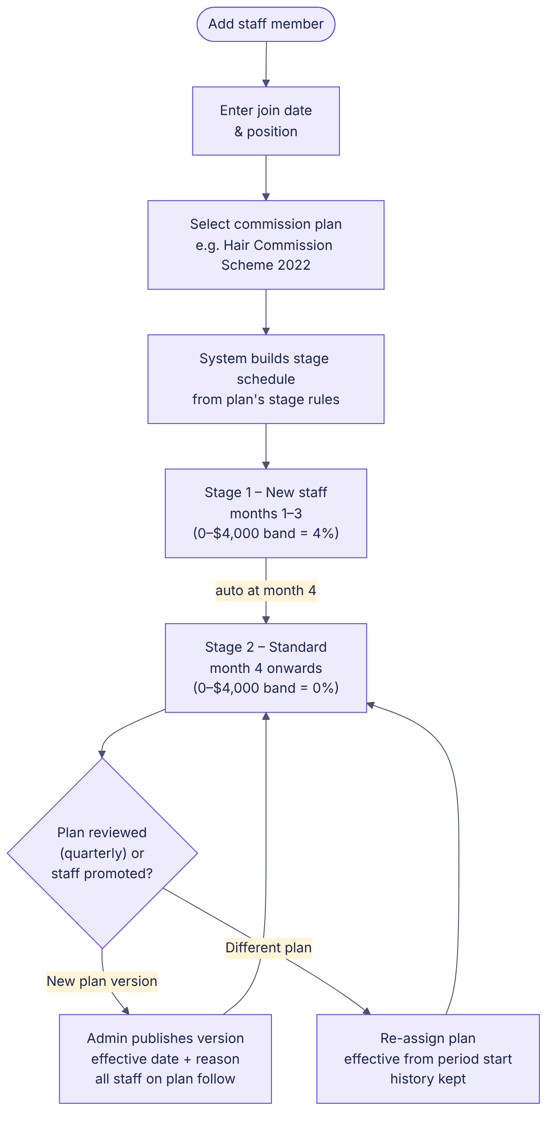
Figure 5.1 – Plan assignment and automatic stages

5.2 Package sale – cash collected
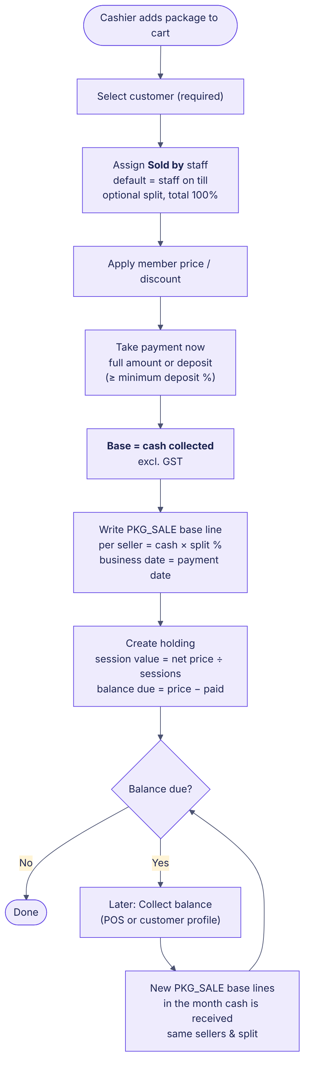
Figure 5.2 – Selling a package, deposit and balance collection

5.3 Treatment visit – redemption
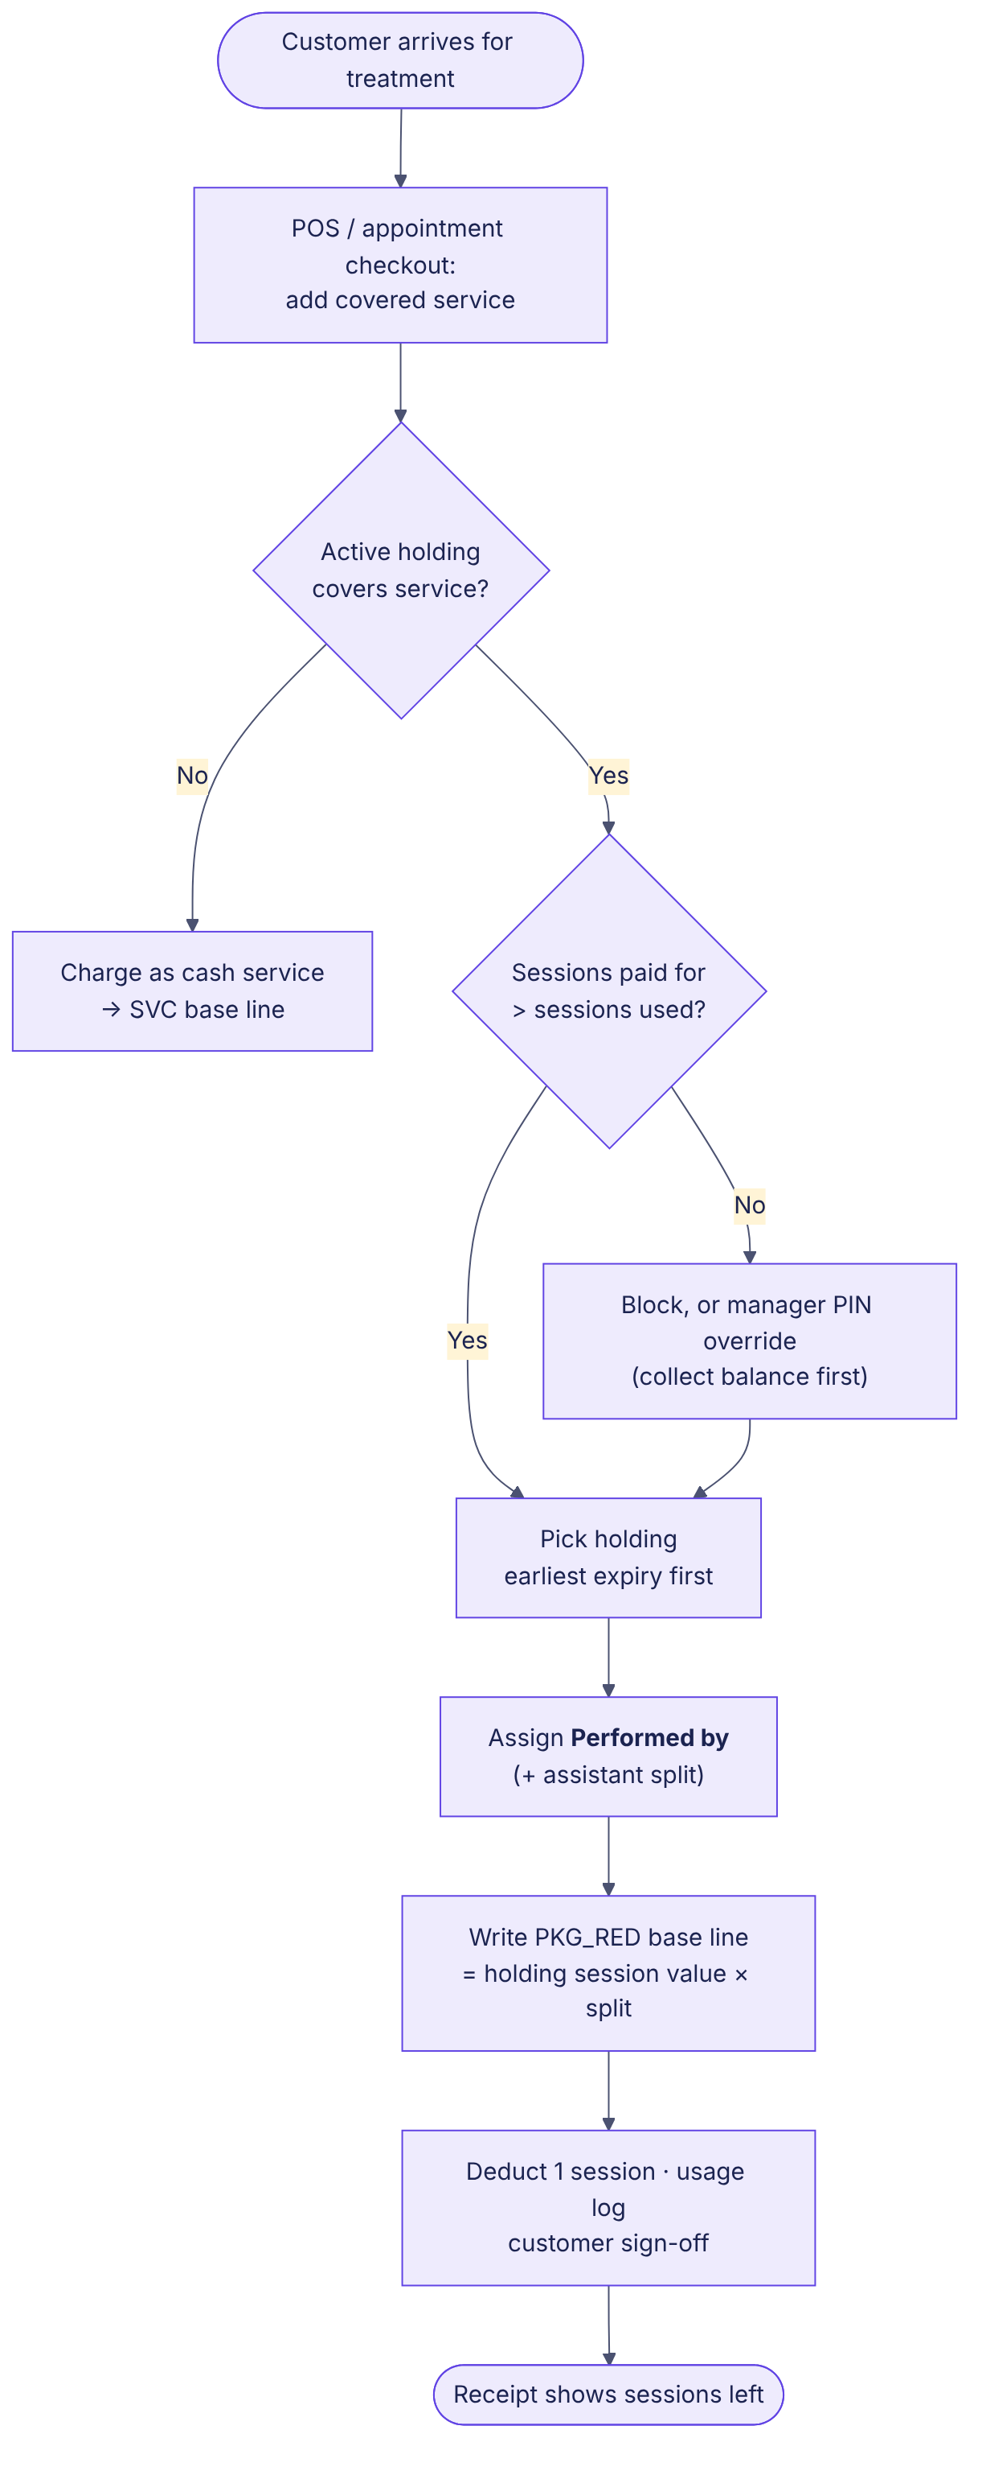
Figure 5.3 – Redeeming a session

5.4 Month-end calculation engine
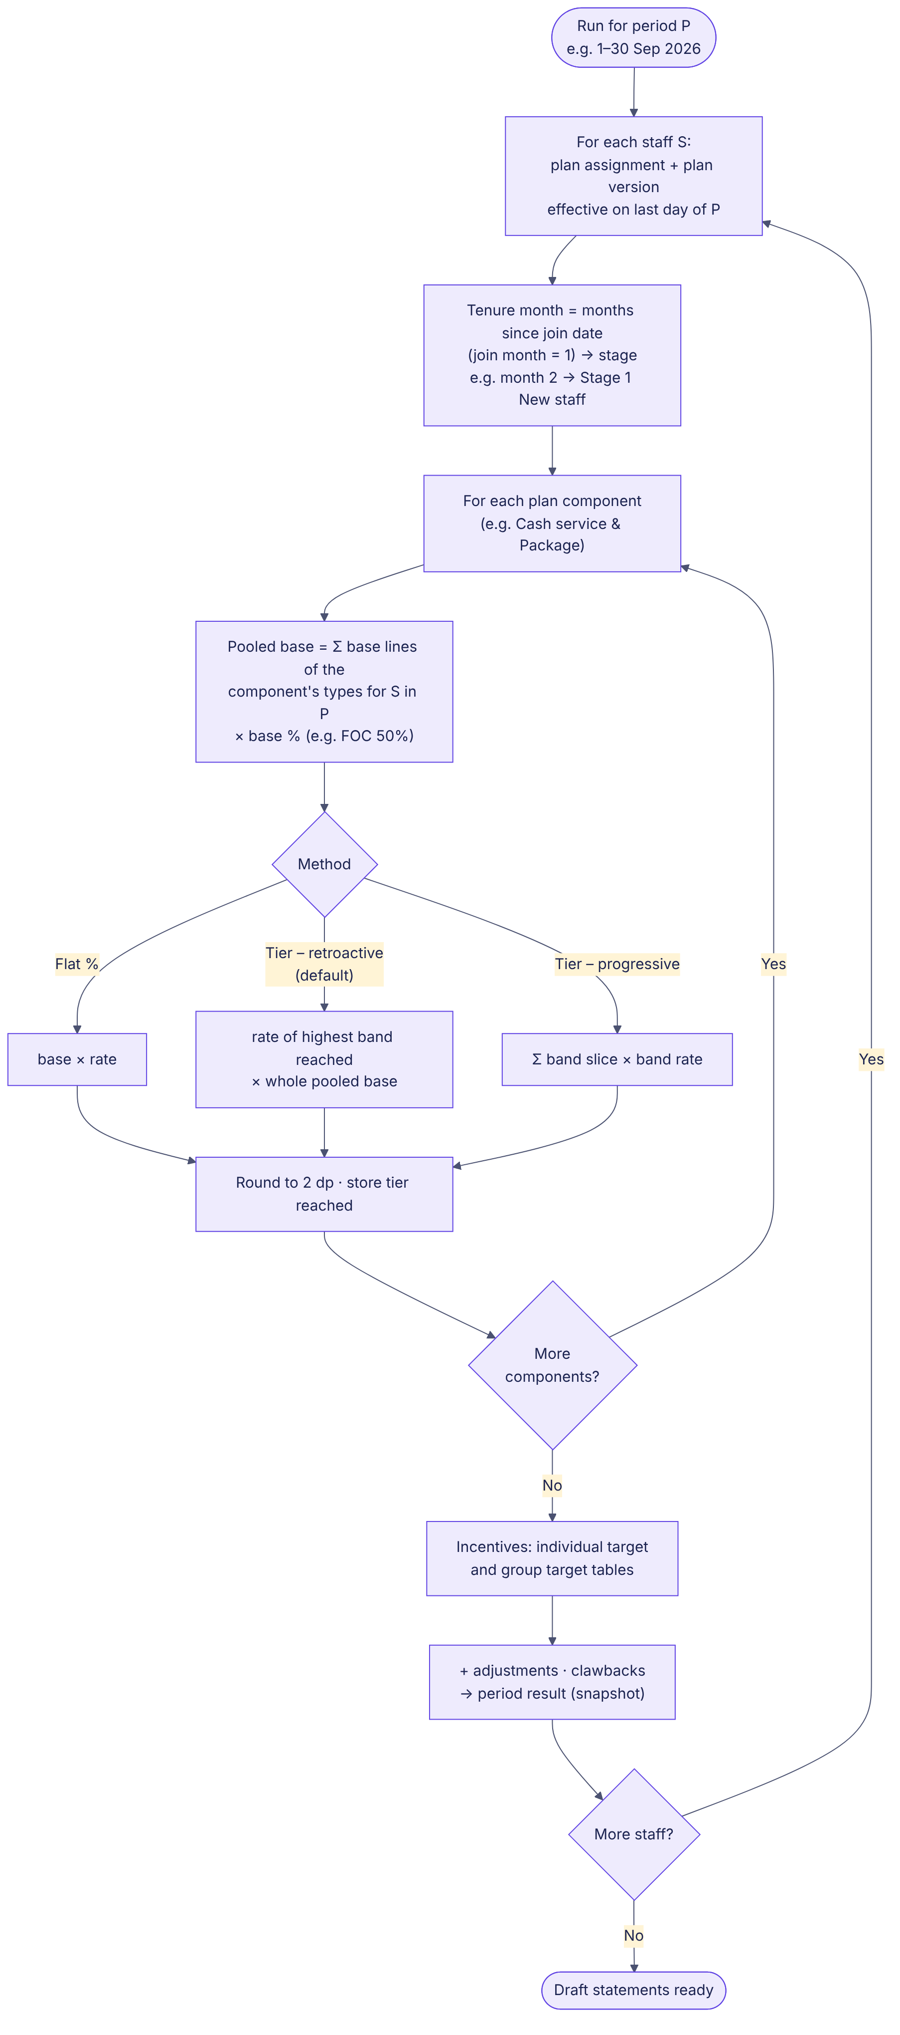
Figure 5.4 – Calculation per staff and component

5.5 Refund
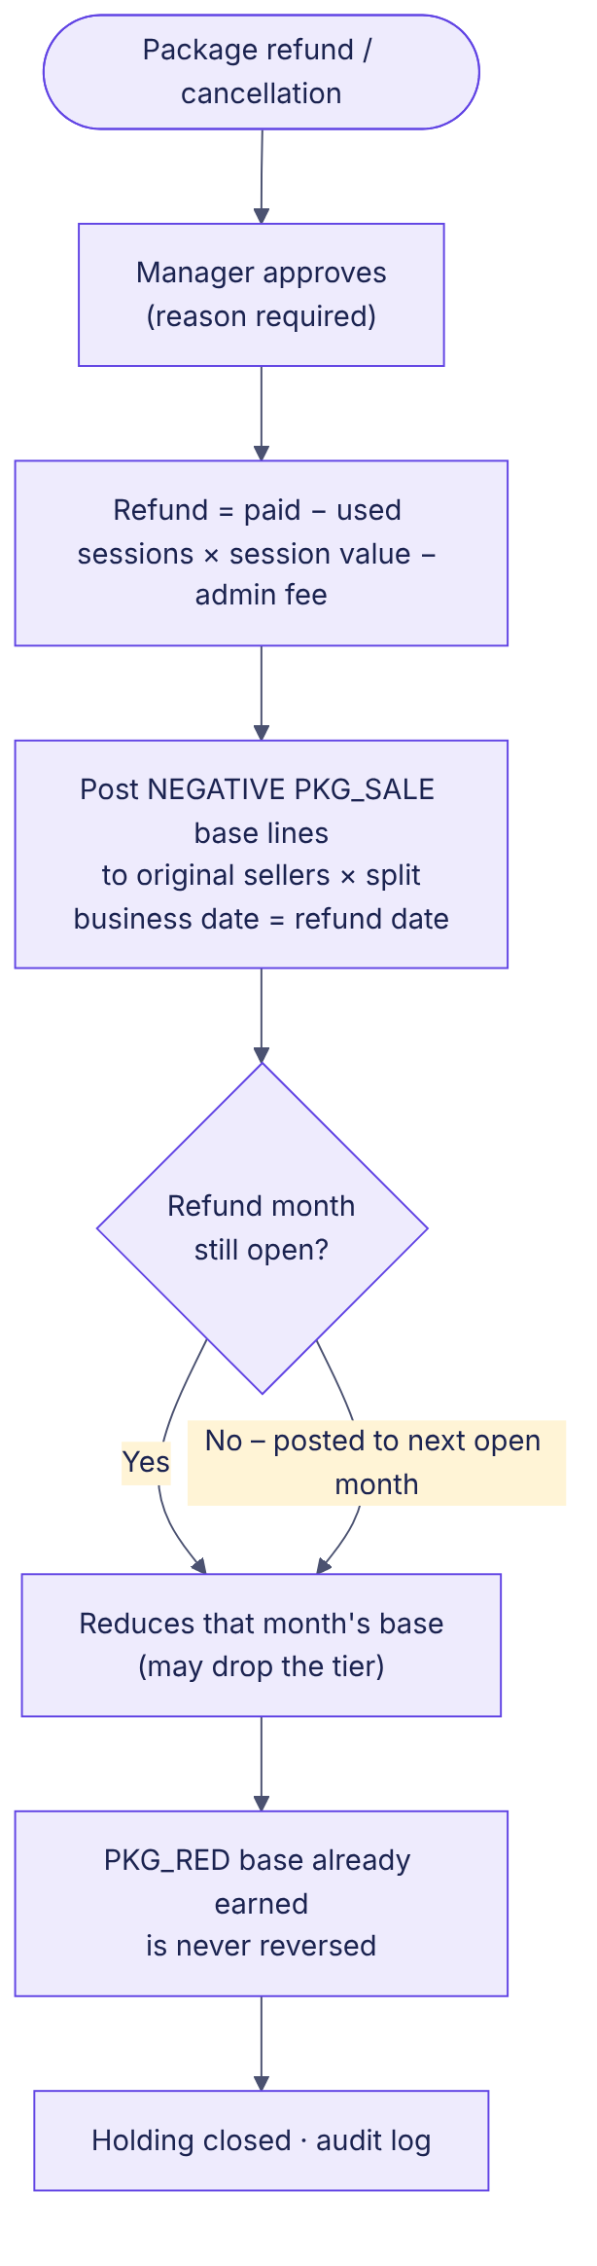
Figure 5.5 – Refund posts negative sales base

5.6 Period close and payroll
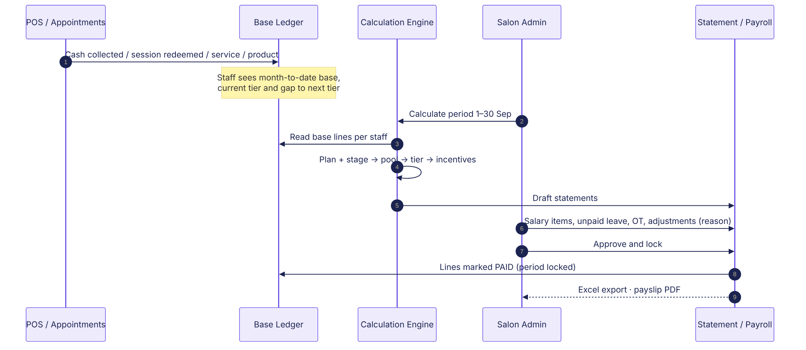
Figure 5.6 – Ledger to approved statement

6. Data model
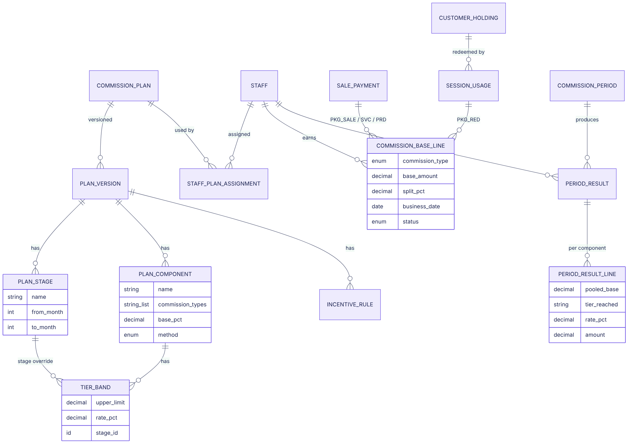
Figure 6.1 – New entities
Entity | Key fields | Notes
commission_plan | id, salon_id, name, description, positions[], outlets[], status | New
plan_version | id, plan_id, version_no, effective_from, reason, status, published_by/at | One published version effective per date
plan_stage | id, version_id, name, from_month, to_month | to_month null = open-ended
plan_component | id, version_id, name, commission_types[], category_filter, base_pct, method, flat_rate, fixed_amount, monthly_cap, sort | method: FLAT | TIER_WHOLE | TIER_SLICE | TIER_MIXED | FIXED_PER_UNIT
tier_band | id, component_id, stage_id (null = standard), sort, upper_limit, rate_pct, apply_mode | upper_limit null = no cap; apply_mode WHOLE | SLICE (used by TIER_MIXED)
incentive_rule | id, version_id, type, individual_metric_types[], group_metric, scope | type: INDIVIDUAL_TARGET | GROUP_AND_INDIVIDUAL
incentive_row | id, rule_id, group_target, individual_target, amount
staff_plan_assignment | id, staff_id, plan_id, from_date, to_date, stage_override_end, reason, created_by
staff (changed) | + join_date | Existing start date can be reused
staff_payroll_profile | staff_id, effective_from, basic_salary, fixed_ot, fwl_levy, payroll_sales_alert_pct
package (changed) | + sale_comm_mode, sale_fixed_amt, red_comm_mode, red_fixed_amt, min_deposit_pct | modes: FOLLOW_PLAN | EXCLUDE | FIXED
customer_holding (changed) | + net_price_paid, cash_collected, balance_due, session_value, sellers_json, comm_snapshot_json
sale_line_staff | sale_line_id, staff_id, role, split_pct | role: SOLD_BY | PERFORMED_BY | ASSISTANT
session_usage | id, holding_id, used_at, service_id, appointment_id, session_value, signature_ref, voided_at, void_reason
commission_base_line | id, staff_id, commission_type, product_category, base_amount, split_pct, business_date, period_id, source_type, source_id, status, reversed_by_id, reason, created_by/at | Append-only
commission_period | id, salon_id, start, end, status, calculated_at, approved_by/at | OPEN | CALCULATED | APPROVED
period_result / _line | staff, plan, version, stage; per line: component, pooled_base, band, rate, amount, next_threshold | Snapshot
carry_forward | staff_id, component_key, period_id, amount | Negative base carried
adjustment | staff_id, period_id, amount, kind, reason, created_by | Unpaid leave, OT, other

7. Screen specifications
Each change is numbered C1–C16. The AS-IS screenshot (live Glampro) marks where the change goes; the TO-BE mockup shows the new design in Glampro’s style.

7.1 Settings › Team & commissions › Commission plans (C1, C2)
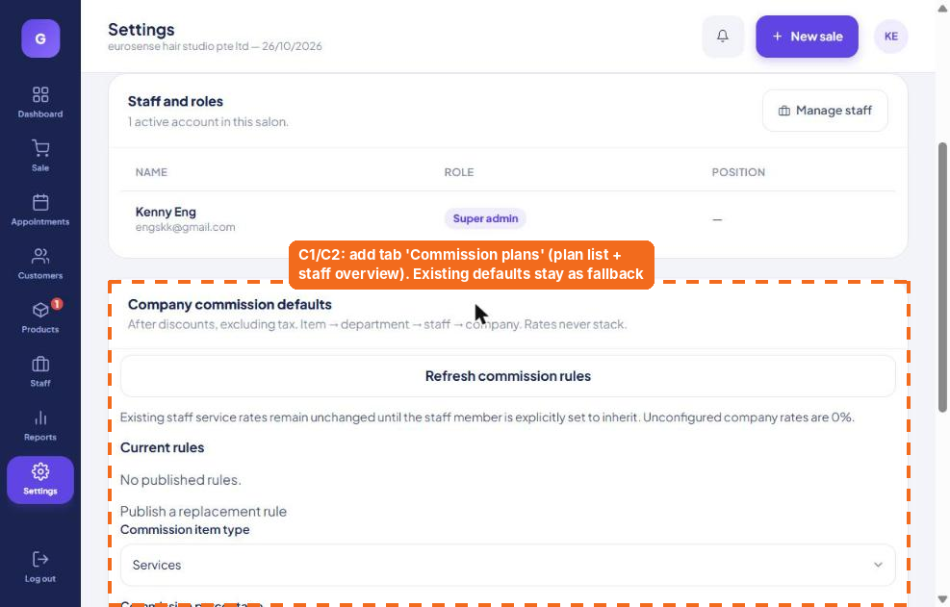
AS-IS – where the change goes
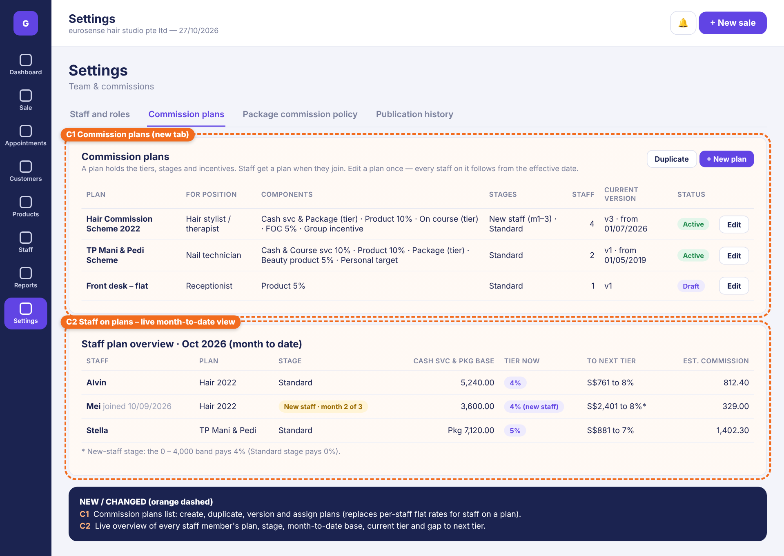
TO-BE – mockup
# | Element | Specification
C1 | Commission plans list | Columns: plan, position, components summary, stages, staff count, current version, status, Edit. Actions: + New plan, Duplicate, Archive. FR-PLN-01, 09.
C2 | Staff plan overview (MTD) | Per staff: plan, stage (with month x of y), MTD base of main tier component, current band, gap to next band, estimated commission. FR-RPT-04.

7.2 Settings › Commission settings – dashboard, editor and calculator (C3 – C5, C17 – C20)
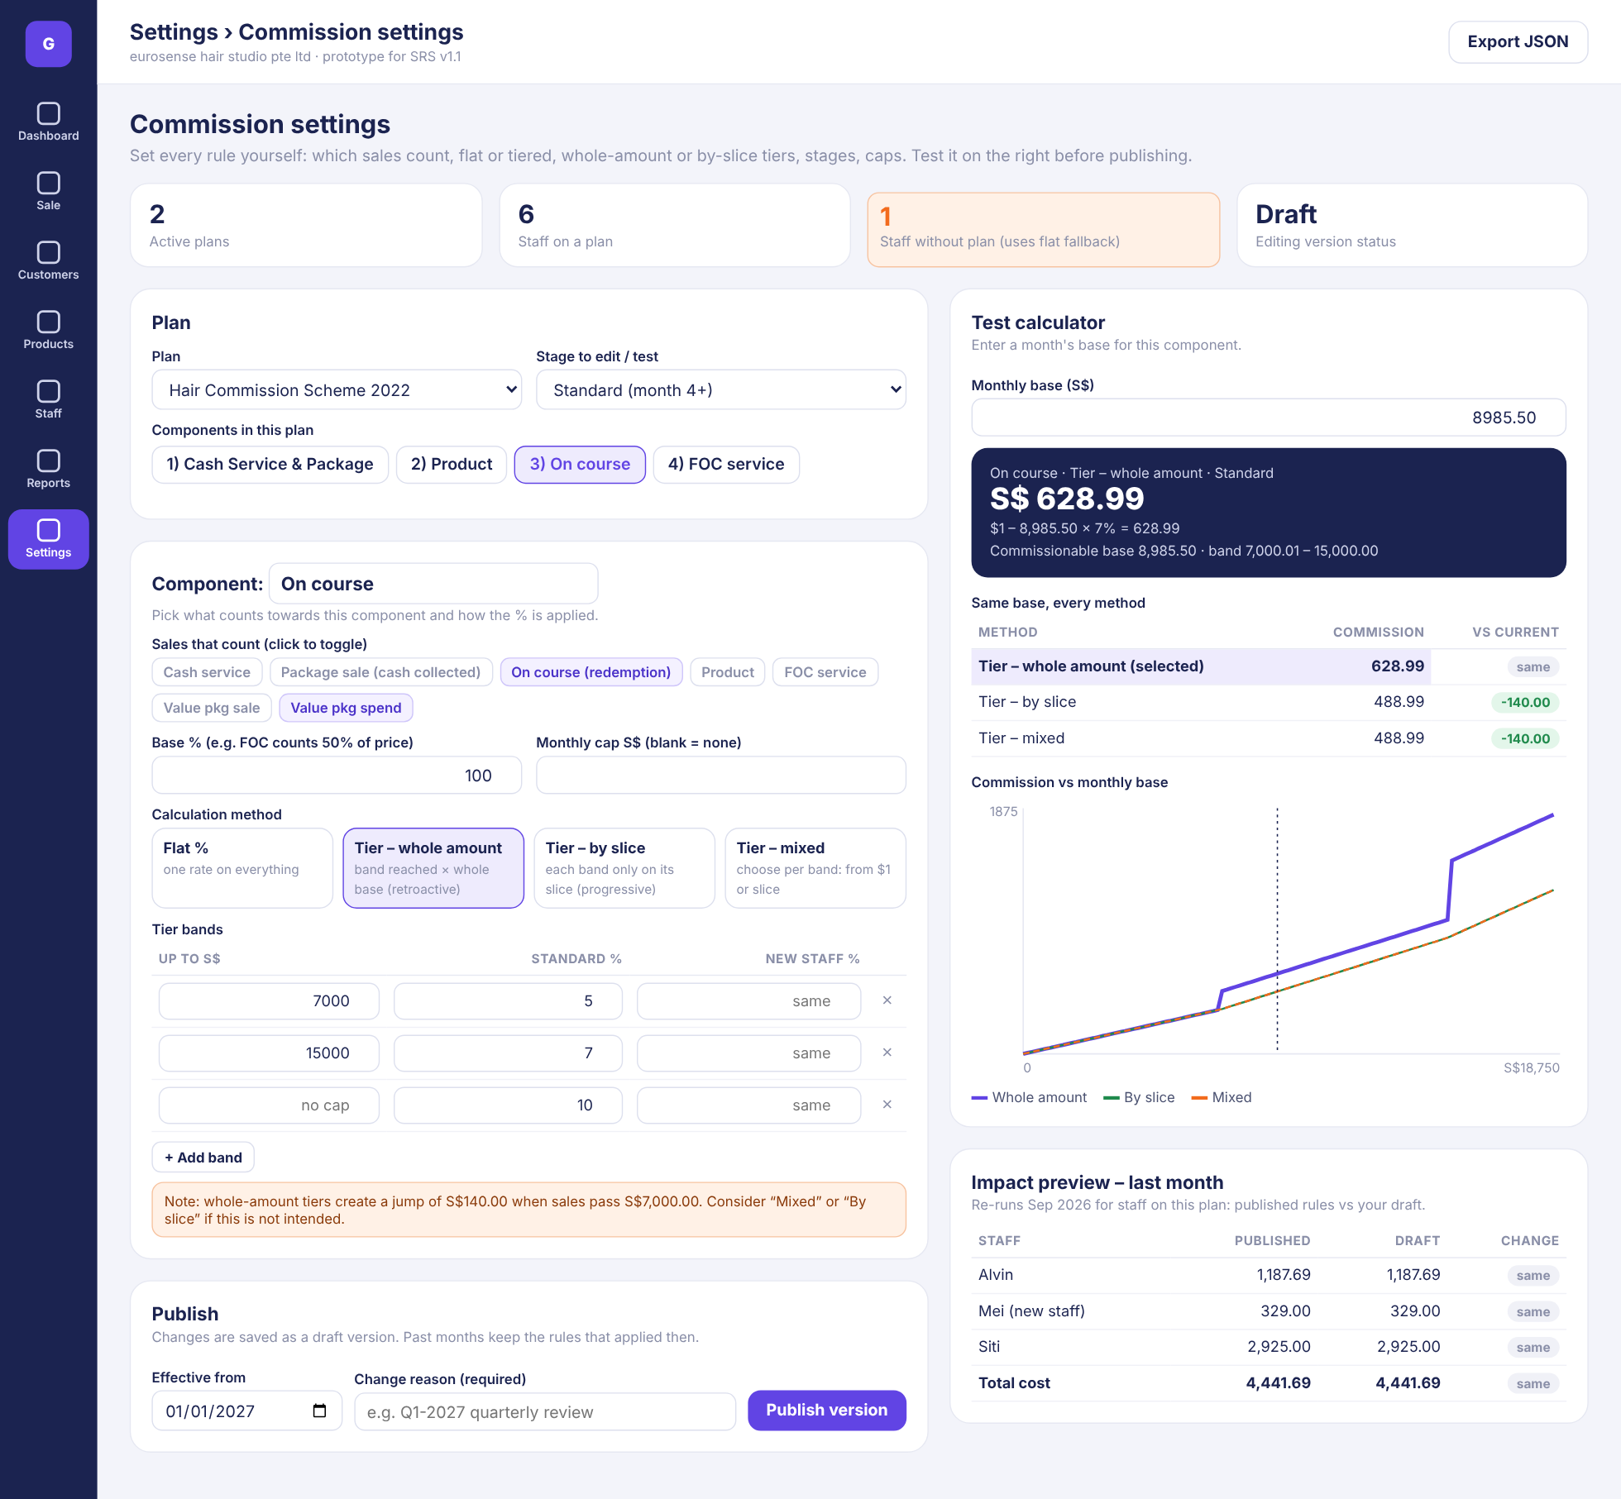
TO-BE – mockup
# | Element | Specification
C3 | Plan & stage | Plan selector, stage to edit / test, component tabs; header cards (plans, staff on plan, staff without plan, version status). FR-SET-01, 02.
C4 | Component editor | Sales that count (chips), base %, monthly cap, method picker (Flat / whole amount / by slice / mixed), band table with stage column and Applies column for Mixed, + Add band, validation and jump warning. FR-SET-03..06, 09.
C5 | Publish | Effective date, required reason, Publish version. FR-SET-11.
C17 | Test calculator | Monthly base input → commission with working lines. FR-SET-07.
C18 | Method comparison + chart | Same base under each method with difference; commission-vs-base chart. FR-SET-08.
C19 | Impact preview | Last month per staff: published vs draft, total cost change. FR-SET-10.

7.2b Example – Tier mixed on Cash Service & Package (S$12,000)
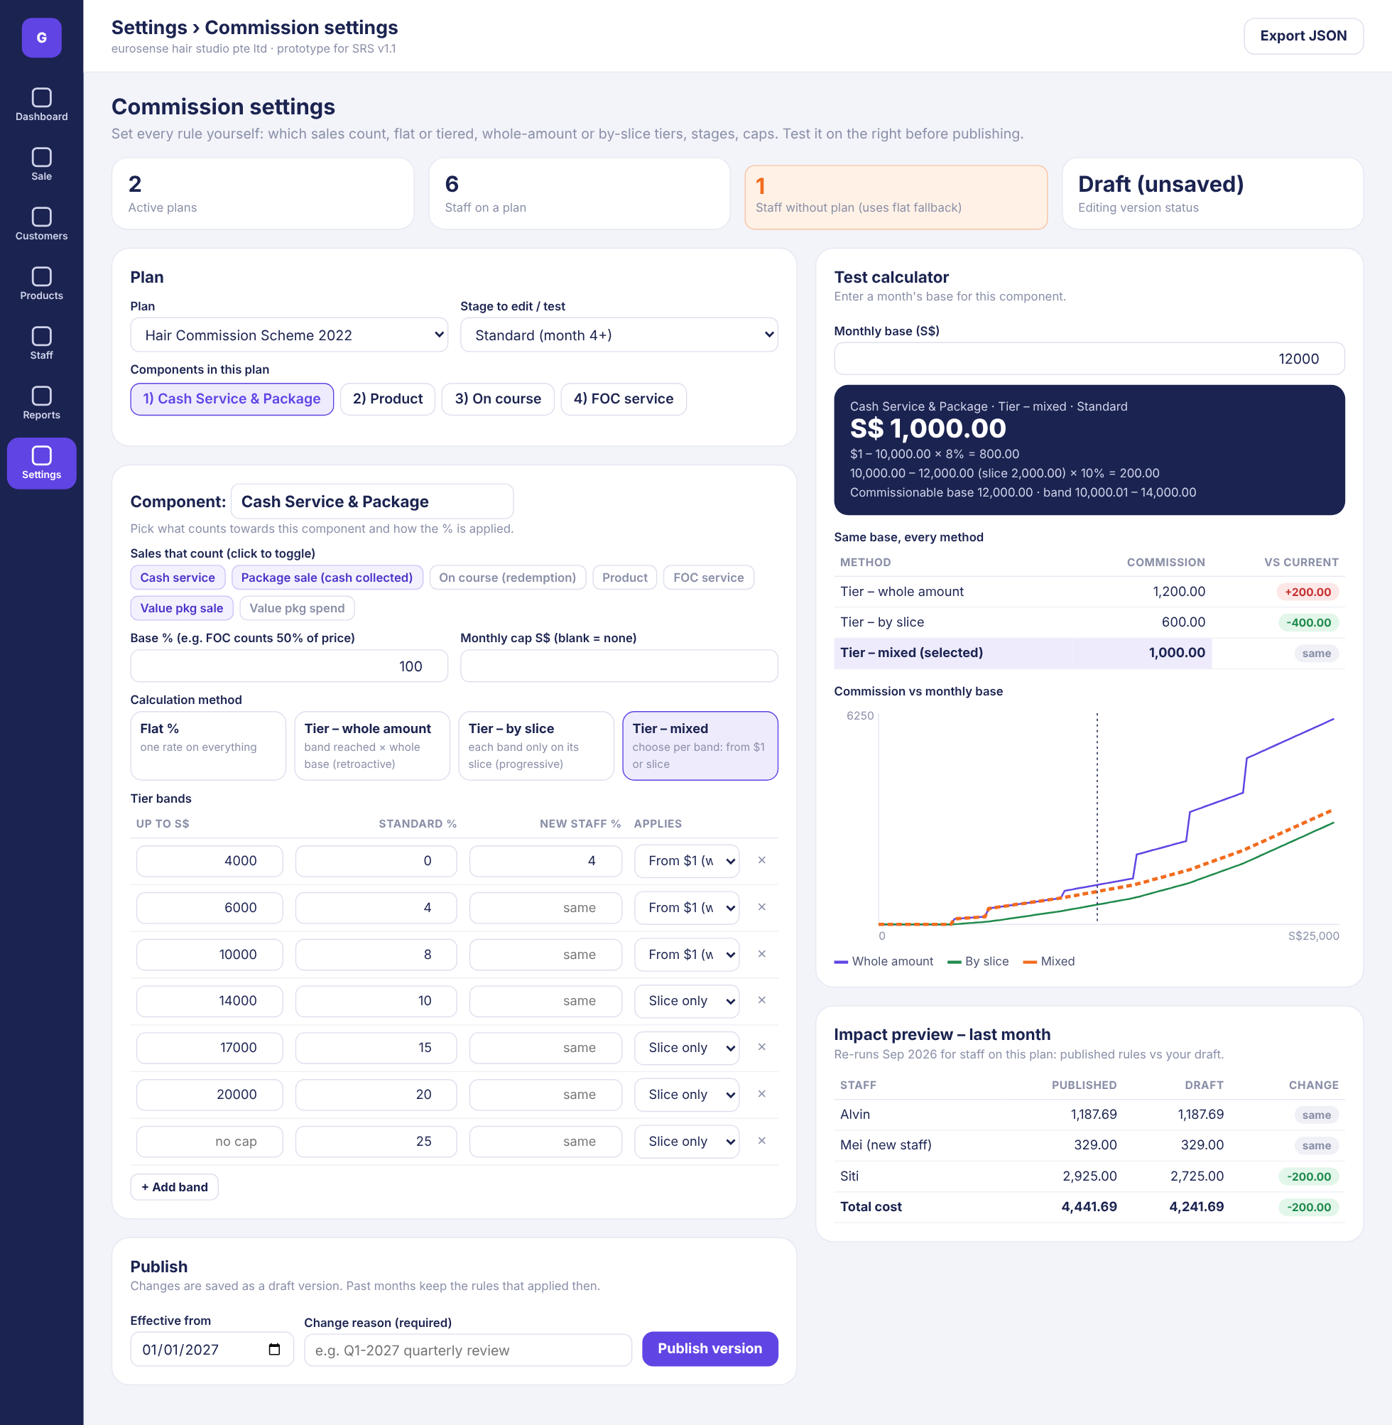
TO-BE – mockup
# | Element | Specification
C20 | Mixed method | Bands up to S$10,000 marked From $1; bands above marked Slice only. S$12,000 → 8% × 10,000 + 10% × 2,000 = S$1,000.00 (whole amount 1,200.00; by slice 600.00).

7.2c Plan editor – incentives and stage overview (C3 – C5)
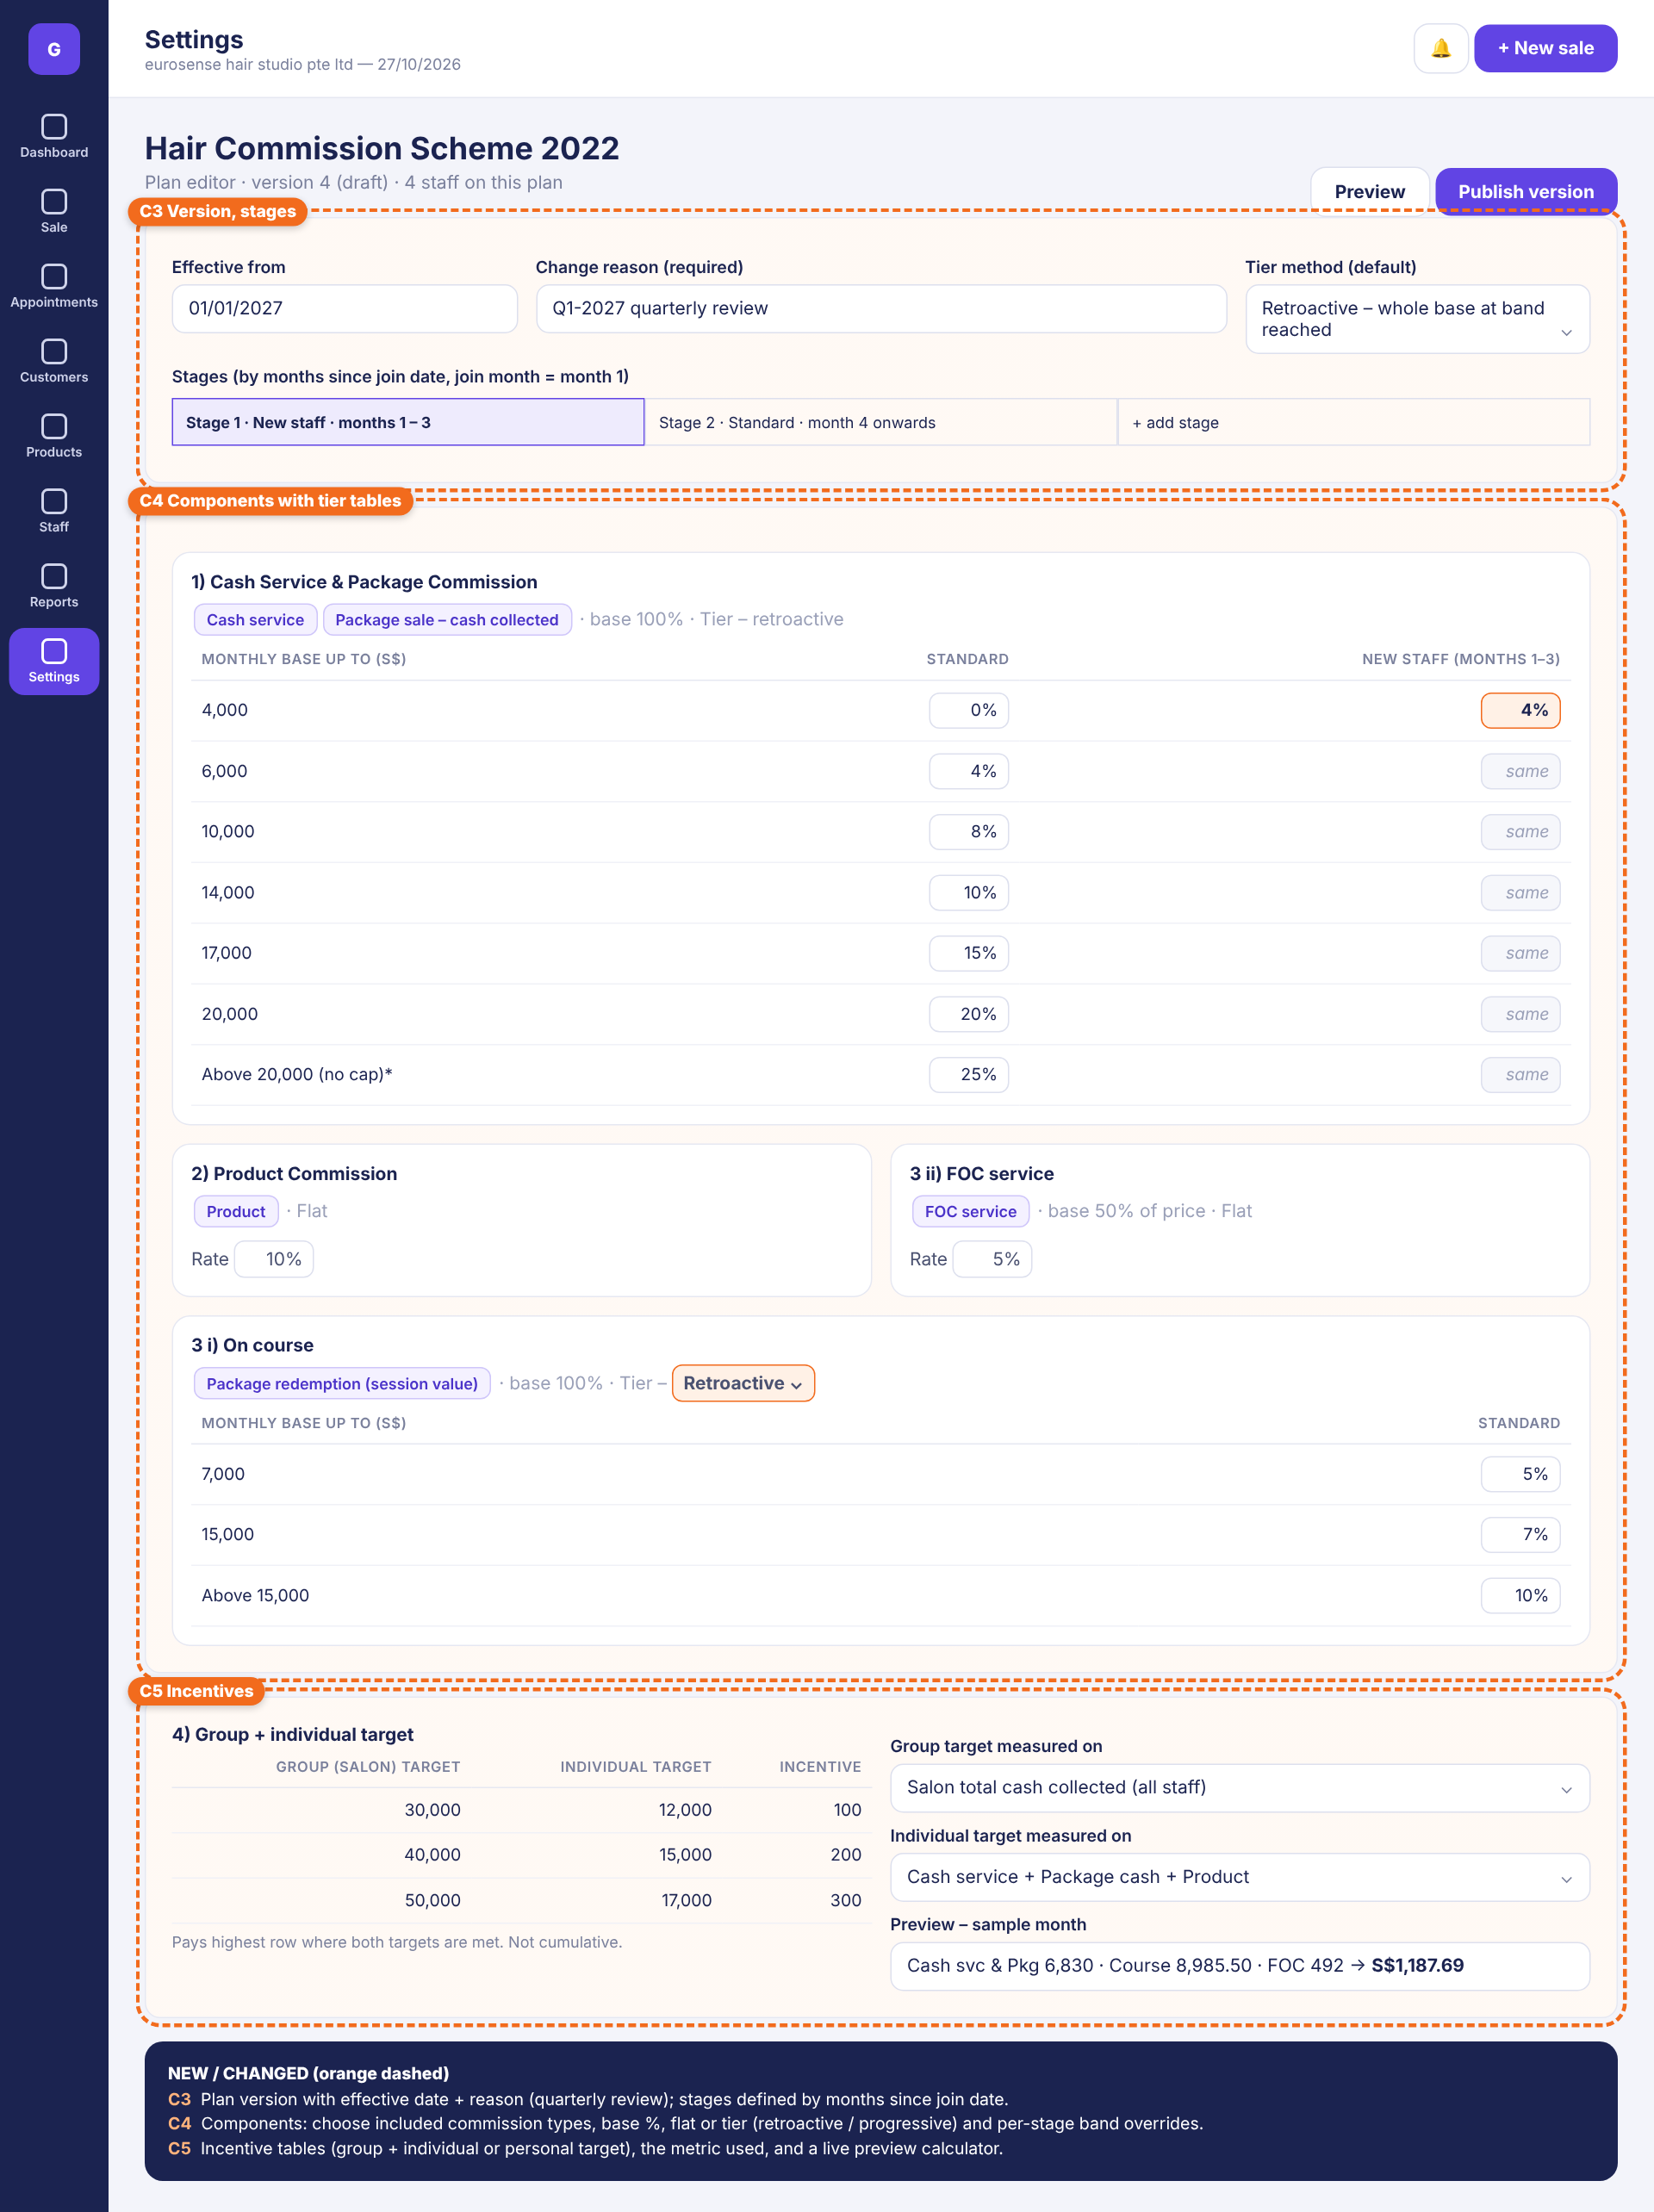
TO-BE – mockup
# | Element | Specification
C5 | Incentives & preview | Incentive table (group target, individual target, amount), metric selectors, live preview. FR-INC-01..04, FR-PLN-08.

7.3 Staff › Edit staff – Commission plan & payroll profile (C6, C7)
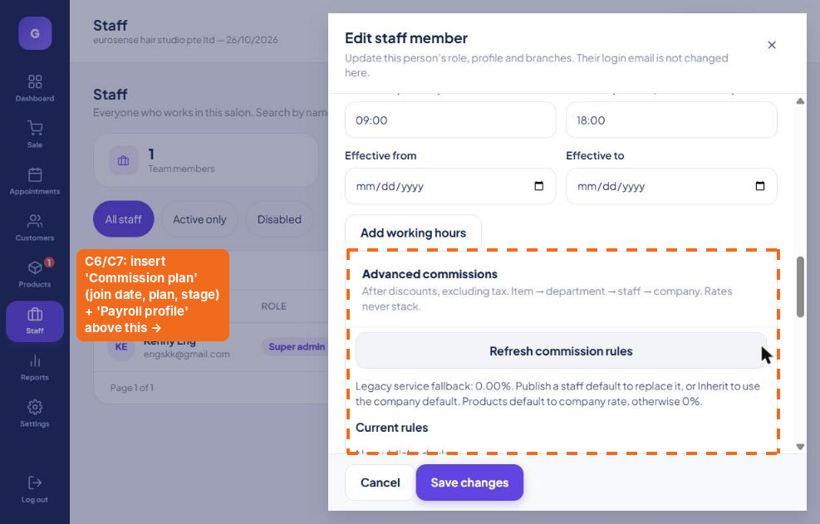
AS-IS – where the change goes
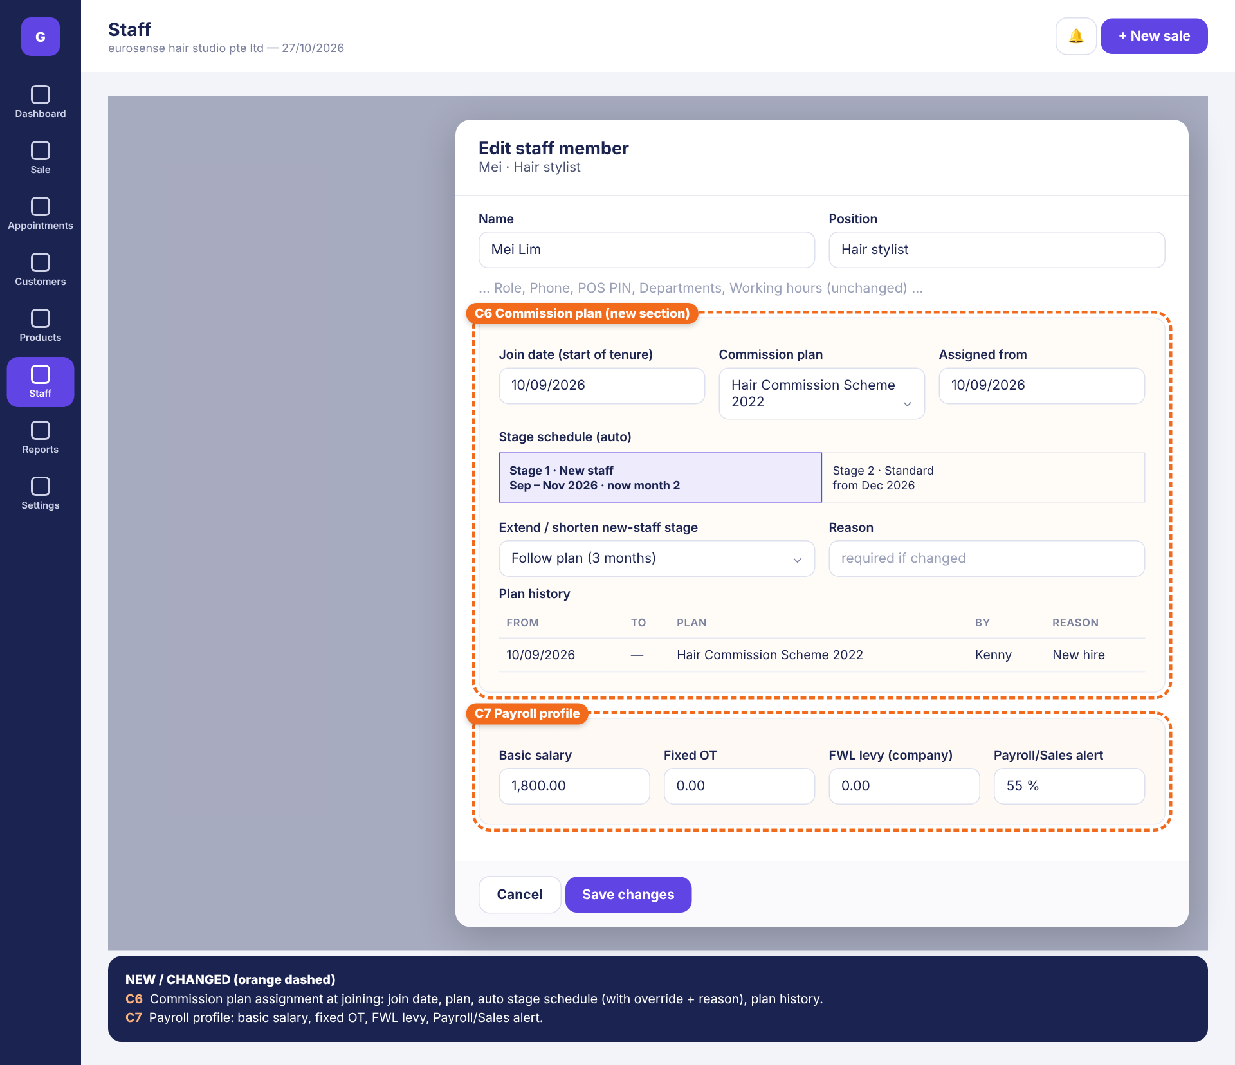
TO-BE – mockup
# | Element | Specification
C6 | Commission plan section | Join date, plan, assigned from; auto stage schedule with current month; stage override with reason; plan history. FR-ASN-01..04, FR-STG-04.
C7 | Payroll profile | Basic salary, fixed OT, FWL levy, Payroll/Sales alert %. FR-PAY-02.

7.4 Sale (POS) (C8 – C11)
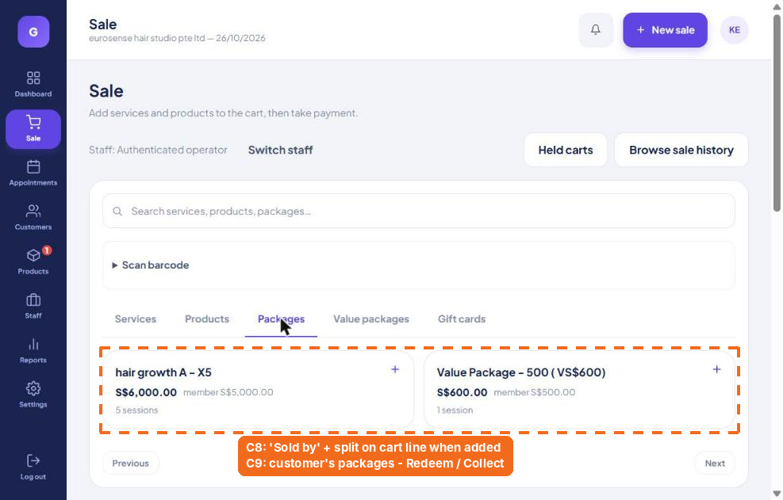
AS-IS – where the change goes
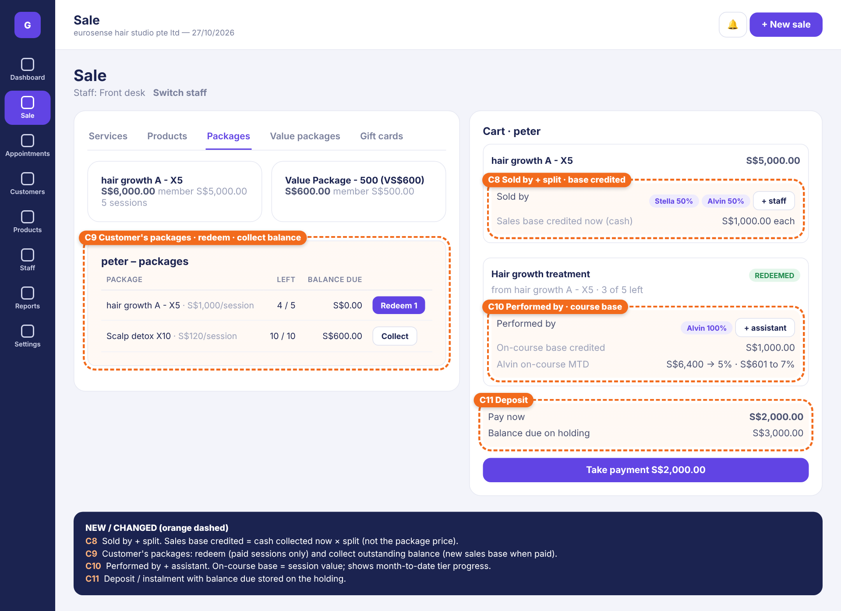
TO-BE – mockup
# | Element | Specification
C8 | Sold by + split | Staff chips with split %, + staff; shows sales base credited now (cash × split). FR-POS-01..03.
C9 | Customer’s packages | Holdings with sessions left, balance due, Redeem 1 / Collect. FR-POS-05, 07, 08.
C10 | Performed by | Therapist + assistant split; on-course base credited; MTD band progress. FR-POS-09.
C11 | Deposit | Pay now (≥ minimum deposit), balance due on holding. FR-POS-04.

7.5 Products › Packages › Edit package (C12, C13)
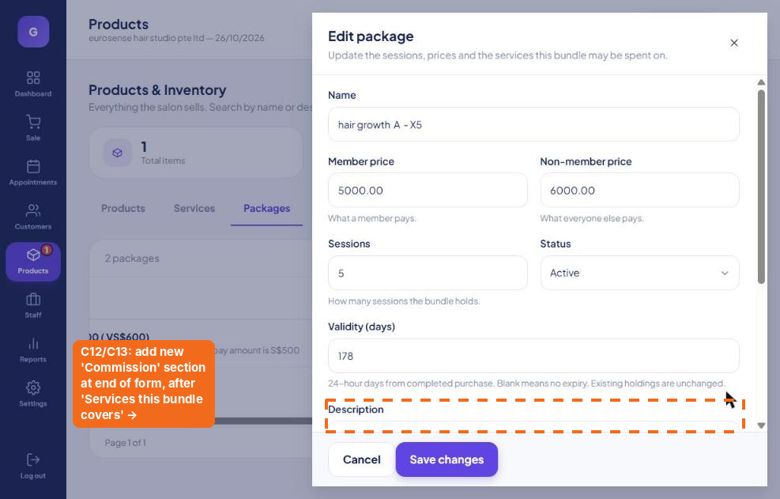
AS-IS – where the change goes
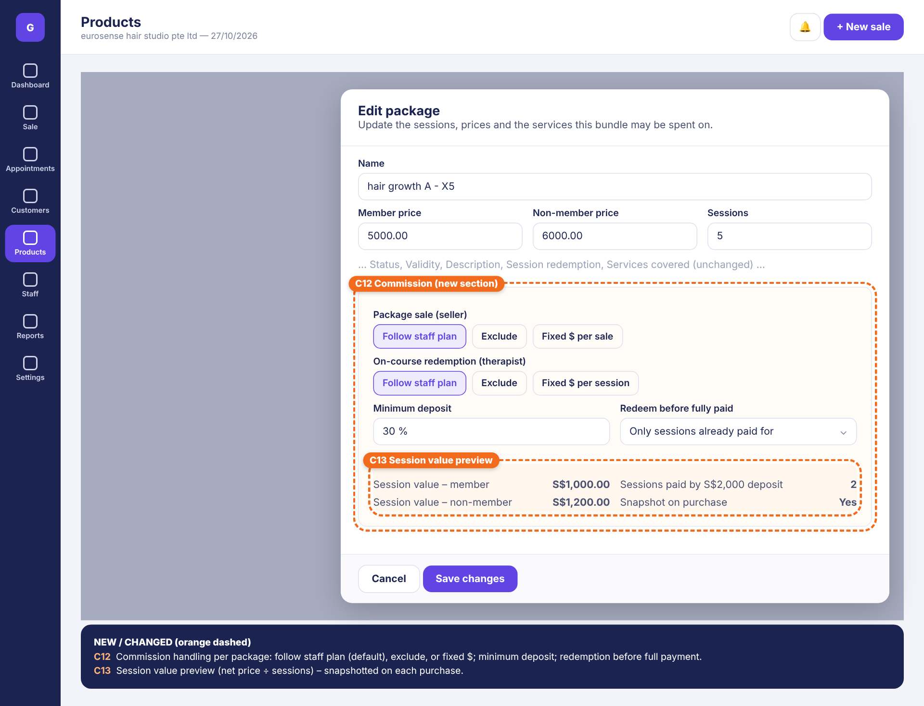
TO-BE – mockup
# | Element | Specification
C12 | Commission section | Package sale: Follow plan | Exclude | Fixed $ per sale. Redemption: Follow plan | Exclude | Fixed $ per session. Minimum deposit %. Info line: only paid-for sessions can be redeemed (D-8). FR-POS-10.
C13 | Session value preview | Member / non-member session value; sessions covered by a sample deposit; snapshot note. FR-POS-06.

7.6 Reports › Commission & payroll (C14, C15)
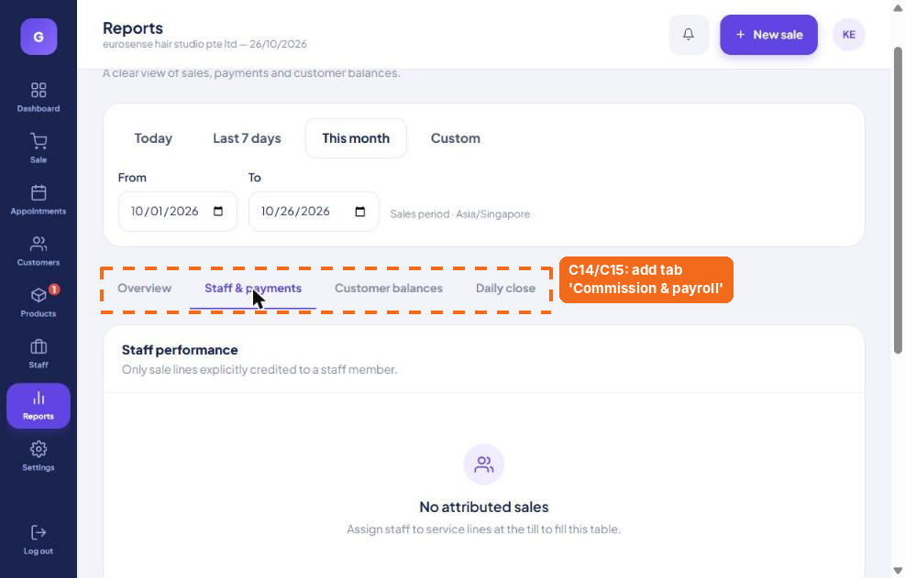
AS-IS – where the change goes
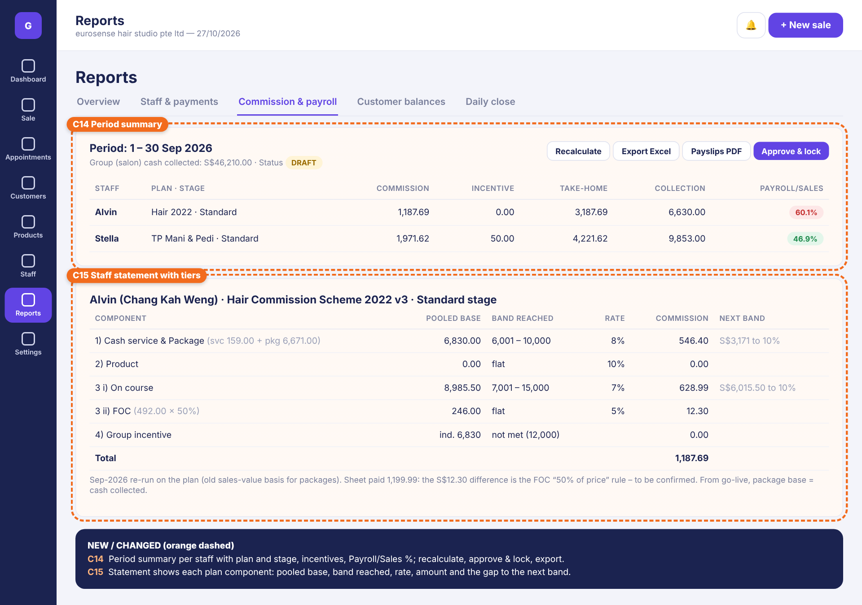
TO-BE – mockup
# | Element | Specification
C14 | Period summary | Group cash collected, status; per staff plan · stage, commission, incentive, take-home, collection, Payroll/Sales %; Recalculate, Export Excel, Payslips PDF, Approve & lock. FR-CAL-01, FR-PAY-01..05.
C15 | Staff statement | Per component: pooled base (with breakdown), band reached, rate, amount, next band; incentives; total; drill-down. FR-RPT-02.

7.7 Customer profile – package payments & session log (C16)
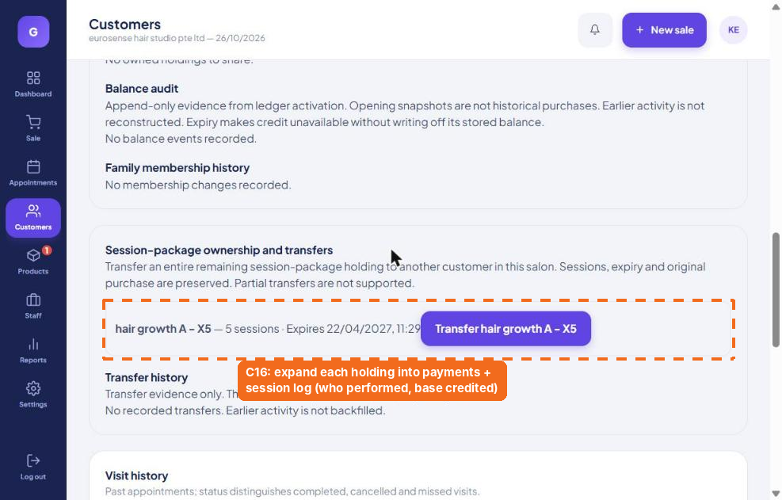
AS-IS – where the change goes
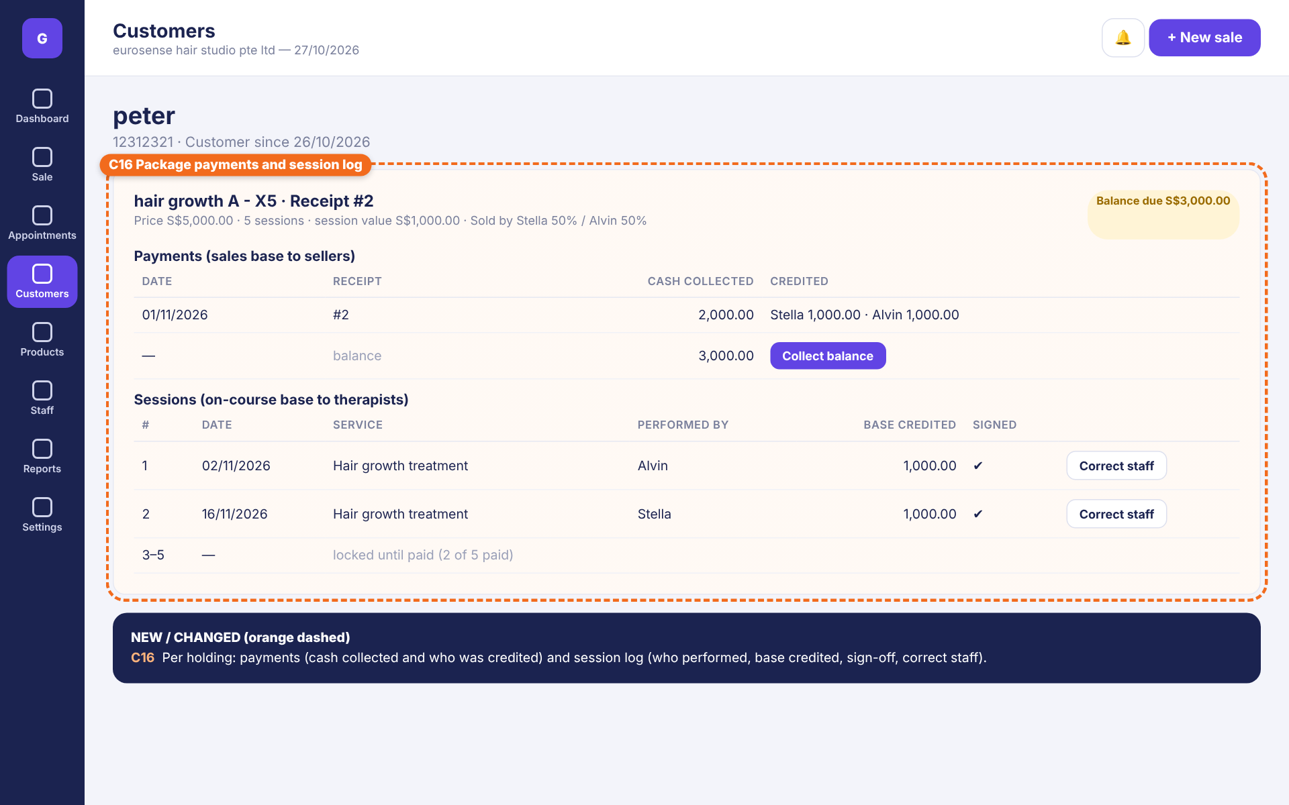
TO-BE – mockup
# | Element | Specification
C16 | Holding detail | Header (price, sessions, session value, sellers, balance due); Payments table (date, receipt, cash, credited to); Sessions table (#, date, service, performed by, base credited, signed, Correct staff); locked sessions until paid. FR-POS-05, FR-ADJ-03/04.

8. Calculation examples

E1 – Alvin, Hair plan, September 2026 (reconciliation)
Component | Pooled base | Band | Rate | Amount
1) Cash service 159.00 + Package 6,671.00 | 6,830.00 | 6,001 – 10,000 | 8% (retro) | 546.40
2) Product | 0.00 | flat | 10% | 0.00
3 i) On course | 8,985.50 | 7,001 – 15,000 | 7% (retro) | 628.99
3 ii) FOC – if 492 is the 50% base | 492.00 | flat | 5% | 24.60
Total (matches sheet) |  |  |  | 1,199.99
Alternative: FOC 492 × 50% = 246.00 | 246.00 | flat | 5% | 12.30 → total 1,187.69
Alternative: On course progressive | 7,000 @5% + 1,985.50 @7% |  |  | 488.99

E2 – Stella, TP plan, September 2026 (reconciliation)
Component | Pooled base | Band | Rate | Amount
1) Cash svc 1,087.00 + Course 12,071.84 | 13,158.84 | flat | 10% | 1,315.88
2) Product | 78.00 | flat | 10% | 7.80
3) Package (sales value, Sept sheet) | 9,256.31 | 8,001+ | 7% (retro) | 647.94
Total commission |  |  |  | 1,971.62
5) Personal target (pkg + svc + product) | 10,421.31 | ≥ 10,000 |  | 50.00
Same month on CASH COLLECTED basis: Package | 8,688.00 | 8,001+ | 7% | 608.16
Personal target on cash basis | 9,853.00 | < 10,000 |  | 0.00

E3 – Whole amount vs by slice vs mixed
Hair component 1, monthly base S$12,000, Standard stage: Retroactive = 12,000 × 10% = 1,200.00. Progressive = 4,000×0% + 2,000×4% + 4,000×8% + 2,000×10% = 600.00. Mixed (bands to 10,000 from $1, above by slice) = 10,000×8% + 2,000×10% = 1,000.00. On course S$8,985.50: whole amount 628.99, by slice 488.99 – the admin picks in settings.

E4 – New staff stage (Mei, Hair plan, joined 10 Sep 2026)
Component | Base | October (month 2 – New staff) | December (month 4 – Standard)
1) Cash svc 2,100 + Package cash 1,500 | 3,600.00 | 4% → 144.00 | 0% → 0.00
3 i) On course | 3,000.00 | 5% → 150.00 | 5% → 150.00
3 ii) FOC list 200 × 50% | 100.00 | 5% → 5.00 | 5% → 5.00
2) Product | 300.00 | 10% → 30.00 | 10% → 30.00
Total |  | 329.00 | 185.00

E5 – Package with deposit and split across two months
hair growth A - X5, S$5,000.00, 5 sessions (session value 1,000.00), Sold by Stella 50% / Alvin 50%. Deposit 2,000.00 on 25 Oct; balance 3,000.00 on 5 Nov.
Date | Event | Base line(s)
25 Oct | Deposit 2,000.00 | PKG_SALE: Stella +1,000.00 · Alvin +1,000.00 (October)
28 Oct | Session 1 by Alvin | PKG_RED: Alvin +1,000.00 (October) – allowed, 2 sessions paid
30 Oct | Session 2 by Stella | PKG_RED: Stella +1,000.00 (October)
31 Oct | Session 3 attempted | Blocked – 2 of 5 sessions paid (manager PIN override possible)
05 Nov | Balance 3,000.00 | PKG_SALE: Stella +1,500.00 · Alvin +1,500.00 (November)
Alvin’s +1,000.00 PKG_SALE joins his Hair component 1 pool for October (with cash services); Stella’s joins her TP Package component. Rates are decided by each person’s own monthly totals.

E6 – Refund
Customer cancels on 20 Nov after 2 sessions. Refund = 5,000 − 2 × 1,000 − admin fee 100 = 2,900.00 → PKG_SALE −1,450.00 to Stella and −1,450.00 to Alvin dated 20 Nov. Redemption base unchanged.

E7 – Group + individual incentive (Hair)
Salon cash collected in month = 46,210.00. Stylist A individual = 15,500 → rows met: (30k, 12k) and (40k, 15k) → pays S$200. Alvin individual = 6,830 → none met → S$0.

9. Acceptance test cases
ID | Given / When | Expected
TC-01 | Hair plan, Standard; component 1 base 6,830.00 | 546.40 (band 6,001–10,000, 8% retro)
TC-02 | Hair plan; on course 8,985.50; method TIER_WHOLE | 628.99
TC-03 | Same with TIER_SLICE | 488.99
TC-04 | Hair plan; component 1 base exactly 4,000.00 / 4,000.01 / 6,000.00 / 6,000.01 (Standard) | 0.00 / 160.00 / 240.00 / 480.00
TC-05 | Joined 10 Sep; period Oct; base 3,600 | Stage New staff (month 2); 144.00
TC-06 | Same staff; period Dec; base 3,600 | Stage Standard (month 4); 0.00
TC-07 | TP plan package base 9,256.31 | 647.94
TC-08 | TP personal target; individual metric 10,421.31 / 9,853.00 | S$50 / S$0
TC-09 | Package 5,000, deposit 2,000 in Oct, balance in Nov, split 50/50 | Oct PKG_SALE 1,000 each; Nov 1,500 each; no base on sale date for unpaid part
TC-10 | Redeem 3rd session with 2,000 paid on 1,000 session value | Blocked; succeeds with manager PIN; audit logged
TC-11 | Package price edited after purchase | Existing holding session value unchanged
TC-12 | Refund 2,900 on package sold 50/50 | PKG_SALE −1,450 each in refund month; PKG_RED unchanged
TC-13 | Refund makes component base −500 in month | Amount 0.00; −500 carried to next month
TC-14 | Plan v4 published effective 01 Jan 2027 | Dec 2026 statement uses v3; Jan 2027 uses v4
TC-15 | Plan changed for staff on 15 Nov | Whole November uses new plan (last-day rule)
TC-16 | Holding transferred; session performed by Mei | PKG_RED to Mei at original session value; PKG_SALE stays with sellers
TC-17 | Value package 500 → 600; spend 100 | VP_SALE 500.00; VP_SPEND 83.33
TC-18 | Checkout with package line, no Sold by, setting on | Checkout blocked with message
TC-19 | Approve Sep; then correct staff on a Sep session | Sep locked; reversal + re-post in Oct
TC-20 | Export Sep Excel | Totals equal on-screen statements to the cent
TC-21 | Hair component 1 TIER_MIXED (bands ≤10,000 WHOLE, above SLICE); base 12,000 | 1,000.00
TC-22 | Component cap 500; calculated 628.99 | 500.00, working line “Capped”
TC-23 | Admin switches On course to TIER_SLICE effective 01 Jan 2027 | Dec 2026 = 628.99 rule; Jan 2027 uses by slice; impact preview showed −140.00 for Alvin before publish
TC-24 | Band table with 2nd band limit lower than 1st | Publish blocked with validation message
TC-25 | Impact preview totals | Equal to a full calculation run on the same month and rules

10. Non-functional requirements
ID | Requirement
NFR-01 | Money stored as decimal (no floating point): base lines 4 dp, statement amounts 2 dp, half-up rounding.
NFR-02 | All dates by salon time zone (Asia/Singapore); period boundaries 00:00:00 – 23:59:59 local.
NFR-03 | Calculation for 50 staff × 1 month completes in < 10 s; MTD estimate on POS < 500 ms.
NFR-04 | Base lines, results and audit logs are immutable once the period is approved.
NFR-05 | Multi-tenant: plans, staff and ledgers isolated per salon; plans may be limited to outlets.
NFR-06 | Role-based access per section 4.11; staff can only see their own commission.
NFR-07 | Unit tests for the tier engine covering every TC in section 9 (boundary values included).

11. Seed data and migration

11.1 Plan: Hair Commission Scheme 2022
plan: "Hair Commission Scheme 2022" version: 1 effective_from: 2022-01-01
stages: [ {name:"New staff", from:1, to:3}, {name:"Standard", from:4, to:null} ]
components:
1 "Cash Service & Package" types:[SVC, PKG_SALE, VP_SALE] base:100% TIER_WHOLE
bands (upper:rate): 4000:0% [New staff 4%] | 6000:4% | 10000:8% | 14000:10%
17000:15% | 20000:20% | null:25%
2 "Product" types:[PRD] FLAT 10%
3 "On course" types:[PKG_RED, VP_SPEND] base:100% TIER_WHOLE
bands: 7000:5% | 15000:7% | null:10% (admin may switch to TIER_SLICE in settings)
4 "FOC service" types:[FOC] base:50% FLAT 5% (OP-2)
incentive: GROUP_AND_INDIVIDUAL individual:[SVC,PKG_SALE,PRD] group:salon cash
rows: (30000,12000,100) (40000,15000,200) (50000,17000,300)

11.2 Plan: TP Mani & Pedi Scheme
plan: "TP Mani & Pedi Scheme" version: 1 effective_from: 2019-05-01
stages: [ {name:"Standard", from:1, to:null} ]
components:
1 "Cash & Course Services" types:[SVC, PKG_RED, VP_SPEND] FLAT 10%
2 "Product" types:[PRD] category != Beauty FLAT 10%
3 "Package" types:[PKG_SALE, VP_SALE] TIER_WHOLE
bands: 4000:2% | 6000:4% | 8000:5% | null:7%
4 "Beauty product" types:[PRD] category = Beauty FLAT 5%
incentive: INDIVIDUAL_TARGET individual:[SVC,PKG_SALE,PRD]
rows: (10000,50) (13000,100) (16000,150)

11.3 Migration steps
- Create the two plans above (published).
- Add join date and plan for every existing staff (Alvin → Hair; Stella → TP; others per owner).
- Backfill session value and cash collected for existing holdings (session value = net price ÷ sessions; cash collected = paid to date).
- Run September 2026 in a test salon and compare with the salary sheets (E1, E2) before go-live.
- Go-live on the first day of a month; earlier months stay in Excel.

12. Open points for owner confirmation
# | Question | Proposed default
OP-1 | On course method: now a setting (whole amount 628.99 vs by slice 488.99 for Alvin’s September). Which should be selected at go-live? | Whole amount (current practice) – change any time in settings
OP-2 | FOC “50% of price”: was S$492 the full price (→ 12.30) or already 50% (→ 24.60)? | Base = 50% of list price
OP-3 | Hair component 1 above S$25,000 – keep 25%? | 25%, no cap
OP-4 | Do the Hair scheme’s first-3-months 4% and stages apply to TP staff too? | No – TP has a single stage
OP-5 | Individual / personal target metric: cash-collected sales (svc + package cash + product), excluding redemptions? Note impact on Stella (E2). | Yes
OP-6 | Group target metric: salon total cash collected, per outlet or whole company? | Per outlet
OP-7 | Value package sale/spend: pool with package sale / on course as in seed data? | Yes
OP-8 | Staff joining after the 15th: count joining month as month 1? | Yes (setting off)
OP-9 | Package minimum deposit % and refund admin fee. | 30% · S$100

13. Delivery phases
Phase | Scope | Requirements / screens
1 – Capture | Commission types, base ledger, Sold by / Performed by + split, session value snapshot, deposits & balance collection, redemption rules, package commission settings. | FR-BAS, FR-POS · C8–C13, C16
2 – Plans & engine | Commission settings dashboard (editor, calculator, comparison, impact preview), plans, versions, components, tiers, stages, incentives, assignment, calculation engine, statements, Excel export, seed data & September reconciliation. | FR-PLN, FR-STG, FR-ASN, FR-INC, FR-CAL, FR-RPT-01..03 · C1–C7, C14–C15
3 – Payroll & self-service | Payroll profile, approve & lock, payslip PDF, adjustments, refunds/carry-forward, My commission, MTD overview, package liability. | FR-PAY, FR-ADJ, FR-RPT-04..06

Appendix – References
- Eurosense Hair Commission Scheme (2022) – owner-supplied PDF
- TP Mani & Pedi Commission Scheme (May 2019) – owner-supplied Word document
- Eurosense September 2026 salary sheets – Alvin (Chang Kah Weng), Stella
- Glampro Suite live review, glampro.tusphere.com, 26 Oct 2026
- Interactive prototype: commission_settings_prototype.html (supplied with this SRS)
- Zenoti – Commission Management: https://www.zenoti.com/platform/commission-management
- Fresha – Commissions update (tiers: progressive vs retroactive): https://www.fresha.com/blog/fresha-commissions-update
- Meevo – Redeeming Items from a Package: https://docs.meevo.com/multi-location/Register/RedeemingItemsPackage.htm
- Pabau – Commission structure for packages: https://support.pabau.com/en/pabau2/commission-structure-for-packages

