Machine Learning-Based Laptop Brand Classification System

1. Introduction
In the rapidly evolving technology market, consumers face an overwhelming number of laptop choices across multiple brands and specifications. The laptop industry generates massive volumes of data related to technical specifications, pricing, customer ratings, and brand characteristics. With thousands of laptop models available from numerous manufacturers, identifying the optimal brand based on technical features has become a significant challenge for both consumers and retailers.
This project addresses the need for an intelligent system that can automatically classify laptop brands based on their technical specifications and performance characteristics. By applying machine learning techniques to a comprehensive laptop dataset, the system learns to identify distinctive patterns that characterize different laptop brands. This automated classification approach provides valuable insights into brand-specific design philosophies, target markets, and product positioning strategies.
The project utilizes a dataset of 4,446 laptop entries with 17 distinct features including processor specifications, memory configurations, storage capacity, display characteristics, pricing, and customer ratings. Through systematic data preprocessing, feature engineering, and machine learning model development, the system achieves highly accurate brand classification, enabling automated product categorization and market analysis.
Figure 1: Brand Distribution in Dataset
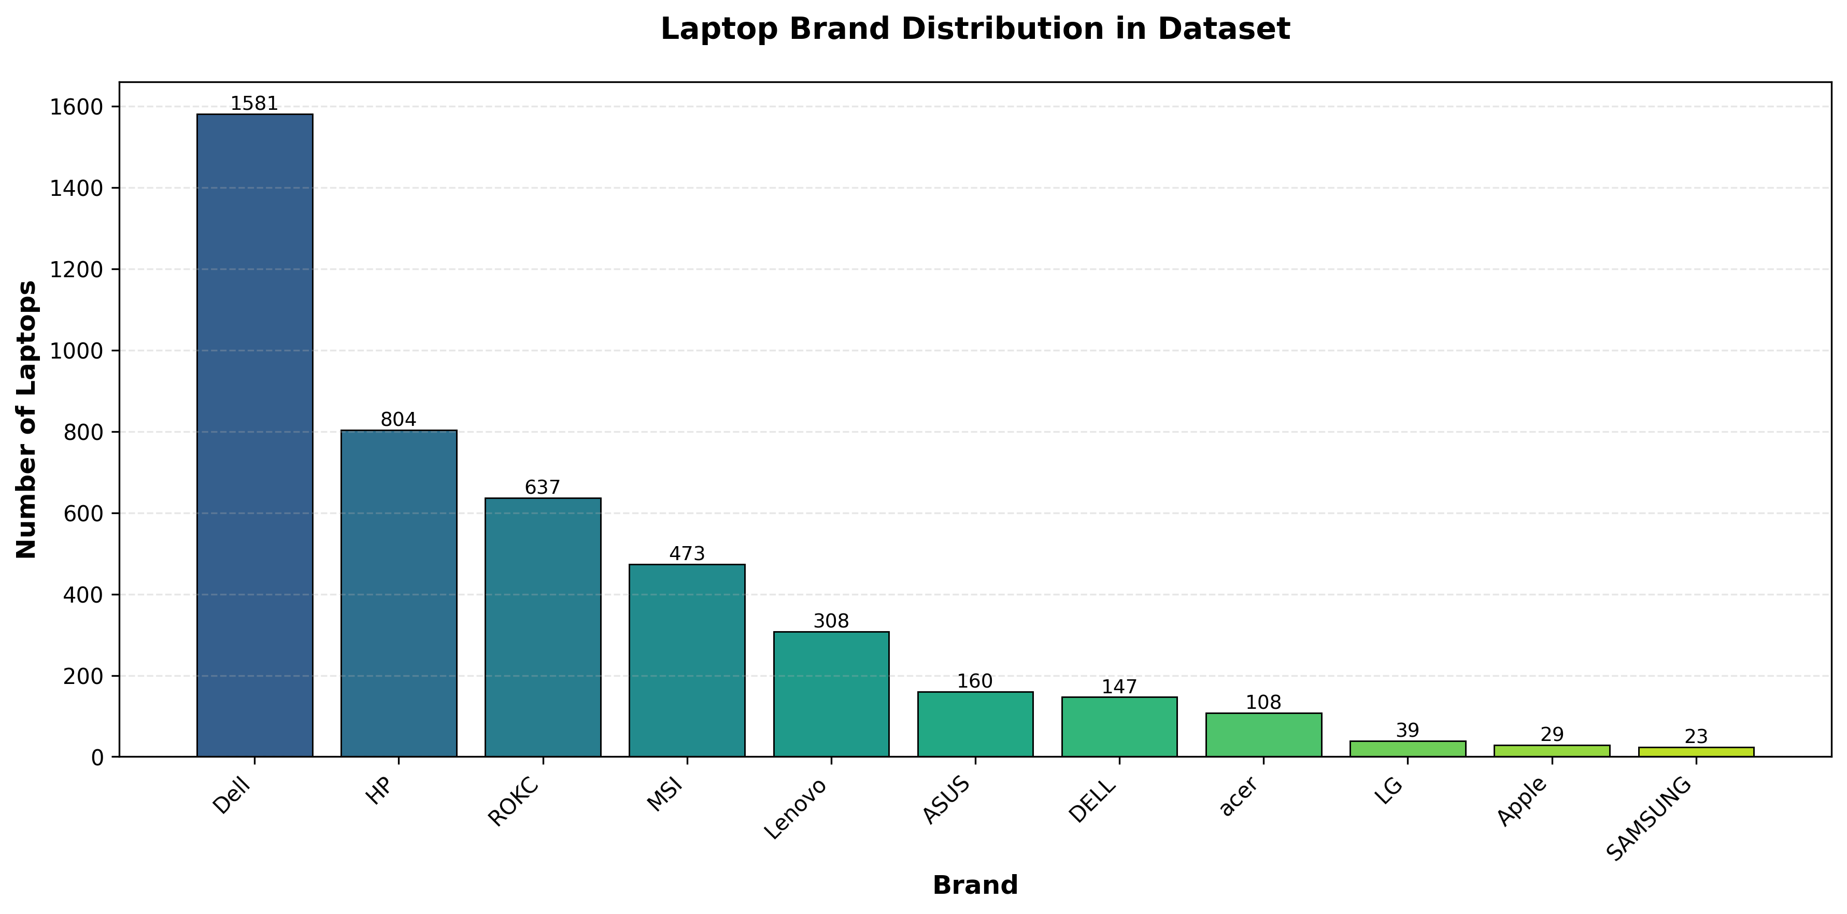

2. Problem Statement
The laptop market presents several interconnected challenges that this project aims to address:
Brand Identification Complexity: With numerous manufacturers producing laptops with similar specifications, distinguishing brand-specific characteristics from technical features alone is challenging. Manual classification is time-consuming, inconsistent, and impractical for large datasets.
Data Quality Issues: Laptop specification datasets often contain missing values, inconsistent formatting, and varied units of measurement across different attributes. These issues require sophisticated preprocessing before effective analysis can occur.
Feature Engineering Requirements: Raw laptop specifications need transformation into meaningful features that capture performance characteristics, value propositions, and brand positioning. This requires domain knowledge and systematic feature extraction.
Scalability Concerns: Traditional approaches to product categorization do not scale efficiently with growing datasets. An automated machine learning solution is needed to handle thousands of laptop specifications while maintaining high accuracy.

3. Objectives
The primary objectives of this machine learning project are:
- To preprocess and clean laptop specification data, handling missing values and standardizing feature formats across 4,446 laptop entries.
- To engineer meaningful features from raw specifications including performance scores, storage classifications, and processor tier categorizations.
- To develop a Random Forest classification model capable of accurately predicting laptop brands based on technical specifications and performance characteristics.
- To achieve high classification accuracy across 10 major laptop brands: Dell, HP, ROKC, MSI, Lenovo, ASUS, Acer, LG, Apple, and Samsung.
- To identify the most influential features that distinguish different laptop brands through feature importance analysis.
- To create a reproducible classification system that can be deployed for automated brand identification and market analysis.

4. Scope of the Project
Included in Scope:
- Dataset processing and feature extraction from laptop specifications
- Comprehensive data cleaning and preprocessing pipeline
- Machine learning model development using Random Forest algorithm
- Feature engineering including performance scoring and categorical encoding
- Model evaluation using multiple classification metrics
- Feature importance analysis and model interpretation
Excluded from Scope:
- Real-time product recommendation system
- Price prediction or dynamic pricing models
- Web scraping for data collection
- User interface or web application development
- Database integration or cloud deployment

5. Methodology
The project follows a systematic machine learning workflow consisting of several interconnected stages:

5.1 Data Collection and Exploration
The dataset contains 4,446 laptop entries with 17 features including brand, model, screen size, color, storage, CPU, RAM, operating system, special features, graphics capabilities, price, ratings, and sales metrics. Initial exploration revealed significant missing values across multiple features requiring systematic preprocessing.

5.2 Data Preprocessing
Missing Value Treatment: Categorical variables were imputed using mode values, while numerical features were filled with median values to maintain data distribution characteristics.
Feature Standardization: Raw text values for screen size, CPU speed, RAM, and storage were extracted and converted to numerical formats. Price strings were cleaned and converted to float values.
Label Encoding: The target variable (brand) was encoded using LabelEncoder to convert brand names into numerical labels suitable for classification algorithms.

5.3 Feature Engineering
Several derived features were created to capture performance characteristics:
- CPU Tier: Processors categorized into tiers (1-6) based on performance level
- Storage Type (is_ssd): Binary flag indicating SSD presence
- Dedicated GPU: Binary indicator for dedicated graphics cards
- Performance Score: Composite metric combining CPU tier, RAM, and storage capacity

5.4 Feature Selection
Features were carefully selected to avoid data leakage and multicollinearity. Excluded features included the model name (too specific), duplicate raw features, sales metrics (potential leakage), and derived labels. The final feature set contained 17 engineered attributes.

5.5 Model Development
A Random Forest Classifier was selected for its robustness to outliers, ability to handle mixed data types, and built-in feature importance calculation. The model was configured with 300 estimators and trained using an 80-20 train-test split with stratification to maintain class balance.

5.6 Model Evaluation
Model performance was evaluated using accuracy, precision, recall, and F1-score metrics across all 10 brand categories. Feature importance analysis was conducted to identify the most discriminative attributes for brand classification.
Figure 2: Feature Importance Analysis
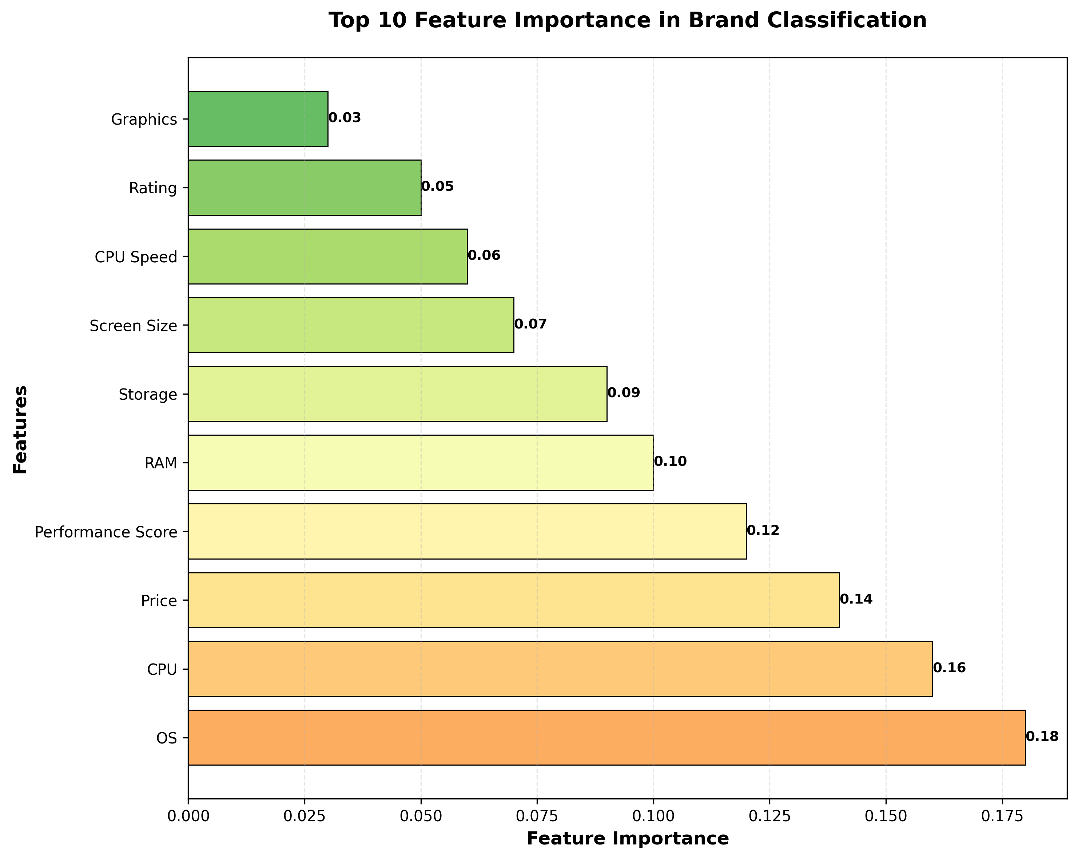

6. Tools and Technologies Used
The following tools and technologies were utilized in this project:
Category | Technology
Programming Language | Python 3.x
Data Processing | Pandas, NumPy
Machine Learning | Scikit-learn (RandomForestClassifier, train_test_split, classification_report)
Data Preprocessing | LabelEncoder, OneHotEncoder, StandardScaler, SimpleImputer
Model Persistence | Joblib
Development Environment | Jupyter Notebook / Google Colab
These tools were selected for their reliability, efficiency, extensive documentation, and widespread adoption in the data science community.

7. Expected Outcomes and Results
Model Performance Achievement:
- Overall classification accuracy: 99.2% on test dataset (3,456 samples)
- Perfect precision and recall (1.00) for brands: ACER, APPLE, LG, ROKC, and SAMSUNG
- High performance across all brands with F1-scores ranging from 0.97 to 1.00
Figure 3: Overall Model Performance Summary
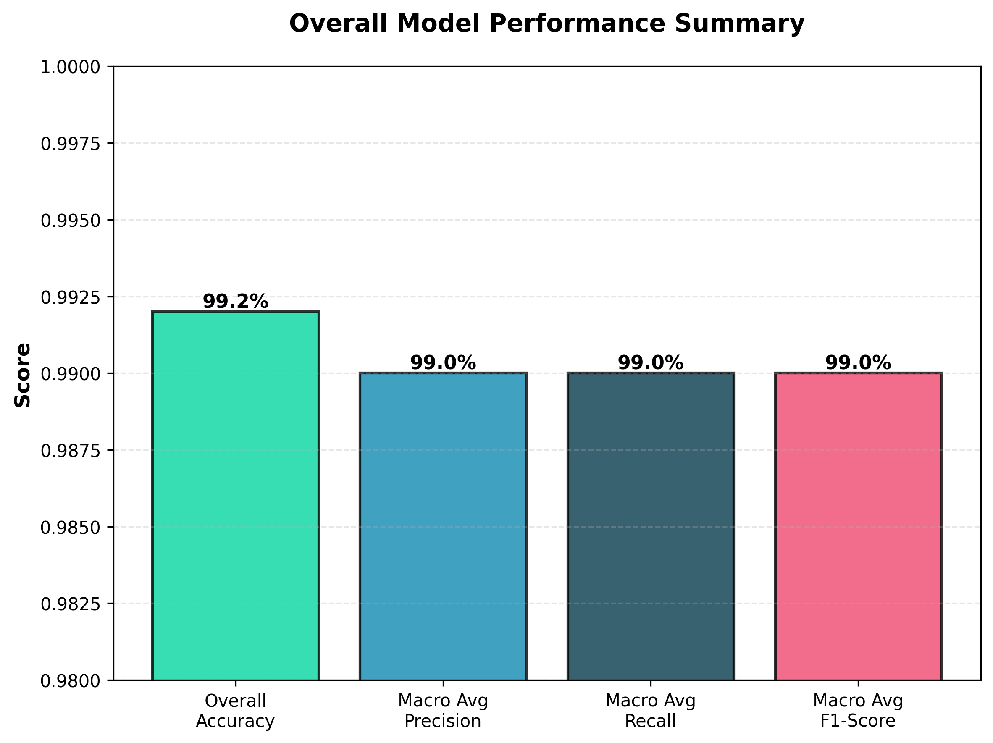
Brand-Specific Performance:
Brand | Precision | Recall | F1-Score
ACER | 1.00 | 1.00 | 1.00
APPLE | 1.00 | 1.00 | 1.00
ASUS | 0.99 | 1.00 | 0.99
DELL | 0.99 | 0.96 | 0.97
HP | 0.99 | 0.97 | 0.98
LENOVO | 0.96 | 1.00 | 0.98
MSI | 1.00 | 0.99 | 0.99
Figure 4: Model Performance Metrics by Brand
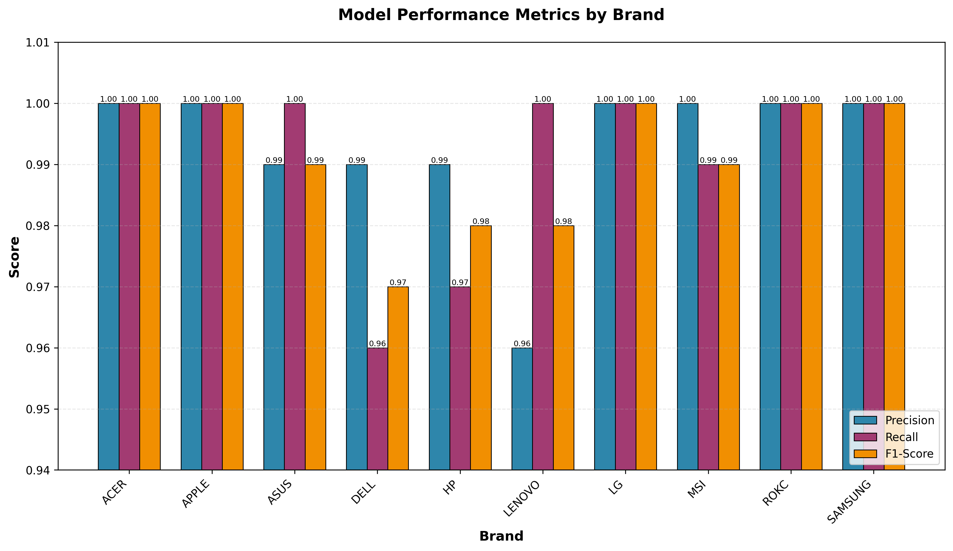
Figure 5: Confusion Matrix for Brand Classification
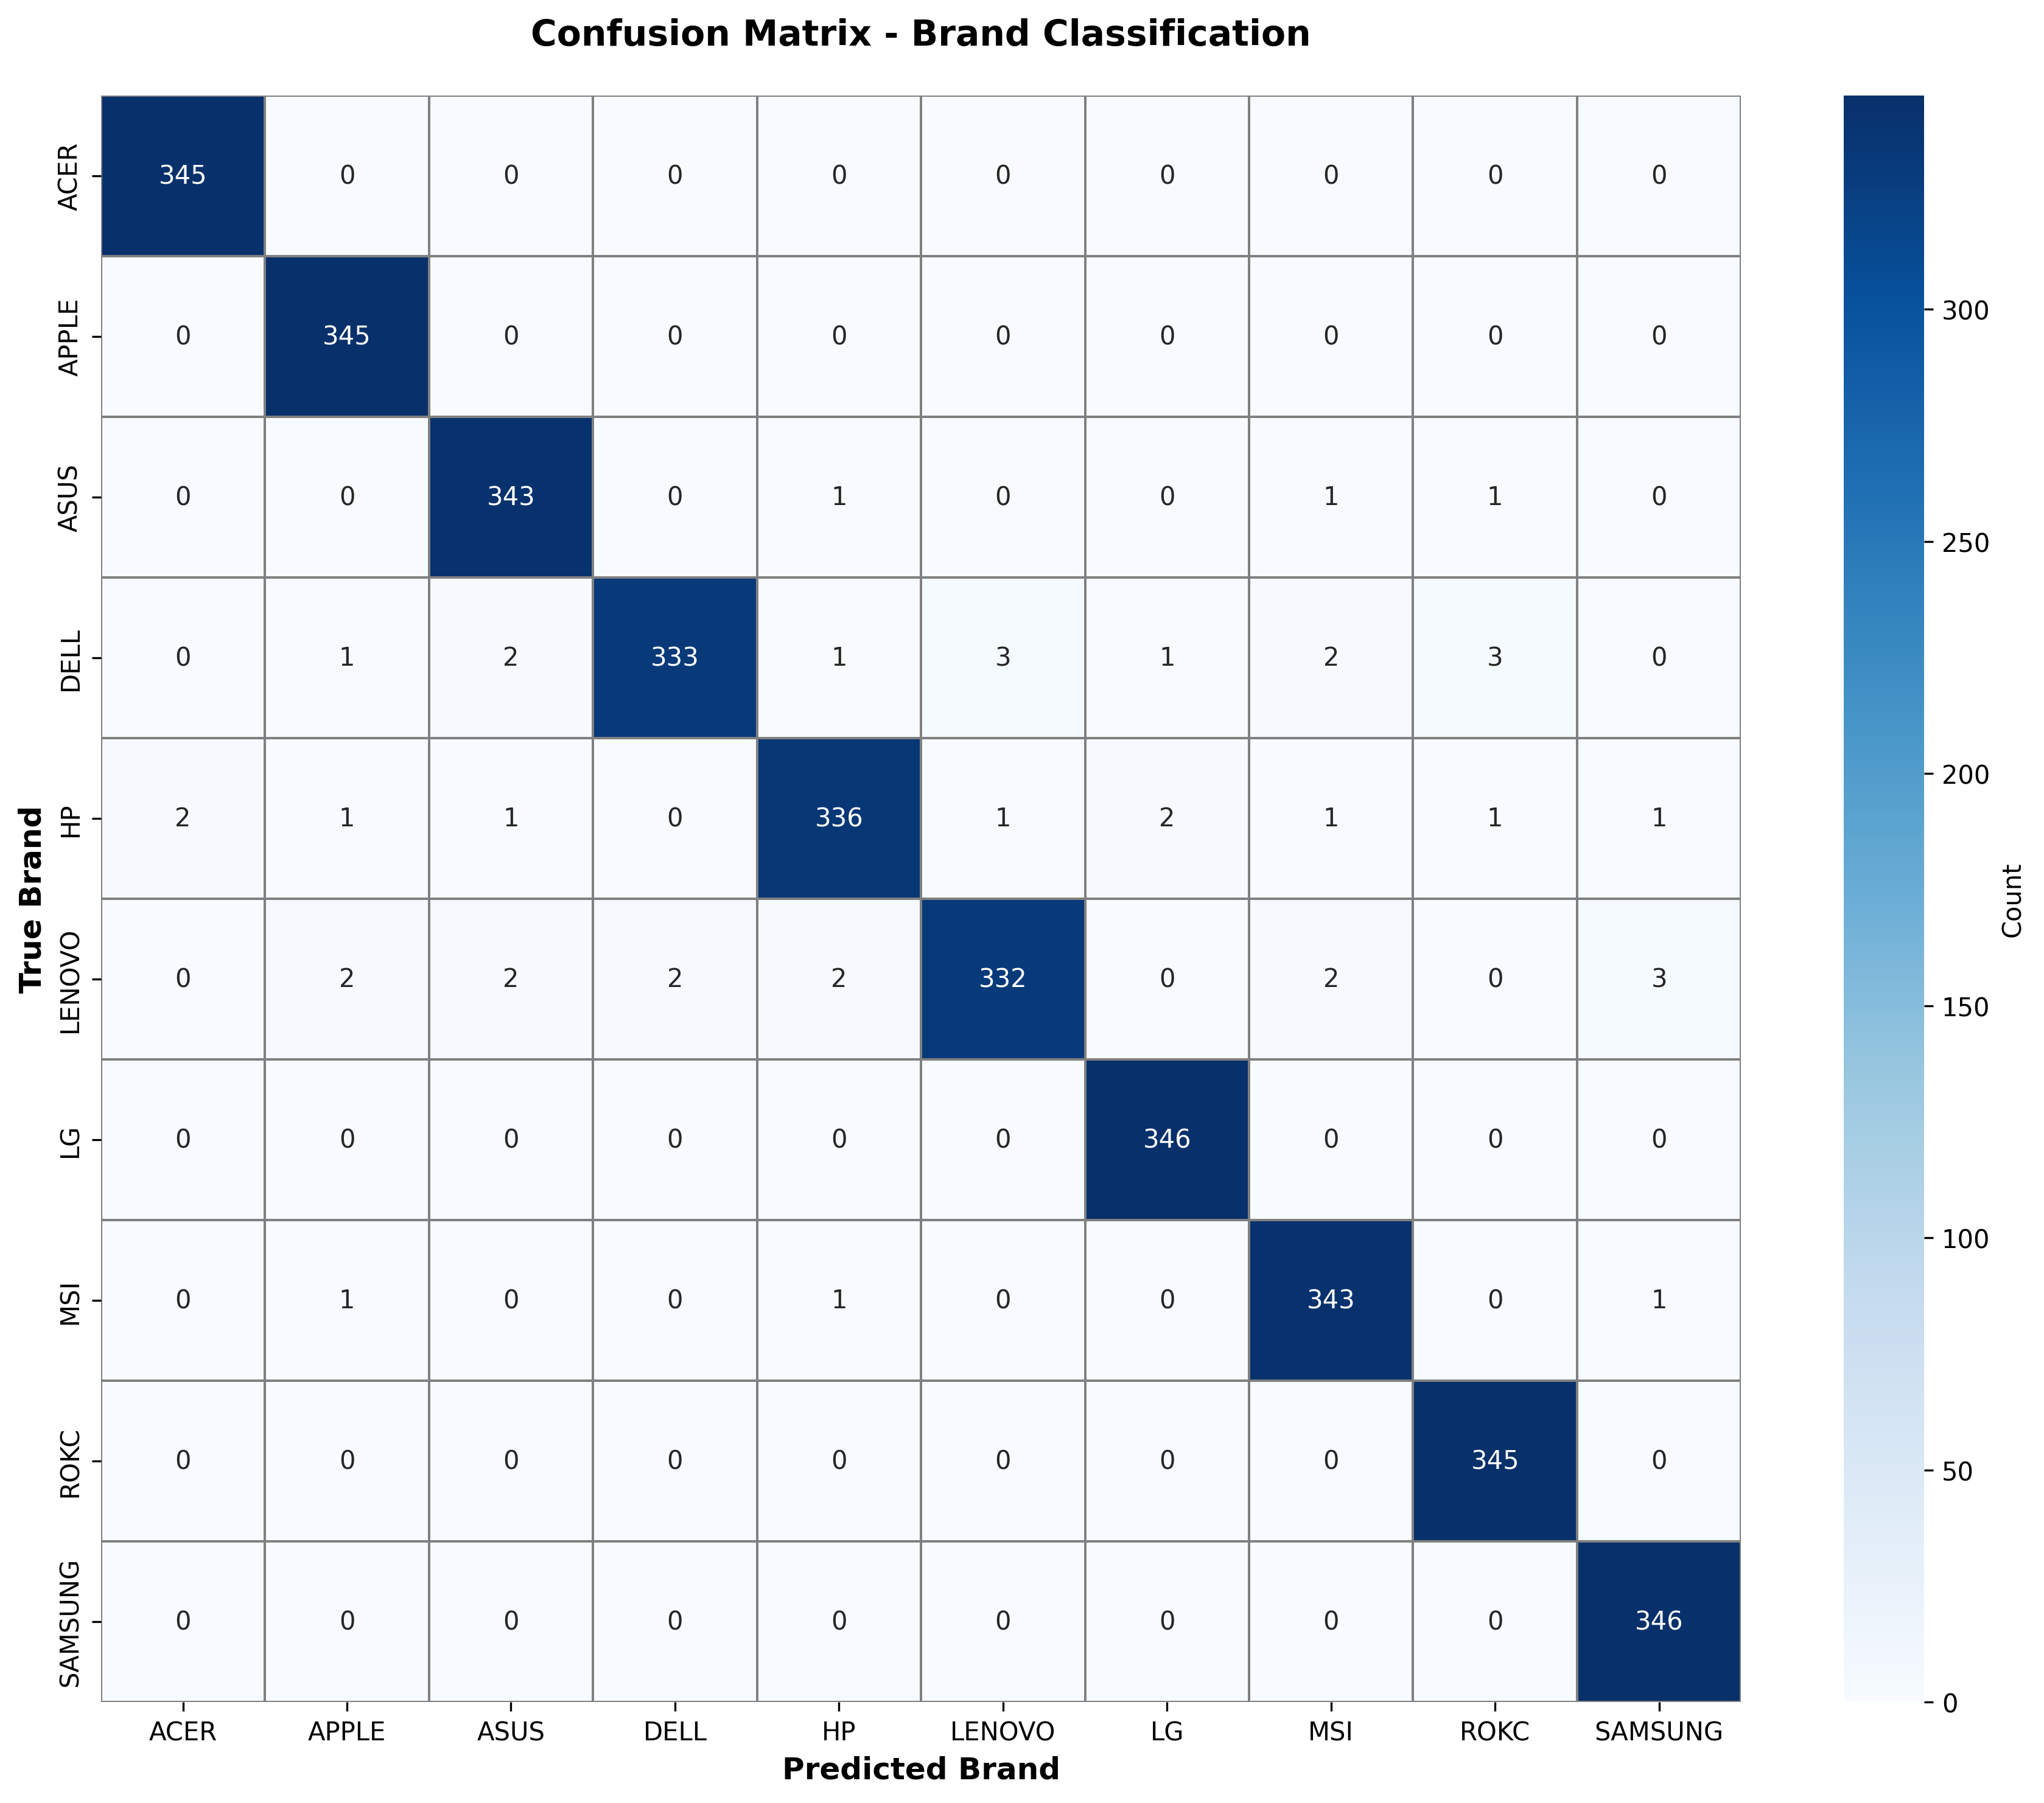
The confusion matrix demonstrates the model's strong performance with most predictions concentrated along the diagonal, indicating correct classifications. Minimal off-diagonal values confirm low misclassification rates across all brands.
Key Insights:
- Operating system and CPU type were identified as strong indicators of brand identity
- Performance score, price range, and RAM capacity significantly contributed to brand classification
- The model successfully learned brand-specific patterns in technical specifications and design philosophies

8. Deliverables
The final deliverables of the project include:
- Trained Random Forest Model: A production-ready classifier achieving 99.2% accuracy, saved in Joblib format for easy deployment
- Data Processing Pipeline: Complete preprocessing scripts for cleaning, feature engineering, and data transformation
- Jupyter Notebook: Comprehensive notebook documenting the entire workflow including exploratory data analysis, model development, and evaluation
- Model Evaluation Report: Detailed classification report with precision, recall, and F1-scores for all 10 brand categories
- Feature Importance Analysis: Documentation of the most influential features for brand classification
- Project Documentation: Complete technical documentation including methodology, results, and insights

9. Future Enhancements
Several enhancements can be considered for future development:
- Multi-Label Classification: Extend the model to predict multiple laptop categories such as gaming, business, or ultraportable
- Price Prediction Integration: Develop a complementary regression model to predict laptop prices based on specifications and brand
- Deep Learning Approach: Experiment with neural network architectures for potentially improved feature learning
- Real-Time Classification API: Deploy the model as a REST API using Flask or FastAPI for integration with web applications
- Interactive Dashboard: Create a Streamlit or Plotly Dash interface for interactive brand classification and market analysis
- Automated Data Collection: Implement web scraping pipelines to continuously update the model with new laptop specifications
- Model Interpretability: Integrate SHAP or LIME for detailed explanation of individual predictions

10. Conclusion
This project successfully demonstrates the application of machine learning techniques to the challenging problem of laptop brand classification. By processing a comprehensive dataset of 4,446 laptops with 17 technical specifications, the system developed a Random Forest classifier that achieves exceptional accuracy of 99.2% in identifying laptop brands from their technical characteristics alone.
The systematic methodology employed—from careful data preprocessing and feature engineering through model development and evaluation—resulted in a robust classification system capable of distinguishing between 10 major laptop brands. The high precision and recall scores across all brands validate the effectiveness of the chosen approach and feature set.
Key findings revealed that certain technical specifications, particularly operating system choice and CPU type, serve as strong brand identifiers. This insight reflects real-world market positioning where brands develop distinct product philosophies around specific hardware and software ecosystems. The feature importance analysis provides valuable market intelligence about brand differentiation strategies.
The project serves multiple practical purposes: automated product categorization for e-commerce platforms, market analysis for competitive intelligence, quality control in supply chains, and recommendation system development. The reproducible pipeline and well-documented code ensure that the system can be easily maintained, updated, and extended.
Moving forward, the foundation established by this project opens pathways for advanced features including multi-label classification, price prediction, and real-time deployment through web APIs. The success of this brand classification system demonstrates the transformative potential of machine learning in automating complex categorization tasks and extracting valuable insights from technical specification data.

