ARDUINO TECHNOLOGY: SMART PEST TRAP

A Capstone Project
Presented to the
Department of Information and Computer Technology
BENEDICTO COLLEGE
A.S. Fortuna St., Bakilid Mandaue City

In Partial Fulfillment
of the Requirements
for the degree
Bachelor of Science in Information Technology

By
KENNETH DARAMAYO MAYOL
JOSEPH CARL DELA CERNA TAN

May 2020
APPROVAL SHEET
This Capstone Project entitled “ARDUINO TECHNOLOGY: SMART PEST TRAP’’ prepared and submitted by KENNETH DARAMAYO MAYOL, and JOSEPH CARL DELA CERNA TAN in partial fulfillment of the requirements for the degree Bachelor of Science and Information Technology has been examined and recommended for approval and acceptance.
RECOMMENDED:
MR. RICHARD C. CUPAL MS. JENNIFER S. POVADORA
Adviser Project Design Instructor

MITCH E. CORTES, MATCS
Dean, DICT
________________________________________________________________________
APPROVED by the Committee on Oral Examination with grade _______ on May __, 2019

MR. RICHARD C. CUPAL MS. JULIE AIKA PERALES
Adviser Panel Member

MR. PAULE GLENN ACUIN MS. MARIA SHEENA VENANZUELA
Panel Member Panel Member

MITCH E. CORTES, MATCS
Chairman
_____________________________________________________________
ACCEPTED and APPROVED in partial fulfillment of the requirements in Bachelor of Science in Information Technology.
LILAN BENEDICTO-HUAN
School President

G R A M M A R I A N’ S C E R T I F I C A T E
This is to certify that the undersigned has reviewed and went through all the pages of the proposed capstone project entitled "ARDUINO TECHNOLOGY: SMART PEST TRAP" as against the set of structural rules that govern the composition of sentences, phrases, and words in the English language.

Signed:

MS. JULIE AIKA PERALES
Grammarian

Conforme:

MITCH E. CORTES, MATCS
Chairman Oral Defense Committee

ABSTRACT
Title: ARDUINO TECHNOLOGY: SMART PEST TRAP
Researcher: KENNETH DARAMAYO MAYOL,
JOSEPH CARL DELA CERNA TAN
Degree: BACHELOR OF SCIENCE IN INFORMATION
TECHNOLOGY
Adviser: RICHARD C. CUPAL
Institution: BENEDICTO COLLEGE
Address: A.S FORTUNA ST., MANDAUE CITY

Year Completed: 2020 No. of Pages: 72
______________________________________________________________
This study assessed the Arduino Technology: Smart Pest Trap during the academic year 2019 -2020. This system aims to help homeowners and establishment owners in getting rid of pests in their premises.

ACKNOWLEDGEMENT
First and foremost, the researchers would like to thank the Almighty God for guiding us throughout the whole process of the project, for giving us all the blessings that we needed in order for us to complete the project and for giving us the strength and courage to pursue and make our project successful despite all the challenges we faced. The researchers would also like to the following people:
Mr. Mitch Cortes, Dean of the Department of Information and Computer Technology, for imparting his expertise in order for us to produce good quality output and for helping us in improving our project.
Ms. Maria Sheena Venanzuela, Panelist, for her good criticism regarding our project. Because of such, we were able to expand our knowledge to come up with great ideas and details which lead us to meet her expectations.
Ms. Jennifer Povadora, Project Design I and II Coordinator, for organizing the schedules of the defense, understanding and listening to the researchers’ concerns regarding the project and for reminding the researchers to do their tasks.
Mr. Richard Cupal, Capstone Adviser, for sharing his ideas, time and effort despite his busy schedule. For all his support and advice to make our project successful.
This acknowledgement will be incomplete without the strength of the researchers, their family. For the love, care and financial support of Mr. Oscar Mayol and Mrs. Georgene Mayol and Mr. and Mrs. Tan.

The researchers thank all of them for being there through all the difficult moments where the researchers felt confused, and discouraged. For motivating the researchers in completing their project so they can reach their dream and have a degree. This would not have been possible without their undying support and unconditional love.

Kenneth D. Mayol
Joseph Carl D. Tan

DEDICATION


TABLE OF CONTENTS
PAGE
TITLE PAGE i APPROVAL SHEET ii
GRAMMARIAN’S CERTIFICATE iii
ABSTRACT iv
ACKNOWLEDGEMENT v
DEDICATION vi
TABLE OF CONTENTS vii
LIST OF TABLES viii
LIST OF FIGURES ix
CHAPTER 1
INTRODUCTION
Project Context 1
Theoretical Background 2
Statement of the Problem 3
Purpose and Description of the Project 3
OBJECTIVES OF THE PROJECT 4
General Objective 4
Specific Objective 4
SCOPE AND LIMITATIONS OF THE PROJECT 5
Scope 5
Limitations 5
Significance of the Study 5
METHODOLOGY 6
Technical Feasibility 6
Operational Feasibility 11
Flow Chart 11
Use Case Models 14
Economic Feasibility 19
Schedule Feasibility 22
DEFINITION OF TERMS 24
CHAPTER 2
REVIEW OF RELATED LITERATURE AND SYSTEMS 25
Related Literature 25
Related Systems 26
CHAPTER 3
TECHNICAL BACKGROUND 29
Statistical Computation 30
System Development 33
Peopleware 35
CHAPTER 4
CONCLUSION AND RECOMMENDATIONS 36
Conclusion 36
Recommendations 36
CHAPTER 5
OUTPUT OF THE STUDY 37
The rationale of the Study 37
Target Clientele 37
Scheme of Implementation 37
BIBLIOGRAPHY 38
APPENDICES 40
Questionnaire 41
CODES 42
CURRICULUM VITAE 46
OPERATIONAL MANUAL 51

LIST OF TABLES
Tables Page no.
- Flow of the Catch a Pest System Use Case 16
- Flow of the Release Pest System Use Case 18
- List of Equipments used during System Development 20
- Household Survey Results 30
- List of Softwares used in System Development 33
- List of Hardwares used in System Development 33

LIST OF FIGURES
Figures Page no.
- The Technical Framework of the Project 9
- Circuit Diagram of the System 10
- User Flow Chart 12
- Business Use Case of the System 13
- Catch a Pest System Use Case 15
- Release Pest System Use Case 17
- Schedule Feasibility Gantt chart 23

Chapter 1
INTRODUCTION
Project Context
Health is a state of complete physical, mental and social well-being. For a healthy life cycle, a person needs to have a balanced diet and should have a safe, clean and healthy environment. Better health is central to human happiness and well-being. It also makes an important contribution to economic progress, a healthy population live longer, are more productive, and save more. Many factors influence health status and the ability of the country to provide quality health services for its people. For example: investments in roads can improve access to health services; inflation targets can constrain health spending; and civil service reform can create opportunities – or limits – to hiring more healthy workers.
Pest had a number of diseases. It also takes a toll in our home and they are known to eat just about anything – including parts of our house. The teeth of the rat can bite at or nibble something persistently on insulation, wallboards, card board, even wood. Some are especially fond of electrical wiring and that can lead to real danger that is why pest should be eliminated inside our homes and other establishments. The researchers develop a project that will help homeowners and establishment owners get rid of the pest.
Since in homes and urban environments, the pests are the rodents, birds, insects and other organisms that share the habitat with human, and that feed on and spoil possessions. Control of these pests are attempted through exclusion, repulsion, physical removal or chemical means. Alternatively, various methods of biological control can be used including sterilization programmers. Pest is a member of the animal kingdom that impacts adversely on human activities. The human response depends on the importance of the damage done, and will range from tolerance, through deterrence and management, to attempt to completely eradicate the pest. Pest control measures may be performed as part of an integrated pest management strategy.
Therefore, Smart pest trap despite its cost is the ideal solution to trap a pest and therefore avoid all the inconvenience from putrefaction. Unlike the traditional pest traps such as Spring Traps which are powerful devices that can kill pest in an instant which causes foul odors specifically if rats were left to decay, they may break human fingers too if it is not properly handled or if someone stepped on it. Traps may not be sensitive enough to spring when a mouse takes the bait and is not 100% percent sure that it catches the pest if it takes the bait, unlike with the smart pest trap when the ultrasonic sensor senses a moving object nearby it will automatically trigger the cage to drop down trapping the pest inside.
Theoretical Background
This chapter assesses the Arduino Technology: Smart Pest Trap.
Pest insects can have adverse and damaging impacts on agricultural production and market access, the natural environment, and our lifestyle. Pest insects may cause problems by damaging crops and food production, or being a nuisance and health hazard to humans.
According to the National Pest Management Association, termites and other insects cause over Php 20 billion in damage to homes in the Philippines every year. Many homeowner’s insurance policies won’t cover the cost of these damages, so regular inspections are recommended.
Rats and mice damage insulation and wiring in walls and attics as they build their nests. Similarly, squirrels have been known to chew holes in soffits and siding to gain access to attics. A common theory is that rats, mice, and squirrels are to blame for many of the nation’s mysterious house fires. There are specific times of year that infestations are likely to affect your home: April is for ants, May is for moths, June is woodworm month, July is for flying ants, August is wasp month, and rodents make their appearance in October and November.
Rodents are particularly harmful, in that they contaminate the areas in which they search for food. Mice dribble urine as they scurry around your home, meaning they are constantly spreading diseases they could be carrying. Examples of diseases found in household mice and other rodents include: salmonella, E. coli, and Lyme Disease.
Statement of the Problem
This study assessed the Arduino Technology: Smart Pest Trap.
Specifically, this answered the following:
What are the common pest problem in your house
1.1 Rats or Mice
1.2 Cockroaches
- Based on the findings of the study, families are having trouble in their houses need this Arduino Technology: Smart Pest Trap

Purpose and Description of the Project
The main purpose of this Smart Pest Trap Project is to trap a pest inside a cage and notifies the user that the trap catches a pest inside through a SMS notification and buzzer alarm. The trap is built using a rectangular project enclosure. We use a rectangular cage and through the use of baits such as peanut butter, nuts, raisins and etc. which will be placed at the center of the cage to lure unwanted pests. When the ultrasonic sensor place inside the cage senses an object within its field of view, the door of the cage will automatically drop down trapping the pest inside. Once a pest is trapped inside, a SMS notification will be sent to the user and the buzzer sounds the alarm to notify the homeowner that a pest has been trapped. We will be using a potentiometer for resetting purposes, so when the user wants to activate the trap again all he/she have to do is to turn the potentiometer 90 degrees and open the cage door and wedge it to the micro servo. This project will be using a Power Bank for its power source. The project is built with an easy to handle cage. The target clients, end users or beneficiaries of this project are the household owners or any establishment owners who have problems dealing with pests.
OBJECTIVES OF THE PROJECT
General Objective
This main objective of this proposed system is to design and develop a Smart Pest trap that will catch pests.
Specific Objective
The specific objectives of this study are to effectively catch and trap any unwanted pests inside a cage and to notify the user once the trap catches a pest.

SCOPE AND LIMITATIONS OF THE PROJECT
Scope
The Smart Pest Trap is a specialized type of animal trap design primarily to catch any unwanted pests roaming inside our homes or establishments. These Traps are usually set in an indoor location where there is suspected infestation of pests. Through the use of baits such as cheese, nuts and peanut butter that are place at the center of the cage, it will lure pests and when the ultrasonic sensor senses a pest inside the cage, the door cage will suddenly drop down, trapping the pest inside. And after trapping the pest inside the cage, the device will send a SMS notification to the user and the buzzer alarm will sound. The Arduino sim must have a prepaid load for it to send the notification message. The power source of this project will be through a Power bank. The project is user friendly and comes with an easy to carry cage.
Limitations
The researchers expected a list of limitations along the way considering the scope stated above. The limitations of the project outcome cover the following:
- The System can only catch one pest at a time.
- The System Battery will not be long lasting since it will be using a Power Bank for its power source.
- The system will not be able to send SMS notification to the user when there is no network coverage.
Significance of the Study
The aim is to develop a Smart Pest Trap system with SMS notification for the user in urban and rural communities. Moreover, it will be very advantageous to the following:
Rural and Urban Communities: The results will provide the families in rural and urban with some knowledge on how it can be avoided. This study will give suggestions on how to improve the cleanliness in our society which in turn may result to better opportunities. At the end of the study it will give the families realization that pests have been a major problem to the society.
Homeowners and Establishment Owners: Our project can help catch pests such as rats inside of your companies by creating this smart pest trap. So that it will not bother the people living or working in the place especially to the food that they store in the kitchen, fridge or in the cabinet.
Future Researchers. Hence, this study had limitations the researchers suggest to the future researcher to improve more about the project. This would serve as handy reference for the other researcher who would make similar study.

METHODOLOGY
Technical Feasibility
This study assessed the Arduino Technology: Smart Pest Trap. This premise is supported by Arduino Technology of David Cuartielles and Massimo Banzi.
Arduino is an open-source electronics platform based on easy-to-use hardware and software. Arduino boards are able to read inputs - light on a sensor or a finger on a button- and turn it into an output - activating a motor, turning on an LED. You can tell your board what to do by sending a set of instructions to the microcontroller on the board. (arduino.cc).
There are many projects that are designed around Arduino that aim to help clients in preventing and catching unwanted pest in their premises. This application is somehow effective; however, there are multiple ways a Pest Trap will not set off even when the pest already took the bait and some traps are very sensitive that will set off when the trap is touched or moved. This is where Arduino Technology: Smart Pest Trap is coming to play using Ultrasonic Sensor and GSM module to send SMS to the user.
The modules of the Arduino are Arduino Mega 2560 Pro, SIM800 GSM/, Ultrasonic sensor, Micro Servo, Buzzer and Potentiometer.
Modules used in this project as shown in Figure 1 are the Arduino Mega 2560 Pro. It features 54 digital input/output pins (of which 15 can be used as PWM outputs), 16 analog inputs, 4 UARTs (hardware serial ports), a 16 MHz crystal oscillator, a USB connection, a power jack, an ICSP header, and a reset button. It contains everything needed to support the microcontroller; simply connect it to a computer with a USB cable or power it with a AC-to-DC adapter or battery to get started. The Mega 2560 board is compatible with most shields designed for the Uno and the former boards Duemilanove or Diecimila. (arduino.cc).
The SIM800 GSM/GPRS shield is a GSM modem, which can be integrated into a great number of IoT projects. You can use this shield to accomplish almost anything a normal cell phone can. (lastminuteengineers.com)
The Micro Servo Motor is a small device that incorporates a two wire DC motor, a gear train, a potentiometer, an integrated circuit, and an output shaft. Of the three wires that stick out from the motor casing, one is for power, one is for ground, and one is a control input line. The shaft of the servo can be positioned to specific angular positions by sending a coded signal. As long as the coded signal exists on the input line, the servo will maintain the angular position of the shaft. If the coded signal changes, then the angular position of the shaft changes. (lastminuteengineers.com)
The Ultrasonic Sensor is an electronic device that measures the distance of a target object by emitting ultrasonic sound waves, and converts the reflected sound into an electrical signal. Ultrasonic waves travel faster than the speed of audible sound. (arduinomodules.info).
The Buzzer is an audio signaling device, which may be mechanical, electromechanical, or piezoelectric. Typical uses of these include alarm devices, timers, and confirmation of user input such as a mouse click or keystroke. (arduinomodules.info).
The Potentiometer is a three-terminal resistor with a sliding or rotating contact that forms an adjustable voltage divider. (lastminuteengineers.com)
The System includes the following main features: An Arduino board will serve as the microcontroller for the system. An Ultrasonic sensor will be used to sense any moving objects inside the cage. Micro Servo is used to drop down the door of the cage when the Ultrasonic sensor is triggered. SIM800 GSM is used to send a SMS notification to the user if the trap has set off. Buzzer is used as a sound alarm. A Potentiometer is used for resetting purposes, to control the micro servo manually. An Arduino IDE will be used as the compiler for the microcontroller code.
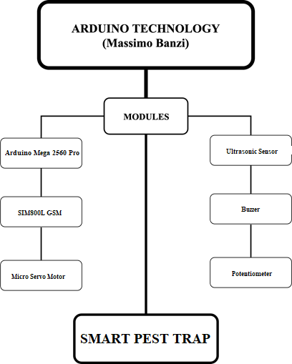

Figure 1. The Technical Framework of the Project

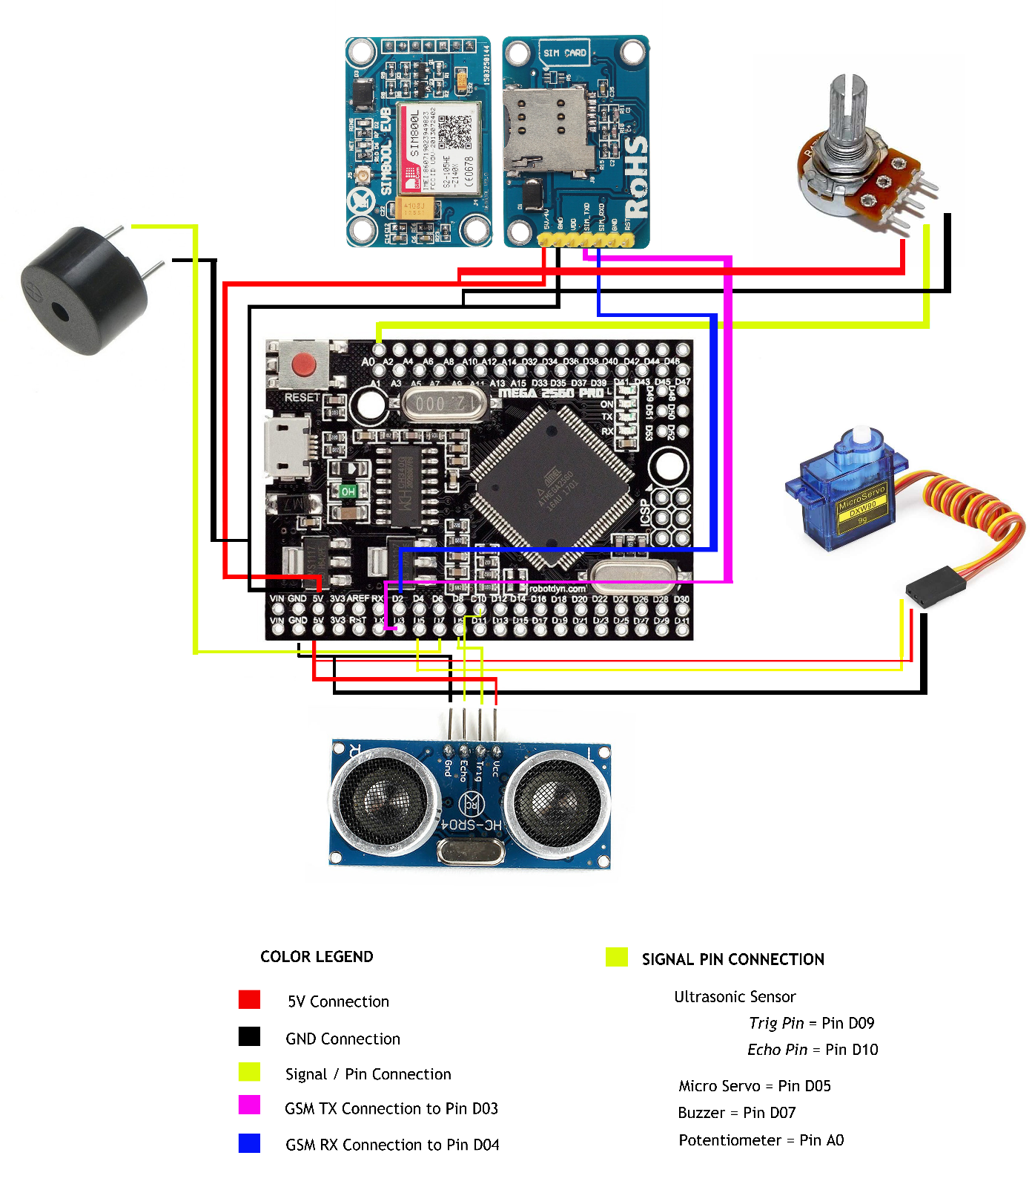

Figure 2. Circuit Diagram of the System
Operational Feasibility
Flow Chart
A Flow Chart is a type of diagram that represents a process and through this, it will be easy to understand what the task is about. The following Flow Chart shows the relationship between the user and the system.
On the next page shows Figure 3 User Flow Chart, wherein the user activates the trap and add the bait. When the pest takes the bait the Ultrasonic sensor will trigger the Micro Servo Motor to drop down the door cage. Then the buzzer alarm will sound and the SIM800 GSM module will send a SMS notification to the user. To release a pest, the user will manually open the cage. To catch pest again, the user will wedge the door cage to the Micro Servo motor and add another bait.

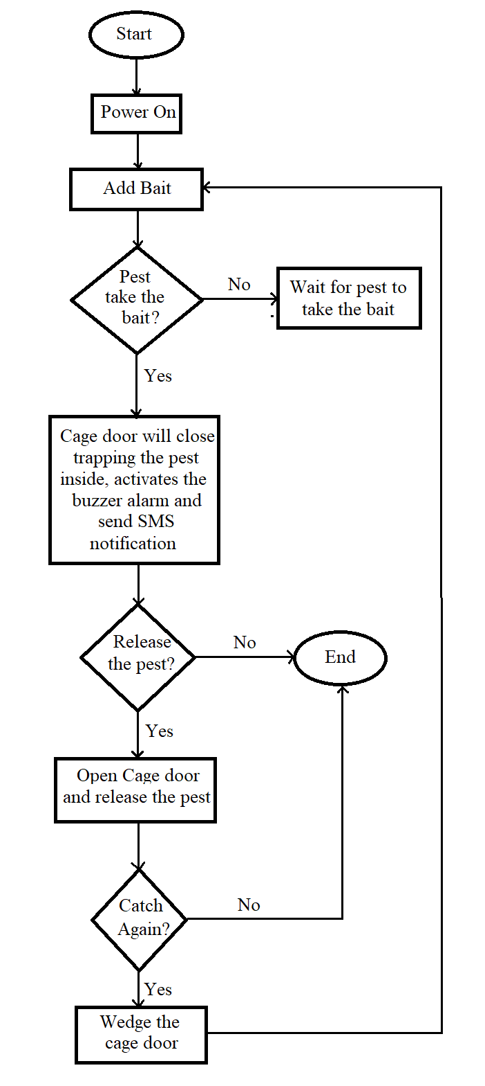

Figure 3. User Flow Chart
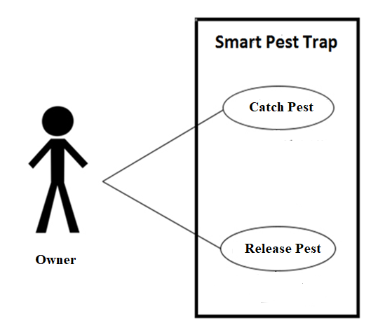

Figure 4. Business Use Case of the System

Use Case Model
A Use-Case Model is a model of how different types of users interact with the system.
There are two types of Use Case representing:
- Business Use Case - are used to represent the functionality provided by an organization as a whole.
- System Use Case - focus on the part of the process to be implemented by the system. Normally written at a level of detail equivalent to a detailed functional specification.
Shown on page 13 is Figure 4 Business Use-Case of the System.
The diagram shows the user’s interaction with the system. The user uses the Smart Pest Trap to catch and release pests.

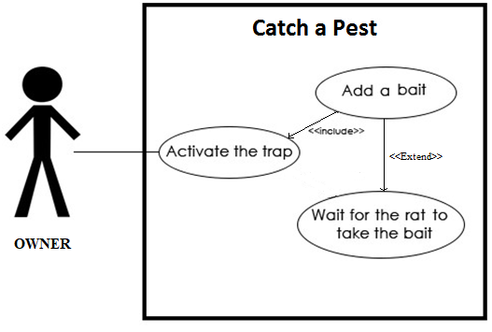

Figure 5. Catch a Pest System Use Case

Use Case name: Catch a Pest System Use Case
Triggering Actor: Owner
Benefiting Actor: Owner
Purpose: To catch unwanted pests inside the premises
Pre-condition:. Activate the trap and set the bait.
Post-condition: Pest will be trapped inside the cage.
Table 1
Flow of the Catch a Pest System Use Case
Owner | System
1. Activate the trap  2. Add a bait | 3.Ultrasonic sensor will sense pests moving inside the cage.  4. Micro Servo will drop down the cage door.  5. Sounds Buzzer alarm  6. Sends SMS notification to the user.

Table 1 shows the flow of the system when the user activates the Trap. The User will add a bait inside the cage. The Ultrasonic Sensor will detect presence of pests inside the cage. When the pest is inside the cage the Ultrasonic Sensor will trigger the Micro Servo to drop down the cage of the door. The system will sound the buzzer alarm and sends SMS notification to the user.

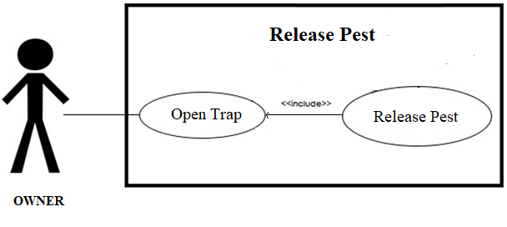

Figure 6. Release Pest System Use Case

Use Case name: Release Pest System use case
Triggering Actor: Owner
Benefiting Actor: Owner
Purpose: To release the trapped pest.
Pre-condition: Open the door of the cage
Post-condition: The pest will be release
Table 2
Flow of the Release Pest System use case
Owner | System
1. Open the cage door | 2. Release the pest

Table 2 shows the flow of the system how to release the pest that has been trapped inside the cage. The user will open the cage door and release the pests.

Economic Feasibility
Cost/Benefit Analysis provides adequate cost and benefit information. This technique is conducted to evaluate if investing on this system is beneficial to the business and to estimate the possible costs for the development of the proposed system. Table 3 contains the costs that were incurred during system development.
There are two tables representing Development and Operational.
- DEVELOPMENT COST- The development costs are those that are spent during the development of the system.
- OPERATIONAL COST- The operational costs are those that are spent after the implementation of the system.

Table 3
List of Equipments used during System Development
C  O  S  T  O  P  E  R  A  T  I  O  N  A  L | DEVELOPMENT | EQUIPMENT | QNTY | UNIT PRICE | PRICE  (Php)
 |  | Arduino UNO | 1 | 550.00 | 550.00
 |  | Bread Board | 1 | 110.00 | 110.00
 |  | GSM a6 Pro | 1 | 950.00 | 950.00
 |  | Infrared Sensor | 1 | 180.00 | 180.00
 |  | Micro Servo Motor | 1 | 250.00 | 250.00
 |  | Buzzer | 1 | 70.00 | 70.00
 |  | Jumper Wires | 1 | 150.00 | 150.00
 |  | Cage | 1 | 200.00 | 200.00
 |  | Potentiometer | 1 | 100.00 | 100.00
 |  | TOTAL |  |  | 2,560.00
 |  | EQUIPMENT | QNTY | UNIT PRICE | PRICE  (Php)
 |  | Arduino Mega 2560 Pro | 1 | 900.00 | 900.00
 |  | Ultrasonic Sensor | 1 | 220.00 | 220.00
 |  | SIM800L GSM Module | 1 | 900.00 | 900.00
 |  | Handle | 1 | 125.00 | 125.00
 |  | Junction Box | 1 | 75.00 | 75.00
 |  | Lab Mice | 2 | 50.00 | 100.00
 |  | TOTAL |  |  | 2,320.00

Schedule Feasibility
The schedule feasibility shows the activities made throughout the implementation of the project. It includes the starting date and ending date of the project. Figure 7 shows the activities during the analysis, planning, designing, implementation and maintenance phase of the project.
As shown in Figure 5, Planning of the project ranged from the month of July to the month of August. In the planning stage, forming the team and assigning each team member a position and task was made.
Analysis stage was within the month of September to October. In this stage, the team analyzed the project title and the hardwares that will be used in the system.
The Design of the project is from October 2019 to February 2020. Here includes the designing of the circuit diagram and hardware positioning and wiring of the cage.
Implementation of the project is from January to February. Setting up the cage and placing the hardwares into the cage, documentations like taking videos and pictures is done in this stage.
March to April will be for the maintenance of the project. The hardware and the wirings will be checked in this stage.

METHOD | J  U  L  Y | A  U  G  U  S  T | S  E  P  T  E  M  B  E  R | O  C  T  O  B  E  R | N  O  V  E  M  B  E  R | D  E  C  E  M  B  E  R | J  A  N  U  A  R  Y | F  E  B  R  U  A  R  Y | M  A  R  C  H | A  P  R  I  L
PLANNING
ANALYSIS
DESIGN
IMPLEMENTATION
MAINTAINANCE

Figure 7. Schedule Feasibility Gantt chart

DEFINITION OF TERMS
To understand the terms used in the study, the following is hereby defined:
Pest Trap
are devices that catches any unwanted pest inside the premises.
Pest
is any animal or plant which has a harmful effect on humans, their food or their living conditions.
Rodents
a gnawing mammal of an order that includes rats, mice, squirrels, hamsters, porcupines, and their relatives, distinguished by strong constantly growing incisors and no canine teeth. They constitute the largest order of mammals.
Bait
Is a food in which you put on a hook or in a trap in order to catch and lure fish, animals and pests.
Putrefaction
the process of decay or rotting in a body or other organic matter.
SMS
Stands for "Short Message Service." SMS is used to send text messages to mobile phones
Power Bank
A battery charger, or recharger, is a device used to put energy into a secondary cell or rechargeable battery by forcing an electric current through it. Power Bank will the power source in this System.
Chapter 2
REVIEW OF RELATED LITERATURE AND SYSTEMS
Related Literature
As mentioned earlier in the previous chapter, the cost factor plays a very important role in this project. Subsequently, to design a system with the objectives mentioned above requires research and studies that are described in this chapter. This chapter will include three subtopics, a previous case study on pest trap systems, hardware and software studies.
The researchers have created a design that will catch pests efficiently. According to Nancy D. Epsky et al (2010) and Wendell L. Morrill et al (2010). Traps developed for capturing pests are as varied as the purpose for the trapping, the pest targeted, and the habitats in which they are used. Traps are used for general survey of pest diversity, and these usually are simple interception devices that capture pests moving through an area. Traps also are used for detection of new invasions of insect pests in time and/or space, for delimitation of area of infestation, and for monitoring population levels of established pests. This information is used to make decisions on the initiation of control measures or to measure effectiveness of a pest management program. Traps may be used as direct control measure, for example, by mass trapping (use of a high density of traps throughout the infested area) to remove a large number of individuals, with the goal of preventing or suppressing population buildup. Traps can be used as direct control measure if they are highly effective, if they capture a high percentage of females (especially if they capture them before they have a chance to lay eggs), and if they are integrated with other pest management approaches. Factors such as a cost per trap, the need to service the traps frequently and the high reproductive rate of individuals that escape capture, however, prevent widespread use of traps as stand-alone pest control measure. (ars.usda.gov)
Traps for speciﬁc insect species or pest groups may use combinations of cues to lure the target insect and exploit aspects of the insect’s behavior to facilitate movement of insects into the trap. Several factors inﬂuence the eﬀectiveness of a speciﬁc trap. ability of the trap to mimic and present those cues to the insect, the strength of those cues in inﬂuencing the insect’s behavior, and the proper placement of the trap in the habitat are important.
Related Systems
Designs and develops systems and solutions for dealing with pests. Below are the following examples:
Ultrasonic Pest Repeller (UPR)
Ultrasonic pest repeller was constructed to repel pest like rodent from home in order to prevent damage and possible infections or disease caused by rodents. Rodents can perceive ultrasonic sound of frequencies within the range of 20 to 65 kHz. Our UPR when tested emit varying ultrasonic frequencies approximately within the range of 20 to 50 kHz. We hound that these varying frequencies are like sound produced by Jackhammer and causes auditory stress to rodents and discourages them from habituating within the environment where this sounds are effective. Ultrasonic frequencies are frequencies about 20 kHz. This work was simulated with electronics simulator software called PROTEUS to study and ensure its operating characteristics before construction.
Because of such immunity, an ultra-high frequency sound which is initially effective as a repellant will gradually begin to lose it effectiveness. In order to overcome the undesirable effects of deafness immunity, attempts have been made to constantly vary the frequency of the radiated energy. But because such variations in frequency are regular with respect to time, the rodents are able to accommodate themselves to such radiation and tend to reappear. Unfortunately, the science behind ultrasonic pest repellers is ultra-shaky. Just a plug a charger-sized device emitting undetectable sound into the wall, wait about 2 weeks, then BAM, your garage oasis is insect and rodent free without the use of chemical pesticides or inhumane traps. Too bad these devices have never been proven to actually work.
Ultrasonic sound waves have frequency higher than what human ears can hear, but invading species can detect them. The sound is meant to irritate pesky critters and prevent them from making homes near the source of the noise. I’m pretty sure this is similar to how I feel about Montreal’s constant construction in all fairness, I would move away too if I had the choice. But this only makes sense in theory. In actuality some animals seem to habituate to the noise, and others just don’t seem bothered at all. (morningchores.com)
Nooski Rat Trap
The Nooski Trap System utilizes an expandable rubber latex ring as the killing device. Attracted by bait the rodent enters the trap pushing past the release trigger, which in turn releases a powerful ring onto the rodent's neck/chest area causing the rodent to spring free of the trap and die quickly and humanely next to the trap. Unlike conventional snap traps that regularly misfire or maim rodents, the Nooski System cannot misfire and is lethal every time.
No more jammed fingers and no more poisoning the environment. The Nooski Trap is considerably safer than poisons and snap traps with nothing more than a tingling sensation if released onto your finger. However, as with any kill trap it is recommended to set out of reach of pets .Built from tough ABS plastic, the NOOSKI rat trap will give years of service. The safety tunnel is a dual purpose design acting as the bait holder as well as safety tunnel. Featuring a tamper proof locking system to prevent curious pets from accessing the trigger housing. Nooski Ltd still strongly recommends setting the trap out of reach of pets to be 100% safe. (tuiproducts.co.nz)
D2K – Single Rat Station Economy
The D2K Rat Bait Stations are the result of decades of practical field experience, and uses the very latest in design technology and materials. Combined with the D2K Snap Trap and D2K Lures, those Rat Station becomes the world's toughest and most non-toxic rat trapping solution. (designed2kill.info)
- Easy to open with secure lock
- Unique lock in rat trap system
- Specific compartments for grain rat bait
- Complete with rod for block and pasta sachets
- Tunneled entrance for rapid rodent acceptance
- Extremely Strong

Chapter 3
TECHNICAL BACKGROUND

Observation
This chapter presents the technical background of the researchers observation in view of the existing pest traps is that most of it is not 100% efficient in catching pest, most commonly the pest would take the bait and not set the trap off. With this concern, the proponents found an opportunity to make a system that will provide the homeowners a pest trap that will be 100% efficient in catching unwanted pests inside the premises. The proponents also added some features in this system, once the trap catches a pest, a cellphone notification will be sent to the user and a Buzzer alarm will sound.
Survey
The proponents conducted a survey of 20 respondents from Barangay Bakilid, Mandaue City, Cebu on August 25, 2019 about our propose system Smart Mouse Trap.

STATISTICAL COMPUTATION
The data gathered from the survey was tabulated and analyze. The questionnaires are answerable by a check mark beside the corresponding answer.
Homeowners or Small Establishments owners
QUESTIONS | YES | NO
- Do you have an issue with pests such as rats and mice in your area? | 20 | 0
- Do you have a pre-planned way of preventing pests from entering your place? | 16 | 4
- If yes, is your method effective in getting rid of these pests? | 6 | 10
- Is your trap lethal or non-lethal? | Lethal  13 | Non-Lethal  3
- Which Mouse traps do you prefer? Traps that will kill pests or traps that will catch it alive? | Kill  9 | Alive  11
- Do you prefer the need to quickly know whether a pest has been caught in your trap? | Yes  17 | No  3
Table 4. Household Survey Results
As seen in the table 4, in the first question all of the 20 respondents have an issue with pest running around their place. These data showed that All 20 respondents confirms that they have problem with pest in their homes or establishments.
On the next question, out of 20 respondents , 16 of them have ways or methods in preventing pest from running around their premises, while on the other hand 4 of the respondents doesn’t have ways or methods in preventing pest from running around their premises. These data shows that 80% of the respondents have exerted efforts of getting rid of these animals while 20% of them doesn’t bother to exert ways to get rid of them.
On the next question, based on the 16 respondents in Question #2 that answered they have ways and methods in dealing with rats , 6 of them find their ways or methods of getting rid of pest effective while 10 of them doesn’t find their ways effective enough. These data shows that 37% of them are successful in preventing pest from running around their premises while 63% of them are not successful in getting rid of these.
On the Fourth question, based on the 16 respondents in Question #2 that answered they have ways and methods in dealing with pest, 13 of them used lethal traps and 3 used non-lethal traps, but with regards to the result in question #3 only 37% percent of these are traps are successful in getting rid of.
On the Fifth question, out of 20 respondents, 8 of them prefer to kill pest and 12 of them prefer not to kill the pest. These data shows that 60% of the respondents prefer not to kill pest.
On the Last question, out of 20 respondents, 17 of them prefer to be notified when their traps catches a pest while 3 of them doesn’t bother to know at all. These data shows that 85% of the respondents wants to be notified if there traps catches a pest especially a rat or mice, because most of the time the users tend to forget about the traps they set until they notice a foul odor and maggots crawling in the place cause when rat dies and decompose.
Proposal
The researcher’s propose capstone project was named Smart Mouse trap but the title was change into Arduino Technology: Smart Pest Trap. Thank you for the opportunity and trust that has been given to us, Smart Pest Trap, to submit pest control service, a pest control system that includes cockroaches, rats or mice and etc. in the neighborhood. This project was engaged in pest control and located at Barangay Bakilid, Mandaue City and further places that need this project. As you know, there are various kinds of insects that live around us. The insects are disturbing tranquility and comfort. Researchers aim the good health of all the people, it is important to have a good health so that we can recover and bounce back from illness and other problems. The awareness of the importance of health is organisms depends on their surroundings or their environment, public cleanliness, the food that we eat and lastly to be happy in order to be truly healthy. That’s the main goal of this propose capstone project.

SYSTEM DEVELOPMENT
The succeeding tables present the list of Tools, Software, Hardware, and Peopleware in System Development.
Table 5 shows a list of tools and software used in system development. Arduino IDE compile the code for both the hardware and software.
Table 5
List of Tool and Software used in System Development
SOFTWARE | USES
Arduino IDE | This will compile the codes of Arduino that will execute the program.

Table 6 shows the list of hardware used in system development. Arduino Mega 2560 Pro is used as a controller to the following modules: SIM800L GSM, Ultrasonic Sensor, Micro Servo, Buzzer, and Potentiometer.
Table 6
List of Hardware used in System Development
HARDWARE | USES
Arduino Mega 2560 Pro | The board is an excellent solution for developing projects based on ATmega2560. Even though it is an Embed board, it is solid as stable as the Mega Board. It uses the original chip, and a 16 MHz high-quality quartz resonators are present on the board.
SIM800 GSM | It is a chip or circuit that will be used to send SMS notification to the user.
Ultrasonic Sensor | An ultrasonic sensor is an instrument that measures the distance to an object using ultrasonic sound waves. An ultrasonic sensor uses a transducer to send and receive ultrasonic pulses that relay back information about an object's proximity.
Micro Servo Motor | Is a rotary actuator or linear actuator that allows for precise control of angular or linear position, velocity and acceleration. It consists of a suitable motor coupled to a sensor for position feedback.
Buzzer | Is an audio signaling device.
Potentiometer | Is a three-terminal resistor with a sliding or rotating contact that forms an adjustable voltage divider.

Peopleware
This is where we describe the role of the researchers that is making this project. For this project, there is a Project Manager, a System Analyst, a Software Engineer or Programmer and a QA Tester or Technical Writer.
The Project Manager, System Analyst, Programmer and QA Tester/Technical Writer is Kenneth D. Mayol. Also, Part of the Programmer and QA Tester/Technical Writer is Joseph Carl D. Tan.

Chapter 4
CONCLUSION AND RECOMMENDATIONS
Conclusion
Based on the survey, the users have raise some problems especially when the traps they set weren’t 100% accurate in catching pest, some may take the bait and not set the trap off. Users also tend to forget about the traps they set most of the time.
Therefore, to solve these issues, the use of Arduino Technology: Smart Pest Trap is definitely the recommended solution for this problem. Given that the main objective of the Smart Pest Trap is to catch the pest at a 100% accuracy. And also one of the main features of this Project is to notify the users through a SMS notification and buzzer sound alarm whenever their trap catches pest.

Recommendations
After a very careful, thorough research and analysis process, here are some recommendations from the researchers in order to enhance future work/study of this application.
- Survey other possible locations where there is suspected infestation of pests.
- Knowledge on how to use this project, Evaluation of its functionalities should be performed so that errors and problems found during the testing can be solved and system should be maintained to cope with changing needs of users

Chapter 5
OUTPUT OF THE STUDY
This chapter presents the output of the study.
Rationale
Pests has been a major problem of household and establishment ownwers both in rural and urban communities in the Philippines. Technology has evolved and shape our workplaces in many ways. With these given scenarios, the researchers took a chance to develop a system that would catch unwanted pests inside the premises efficiently.
Target Clientele
This project is for the residents of Barangay Bakilid, Mandaue City that are having pests problems.
SCHEME OF IMPLEMENTATION
In relation to the data at hand, the Ardiuno Technology: Smart Pest Trap will catch any unwanted pests effectively and efficiently inside the household or establishment premises both in urban and rural communities. The system is durable and at the same time budget friendly.
The system provides a more improved way in catching pests which have its own user notification feature if the trap catches a pest. This will surely help household and establishment owners get rid of pests conveniently and effectively.

BIBLIOGRAPHY

- Books
Merriam-Webster’s Dictionary
- Published Materials
Dobias,A et al (2010) “Advantages of Using Mouse Traps” https://doi.org/10.1016/0377-2217(90)90061-F
Baker,S et al (2012) “Mechanical Performance of Rat, Mouse, Mole Spring Traps, and Possible Implications for Welfare Performance” https://doi.org/10.1371/journal.pone.0039334
Dagg,J et al (2011) “ Exploring Mouse Trap History” https://evolution-outreach.biomedcentral.com/articles/10.1007/s12052-011-0315-8
Health,E et al (2012) “ The acceptability of rat trap use over pesticides for rodent control” https://www.ncbi.nlm.nih.gov/pmc/articles/PMC3508837/
- Unpublish Materials
Corrigan,R et al (1998) “ The Efficacy of Glue Traps against Wild Populations of House Mice, Mus Domesticus” https://digitalcommons.unl.edu/cgi/viewcontent.cgi?article=1024&context=vpc18
- Internet Source
https://www.slideshare.net/epestsolutions/advantages-of-using-mouse-traps
https://www.familyhandyman.com/article/do-sticky-mousetraps-work/
http://www.authorstream.com/Presentation/epestsolutions-1853072-advantages-using-mouse-traps/
https://www.allaboutcircuits.com/projects/reading-sensors-with-an-arduino/
https://www.mathworks.com/help/supportpkg/arduinoio/ug/configure-setup-for-arduino-hardware.html
https://www.rentokil.com.ph/rats/signs-of-rats/
https://www.discoverwildlife.com/how-to/how-to-deal-with-rats-and-mice-in-your-house/
https://healthywa.wa.gov.au/Articles/N_R/Protect-your-health-keep-rats-under-control
https://www.researchgate.net/publication/312976228_Philippine_rats_ecology_and_management

APPENDICES

APPENDIX A
SURVEY QUESTIONNAIRE

Questionnaire
Title: Smart Mouse Trap using Arduino Technology
Instruction: Please mark check mark (√) on the box that corresponds to your answer.

- Do you have an issue with rodents such as Yes No
Rats and mice in your area?

- Do you have a pre-planned way of preventing Yes No
Rats and mice from entering our place?

- If yes, is your method effective in getting rid Yes No
Of these rodents ?

- Is your trap lethal or non lethal? Lethal Non Lethal

- Which mouse traps do you prefer? Traps that will kill rats Traps that catches rats alive
- Do you feel the need to quickly know whether
a rat or mouse has been caught? Yes No

Comments and Suggestions:

CODES

ARDUINO CODE

#include <Servo.h>
#include <SoftwareSerial.h>

const int trigPin = 9;
const int echoPin = 10;
Servo tap_servo;
long duration;
int distance;
int buzzer = 7;
int tap_servo_pin = 5;
SoftwareSerial mySerial(3, 2);
int potpin = 0;
int val;

void setup() {
mySerial.begin(9600);
pinMode(trigPin, OUTPUT);
pinMode(echoPin, INPUT);
pinMode(buzzer, OUTPUT);
tap_servo.attach(tap_servo_pin);
Serial.begin(9600);

}
void loop() {

digitalWrite(trigPin, LOW);
delay(50);

digitalWrite(trigPin, HIGH);
delay(50);
digitalWrite(trigPin, LOW);

duration = pulseIn(echoPin, HIGH);
distance = duration*0.034/2;

Serial.print("Distance : ");
Serial.println(distance);

if (distance <= 18)
{
tap_servo.write(160);
digitalWrite(buzzer, HIGH);

Serial.println("SENDING SMS NOTIFICATION...");
delay(1000);

mySerial.println("AT"); //Once the handshake test is successful, it will back to OK
updateSerial();

mySerial.println("AT+CMGF=1"); // Configuring TEXT mode
updateSerial();
mySerial.println("AT+CMGS=\"+639505006528\"");//change ZZ with country code and xxxxxxxxxxx with phone number to sms
updateSerial();
mySerial.print("ALERT: A Pest has been trapped inside the cage"); //text content
updateSerial();
mySerial.write(26);
delay(2000);
digitalWrite(buzzer, LOW);
delay(5000);
}

if (distance > 18)
{
tap_servo.write(15);
digitalWrite(buzzer, LOW);

val = analogRead(potpin);
val = map(val, 0, 1023, 0, 180);
tap_servo.write(val);
delay(15);
}}

void updateSerial()
{
delay(500);
while (Serial.available())
{
mySerial.write(Serial.read());//Forward what Serial received to Software Serial Port
}
while(mySerial.available())
{
Serial.write(mySerial.read());//Forward what Software Serial received to Serial Port
}
}

CURRICULUM
VITAE


Name : Kenneth D. Mayol
Birth Date : December 9, 1996
Birth Place : Cebu
City Address : House #13 Zone 4, Canduman, Mandaue City
Provincial Address : Mandaue City
Gender : Male
Civil Status : Single
Religion : Roman Catholic
Nationality : Filipino
Email Address : knnthprimo@gmail.com

Educational Background
Elementary : Santa Isabel Child Development Center Inc.
Talamban, Cebu City
Secondary : San Isidro Parish School
Talamban, Cebu City
College : Benedicto College
A.S.Fortuna St., Brgy.Bakilid, Mandaue City

SEMINAR AND TRAINING EXPERIENCES

PSITE 7 15TH CEBU ICT STUDENT CONGRESS
March 1, 2019
TECHNOPRENEURSHIP
October 30, 2018
DATA MINING
October 30, 2018
ROBOTICS; ARDUINO TECHNOLOGY
January 25, 2018



Name : Joseph Carl D. Tan
Birth Date : November 30, 1997
Birth Place : Cebu
City Address : Maguikay, Mandaue City
Provincial Address : Mandaue City
Gender : Male
Civil Status : Single
Religion : Roman Catholic
Nationality : Filipino
Email Address : tanjosephcarl@gmail.com

Educational Background
Elementary : Maguikay Elementary School
: Maguikay, Mandaue City
Secondary : St. Paul College Foundation Inc.
Bakilid, Mandaue City
College : Benedicto College
A.S.Fortuna St., Brgy.Bakilid, Mandaue City

SEMINAR AND TRAINING EXPERIENCES

PSITE 7 15TH CEBU ICT STUDENT CONGRESS
March 1, 2019
TECHNOPRENEURSHIP
October 30, 2018
DATA MINING
October 30, 2018
ROBOTICS; ARDUINO TECHNOLOGY
January 25, 2018

OPERATIONAL MANUAL

ARDUINO TECHNOLOGY: SMART PEST TRAP

USER’S MANUAL
This document presents information and guidelines for the use of Arduino Technology: Smart Pest Trap

Kenneth D. Mayol
Joseph Carl D. Tan

Department of Information and Computer Technology
Benedicto College
A.S. Fortuna Street, Mandaue City

TABLE OF CONTENTS
Page
INTRODUCTION
About this Document 1
System Overview 1
SYSTEM REQUIREMENTS 1
Hardware Requirements 1
Software Requirements 1
USER INTERFACE GUIDELINES 2
Turning on/off the Device 2
Setting up the Trap 3
Placing the Sim 5

INTRODUCTION
About this Document:
This Document is intended for homeowners or establishment owners that provide information on what the system is about and instructions on how to use and operate the smart mouse trap device.
System Overview:
This Arduino Technology: Smart Pest Trap is a device that will catch any unwanted pest inside your premises and will automatically sound a buzzer alarm and send a message notification to the user whenever the trap sets off.
SYSTEM REQUIREMENTS
The following hardware and software requirements used in system development are listed below:
Hardware Requirements
- Arduino Mega Pro
- Ultrasonic Sensor
- Micro Servo Motor
- SIM800L GSM
- Buzzer
- Potentiometer
- Mouse Cage
- Power Bank
Software Requirements
- Arduino IDE
USER INTERFACE GUIDELINES
This document provides a basic set of user interface design guidelines for Arduino Technology: Smart Pest Trap. This is to ensure that the operator will be guided properly on the usage and flow of the system with the provided information.

TURNING ON/OFF THE DEVICE
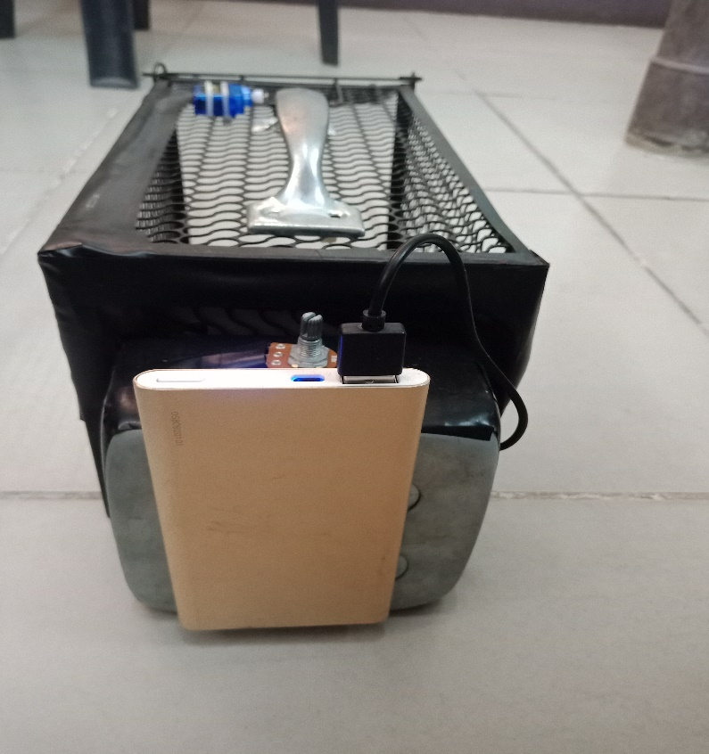

1

2

Parts:
- USB Power Cable – Connects the Arduino Microcontroller to the Power Source.
- Power Bank – Serves as the Power Source of the Device.
Instructions:
- To Turn on the Device just connect the USB Power Cable to the Power Bank. Make sure Power Bank has battery and is not empty.
- To Turn Off just remove the USB Power Cable to the Power Bank.
SETTING UP THE TRAP
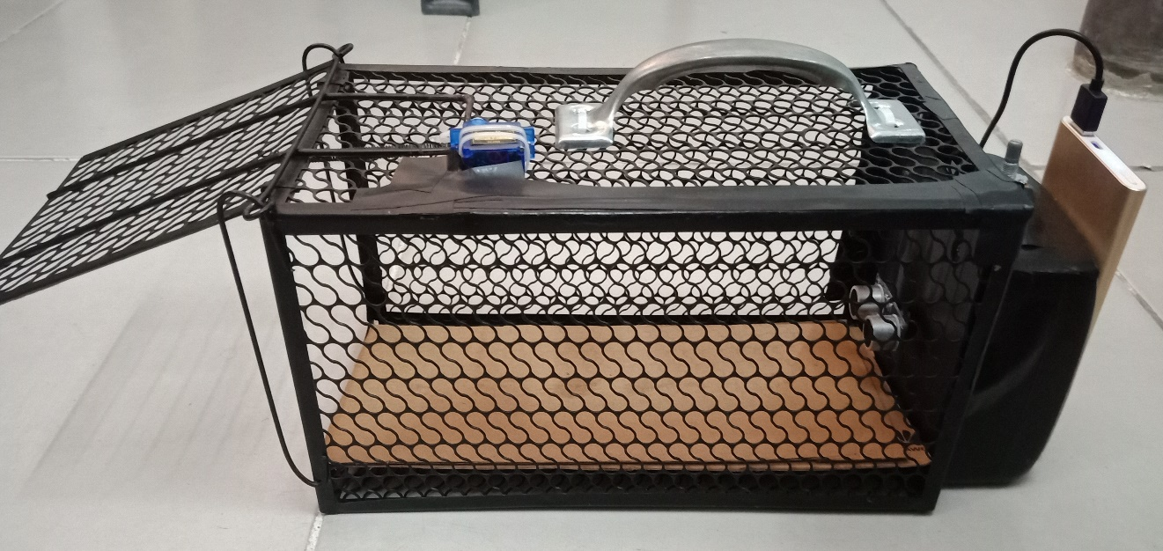

6
5
4
3

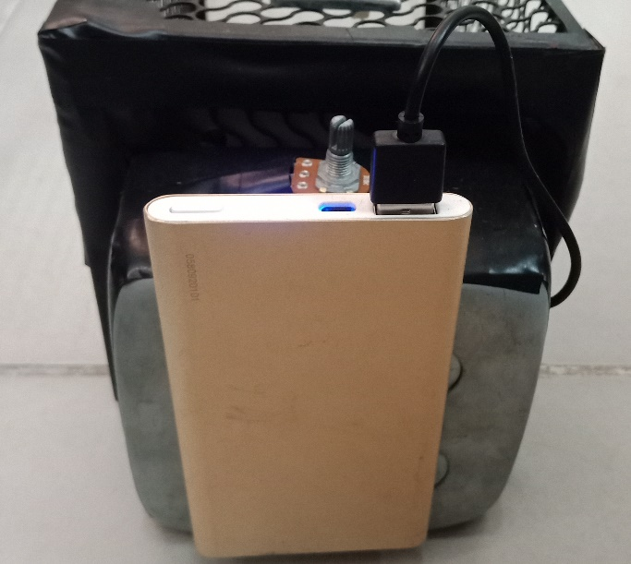
7

Parts:
- Cage Door – Open the cage and wedge the door to the Micro Servo Motor.
- Micro Servo Motor – holds the cage door open until the trap sets off.
- Bait – foods such as cheese, peanuts, grains, etc. to lure the pest inside the cage.
- Ultrasonic Sensor – will sense any moving or upcoming pests inside the cage.
- Potentiometer – use to control the Micro Servo Motor Manually
Instructions:
- Open the cage and wedge the door to the Micro Servo Motor.
- Use the Potentiometer to manually control the Servo Motor to wedge it to the cage door.
- Place a bait inside the cage.
- Turn on the device by connecting the Power Cable to the Power Bank.
- Wait for the pest to take the bait.
- Cage door will automatically drop down if the pest is inside the cage.
- Buzzer Alarm will sound
- Message Notification will be sent to the user.
- For Resetting the trap purposes, use the potentiometer to control the Micro Servo and wedge the cage door again to the servo.

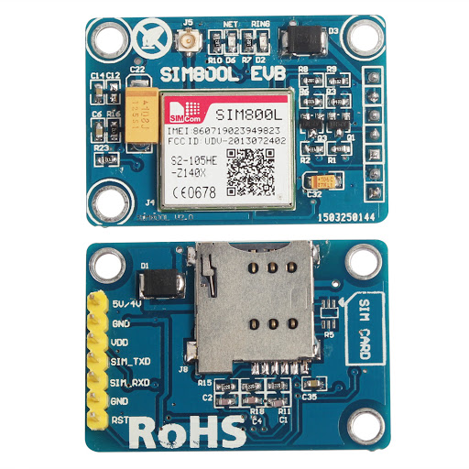
PLACING THE SIM

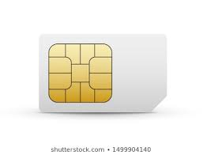

9
8

Note: This hardware is place inside the metal box attach at the back of the cage. Sim Card must have a load in it.
Parts:
- Sim Card Holder – Found at the back of the hard, this is where the Sim card will be placed.
- Sim Card – serves as the mobile number that will send the message notification to the user.
Instructions:
- Open the metal box attached at the back of the cage.
- Locate the SIM800l hardware.
- Insert the sim card.

