Animation Brief
How the Montgomery multiplier works, shown with moving circles
For the animation teammate. Project: Montgomery multiplication core for ZKP (CS-431 Digital System Design). Used in the OEL viva.

1. What we need
One continuous animation of about 3.5 minutes that shows, with moving circles, how our hardware multiplies two numbers A and B on a clock of M hours. It follows the real code, state by state. A viewer with no hardware background should be able to answer these five questions after watching it:
- Where does M go, and what is it for?
- How is A cut into pieces?
- How do the bits of B arrive, one by one?
- How does the result S collect the additions?
- Why is S halved in every round?

The six rules
1. One continuous flow. No cuts between scenes. The stage stays the same; things move, grow and fade.
2. Numbers are circles: A blue, B orange, M green, S purple. They move between places.
3. Clean and modern, not cartoon. No faces, no characters.
4. Controls: only Play/Pause. No sliders, no step buttons.
5. Small toy numbers first (A = 45, B = 61, M = 63). The real 256-bit size appears only in the last 30 seconds.
6. One short caption at a time. No code on screen. Only the machine state names in a small strip at the bottom.

2. The idea in six lines
Read this before you start, so the pictures make sense.
- The loop. The machine looks at the bits of B, starting from the smallest bit. For each bit it does three things: (1) add M if S would otherwise be odd, (2) add A if the bit is 1, (3) halve S. This is one round.
- M is the clock size. Numbers wrap around at M, like a clock with M hours. Adding M is one full turn, so the answer does not change. We add it only to make S even, so that halving is exact.
- Halving every round. After 8 rounds S has been halved 8 times, which divides by 256. So the machine gives A × B ÷ 256 on the clock of M hours, not A × B. The wrapper runs the machine 4 times to cancel the ÷ 256 (shown at the end).
- Small adder, so numbers are cut into words. The toy chip cuts each number into 2 words of 4 bits. The real chip cuts a 256-bit number into 8 words of 32 bits. Only one word is handled per tick.
- Opposite directions. Adding goes from the small word to the big word, because the carry travels up. Halving goes from the big word to the small word, because the bit that falls out of a word becomes the top bit of the next one.
- Memory answers one tick late. In tick t the chip sends a slip with an address. The word comes back in tick t+1. This is why the chip sometimes waits for one tick.

3. The toy machine we animate
It is a scaled-down copy of the real hardware with the same states and the same order. Use exactly these numbers.
Item | Value | Notes
A | 45 = 0010 1101 | Word 0 (big) = 0010 = 2. Word 1 (small) = 1101 = 13.
B | 61 = 0011 1101 | Bits from the smallest: 1, 0, 1, 1, 1, 1, 0, 0. One bit per round.
M | 63 = 0011 1111 | Word 0 = 3. Word 1 = 15. Show M as a clock ring with 63 marks.
Rounds | 8 | One round per bit of B. Real chip: 256 rounds.
Ticks | 11 per round, 96 in total | Round = 1 + 1 + 2 + 1 + 2 + 1 + 2 + 1. Real chip: 29 per round.
Machine answer | S = 72 | Then the wrapper does 72 − 63 = 9 because 72 ≥ 63.
Check | 9 | 45 × 61 ÷ 256 on a clock of 63 hours = 9 (checked by script).

Word order on screen: word 0 (big) on the left, word 1 (small) on the right, like digits in a written number. Additions therefore move right to left; halving moves left to right.

4. The stage (one fixed layout)
The same stage is used from start to end. The camera may zoom softly, but there are no cuts.
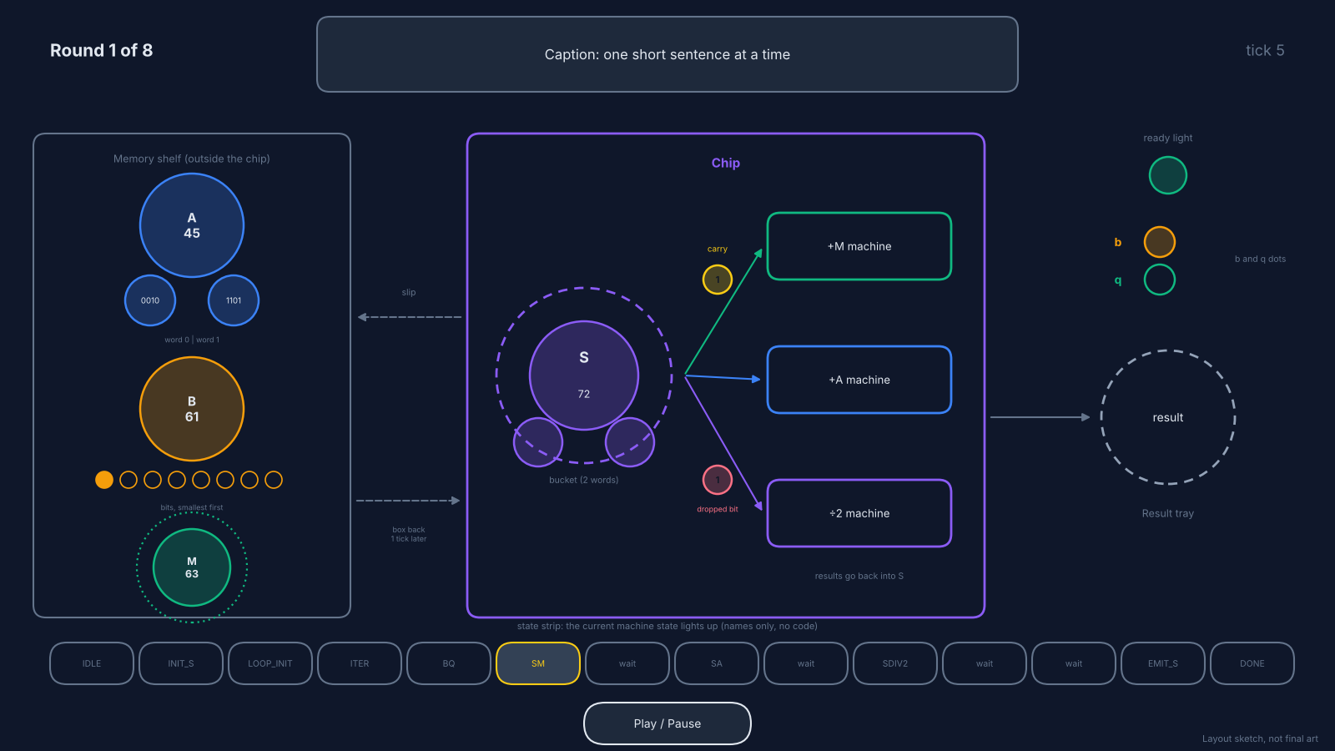
Figure 1. Layout sketch (not final art). Left: memory shelf with A, B, M. Centre: the chip with the bucket S and three machines. Right: result tray. Bottom: the state strip and the Play/Pause button.

What each thing looks like
Thing | Shape | Colour | Notes
A | Big circle with two word circles attached | #3B82F6 blue | Word circles show 4 bits. Big word on the left.
B | Big circle with 8 small bit dots below it | #F59E0B orange | A pointer lights the current bit. It walks from the smallest bit.
M | Green circle inside a clock ring (63 marks) | #10B981 green | The ring is used again at the end for 72 → 9.
S (the bucket) | Purple circle inside a dashed bucket ring, with two word circles | #8B5CF6 purple | Its value changes after every pass. This is the only place results are kept.
Word circle | Small circle with a 4-bit value | Colour of its parent | One word moves per tick.
Carry | Small circle with 1 | #FACC15 yellow | Hops from the small word to the big word during adding.
Dropped bit | Small circle with 1 or 0 | #FB7185 rose | Falls from the big word into the top of the small word during halving.
b and q dots | Two small dots near the shelf | b orange, q green | Lit = 1, dim = 0. Set once per round.
Machines | Three rounded boxes: +M, +A, ÷2 | Outline in the colour of what they add | A machine takes word circles in and gives one word circle out.
Slip | Small dashed circle | Grey | Flies to the shelf in tick t. The word comes back in tick t+1.
State strip | 14 small pills along the bottom | Grey, current one yellow | Names only: IDLE, INIT_S, LOOP_INIT, ITER, BQ, SM, wait, SA, wait, SDIV2, wait, wait, EMIT_S, DONE.

Background dark navy #0F172A, text off-white, font Inter or Poppins. Do not use red and green alone to mean different things (colour-blind viewers).

5. The timeline (one flow, in the order of the code)
Each row is one beat. The line numbers are in montprod.v, so the presenter can show the code if asked. Beats 3 to 10 are one round; the same round repeats.
# | Machine state (lines) | What happens on screen | Caption | Time
0 | IDLE (422-437) | A, B, M sit on the shelf. The chip is empty and its ready light is on. The wrapper presses start and the light turns off. M shows its clock ring. | Goal: A × B on a clock of 63 hours. | 12 s
1 | INIT_S (439-446) | The bucket S has two word circles. Each is filled with 0, one per tick, small word first. | First, empty the bucket, one box at a time. | 8 s
2 | LOOP_INIT (449-453) | The round counter appears: Round 1 of 8. The 8 bit dots appear under B. A pointer waits at the smallest bit. | We repeat 8 times, once for every bit of B. | 5 s
3 | LOOP_ITER (457-462) | Three slips fly from the chip to the shelf: to B (the pointer moves to the current bit), to A and to S (their small words). | Ask the shelf for what we need. | 6 s
4 | LOOP_BQ (464-469) | One tick later the answers return. B gives its bit: b pops out as an orange dot. Then the chip checks the last bit of S, the last bit of A and b: is S + b·A odd? If yes, the q dot lights green. | b: do we add A? q: would the sum be odd? | 8 s
5 | CALC_SM (471-479) | If q = 1: word circles of S and M go into the +M machine, small word first. A new word circle comes out and lands in S. The carry circle hops from the small word to the big word. If q = 0: the machine runs but nothing lands in S and S stays the same. | M makes S even. Small word first, the carry moves up. | 14 s
6 | STALLPIPE_SM (481-486) | One waiting tick with a small hourglass over S: the last word is still being put in place. | Wait: the last box is still being placed. | 3 s
7 | CALC_SA (488-496) | Same movement with A and the +A machine. If b = 0 nothing lands in S. | If b is 1, add A. | 14 s
8 | STALLPIPE_SA (498-503) | Hourglass tick. The pointer in S jumps to the big word. | Wait again, then start from the big word. | 3 s
9 | CALC_SDIV2 (505-513) | Word circles go through the ÷2 machine, big word first. The dropped bit (rose) falls from the big word into the top of the small word. The value of S visibly halves. | Halve S. The dropped bit slides into the next box. | 14 s
10 | STALLPIPE_D2 (515-525) | The round counter changes (Round 1 → Round 2). A small loop arrow shows that it goes back to beat 3 on the same stage. Not a cut. | Next bit of B. | 4 s
11 | Rounds 2 and 3 | Same states at about 3 times the speed. Round 2 shows both passes writing nothing (b = 0, q = 0): only the halving changes S. Round 3 shows q = 0 and b = 1: only the +A pass writes. | Nothing to add this time. / Only A is added. | 45 s
12 | Rounds 4 to 8 | Fast forward, about 4 s per round. Only the values of S, b and q change and the B pointer walks to the last bit. | The same thing, five more times. | 20 s
13 | STALLPIPE_ES, EMIT_S (527-543) | The words of S slide out of the chip into the result tray, small word first. The tray shows 72. | Send the answer out. | 6 s
14 | DONE (545-551) and the wrapper | The tray asks: 72 ≥ 63? The M clock ring appears around it. 72 wraps past 63 and lands on 9. The ready light turns on. | On a clock of 63 hours, 72 is the same as 9. | 12 s
15 | Epilogue (zoom out, same stage) | The toy chip fades into the real one. Numbers become 256 bits cut into 8 words. Counters show: 256 rounds, 29 ticks per round, about 7,448 ticks. Then four chip icons in a row: A·R, B·R, A·B·R, A·B, and the total 30,305 ticks. | The real chip does the same thing, 256 times. The wrapper runs it 4 times to cancel the ÷ 256. | 30 s

Total about 3 minutes 25 seconds. Speed guide: Round 1 about 6 s per tick (everything is shown), Rounds 2 and 3 about 2 s per tick, Rounds 4 to 8 about 4 s per round.

6. The numbers (do not invent others)

All eight rounds
S before the round, S after adding M, S after adding A, S after halving. b is the bit of B, q is the check for odd.
Round | b | q | S before | after + M | after + A | after ÷ 2 | What to show
1 | 1 | 1 | 0 | 63 | 108 | 54 | Both passes write. Carry in +A pass.
2 | 0 | 0 | 54 | 54 | 54 | 27 | Nothing written. Only halving.
3 | 1 | 0 | 27 | 27 | 72 | 36 | Only +A writes. Carry in +A pass.
4 | 1 | 1 | 36 | 99 | 144 | 72
5 | 1 | 1 | 72 | 135 | 180 | 90
6 | 1 | 1 | 90 | 153 | 198 | 99
7 | 0 | 1 | 99 | 162 | 162 | 81 | +A pass writes nothing.
8 | 0 | 1 | 81 | 144 | 144 | 72 | Final S = 72.

S may be larger than M (up to 2M = 126) during the rounds. That is normal. Only at the end 72 − 63 = 9.

Word by word for rounds 1 to 3 (use these for the detailed animation)
Round | Pass | Small word (word 1) | Big word (word 0) | S after the pass
1 | +M (q=1) | 0 + 15 = 15, carry 0 | 0 + 3 = 3 | 63 = 0011 1111
1 | +A (b=1) | 15 + 13 = 28, write 12, carry 1 | 3 + 2 + 1 = 6 | 108 = 0110 1100
1 | ÷2 | 12 with top bit 0 = 0110 = 6 | 6 → 3, dropped bit 0 (big word goes first) | 54 = 0011 0110
2 | +M (q=0) | nothing written | nothing written | 54, unchanged
2 | +A (b=0) | nothing written | nothing written | 54, unchanged
2 | ÷2 | 6 with top bit 1 = 1011 = 11 | 3 → 1, dropped bit 1 (big word goes first) | 27 = 0001 1011
3 | +M (q=0) | nothing written | nothing written | 27, unchanged
3 | +A (b=1) | 11 + 13 = 24, write 8, carry 1 | 1 + 2 + 1 = 4 | 72 = 0100 1000
3 | ÷2 | 8 with top bit 0 = 0100 = 4 | 4 → 2, dropped bit 0 (big word goes first) | 36 = 0010 0100

The q check, round 1: last bit of S = 0, last bit of A = 1, b = 1, so q = 0 XOR (1 AND 1) = 1. Round 3: S = 27 (last bit 1), A last bit 1, b = 1, so q = 1 XOR (1 AND 1) = 0.

7. Controls and output
- Controls: one Play/Pause button (and the space bar). It starts paused on the first frame with a large Play. At the end the same button becomes Replay. Nothing else: no speed slider, no step buttons, no progress scrubbing.
- Format: MP4, 1920 × 1080, 30 fps, plus the editable source file. If you build it as a web page, the same rules apply.
- Sound: not needed. Captions are enough. The presenter may speak over it in the viva.
- Captions: simple English, one sentence, large and readable on a projector. Use the captions in the timeline table.
- Tools (use what you know): PowerPoint (Morph and motion paths, export to MP4), Canva or Figma with export, After Effects, or a web page with GSAP.
Please avoid: cartoon faces, scene cuts and title cards between beats, code on screen, words like multiplexer or FSM in captions, more than one caption at a time, extra buttons.

8. Correctness checklist (the presenter will check this)
# | Must be true in the animation
1 | B is read from its smallest bit to its biggest bit.
2 | Order in every round: get b and q, then add M (if q = 1), then add A (if b = 1), then halve S.
3 | q = (last bit of S) XOR ((last bit of A) AND b). q = 1 means S + b·A would be odd, so M is added first.
4 | Adding goes from the small word to the big word and the carry hops up. Halving goes from the big word to the small word and the dropped bit goes down.
5 | When q = 0 or b = 0 the machine still runs the pass and takes the same ticks, but writes nothing. S does not change.
6 | Memory answers one tick later (address in tick t, word in tick t+1). After each pass there is one waiting tick.
7 | During the rounds S may become bigger than M. The fix 'if S ≥ M then S − M' is done once at the end by the wrapper, not by the core.
8 | The machine gives A × B ÷ 256 (on the clock of M hours), not A × B. The wrapper runs it 4 times to get the real A × B.
9 | Numbers to quote: toy = 11 ticks per round and 96 in total. Real = 29 ticks per round, about 7,448 ticks per run and 30,305 ticks for one full multiplication (512 of them prepare R² mod M).
10 | Use only the numbers in section 6.

9. Schedule
Date | What
16 Nov | Stage layout and Round 1 (beats 0 to 10) as a rough draft. Send to the presenter.
18 Nov | Full draft with rounds 2 to 8, the ending and the epilogue.
19 to 20 Nov | Corrections using the checklist in section 8. (The CEP report is due on 20 Nov and has priority for the presenter.)
21 Nov | Final export (MP4 and source file). OEL submission is on 23 Nov.

Where the facts come from: montprod.v (the line numbers above) and the project workbook Montgomery_Core_Design_Workbook.xlsx (sheets FSM State Table, Trace Start-up, Trace One Pass, Observations).

