Q. No. 01: Write down the application of Functions, Absolute Value function, Limit of a function, Derivative in computer science, Physics and in Engineering or in daily life. (3-5 Pages).

APPLICATIONS OF FUNCTIONS, ABSOLUTE VALUE FUNCTION, LIMIT OF A FUNCTION, AND DERIVATIVES

1. Applications of Functions
A function is a rule that takes an input, performs a process, and gives an output. Functions help us understand how one quantity depends on another.

A. In Computer Science
- Programming
- Every programming language uses functions to perform tasks.
- Example: A function that adds two numbers:
add(3, 5) = 8
- Login Systems
  - Input: email + password
  - Function checks if they match the database
  - Output: “Login successful” or “Incorrect password”
- Search and Sorting
- Apps sort items using functions, like sorting prices from low to high.
- Search engines use functions to return the most relevant results.
- Graphics / Game Development
  - Movement of a character is defined by functions.
  - Example:
position(t) = initial_position + speed × t

B. In Physics
- Motion
  - Distance covered is a function of time:
d(t) = vt
- Temperature Conversion
  - F(T) = (9/5)T + 32
- Hooke’s Law
  - Force is a function of extension:
F = kx

C. In Engineering
- Electric Circuits
  - Ohm’s law shows a function:
V = IR
- Structural Engineering
  - Load on a beam is a function of its length and width.
- Thermodynamics
  - Heat transfer depends on temperature difference:
Q = kA(T1 − T2)

D. In Daily Life
- Mobile Maps
  - Input: Starting and ending point
  - Output: Best route
  - This is a function.
- Electricity Bill
  - Bill = Units × Rate
Example: 300 units × Rs. 40 = Rs. 12,000
- Shopping Apps
  - Discounted price is a function of original price:
discounted = original × (1 − discount%)

2. Applications of the Absolute Value Function
The absolute value of a number is its positive distance from zero.
Example:
|–7| = 7
|5| = 5

A. In Computer Science
- Error Checking in Algorithms
  - Error = |actual – predicted|
  - Example:
Actual = 10, Predicted = 7
Error = |10 – 7| = 3
- Distance Between Points in Games
  - Horizontal distance = |x1 – x2|

B. In Physics
- Displacement
  - Direction may change, but displacement uses absolute value.
Example: Moving left (–5 m) then right (+3 m):
Displacement = |–5 + 3| = |–2| = 2 m
- Electric Charge
  - Charge magnitude is always written as |q|.

C. In Engineering
- Measurement Error
  - Error = |actual – measured|
Example: |100 – 98| = 2 units
- Signal Strength
  - Strength of a signal uses absolute amplitude |A|.

D. In Daily Life
- Temperature Difference
  - Difference = |T1 – T2|
Example: |10°C – 2°C| = 8°C
- Height or Weight Difference
  - |160 – 152| = 8 cm
- Money Difference
  - |500 – 300| = 200 rupees

3. Applications of the Limit of a Function
A limit tells us what value a function is approaching as the input gets closer to a certain point. Limits help us understand behavior near a point where the function may not be perfectly defined.

A. In Computer Science
- Algorithm Analysis
  - Limits help calculate how running time grows as input increases.
Example: As input size n → large, time → limit of T(n).
- Machine Learning
  - Gradient descent uses limits to move closer to the minimum error.

B. In Physics
- Instantaneous Speed
  - Average speed approaches real speed as time interval → 0.
- Wave Behavior
  - Limits describe motion when time becomes very small.
- Electric Fields
  - Limit is used when distance between charges becomes extremely small.

C. In Engineering
- Stress and Strain Analysis
  - Engineers find stress as deformation approaches zero.
- Control Systems
  - Limits help study system stability when time → infinity.
- Fluid Mechanics
  - Used to find flow rate as pipe radius becomes extremely small.

D. In Daily Life
- Approaching a Speed
  - A car approaches a speed limit, even if it never crosses exactly 60 km/h.
- Cooking Temperature
  - Water approaches the boiling point 100°C.
- Sound fading
  - As you walk away, sound level approaches 0.

4. Applications of Derivatives
A derivative shows how fast something is changing.
It is the rate of change.

A. In Computer Science
- Machine Learning
  - Derivatives minimize error using gradient descent.
- Animation / Graphics
  - Smooth motion requires velocity and acceleration, both found using derivatives.
- Network Optimization
  - Change in data flow rate is measured using derivatives.

B. In Physics
- Velocity and Acceleration
  - Velocity = rate of change of position
v = dx/dt
  - Acceleration = rate of change of velocity
a = dv/dt
- Heat Transfer
  - Rate of temperature change uses derivatives.
- Wave Motion
  - Speed of waves depends on displacement derivatives.

C. In Engineering
- Electrical Engineering
  - Current is the derivative of charge:
I = dq/dt
- Mechanical Engineering
  - Force = mass × acceleration (a is derivative of velocity).
- Civil Engineering
  - Rate of load change on a structure uses derivatives.
- Chemical Engineering
  - Rate of reaction = derivative of concentration.

D. In Daily Life
- Speed of a Car
  - Speedometer shows the derivative of distance (how fast distance is changing).
- Bank Balance Change
  - How fast money is being spent or earned is a derivative.
- Population Growth
  - Rate of increase of population is found using derivatives.
- Heart Rate
  - Heartbeat monitor measures rate of change in blood pressure

Conclusion
These four concepts—functions, absolute value, limits, and derivatives—are not just mathematical ideas. They are essential tools used in computers, machines, transportation, medicine, communication systems, and everyday human activities. They help us analyze change, predict outcomes, and design modern technology.

Q. No. 02: Make a piecewise defined function with its graph for your electricity bill up to 700 units, as the cost of electricity is dependent upon the number of units in different intervals.

Piecewise Defined Function for Electricity Bill (0–700 Units)
The electricity tariff refers to the rate structure of electricity in which different charges apply at various intervals of units (x).

Types of Tariff
- Residential Tariff
- Commercial Tariff
- Industrial Tariff

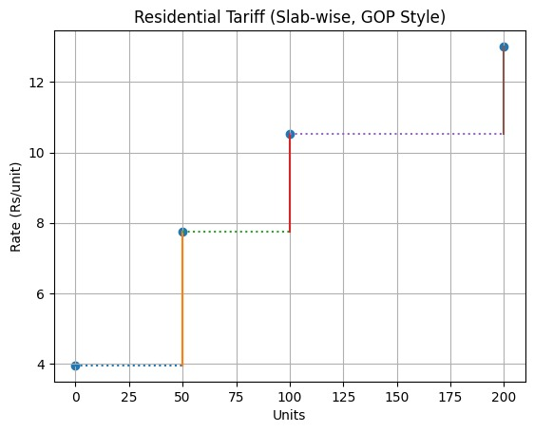
1. Residential Tariff Types
- Protected Consumers
- Unprotected Consumers
Protected Slab Graph
Units (x) | Rates (y)
0 | 3.95
50 | 7.74
100 | 10.54
200 | 13.01

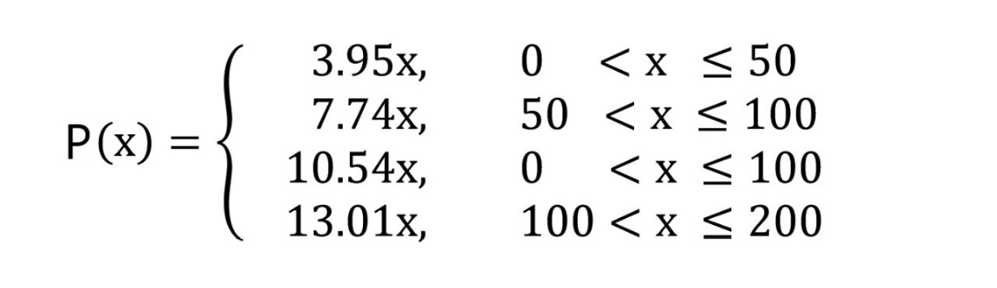
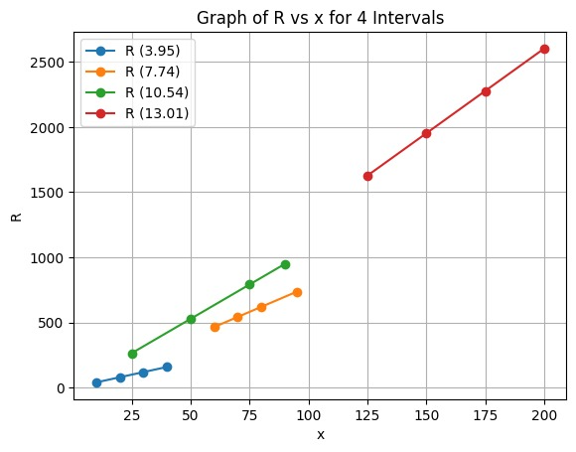
Protected Function

x | R (3.95) | x | R (7.74) | x | R (10.54) | x | R (13.01)
10 | 39.5 | 60 | 464.4 | 25 | 263.5 | 125 | 1626.25
20 | 79 | 70 | 541.8 | 50 | 527 | 150 | 1951.5
30 | 118.5 | 80 | 619.2 | 75 | 790.5 | 175 | 2276.75
40 | 158 | 95 | 735.3 | 90 | 948.6 | 200 | 2602

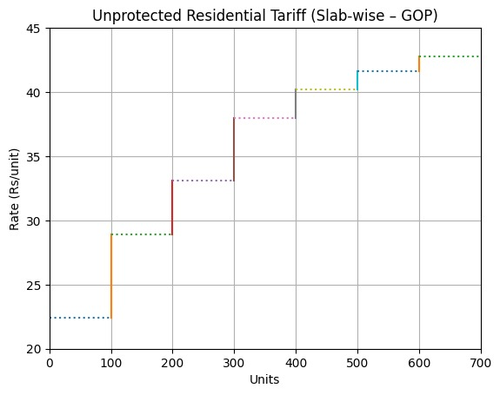
Unprotected Slab Graph:
Units (Range) | Rate (Rs/unit)
1 – 100 | 22.44
101 – 200 | 28.91
201 – 300 | 33.1
301 – 400 | 37.99
401 – 500 | 40.2
501 – 600 | 41.62
601 – 700 | 42.76

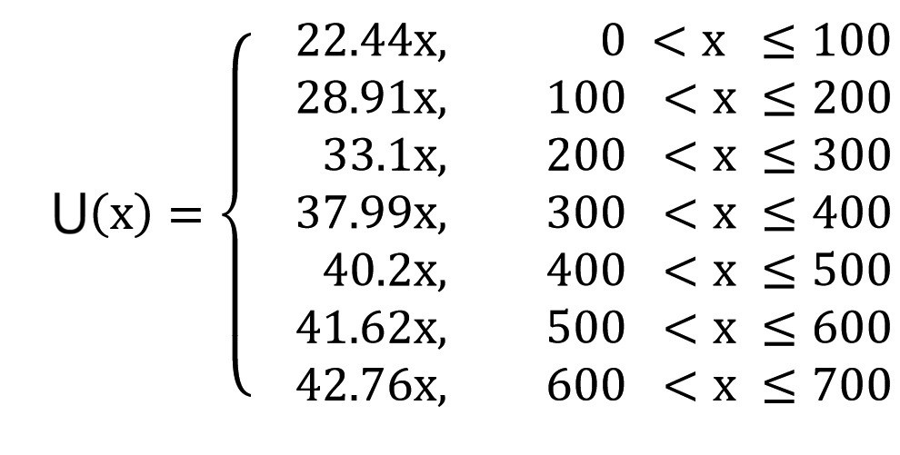
Unprotected Function

x | R 22.44x | x | R  28.91x | x | R 33.10x | x | R 37.99x | x | R 40.20x | x | R  41.62x | x | R 42.76x
25 | 561 | 125 | 3613.75 | 225 | 7447.5 | 325 | 12346.75 | 425 | 17085 | 525 | 21850.5 | 625 | 26725
50 | 1122 | 150 | 4336.5 | 250 | 8275 | 350 | 13296.5 | 450 | 18090 | 550 | 22891 | 650 | 27794
75 | 1683 | 175 | 5059.25 | 275 | 9102.5 | 375 | 14246.25 | 475 | 19095 | 575 | 23931.5 | 675 | 28863
100 | 2244 | 200 | 5782 | 300 | 9930 | 400 | 15196 | 500 | 20100 | 600 | 24972 | 700 | 29932

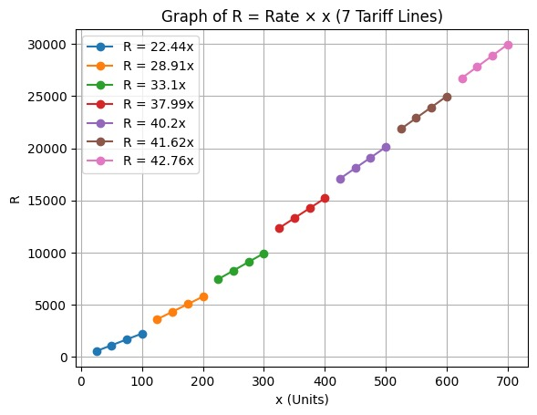
Commercial Tariff
Units(Rage) | Rates (RS/Units)
0 - 25 | 37.44
25 - 500 | 39.76
Commercial Slab Values

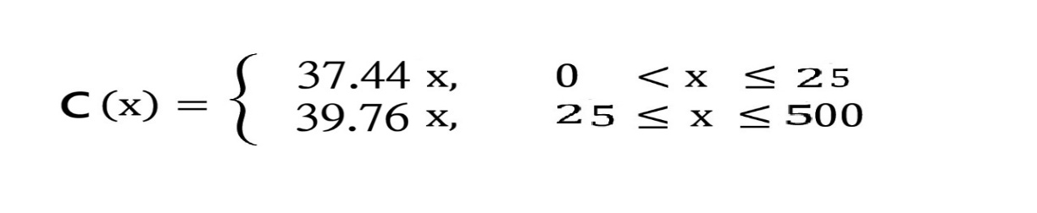
Commercial Function
Industrial Tariff
Industrial Slab Values

Sanctioned Load & Voltage Particulars = units (x) | y (Rs/kWh)
Upto 25 kW | 30.80
25-500 kW | 30.73
5000 KW (at 11, 33 kV) | 31.00
5000 KW (at 66, 132 kV & above) | 30.43

Industrial Piece Define Function:
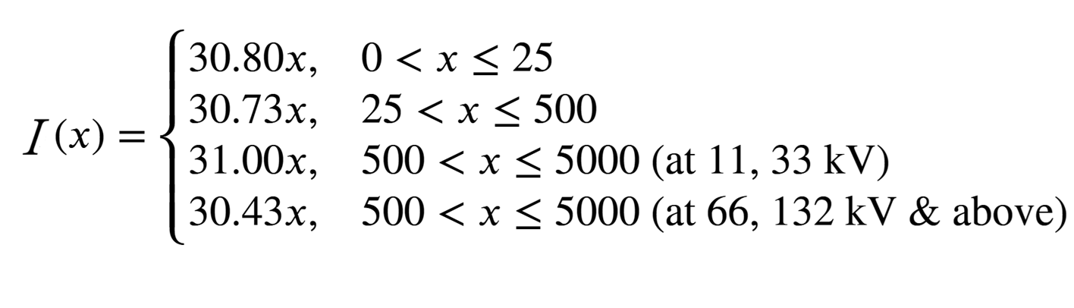
Industrial Slab Values :
x | R 30.80x | x | R 30.73x | x | R 31.00x | x | R 30.43x
10 | 308 | 100 | 3073 | 1000 | 31000 | 1000 | 30430
20 | 616 | 200 | 6146 | 2000 | 62000 | 2000 | 60860
30 | 924 | 300 | 9219 | 3000 | 93000 | 3000 | 91290
40 | 1232 | 400 | 12292 | 4000 | 124000 | 4000 | 121720
50 | 1540 | 500 | 15365 | 5000 | 155000 | 5000 | 152150

Q. No. 03: Write down only four pages in your own words very precisely by studying the history of Mathematics, on the topics below. The Role of Newton and Leibniz in the Development of Calculus

The Role of Newton and Leibniz in the Development of Calculus
Calculus is one of the most important branches of mathematics. It deals with continuous change, motion, growth, and accumulation. Today, calculus is used in physics, engineering, computer science, astronomy, economics, and many other fields.
The full development of calculus is mainly credited to Sir Isaac Newton (1642–1727) and Gottfried Wilhelm Leibniz (1646–1716). Both of them worked independently and created the basic ideas, rules, and notation that we still use today.
Although they are often remembered for the famous “calculus controversy,” their individual contributions shaped modern science and mathematics.

1. Background: Why Calculus Was Needed
Before Newton and Leibniz, mathematicians could calculate simple slopes and areas, but they could not solve problems involving:
- changing speed,
- falling objects,
- planetary motion,
- growth and decay,
- curves with varying slopes.
These problems required new ideas, especially the ability to:
- find instantaneous rates of change (derivatives), and
- find areas under curves or total accumulation (integrals).
Newton and Leibniz supplied the methods needed to solve these problems.

2. Isaac Newton’s Role in the Development of Calculus
Newton developed calculus mainly to solve problems in physics, especially motion and gravity. His version of calculus is often called the “method of fluxions.”

a) Newton’s Key Idea: Quantities That Flow
Newton thought of quantities as changing continuously with time, like flowing water.
He called a changing quantity a “fluent,” and its rate of change a “fluxion.”
- Position is a fluent
- Velocity is its fluxion
- Acceleration is the fluxion of velocity
This directly matches the modern idea of derivatives.

b) Newton and Instantaneous Rate of Change
Newton introduced the idea of taking a very small interval of time and finding how fast something changes at an exact instant.
Example:
If a ball’s position is given by
s(t) = t²
Newton’s fluxion (derivative) is
ds/dt = 2t
This gives the instantaneous speed at any time t.

c) Newton and the Discovery of the Fundamental Theorem of Calculus
Newton recognized that:
- Differentiation (finding rate of change)
- Integration (finding area or total accumulation)
are inverse processes.
This connection made calculus a complete and powerful system.

d) Use of Calculus in Physics
Newton used calculus to:
- describe motion of falling bodies,
- study orbits of planets,
- explain gravity using mathematical laws.
For example, with calculus he showed that planets move in elliptical orbits due to gravitational force decreasing with distance.

e) Newton’s Strengths
- He used calculus for practical scientific problems.
- His methods led directly to classical physics.
- He discovered calculus earlier (1660s), though he did not publish it immediately.

3. Leibniz’s Role in the Development of Calculus
Leibniz developed calculus with a more symbolic, logical, and systematic approach.
His version focused on clear notation and general rules.

a) Leibniz’s Key Ideas
Leibniz introduced the notation we use today:
- The derivative: dy/dx
- The integral sign: ∫
- The “d” for a very small change in a quantity
This notation made calculus easier to learn, understand, and apply.

b) Leibniz and the Concept of Infinitesimals
Leibniz spoke of quantities becoming very small—almost zero but not exactly zero—called infinitesimals.
Example:
If y = x², then
dy = 2x dx
Here, dx and dy are tiny changes in x and y.
This simple formula is still used in differential equations and many other subjects.

c) Leibniz and the Integral as Summation
Leibniz viewed the integral as adding up infinitely small pieces.
Example:
The area under y = x from 0 to 2:
∫ x dx = x²/2
From 0 to 2 gives 2²/2 = 2 units²
This approach is the basis of Riemann integration used in modern calculus.

d) Leibniz’s Systematic Calculus
Leibniz created general rules, such as:
- product rule
- quotient rule
- chain rule
- integration by parts
Because of his rules and notation, calculus became a clear, step-by-step system.

e) Publication and Influence
Leibniz published his work earlier than Newton, so Europe quickly adopted Leibniz’s methods.
His ideas spread through mathematicians like the Bernoulli brothers, who advanced calculus further.

4. The Calculus Controversy
A major debate happened between supporters of Newton and supporters of Leibniz about who invented calculus first.
Key points:
- Newton discovered calculus earlier but did not publish his work immediately.
- Leibniz discovered it independently and published it first.
- Both developed different methods but reached similar conclusions.
Modern historians agree that:
Both Newton and Leibniz independently developed calculus, and both deserve equal credit.

5. The Combined Impact of Newton and Leibniz
Because of both mathematicians:

a) Calculus became a universal language
Newton provided the physical meaning, and Leibniz provided the perfect notation.

b) Science and Engineering advanced rapidly
With calculus, scientists could explain motion, growth, waves, electricity, light, and energy.

c) Modern technology became possible
Everything from rockets to computers uses calculus.

d) Mathematics became more powerful
Calculus opened new fields like:
- differential equations
- vector calculus
- mathematical physics
- dynamical systems

6. Examples That Show Their Influence

Example 1: Falling Object
Newton used calculus to find velocity:
s(t) = 5t² → velocity = 10t
This explains acceleration due to gravity.

Example 2: Area Under a Curve
Leibniz introduced the integral sign
∫ x dx = x²/2
This method is used today for physics, economics, and engineering.

Example 3: Planetary Motion
Newton used calculus to show planets follow elliptical paths due to gravitational forces.

Example 4: Engineering Design
Modern engineers use derivatives to find the rate of heat transfer, stress in beams, and maximum or minimum values for optimization.

Conclusion
Newton and Leibniz together transformed mathematics through the creation of calculus.
- Newton focused on physical meaning, motion, gravity, and rates of change.
- Leibniz focused on notation, rules, and mathematical structure.
Their combined work created a complete mathematical system used in nearly every scientific and technological field today.
Without the contributions of Newton and Leibniz, modern science, engineering, and even everyday technologies would not exist in their current form.

