**Basic Programming**

1. What is the data-type usually used in arithmetic operation ?

Answer : **Integer**

1. What is the data-type usually used in word and character ?

Answer : **CHAR,STRING,VARCHAR**

1. Answer : **113**

**Because, arithmetic operation give precedence to multiplication and division in the calculation method**

1. Answer : **2**

**Because, the Looping will return even number, and the last number will be chosen. and the number divided by 6. (12 / 6 = 2)**

1. Answer : 3566GoldenStreetMiami

**Because, in *replace* method will replacing all the old char to new char.**

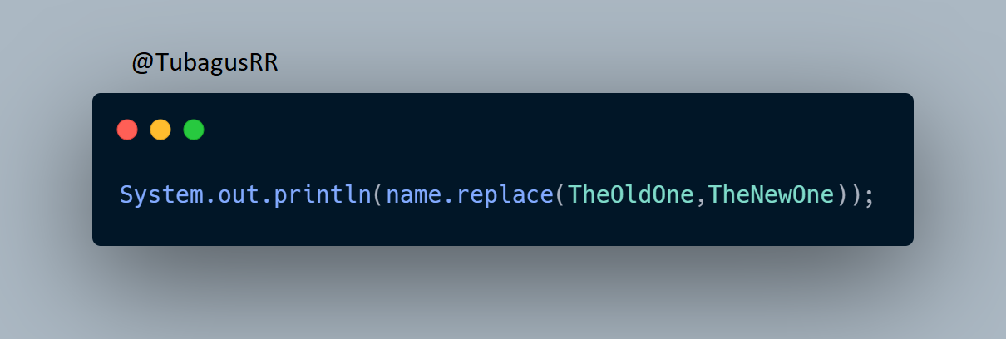

**Flaky Test**

1. What is a flaky test?

Answer : **Flaky Test is when the code is not changed, but the Test return passes and fails periodically**

1. An Element in a Website is using ajax/javascript to show the data (processed as asynchronous). What do you do to test that element?

Answer : **In asynchronous processed, for test element should use ExpectedConditions method, because with that function, it won’t wait for an element too long or too short, because that wait function will terminate if the element appears.**

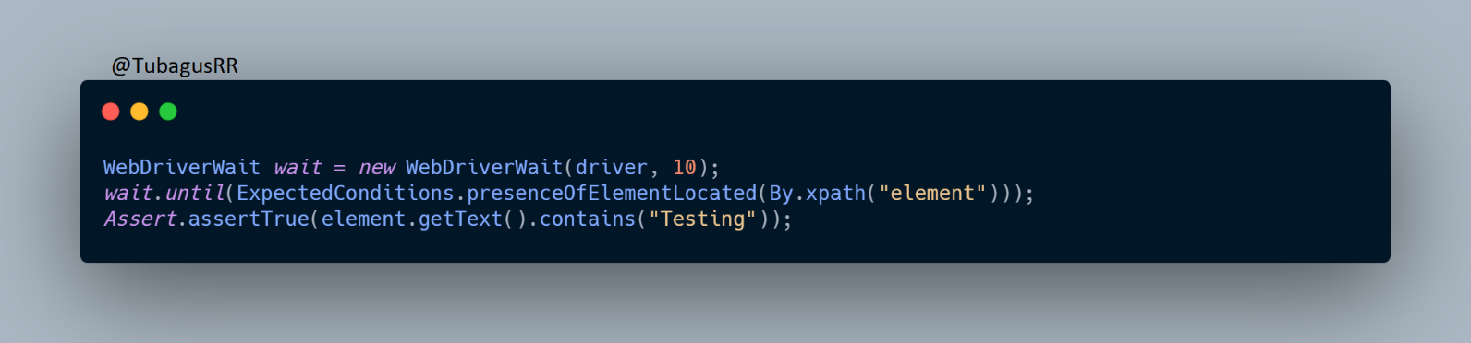

1. A website page can only be accessed with CAPTCHA. How do you test that page?

Answer : **It can’t be Tested because CAPTCHA won’t work if the Robot(Automation Test) do it. For test the page, Tester should ask Developer to remove the CAPTCHA before doing Automation Test.**