Problem 1:

The class for the value (1,5) is “YES”:

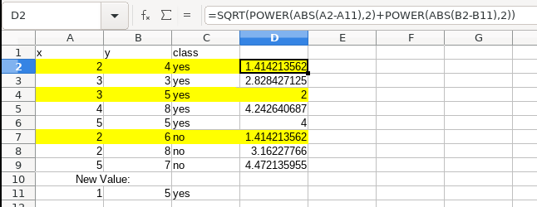

Problem 2:

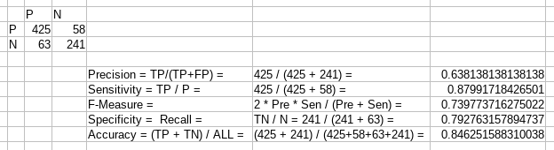

Problem 3:

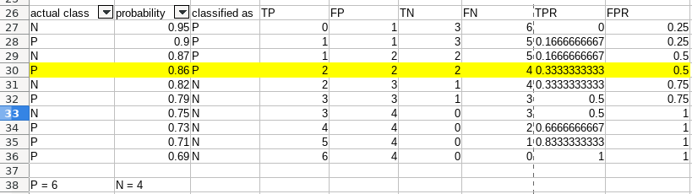

install.packages("readxl")

library("readxl")

# library("rpart")

data <- read.csv("../../lab8.csv")

data

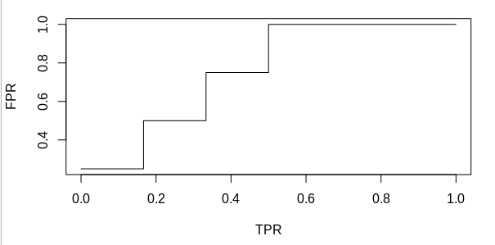plot(x=data$TPR, y=data$FPR, type="l", xlab="TPR", ylab="FPR")