SPEAR User Guide

# Overview

SPEAR stands for “Spectra Parser for Easy Analysis of Results”. SPEAR was created for extracting nuclides and spectra detected from varying file formats characterized by a range of different devices. More specifically, SPEAR can read in a batch of files created by radiation detectors. Extract the timestamp when the spectrum was taken, extract all the identified nuclides with each of their confidence ratings, and output an organized spreadsheet with the results. For quality control, SPEAR also bundles all files used into a zipped archive in the same location as the spreadsheet.

# Compatible Devices

Below is a table of detectors SPEAR currently supports along with each detector’s file formats supported.

|  |  |  |  |  |  |
| --- | --- | --- | --- | --- | --- |
|  | | **File Formats Supported** | | | |
| **N42** | **SPE** | **SQL** | **ID** |
| **Detectors Supported** | **AtomTex** | X | X |  |  |
| **BNC SAM 950** |  |  | X |  |
| **Detective X** | X |  |  |  |
| **R400** |  | X |  |  |
| **R500** |  | X |  |  |
| **NucTech** | X | X |  |  |
| **Polimaster** |  | X |  |  |
| **RadEagle** |  | X |  |  |
| **RadSeeker** | X |  |  |  |
| **RIID Eye X** | X |  |  |  |
| **RSI SR-10** | X |  |  |  |
| **Verifinder** | X |  |  |  |
| **AISense** |  |  |  | X |

# Using SPEAR

Below is an example on how to use SPEAR. The example this guide follows is the collection from an AtomTex AT6102 detector.

## Collecting Spectra

The first step is collecting spectrum from the AtomTex detector. In this example we have setup the device to output all file formats it can. We can specify what file format we want SPEAR to look for later. The only requirement in this step is to have all files in the same directory as seen below.

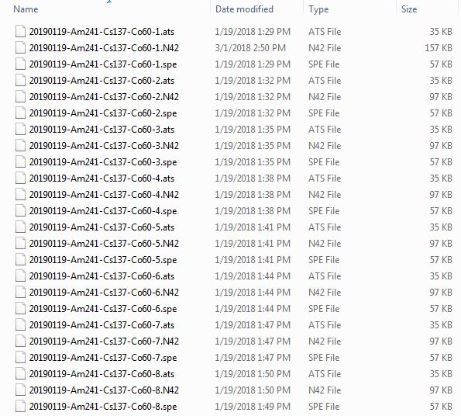

## Configuring SPEAR

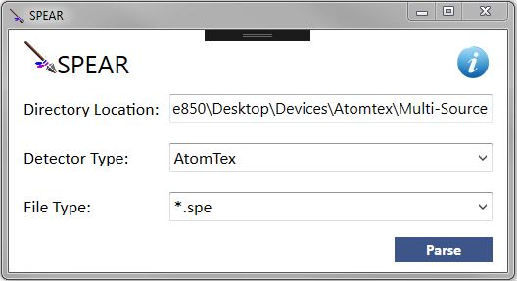This step details what each field SPEAR is asking for in order to parse the data we have collected. Below is an example how we have setup SPEAR.

### Directory Location

The first field is a text box called “Directory Location”. This is expecting the path to the directory where all the files we have collected earlier. In this example, my files are on my desktop with the path below.

“C:\Users\ehle850\Desktop\Devices\Atomtex\Multi-Source”

### Detector Type

The next field is “Detector Type” which has a dropdown menu with the list of detectors that are supported. In our example, we select the AtomTex detector.

### File Type

The last field is “File Type”. This field is also a dropdown menu. Depending on the detector type we selected earlier, this dropdown will change based on the types of file formats supported for the selected detector. Here we want SPEAR to parse our data from the SPE files ending with “.spe”. So we selected this option.

## Output

Once all fields are set in SPEAR and we are ready to extract our data we click parse in the bottom right corner of the application. After a moment, a confirmation window should appear informing us the data collection is finished parsing.

With SPEAR finished, there will be two new files generated in the same directory we specified earlier in the “Directory Location” field. The two files are a CSV file and a Zip file with the name of the detector we selected.

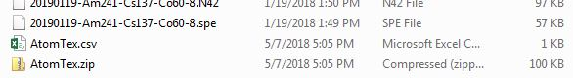

### CSV

The first is a CSV with all the data SPEAR has collected from the files in the directory. This will contain all identified nuclides, confidences, and time stamps of each of the files.

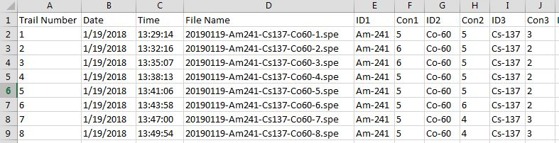

### Zip Archive

For quality control, the second file is a zipped archive of all the files used in the directory. Below are all the files SPEAR used in this example.

