

**School of Computer Science**

**Faculty of Science**

**COMP-2650: Computer Architecture I: Digital Design**

**Fall 2020**

|  |  |  |  |  |
| --- | --- | --- | --- | --- |
| Date | Duration | Title | Due Date | Grade Release Date |
| Oct 19, 2020 | 180 minutes | **Midterm Exam** | Oct. 19, 2020 Midnight [AoE](https://www.timeanddate.com/time/zones/aoe) | Nov. 11, 2020 |

**Questions**

You must show your work and all steps for every question!

**Question 1: [10 marks: 2.5 marks each]**

Explain the following terms in two or three sentences.

* 1. Continuous Quantity
  2. Number System
  3. Hexadecimal Number System
  4. Digital System

**Question 2: [10 marks: 2.5 marks each]**

Assuming unsigned base-5 number system (all numbers are positive), show the maximum and the smallest unit of increment given 3 integer and 2 fraction positions in base-5 and their equal decimal values.

1. (Max?)5 = (?)10
2. (Smallest Unit?)5 = (?)10

**Question 3: [10 marks]**

Determine the radix r in this equation: (170)r = (2100)4

**Question 4: [10 marks]**

Show the minimum possible error when converting (16.4)10 to base-4 if only 5 positions are given in total for both integer and fraction parts. Report the error in base-10.

**Question 5: [5 marks]**

Prove for any base-r, (r-1)'s-complement((r-1)’s-complement(X)) = X.

**Question 6: [10 marks: 2.5 marks each]**

Show the negative and positive number for decimal number 86 in base-6 using the signed-magnitude and signed-radix-complement number systems, given 5 positions for integer part with no fraction part.

1. Positive number in signed-magnitude base-6:
2. Negative number in signed-magnitude base-6:
3. Positive number in signed-radix-complement base-6:
4. Negative number in signed-radix-complement base-6:

**Question 7: [10 marks: 5 marks each]**

Perform the following arithmetic in singed-2’s-complement base-2 for the following decimal numbers using least number of bits and check whether an overflow happens.

1. (+31) – (–1)
2. (+31) + (–1)

**Question 8: [5 marks]**

Using truth table, prove (A+B)’ = A’B’

**Question 9: [10 marks: 2.5 marks each]**

Find all possibilities for X= x4x3x2x1 as a 4-bit number, when the logic operation OR applies on each bit and the result in 1111:

|  |  |  |  |  |
| --- | --- | --- | --- | --- |
| OR | 0 | 1 | 1 | 0 |
| x4 | x3 | x2 | x1 |
|  | 1 | 1 | 1 | 1 |

**Question 10: [10 marks]**

Analyze the logic circuit shown below and find the Boolean expression (function) F.

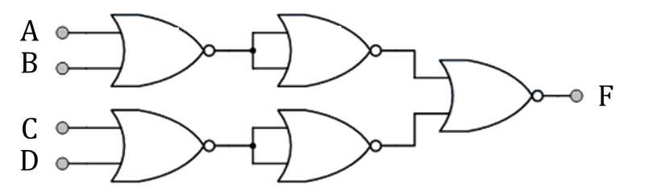

**Question 11: [10 marks]**

Design the logic circuit for F = ∑m(1,5,6)