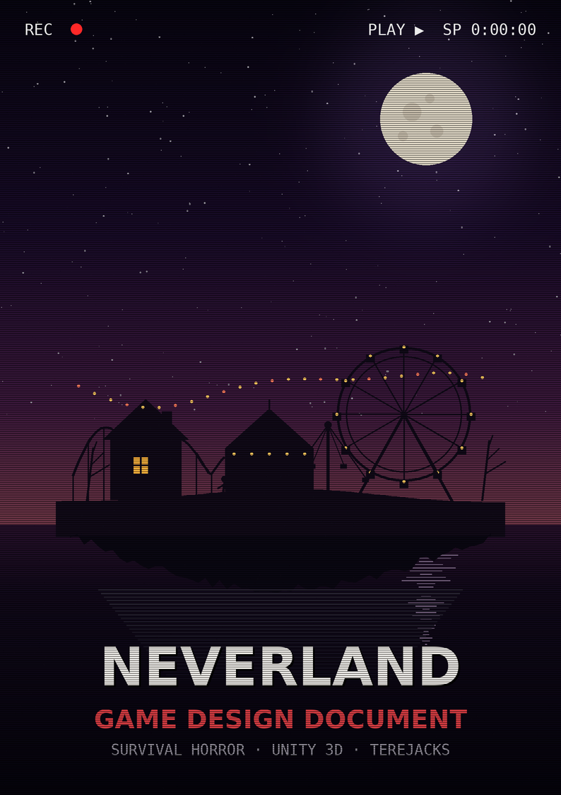

NEVERLAND
GAME DESIGN DOCUMENT
First-person survival horror · Unity 3D
DOCUMENT SHEET
Project title | Neverland (codename: NEVERLAND)
Document version | 1.0 — complete pre-production draft
Date | July 2026
Author / Studio | Tucano (TucanoiDEV) · TEREJACKS
Engine | Unity 2022.3.62f3 LTS (3D, URP)
Genre | Survival horror · Stealth · Escape room
Target platforms | PC (Steam / itch.io); consoles under evaluation
Expected rating | 18+ (explicit gore, sensitive themes, horror)
Status | Pre-production

“All children grow up. Except one.” — the classic Peter Pan premise, re-read here as a threat: what if never growing up were not a gift, but a prison?

CONFIDENTIAL DOCUMENT — INTERNAL USE

TABLE OF CONTENTS
NEVERLAND · GAME DESIGN DOCUMENT
01 · Overview 5
1.1 High Concept 5
1.2 Quick sheet 5
1.3 Design pillars 5
1.4 Key references 6
1.5 What makes the game unique (USPs) 6
1.6 Target player experience 7
02 · Story 8
2.1 Premise 8
2.2 Themes 8
2.3 Synopsis structured in acts 8
2.4 The ending and its readings 9
2.5 Dialogue and Lucidity (the protagonist's voice) 10
2.6 Findable documents (environmental narrative) 10
03 · Characters 11
3.1 Wendy — the protagonist 11
3.2 Tinker Bell — the fairy / the pursuer 11
3.3 Peter Pan — the antagonist 12
3.4 Supporting cast 13
3.5 Relationship map 13
04 · World & Levels 14
4.1 The Real Bedroom (prologue) 14
4.2 Open Neverland 14
4.3 Peter Pan's House (main map) 15
4.4 Peter Pan's Room 16
4.5 The Basement — the butchery 16
05 · Game Systems 17
5.1 Camera and perspective 17
5.2 Controls (PC — reference) 17
5.3 Movement, stamina, and noise 17
5.4 Hiding 18
5.5 Inventory and items 18
5.6 Signature mechanic: Closing the Eyes 18
5.7 Capture, death, and saving 18
5.8 The core loop 19
5.9 Dialogue and Lucidity system 19
06 · Enemies & AI 21
6.1 Tinker Bell (monster form) — AI overview 21
6.2 Peter Pan (scripted threat) 22
6.3 The Crocodiles (living boundary) 23
07 · Items & Puzzles 24
7.1 Progress items 24
7.2 Tools (against the hunter) 24
7.3 Main puzzles (linear chain) 25
7.4 The final escape (playable climax sequence) 25
08 · Structure & Flow 27
8.1 General flow 27
8.2 Tension curve 27
8.3 Endings 28
8.4 Replayability 28
09 · Interface 30
9.1 HUD during gameplay 30
9.2 Menus 30
9.3 Dialogue box (Lucidity system) 30
9.4 Options and accessibility 31
10 · Art Direction 32
10.1 General guidelines 32
10.2 Palette per environment 32
10.3 Character direction 32
10.4 Lighting and cutscene cameras 33
11 · Sound Direction 34
11.1 Music — adaptive system 34
11.2 Diegetic sound (the real HUD) 34
11.3 Voices 34
11.4 Silence 35
12 · Technical Spec 36
12.1 Stack 36
12.2 Scene architecture 36
12.3 Performance targets 36
12.4 Technical risks and mitigation 37
13 · Production & Scope 38
13.1 Phases and milestones 38
13.2 Cut order (if scope tightens) 38
13.3 Design success metrics 38
Appendices 39
A. Project glossary 39
B. Declared references and inspirations 39
C. Dialogue and Lucidity script (sample) 39
D. Final note 41


This chapter defines what the game is in a single page: concept, pillars, references, and what makes it unique. Every decision in the following chapters must answer to this section.

1.1 High Concept
A first-person survival horror with a PS1/VHS aesthetic, in which a boy named Wendy flees the violent reality of his home and wakes up in Neverland — a childhood paradise that, by night, is revealed to be a trap. No weapons, no combat: only items, hiding places, puzzles, and the courage of a child who just wants to go home.
Neverland subverts the tale of Peter Pan: the place where children never grow up becomes, here, the place children never leave. The player experiences this horror from the low, vulnerable perspective of a child, through the dirty, grainy visual language of Puppet Combo games and a linear, short, relentless escape — the format of Puppet Combo's own games. The puzzles follow the house-prison logic popularized by Granny.

1.2 Quick sheet
ASPECT | DEFINITION
Genre | Survival horror · Stealth · Escape room, first person
Perspective | First person (child height, ~1.20 m), with fixed-camera PS1-style cutscenes
Combat | None. The player never attacks; they only flee, hide, and use items
Target length | ~40 min per run (Puppet Combo format) · replayability through endings, achievements, speedrun, and semi-random spawns
Structure | Linear and continuous: prologue + 1 day of false peace + a single night of escape + climax and epilogue
Tone | Psychological horror with a fairy-tale facade; melancholic, oppressive, with explicit gore in the Puppet Combo mold
Target audience | Indie horror fans (Puppet Combo, Chilla's Art, Granny, Dark Deception), streamers, 18+
Model | Low-cost premium game (US$ 4.99–7.99), optional early access launch

1.3 Design pillars
Four pillars guide every decision. If a feature doesn't support at least one of them, it doesn't get in.
- ABSOLUTE VULNERABILITY — Wendy is a child. There are no weapons, blows, or counterattacks. All player power comes from knowledge (routes, patterns, puzzles) and items. Fear is born of physical helplessness.
- PARADISE IS THE PRISON — Neverland is beautiful by day and monstrous by night. Art direction, sound, and level design sell the false safety only to strip it away. Contrast is the game's main horror weapon.
- TENSION THROUGH NOISE AND ROUTINE — As in Granny, danger is governed by sound and routine: every creaking board, slamming drawer, or breaking glass summons the pursuer. The player learns the house, and the house learns the player.
- CORRUPTED NOSTALGIA (PS1/VHS) — Low poly, low-res textures, dithering, CRT, and home tapes. The Puppet Combo aesthetic is not a filter: it's narrative language — a childhood memory degraded like a worn-out tape.

1.4 Key references
REFERENCE | WHAT WE TAKE | WHAT WE DON'T TAKE
Puppet Combo (catalog) | PS1/VHS aesthetic, cutscene cameras, raw sound design, chase pacing, brevity (~40 min), explicit gore | Tank controls as default (here, optional only)
Granny | House-prison puzzle logic, item progression, enemy hearing | Multi-night structure and involuntary humor; here the escape is linear and the tone is serious
Outlast (Red Barrels) | Total helplessness (no combat), hide-and-seek under pressure, real darkness navigated with a limited light source | Camera battery and found footage as a device (here, VHS is aesthetic, not gadget)
Silent Hill 2 | The structure of this GDD, horror as psychological metaphor, a score that tells a story | Combat and weapon systems
Resident Evil 2/3 (Mr. X / Nemesis) | A persistent stalker that invades the player's safe space | AAA scale and action set pieces
Peter Pan – La Obscura Verdad (short) | The dark retelling of the myth; the cliff scene that inspires the climax | —
Little Nightmares / Among the Sleep | Horror through a child's perspective and scale | 2.5D platforming / puzzle physics

1.5 What makes the game unique (USPs)
- A public-domain retelling with its own identity: Peter Pan as a childhood horror cult — recognizable in the first second of the trailer.
- A child, unarmed protagonist in first-person 3D: a niche barely explored in the Puppet Combo format.
- Two faces of the same map: the same enchanted park explored by day (diegetic tutorial) becomes the labyrinth of the night.
- A shapeshifting pursuer: Tinker Bell alternates between fairy guide (day) and hunting monster (night) — the same character, two systems.
- An authored, impactful ending, faithful to the project's original script, with strong potential for stream reactions.

1.6 Target player experience
In an ideal session (~40 minutes, end to end, no cuts), the player should feel, in this order: comfort (prologue), suspicious wonder (the day on the island), panic (Tinker Bell's reveal), rising tension (the escape through the house), euphoria (the escape itself), and, finally, a quiet emotional gut-punch (the cliff and the epilogue). The whole game fits in a single sitting — the classic Puppet Combo format: short enough for a livestream, dense enough to stay in your head for days.


The narrative below is the game's canonical script, organized into acts. The gameplay aspects mentioned here are only anchors; the systemic detail lives in chapters 5 through 8.

2.1 Premise
Wendy, a boy of about 9, lives in a home marked by domestic violence. To survive emotionally, he has developed a ritual: closing his eyes and fleeing into his own happy memories. During one of these escapes, he opens his eyes somewhere else — Neverland. What seems like a dream of protection is revealed, over a single night, to be a captivity no child has ever left.

2.2 Themes
- Escape from reality — Escapism as a child's defense mechanism — and the price of never coming back.
- Imprisoned childhood — The promise of 'never growing up' read as abduction: a paradise that lets no one leave.
- False protectors — Figures who embrace in order to control. Peter Pan and Tinker Bell mirror abuse dynamics: public affection, private threat.
- Sacrifice and freedom — Escaping demands losing part of yourself — made literal in the hand scene. Wendy's freedom has a permanent cost.
Sensitivity note: the game handles domestic violence implicitly (sounds behind a door, never on screen). The goal is empathy, not shock. A card with support resources (e.g., local helplines) is shown in the credits.

2.3 Synopsis structured in acts

› PROLOGUE — The real bedroom
Interior, night. Wendy's room, lit only by light leaking through the ajar door. His mother, sitting at the edge of the bed, recites the Lord's Prayer. When she finishes, she says goodnight and shuts the door with a dry thud. Seconds later, through the wall: raised voices, furniture dragged, sounds of assault — the father against the mother. Wendy squeezes his eyes shut. The player sees, in grainy VHS flashes, the boy's happy memories: a birthday, a park, his mother laughing. The screen sinks into darkness. A voice whispers. Wendy opens his eyes.

› ACT I — THE DAY (arrival and false peace)
Wendy wakes in a golden field under an impossible sky. Everything is perfect — too perfect. A fairy approaches: 'You finally woke up!' She introduces herself as Tinker Bell and explains that they are in Neverland, 'a magical and special place.' Tinker Bell guides him along a path lined with giant toys, like an endless amusement park, passing countless fairies and many, many children.
They reach a ring of seated children. At the center, a boy standing: Peter Pan. He offers to show Wendy around. During the tour (a diegetic exploration tutorial), Wendy notices oddities — children who always smile the same way, toys that creak on their own, no adults, no exit — but stays quiet, thinking he's dreaming. At the end, Peter Pan hands Wendy a list of toys: the boy plays on each one (mini-interactions that teach the controls). As dusk falls, Peter Pan orders, with a sweetness that brooks no refusal: 'Now, go to sleep.'

› ACT II — THE NIGHT · 1. The reveal
Late at night, Wendy wakes in the children's room of the great house and understands: he is still in Neverland. This is not a dream. In despair, he tries to flee impulsively — and runs into Tinker Bell in the hallway. Sensing the escape, the fairy contorts and grows in a grotesque transformation: torn wings, an elongated body, the little bell at her neck now a dull clapper. The game's pursuer is born — relentless as Nemesis or Mr. X. Wendy runs. The house closes in. The escape begins — continuous, no cuts, all the way to the exit door.

› ACT II — THE NIGHT · 2. The escape through the house
Still in the same night, Wendy searches Peter Pan's house in silence: he finds items, solves puzzles in sequence, uncovers the secrets of the children who came before him, and unlocks, piece by piece, the triple lock of the exit — always hunted by the monstrous Tinker Bell. Each room opened deepens the horror: notes from old children, cages in the basement, a list of crossed-out names. (Gameplay detailed in chs. 5–8: puzzles in Granny's logic, linear structure in the Puppet Combo format.)

› ACT II — THE NIGHT · 3. The cliff (climax)
With the door finally open, Wendy escapes the house and runs through nighttime Neverland — the enchanted park now a graveyard of toys. Peter Pan spots him from afar. He doesn't run: he walks, calm, inevitable. Cornered at the edge of the cliff over the sea, with no way out, Wendy throws himself. A second before the water, Peter Pan's hand grabs his arm — a framing inspired by the short Peter Pan – La Obscura Verdad. Dangling over the abyss, Wendy draws the machete — found in the basement butchery — and cuts off his own hand to break free. He falls into the dark waters. (Without the machete, there is no salvation: see Endings, ch. 8.3.)

› EPILOGUE — The crocodiles
At the edge of the cliff, Tinker Bell reaches Peter Pan and asks what should be done. Peter Pan consoles her, serene, gazing at the sea: there is no reason to worry — the crocodiles will solve the problem. Cut to black. The sound of water. A distant ticking. Credits.

2.4 The ending and its readings
The ending is deliberately ambiguous and must remain so across all of the game's material:
- Literal reading: Wendy escaped the island, mutilated, and his fate at sea is left open — the crocodiles as the final threat.
- Psychological reading: Neverland is Wendy's mind; cutting off his hand is the cost of abandoning the fantasy and returning to a reality that also hurts him. The crocodiles are the reality waiting for him.
- Directive: the game NEVER confirms any reading. No explanatory post-credits scene.

2.5 Dialogue and Lucidity (the protagonist's voice)
During conversations, the player chooses Wendy's lines — and each choice reveals how much the boy still believes the fantasy or has already seen through it. Accepting Neverland ('Yay, I can't wait to have fun!') keeps the disguise up; resisting it ('But I don't want to play…', 'I miss my mom') accumulates Lucidity. The island notices. The more lucid Wendy sounds, the more Peter Pan and Tinker Bell let the mask slip — sweetness turns to surveillance, the guide turns to shadow. It's the narrative way of giving the protagonist a voice without taking away his helplessness: he can see the truth, but seeing does not free him. The mechanical system is in ch. 5.9; the dialogue script is in Appendix C.

2.6 Findable documents (environmental narrative)
The island's deep story is told through 18 optional collectibles, in the classic survival-horror mold:
TYPE | EXAMPLES | NARRATIVE FUNCTION
Children's notes | “João tried to leave by the sea. Tinker Bell was sad.” | Prove Wendy isn't the first — and that no one left
Children's drawings | Crayon: fairies with teeth; a boy missing his hand | Foreshadow Tinker Bell's transformation and the ending
The List | Children's names; most crossed out; 'Wendy' newly written | Turn the notice board into a threat
Pages of Peter Pan's 'diary' | Island rules written in a too-perfect childish hand | Characterize Peter Pan as a jailer who believes himself a protector
VHS tapes (bonus) | Distorted excerpts of other children's 'welcomes' | Exploration reward; ties the VHS aesthetic to the fiction


Complete cast sheets. 3D models follow the art direction in ch. 10: low poly (500–1,500 tris), 128–256 px textures, deliberately stiff 'marionette' animation.

3.1 Wendy — the protagonist
CAMPO | DESCRIÇÃO
Age / role | 9 years old · playable protagonist
Appearance | Scrawny; faded blue dinosaur pajamas; barefoot from the night on; dark circles under his eyes
Personality | Quiet, observant, imaginative; a courage born of fear, not of strength
Central wound | Witness to his father's violence against his mother; guilt over 'escaping' into his own head
Arc | From passive escape (closing his eyes) to active escape (opening the door): learning that truly escaping costs dearly
In the system | No attacks; runs little (short stamina bar), hides in small spaces adults can't reach, crawls through child-only passages
Voice | No audible lines in gameplay (breathing, whimpers); speaks only in cutscenes, sparingly
Design note | The name 'Wendy' on a boy is intentional and never explained — the first clue that something is 'out of place' in the game's world

3.2 Tinker Bell — the fairy / the pursuer

› Fairy form (days)
CAMPO | DESCRIÇÃO
Appearance | Small (25 cm), pulsing amber light, a dress of leaves, a tiny bell at her neck; pretty 'like a memory'
Behavior | Guides, praises, watches. Always a little too close. Her bell chimes when Wendy nears forbidden areas
Function | Diegetic tutorial and false ally; the player must like her before fearing her

› Monster form (night) — the hunter
CAMPO | DESCRIÇÃO
Transformation trigger | Witnessing any escape attempt (canonically: Wendy's impulsive flight at night)
Appearance | 2.4 m; a fairy body stretched like melted wax; torn wings dragging on the floor; the bell, now deep-toned, tolls with every step — the 'sound theme' of the threat (the function of Mr. X / Nemesis's heartbeat)
Behavior | The house's persistent pursuer: patrols, investigates noises, chases, captures (full FSM in ch. 6)
Golden rule | Never vanishes from the map during the night; she only 'loses' the player, never gives up
Weaknesses | Cannot crawl (low passages are safe); strong light stuns her for 2 s (crank flashlight, ch. 7); sound traps displace her
Tragedy | Collectibles suggest she was once a child of the island — the first. Never confirmed

3.3 Peter Pan — the antagonist

› Boy form (the host)
CAMPO | DESCRIÇÃO
Appearance | Eternal boy of ~12; impeccable leaf clothing; a constant smile that never reaches his eyes; floats 3 cm off the ground (a subtle detail, never flaunted)
Personality | The perfect host, absolute owner. He doesn't shout, run, or threaten: he commands with sweetness. His calm is the terror
Philosophy | He genuinely believes he saves children from the adult world. Leaving the island is, to him, a betrayal — and a danger he protects them from
In the system | Does NOT use the pursuit AI. Appears only in scripted moments (days, bedtime orders, climax). His presence freezes the game: when he is on screen, running is impossible (narrative weight by design)
Acting reference | Serene villains: the tone of the short La Obscura Verdad; never a 'cartoon villain'

› Dark form (what lies beneath the fantasy)
CAMPO | DESCRIÇÃO
Nature | Not a combat transformation like Tinker Bell's: it is Peter Pan's truth leaking through the mask. He never 'turns' into the monster in front of the player on purpose — the game merely lets the facade slip until, at the cliff, it drops entirely
Appearance | The boy's silhouette elongates and darkens; the cast shadow has arms too long and tapered fingers; beneath the smile, rows of small teeth; the eyes — always empty — begin to reflect light like an animal's. He keeps the elegance: he is beautiful and wrong at once, never grotesque for its own sake
Glimpses (throughout the game) | Subliminal appearances that escalate with Lucidity (ch. 5.9): a reflection in glass that doesn't match his pose; the shadow on the wall moving half a second late; a frame of the wrong face when the camera passes him; the sweet voice gaining a second deep tone underneath. Always deniable as 'my imagination' — until it isn't
Reveal (climax) | At the cliff, gripping Wendy's arm, the dark form finally takes over entirely: the hand that holds is the elongated claw, the smile opens beyond human, the line about the crocodiles comes out in the double voice. It is the only moment the game confirms what the glimpses suggested
In the system | Pure staging — a visual and audio effect, no AI or pursuit. It does not change controls, threat, or difficulty; Peter Pan remains the scripted antagonist who walks (ch. 6.2). Fear comes from recognition, not from a new mechanic
Restraint directive | The glimpses must be rare and brief — at most a handful in the whole run. Overexposing the dark form turns it into a 'common enemy' and kills the effect. Rule: if the player is sure of what they saw, it was one glimpse too many
CAMPO | DESCRIÇÃO
Climax | The slow walk; the hand (claw) that grabs Wendy at the cliff; the final line about the crocodiles — or, if Wendy arrives without the machete, the outcome where he devours him (8.3)

3.4 Supporting cast
CHARACTER | SUMMARY SHEET
The Mother | Present only in the prologue (voice and silhouette) and in the VHS memories. The Lord's Prayer she recites returns, distorted, in the night's score. Emotionally, she is the 'home' Wendy fights to return to — even though it is a broken home.
The Father | Never seen. Exists only as sound behind the door in the prologue. Directive: never show him; the game's real horror stays off-screen.
The Children | Dozens, all in pajamas, all 'happy.' By day: extras who repeat canned lines ('This is the best place in the world!'). By night: they sleep in perfect rows; some whisper hints if Wendy approaches without noise — the game's only 'hint system' is diegetic.
The lesser Fairies | Fireflies with blurred faces that decorate the scenery during the day. At night they vanish — dormant inside the village lanterns. Their absence is part of the horror: in the dark of the house, the only light left is Wendy's flashlight.
The Crocodiles | Never seen whole: eyes in the water, a back, the classic ticking from the sea (the swallowed clock — an inheritance from the tale). They are the world's boundary: entering the water = instant game over at any point in the game. In the epilogue, they become the final threat-image.

3.5 Relationship map
- Peter Pan → Tinker Bell: owner and instrument. He never dirties his hands; she exists so he doesn't have to.
- Tinker Bell → Wendy: possessive affection that turns to a hunt. 'If you run, you hurt me.'
- Peter Pan → Wendy: collector and new piece. Wendy only matters while he obeys.
- Children → Wendy: mirrors of what he will become if he stays — and the reason the player wants to leave.


The game takes place across three macro-environments: the Real Bedroom (prologue), open Neverland (days and climax), and Peter Pan's House (the night — the heart of the game).

4.1 The Real Bedroom (prologue)
ASPECT | DEFINITION
Scope | A single playable room for ~4 minutes; limited interaction (looking, curling up in bed)
Palette / light | Night blue; the only light source is the crack of the door — which goes out when it closes
Audio | The mother's prayer in the foreground; then the muffled fight mixed 'behind the wall' (never intelligible)
Function | Establish empathy and the eye-closing ritual (a ceremony-mechanic that transitions to the island)

4.2 Open Neverland
An island-park with no visible borders beyond the sea. By day, saturated and golden; by night, desaturated, foggy, and hostile. The layout is the same in both phases — the player must recognize, terrified, the places where they played.

› Zones of the open map
ZONE | BY DAY (Act I) | AT NIGHT (climax)
Waking Field | Golden lawn where Wendy wakes; tall flowers | Dead grass; starting point of the final escape
Ring of Children | Circle of seated children; Peter Pan's introduction | Empty circle with marks on the ground
Toy Park | Carousel, Ferris wheel, teacups, giant slides (the 'list of toys') | Labyrinth of silhouettes; toys creak on their own; the climax's chase route
Fairy Village | Living lanterns; golden swarms | Dark lanterns; dormant swarms — silence and pitch black
Cliff Trail | Blocked by Tinker Bell ('not there, silly!') | The climax's setting: rocky edge over the black sea
The Sea | A beautiful, untouchable horizon | Lethal boundary; submerged ticking; epilogue

› Rules of the open world
- No on-screen map: orientation by visual landmarks (Ferris wheel = north). Spatial coherence is sacred.
- By day the player can't stray from the routes: Tinker Bell 'calls them back' (a diegetic limit, no invisible walls).
- The climax reuses 100% of the day map — no new corridors, only new light, a new trail, and Peter Pan's walk.

4.3 Peter Pan's House (main map — the night)
A house too large, of dark wood and slightly wrong proportions (doors too tall, corridors too narrow). Three floors + basement. It is the board of the escape: the player knows it by day, lit and full of children, and rediscovers it in the dark, room by room, over a single night.
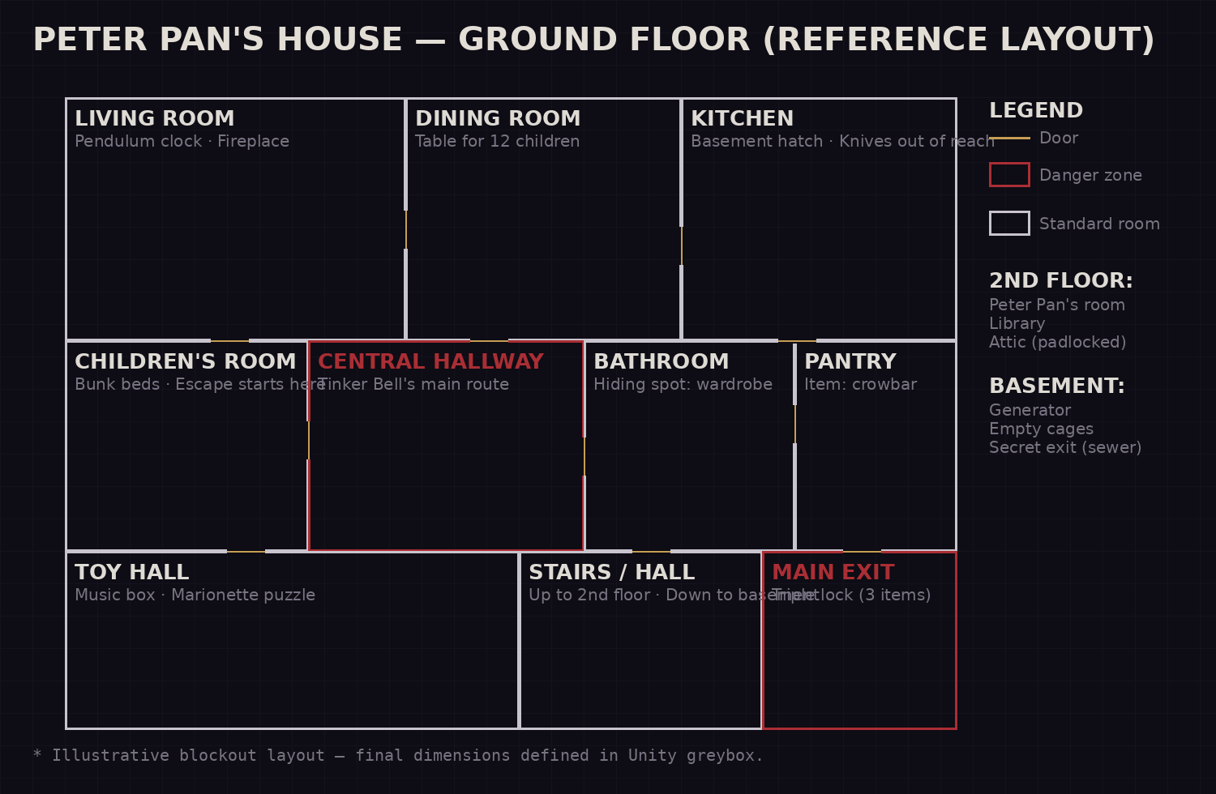
Fig. 4.1 — Ground-floor reference layout (blockout). Upper floors and basement listed in the legend; proper floor plans will be produced in greybox.

› Level-design principles of the house
- Double loop — Every important room has 2 entrances; no chase ends in an unfair dead end (except wardrobes — hiding carries risk).
- Verticality — A central staircase connects the 3 floors and the basement; noises travel between floors (stomping on the 2nd floor alerts Tinker Bell on the ground floor).
- Child passages — Ducts, gaps under furniture, and a kitchen hatch: Wendy-only routes, safe but slow and claustrophobic (Tinker Bell lurks through the cracks).
- Progression by locks — The whole house is technically accessible from the start of the night, but locked in layers (padlocks, boards, a blown fuse, a frozen chain) — each puzzle solved opens ~25% more of the house.
- The 'living' house — With each puzzle solved, small objects shift and a new disturbing detail appears (another crossed-out name on the List; one fewer bed). Never change routes — only the atmosphere.

4.4 Peter Pan's Room
Locked from start to finish; it only opens with the room key (puzzle 7.3-D). Inside, it is the opposite of the 'perfect' house: utterly dusty and disordered — broken toys, curtains shut for decades, dust hanging in the air — and, on the bed, a decomposing body that no character ever remarks on. The room holds the wax seal, the fuse, the diary, and the iron key to the butchery. Sound directive: no music there; only Wendy's breathing.

4.5 The Basement — the butchery
The basement is 'unlocked' from the start of the night — but only reachable with items: the kitchen hatch requires the crowbar, and the butchery's inner door requires the iron key (found in Peter Pan's room). There are two wings. The GENERATOR wing is mandatory: it powers the exit's electric lock and hides the escape route through the sewer. The BUTCHERY is optional — a slaughter hall inspired by Pyramid Head's room in Silent Hill 2: hooks, stained countertops, cages, and the bodies of murdered and tortured children. It is the only place where the island's truth is explicit and where the game's gore hits its ceiling. Hanging among the hooks is the MACHETE — the item that decides the ending (ch. 8.3). The design must treat the basement as 'the lowest note' of the game.


Rules and mechanics. Absolute principle: Wendy never attacks. The whole system exists to turn silence, observation, and items into progress.

5.1 Camera and perspective
- First-person gameplay, camera height 1.20 m (child scale: doorknobs at eye level, adults and the monster always 'up above').
- Subtle head-bob tied to stamina; intensifies while running, trembles while hiding with Tinker Bell nearby.
- Cutscenes and Peter Pan moments in fixed cameras at low/high angles, PS1 style (Puppet Combo) — reinforcing helplessness.
- Default FOV 70° (adjustable 60–90° in options).

5.2 Controls (PC — reference)
ACTION | KEYBOARD/MOUSE | NOTES
Move | WASD | Walk speed: 2.2 m/s
Run | Shift (hold) | 3.6 m/s; consumes stamina; VERY loud
Crouch / crawl | Ctrl (toggle) | 1.1 m/s; nearly silent; accesses child passages
Interact / pick up | E or left click | Contextual: open, pull, turn, push
Slow interaction | Hold E | Opening doors/drawers slowly = no noise (core of the stealth)
Close eyes | Space (hold) | Signature mechanic: reduces visual terror, sharpens hearing (see 5.6)
Quick inventory | Mouse wheel / 1–4 | No pause: the game keeps running while the player chooses
Use item | Right click | Item equipped in hand
Lean / peek | Q / E (lean) | Peek around corners and through wardrobe cracks
Drop item | G | Items can be dropped to create noise/distraction

5.3 Movement, stamina, and noise
- Stamina — An invisible bar of ~6 s of running; recovers in 8 s standing, 12 s walking. Out of stamina: Wendy pants LOUDLY (noise radius doubled) — running is always a debt.
- Noise model — Each action emits a noise value with a radius in meters (table 6.2). Surfaces modulate it: carpet ×0.5 · wood ×1.0 · loose board ×2.0 (marked by a warning creak when stepped on slowly).
- Item weight — Large items (crowbar, hammer) take both hands: Wendy can't crawl while carrying them — constant logistics decisions.

5.4 Hiding
Hiding places are the central defense: under beds, inside wardrobes, behind curtains, and in the toy chest. Rules:
- Entering a hiding place within Tinker Bell's sight doesn't work — she saw, she pulls Wendy out (death).
- Inside a hiding place, a breathing minigame: keep the cursor in a zone that shrinks as the monster approaches; failing = noise.
- Hiding 3 times in the same hiding spot of the same room teaches Tinker Bell: she starts checking that room on patrol (anti-exploit and rising horror).
- Crawl hiding spots (ducts, the hatch gap) are inviolable, but dark and blind — she can wait outside.

5.5 Inventory and items
- 4 slots + 1 'key item' slot (puzzle items don't take common slots).
- Diegetic interface: Wendy opens his school backpack in front of his body; the world does NOT pause.
- Items are the only 'weapon': distract (music box), delay (chair against the doorknob), light (crank flashlight), open (keys/tools). No item deals damage.

5.6 Signature mechanic: Closing the Eyes
In the prologue, closing his eyes is how Wendy flees. In the game, it's how he faces things.
- Hold Space: the screen darkens to a thread of light; sounds gain clarity and direction (binaural mix); Tinker Bell's toll becomes a precise 'sonar.'
- Cost: real blindness. Walking with eyes closed is possible — blind, but guided by sound: useful for 'reading' Tinker Bell's exact position through walls before crossing an open area.
- Narratively, the mechanic inverts the ritual of trauma: what was escape becomes sensory courage.

5.7 Capture, death, and saving
EVENT | CONSEQUENCE
Captured by Tinker Bell | Death in a short fixed-camera cutscene, with explicit gore in the Puppet Combo mold; cut to VHS static and return to the last checkpoint
Touching the sea water | Instant game over (ticking + darkness) at any point in the game
Seen by Peter Pan out of hours (days) | No game over: he simply 'corrects' Wendy and takes him back — scarier than dying
Saving | Automatic checkpoints at puzzle milestones and act transitions. No manual save (Puppet Combo-style tension); the ~40-min run makes up for it

5.8 The core loop
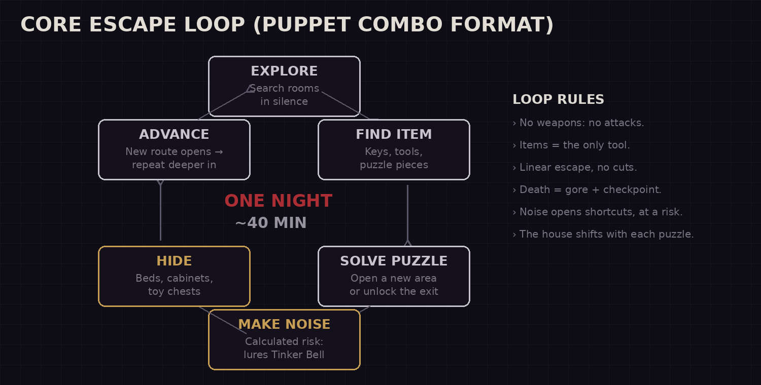
Fig. 5.1 — Core escape loop: explore → item → puzzle → calculated noise → hide → advance.

The player alternates between silent phases (gathering information) and spikes of risk (loud actions that unlock progress). The design of each stretch guarantees at least 1 inevitably loud action — there is no 100% stealthy run; there is noise chosen at the right time.

5.9 Dialogue and Lucidity system
In scripted conversation moments (chiefly during the Day, with Tinker Bell and Peter Pan), the player chooses between lines in a dialogue box. Each choice belongs to one of two natures: SURRENDER lines, in which Wendy accepts the fantasy ('Yay, I can't wait to have fun!'), and LUCIDITY lines, in which he resists it ('But I don't want to play…', 'I miss my mom'). It's a system of flavor and characterization — there is no 'right' answer nor game over from dialogue — but it feeds a hidden counter that changes how the island treats the boy.

› The Lucidity counter (L)
- Lucidity is an invisible value that starts at 0. Each Lucidity line chosen adds +1 (L); surrender lines don't subtract — Lucidity never drops, mirroring that perceiving the truth is irreversible.
- The counter does NOT appear on screen: the player feels Lucidity through the world's reactions, never through a number or bar (consistent with the HUD philosophy, ch. 9).
- Certain dialogue branches only open at thresholds — e.g., at L ≥ 2, Wendy can retort to Peter Pan with 'I miss my mom' (script in Appendix C).
- Golden rule: Lucidity alters narrative behavior and NPC reactions — NEVER the hunt's difficulty parameters (noise radii, sight, speed). Difficulty only rises through death (ch. 6). So being lucid is never 'punished' with a mechanically harder game.

› Effect on the NPCs
L RANGE | PETER PAN | TINKER BELL
L 0 (Dreamer) | Sweet, paternal host; praises Wendy; treats him as a special guest | Affectionate, chatty guide; stays close, praising
L 1–2 (Awake) | The sweetness gains an undertone of correction: pauses, a smile held too long, possessive phrases ('you're OURS now') | Fewer compliments, more surveillance; the bell chimes before she appears, as a warning
L 3+ (Lucid) | Coldness beneath the veneer: stares at Wendy directly, remarks that he's 'thinking too much'; the end-of-Day inspection is longer and more menacing | Silent appearances at his back during the Day; the monster form is foreshadowed in glimpses (reflections, shadows) before the night's transformation
- The effects are staging (lines, animations, camera, sound, scripted-event spawns), not balancing. The night of escape is identical at L 0 or L 5 — the frame changes, not the rules.
- Reward detail: at high L, some extra narrative collectibles appear (one more drawing, a note only an 'awake' boy would notice), rewarding those who pay attention. They are optional and never required to progress.

› Writing and implementation guidelines
- Every choice must fit in 1–2 lines, be read aloud in < 4 s, and sound like a 9-year-old — never adult exposition.
- Surrender and lucidity lines must be equally appealing: the player chooses by identification, not by 'which gives the bonus.' The system rewards character consistency, not optimization.
- Technical: a simple node-based dialogue machine (graph), with an integer 'lucidity' variable persisted in the save; branch conditions by threshold. No giant tree — the base script fits in Appendix C. See ch. 12 for the Unity implementation.


The threat is a single one and it is perfect at it: the monstrous Tinker Bell, the house's persistent pursuer. Peter Pan and the crocodiles orbit that core.

6.1 Tinker Bell (monster form) — AI overview
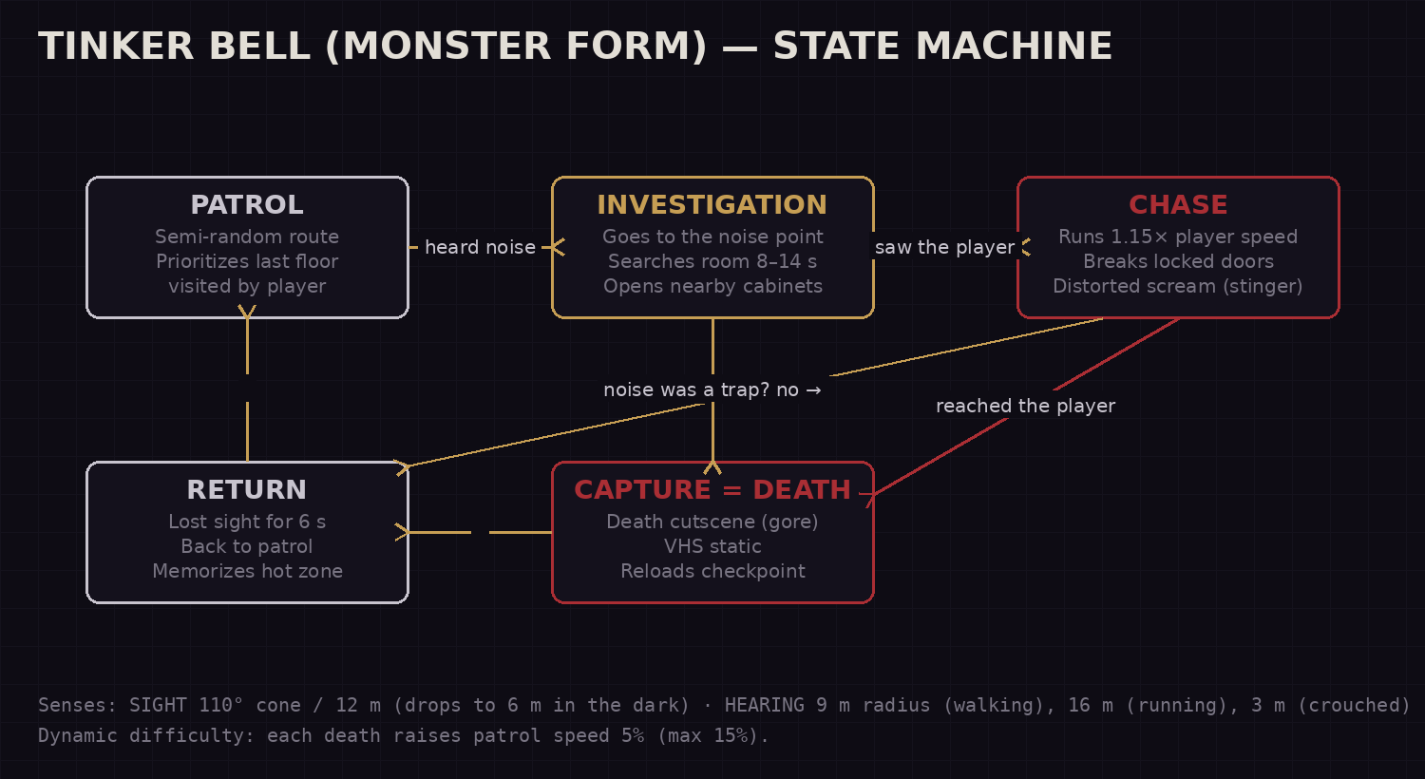
Fig. 6.1 — The pursuer's state machine, with senses and dynamic difficulty.

› States in detail
STATE | BEHAVIOR
PATROL | Walks through waypoints in semi-random order, weighted by the 'heat map' (areas where the player made noise recently get +40% visits). Opens 1 random door per cycle. The bell's toll announces distance and floor.
INVESTIGATION | Moves to the exact point of the last noise; searches the room for 8–14 s; 35% chance to open the hiding spot nearest the noise. Chained noises extend the search.
CHASE | Line of sight confirmed for 0.4 s → scream (stinger) and hunt at 1.15× the player's run speed. Breaks common locked doors in 3 s (puzzle doors are inviolable). Collision = DEATH (5.7).
RETURN | Lost contact for 6 s: memorizes the 'hot zone,' searches 2 neighboring rooms, and resumes patrol biased toward there.
CAPTURE | Death cutscene (gore, 5.7) and reload of the last checkpoint. On reload, Tinker Bell restarts on the floor OPPOSITE the player (pacing fairness).

› Senses and noise table
PLAYER ACTION | RADIUS | NOTES
Crawl / slow interaction | 3 m | Practically safe outside the same room
Walk | 9 m | Passes through 1 thin wall; carpets halve it
Run | 16 m | Travels across floors via the central staircase
Open door/drawer quickly | 10 m | Slow interaction zeroes the noise
Loose board | 18 m | Marked by a warning creak; memorizable
Break glass / knock over object | 22 m | Always triggers immediate INVESTIGATION
Music box (item) | 20 m | A 'throwable' noise: redirects the patrol for 25 s

› Fairness rules (anti-frustration)
- Tinker Bell NEVER spawns in the player's room nor 'teleports'; every movement is audible through the toll.
- Honest vision cone: 110°, 12 m (6 m in the dark); wardrobe cracks require her to be within <1.5 m looking directly.
- After reloading a checkpoint, 20 s of 'cold period' with no pursuit — the player breathes and replans.
- Dynamic difficulty rises only with deaths (never with time): good players face the base hunter.
- Lucidity (ch. 5.9) does NOT touch this AI: at high L, Tinker Bell's fairy form appears earlier and more silently during the Day (staging), but the night hunter is always the same. Perceiving the truth changes the mood, not the rules.

6.2 Peter Pan (scripted threat)
- No FSM: appears only in scripted events (bedtime order, day inspections, climax). Never chases during the escape.
- Presence = rule: when Peter Pan is on screen, the run input is disabled and the camera grows heavy (subtle aim drag). The player's body 'obeys' before the player does.
- Reacts to Lucidity (ch. 5.9): at low L he is the sweet host; at high L he stares at Wendy, makes possessive remarks, and the end-of-Day inspection lengthens. These are staging changes (lines, camera, animation) — never pursuit parameters.
- At the climax, his walk uses the player's exact walk speed +0.1 m/s: impossible to gain distance by walking — the escape demands spending stamina perfectly.
- Dark form (staging — ch. 3.3): the system triggers scripted glimpses of Peter Pan's true form (reflections, delayed shadow, wrong-face frame, second deep voice) at fixed triggers with a frequency weighted by Lucidity. It is a purely audiovisual subsystem — it spawns no collider, does not chase, does not change difficulty. At the cliff, a final trigger reveals the form entirely. Strict budget: few glimpses per run, each brief, so the reveal isn't cheapened.

6.3 The Crocodiles (living boundary)
- No AI model: they are a world limit with sound direction (ticking rises near the water) and epilogue scripts.
- Design function: they make the sea — the 'obvious way out' of an island — the only thing scarier than the house.


With no weapons, items are the player's entire vocabulary. Divided into three families: Progress (open the house), Tools (manipulate the hunter), and Key (unlock the final exit).

7.1 Progress items
ITEM | USE | LOCATION (DEFAULT)*
Rusty key | Opens the pantry (start of the escape) | Living-room drawer
Crowbar | Removes boards from doors/windows; pries the hatch | Pantry
Toy hammer | Breaks porcelain safes and the attic's worn padlock (LOUD: 22 m) | Toy-hall chest
Fuse | Restores power to the basement (enables the generator minigame) | Peter Pan's room (4.4)
Room key | Opens Peter Pan's room (puzzle 7.3-D) | Sewn into the throne cushion in the hall
Iron butchery key | Opens the butchery wing in the basement — where the machete is | Peter Pan's room (4.4)
Crank | Opens the attic skylight (alternate escape route between floors) | Basement cage
Clock key | Winds the pendulum clock (puzzle 7.3-C) | Behind the List's picture frame
Lamp oil | Silences the hinges of 3 doors of the player's choice (route strategy) | Kitchen, high shelf (requires pushing a chair = noise)
*Semi-random positions: each item has 3 possible spawn points, drawn per run — replayability in the Granny mold.

7.2 Tools (against the hunter)
ITEM | EFFECT | LIMITS
Music box | Wind it and drop it on the floor: plays for 25 s, drawing Tinker Bell to the spot | 2 uses per run (worn spring)
Crank flashlight | A strong beam stuns Tinker Bell for 2 s at close range | The crank lasts 8 s; recharging makes 6 m of noise; does NOT work on Peter Pan
Chair | Jams a common door for 3 s against the pursuit (she breaks it) | Dragging chairs outside the chase = 10 m of noise
Toy bell | Mimics Tinker Bell's toll: sleeping children whisper hints, thinking it's her | Fragile: breaks after 3 uses
MACHETE (from the butchery) | The item that decides the ending: with it, Wendy cuts off his own hand at the cliff (8.3). Hanging among the basement butchery's hooks — optional and missable | No use in common gameplay: the game NEVER allows using it as a weapon against Tinker Bell or Peter Pan

7.3 Main puzzles (linear chain)

› A · The Welcome Lock
Tutorial objective of the escape: grab the rusty key, open the pantry, get the crowbar, and remove the boards from the toy-hall door. Teaches slow interaction, noise, and the first full encounter with Tinker Bell.

› B · The Marionettes
In the hall, 5 marionettes of children. Scattered notes describe 'the order in which we arrived on the island.' Hanging the marionettes in the correct order opens the compartment with the 2nd-floor key. Getting it wrong makes ALL of them clap at once (22 m noise) — a puzzle with a cost, not a block.

› C · The Clock Without Hours
The living-room pendulum clock has no painted hands: the hours are in the collectible children's drawings (a sun between two trees = 2 p.m., etc.). Winding it and setting the clock to the island's official 'bedtime' unlocks the library door. It integrates collectibles into progression without making them mandatory (the hints also exist, harder, in the environment).

› D · The Room Key
Peter Pan's room door has no visible lock. The diary, in the library, gives the clue: 'the house keeps the key of the one who rules.' The room key is sewn into the throne cushion in the toy hall — tearing it is inevitably loud (16 m), forcing the player to prepare a route and a distraction first. Inside the room (4.4): the body on the bed, the wax seal, the fuse, and the iron butchery key. No enemy enters there — the horror is all scenery.

› E · The Generator and the Triple Lock
Open the basement (kitchen hatch + crowbar), install the fuse, and restart the generator in a breaker-sequence minigame (each error = a 22 m noise burst), and gather the 3 pieces of the exit lock: master key (attic), gear (clock, removable after puzzle C), and wax seal (Peter Pan's room). Next to the generator, the butchery door (iron key) hides the MACHETE — optional now, decisive later. Exit door open → transition to the climax.

7.4 The final escape (playable climax sequence)
- An open chase through the night park: no inventory, no interactions — only running, managing stamina, and choosing routes among the toys.
- Peter Pan walks in constant interception (6.2); Tinker Bell hunts behind; toys light up on their own, illuminating the wrong path on purpose.
- At the cliff, an interactive cutscene: the leap, the hand that grabs. If Wendy carries the machete, a single prompt, dry, with no pretty icon: HOLD [E] TO CUT — the player performs the ending's cost with their own hands. If he doesn't carry it, no prompt appears (8.3).


The game's spine: chapter order, objectives, tension curve, and ending conditions.

8.1 General flow
BLOCK | CONTENT | PLAYER OBJECTIVE | DURATION
Prologue | Real bedroom; prayer; the fight; closing the eyes | None (playable ceremony) | 4–5 min
The Day | Arrival, Tinker Bell, Peter Pan, tour + list of toys; nightfall and bedtime order | Complete the list (diegetic tutorial) | 8–10 min
The Night · Reveal | Waking in the middle of the night; escape attempt; Tinker Bell's transformation | Survive the first encounter | 2–3 min
The Night · Escape (house) | Puzzles A→E in a chain; the house opens up; the List gains Wendy's name; Peter Pan's room, basement, butchery, and machete | Assemble the triple lock and open the exit | 16–20 min
The Night · Climax | Escape through the park; cliff; the hand; the cut (or the machete-less outcome) | Reach the sea | 5–6 min
Epilogue | Tinker Bell and Peter Pan; crocodiles; credits + support card | — | 2–3 min

8.2 Tension curve
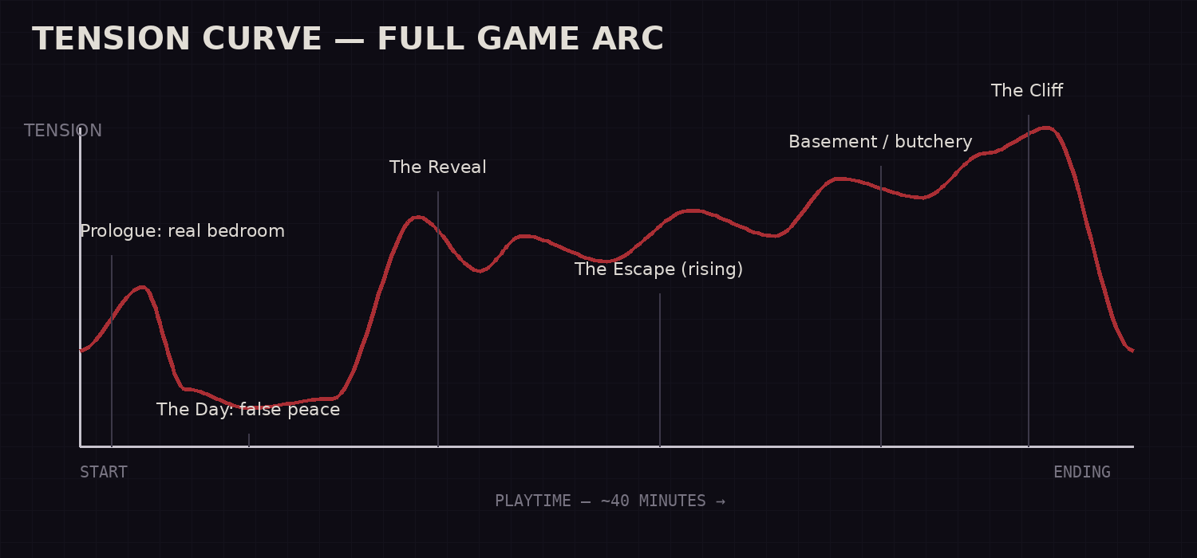
Fig. 8.1 — Tension curve of the full arc (~40 min): a single daytime valley, then a continuous climb to the cliff.

The single day isn't filler: it's the valley that gives contrast back to the horror. From the transformation on, tension only rises — with controlled micro-valleys (hiding spots, stretches of silence) that prevent desensitization — up to the cliff's peak and the absolute silence of the epilogue.

8.3 Endings
There are exactly two endings, decided by a single factor: whether or not Wendy carries the MACHETE from the butchery when he reaches the cliff. No warning, no meter — only the consequence of having (or not) descended to the island's worst place.
ENDING | CONDITION AND CONTENT
GOOD ENDING — 'The Waters' (canonical) | Reaching the cliff WITH the machete. The leap, Peter Pan's hand, the cutting prompt, the fall into the dark waters; the crocodile epilogue exactly as in the ch. 2 script.
BAD ENDING — 'Devoured' | Reaching the cliff WITHOUT the machete. There is no instrument, no prompt, no salvation: the camera holds the shot as Peter Pan slowly pulls Wendy up, serene as ever — and devours him. Gore at the ceiling of the Puppet Combo mold. Cut to black; credits with no music.
Design note: the bad ending is not a punishment for skill, but for curiosity not exercised — whoever avoids the butchery avoids the truth, and the island collects. This turns the basement's gore into a narrative decision, not gratuitous shock.

8.4 Replayability
- Semi-random item spawns (3 points per item) and 2 patrol-route variations per run.
- An optional speedrun timer after the first completion — the ~40-min format invites optimized runs (Puppet Combo culture).
- Nightmare Mode (New Game+): no toll on Tinker Bell's bell (silent hunt) and checkpoints only at the start of each act.
- Style achievements: 'No Wardrobe' (finish without hiding spots), 'Steady Hand' (reach the cliff with the machete without dying once), 'Absolute Silence' (never enter CHASE).


Philosophy: the least screen possible. Any information that can live in the world (diegetic) lives in the world.

9.1 HUD during gameplay
ELEMENT | RULE
Reticle | A 2 px dot that appears only over interactive objects; turns into a hand icon within reach
Stamina | NO bar: communicated through breathing (audio), head-bob, and a pulsing vignette
Health | Nonexistent — there is no gradual damage; only capture/water
Items | The selected item stays VISIBLE throughout gameplay, 'levitating' in front of the camera in the Puppet Combo mold (10.3). Edge case: the flashlight, which lights the environment — without it equipped, the night is real pitch black, impossible to navigate
Threat | 100% through sound (toll) and light. Never a radar, never an indicator
Objective | Wendy's little notebook (TAB key): pencil-drawn notes, updated by event — the 'quest log' is an object of the fiction
Subtitles | Optional, with directional sound indicators for accessibility ([bell to the left])

9.2 Menus
- Main menu: the real bedroom's tube TV showing static; options like a VHS tape being rewound; 'NEW GAME' appears as PLAY ▶.
- Pause menu (only during the day; the night does NOT pause — a tension decision, with a clear warning in the options): a polaroid of the current scene with handwritten options.
- The water game-over screen: only the ticking on a black screen, 5 seconds, no text.

9.3 Dialogue box (Lucidity system)
- Appears only in scripted conversation moments (ch. 5.9). Diegetic visual: a pencil-drawn speech bubble, as if from Wendy's notebook; handwritten font, no RPG frames.
- 2 to 3 options at a time, with no 'good/bad' labels, no karma icons, no consequence preview. The player chooses by identification with the character, not by optimization.
- The Lucidity counter is INVISIBLE: there is never a number, bar, or 'ding.' The feedback is 100% diegetic — the shift in the NPCs' tone (ch. 5.9) is the only confirmation that the choice mattered.
- Lucidity lines may get a slight VHS tremor/static when highlighted — a visual whisper that 'this is the true line' — without ever making the system explicit.

9.4 Options and accessibility
CATEGORY | OPTIONS
Video | CRT/dithering filter intensity (0–100%), FOV, brightness with a calibration image
Audio | Independent volumes; 'headphone audio' (binaural) mode recommended at startup
Accessibility | Directional subtitles; colorblind mode for light and item color codes; reduce head-bob; hold→toggle on all inputs; 'Story' mode (Tinker Bell 20% slower and cold period doubled) clearly labeled
Content | Sensitive-themes warning on first boot; option to skip the prologue in NG+


The aesthetic is PS1/VHS à la Puppet Combo — not as a nostalgic filter, but as language: Wendy's childhood is a tape recorded over.

10.1 General guidelines
- Honest low poly — Characters 500–1,500 tris; props 50–300 tris. Silhouette over detail: everything must be legible as a shadow.
- Textures — 64–256 px, hand-painted, point filtering (pixelated); a limited palette per scene.
- PS1 render — Vertex snapping (jitter), affine texture mapping (warp), no anisotropic filtering, internal resolution 320×240 or 480×270 upscaled; 4×4 ordered dithering.
- VHS post-process — Scanlines, chroma bleed, tape noise, and tracking errors at reality-transition moments (configurable intensity).
- 'Marionette' animation — 12 fps interpolated on the NPCs; the children blink in sync (a disturbing background detail). The monster Tinker Bell animates at 24 fps — she is the only 'fluid' thing in the world, which makes her wrong.

10.2 Palette per environment
ENVIRONMENT | PALETTE / LIGHT | INTENT
Real bedroom | Night blue, amber from the door crack | Cold and small; the only light comes 'from the adults'
Neverland (day) | Saturated gold, fairy-tale greens, turquoise sky | Saturation slightly TOO high: beautiful like old advertising
Neverland (night) | Desaturated purples, fog, a cold moon | The same map with the color 'ripped out' — a visible loss of enchantment
House (night) | Dark wood, warm sparse candles, real pitch black between them | Islands of light in an ocean of dark; light attracts and betrays
Basement | Sickly generator green, rust | The island's truth: the color of an institution, not a fairy tale

10.3 Character direction
- Wendy in first person: NOTHING of the body appears — no hands, no arms. Equipped items 'levitate' in front of the camera, in the Puppet Combo mold. The child's hand is seen only ONCE, in the final cliff cutscene — a rarity that makes the cut unbearably intimate.
- Children: 4 base models × pajama palettes; painted-texture faces with IDENTICAL smiles (uniformity as horror).
- Fairy Tinker Bell: amber light with a soft bloom — the game's only bloom; when she turns monster, the bloom dies forever.
- Monster Tinker Bell: cracked-porcelain texture; wings like broken stained glass dragging along; a darkened bell of absurd size.
- Peter Pan: the game's 'cleanest' and most symmetric model, with his own shadow slightly desynced from the mesh (an intentional bug).
- Peter Pan dark form: NOT a second model swapped in on scene — it is the same mesh with a 'truth shader' that manifests only in glimpses. Resources: a blend shape that elongates the silhouette and hands; a second jaw of teeth revealed for just 1–2 frames; reflection/shadow using an alternate mesh (the dark form) while the visible body stays the boy; a deep voice layer in the mixer triggered alongside. The alternate mesh appears in full only in the cliff cutscene.

10.4 Lighting and cutscene cameras
- Candle/lantern lights with a 2–4 Hz flicker; hard low-resolution shadows (PS1 aesthetic, and cheap to render).
- Cutscenes with fixed cameras at uncomfortable angles (low angle on the authority figures; high angle on Wendy).
- The cliff moment: a fixed lateral camera, the game's only 'cinematic' shot — a direct citation of the reference short's framing.

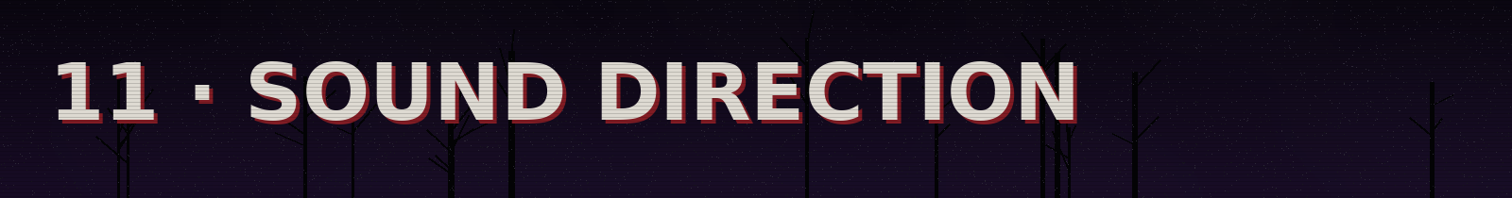
Half of this game's horror is audio. An original score composed in FL Studio by the author; a mix designed for headphones.

11.1 Music — adaptive system
Four independent musical states, cross-fading by layers (stems), in the model already validated by the author on the Graywater project:
STATE | MUSICAL CONTENT | TRIGGER
CALM (days) | A music box in C major, celesta, toy strings; slightly out of tune (−12 cents) | Daytime phases
VIGIL (night, no threat) | Deep drones, the SAME music-box melody stretched 8×, a reversed bell | Standard night loop
HUNT | Percussion from household objects, string clusters, the toll woven into the meter | The AI's CHASE state
FINALE | A wordless children's choir + the mother's Lord's Prayer, filtered like a worn tape | Act IV and epilogue
- A single leitmotif: the music-box theme IS the game's theme — introduced as comfort, corrupted as threat, redeemed in the finale.
- Technical spec: WAV stems 16-bit / 44.1 kHz with seamless loop points (an export standard the author already uses).

11.2 Diegetic sound (the real HUD)
SOURCE | FUNCTION
Tinker Bell's toll | The threat's position, distance, and floor; attenuation and occlusion through walls (FMOD/Unity Audio Mixer with snapshots)
Wendy's breathing | Stamina and fear; speeds up near the monster even while hidden
Surfaces | Each material with its own footsteps; loose boards with a WARNING creak before the burst
Ticking | Proximity to the sea/crocodiles; it is also the puzzle-C clock — the same sound with two fears
The house | Settling wood, wind, a clock in another room: a bed of noise that hides/reveals information

11.3 Voices
- Minimalist direction: fairy Tinker Bell with a sweet, slightly 'stretched' voice; the monster reuses the SAME recording with granular + pitch −800 cents (an audible continuity of the character).
- Peter Pan: always at conversational volume, even at 20 meters (a non-naturalistic mix — he sounds close because he is inescapable).
- The prologue prayer is recorded a single time and reused in 3 contexts (prologue, finale score, VHS collectible) with different degradations.

11.4 Silence
A mixing rule: at least 20% of the night happens with NO music at all. Silence is budgeted as if it were an asset — it is where the toll works.

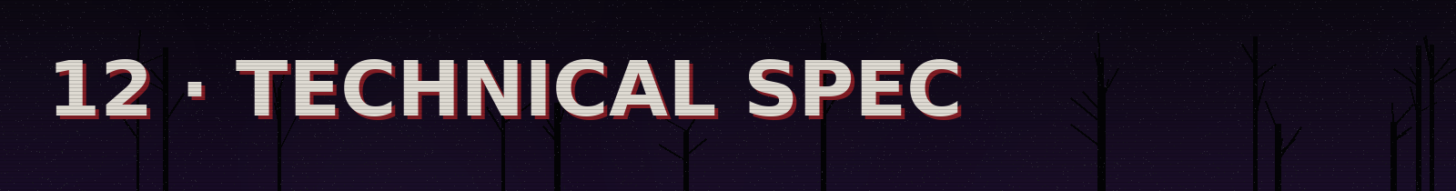
Implementation specs in Unity, aligned with the author's prior experience (Unity 2022.3 LTS, C#, earlier 2D URP projects).

12.1 Stack
LAYER | CHOICE
Engine | Unity 2022.3 LTS · 3D URP pipeline
Language | C# · assembly definitions per module (Core, AI, Interaction, Audio, UI)
PS1 render | Shader Graph: vertex snapping + affine mapping + per-vertex fog; RenderTexture 480×270 → point upscale; CRT/dither post in a fullscreen pass
AI | NavMesh + custom FSM (enum + state classes); waypoints editable via ScriptableObject
Dialogue | A node graph in ScriptableObject; an int 'lucidity' variable persisted in the save; branches by threshold; NPC lines read lucidity to swap line/animation (ch. 5.9)
Audio | Unity Audio Mixer with snapshots per musical state; evaluate FMOD if native occlusion falls short
Save | A light encrypted JSON in persistentDataPath; automatic slots per chapter
Input | Input System (new), with rebind and controller support from day 1
Versioning | Git + GitHub (TucanoiDEV) · Git LFS for binaries · feature branches

12.2 Scene architecture
- Boot → MainMenu → Prologue → Island_Day (additive: Park + House_Exterior) → House_Night (additive per floor) → Island_Climax → Epilogue.
- The house loads the 4 levels (ground, 2nd, attic, basement) as always-active additive sub-scenes: Tinker Bell patrols floors out of the player's sight for real (nothing faked).
- The day island and the climax island are the SAME scene with light/post/audio profiles swapped via a 'Phase' ScriptableObject.

12.3 Performance targets
METRIC | TARGET | NOTE
Frame rate | 60 fps on a modern integrated GPU | The PS1 aesthetic is light by nature; don't waste the headroom
Draw calls | < 300 per frame | Texture atlases per environment; static batching in the house
Memory | < 2 GB RAM | Tiny textures help; audit the audio (the heaviest weight)
Build | < 1.5 GB | Vorbis compression on the music stems
Loading | < 5 s between chapters | Additive scenes + a VHS static screen as a mask

12.4 Technical risks and mitigation
RISK | MITIGATION
An 'unfair' or 'dumb' pursuer AI | Prototype the FSM in greybox BEFORE any art; capture telemetry in playtests; the ch. 6.1 fairness rules as automated tests
Horror turning to frustration (no weapons) | Blind playtests from the vertical slice on; measure drop-off rate per stretch; tune the 'cold period' and diegetic hints
Open-world scope | The island is a wide scenographic corridor, not an open world: collisions guide; cut zones before shrinking the house
PS1 shader in URP | There are abundant community references; reserve 1 sprint just for the visual pipeline at the start
Positional audio/occlusion | A proof of concept of the toll in week 1 of the prototype — it is the game's most important feature


A realistic production plan for a solo developer with occasional collaborations, in phases with verifiable deliverables.

13.1 Phases and milestones
PHASE | DELIVERABLE | ESTIMATED DURATION
0 · Pre-production | This GDD approved; a paper prototype of the puzzles; moodboard/blockout of the house | 2–3 weeks
1 · Prototype | Greybox of the ground floor + Tinker Bell's FSM + noise/hiding + positional toll. NO ART. Goal: 'is it scary yet?' | 4–6 weeks
2 · Vertical slice | The first stretch of the night complete (reveal + puzzles A and B) with final art (PS1 pipeline), save, menu. Basis of the first trailer | 6–8 weeks
3 · Production | The full night, day, island, climax; the full score; collectibles | 4–6 months
4 · Alpha → Beta | Complete content; closed playtests; accessibility pass; PT-BR/EN localization | 6–8 weeks
5 · Launch | Steam page 3+ months ahead; demo (prologue + start of the night) at Next Fest; keys for horror streamers | —

13.2 Cut order (if scope tightens)
Pre-decided cuts, from first to last — the core is untouchable:
- 1st: The secret ending (8.3) · 2nd: VHS collectible tapes · 3rd: Nightmare Mode · 4th: Days 2–4 become non-playable vignettes · 5th: Attic (merge its puzzle into the 2nd floor).
- NEVER cut: the prologue, Tinker Bell's transformation, the eye-closing mechanic, the cliff scene, and the epilogue.

13.3 Design success metrics
- Playtest: ≥70% of players complete the first run without quitting; average time between 35 and 50 min.
- No playtester describes Tinker Bell as 'random' or 'unfair' after the first 10 minutes of the hunt.
- Streamers: spontaneous strong reactions throughout the whole run (an informal metric, but it's the target market).

APPENDICES

A. Project glossary
TERM | DEFINITION
Toll | The monster Tinker Bell's signature sound; the main threat-information channel
Slow interaction | Holding the interact button to act without noise
The List | The anchor document of the environmental narrative: children's names, crossed out
Heat map | The AI's memory of areas with a history of player noise
Lucidity (L) | A hidden counter of resistance to the fantasy; rises with Lucidity lines and changes the NPCs' staging (ch. 5.9)
Surrender / Lucidity line | The two natures of dialogue choice: accepting or resisting Neverland
The Night | The game's main act: a linear, continuous escape through the house, no cuts
Butchery | The optional basement wing (4.5): the island's truth and the machete
Cold period | 20 s with no pursuit after reloading a checkpoint (a fairness rule)
Triple lock | The 3-component lock of the house's exit (the macro objective)

B. Declared references and inspirations
- Puppet Combo — PS1/VHS aesthetic direction and chase pacing (a language reference, with no use of assets).
- Granny (DVloper) — a reference for house-prison puzzle logic and enemy hearing (not for the structure).
- Silent Hill 2 (Team Silent) — the documental structure of this GDD and horror as metaphor.
- Resident Evil 2/3 Remake — persistent-pursuer design.
- Outlast (Red Barrels) — total helplessness without combat and escape horror with a limited light source.
- Peter Pan – La Obscura Verdad — the tone of the retelling and the climax framing.
- J. M. Barrie, Peter and Wendy (1911, public domain) — the base mythology: Neverland, Peter, Tinker Bell, the crocodile, and the clock.

C. Dialogue and Lucidity script (sample)
The writing base for the ch. 5.9 system. Lines marked [L] add +1 Lucidity; [S] lines are surrender (no effect). Bracketed branches with a condition (e.g., [if L≥2]) appear only at the indicated threshold. This is the canonical core of the Day — the full script is kept in an external spreadsheet linked to the dialogue graph.

› Meeting Tinker Bell (waking on the island)
LINE / CHOICE | NATURE AND EFFECT
Tinker Bell: 'You finally woke up!' | Fixed NPC line
› 'Who are you?' | [S] Neutral curiosity
› 'Where am I?' | [L] First spark of unease (+1)
Tinker Bell: 'I'm the most special fairy of this place, Tinker Bell! We're in the most magical place in the universe!' | Fixed line; tone shifts if L is already ≥1

› Peter Pan's introduction (the ring of children)
LINE / CHOICE | NATURE AND EFFECT
Peter Pan: 'Well well, if it isn't Wendy. We were waiting for you!' | Fixed NPC line
› 'Who are you?' | [S] Neutral
› 'How do you know my name?' | [L] Suspicion (+1); Peter dodges ('everyone here knows you, you're special')
Peter Pan: 'How about we show you the toys? Come, follow me!' | Transition to the tutorial

› The list of toys (end of the tour)
LINE / CHOICE | NATURE AND EFFECT
Peter Pan: 'Play on each one on the list, just once!' | Tutorial objective
› 'Yay, I can't wait to have fun!' | [S] Wendy enters the fantasy
› 'But I don't want to play…' | [L] Refusal (+1); Peter: 'For a child, EVERY moment is time to play.'

› The order to sleep (dawn)
LINE / CHOICE | NATURE AND EFFECT
Peter Pan: 'Finished the list? Very good. It's bedtime now.' | Closes the Day
› [if L≥2] 'I miss my mom.' | [L] Special branch (+1); Peter hardens — the mask slips for the first time
› 'Okay.' | [S] Obedience; direct transition to the room
Peter Pan: 'Welcome to your new home.' | Last line before the night; intonation varies with L
Continuity note: the Lucidity accumulated during the Day does not change the structure of the escape night (identical at any L), only how much Peter Pan and Tinker Bell had already let the truth show before it. It is characterization and a reward for attention — never a progression gate nor a difficulty modifier.

D. Final note
This document is alive: every system described here must be validated in prototype before becoming truth. What cannot change is written in ch. 13.2 — everything else exists to serve the boy who closes his eyes to survive and must open them to escape.
— Tucano · TEREJACKS · 2026

