CS 255 System Design Document Template

UML Diagrams

UML Use Case Diagram
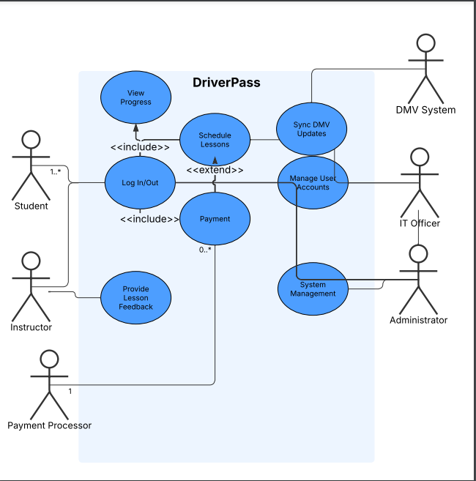

UML Activity Diagrams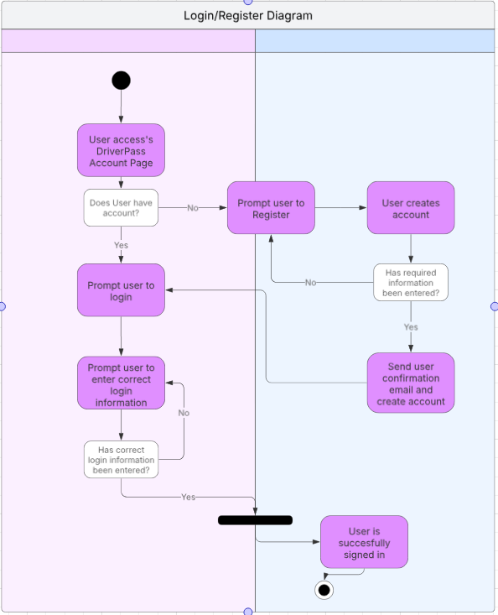
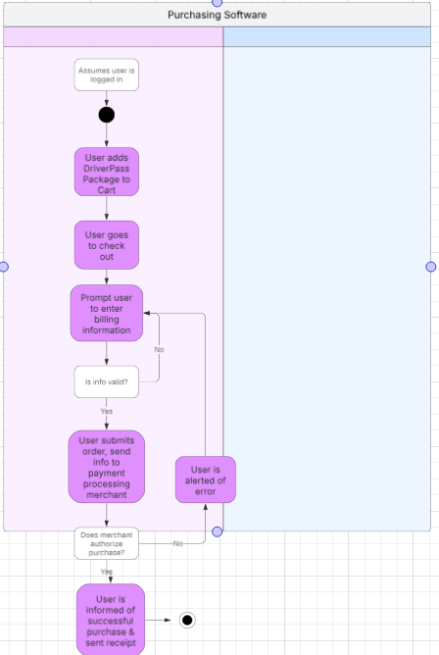

UML Sequence Diagram
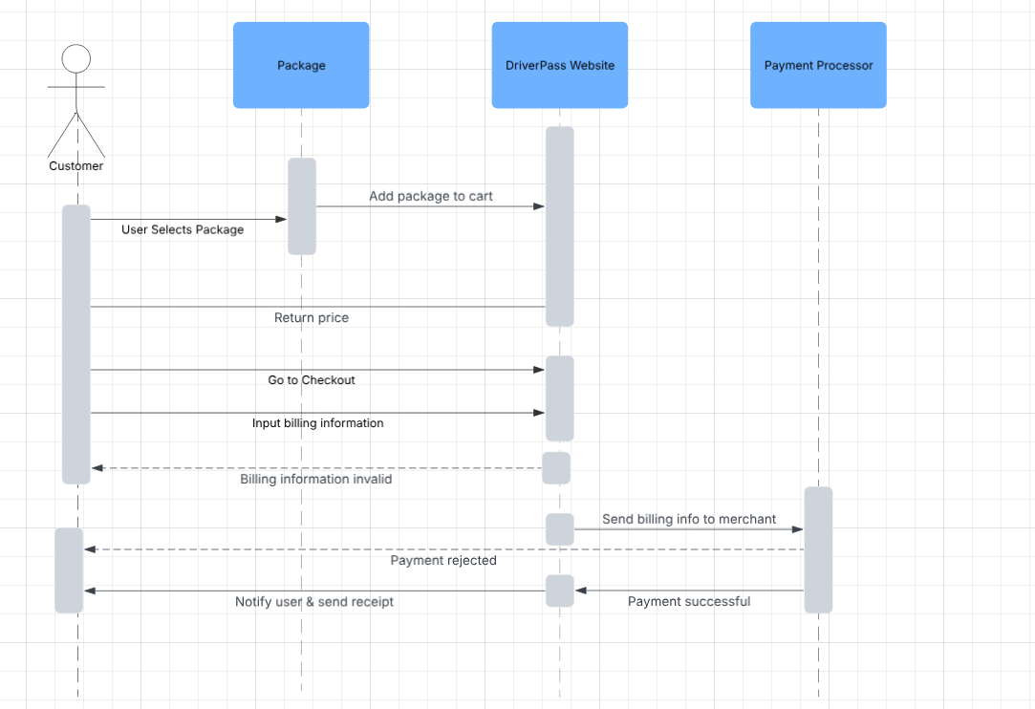

UML Class Diagram
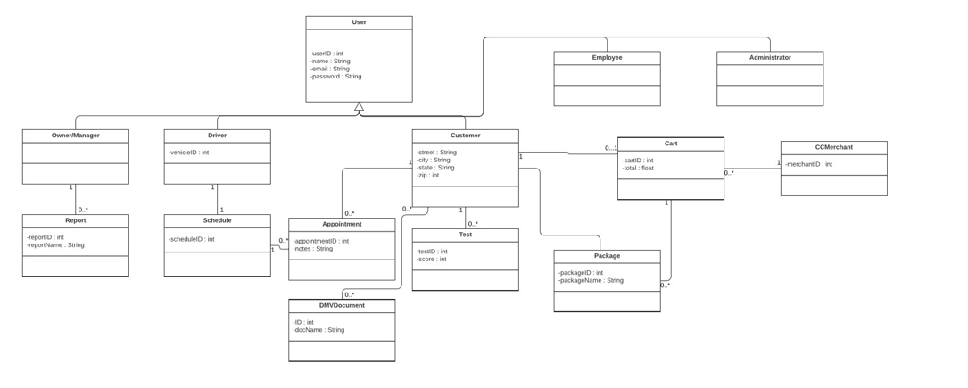

Technical Requirements
Required hardware includes desktop, laptop, tablet or smartphone compatibility and access. The server infrastructure must be able to handle multiple users accessing the software at the same time. There should be a dedicated server, stable internet connection, database storage. Software should include a windows server as well as an SQL Server for the database. Backups made in case of cyber attacks or bugs in the software. Website should be accessible in America. Cloud hosting can be utilized as well and the system should have the scalability to support multiple users simultaneously without delays.

