

Ministry of Education and Research of the Republic of Moldova

Technical University of Moldova

Department of Software and Automation Engineering

**REPORT**

Laboratory work No. 4

**Discipline**: Cryptography and Security

Elaborated: Gavriliuc Tudor, FAF - 221

Checked: asist. univ., Nirca Dumitru

Chișinău 2024

## Topic: Cypher Blocks. DES Algorithm

## Tasks:

To develop a program in one of the preferred programming languages for implementing an element of the DES algorithm. The task will be chosen based on the student's ordinal number nn in the group list, according to the formula: nr_task=nmod  11nr\_task = n \mod 11. For each task, the tables used and all intermediate steps must be displayed on the screen. The input data should either be user-provided or generated randomly.

## 2.2. Given K+ in the DES algorithm, determine Ci and Di for a given i

## Theoretical notes:

**1. Initial Key Permutation (PC-1)**

* **Purpose**: The initial permutation (PC-1) rearranges the bits of the 64-bit key K+K^+K+ to reduce dependencies between input bits and their corresponding output bits.
* **Mechanism**:
  + A predefined table (PC-1) selects and permutes 56 bits from the 64-bit key.
  + The 8 parity bits (one for each byte) are ignored during this process.

**Formula**:

Permuted Key=PC-1(K+)\text{Permuted Key} = \text{PC-1}(K^+)Permuted Key=PC-1(K+)

**Output**:

* A 56-bit permuted key is divided into two halves:
  + C0C_0C0​: The leftmost 28 bits.
  + D0D_0D0​: The rightmost 28 bits.

**2. Splitting into C and D Components**

* The permuted 56-bit key is divided into two halves for independent manipulation:
  + CCC: Represents the left half of the key.
  + DDD: Represents the right half of the key.
* This separation allows for bitwise operations to be performed independently on each half.

**3. Left Circular Shifts**

* **Purpose**: To introduce variability and diffusion in the subkey generation.
* **Mechanism**:
  + CCC and DDD are each shifted left by a number of bits specified by the **shift schedule** for the current round iii.
  + The shifts are **circular**, meaning bits that overflow the leftmost end are reintroduced at the rightmost end.

**Formula**:

Ci=LeftShift(Ci−1,shifts[i])C_i = \text{LeftShift}(C_{i-1}, \text{shifts}[i])Ci​=LeftShift(Ci−1​,shifts[i]) Di=LeftShift(Di−1,shifts[i])D_i = \text{LeftShift}(D_{i-1}, \text{shifts}[i])Di​=LeftShift(Di−1​,shifts[i])

**Shift Schedule**:

* A predefined array dictates the number of shifts for each round iii. For example:
  + Round 1: 1 shift.
  + Round 2: 1 shift.
  + Round 3: 2 shifts, and so on.

**4. Intermediate Values**

* The CiC_iCi​ and DiD_iDi​ values at each round are crucial for deriving the round-specific subkeys KiK_iKi​.
* These intermediate values illustrate how the initial key evolves across rounds, introducing complexity and security into the DES encryption process.

**5. Relevance in DES**

The key scheduling process, including the steps to compute CiC_iCi​ and DiD_iDi​, ensures:

* **Diffusion**: Small changes in the initial key propagate to all subkeys.
* **Unpredictability**: The use of a shift schedule and permutations increases the complexity of reverse-engineering subkeys.

**Implementation:**

**1. generate_random_key()**

**Purpose**: Generates a random 64-bit key, simulating a possible input for the DES encryption process.

**Usage**:

* Used when the user opts for automatic generation of a key.
* Ensures the key has random bit values (0 or 1).

**Output**: A 64-character binary string representing a 64-bit key.

**2. apply_permutation(table, key)**

**Purpose**: Applies a specific permutation to the input key based on a given table.

**Usage**:

* Implements the **PC-1 permutation** in the DES algorithm.
* Rearranges or selects bits from the input key based on indices provided in the table.

**Parameters**:

* table: A list of integers specifying the new positions of bits.
* key: The original key to be permuted (binary string).

**3. left_shift(bits, shifts)**

**Purpose**: Performs a circular left shift (rotation) on a binary string.

**Usage**:

* Shifts the bits in the CCC and DDD halves during key scheduling.
* Ensures bits that overflow on the left are reintroduced at the right.

**Parameters**:

* bits: Binary string representing the bits to be shifted.
* shifts: Number of positions to shift.

Here is a summary of the **key functions** implemented in the DES key scheduling task and their respective meanings:

**1. generate_random_key()**

**Purpose**: Generates a random 64-bit key, simulating a possible input for the DES encryption process.

**Usage**:

* Used when the user opts for automatic generation of a key.
* Ensures the key has random bit values (0 or 1).

**Output**: A 64-character binary string representing a 64-bit key.

**2. apply_permutation(table, key)**

**Purpose**: Applies a specific permutation to the input key based on a given table.

**Usage**:

* Implements the **PC-1 permutation** in the DES algorithm.
* Rearranges or selects bits from the input key based on indices provided in the table.

**Parameters**:

* table: A list of integers specifying the new positions of bits.
* key: The original key to be permuted (binary string).

**Output**: A permuted binary string.

**Example**:

python

Copiază codul

table = [3, 1, 2] # Example table

key = "101" # Original key

result = apply_permutation(table, key) # Result: "011"

**3. left_shift(bits, shifts)**

**Purpose**: Performs a circular left shift (rotation) on a binary string.

**Usage**:

* Shifts the bits in the CCC and DDD halves during key scheduling.
* Ensures bits that overflow on the left are reintroduced at the right.

**Parameters**:

* bits: Binary string representing the bits to be shifted.
* shifts: Number of positions to shift.

**Output**: A binary string that has been circularly shifted.

**Example**:

python

Copiază codul

bits = "1010"

shifts = 1

result = left_shift(bits, shifts) # Result: "0101"

**4. des_key_schedule(key_plus, i)**

**Purpose**: Calculates CiC_iCi​ and DiD_iDi​ for a specific round iii in the DES key schedule.

**Usage**:

* Implements the core of the key scheduling process.
* Applies the **PC-1 permutation** and performs **left shifts** for each round up to iii.

**Parameters**:

* key_plus: The initial 64-bit key (binary string).
* i: The round number for which CiC_iCi​ and DiD_iDi​ are required.

**Steps**:

1. Apply **PC-1** to permute the key and split it into C0C_0C0​ and D0D_0D0​.
2. Perform **circular left shifts** for each round up to iii.
3. Display intermediate CCC and DDD values.

**Output**: The CiC_iCi​ and DiD_iDi​ values as binary strings.

**Results:**

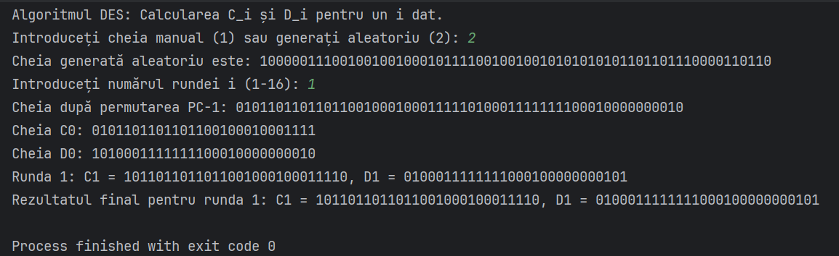

**Conclusion**

This implementation provides a detailed look into the DES key scheduling process. It includes step-by-step calculations and displays intermediate results for better understanding. The program allows for flexibility in input by either accepting a user-provided key or generating one randomly. This makes the implementation versatile and suitable for educational purposes.