EX 0: Site: https://www.w3schools.com/

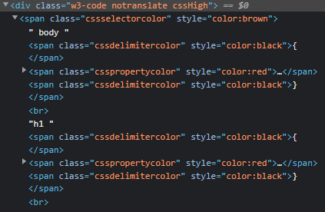

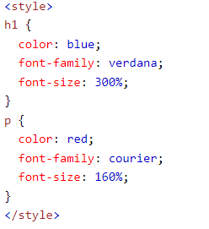

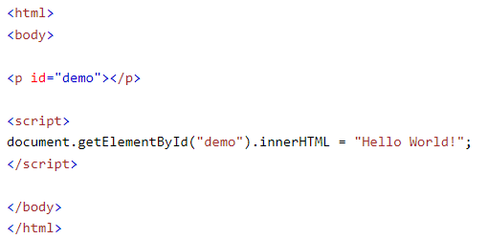



EX 1, 2, 3: https://github.com/TudorErdei/lab04