Version overview

Date | Version | Author | Comment
7.11.2023 | 0.0 | Giuroiu Tudor | The initial documentation.
9.12.2023 | 0.1 | Giuroiu Tudor | Finished 90% of the documentation.

System requirements for Ticket Shop Application

1 Introduction 2
2 General view of actors and use cases 2
3 Detailed description of actors and use cases 2
3.1 Actors 2
3.1.1 Administrator 2
3.1.2 Customer 3
Type: ……….. 3
3.1.3 Provider 3
3.2 Use cases 3
3.2.1 Use Case Diagram for Actor1 3
3.2.2 Use Case Diagram for Actor2 3
3.2.3 Use Case Diagram for Actor3 4
3.2.4 Use Case Diagram for Actor_{n} 4
4 Glossary – used terms 5

Introduction

The project presented in this document is a Ticket Shop Application. The application serves as a platform for managing and purchasing event tickets, offering users the capability to both make acquisitions and effect updates, a privilege reserved for administrators. The system facilitates user engagement through the creation of individual accounts, enabling login experiences or, alternatively, permitting users to explore the site as guests.

Upon accessing the application, users are presented with a selection of events, each of which can be further explored by navigating to event pages. Within these pages, users are provided with details regarding available tickets for the selected event. Users have the ability to curate their event experience by selecting desired tickets and placing them in a virtual basket, effectively creating a temporary repository for their chosen items.

Users can proceed to purchase the selected tickets from their basket, ending with the issuance of a confirmation of the transaction. Administrative users, distinguished by their enhanced privileges, are equipped with the authority to perform CRUD operations on the events and tickets. This includes the ability to modify pricing structures, adjust ticket quantities, and undertake other pertinent administrative functions to ensure optimal event management and user satisfaction.

General view of actors and use cases
Administrator: The Administrator manages the system by overseeing events, tickets, discounts, and performing administrative tasks such as creating and editing events, and adjusting prices.

Customer: The Customer engages in general operations, visiting web pages, exploring events, adding tickets to a basket, and making purchases.

Actor | Type | Description
Administrator | Human | The person administrating the system, managing the events and the tickets.
Customer | Human | Performs general operations over the system, such that visiting the Webpages, adding products to basket, buying them

The use cases present in the system are: Event Ticket Purchases, User Account Management, Guest Browsing, Event and Ticket Management for Administrators, Basket Functionality, Purchase Confirmation, Discount Application for Users.

Detailed description of actors and use cases

Actors

Administrator

Type: human
Detailed description:

Within the system, Administrators take on a vital role with special privileges, overseeing various aspects of the application. They are making sure everything runs smoothly. Their tasks cover a range of activities, starting with event management. Admins have the power to create new events, keeping the lineup fresh for users. They can also tweak event details, fix things, or update info. And if an event is no longer happening, they can take it off the list.

Admins call the shots on quantities and prices. They can add new ticket categories when needed or retire old ones. They can create, delete, and update information about tickets and events. This helps keep the ticketing system in top-notch shape.

As for discounts, Admins are responsible here. They can create discount codes and promotions, making the whole marketing and sales thing a breeze.

Where is used:
This actor is used in the: “Administrator Log-in” use case
“Administrator Log-out” use case
“Creating a ticket in the Database” use case
“Editing a ticket in the Database” use case
“Deleting a ticket in the Database” use case
“Creating an event in the Database” use case
“Editing an event in the Database” use case
“Deleting an event in the Database” use case
“Creating a discount in the Database” use case
“Editing a discount in the Database” use case
“Deleting a discount in the Database” use case
All the use cases of a Customer

Customer

Type: human
Detailed description:

In the Ticket Shop Application, the Customer plays a crucial role in the journey of exploring, selecting, and purchasing event tickets. This customer actively engages with the platform by creating individual accounts, enabling a personalized and convenient event selection process.
Upon entering the application, customers are greeted with a diverse array of events, each offering a unique experience. Customers can navigate to dedicated event pages. These pages provide customers with details about available tickets, allowing them to make informed decisions regarding their event attendance.

The application provides customers with the ability to select specific tickets and placing them in a virtual basket. This basket acts as a temporary repository, allowing users to review and finalize their selections before proceeding to the purchase stage.

Once satisfied with their ticket choices, customers can seamlessly proceed to purchase directly from their basket. The transaction issues a confirmation, providing customers with the assurance of a successful ticket purchase.

Where is used:
This actor is used in the: “Customer Log-in” use case.
“Customer Log-out” use case.
“Customer Account Creation” use case.
“Event Exploration” use case
“Ticket Selection and Basket Management” use case
“Ticket Purchase” use case
“Account Management” use case
“Applying Discount” use case

Use cases

Use Case Diagram for Administrator
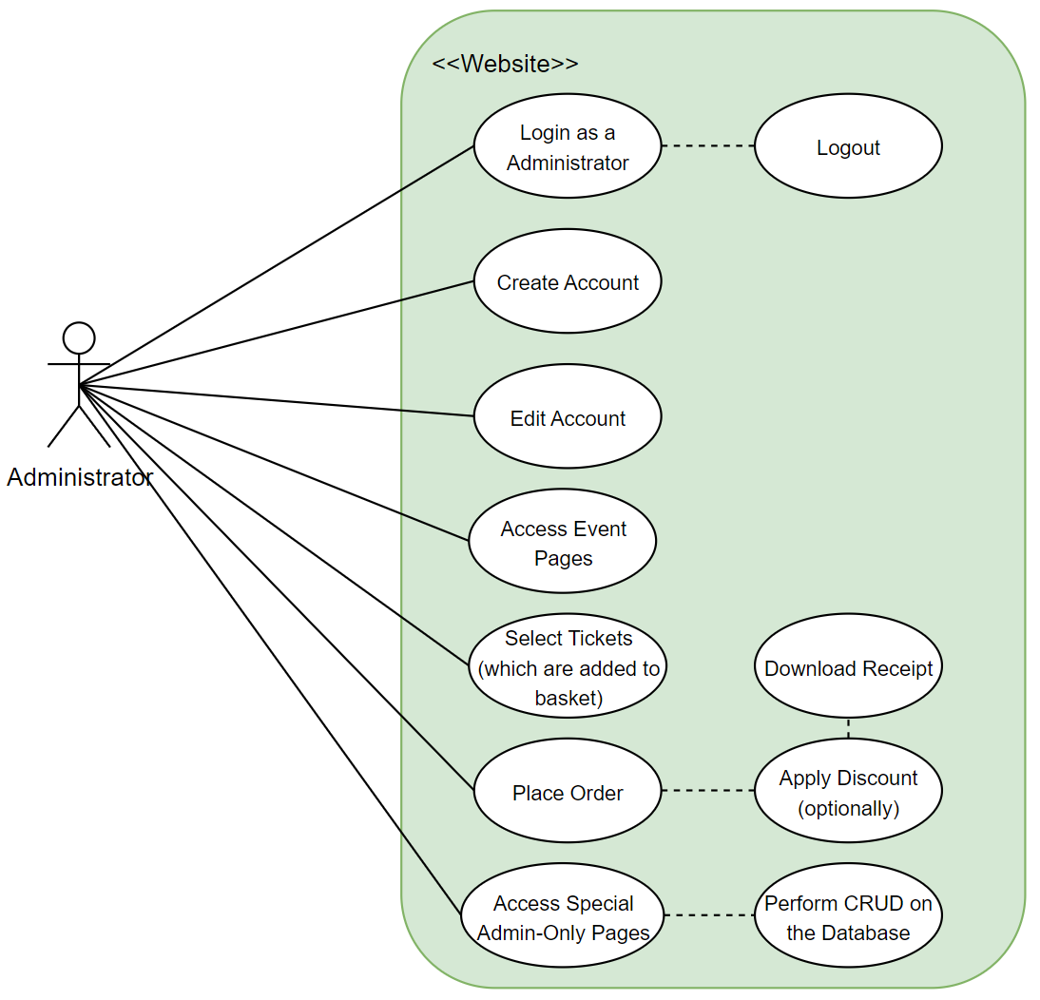
Description:
The Use Case Diagram for the Administrator illustrates the key interactions with the system. Dotted lines signal use cases that can be accessed only after other certain use cases are accessed. An important note is that Administrators have all the use cases as Customers, in addition to Admin-only privileges.
Actor: Administrator
Precondition: The system is operational, and the Ticket Shop Application is accessible. The Administrator has valid login credentials.
Postcondition: Selected tickets are successfully purchased, and a confirmation of the transaction is issued. Database is updated with the purchase history. Changes made to events or tickets are successfully saved, ensuring that updates are reflected in the system.
Behavior: Navigates through the application to explore available events. Selects tickets and adds them to the virtual basket. Proceeds to checkout, providing necessary information for the transaction. Receives confirmation of the transaction after successful purchase. Can manage account settings (for registered users). Logs in with administrative credentials. Accesses the administrative dashboard for events and tickets. Performs CRUD operations, such as adding new events, updating ticket prices, or modifying event details.

Use Case Diagram for Customer
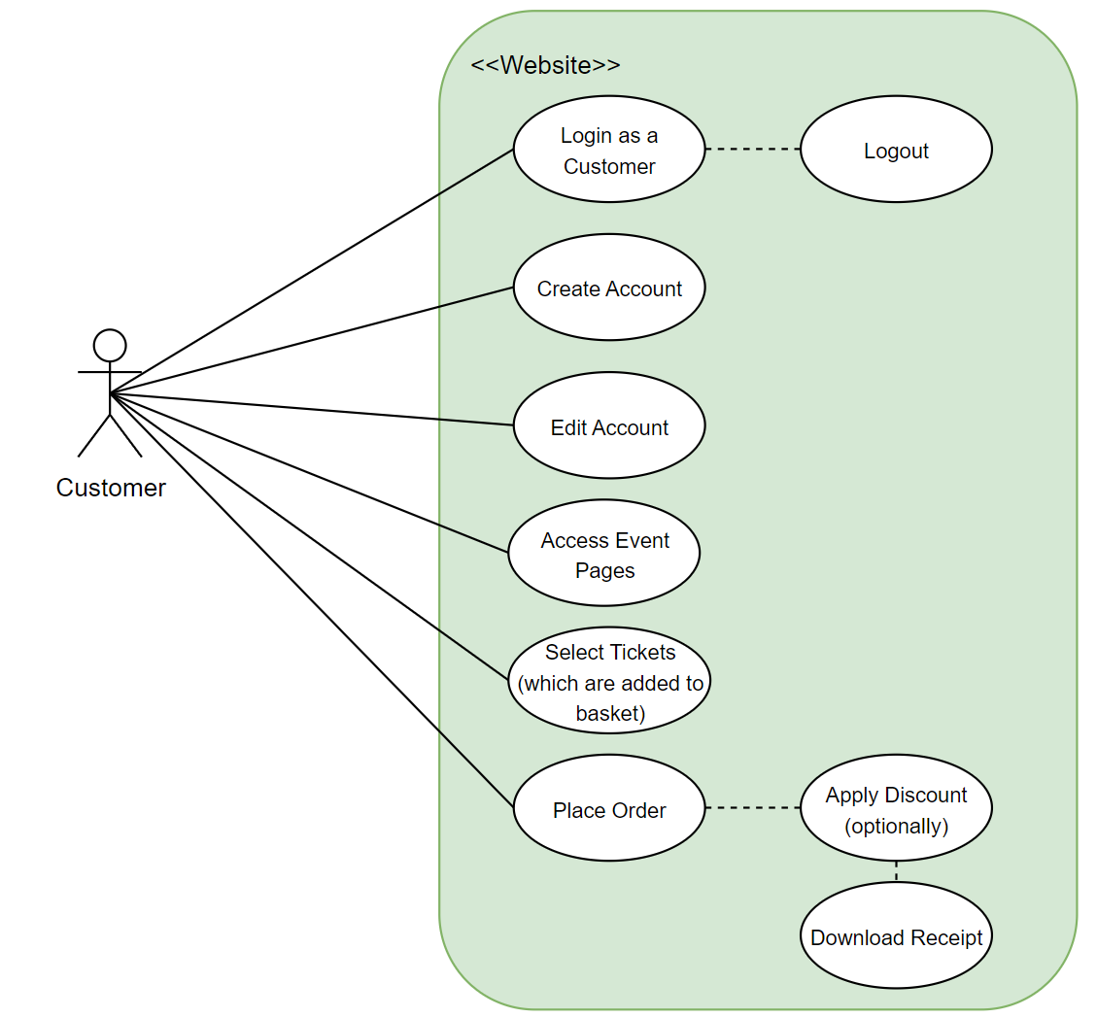
Description:
The Use Case Diagram for Customers outlines the primary interactions with the system. Dotted lines indicate use cases that become accessible only after certain other use cases are accessed.
Actor: Customer
Precondition: The system is operational, and the Ticket Shop Application is accessible. The Customer has valid login credentials.
Postcondition: Selected tickets are successfully purchased, and a confirmation of the transaction is issued. Database is updated with the purchase history.
Behavior: Selected tickets are successfully purchased, and a confirmation of the transaction is issued. Database is updated with the purchase history.

Glossary – used terms
Term | Use cases | Description
Basket | Ticket Selection and Basket Management use case  Ticket Purchase use case | A virtual repository within the Ticket Shop Application where users can temporarily store selected tickets before proceeding to the purchase stage.
Login credentials | Log-in use case | Contains all the information needed by a Customer or Administrator that wants to authenticate itself in the system.
Event | Event Exploration use case | An occurrence or happening organized and managed within the Ticket Shop Application. Events include various activities and are presented to Users for exploration. Admin have the authority to create new events, update event details, and remove events that are no longer happening.
Receipt | Ticket Purchase use case | A document or confirmation issued to the User upon the successful completion of a ticket purchase. The receipt provides details of the transaction.
CRUD | Creating, Editing, Deleting a ticket, event, or ticket in the Database use case | An acronym representing the fundamental operations in database management: Create, Read, Update, and Delete. In the context of the Ticket Shop Application, Admin Users utilize CRUD operations to manage events, tickets, and discounts.
Page (Endpoint) | Event Exploration use case Ticket Selection and Basket Management use case | In the context of the Ticket Shop Application, a digital interface or endpoint representing a specific screen or view within the application. Pages allow users to interact with and explore events, tickets and different objects of the application.

Term Groups | Included terms and term groups | Description
Authentication | Administrator password authentication, Provider password authentication | Defines a general group of credentials used in the authentication process

