Versions:

Date | Versiune | Autor | Comentarii
19.11.2023 | 0.0 | Giuroiu Tudor | Initial Version.
26.11.2023 | 0.1 | Giuroiu Tudor
5.12.2023 | 0.2 | Giuroiu Tudor | Added some diagrams and architecture text

Analisys&Design for Ticket Shop Application

Continut:
- General Presentation

- Theoretical Fundamentals

- IT Technology (which will be implemented)

- Functionalities

- Actors and related access rights

- Use Case Diagrams

- System Architecture

- Design (UML Diagrams)

- Operation Mode (Operation Guide, including screen-shots)

- Portability

1. General Presentation

The project presented in this document is a Ticket Shop Application. The application serves as a platform for managing and purchasing event tickets, offering users the capability to both make acquisitions and effect updates, a privilege reserved for administrators. The system facilitates user engagement through the creation of individual accounts, enabling login experiences or, alternatively, permitting users to explore the site as guests.

This project provides users with a convenient avenue to engage in various events, fostering a community of content and dedicated individuals. The application simplifies the process of joining events with friends, enhancing the overall experience of shared participation.

- Theoretical Fundamentals

- IT Technology

The application has been developed utilizing the Java programming language and the Spring framework.

- Functionalities

The Ticket Shop Application offers a range of functionalities to facilitate seamless event management and ticket purchasing experiences for users.

User Account Management: Users are empowered to create individual accounts, enabling a personalized interaction with the application. The registration process facilitates the management of their event-related activities. Users can choose to log in or explore the site as guests.
Event Exploration: Upon accessing the application, users are presented with a curated list of events. This serves as a starting point for their exploration, allowing them to search further into detailed event pages. These pages provide comprehensive information about each event, guiding users in their decision-making process.
Ticket Selection and Basket Management: To enhance the user's control over their event experience, the application introduces a virtual basket. Users select specific tickets and place them in the basket. This virtual repository acts as a temporary holding space, enabling users to review and manage their decisions before proceeding to the purchase stage.
Ticket Purchase: The ticket purchase process is designed for simplicity and efficiency. Users can proceed to purchase the selected tickets from their virtual basket. The transaction concludes with the issuance of a confirmation.
Administrative Privileges: Administrative users, distinguished by their enhanced privileges, play a crucial role in the overall management of the application. They have the authority to perform CRUD operations on events and tickets, ensuring dynamic event management. This includes modifying pricing structures, adjusting ticket quantities, and undertaking various administrative functions to optimize event organization and user satisfaction. Not only can they organize the event-related data of the application, but also the customer accounts.

- Actors and related access rights

Administrators: Within the system, Administrators take on a vital role with special privileges, overseeing various aspects of the application. They are making sure everything runs smoothly. Their tasks cover a range of activities, starting with event management. Admins have the power to create new events, keeping the lineup fresh for users. They can also tweak event details, fix things or update info. And if an event is no longer happening, they can take it off the list.
Admins call the shots on quantities and prices. They can add new ticket categories when needed or retire old ones. They can edit, create delete and update information about tickets and events. This helps keep the ticketing system in top-notch shape.
As for discounts, Admins are responsible here. They can create discount codes and promotions, making the whole marketing and sales thing a breeze.

Administrators have access across the entire application. Beyond the capabilities available to regular customers, administrators can utilize specialized options embedded within event pages specifically designed for content management purposes. This includes the ability to manipulate and oversee the information presented on event pages, ensuring tailored and effective content presentation.
Additionally, administrators benefit from a designated section within the application dedicated to the management of customer accounts. This exclusive area provides administrators with the tools and features necessary to efficiently oversee and administer customer accounts.

Customers: In the Ticket Shop Application, the Customer plays a crucial role in the journey of exploring, selecting, and purchasing event tickets. This customer actively engages with the platform by creating individual accounts, enabling a personalized and convenient event selection process.
Upon entering the application, customers are greeted with a diverse array of events, each offering a unique experience. Customers can navigate to dedicated event pages. These pages provide customers with details about available tickets, allowing them to make informed decisions regarding their event attendance.
The application provides customers with the ability select specific tickets and placing them in a virtual basket. This basket acts as a temporary repository, allowing users to review and finalize their selections before proceeding to the purchase stage.
Once satisfied with their ticket choices, customers can seamlessly proceed to purchase directly from their basket. The transaction issues a confirmation, providing customers with the assurance of a successful ticket purchase.

Customers have access to all the basic and customer-indended features of the application. They cannot access the special area for account management and the special embedded options designed for the admins.

- Use Case Diagrams

- System Architecture

The Ticket Shop Application is a web-based platform designed to manage and facilitate the purchase of event tickets. The system employs the Model-View-Controller (MVC) architecture, providing a robust structure for handling user interactions, managing data, and presenting a seamless experience for both regular users and administrators.
Purpose
The primary purpose of the Ticket Shop Application is to streamline the process of discovering, purchasing, and managing event tickets. The platform aims to foster a sense of community by enabling users to easily engage in various events, simplifying the coordination of attendance with friends and enhancing the overall experience of shared participation.
Architecture Overview
Model
The Model component represents the core of the application, encapsulating the data and business logic. In the Ticket Shop Application, the Model includes entities such as Event, User, and Ticket. These entities are responsible for storing information about events, user accounts, and purchased tickets, respectively.
View
The View component handles the presentation layer of the application. It encompasses the user interface elements that users interact with. The Ticket Shop Application utilizes HTML templates, powered by Thymeleaf, to dynamically generate views. Views include pages for event listings, user authentication, ticket purchase forms, and account management.
Controller
The Controller component acts as an intermediary between the Model and the View. It receives user inputs, processes them, and updates the Model accordingly. In the Ticket Shop Application, controllers manage actions such as user registration, event browsing, ticket purchasing, and administrative functions. Controllers are annotated with @Controller and define mappings using @RequestMapping annotations.

- Design (approx. 12 UML Diagrams!!!)

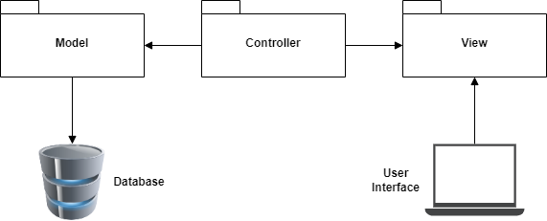

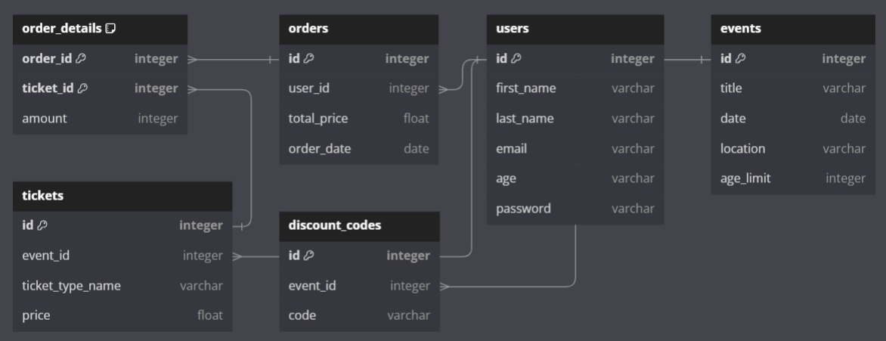

- Operation Mode (Interactivity presentation) + screen shots (UI design)

- Portability

- Competing software

