Versions:

Date | Version | Author | Comments.
19.11.2023 | 0.0 | Giuroiu Tudor | Initial Version.
26.11.2023 | 0.1 | Giuroiu Tudor
5.12.2023 | 0.2 | Giuroiu Tudor | Added some diagrams and architecture text
9.12.2023 | 0.3 | Giuroiu Tudor | Added IT Technology text, use case diagrams
10.12.2023 | 0.4 | Giuroiu Tudor | Changed table names so they are in English, finished section 7, added all diagrams.
11.12.2023 | 0.5 | Giuroiu Tudor | Fixed some diagrams, organized the layout.

Analisys&Design for Ticket Shop Application

Contents:
- General Presentation

- Theoretical Fundamentals

- IT Technology (which will be implemented)

- Functionalities

- Actors and related access rights

- Use Case Diagrams

- System Architecture

- Design (UML Diagrams)

- Operation Mode (Operation Guide, including screen-shots)

- Portability

1. General Presentation

The project presented in this document is a Ticket Shop Application. The application serves as a platform for managing and purchasing event tickets, offering users the capability to both make acquisitions and effect updates, a privilege reserved for administrators. The system facilitates user engagement through the creation of individual accounts, enabling login experiences or, alternatively, permitting users to explore the site as guests.

This project provides users with a convenient avenue to engage in various events, fostering a community of content and dedicated individuals. The application simplifies the process of joining events with friends, enhancing the overall experience of shared participation.

- Theoretical Fundamentals

When diving into the theoretical fundamentals of an IT project, careful consideration of the project's requirements is important. Analyzing these requirements means identifying the methods and components essential to achieving the project's final goals. In the context of the Ticket Shop Application, its foundation rests on fundamental ticketing system concepts, which intricately manage the purchase and organization of event tickets. These core elements encompass not only event management but also the incorporation of diverse ticket categories and adaptable pricing structures, ensuring a comprehensive approach to catering to user needs.
Given its resemblance to an e-commerce application, the Ticket Shop must embody the defining characteristics of such platforms. This includes facilitating seamless online transactions, enabling the buying and selling of event tickets, electronic fund transfers, and fostering the exchange of data between event-goers and organizers. Aligning with e-commerce principles, the Ticket Shop Application becomes a dynamic and user-centric platform, emphasizing efficiency, security, and a seamless user experience.
Furthermore, as a web application, the project adheres to fundamental web development principles. These encompass user-centered design to enhance the overall user experience, scalability to accommodate growing data, robust security measures to protect user and application data, performance optimization for fast and responsive interactions, responsive design, and modularity with an emphasis on code reusability for maintainability.
Amidst these considerations, the database emerges as a pivotal component, with its design wielding substantial influence over the final product. Selecting an appropriate database design is critical, as it directly impacts the application's efficiency, data management capabilities, and overall performance. The database serves as the repository for event details, ticket information, and user data, necessitating a well-thought design to ensure seamless and reliable functioning.

- IT Technology

The Ticket Shop Application will have a simple and efficient architecture, using the Java programming language and the Spring framework. To manage project dependencies effectively, Maven is employed. Maven is an open-source build automation and project management tool widely used in Java development. It simplifies project configuration, dependency management, and the build lifecycle.
Spring Boot is an open-source Java framework that simplifies the development of applications by providing conventions, embedded servers, and auto-configuration. It streamlines the creation of stand-alone, Spring-based applications, enabling developers to focus on business logic with minimal setup. It will be used during the development of this application.
For the front-end, the application employs HTML as the primary design language, CSS for styling, and occasional use of JavaScript to enhance the user interface's liveliness. Thymeleaf is a Java-based templating engine commonly used in web development. It enables the seamless integration of dynamic data with HTML templates, simplifying the creation of server-side-rendered web pages in Java applications. Thymeleaf will be utilized as a templating engine to integrate data from the back-end into the front-end. This ensures a cohesive and dynamic user experience.
The back-end is powered by Spring Boot, providing a scalable and efficient foundation for handling business logic and processing user requests.
The database for the Ticket Shop Application is hosted on a MySQL server. MySQL provides a reliable and widely-used relational database management system, ensuring data integrity and efficient querying. The integration with Spring Boot simplifies database operations, enhancing overall application performance.
The server hosting the application is facilitated by Tomcat, the default embedded servlet container provided by Spring Boot. Tomcat ensures the smooth deployment and execution of the application, handling HTTP requests and managing the application's lifecycle.

- Functionalities

The Ticket Shop Application offers a range of functionalities to facilitate seamless event management and ticket purchasing experiences for users.

User Account Management: Users are empowered to create individual accounts, enabling a personalized interaction with the application. The registration process facilitates the management of their event-related activities. Users can choose to log in or explore the site as guests.
Event Exploration: Upon accessing the application, users are presented with a curated list of events. This serves as a starting point for their exploration, allowing them to search further into detailed event pages. These pages provide comprehensive information about each event, guiding users in their decision-making process.
Ticket Selection and Basket Management: To enhance the user's control over their event experience, the application introduces a virtual basket. Users select specific tickets and place them in the basket. This virtual repository acts as a temporary holding space, enabling users to review and manage their decisions before proceeding to the purchase stage.
Ticket Purchase: The ticket purchase process is designed for simplicity and efficiency. Users can proceed to purchase the selected tickets from their virtual basket. The transaction concludes with the issuance of a confirmation.
Administrative Privileges: Administrative users, distinguished by their enhanced privileges, play a crucial role in the overall management of the application. They have the authority to perform CRUD operations on events and tickets, ensuring dynamic event management. This includes modifying pricing structures, adjusting ticket quantities, and undertaking various administrative functions to optimize event organization and user satisfaction. Not only can they organize the event-related data of the application, but also the customer accounts.

- Actors and related access rights

Administrators: Within the system, Administrators take on a vital role with special privileges, overseeing various aspects of the application. They are making sure everything runs smoothly. Their tasks cover a range of activities, starting with event management. Admins have the power to create new events, keeping the lineup fresh for users. They can also tweak event details, fix things or update info. And if an event is no longer happening, they can take it off the list.
Admins call the shots on quantities and prices. They can add new ticket categories when needed or retire old ones. They can edit, create delete and update information about tickets and events. This helps keep the ticketing system in top-notch shape.
As for discounts, Admins are responsible here. They can create discount codes and promotions, making the whole marketing and sales thing a breeze.

Administrators have access across the entire application. Beyond the capabilities available to regular customers, administrators can utilize specialized options embedded within event pages specifically designed for content management purposes. This includes the ability to manipulate and oversee the information presented on event pages, ensuring tailored and effective content presentation.
Additionally, administrators benefit from a designated section within the application dedicated to the management of customer accounts. This exclusive area provides administrators with the tools and features necessary to efficiently oversee and administer customer accounts.

Customers: In the Ticket Shop Application, the Customer plays a crucial role in the journey of exploring, selecting, and purchasing event tickets. This customer actively engages with the platform by creating individual accounts, enabling a personalized and convenient event selection process.
Upon entering the application, customers are greeted with a diverse array of events, each offering a unique experience. Customers can navigate to dedicated event pages. These pages provide customers with details about available tickets, allowing them to make informed decisions regarding their event attendance.
The application provides customers with the ability select specific tickets and placing them in a virtual basket. This basket acts as a temporary repository, allowing users to review and finalize their selections before proceeding to the purchase stage.
Once satisfied with their ticket choices, customers can seamlessly proceed to purchase directly from their basket. The transaction issues a confirmation, providing customers with the assurance of a successful ticket purchase.

Customers have access to all the basic and customer-indended features of the application. They cannot access the special area for account management and the special embedded options designed for the admins.

- Use Case Diagrams

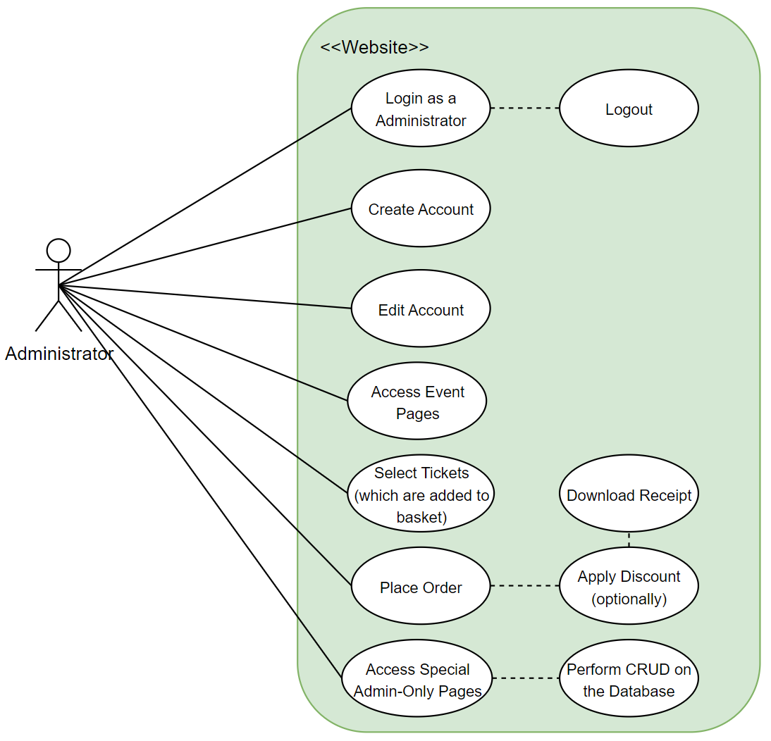

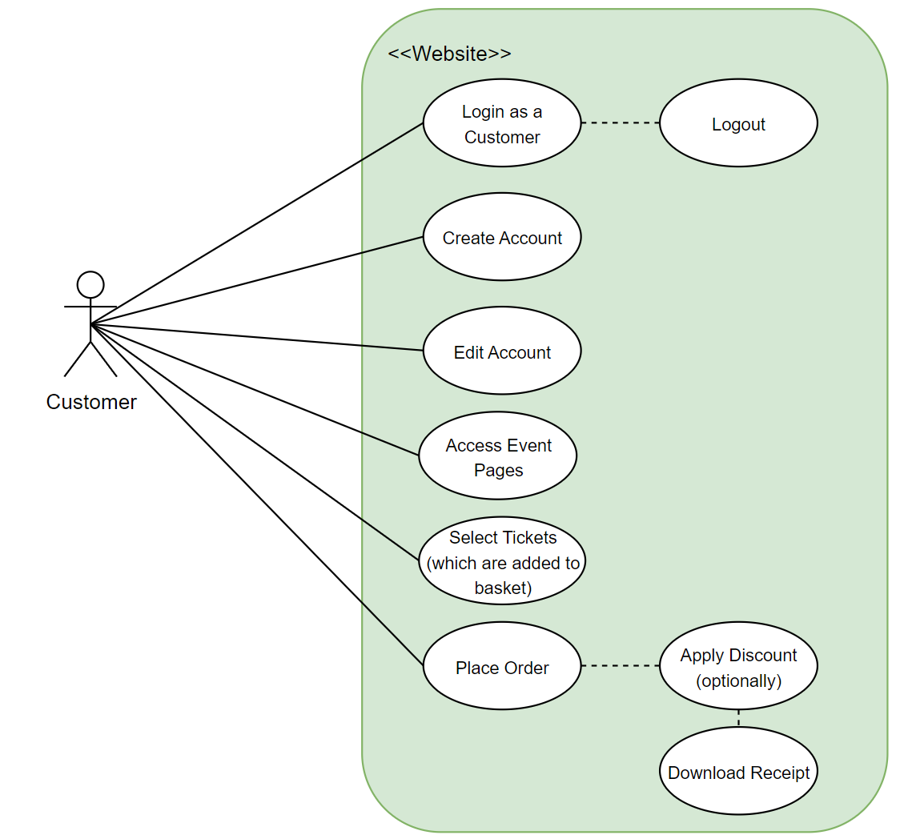

- System Architecture

The Ticket Shop Application is a web-based platform designed to manage and facilitate the purchase of event tickets. The system employs the Model-View-Controller (MVC) architecture, providing an organized structure for handling user interactions, managing data, and presenting a seamless experience for both regular users and administrators.
The Model component represents the core of the application, encapsulating the data structure. In the Ticket Shop Application, the Model includes entities such as User, Event, Ticket, Order, OrderDetails, and DiscountCodes. These entities are responsible for storing information about user accounts, available events and tickets, facilitated orders along with some details related to them, respectively.
The View component handles the presentation layer of the application. It encompasses the user interface elements that users interact with. Views include pages for event listings, user authentication and registration, ticket purchase forms, account management, and admin content-management pages. Pages can be grouped depending on the common section they are build upon. For example, user registration page, user login page, and account management page are related between them through the common user part of the application. That is why they will be grouped in a sepparate directory. Grouping the HTML pages will achieve modularity and make the project code and file navigation simpler.
In the Spring MVC architecture, the Controller component serves as a crucial intermediary between the application's Model and View. Its primary role is managing incoming requests, processing them, and managing the generation of an appropriate response. Within this framework, each significant endpoint or URL is typically associated with a designated controller. These controllers receive user inputs, such as HTTP requests, and carry out the necessary operations to update the application's underlying Model, with the help of other classes.
To facilitate interaction with the database, a separate package known as the Data Access Object (DAO) package is employed. The DAO classes within this package are responsible for handling database operations, such as retrieving or persisting data. By encapsulating these data access concerns in a dedicated package, the application achieves separation of concerns and a modular structure.
The core business logic of the application is typically managed by classes within the Service package. These Service classes act as intermediaries between the Controllers and the DAO classes. They facilitate the abstraction of business operations, providing a layer of insulation between the web layer (Controllers) and the data access layer (DAO). This abstraction enhances modularity, making it easier to update or replace components without affecting the entire system.
For addressing the security aspects of the application, a specialized security package is often created. This security package contains essential classes responsible for user authentication and authorization. Authentication verifies the identity of users, ensuring they are who they claim to be, while authorization determines the permissions and access levels granted to authenticated users.

- Design (approx. 12 UML Diagrams!!!)

Database Diagram:
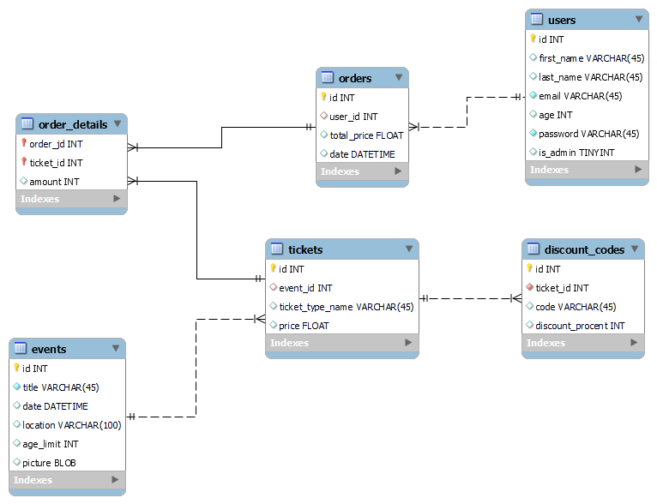

Package Diagram:

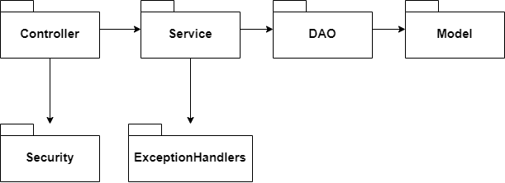

Class Diagram:

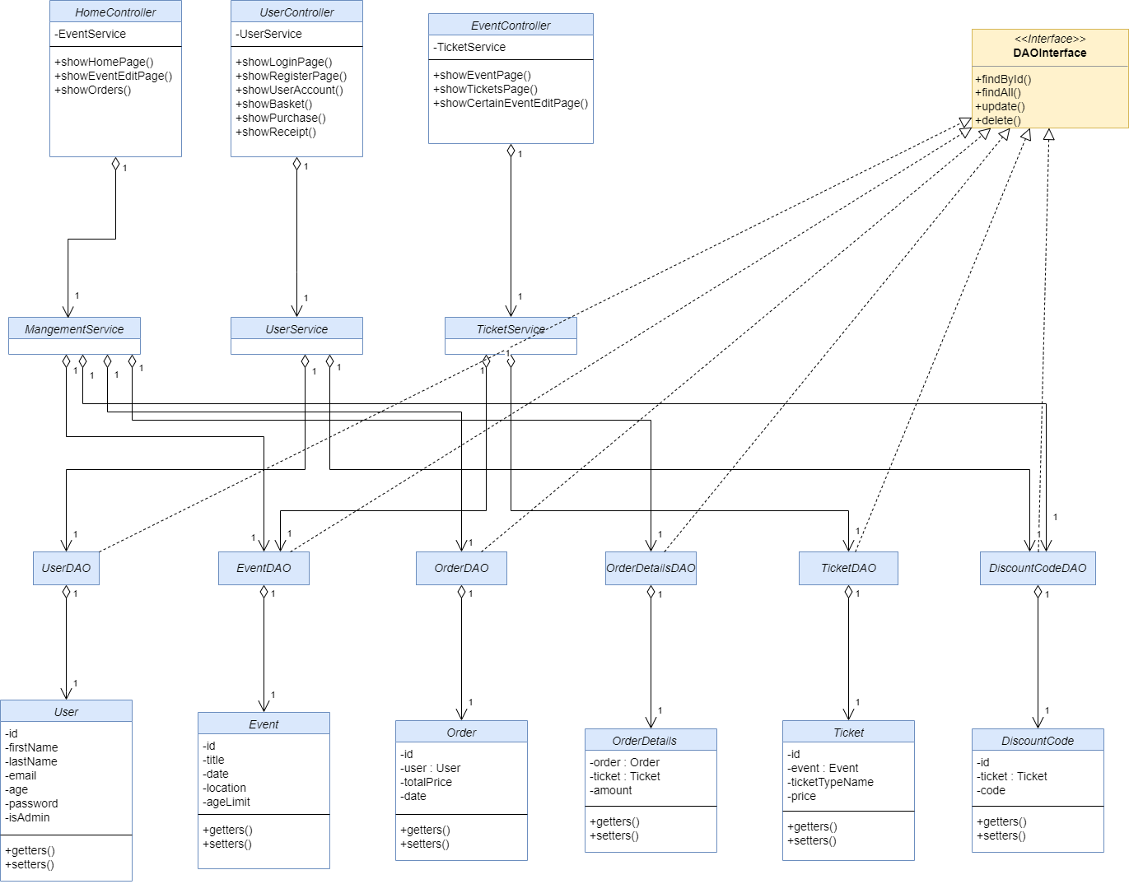

Structure Diagram:
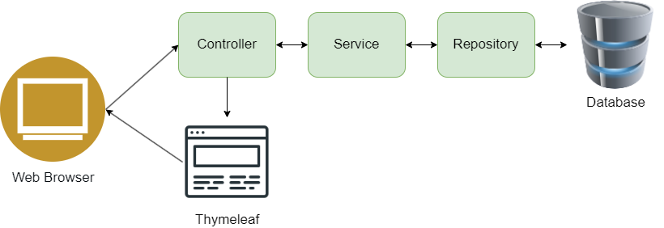

Security Diagram:
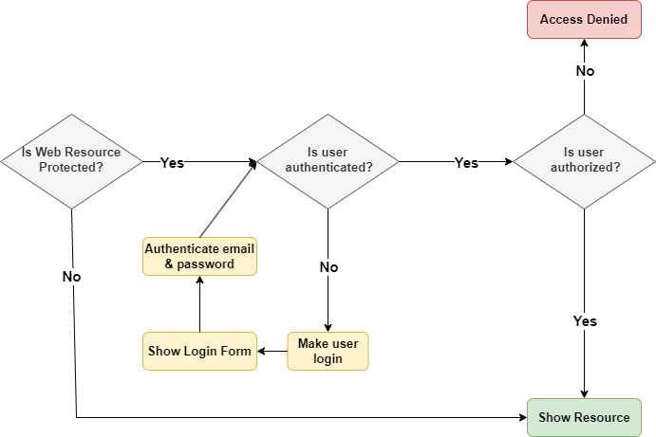

State Diagram:

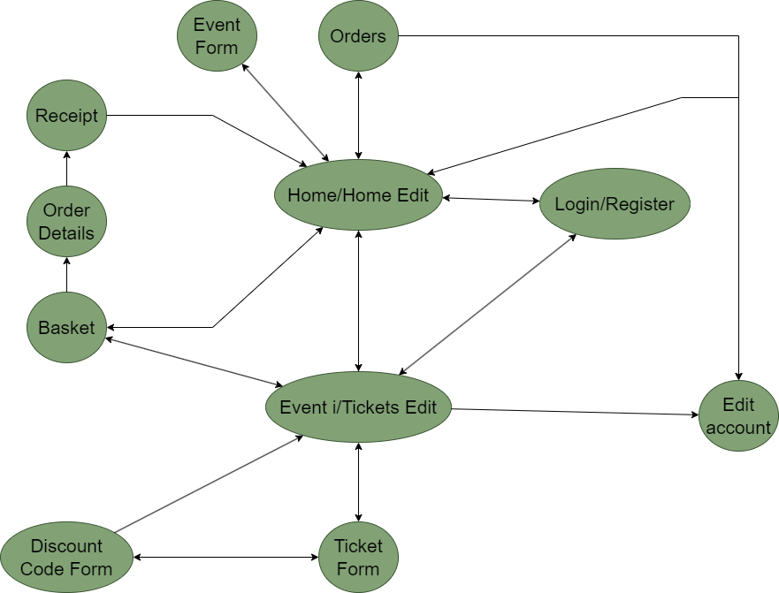

Sequence Diagram:

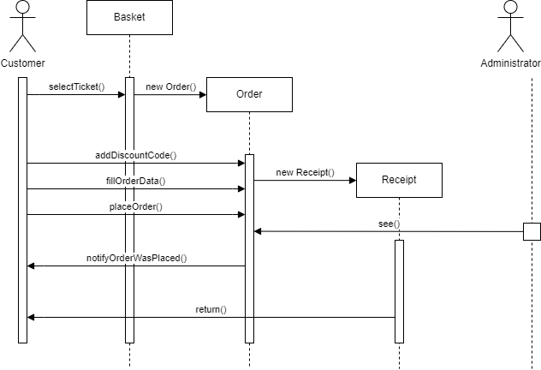

Activity Diagram:
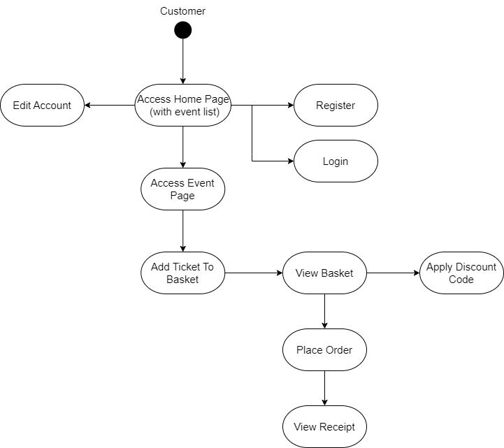
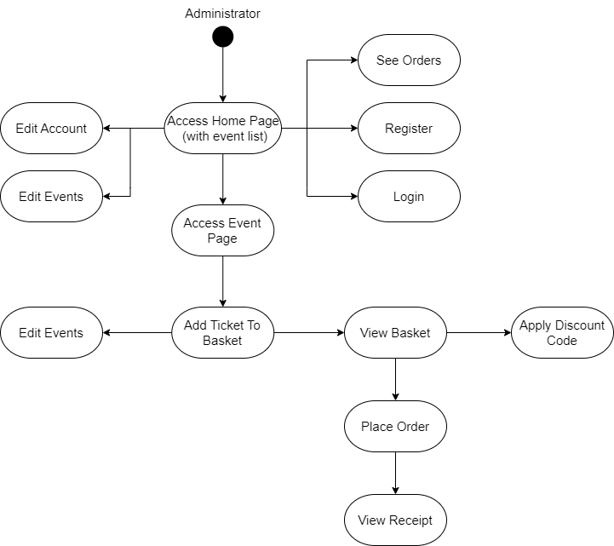

Deployment Diagram:

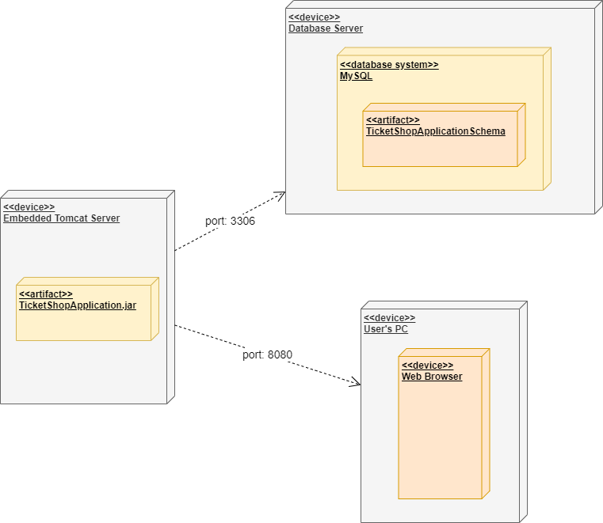

- Operation Mode (Interactivity presentation) + screen shots (UI design)

Customers and Admins:
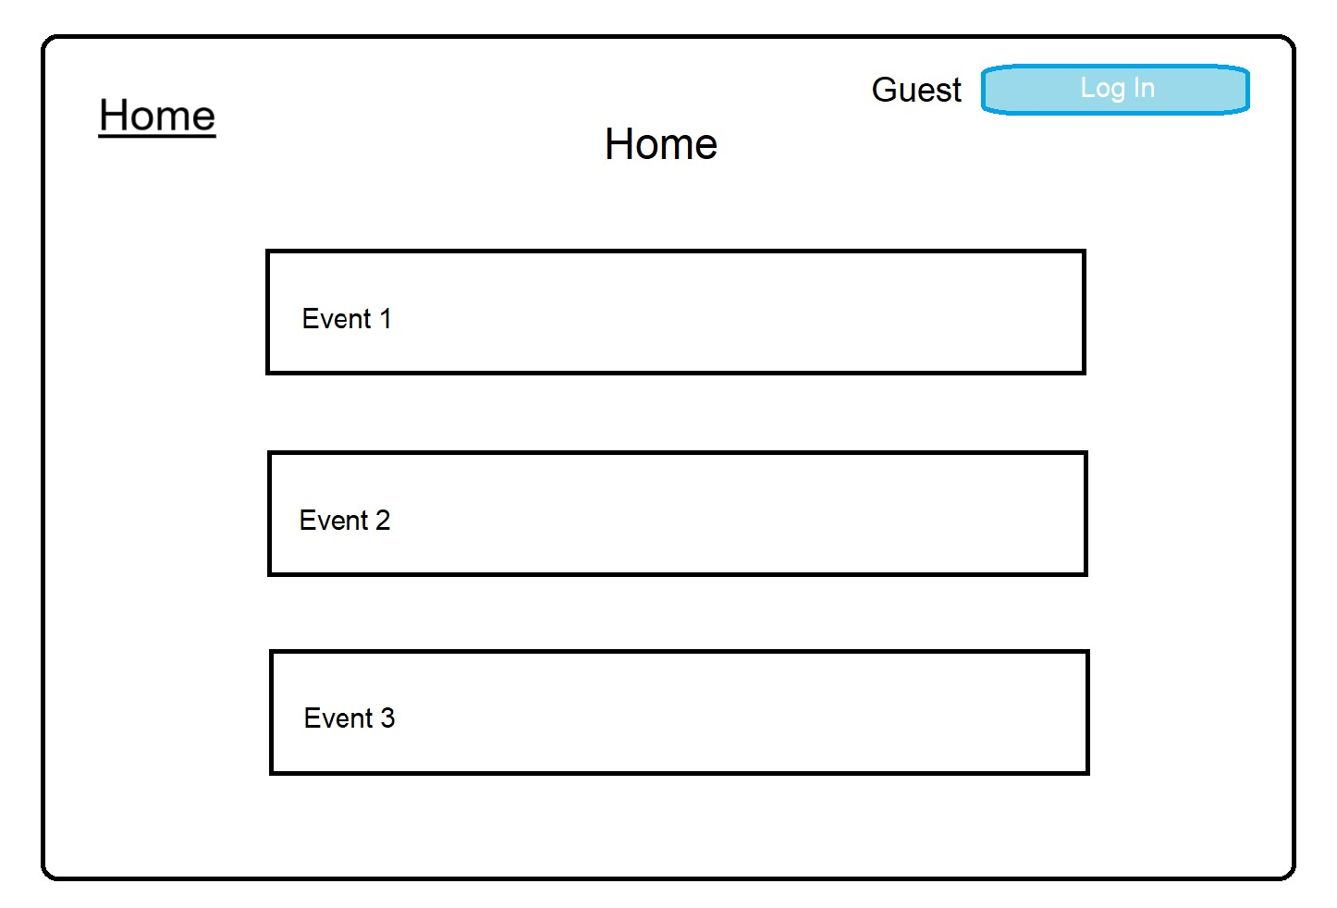
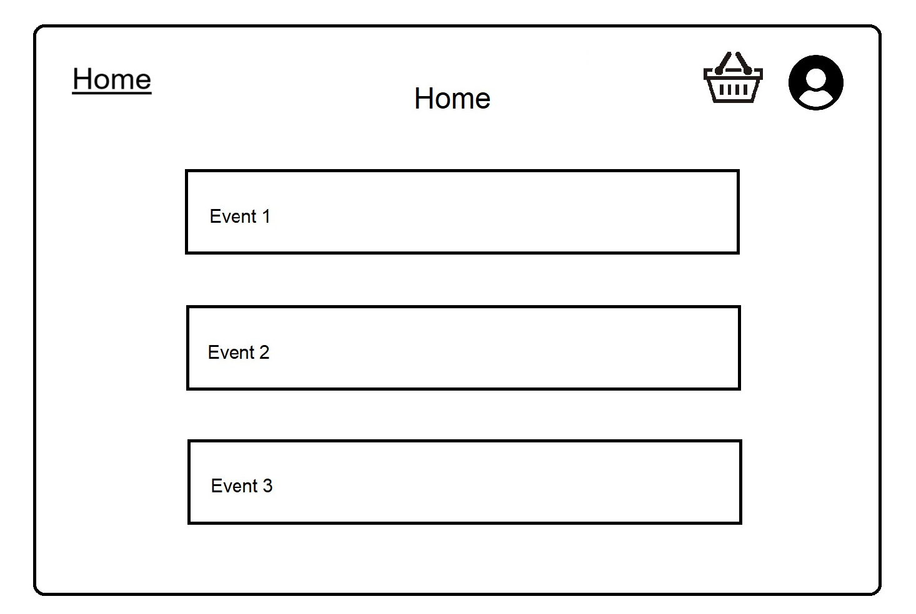
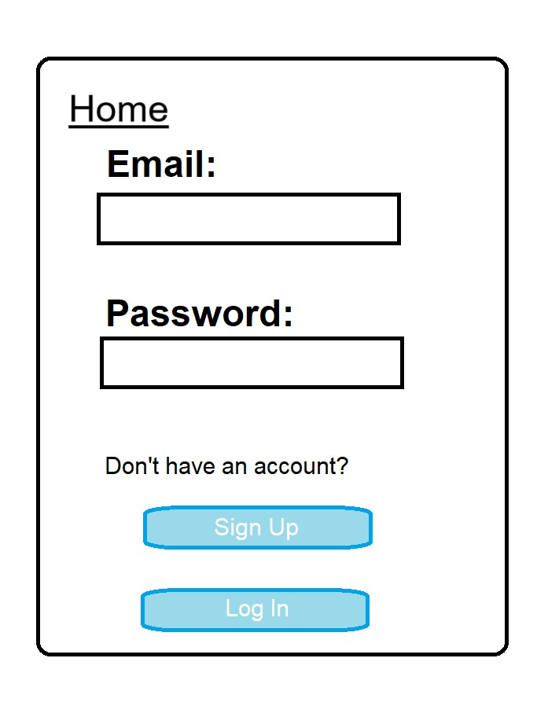
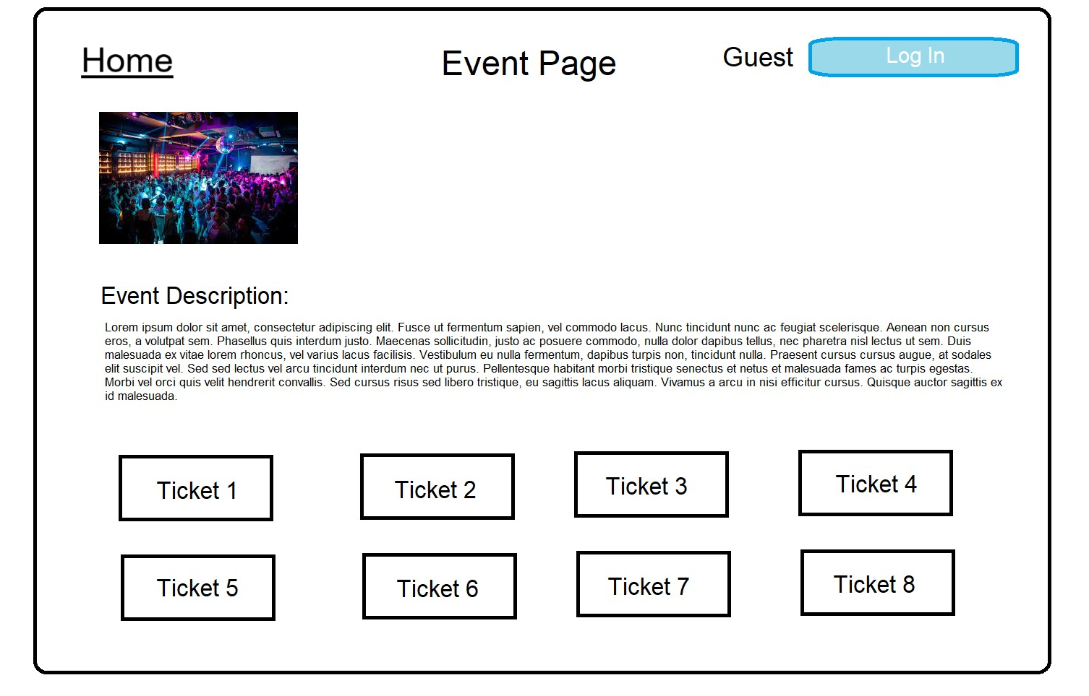

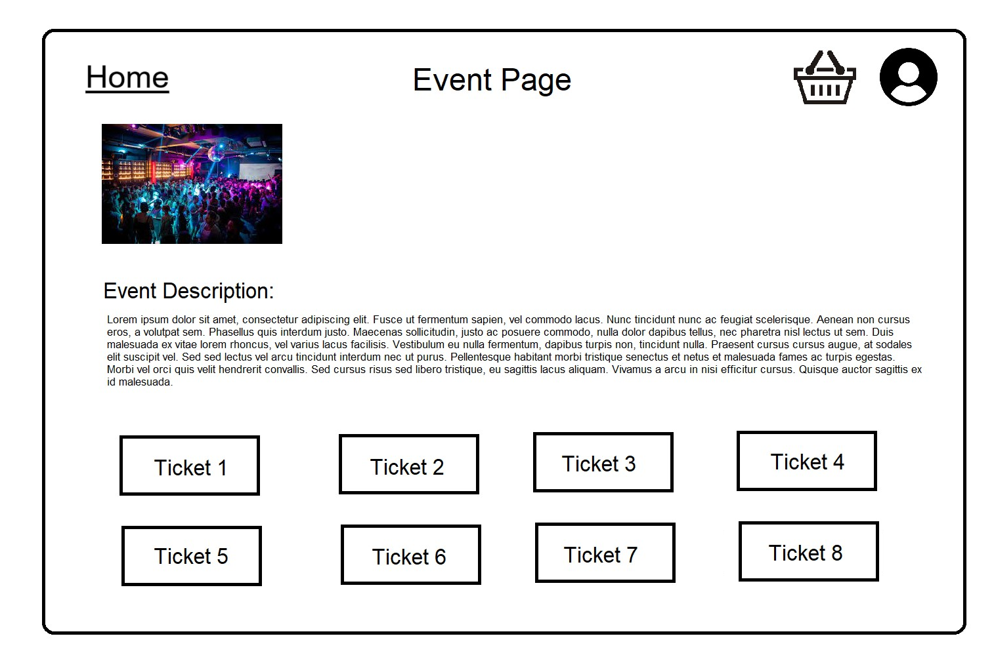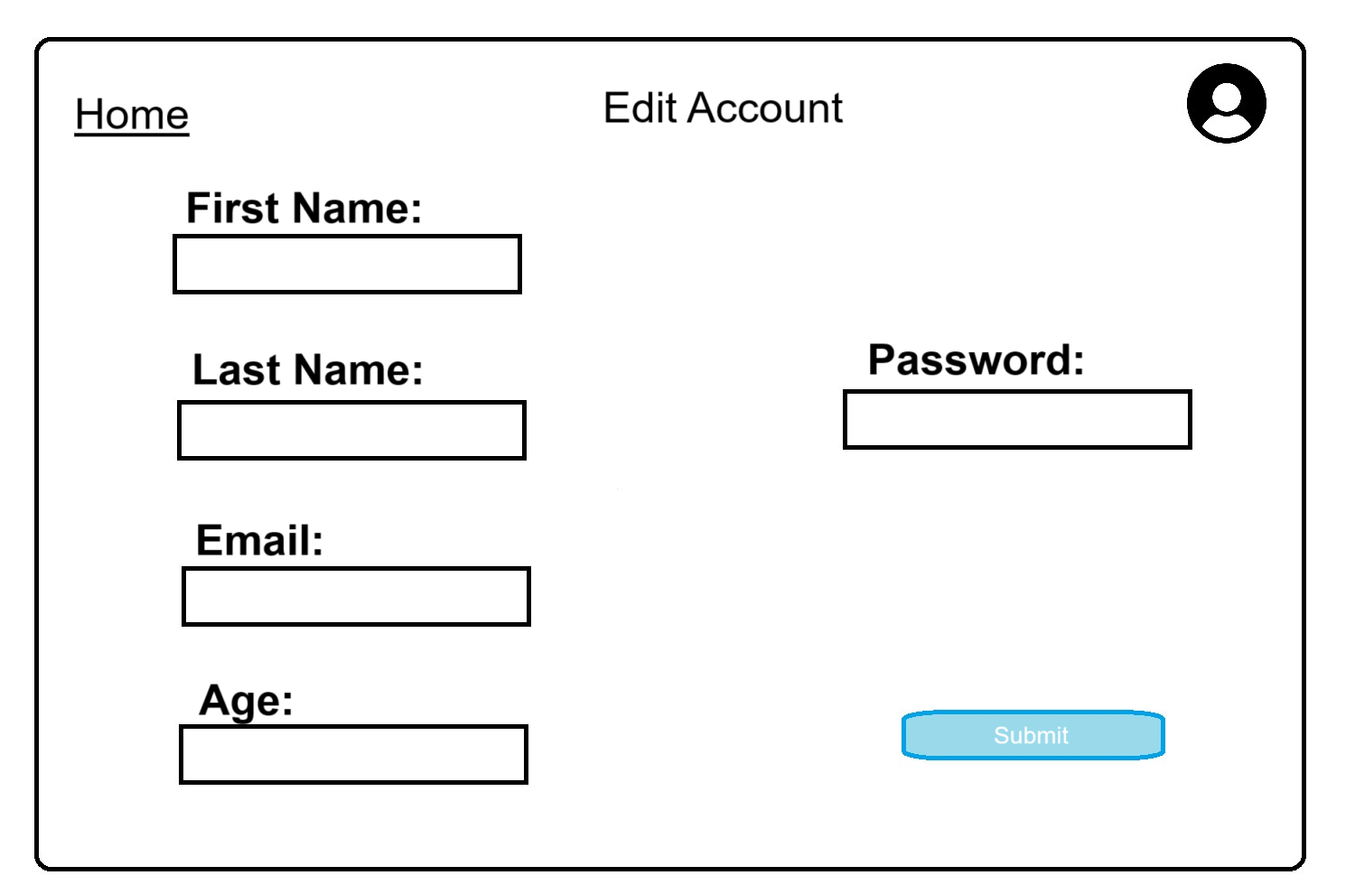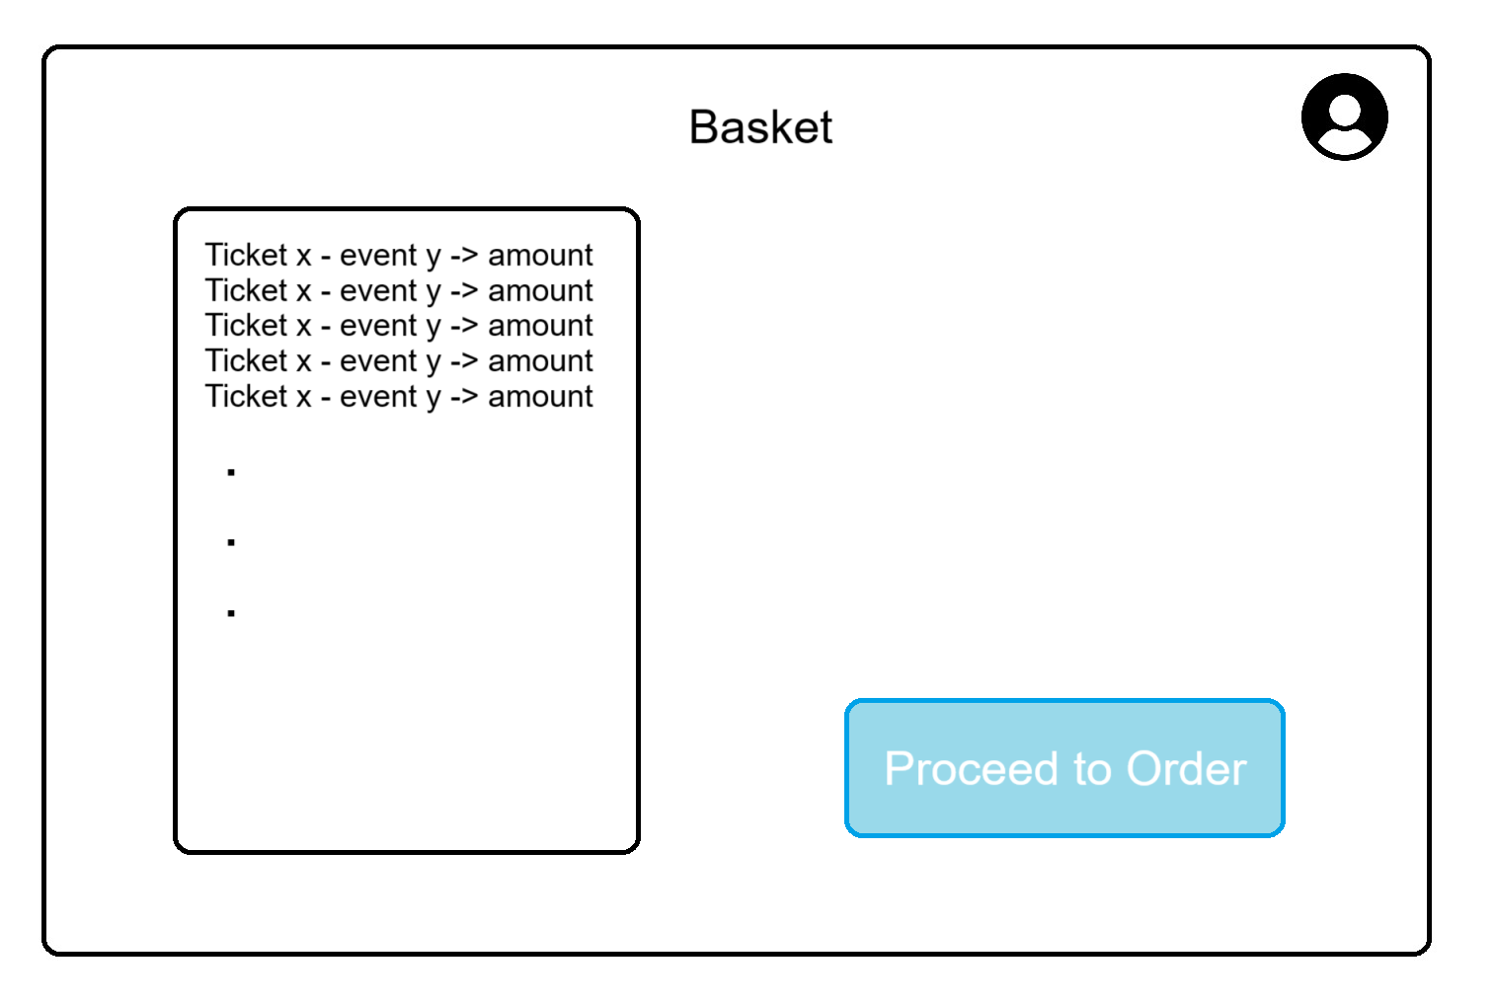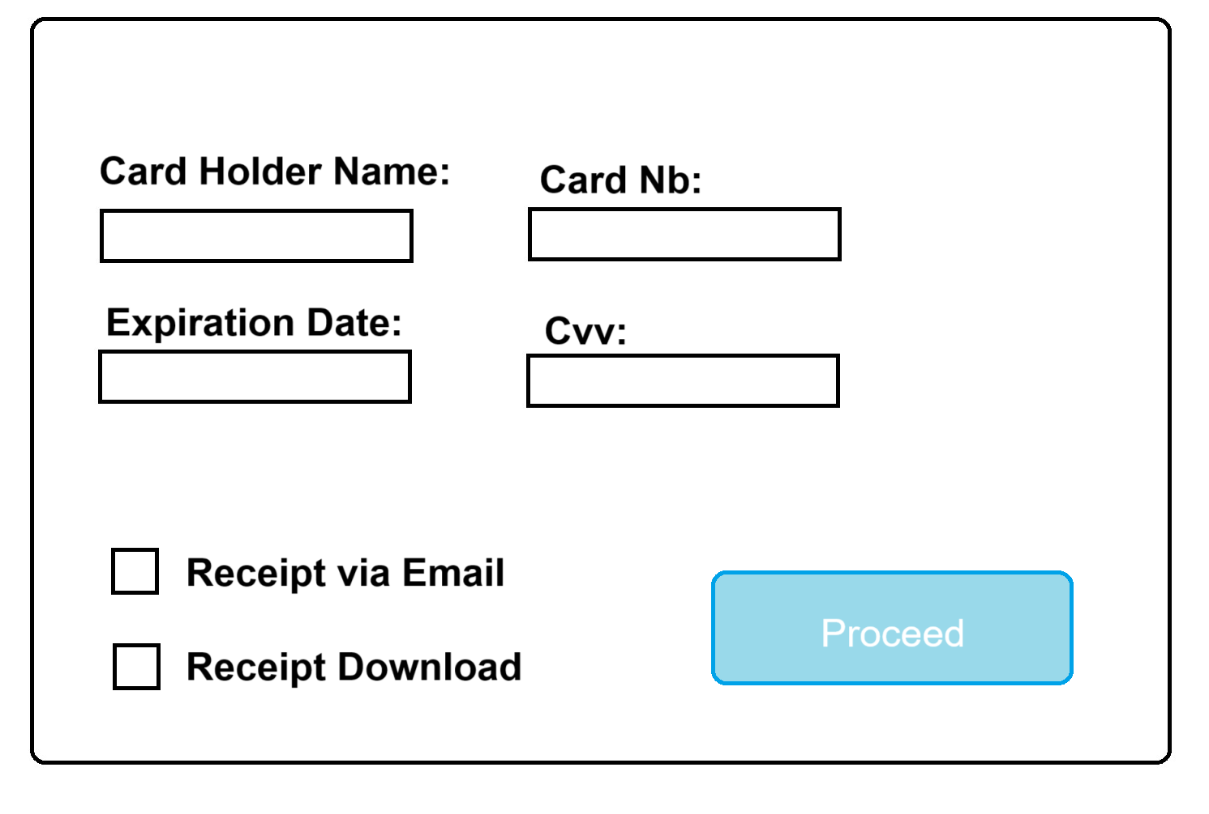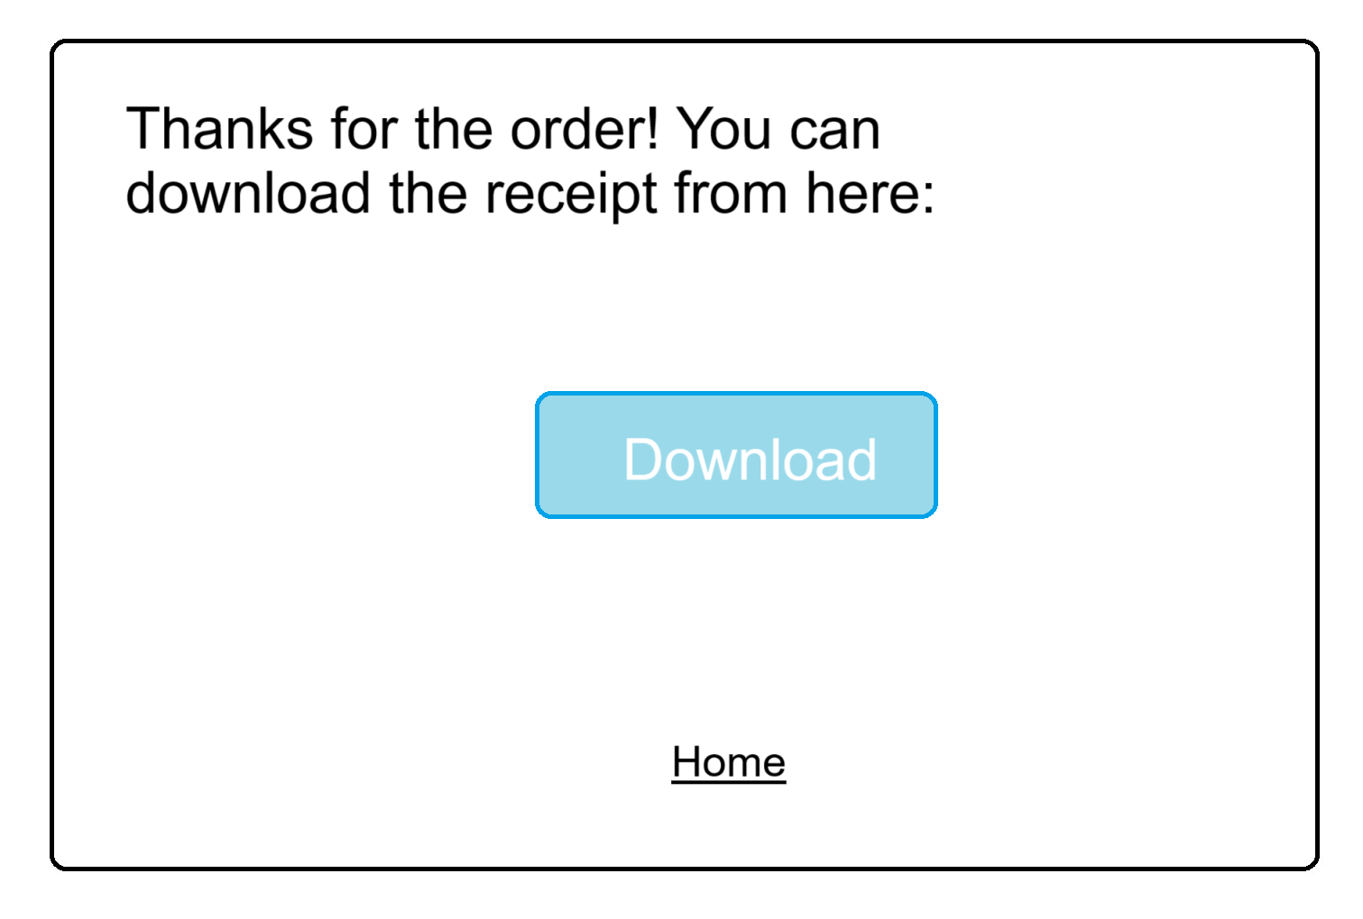

Admins:
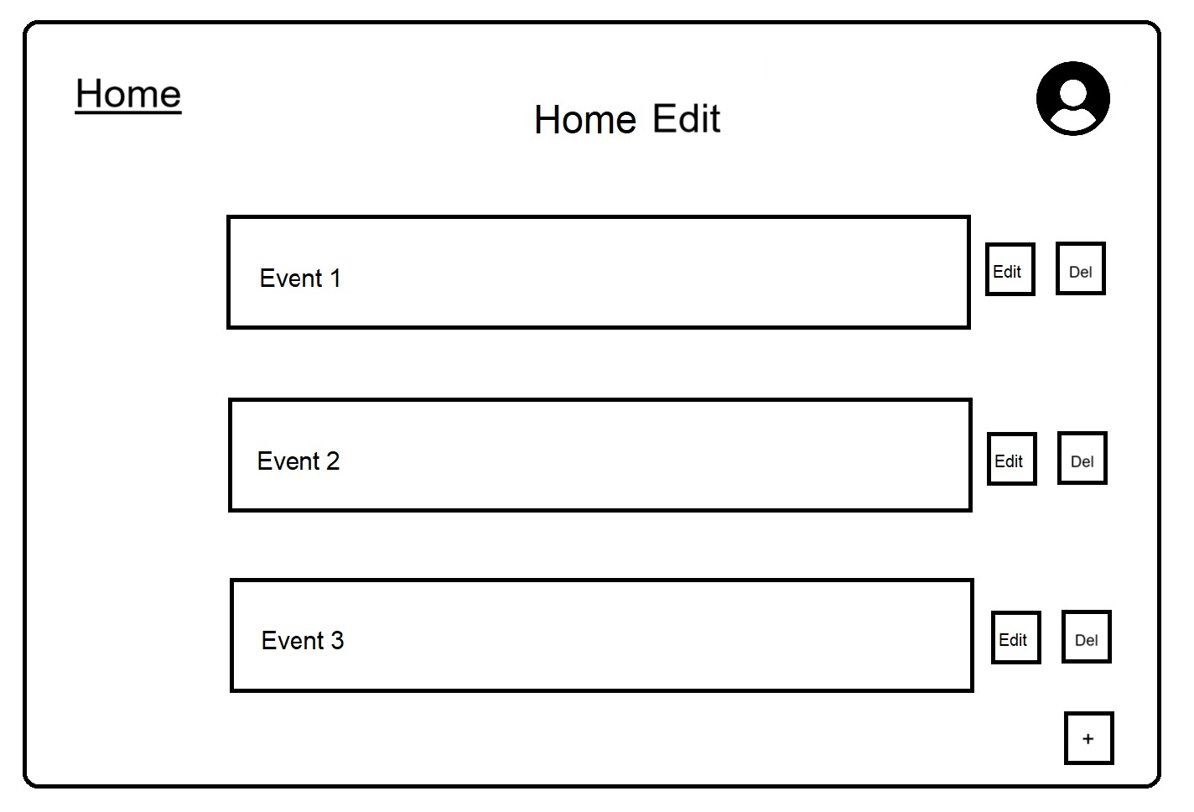
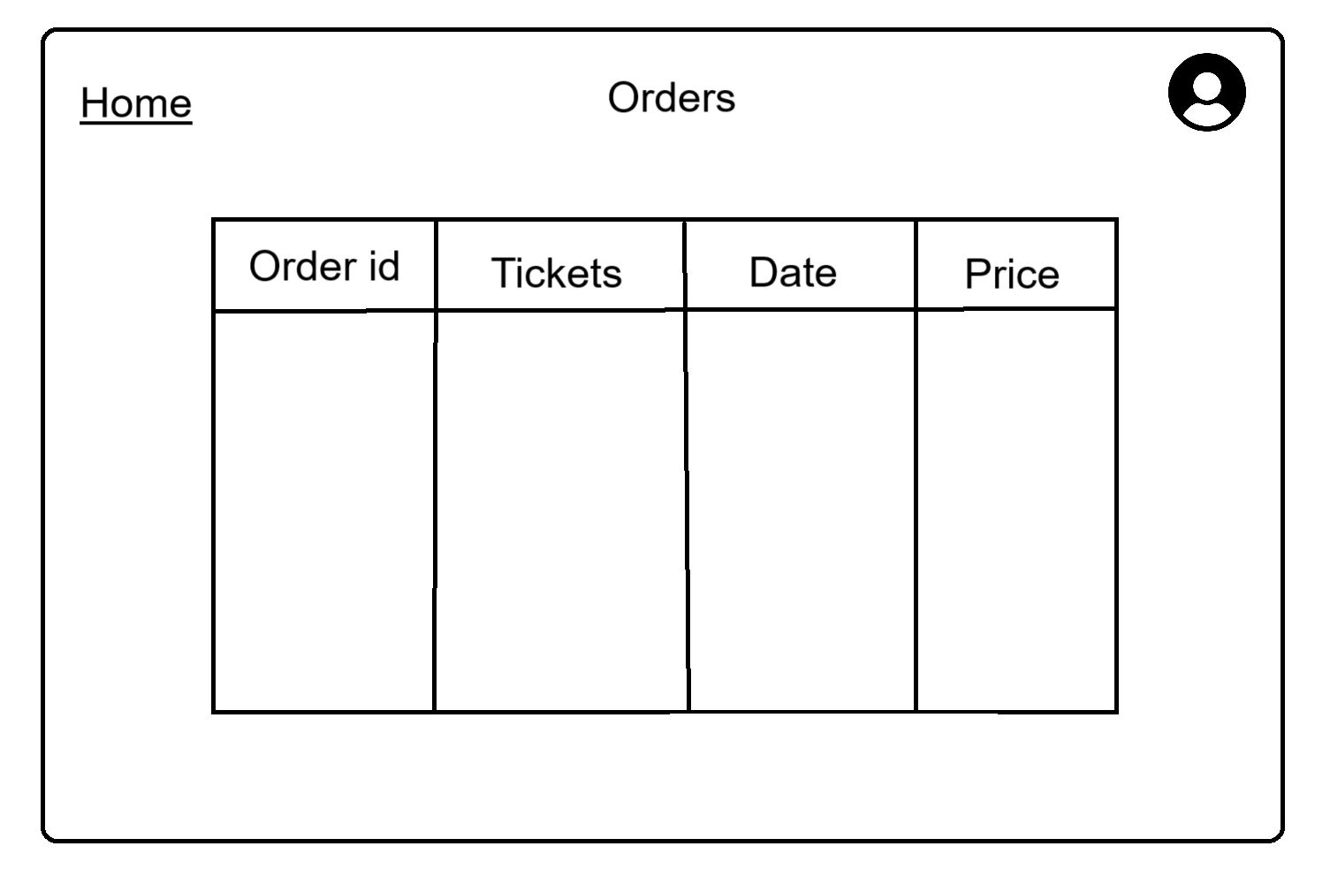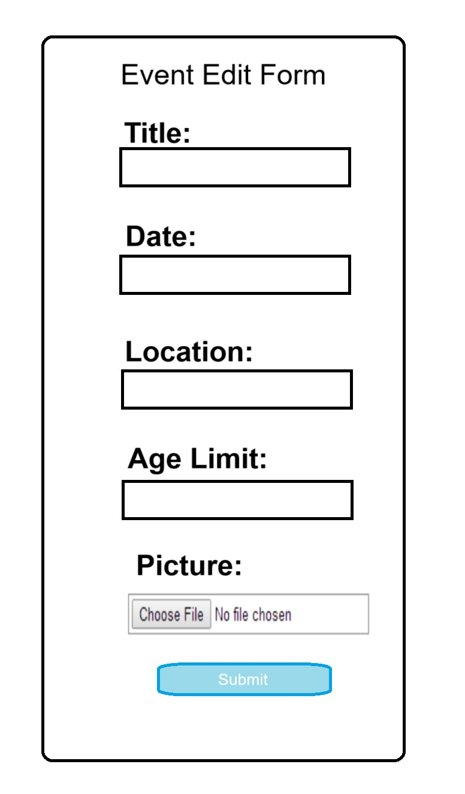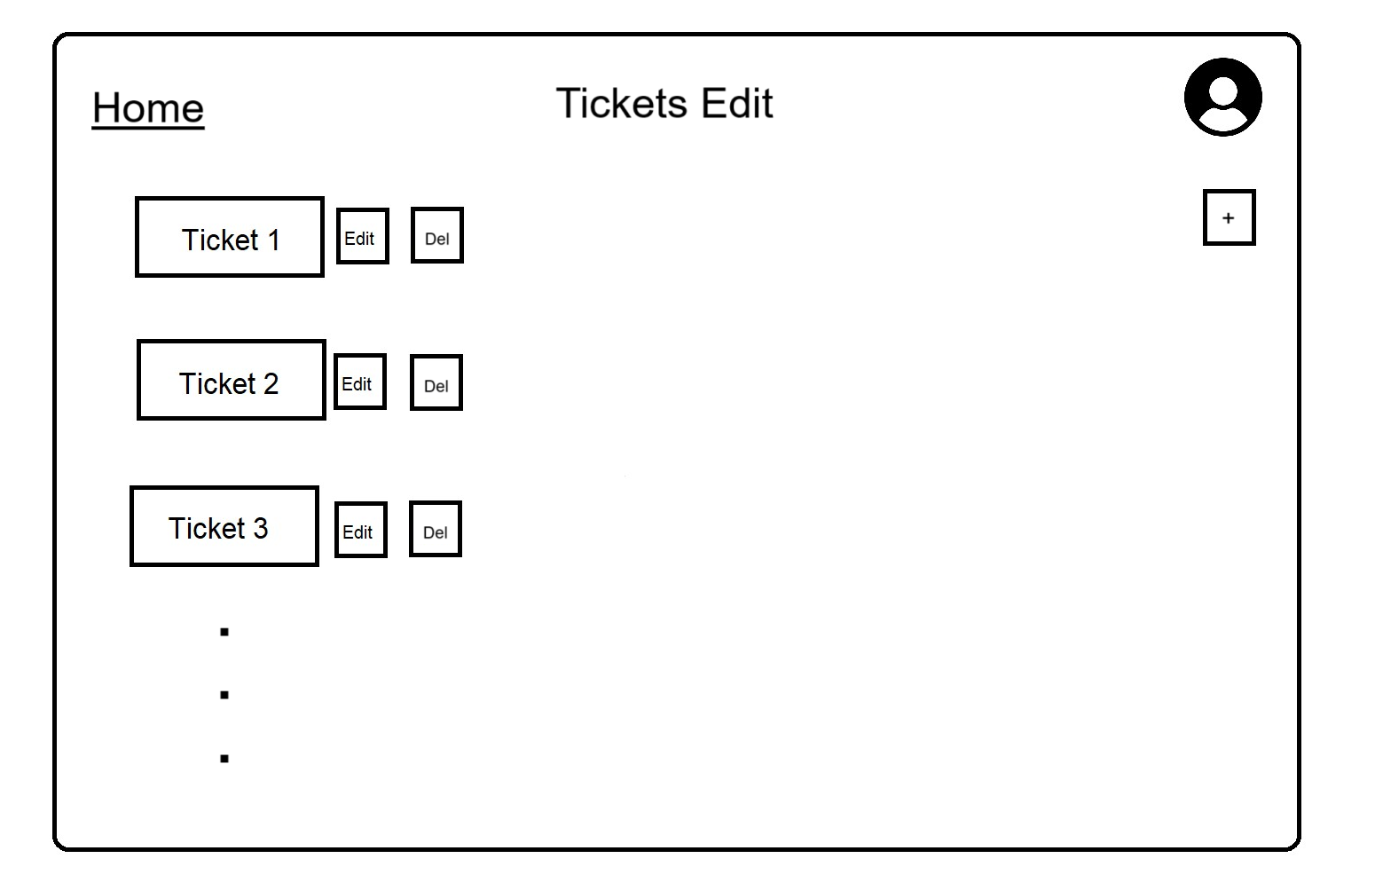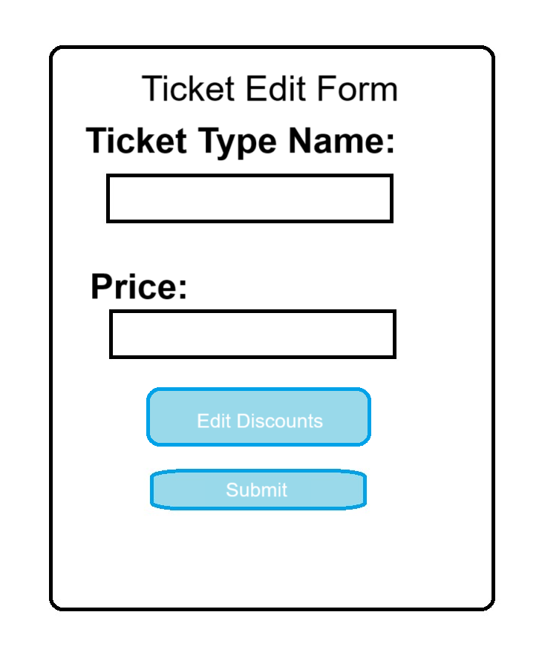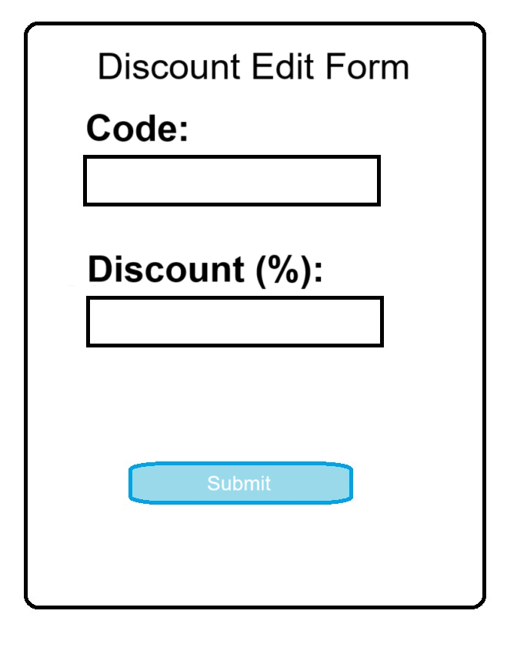

- Portability

Porting the Ticket Shop Application to another machine involves several steps to ensure a seamless transition. Begin by retrieving the application code and configurations from the version control system, ensuring consistency with the intended version. Adjust environment-specific settings in configuration files, build the application using the appropriate tools, and configure the database connection to align with the target machine. Launch the application and conduct thorough testing to validate its functionality, addressing any issues that may appear. Review and update security configurations, document the deployment process for the target environment. By following these steps, the Ticket Shop Application can be successfully ported to another machine, providing a reliable and consistent experience in the new deployment environment. Regularly updating documentation ensures that the deployment process remains well-documented for future reference.

- Competing software

Within the realm of electronic commerce, various applications may be considered competitors or alternatives to the Ticket Shop Application. E-commerce applications, by nature, involve the online buying and selling of goods or services and often share common functionalities.

