Version overview

Date | Version | Author | Comment
7.11.2023 | 0.0 | Giuroiu Tudor | The initial documentation.

System requirements for Ticket Shop Application

1 Introduction 2
2 General view of actors and use cases 2
3 Detailed description of actors and use cases 2
3.1 Actors 2
3.1.1 Administrator 2
3.1.2 Customer 3
Type: ……….. 3
3.1.3 Provider 3
3.2 Use cases 3
3.2.1 Use Case Diagram for Actor1 3
3.2.2 Use Case Diagram for Actor2 3
3.2.3 Use Case Diagram for Actor3 4
3.2.4 Use Case Diagram for Actor_{n} 4
4 Glossary – used terms 5

Introduction

The project presented in this document is a Ticket Shop Application. The application serves as a platform for managing and purchasing event tickets, offering users the capability to both make acquisitions and effect updates, a privilege reserved for administrators. The system facilitates user engagement through the creation of individual accounts, enabling login experiences or, alternatively, permitting users to explore the site as guests.

Upon accessing the application, users are presented with a selection of events, each of which can be further explored by navigating to event pages. Within these pages, users are provided with details regarding available tickets for the selected event. Users have the ability to curate their event experience by selecting desired tickets and placing them in a virtual basket, effectively creating a temporary repository for their chosen items.

Users can proceed to purchase the selected tickets from their basket, ending with the issuance of a confirmation of the transaction. Administrative users, distinguished by their enhanced privileges, are equipped with the authority to perform CRUD operations on the events and tickets. This includes the ability to modify pricing structures, adjust ticket quantities, and undertake other pertinent administrative functions to ensure optimal event management and user satisfaction.

General view of actors and use cases
This chapter should give a brief description of the actors interacting with the system (the types of external users, user groups and external entities). It also should describe the use cases present in the system.
Here is an example of the actors’ table (in case of an e-commerce project):

Administrator: The Administrator manages the system by overseeing events, tickets, discounts, and performing administrative tasks such as creating and editing events, and adjusting prices.

Customer: The Customer engages in general operations, visiting web pages, exploring events, adding tickets to a basket, and making purchases.

Actor | Type | Description
Administrator | Human | The person administrating the system, managing the events and the tickets.
Customer | Human | Performs general operations over the system, such that visiting the Web-pages, adding products to basket, buying them

The use cases present in the system are: Event Ticket Purchases, User Account Management, Guest Browsing, Event and Ticket Management for Administrators, Basket Functionality, Purchase Confirmation, Discount Application for Users.

Detailed description of actors and use cases

Actors

Administrator

Type: human
Detailed description:

Within the system, Administrators take on a vital role with special privileges, overseeing various aspects of the application. They are making sure everything runs smoothly. Their tasks cover a range of activities, starting with event management. Admins have the power to create new events, keeping the lineup fresh for users. They can also tweak event details, fix things or update info. And if an event is no longer happening, they can take it off the list.

Admins call the shots on quantities and prices. They can add new ticket categories when needed or retire old ones. They can edit, create delete and update information about tickets and events. This helps keep the ticketing system in top-notch shape.

As for discounts, Admins are responsible here. They can create discount codes and promotions, making the whole marketing and sales thing a breeze.

Where is used:
This actor is used in the: “Administrator Log-in” use case
“Administrator Log-out” use case
“Creating a ticket in the Database” use case
“Editing a ticket in the Database” use case
“Deleting a ticket in the Database” use case
“Creating an event in the Database” use case
“Editing an event in the Database” use case
“Deleting an event in the Database” use case
“Creating a discount in the Database” use case
“Editing a discount in the Database” use case
“Deleting a discount in the Database” use case

Customer

Type: human
Detailed description:

In the Ticket Shop Application, the Customer plays a crucial role in the journey of exploring, selecting, and purchasing event tickets. This customer actively engages with the platform by creating individual accounts, enabling a personalized and convenient event selection process.
Upon entering the application, customers are greeted with a diverse array of events, each offering a unique experience. Customers can navigate to dedicated event pages. These pages provide customers with details about available tickets, allowing them to make informed decisions regarding their event attendance.

The application provides customers with the ability select specific tickets and placing them in a virtual basket. This basket acts as a temporary repository, allowing users to review and finalize their selections before proceeding to the purchase stage.

Once satisfied with their ticket choices, customers can seamlessly proceed to purchase directly from their basket. The transaction issues a confirmation, providing customers with the assurance of a successful ticket purchase.

Where is used:
This actor is used in the: “Customer Log-in” use case.
“Customer Log-out” use case.
“Customer Account Creation” use case.
“Event Exploration” use case
“Ticket Selection and Basket Management” use case
“Ticket Purchase” use case
“Account Management” use case
“Applying Discount” use case

Use cases
This sub-chapter should describe how each actor would interact with the system. If the actor is a human, then describe typical ways he will use the system. System requirements captured in this way are called use cases.

Use Case Diagram for Administrator
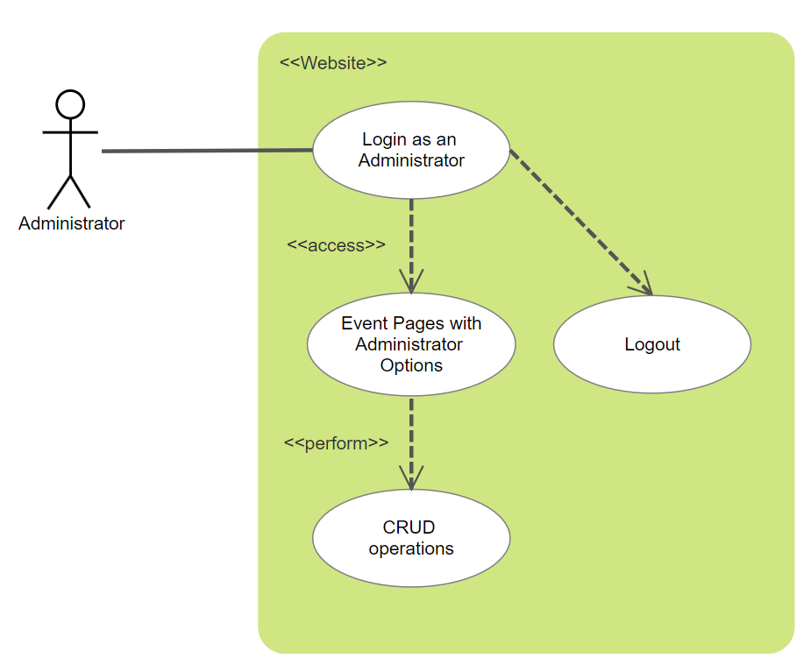
Description:
Actor: ……………..
Precondition:
Postcondition: …………………..
Behavior: ………………………………

Use Case Diagram for Actor2
………………….. / put here the use case diagrams for Actor2/

Description:
Actor: ……………..
Precondition: -
Postcondition: …………………..
Behavior: ………………………………

Use Case Diagram for Actor3

………………….. / put here the use case diagrams for Actor1/

Description:
Actor: ……………..
Precondition: -
Postcondition: …………………..
Behavior: ………………………………

………………………………

Use Case Diagram for Actor_{n}

………………….. / put here the use case diagrams for Actor_{n}/

Description:
Actor: ……………..
Precondition: -
Postcondition: …………………..
Behavior: ………………………………

Glossary – used terms
This chapter should contain all the key items or terms or entities the application deals with.
Here is an example were the glossary terms are defined:

Term | Use cases | Description
Administrator account  authentication | Administrator Log-in use case | Contains all the information needed by the administrator that wants to authenticate itself in the system using a user password schema
Provider account authentication | Provider Log-in use case | Contains all the information needed by a Provider that wants to authenticate itself in the system using a ticket schema
Maintenance file | Administrator page case | Contains all the information used by the system.
Order file | Order page | Latest orders.
Shopping Card | Adding an Article to the Shopping Cart,  Ordering, Delivery and payment | It is used for buying and ordering a product
…………….. | …………… | ………………………………………………………….
………………. | ………… | ………………………………………………………….

Terms with related meanings and/or that are used in similar contexts can be grouped by term groups as depicted in the following table.

Term Groups | Included terms and term groups | Description
Authentication | Administrator password authentication, Provider password authentication | Defines a general group of credentials used in the authentication process

