SEMESTER PROJECT

**Fundamentals of Computer Aided Graphics**

**TWO-PORT DR SWITCHING CIRCUITS**

**Supervisors: Student:**

Conf. Dr. Ing. Mihaela Carlugea Tudor Cristian Ienuțaș

Prof. Farago Paul Group 2023

Table of contents

I. Introduction 3

1. The DR Two-port network 3

I.1.1. Common circuits and applications where DR two-port networks are used 5

I.1.2. History of DR Two-Port Networks 5

2. Matlab 5

I.2.1. Short description 5

I.2.2. Matlab history 5

II. Illustration (3D) (2D) 6

III. Experimental results 8

IV. Conclusions 12

V. References 12

# Introduction

## The DR two-port network in general

A DR two-port network, which stands for Diode and Resistor, refers to a network that incorporates both diodes and resistors in its structure. This type of network is commonly used in electronic circuits where the interaction between diodes and resistors plays a significant role in determining the overall behavior of the system. The inclusion of diodes introduces nonlinear elements to the network, making the analysis more complex than that of linear networks.

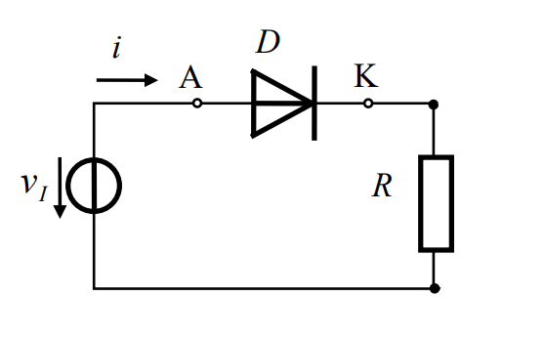

* + 1. **Common circuits and applications where DR two-port networks are used**

**A.Rectifier Circuits**:

DR networks are often employed in rectifier circuits, where diodes convert alternating current (AC) to direct current (DC). Resistors in the circuit might be used for load balancing or current limiting.

**B.Voltage Regulators:**

In voltage regulator circuits, DR networks can be utilized for voltage regulation, ensuring a stable output voltage despite variations in input voltage or load conditions. Resistors may be employed to set reference voltages or to divide voltage for feedback purposes.

**C.Amplifiers**:

DR networks are integrated into amplifiers, especially in RF (Radio Frequency) and microwave circuits, where diodes are used for signal detection and rectification.Resistors may be used in biasing circuits to establish the operating point of amplifying devices.

**D.Signal Processing Circuits:**

In signal processing applications, DR networks can be used for functions like signal conditioning, filtering, and modulation.

Diodes may be employed for nonlinear operations, while resistors play a role in shaping the frequency response.

|  |  |
| --- | --- |
|  | * Vd: Voltage across the diode * Id: Curren across the diode     **Electronic symbol For Diode and Rezistor** |
|  | |

* + 1. **History of DR TWO-PORT NETWORKS**

The history of DR (Diode-Resistor) two-port networks is intertwined with the broader evolution of network theory and electronic circuit analysis. In the 19th century, foundational work by scientists like George Green and Lord Kelvin set the stage for understanding electrical circuits. The development of the Telegrapher's Equations in the 1840s was pivotal for analyzing transmission lines.

Matrix methods emerged in the 1920s-1930s, with researchers like Harry Nyquist contributing to the mathematical representation of networks. By the 1940s, the formalization of two-port networks gained prominence, offering a simplified approach to analyze complex electronic systems. Initially focused on linear systems, advancements in the later 20th century addressed the integration of nonlinear elements, reflecting the evolving landscape of electronics and circuit analysis.

## 2.Matlab

### Short description

MATLAB (Matrix Laboratory) is a powerful and widely used high-level programming language and interactive environment designed for numerical computation, data analysis, and visualization. Developed by MathWorks, MATLAB excels in handling matrices and arrays, making it a versatile tool for scientific and engineering applications.

It provides a user-friendly interface, extensive libraries, and a rich set of functions for tasks ranging from mathematical modeling and simulation to data analysis and plotting. MATLAB is popular across various disciplines for its efficiency in algorithm development, mathematical modeling, and problem-solving.

### Matlab history

MATLAB, short for Matrix Laboratory, was created by Cleve Moler in the late 1970s. Moler, a computer scientist and mathematician, developed MATLAB to provide his students with access to the LINPACK and EISPACK libraries for numerical computing. Initially developed for use with his teaching and research, MATLAB quickly gained popularity due to its intuitive syntax and powerful capabilities.

In the 1980s, Moler co-founded MathWorks, a company dedicated to further developing and distributing MATLAB. The software evolved over the years, incorporating new features, toolboxes, and functions to cater to a broad range of applications in engineering, science, and beyond. Today, MATLAB is an industry-standard tool for numerical computing, algorithm development, and data analysis, with a global user base spanning academia, research, and industry.

# Illustration of the circuit in different programs

## Two-port DR network (2D FORMAT)(Ltspice)

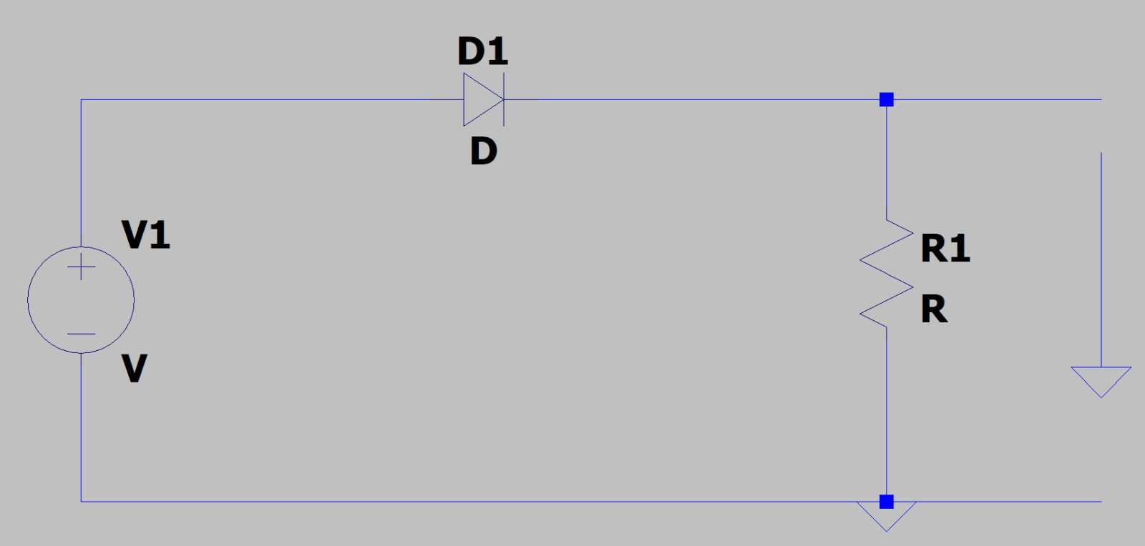

**Two-port DR network with output across R**

**Two-port DR network with output across D**

# Experimental results

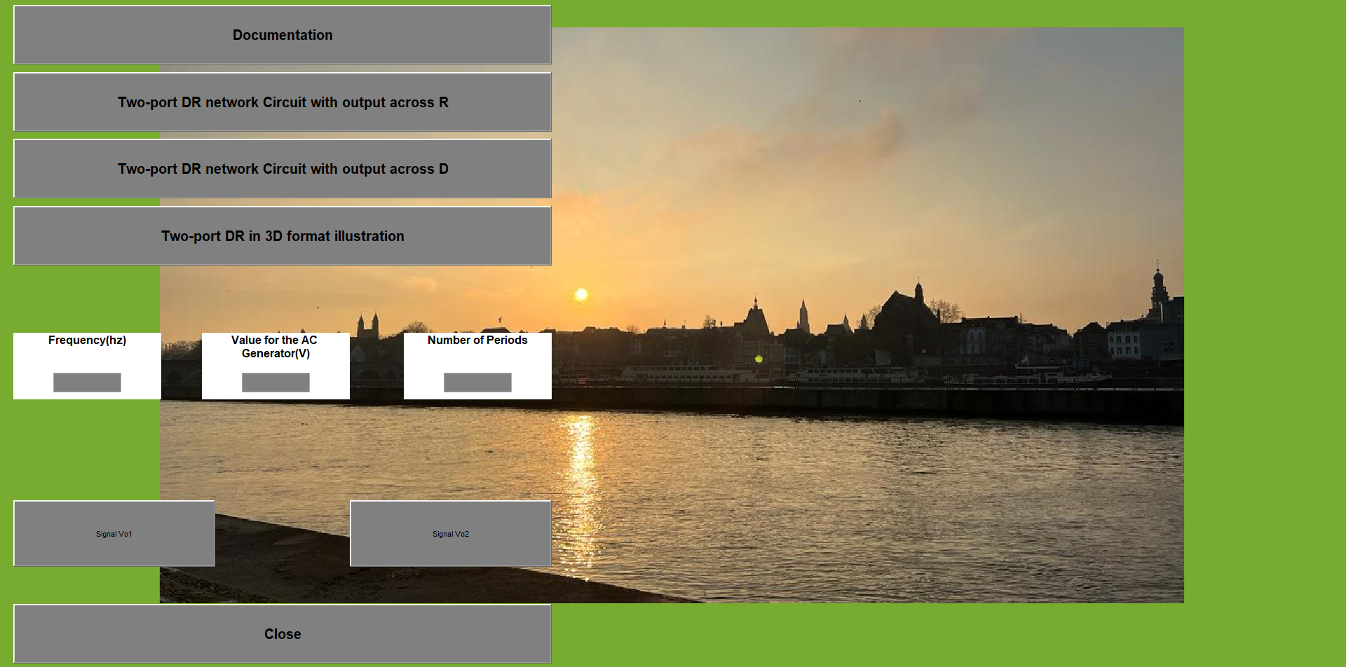

**The interface in Matlab**

This interface contains the following :

* 7 push buttons:
* **Documentation** – opens the docx file about the theoretical documentation.
* **Two-port DR network Circuit with output across R** – opens the jpg file showing the circuit made in Ltspice.
* **Two-port DR network Circuit with output across D -** opens the jpg file showing the circuit made in Ltspice.
* **Two-port DR in 3d format illustration. –** opens the jpg file showing the circuit made in Crumb.
* **Signal Vout1** – plots the graphic for the circuit with output across R;
* **Signal Vout2** – plots the graphic for the circuit with output across D;
* **Close**- close button.
* 3 edit buttons, which you can edit the values for the plots.
* 3 text buttons:
* **Frequency(hz)**
* **Value for the AC Generator(V)**
* **Number of periods**

**The circuits schematic represented in LTspice**

The images of the circuit are opened in Matlab with the function *imagine.* This window contains also a push button that links it to the interface.

**The plots of Vout1 and Vout2 in Matlab**

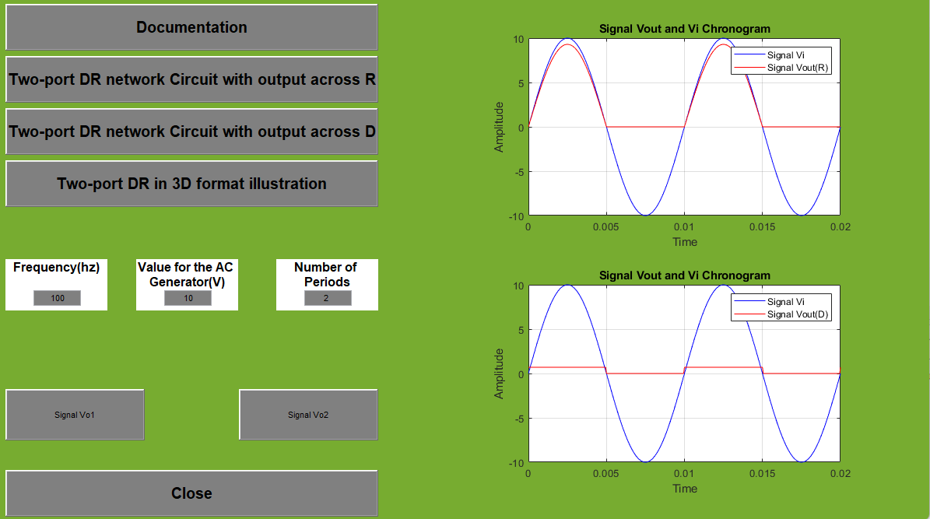

# Conclusions

For this project “**TWO-PORT DR SWITCHING CIRCUITS**” I made a Matlab GUI that can show the plots for the output of the diode (Vo1), and for rezistor(Vo2)The values can be changed for the frequency, generator and number of periods that can be changed from the edit boxes.

# References

# https://en.wikipedia.org/wiki/MATLAB

# http://www.bel.utcluj.ro/dce/didactic/ed/4.DR_circuits_eng.pdf

# http://www.bel.utcluj.ro/dce/didactic/ed/ http://www.bel.utcluj.ro/dce/didactic/ed/C3.%20DR%20switching%20circuits.pdf

# 

## 