Analysing Audio Signals for IP3 Calculation Using FFT  
Puscasu Tudor

**Abstract**

This report investigates the application of Fast Fourier Transform (FFT) to analyse audio signals recorded at varying playback volumes to calculate the third-order intercept point (IP3), a critical measure of intermodulation distortion. The analysis involved identifying key frequency peaks, calculating IP3 values, and observing their trends across different volume levels. The results provide insights into distortion characteristics in real-world audio environments and the potential influence of ambient noise on intermodulation distortion.

**Introduction**

Intermodulation distortion (IMD) is a common phenomenon in audio systems, particularly in environments with nonlinear components. The third-order intercept point (IP3) quantifies the system's tolerance to such distortion, offering valuable insights into its performance. This study focuses on analysing real-world audio signals played back and recorded at different volume levels. Using FFT, the signals' frequency spectra were examined, and key peaks were identified to calculate IP3 values. The goal was to observe how nonlinear distortion varies with playback volume and identify potential environmental influences on recorded signals.

**Methodology**

**Experimental Setup**

1. **Audio Playback and Recording:**
   * Audio signals were played back at five distinct volume levels: **10%, 30%, 50%, 70%, and 100%.**
   * Recordings were captured in an environment influenced by ambient noise using a microphone setup.
   * Audio files were exported in **48 kHz 24-bit PCM mono format** using the **Audacity application.**

**Signal Processing**

1. **Preprocessing and Normalization:**
   * The recorded audio signals were imported as .wav files and processed using the Python scipy library.
   * Signals were normalized by dividing all samples by the maximum absolute value to ensure consistent scaling.
2. **FFT Analysis:**
   * FFT was applied to convert the time-domain audio signals into the frequency domain.
   * The analysis focused on **positive frequencies** by filtering out negative components, retaining only the meaningful spectrum.
3. **Visualization and Plotting:**
   * FFT spectra were visualized with **frequency (Hz)** on the x-axis and **magnitude (dB)** on the y-axis.
   * Two prominent peaks corresponding to the **fundamental frequencies** (f1f_1f1​ and f2f_2f2​) were highlighted using red dots for clear identification.

**Peak Detection and IP3 Calculation**

1. **Peak Detection:**
   * The two strongest peaks in the FFT spectrum were identified as f1 and f2.
   * The intermodulation distortion (IMD) frequencies, 2f1 - f2 and 2f2 - f1, were also located.
2. **IP3 Calculation:**
   * IP3 values were calculated for each volume level using the power levels of f1, f2, and the IMD frequencies.
   * Both lower (2f1 - f2) and upper (2f2 - f1) IP3 values were derived for comparative analysis.

**Results**

**Tabulated Results**

| **Volume Level (%)** | **f1​ (Hz)** | **f2 (Hz)** | **IP3 Lower (dB)** | **IP3 Upper (dB)** |
| --- | --- | --- | --- | --- |
| 10% | 999.89 | 1499.83 | 41.84 | 42.88 |
| 30% | 999.94 | 1499.81 | 42.11 | 42.83 |
| 50% | 1000.00 | 1499.80 | 41.17 | 42.01 |
| 70% | 999.94 | 1499.82 | 41.50 | 41.62 |
| 100% | 999.78 | 1499.77 | 40.68 | 41.28 |

**Visualizations**

**FFT spectrum plots for each volume level were generated, showing clear frequency peaks for f1 and f2. The highest peaks were marked with red dots for clarity, corresponding to the fundamental frequencies used in IP3 calculations.**

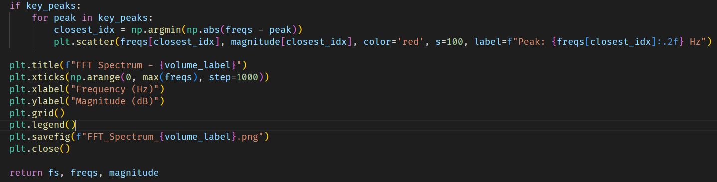

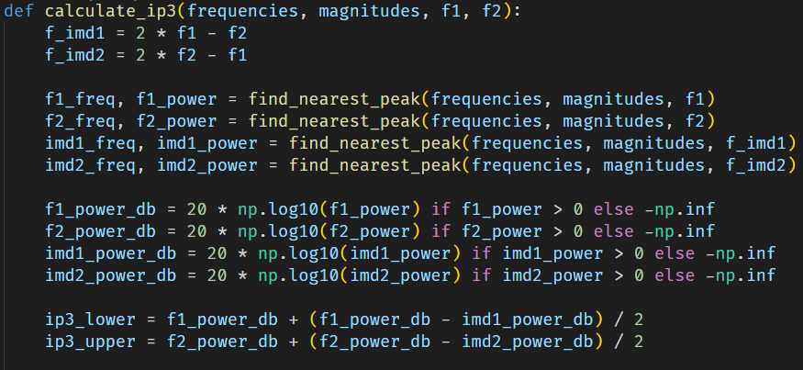

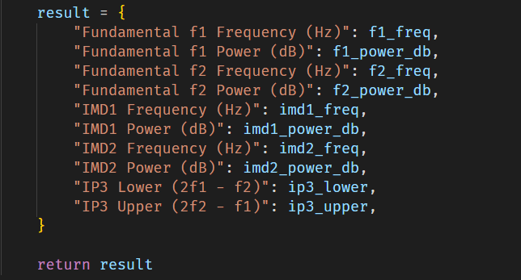

FFT Plot for 10% volume

FFT Plot for 30% volume

FFT Plot for 50% volume:  
  
FFT Plot for 70% volume:

FFT Plot for 100% volume:

Output:  
Analysing 10% Volume recording...

Detected f1: 999.89 Hz, f2: 1499.83 Hz

IP3 Calculation Results for 10% Volume:

Fundamental f1 Frequency (Hz): 999.89 Hz

Fundamental f1 Power (dB): 39.11 dB

Fundamental f2 Frequency (Hz): 1499.83 Hz

Fundamental f2 Power (dB): 39.18 dB

IMD1 Frequency (Hz): 499.94 Hz

IMD1 Power (dB): 33.66 dB

IMD2 Frequency (Hz): 1999.77 Hz

IMD2 Power (dB): 31.76 dB

IP3 Lower (2f1 - f2): 41.84 dB

IP3 Upper (2f2 - f1): 42.88 dB

Analysing 30% Volume recording...

Detected f1: 999.94 Hz, f2: 1499.81 Hz

IP3 Calculation Results for 30% Volume:

Fundamental f1 Frequency (Hz): 999.94 Hz

Fundamental f1 Power (dB): 39.01 dB

Fundamental f2 Frequency (Hz): 1499.81 Hz

Fundamental f2 Power (dB): 39.21 dB

IMD1 Frequency (Hz): 499.87 Hz

IMD1 Power (dB): 32.81 dB

IMD2 Frequency (Hz): 1999.68 Hz

IMD2 Power (dB): 31.97 dB

IP3 Lower (2f1 - f2): 42.11 dB

IP3 Upper (2f2 - f1): 42.83 dB

--------------------------------------------------

Analysing 50% Volume recording...

Detected f1: 1000.00 Hz, f2: 1499.80 Hz

IP3 Calculation Results for 50% Volume:

Fundamental f1 Frequency (Hz): 1000.00 Hz

Fundamental f1 Power (dB): 38.88 dB

Fundamental f2 Frequency (Hz): 1499.80 Hz

Fundamental f2 Power (dB): 39.15 dB

IMD1 Frequency (Hz): 500.00 Hz

IMD1 Power (dB): 34.29 dB

IMD2 Frequency (Hz): 1999.80 Hz

IMD2 Power (dB): 33.45 dB

IP3 Lower (2f1 - f2): 41.17 dB

IP3 Upper (2f2 - f1): 42.01 dB

--------------------------------------------------

Analysing 70% Volume recording...

Detected f1: 999.94 Hz, f2: 1499.82 Hz

IP3 Calculation Results for 70% Volume:

Fundamental f1 Frequency (Hz): 999.94 Hz

Fundamental f1 Power (dB): 39.28 dB

Fundamental f2 Frequency (Hz): 1499.82 Hz

Fundamental f2 Power (dB): 39.22 dB

IMD1 Frequency (Hz): 499.87 Hz

IMD1 Power (dB): 34.60 dB

IMD2 Frequency (Hz): 1999.89 Hz

IMD2 Power (dB): 34.64 dB

IP3 Lower (2f1 - f2): 41.62 dB

IP3 Upper (2f2 - f1): 41.50 dB

Analysing 100% Volume recording...

Detected f1: 999.78 Hz, f2: 1499.77 Hz

IP3 Calculation Results for 100% Volume:

Fundamental f1 Frequency (Hz): 999.78 Hz

Fundamental f1 Power (dB): 38.86 dB

Fundamental f2 Frequency (Hz): 1499.77 Hz

Fundamental f2 Power (dB): 39.79 dB

IMD1 Frequency (Hz): 499.99 Hz

IMD1 Power (dB): 35.23 dB

IMD2 Frequency (Hz): 1999.75 Hz

IMD2 Power (dB): 36.82 dB

IP3 Lower (2f1 - f2): 40.68 dB

IP3 Upper (2f2 - f1): 41.28 dB

Script for generating two-tone signal

**Discussion**

The IP3 values across the tested volume levels exhibited minor variations, remaining relatively stable. This indicates that the observed distortion is not significantly influenced by playback volume.

**Key Observations:**

1. The consistency in f1 and f2 frequencies across all recordings suggests minimal signal degradation during playback and recording.
2. Ambient noise, rather than playback volume, likely contributes to variations in IMD magnitudes. This includes environmental factors such as background noise and recording artifacts.
3. The use of FFT effectively identified fundamental and IMD frequencies, enabling accurate IP3 calculations.

**Limitations:**

1. The analysis was conducted in an uncontrolled environment, allowing for ambient noise interference.
2. FFT resolution may limit peak detection accuracy for closely spaced frequencies.

**Conclusion**

This project successfully applied FFT to analyse real-world audio signals and calculate IP3 values at various playback volumes. The results demonstrate that IP3 remains stable across different playback levels. Future work could focus on controlled experiments to minimize noise interference and enhance peak detection accuracy, as well as better file

**References**

1. NumPy Documentation: <https://numpy.org/doc/>
2. Matplotlib Documentation: <https://matplotlib.org/stable/contents.html>
3. Scipy Library: <https://scipy.org/>
4. Audacity Application: <https://www.audacityteam.org/>