Food order management

Assignment 3

STUDENT NAME: TRASCULESCU TUDOR
GROUP: 30424

CUPRINS

1. Assignment objective 3
2. Problem analysis, modeling, scenarios, use cases 3
3. Design 5
4. Implementation 7
5. Results 8
6. Conclusions 8
7. Bibliography 8

Assignment objective
Consider an application Order Management for processing customer orders for food. A customer can choose from a menu a specific food and a quantity which he desires. Relational databases are used to store the products, the clients and the orders. The main objective of the project is to be able to communicate to the database, to query the database in order to store the given results. The user will interact with the graphical users interface which in order to add or remove clients or products and to make some orders that he wishes.
Sub-objectives:
- Analyze the problem and identify the requirements: after analyzing the problem, the requirement for the problem and is to manage the orders system in such a way that the time each client makes an order, the right output will be displayed and will guide him to a better understanding of the application (chapter 2.0).
- Designing the orders management system: processing the data and apply the necessary algorithms in order to have a nice flow of the program and a smooth communication with the database without any unpredictable exceptions (chapter 2.3).
- Implement the orders management system: the main classes and their methodology will be presented (chapter 4).
- Some results may be seen after each order. Inside the repository after each order the file “bill.txt” is updated according to the order and the final price that a certain client has to pay for a product.

Problem analysis, designing, scenarios, use cases
2.0 Problem analysis
The application should resolve the problem of managing orders of food. In order to meet these requirements, my database contains certain tables for the implied entities. Also some specific relationships between the tables is required. For example, between product and client should be a many to many relationship because a client can order many products and the same product can be ordered by many clients as long as it is in stock. The table which makes the many to many between clients and products is the orders table itself, where the id of the client, the id of the ordered product and a quantity are set.
Some simple operations will be implemented in order to communicate with the database (create, read, update and delete). Also a user friendly interface is needed in order to be easy for anyone to use the application. For the database, I chose Postgres, just because I am more familiar with it.
The application should signal to the user if the data which he entered is wrong and should guide him to a better understanding after each mistake that the user does. Some alerts will be popped on the screen and will guide the user to learn from his mistakes.
2.1 Model
First of all the way that data is represented in the database is straight forward since the application does not require a complex database with a lot of tables and entities. Three main tables will be declared: Product, Client and Orders. The relationship between the tables is a many to many between the Product and the Client, which is represented by the Orders table. A client can place multiple orders of multiple quantities as long as there are enough products in the stock.
2.2 Design
The overall design is simple, the user will be able to insert new clients, new products and also make some orders, all of the above will query a database which will return some values which will be available in the Table View of the graphical user interface or some alerts will be generated guiding the user.

2.3 Scenarios
As developers, we can not predict what the user is going to do once he starts the application. But we can restrict the output that is displayed based on some assumptions. For example, as long as the input is not in the correct form an alert will be generated and it will guide the user to a better understanding of the program. If the user succeeded to enter the correct form of input, all is left to do is to display the results of the certain query on the graphical user interface and also on the database.
2.4 Use cases
The use case diagrams are used to make the relations between users and the system visible. These use case diagrams are very useful for a certain number of reasons:
- They offer a general description of the way the system will be used
- They give a general aspect of all the functionalities provided by the application to the user
- They show how the application interacts with one or more users
- They assure the fact that the system will have a correct and expected behavior
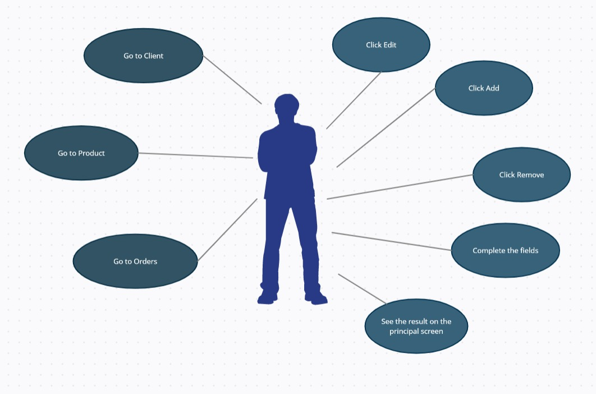

Design
A brief introduction of the overall system design was made in chapter 2.2. Because it is a good practice, in my application I used an architectural pattern. These architectural patterns define structures for software systems in term of predefined subsystems and their responsibilities. The approached architectural pattern is the Model View Controller which divides the application into three areas: processing, input and output.
The classes: Client, Product and Orders are embedded in the Model package for representing the main data from the database. The classes found in Controller package are used as the name suggests to act as Controllers. Since JavaFx provides the views in the .fxml format, each view needs to have its own controller in order for the application to work. This is the reason why for each switch between the scenes on the graphical users interface, also the controller which commands the scene is switched. In the DataAccess package the most important class is AbstractDAO. The CRUD operations on the database will be performed: insert, delete by key, update by key and other queries like selecting every row from the database. This implementation is made using reflection. AbstractDAO is a class which receives a type T and because it is extended by ProductDAO, ClientDAO and OrdersDAO, each query will be generated through reflection using the fields from each Model class. For the purpose of reflection in the Model package each class will have an empty constructor, getters and setters for each field. The name of the fields should be exactly the name of the fields from the database in order for the application to work properly.
In the Business Logic package one can observe three classes: ProductBLL, OrdersBLL and ClientBLL which is used to communicate data from the controllers to the DataAccess package and vice versa. Also the Validators package can be found inside this Business Logic package. Inside of this package there are two classes which implement an interface which has 1 method for validation of the input. Specific for the client the email must be in a certain format and also the age should be a number between some values. Also for the Orders the price must be a positive number. If the conditions don’t hold, then some alerts will be popped on the screen with a suggestive message, which will help the user in the process of understanding the application.
UML diagram:
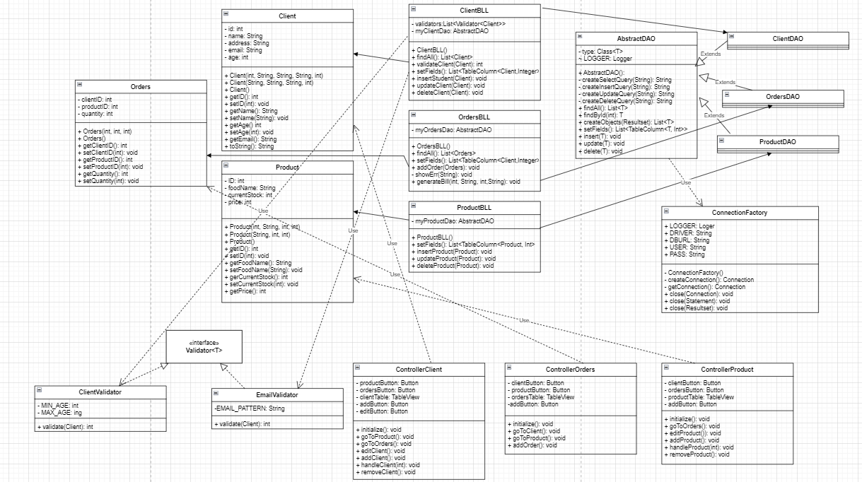

One can observe that the View is completely missing from the UML diagram. That is happening due to the fact that the code is written in JavaFX and my view is in a .fxml format. This cannot be represented in an UML diagram, but the main logic and the use case of the view can also be observed from the previous figure. Also, the class containing the main is missing because it is used only for launching the application and setting the size of the pane seen at the top level by the user.
The package diagram is shown in the next figure:
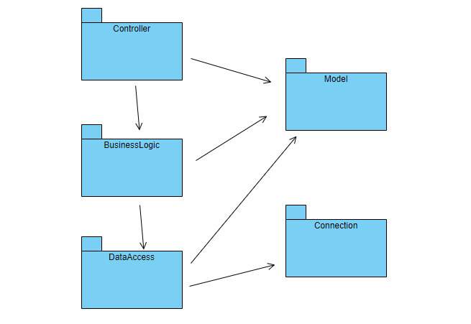

For this application the only data structures that I used are Lists, to be more specific ArrayLists. Their purpose is to store information from the database tables: Lists of objects which will transfer into rows inside the Table View of the application, so that the user will be able to see the queries made in real time.

Implementation
- ClientBLL: This class can be found inside the Business logic package. As the name of the package suggests, its purpose is to take data from the Controller, to validate the input regarding the clients and if the input is in the correct format to pass it to the Data Access package where it will be further processed. One can see that inside this class there are two private fields, one for the validators and the other is an object which refers to the Data Access layer in order to make queries on the database. The main methods of these class are findAll, which is used to find the entire population of a certain table and to pass it to the controller, validateClient which uses the validators in order to see weather the input is correct and the setFields method which will generate through reflection all the fields from the Client.
- OrdersBLL: This class can be found inside the Business Logic package. It’s purpose is to communicate between the Controller and the Data Access layers. The data taken from the controller is validated, then sent to the Data Access layer where the queries will be generated and the results of the queries will be sent back to the Controller, in order to make the changes to the graphical users interface. The class contain one private field which is of OrdersDAO type and is instantiated inside the constructor. Some useful methods are presented, for example addOrder which takes as argument an object of type Orders. In order to perform an order some constraints mus be met. Firstly the same person can not order the same product in different orders. He must choose a quantity that he wants. If the quantity isa a positive number and if the stock of the product is larger or equal to the quantity that the client is ordering, the order will be listed and the stock of that product will be updated. If the previous conditions are not met, then an alert will be popped up n the screen with a suggestive message. Another important method inside this class is the generateBill method which is used for generating a bill after each order. If the order was made with success then a text file “bill.txt” will be generated, where the name of the client, the quantity of the product, the name of the ordered product and the final price can be found.
- ProductBLL: This class is also found in the Business Logic package. It’s main use is to communicate between the Controller and the Data Access classes in order to make queries for the table Product from the database and update the GUI accordingly. It contains only one private field which is of type ProductDAO.
- Model Classes: Client, Orders and Product are used to represent the main data from the database.
- Controller Classes: their main use is to switch between themselves and also between the scenes, and to take the data from the user and to send it further to the Business Logic where it will be further processed.
- Data Access Classes: as presented before, the main class is AbstractDAO, which receives a type T and because it is extended by ProductDAO, ClientDAO and OrdersDAO, each query will be generated through reflection using the fields from each Model classes.
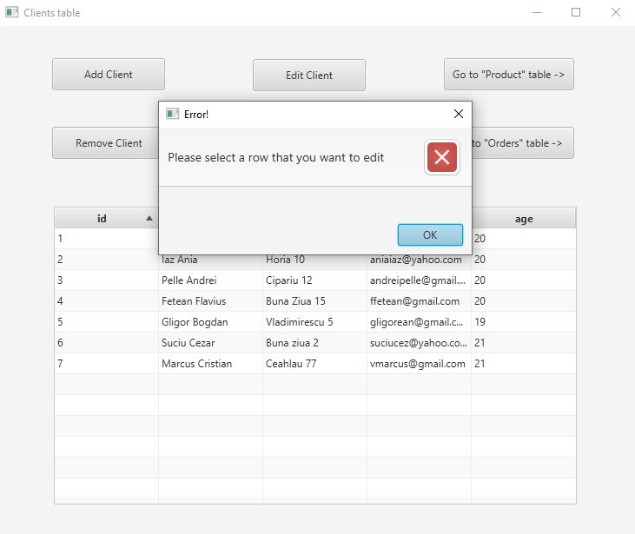

- App Class: this class is used for setting the size of the graphical user’s interface and to launch the application.

Results
The application has been implemented in Java Programming language in the IntelliJ IDE. The database part was implemented using DataGrip IDE with Postgres. For the testing, the application was tested in order to see how it would react to bad input and which types of alerts should be popped in order to make the user understand the mistake in his input and to guide him to a better understanding of the application.

Conclusions
After completing this application I can say that I am more comfortable working with databases and I aceived a lot of new skills in creating and interpreting queries. Also this is the first time that I have worked with reflection and I learnt a lot using this technique. Further development could be clients that could make more complex orders, such that multiple products can be ordered at a time by a certain client.

Bibliography
- https://stackoverflow.com
- https://app.diagrams.net
- https://dsrl.eu/courses/pt/materials/A3_Support_Presentation.pdf
- https://dsrl.eu/courses/pt/materials/PT2021-2022_Assignment_3.pdf

