Queue management system

Assignment 2

STUDENT NAME: TRASCULESCU TUDOR
GROUP: 30424

CUPRINS

1. Assignment objective 3
2. Problem analysis, modeling, scenarios, use cases 3
3. Design 5
4. Implementation 7
5. Results 8
6. Conclusions 8
7. Bibliography 8

Assignment objective
Queues are commonly used to model real world domains. The main objective of a queue is to provide a place for a "client" to wait before receiving a "service". The management of queue-based systems is interested in minimizing the time amount their "clients" are waiting in queues before they are served. One way to minimize the waiting time is to add more servers, i.e., more queues in the system (each queue is considered as having an associated processor) but this approach increases the costs of the service supplier. The queues management application should simulate (by defining a simulation time 𝑡_{𝑠𝑖𝑚𝑢𝑙𝑎𝑡𝑖𝑜𝑛}) a series of N clients arriving for service, entering Q queues, waiting, being served, and finally leaving the queues. All clients are generated when the simulation is started, and all the clients are characterized by three parameters: ID (a number between 1 and N), 𝑡_{𝑎𝑟𝑟𝑖𝑣𝑎𝑙} (simulation time when they are ready to enter the queue) and 𝑡_{𝑠𝑒𝑟𝑣𝑖𝑐𝑒} (time interval or duration needed to serve the client, i.e. waiting time when the client is in front of the queue). The application tracks the total time spent by every client in the queues and computes the average waiting time. Each client is added to the queue with the minimum waiting time when its 𝑡_{𝑎𝑟𝑟𝑖𝑣𝑎𝑙} time is greater than or equal to the simulation time (𝑡𝑎𝑟𝑟𝑖𝑣𝑎𝑙 ≥ 𝑡𝑠𝑖𝑚𝑢𝑙𝑎𝑡𝑖𝑜𝑛).
Sub-objectives:
- Analyze the problem and identify the requirements: after analyzing the problem, the requirement for the problem and is to manage the queue system in such a way that the time each client has to wait is minimum (chapter 2.0).
- Designing the queue management system: processing the data and apply the necessary algorithms in order to maintain the clients in a queue for as little time as possible (chapter 2.3).
- Implement the queue management system: the main classes and their methodology will be presented (chapter 4).
- The results of the tests provided in the laboratory work can be seen in the repository under the name “logx.txt” (where “x” is the number representing the test which was run).

Problem analysis, designing, scenarios, use cases
2.0 Problem analysis
The application simulates a queue management system, which means that a series of randomly generated clients
will be entering queues, will be processed and then will leave the queues after the service time is over. The application besides managing the queues in a way such that the clients will not have to wait very much in the queues, should track the time that the customers are waiting to be served and the efficiency of the queues in different situations.
The problem as simple as it may seem might raise some difficulties. There are some important aspects which should be taken into consideration. First of all, when we think about the processing time of the application, one can observe that the queues don’t affect each other in any way but the the total time of the waiting period per queue. That means that all the queues can run on a different thread which will enhance the performance of the application.
Another main aspect to be taken into consideration is the way the user interacts with the graphical user interface. In order to make sure that the application works properly one can observe that invalid data may corrupt the flow of the program. Also, after making sure that the correct input is received, the application will run properly. The user is allowed to select the number of queues, the number of total clients, an interval for the minimum and the maximum service time, an interval for the minimum and the maximum arrival time of the clients and also the total time of the simulation. The graphical user interface will display in real time the queue evolution after the button “Start” is pressed, or the GUI will display an error message if there is a problem regarding the input from the user. After pressing “Start” the user cannot interact with the interface anymore.
The way the new customers will be distributed in the queues is crucial for the simulation. There were two methods to choose between, like distributing a new client to the shortest queue, or distributing him to the queue with the minimum service time. The method presented in this application is the second one.
2.1 Model
The model used in this problem is the basic queue model. A queue is an abstract data type that applies the FIFO policy (first in first out). The model is represented by the Server Class and by the Task Class which contain the information about each task and where it belongs. Each task has an unique ID, a time at which the task will begin and a service time representing the time that specific task is executed.
The queues and the simulator represent threads which will run at the same time. The queues are supposed to process each client and generate logs based on the client’s arrival in queue and the moment he leaves the queue. The simulator’s job which is also the thread from where all the other threads were started is to associate in a clever way the clients in the queues. The main goal is for the waiting time of each client to be minimal. Also, a very important aspect is to display the evolution of the queues in real time in such a manner that the user can understand exactly how the processes are managed.
2.2 Design
The overall system design can be described in a few words. Basically, the user will enter a number of clients (N), a number of queues (Q) a maximal simulation time, a minimum, and a maximum arrival time, also a minimum and maximum service time. Inside the application N random clients will be generated and the results at each second of the simulation will be seen in the graphical user interface in real time.
2.3 Scenarios
As developers, we can not predict what the user is going to do once he starts the application. But we can restrict the output that is displayed based on some assumptions. For example, as long as the input is not in the correct form an alert will be generated and it will guide the user to a better understanding of the program. If the user succeeded to enter the correct form of input, all is left to do is to press the “Start” button and wait for the application to work and to display the results.
2.4 Use cases
The use case diagrams are used to make the relations between users and the system visible. These use case diagrams are very useful for a certain number of reasons:
- They offer a general description of the way the system will be used
- They give a general aspect of all the functionalities provided by the application to the user
- They show how the application interacts with one or more users
- They assure the fact that the system will have a correct and expected behavior
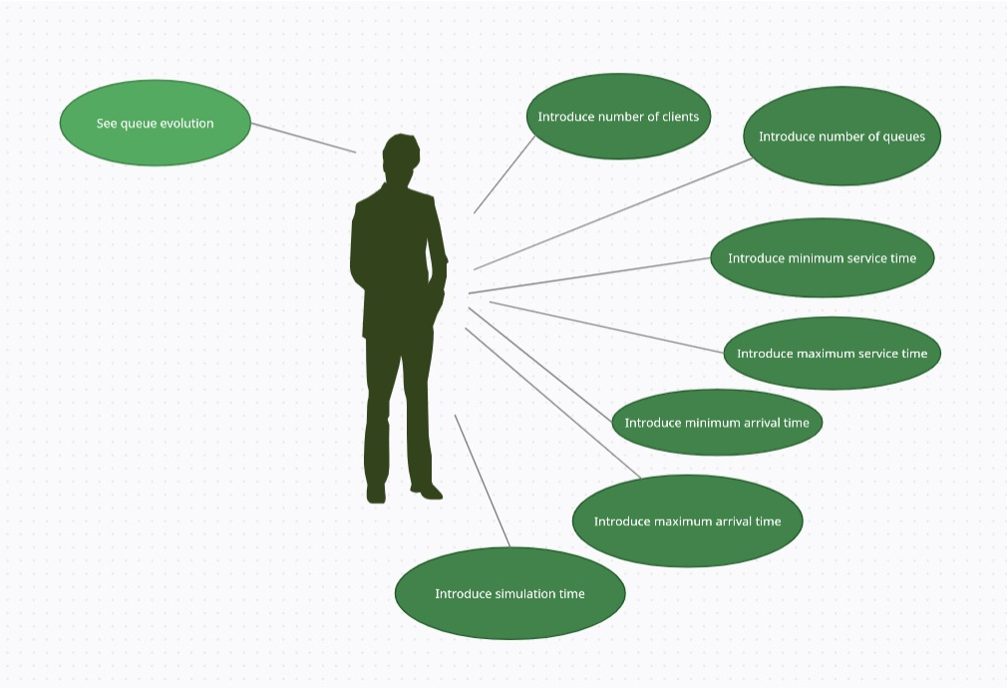

Design
A brief introduction of the overall system design was made in chapter 2.2. Because it is a good practice, in my application I used an architectural pattern. These architectural patterns define structures for software systems in term of predefined subsystems and their responsibilities. The approached architectural pattern is the Model View Controller which divides the application into three areas: processing, input and output.
The classes Task and Server which are embedded in the Model package for representing the queues and the clients in an efficient way. The class controller which is embedded in the package with the same name is used as a way of communication between the user interface and the backend of the application. In order for the application to start, a correct input must be provided along with pressing the button “Start”. After the button is pressed if the application is run successfully, the main application will launch the controller which will create an object of type SimulationManager which will launch the threads for each queue where all the data will be processed and handled. After each second a result will be displayed on the graphical user interface. The View is a .fxml file which can be found in the resources. It’s use case is to communicate between the user and the application and to behave according to the actions performed by the user. The classes which belong to the Business Logic are Scheduler SimulationManager, SelectionPolicy, ConcreteStrategyTime. They are used to send the data and process the data in the best possible way, from the client’s point of view.
UML diagram:
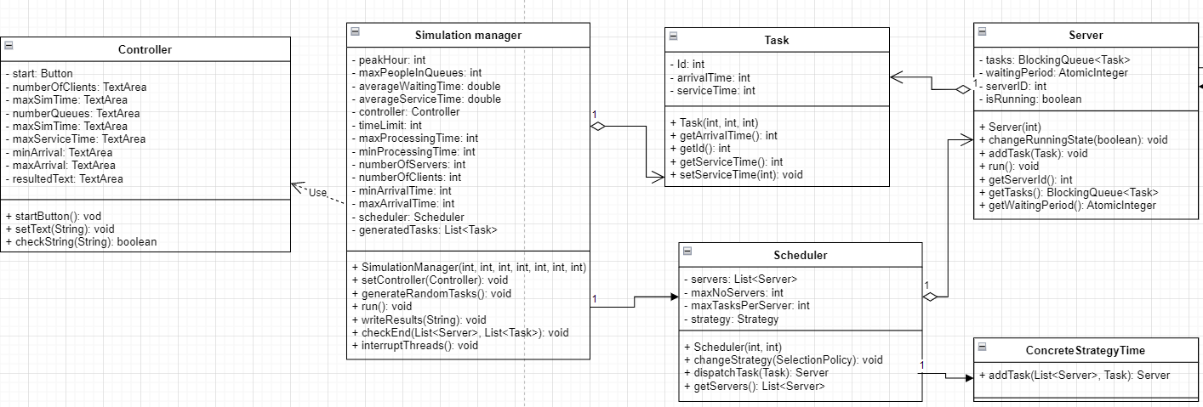

One can observe that the View is completely missing from the UML diagram. That is happening due to the fact that the code is written in JavaFX and my view is in a .fxml format. This cannot be represented in an UML diagram, but the main logic and the use case of the view can also be observed from the previous figure. Also, the class containing the main is missing because it is used only for launching the application and setting the size of the pane seen at the top level by the user.
The package diagram is shown in the next figure:
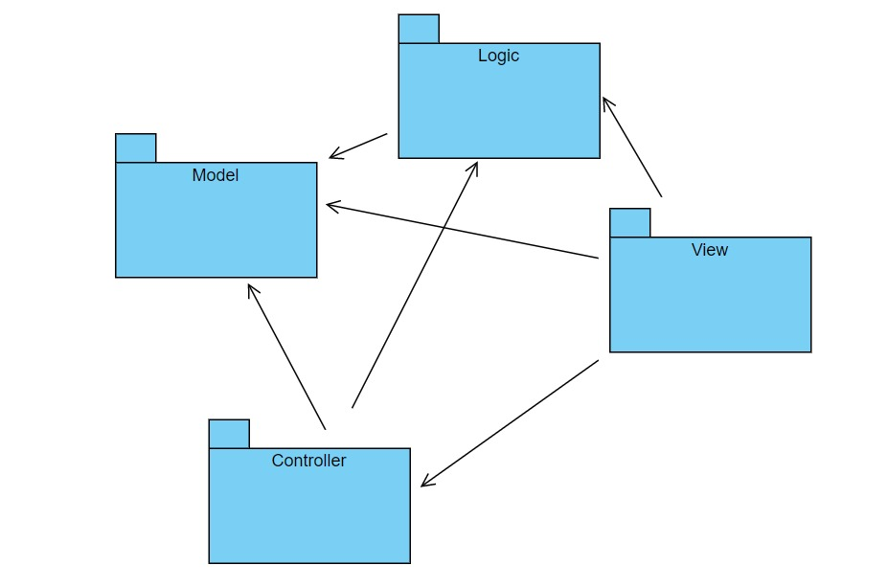

Some special data structures inside the Server class: the Atomic Integer which represents the waiting period per server and the BlockingQueue which represents the queue of tasks from each server.
The SimulationManager Class and the Server Class implement Runnable interface. Each Server represent a Thread and also the Simulation Manager is a Thread which will start all the other Threads. I chose to implement Runnable and not to Extend Thread Class from various reasons. And one of the main reasons is the reusability. One can observer that the class extending Thread contains both thread and job specific behavior code, but when implementing Runnable the class contains only the functionality, we want in the run method.

Implementation
- Server Class: each instance of this class represents a thread (that is implements Runnable). Its main job is to put each task in the correct Server and after a successful assignment of a task, the thread will sleep 1 second in order to be synchronized with the SimulationManager class. Some notable fields are the Atomic Integer, representing the waiting period per Server, and the Blocking Queue, representing the queue of each Server. The reason why I chose these types of data is because they don’t need to be further synchronized.
- Task Class: each Task is in fact representing a client that is going to have an unique ID. Each client also has an arrival time (at which he will be put in a queue) and a service time. The service time represents the time needed for the customer to wait when it’s his turn to be in front of the queue.
- SimulationManager Class: represents a thread from which an instance of the Schedular Class will begin and will start all the queues (a thread for each queue). The tasks will be generated randomly in the generateRandomTasks method. The tasks will be generated randomly according to the minimal service time, maximum service time, minimum arrival time and maximum arrival time. Also, this class contains an object of type Controller, in order to be able to write the results generated at each second directly at the graphical user’s interface. After each second the thread sleeps and then starts processing again the data until the time of the simulation is gone or until there are no more tasks to be processed. After the time of the simulation is over or there are no more tasks in the servers to be processed, the method interruptThreads will be called and all the other threads will be interrupted. Also some general aspects about the simulation will be displayed (i.e average waiting time, average service time for all queues and the peak hour).
- Schedular Class: when the constructor of the Schedular is called, all the Server Threads will be created and start running. This class acts according to its name and schedules the moment when a Task in dispatched to a certain Server by means of the dispatchTask method.
- ConcreteStrategyTime Class: implements the Strategy. The strategy which I chose is the shortest time in a queue, that means that each client will be assigned to the queue with the least waiting time. It has only one method which is the addTask method which iterates through all the Servers and find a best Server (with the minimum waiting period) and will assign the task to that specific Server.
- Controller Class: this class is the bridge between the user’s interface and the business logic. As the name suggests it controls the flow of the application. It will check if the correct input was given by the user or it will display an alert which will guide the user to a better understanding of the program. For example:
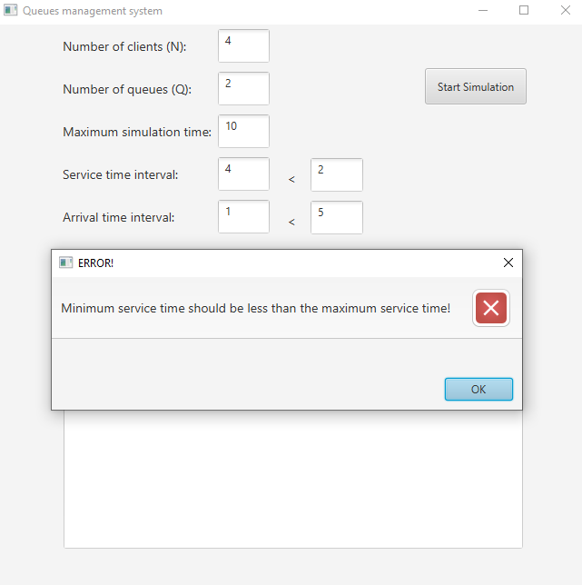
- App Class: this class is used for setting the size of the graphical user’s interface and to launch the application.

Results
The testing result can be seen in the repository under the name “logx.txt”, where x represents the number of the test. All the three scenarios from the laboratory work were tested and the log of each can be seen in these files.

Conclusions
From this assignment I learned how to work with threads and what data structures to use in order to have a synchronized behavior. Also, it was a good practice to work with this new concept of threads, because I think that in the future it will be a good asset to master.
Some future enhancements of the project might be inserting a new button which resets the application and let maybe one more button which aborts the execution at some specific time.

Bibliography
- https://stackoverflow.com
- https://app.diagrams.net
- https://dsrl.eu/courses/pt/materials/PT2021-2022_Assignment_2.pdf
- https://dsrl.eu/courses/pt/materials/A2_Support_Presentation.pdf

