OOPS
Procedural programming is writing methods that perform operation on data
Oops – creating object that contains both methods and data
Oops provide clear structure of a program, faster and easier to execute,

Class
Is a blue print of an object
Object
Is an istance of a class, Eg: car obj= new car()

Constructor
Is a special method that’s used to initialize objects
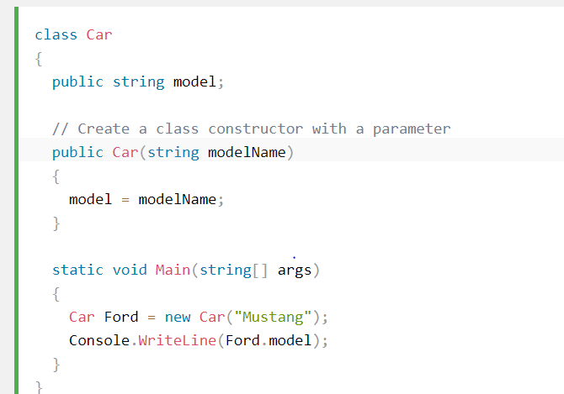

Access Modifier
To control the visibility of class members. To achieve encapsulation making sure the sensitive data is hidden from the users
Public- code will accessible everywhere
Private – code accessible only in the same class
Protected- accessible with in the class or the inherited classes
Internal- it is assesible only with in the assembly
Baseclass- private
Child- protected
Dll- internal
Public- all project

Encapsulation
Make sure the sensitive data is hidden from user.
Declare fields variable as private
Provide public- get and set method to access and update values of a property

Abstraction
Hiding certain details and showing only essential information. Hiding data members and member functions into a single unit.
Abstraction can be achieved either abstract class or interface.

Interface
Interface which can only abstract methods and properties. Interfaces can contain methods and properties but not fields. interface methods are abstract and public by default.
Only skelton will be there in interface

Enum
Enum is a special class which contain group of constants.

