SQL
Select- select data from db.
Select distinct- remove duplicate values.
Where- is using for filtering records
Select * from emp where empid=1
Operators in where clause
=,>,<, <=,>=,<>, Between(between certain range), like(search for a pattern), in(specify multiple values for a column)

And, Or, Not- select * from emp where conition1 or condition2

Orderby- is using for sorting the results(select * from emp orderby empid Desc)

Insert
insert into emp(id, name) values(1, test);
Insert into emp values(value1, value2)

Null values
Value is optional
Select * from emp where address is null;

Update
Update emp set name=test where id=1;
Delete
Delete from emp where id=1;

Select Top Clause
This used for large number of records table, it will return the selected numbers
Select Top 100 from emp where id=1;
Select Top 3* from emp;

Limit Clause- same behavior as top clause
Select * from emp limit 3;

Row Num
Select * from emp where rownum<=3;

TopPercent
Select Top 50 percent * from emp;
Select top 50 percent * from emp where id=2;

Min & Max
Min- return smallest value of the selected column
Select min(id) from emp where condition;
Max- returns the largest number of the selected column
Select max(id) from emp;
Select max(price) AS Largestprice from emp;

Count, avg & sum()
Count- returns the no of rows that match criteria
Select count(id) from emp where condition;
Avg- it returns the average value of a numeric coloumn
Select avg(price) from emp where condition.
Sum- returns the total sum of numeric column
Select sum(salary) from emp;

Like
To search for a specific pattern
%- one or multiple charcters
Where name like ‘a%’
- Uses for single character
Where name like ‘_a’

Wildcard characters
- * for zero or more characters
- ? represent single character
- [] any single character h[o,a]t- eg: hot , hat
- ^ anycharacter not in the bracket h[^oa]t eg- hit but not hot or hat
- - represents a range of charcters c[a-b]t eg cat, bat
Select * from city where name like ‘br%’
Select * from city where name like [b,s,p]%- name starting with b or s or p
Select * from city where name like[a-c]%- starting with a or b or c

In operator
In operator to specify multiple values in where clause
Select * from emp where coloumname in (select * from ..)
Select * fom emp where id in(1,2,3);
Select * from emp where id not in (1,2)
Select * from cust where country in ( select country from suppliers)

Between
Select values with in a given range
Select * from emp where age between 17 and 20

As(Alias- alternate name)
Giving alternate name for table or column
Select id as empid from emp;
Select * from emp as employee;
Select houseno + ‘,’ postcode+’,’ +’,’ city as address from city- combine 4 coloumns and name as address
Alias for tables
Select o.orderid, c.name from customer as c ,order as o where o.id=c.id

Joins-
Join caluse is used to combine rows from two or more table.
Select * from tab1 innerjoin tab2 on condition;
Select o.name, o.age from orders as o inner join customer as c on o.id=c.id

Inner join- return record shaving matching values
Leftouter join- returs all the values from left table and matching records from right table
Right outer- returns all values from right table and matching value from left table
Full join- return all values where thers a match in either tablezs

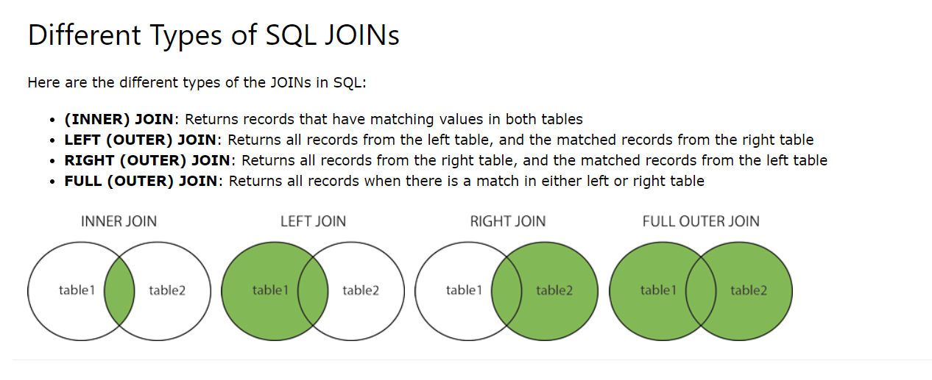

Inner join
Return matching values form both tables
Select * from emp innnerjoin customer on customer.id= emp.id

Join 3 tables
Select * from ((orders innerjoin customers on orders.id=customer.id) innerjoin shippers on order.id=shipper.id)

Left join
Customer- id, name – 1,test1, 2, test2, 3 test3
Order- id, price- 4 p1, 5 p2, 3 p3

Select c.name from customer as c left join order as o on c.id=o.id
Result – 1,2, 3, 3 p3

Group By Clause
Grouping
Eg- no of customers in each country
Select count(custid) from customer group by country order by count(custid) desc;
Select s.shippername, count(o.id) as number of orders from orders o left join shippers s on o.id=s.id groupby shippername

Having clause
Having callus eadded in sqlbecause where caluse cann’t use aggregator fns
Eg- display countries with more than 5 customers
Select count(id) , countryname from country groupby countryname having count(id>5)
Eg – emp and oder table select employes that have more than 10 orders

Select emp.name, count(o.id) from (orders o inner join employee emp on o.id=e.id ) group bt name having count(o.id<=10)
Select the employee David or kuller has registered more than 25 orders
Select e.name from orders o inner join emp e on o.id=e.id where name=’david’ or name=’kuller’ group by name having count(o.id>25)

Constrainsts
Are used to specify rules for data in a table
Notnull- ensures column cant have null values
Unique- all values are different
Primary key- combination of unique and null, to uniquely identify each row
Foreign key- uniquely identify row in the other table
Check- ensures all colum values satisfies specific condition
Default- set default value
Index- create or retrieve dat very quickly]

Create table order(id int primarykey, name char notnull, person id int foreignkeyreferances person)

