**COMPARISION OF SHORTEST PATH ALGORITHMS**

A Project Report submitted in partial fulfillment of the

Requirements for the award of the degree of

BACHELOR OF TECHNOLOGY

in

COMPUTER SCIENCE AND ENGINEERING

with IBM specialization in CYBER SECURITY AND FORENSICS

Submitted by

Anshumaan Singh Rawat(R134217032)

Arth Gupta (R134217037)

Kanwar Sumeer Mankotia(R134217068)

Kartik Chauhan (R134217069)

Under the guidance of

Ms. Shahina Anwarul

Assistant Professor, Department Of Systemics

SoCS



**SCHOOL OF COMPUTER SCIENCE**

UNIVERSITY OF PETROLEUM & ENERGY STUDIES

Bidholi Campus, Energy Acres, Dehradun – 248007.

**DECLARATION**

I hereby declare that this submission is my own and that, to the best of my knowledge and belief, it contains no material previously published or written by another person nor material which has been accepted for the award of any other Degree or Diploma of the University or other Institute of Higher learning, except where due acknowledgement has been made in the text.

Anshumaan Singh Rawat (R134217032) -

Arth Gupta (R134217037) -

Kanwar SumeerMankotia(R134217068) –

Kartik Chauhan (R134217069)-

**CERTIFICATE**

This is to certify that the project titled ‘Comparision of Shortest Path Algorithms’ submitted by Anshumaan Singh Rawat(R134217032), Arth Gupta(R134217037), Kanwar SumeerMankotia (R134217068) and Kartik Chauhan (R134217069) to the University of Petroleum & Energy Studies, for the award of the degree of BACHELOR OF TECHNOLOGY in COMPUTER SCIENCE AND ENGINEERING is a bonafide record of project work carried out by them under my supervision and guidance. The content of the project, in full or parts have not been submitted to any other Institute or University for the award of any other degree or diploma.

Date: __________________

Ms. ShahinaAnwarul HOD

Asst. Professor Dept. of Systemics | SCS

**ACKNOWLEDGEMENT**

We have taken efforts in this project. However, it would not have been possible without the kind support and help of many individuals and organizations. We would like to extend our sincere thanks to all of them.

We are highly indebted to Ms. Shahina Anwarul for her guidance and constant supervision as well as for providing necessary information regarding the project & also for her support in completing the project.

We would like to express our gratitude towards the faculty of School of Computer Science(SoCS) for their kind co-operation and encouragement which help us in completion of this project.

Our thanks and appreciations also go to our colleagues in developing the project and people who have willingly helped us out with their abilities.

**ABSTRACT**

The project concerns with comparing different shortest path algorithms - ‘Dijkstra Algorithm’, ‘Bellman-Ford Algorithm’ and ‘Floyd-Warshall Algorithm’ on the basis of their Time Complexity with graphical representation.

Dijkstra’s Algorithm: Dijkstra's algorithm is an algorithm we can use to find shortest distances or minimum costs depending on what is represented in a graph. You're basically working backwards from the end to the beginning, finding the shortest leg each time.

Bellman-Ford’s Algorithm:The Bellman-Ford algorithm is a graph search algorithm that finds the shortest path between a given source vertex and all other vertices in the graph. This algorithm can be used on both weighted and unweighted graphs.

Floyd-Warshall’s Algorithm:Floyd-Warshall algorithm is a procedure, which is used to find the shortest paths among all pairs of nodes in a graph, which does not contain any cycles of negative length.

Time Complexity:is a concept in computer science that deals with the quantification of the amount of time taken by a set of code or algorithm to process or run as a function of the amount of input.

**Keywords:** Dijkstra’s Algorithm, Bellman-Ford’s Algorithm, Floyd-Warshall’s Algorithm, Time complexity

**TABLE OF CONTENTS**

|  |  |  |  |
| --- | --- | --- | --- |
| DECLARATION | | | ii |
| CERTIFICATE | |  | iii |
| ACKNOWLEDGEMENT | | | iv |
| ABSTRACT | |  | v |
| LIST OF TABLES | | | vii |
| LIST OF FIGURES | | | viii |
| 1 | INTRODUCTION | | 1 |
| 2 | LITERATURE REVIEW | | 2 |
| 3 | METHODOLOGY | | 3 |
| 4 | RESULTS AND DISCUSSION | | 4 |
| 5 | CONCLUSIONS | | 5 |
| REFERENCES | |  | 6 |
| Annexure A: Screen shots | | | 10 |

**INTRODUCTION**

The shortest-path problem is one of the well-studied topics in computer science, specifically in graph theory. An optimal shortest-path is one with the minimum length criteria from a source to a destination. There has been a surge of research in shortest-path algorithms due to the problem’s numerous and diverse applications. These applications include network routing protocols, route planning, traffic control, path finding in social networks and transportation systems, to count a few. Generally, in order to represent the shortest path problem we use graphs. A graph is a set of vertices and edges and each edge connects to the vertices .Along the edges of a graph it is possible to walk by moving from one vertex to other vertices. Depending on whether or not one can walk along the edges by both sides or by only one side determines if the graph is a directed graph or an undirected graph. The lengths of edges are often called weights, and the weights are normally used for calculating the shortest path from one point to another point. There are many algorithms to calculate the shortest path problem. The different shortest path algorithms are Dijkstra algorithm, Bellman-Ford algorithm, Floyd-Warshall algorithm.

**LITERATURE REVIEW**

This section briefly discusses the Dikjstra and Floyd algorithms adopted in the existing studies. Feng (2005) discussed the taxonomy of the shortest path algorithms from the perspective of problem type, network characteristics and solution techniques and compared to the time complexities. However, the most popular sequential shortest path algorithms are evaluated for their practical efficiency with urban traffic networks. The advance of time dependent and parallel shortest path algorithms is also discussed in many studies The earlier studies presented four shortest path algorithms namely Dijkstra’s Algorithm, Floyd-Warshall Algorithm, Bellman-Ford Algorithm, and Genetic Algorithm (GA) for intelligent traffic system. In addition, the earlier study finding shortest path from one node to all other nodes can be derived quickly by using the shortest path algorithm. Further, the earlier study have analyzed dynamic path of all-pairs using shortest path problem for recalculation shortest paths after changing the weight of any single edge. Thus, we can observe two different cases: increasing and decreasing of the weight. The time complexity depends on graph structure and in most cases the time complexity is better than Floyd-Warshall algorithms. In case of decreasing the weight the algorithm which requires O(n^2) time is described. Moreover the earlier study discussed the shortest path between two points in a city road net based on the geographic relevance relationship among roads in the road net. Based on the literature this paper provides some instance which prove applicability and reliability of Dijkstra and Floyd algorithm for national traffic advisory procedures.[1]

**PROBLEM STATEMENT**

* To determine the shortest path among various paths for a single destination.
* Implementing various shortest path algorithms for determining the shortest path between two nodes.

**OBJECTIVE**

* To determine and analyse the shortest path between two different nodes.
* To implement the various algorithms for calculating shortest path.

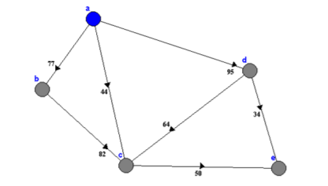

Fig. 1 Illustration of Dijkstra’s Algorithm[2]

**METHODOLOGY**

The main focus of the project is to compare the 3 algorithms on the basis of time complexity.

The methodology of the project will be as such:

**Step 1:Understanding and implementing the algorithm:**

We have done a thorough study of Djisktra algorithms about how this work, how can we implement them in C language, what are their applications.

We have then code and run the algorithm and test it.

**Step 2: Calculation of Time Complexity :**

After understanding and implementing Djisktra algorithm, we have find the time complexity for algorithm.

**Time complexity** is a concept in computer science that deals with the quantification of the amount of time taken by a set of code or algorithm to process or run as a function of the amount of input.

Path(p,n)

for(i=1;i<p;i++) O(n)

for(i=1;i<n;j++) O(n) ~O(n^2)

dis[i]=dis[i] +cost[r][c]

dis(p)

for(i=1;i<p;i++)

if(dis[i]<=min) O(n)

min=dis[i]

time complexity-

O(n^2)+O(n)~O(n^2)

**Step 3: Study Analysis**

The result will be thoroughly analysed and Conclusion will be drawn on the basis of its working.

**FLOW CHART**

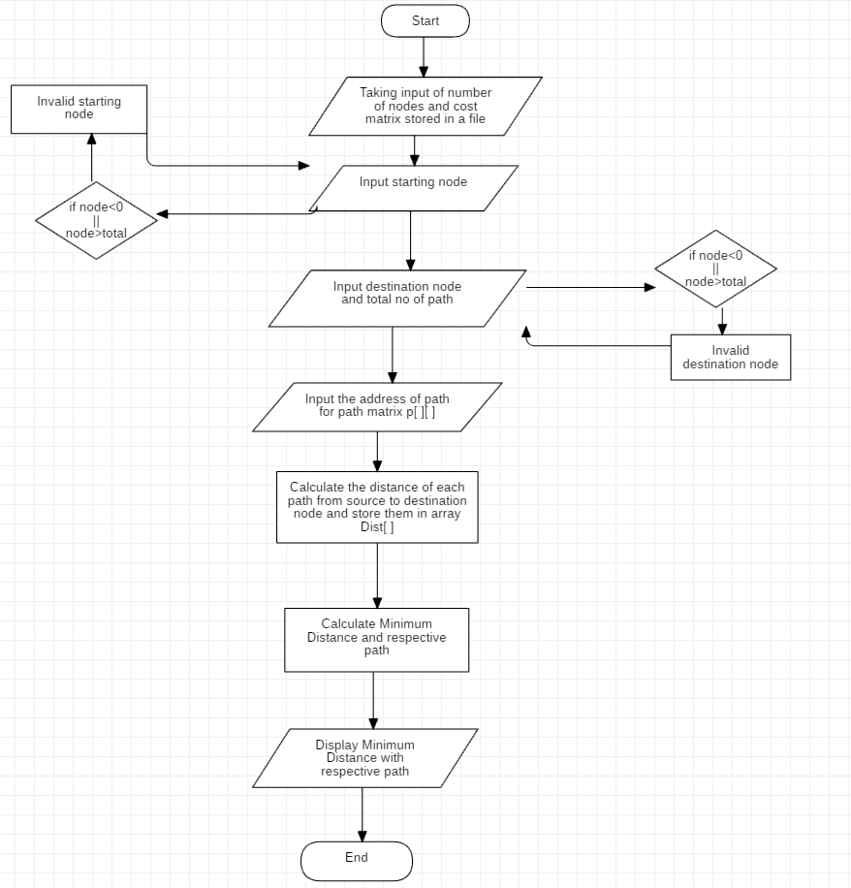

**CONCLUSION AND FUTURE WORK**

The project is based on comparison of shortest path algorithms and successfully implemented Djistra Algorithm and its Time Complexity is O(n^2).

Next up is the implementation of Bellman Ford Algorithm and Floyd Warshall Algorithm and comparison of its Time complexities and determine which of these shortest path algorithms is efficient.

It was a wonderful learning experience for us while working on this project. This project took us through the various phases of project development and gave us a real insight into baseline reference technique and its applications.

**REFERENCES**

1. An Investigation of Dijkstra and Floyd Algorithms in National City Traffic Advisory Procedures (By Arun Kumar Sangaiah , Minghao Han , Suzi Zhang).
2. Implemented Modification in Dijkstra’s Algorithm to Find the Shortest Path for ‘N’ Nodes with Constraint (By Anjali Jain , U.Datta , Neelam.Joshi).

**ANNEXURE**

