**COMPARISION OF SHORTEST PATH ALGORITHMS**

A Synopsis Submitted

in Partial Fulfillment of the Requirements

for the Course of

# Minor Project - I

In

Third year – Vth Semester of

**Bachelor of Technology**

specialization

in

# Cyber Security and Forensics

Under the guidance of

**Ms. Shahina Anwarul**

**(Department of Systemics)**

By

# 500060161 R134217069 Kartik Chauhan

# 500059963 R134217032 Anshumaan Singh Rawat

# 500061299 R134217068 Kanwar SumeerMankotia

# 500061990 R134217037 Arth Gupta



DEPARTMENT OF SYSTEMICS

SCHOOL OF COMPUTER SCIENCE

UNIVERSITY OF PETROLEUM AND ENERGY STUDIES, BIDHOLI, DEHRADUN, UTTRAKHAND, INDIA

August,2019

**Synopsis**

1. **Introduction:**

The shortest-path problem is one of the well-studied topics in computer science, specifically in graph theory. An optimal shortest-path is one with the minimum length criteria from a source to a destination. There has been a surge of research in shortest-path algorithms due to the problem’s numerous and diverse applications. These applications include network routing protocols, route planning, traffic control, path finding in social networks, computer games, and transportation systems, to count a few. Generally, in order to represent the shortest path problem we use graphs. A graph is a set of vertices and edges and each edge connects to the vertices .Along the edges of a graph it is possible to walk by moving from one vertex to other vertices. Depending on whether or not one can walk along the edges by both sides or by only one side determines if the graph is a directed graph or an undirected graph. The lengths of edges are often called weights, and the weights are normally used for calculating the shortest path from one point to another point. There are many algorithms to calculate the shortest path problem. The different shortest path algorithms are Dijkstra algorithm, Bellman-Ford algorithm, Floyd-Warshall algorithm Genetic algorithm Particle Swarm optimization etc. Roads play a Major role to the people live in various states, cities, town and villages, from each and every day they travel to work, to schools, to business meetings, and to transport their goods. Even in this modern era whole world used roads, remain one of the most useful mediums used most frequently for transportation and travel. The manipulation of a shortest paths between various locations appears to be a major problem in the road networks. The large range of applications and product was introduced to solve or overcome the difficulties by developing different shortest path algorithms. Even now the problem still exist to find the shortest path for road networks. To overcome the shortest path problem I make some changes and create new algorithm namely, Modified Dijkstra’s Shortest Path using Priority Queue with Linked List algorithm using multiple parameters is proposed in this paper. The given algorithm is compared with the existing algorithm to prove its better efficiency.[1] Generally, in order to represent the shortest path problem we use graphs. A graph is a set of vertices and edges and each edge connects to the vertices .Along the edges of a graph it is possible to walk by moving from one vertex to other vertices. Depending on whether or not one can walk along the edges by both sides or by only one side determines if the graph is a directed graph or an undirected graph. The lengths of edges are often called weights, and the weights are normally used for calculating the shortest path from one point to another point. There are many algorithms to calculate the shortest path problem. The different shortest path algorithms are Dijkstra algorithm, Bellman-Ford algorithm, Floyd-Warshall algorithm Genetic algorithm Particle Swarm optimization etc.[2]

1. **Motivation:**

[1]There are many applications of shortest path algorithms like Dijkstra’s algorithm. We have studied the algorithm but in this project we want to implement it as these algorithms are used in many fields.

Shortest path algorithms are used in many fields like:

* It is used in finding Shortest Path.
* It is used in geographical Maps.
* To find locations of Map which refers to vertices of graph.
* Distance between the location refers to edges.
* It is used in IP routing to find Open shortest Path First.
* It is used in the telephone network.

**Objective:**

* To implement Dijkstra, Bellman Ford and Floyd-Warshall’s algorithm.
* To compare these algorithms on the basis of their time complexity and space complexity.
* Graphical analysis of the three algorithms.

1. **Proposed Work:**

In this project, we’ll implement three shortest path algorithms in C language.

1. Dijkstra’s Algorithm
2. Bellman Ford’s Algorithm
3. Floyd-Warshall’s Algorithm

We’ll then find time complexity and space complexity for all three algorithms and compare them.

A graph will be drawn on the basis of comparision.

1. **Methodology:**

The main focus of the project is to compare the 3 algorithms on the basis of their time and space complexity.

The methodology of the project will be as such:

**Step 1:Understanding and implementing the algorithms:**

We’ll do a thorough study of all the 3 algorithms about how they work, how can we implement them in C language, what are their applications.

We’ll then code and run all the three algorithms separately and test them simultaneously.

**Step 2: Comparision on the basis of Time and Space Complexity :**

After understanding and implementing all the three algorithms, we’ll find the time and space complexity for each algorithm.

**Time complexity** is a concept in computer science that deals with the quantification of the amount of time taken by a set of code or algorithm to process or run as a function of the amount of input.

**Space complexity** is a measure of the amount of working storage an algorithm needs. That means how much memory, in the worst case, is needed at any point in the algorithm.

From these two parameters, one can easily rank these 3 algorithms from best to worst.

**Step 3: Study Analysis**

The result will be thoroughly analysed and the conclusion will be drawn from the above parameters.

1. **Schedule:**

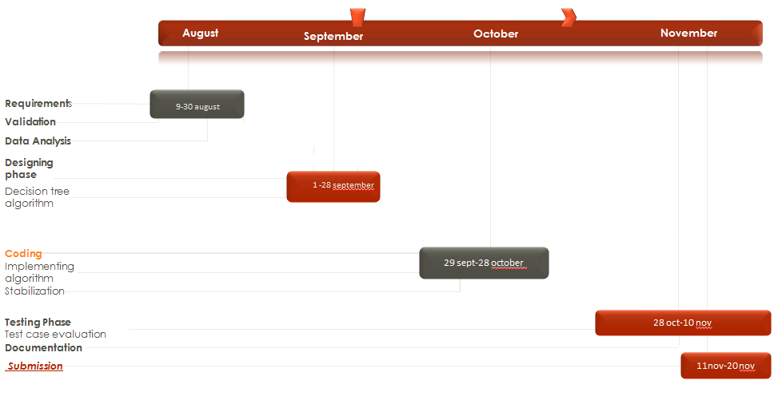

Program Evaluation Review Technique (PERT) Chart for Phishing URL detection

**6.References:**

[1] Anjali Jain, U. Datta, Neelam Joshi  International Journal of Scientific Engineering and Applied Science (IJSEAS) – Volume‐2, Issue 2, February 2016  ISSN: 2395‐3470 [www.ijseas.com](http://www.ijseas.com)

[2] Madhumita Panda, Abinash Mishra International Journal of Applied Engineering Research ISSN 0973-4562 Volume 13, Number 9 (2018) pp. 6817-6820