Name: TUFAIL AHMED B
ROLL No.:241901119

CUSTOMIZE SWITCH WITH NETWORK MODULES USING CISCO PACKET TRACER

AIM:
To customise Switch with Network Modules using Cisco Packet Tracer.
ALGORITHM:
- Open Cisco Packet Tracer and place a switch in the workspace.
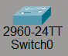
- Click the switch to open its device window and go to the Physical tab.
- Power off the switch by clicking the red power button.
- Select a desired network module from the module list.
- Drag and insert the module into an available slot on the switch chassis.
- Power on the switch by clicking the power button again.
- Verify the new module and interfaces are recognised in the Config or CLI tab.

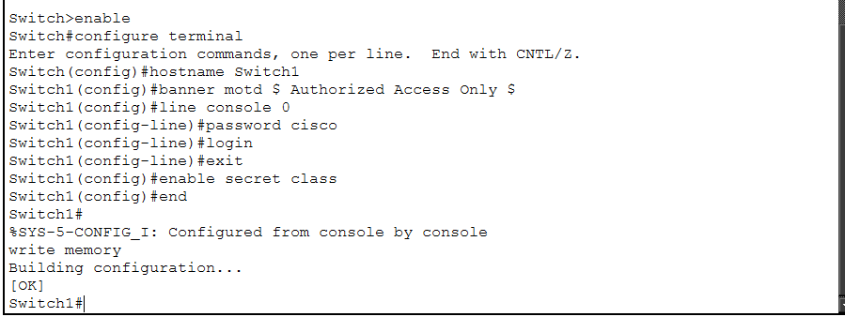
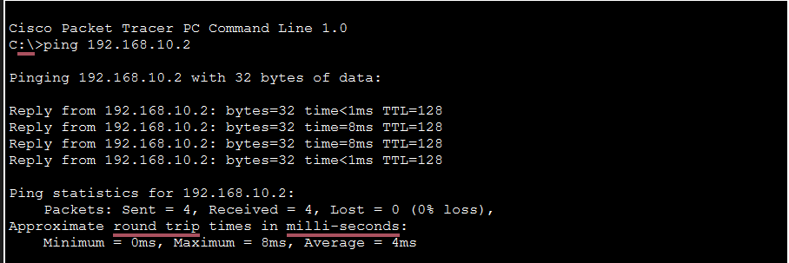

RESULT:
The switch was successfully customised with additional network modules, expanding its interfaces and connectivity options in Cisco Packet Tracer. The switch powered on with new modules recognised and ready for use, enabling more flexible network design and testing.

