Name: TUFAIL AHMED B
Roll No: 241901119
UDP CLIENT- SERVER COMMUNICATION USING SOCKET PROGRAMMING IN PYTHON
AIM:
Server:
1. Start the program.
2.Import the socket module.
3.Create a UDP socket using socket.AF_INET and socket.SOCK_DGRAM.
4.Bind the socket to an IP address and port.
5.Receive a message from the client.
6.Send a reply back to the client.
7.Close the socket.
Client:
1. Start the program.
2.Import the socket module.
3. Create a UDP socket using socket.AF_INET and socket.SOCK_DGRAM.
4.Send a message to the server using the server’s IP and port. 5.Receive the server’s reply.
6.Display the reply message.
7.Close the socket.

CODE:
SERVER:
import socket
sockfd = socket.socket(socket.AF_INET, socket.SOCK_DGRAM) print("UDP Socket Created")
sockfd.bind(('localhost', 55555))
print("Waiting for messages on localhost:55555")
while True:
data, addr = sockfd.recvfrom(1024)
message = data.decode('utf-8')
print(f"Received from {addr}: {message}")
sockfd.sendto(data, addr)
print(f"Echoed back to {addr}")
choice = input("Continue receiving? (y/n): ")
if choice.lower() == 'n':
break
sockfd.close()
print("Server shutdown")
CLIENT:
import socket
clientfd = socket.socket(socket.AF_INET, socket.SOCK_DGRAM) server_addr = ('localhost', 55555)
msg = input("Enter your message: ")
clientfd.sendto(msg.encode('utf-8'), server_addr)
data, _ = clientfd.recvfrom(1024)

print("Echo from server:", data.decode('utf-8')) clientfd.close()
OUTPUT:
Server:
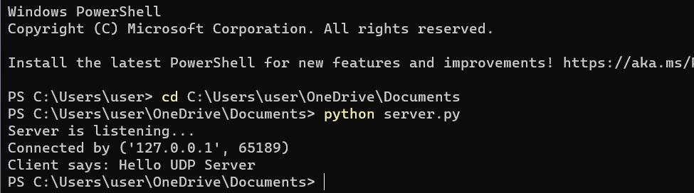
Client:
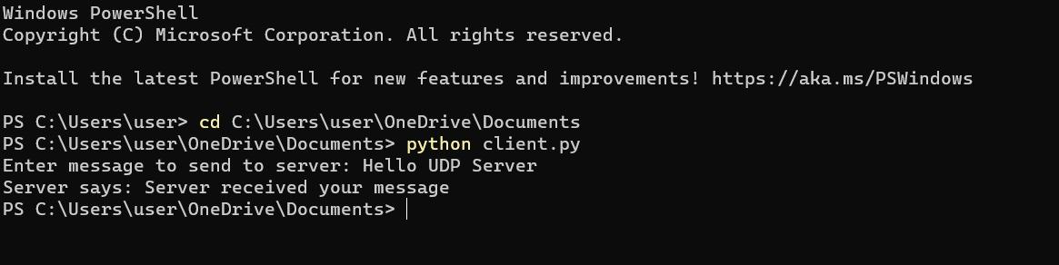
Result:
Thus, UDP server-client communication was successfully implemented using python.

