Assignment:3

Name:Jayesh Randive

a.Generating hash from a data

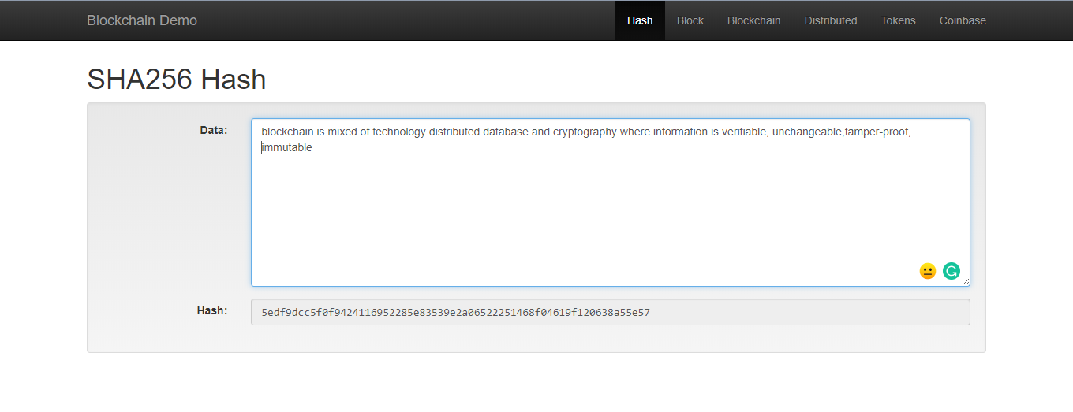

b. block

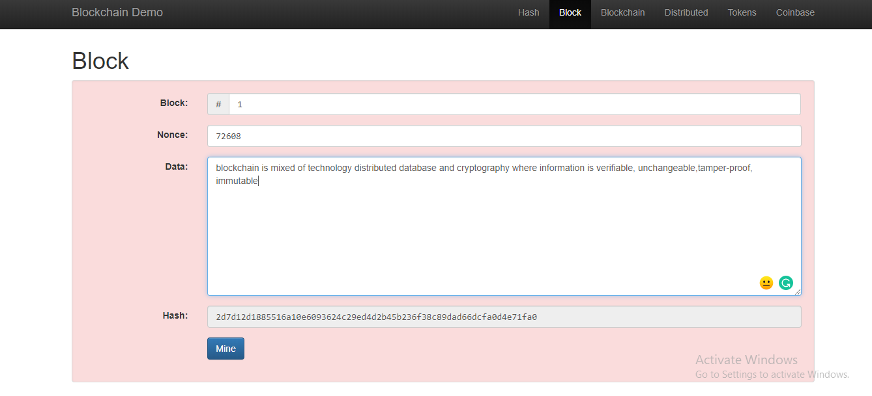

c.mining a block by generating random nonce value

that gives n zero’s to the hash value

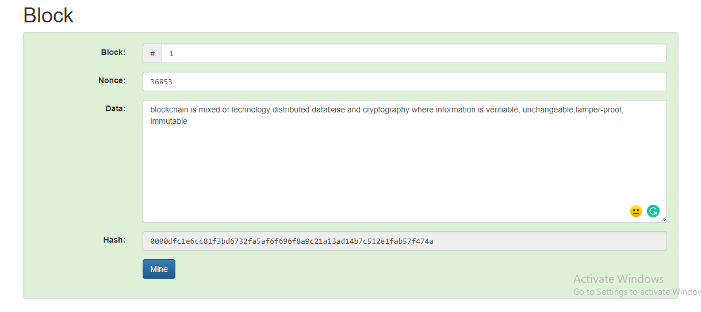

d.blockchain

