# Chapter 3: DESIGN

## INTRODUCTION:

Design is demonstrating a method of concept showing how various modules of framework associate and cooperate with each other. It envisions how a system work from its initial phase to the final phase. Here are the list of modelling that is used in this design phase.

The Unified Modeling Language incorporates a few subsets of outlines, including:

1. Structural Modelling

2. Behavioral Modelling

3. Database and

4. UI Modelling.

# 3.1. Structural Modelling:

* **Static Structural diagram:**

Class diagram

Object diagram

* **Implementation Diagram:**

Component

Deployment

## 3.1.1. Class Diagram:

Class diagram is a portrayal of relationship and conditions between classes through strategies and utilization of various items. It shows how information models are utilized in straightforward or complex data frameworks.

Natural Language Analysis is utilized to distinguish potential classes that could happen in the framework and these classes were spoken to in beginning outline of examination particular stage. The proposed application pursues MVC patter for portrayal of class chart. Separate classes for example models are made alongside individual perspectives and controller.

**Justification:**

## 3.1.2: Flow Chart:

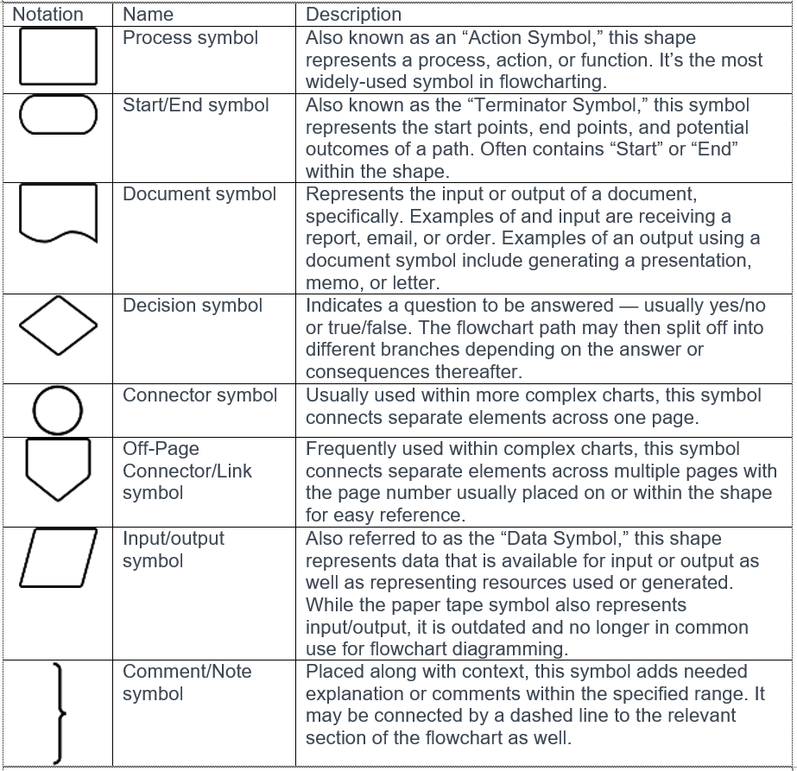

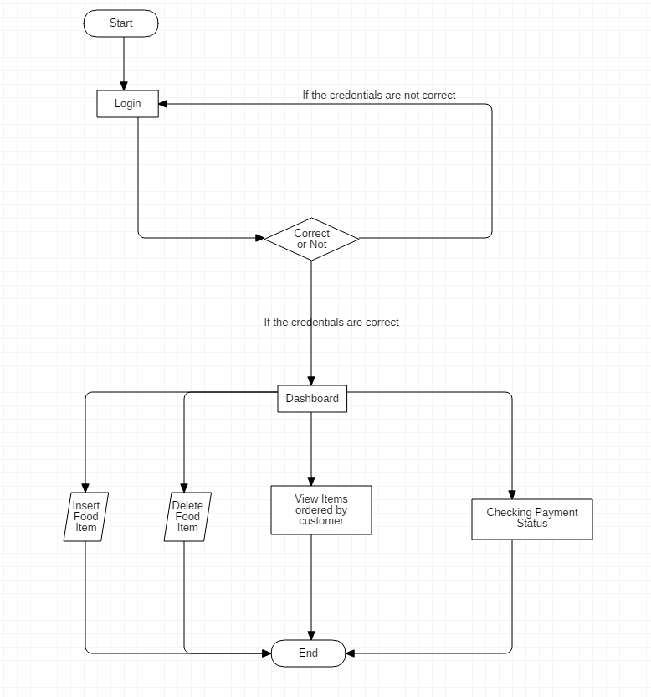

**Fig 5: Flow Chart for Admin**

**Justification of the Admin Flow Chart:**

Here, the admin login by providing the correct information to get logged in otherwise they are sent back to the login page. After they are logged in, they are displayed with the dashboard where they can insert the food items, delete the inserted food items, view items ordered by customers and manage their details as well as check the payment status.

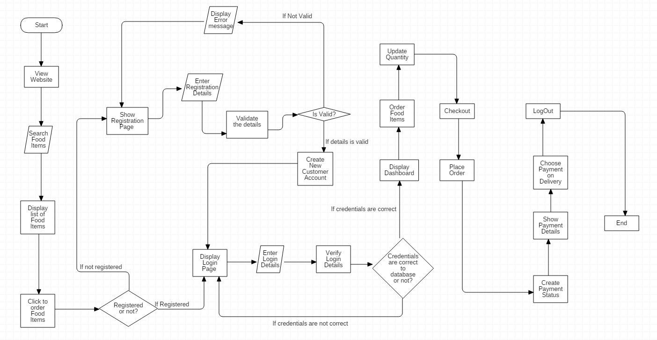

**Fig 6: Flow Chart for Customer’s Processes**

**Justification:**

The above flow chart presents the steps that are required for a customer to begin the process. Here, before logging in they can only view the food items on the website and search for the food items. But, if they want to order the food items they must sign up by creating an account. If the customer is not registered then h/she needs to register for an account. When an account is created or they already have an account then a login page is displayed where they provide their login details after which an order page is shown. The displayed order page is where the customers can view food items and order them. They can update the food items and checkout. After which they can place their Order and that creates their payment status which is also displayed to them. And, finally they choose a payment on delivery option and then logs out which ends the process.

# 3.2. Behavioral Modelling:

## 3.2.1. Activity Diagram:

Activity diagram, is viewed as Behavioral diagram since they depict what must occur in the framework being demonstrated.

**Justification for the approach taken:**

* Movement outlines present various advantages to clients. Consider making an action chart to:
* Exhibit the rationale of a calculation.
* Depict the means performed in an UML use case.
* Represent a business procedure or work process among clients and the framework.
* Streamline and improve any procedure by explaining muddled use cases.
* Model programming engineering components, for example, technique, capacity, and activity

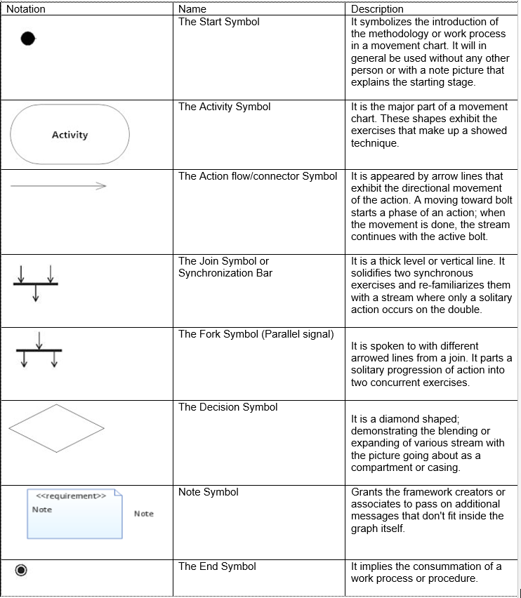

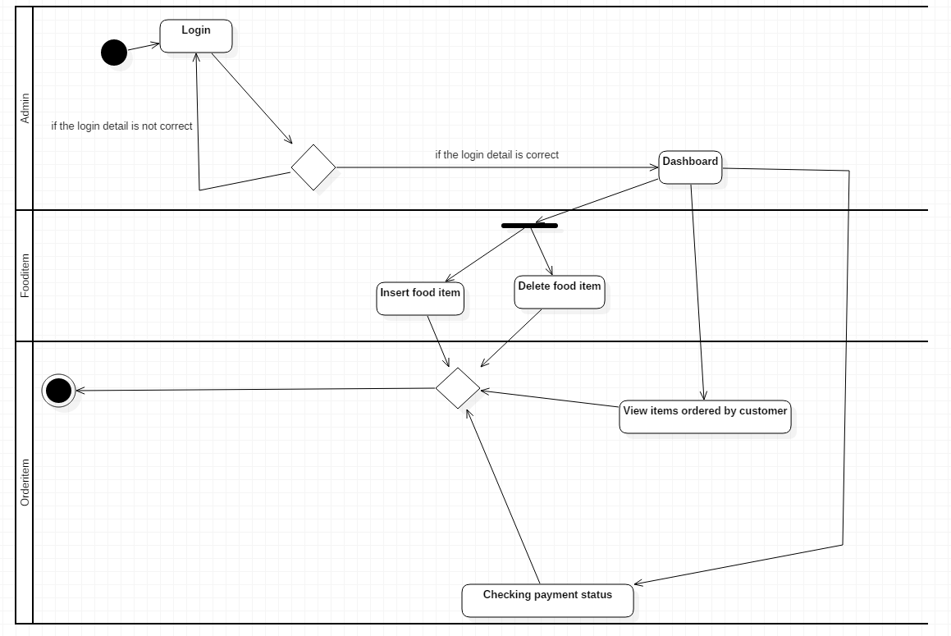

Fig1: Activity Diagram of Admin

This is the activity diagram for admin. Here, admin gets logged in to the system by accessing his username and password. Once the credentials are valid h/she gets to the dashboard but if the login is not valid then h/she is sent back to the login page. The admin can insert food items and delete food items on the Fooditem page. He/She can also check the food items ordered by customer and also checks the payment status of the customer’s food.

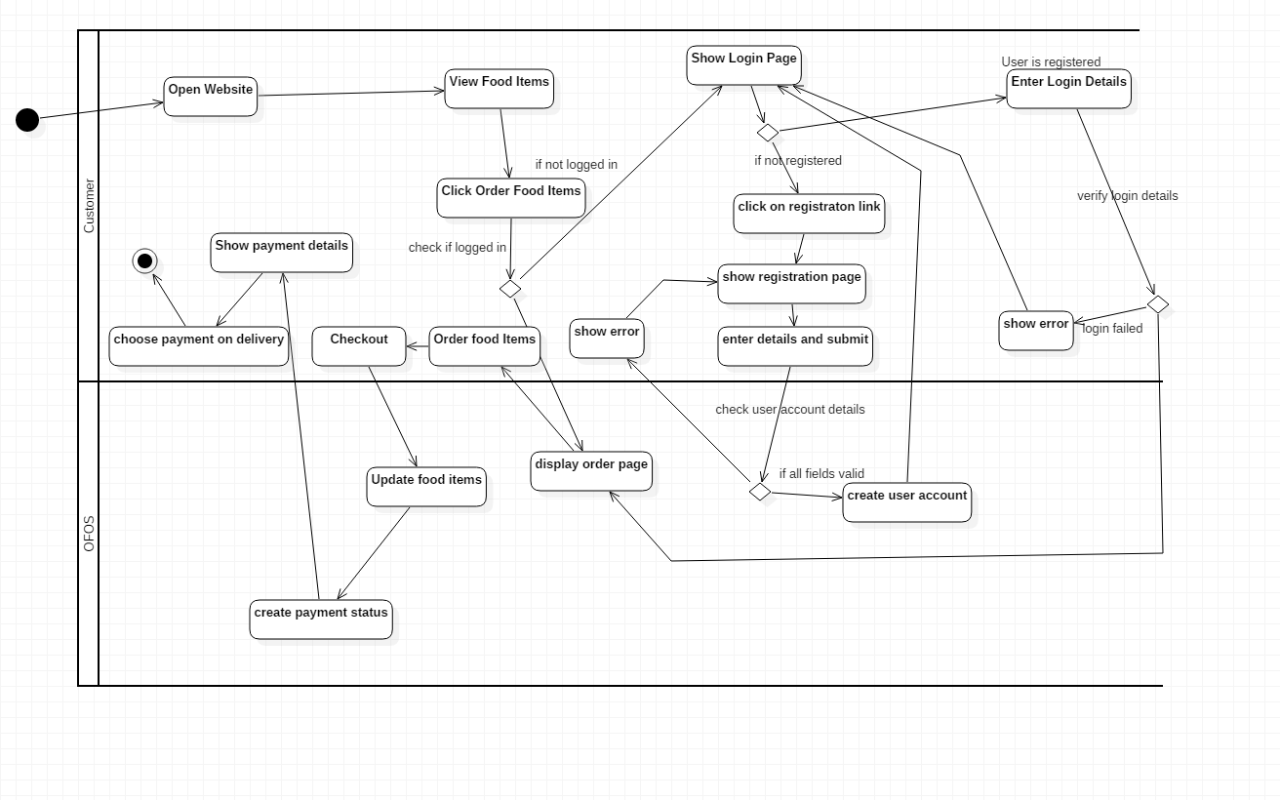

Fig2: Activity diagram of Customer

Activity Diagram Explaning For Customer

This is the Activity Diagram for the Customer. Here, h/she initially, opens the website and there h/she can view food items that are displayed. There they can click on the order button that displays a login form page if the user hasn’t logged in already. And if they have not registered then they are displayed with a registration page where they can fill their details required. And then they are provided with a login page where they can login. If the login information is correct then the order page is displayed. Where they can order and update their entered details and checkout. And the system places their order by creating a payment details, the details are displayed to the users. And they finally choose the payment on delivery.

## 3.2.2. Sequence Diagram:

A sequence diagram, at times alluded to as an occasion chart or an occasion situation, demonstrates the request where items interface. Along these lines, you can outwardly speak to straightforward runtime situations.

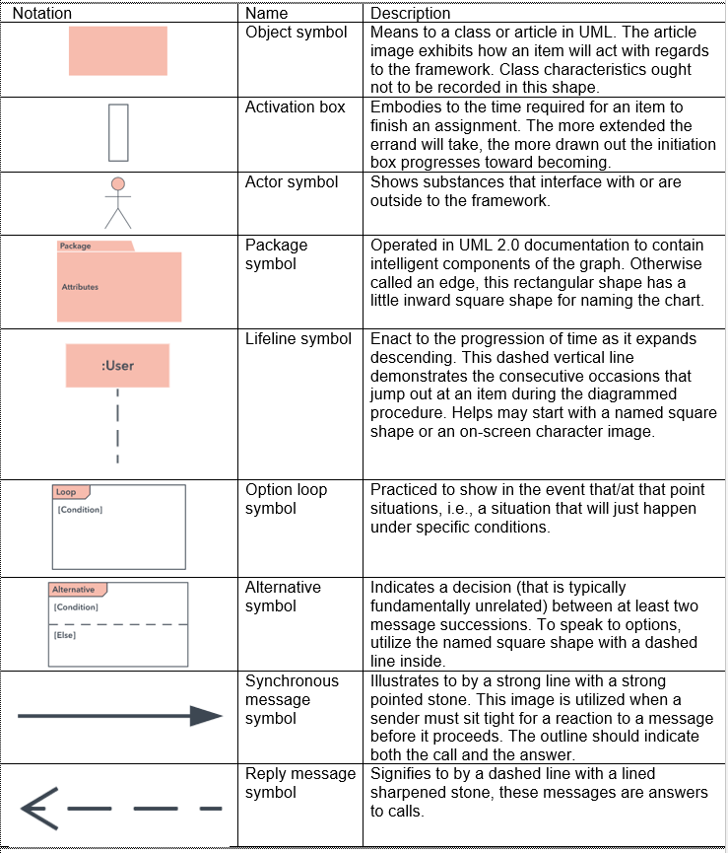

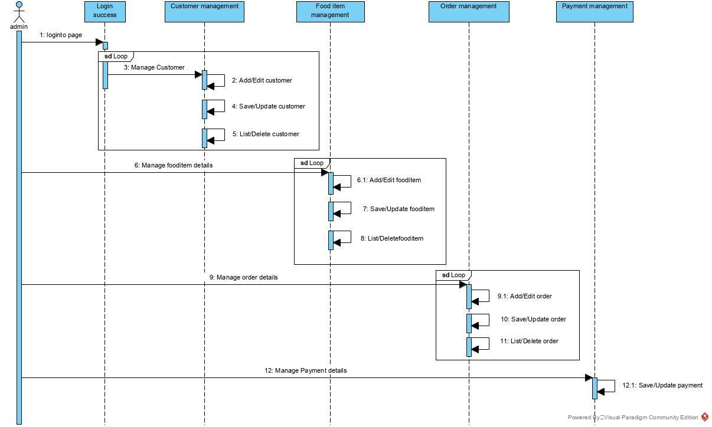

**Fig4: Sequence diagram of admin**

Justification for the Admin’s Sequence Diagram:

Here, in this sequence diagram, admin logs into the Admin page, where, s/he manages Customers Details like, add/edit, save/update and list/delete Customers information. Likewise, admin looks after the food items and add and edit the food item where needed. S/He can also save and update the fooditem as well as list and delete the food items. Similarly, h/she can manage the ordered items by the customer by adding, editing, saving, updating, listing and deleting the orders. The payments status is also managed by admin by saving and updating the payment done by customers.

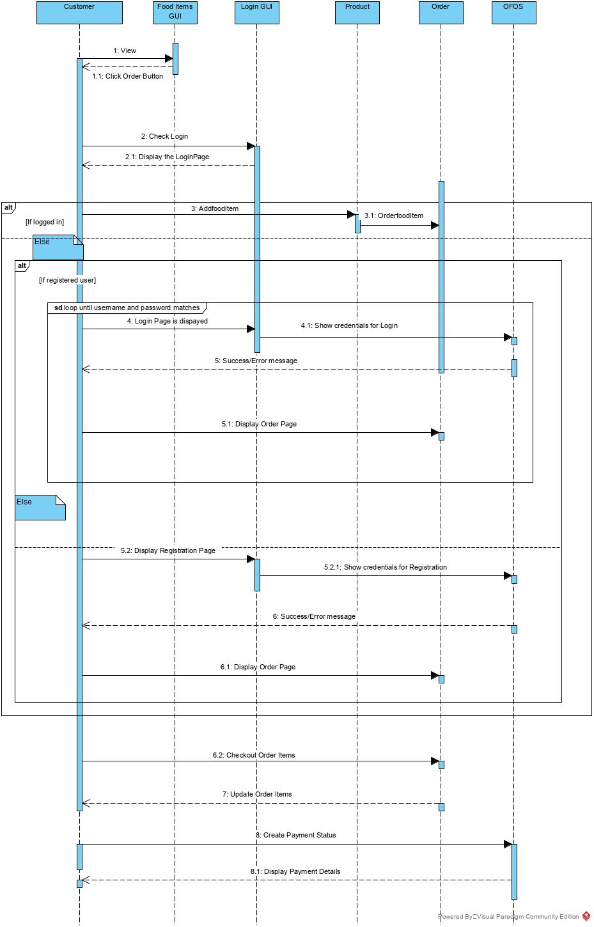

**Fig 5: Sequence diagram of customer**

Justification of the Sequence Diagram of Customer:

Here, Customer firstly, opens the website and view the food items. And when they want to order the food items they click on the Order Button. As they are not logged in and have to login to order. So, they are provided with Login Form. Here, they fill up the required credentials, and gets authentication. But if the customer have not registered already then they have to register in order to login. When they have registered then they can login and get access to order the food items. Users can finally order the food item, checkout and also update their orders. After they have finally placed their order a payment status is created and shown to them where they choose the delivered payment status. Product class handles the request and returns the similar items to search term. Finally, their ordered is confirmed.

# 3.3: Database Modelling:

Database modelling demonstrates the sensible structure of a database, including the relationships and constraints that decide how information can be put away and got to. Singular database models are structured dependent on the principles and ideas of whichever more extensive information model the planners receive. Most information models can be spoken to by a going with database graph.

## 3.3.1. Data Dictionary

Data Dictionary is an once-over of data segments (table or entity and column or attribute) with their characteristics and portrayals. It has a kind of a ton of tables. . A basic stage in isolating a game-plan of articles with which customers’ accomplice is to see each address and its relationship to different things. Data word reference delineates the data objects of customer. It offers the quick report. By giving whole nuances it helps the clients. It outfits the information of every characteristic with its fields. To make the data word reference we should join quality name, data type, length and key.

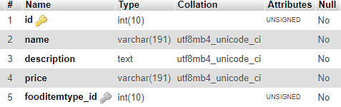

Fig: Table fooditems

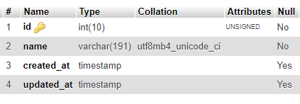

Fig: Table fooditemtypes

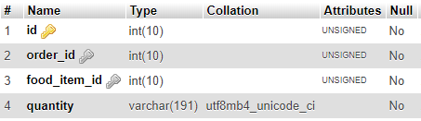

Fig: Table Orderitem

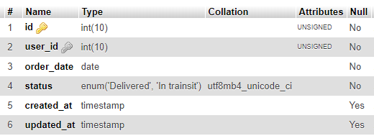

Fig: Table Orders

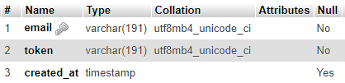

Fig: Table Password Resets

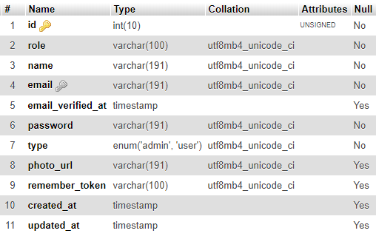

Fig: Table of Customers

## 3.3.2. ER Diagram:

An Entity Relationship (ER) Diagram is a sort of flowchart that outlines the way "components, for instance, people, things or concepts represent each other inside a structure. ER Diagrams are consistently used to structure or examine social databases in the fields of programming building, business information systems, guidance and research. Generally called ERDs or ER Models, they use a described arrangement of pictures, for instance, square shapes, valuable stones, ovals and interfacing lines to depict the interconnectedness of substances, associations and their attributes. They reflect semantic structure, with substances as things and associations as activity words.

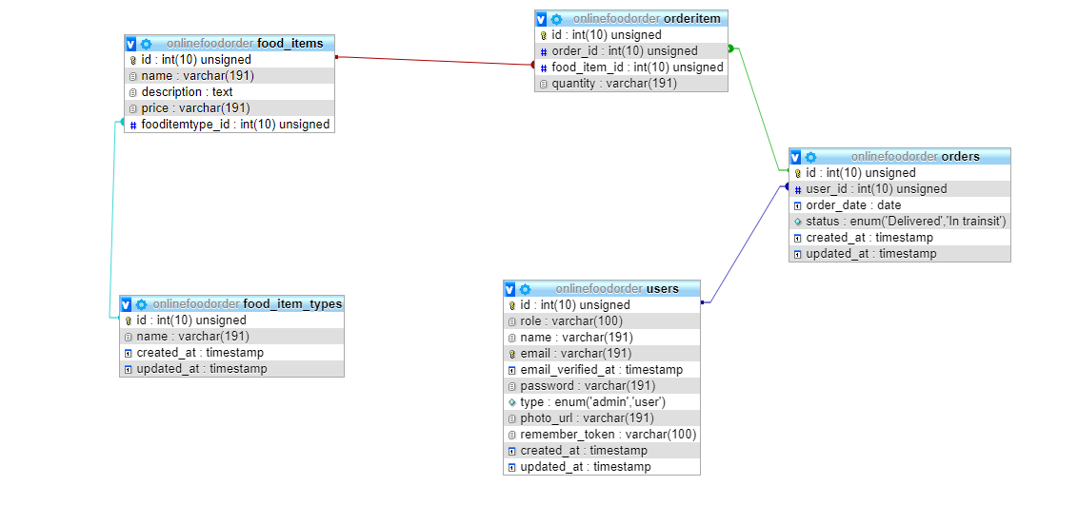

Fig 3: ER diagram

# 3.4. UI modelling:

UI is the front view of application where client communicates so as to utilize the product. Client can control and manipulate the product and hardware by methods for UI.

UI is a piece of programming that is designed in a way that it is relied upon to give the client understanding of the product. UI gives basic stage to human-PC communication.

UI can be content based, graphical, sound video based, contingent on the combination of fundamental equipment and programming. It can be equipment or programming or a blend of both. Prior to coding starts, we make model of the UI and to make that UI model to demonstrate the client, here, Balsamiq wire framing device is used that permits to make UI model before composing.

## 3.4.1. Prototyping:

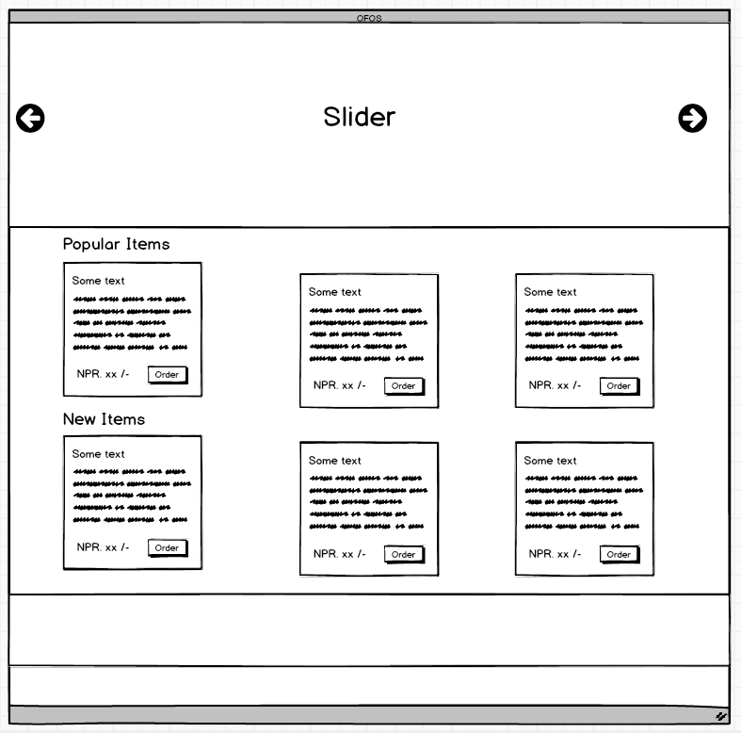

Fig 1: Home Page

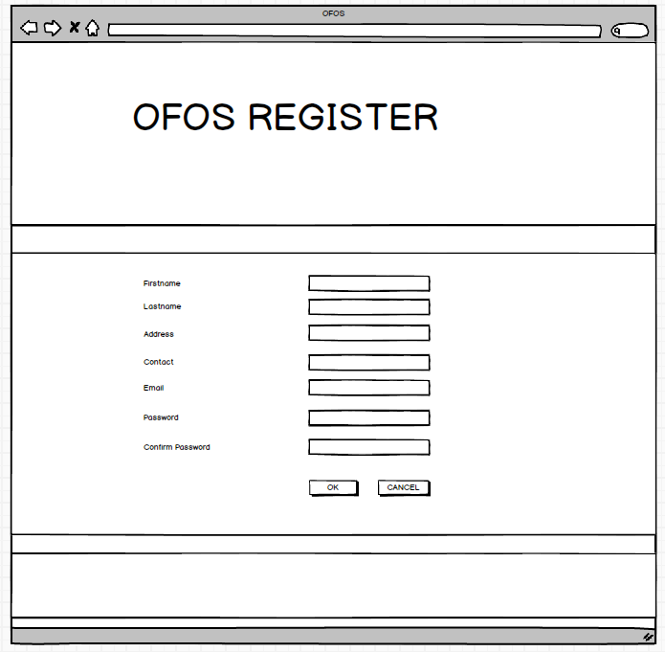

Fig 2: Registration Page

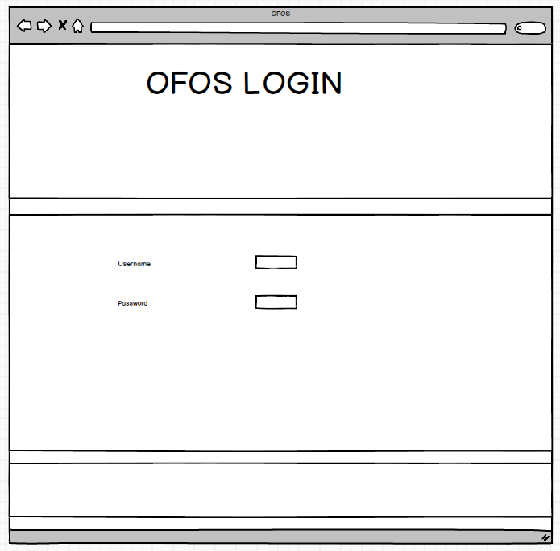

Fig 3: Login Page

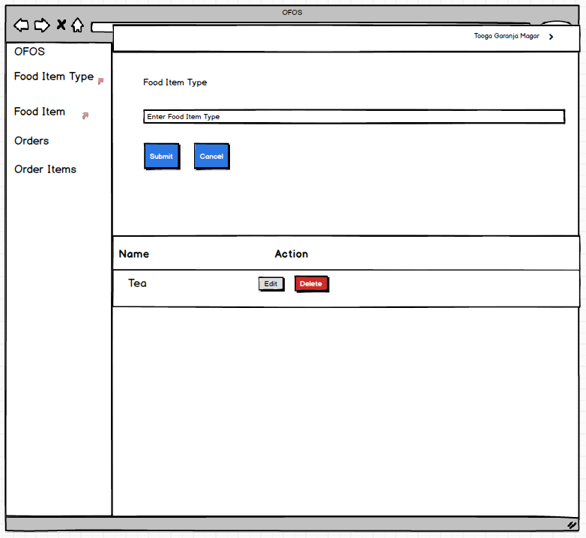

Fig 4: Food Item Page

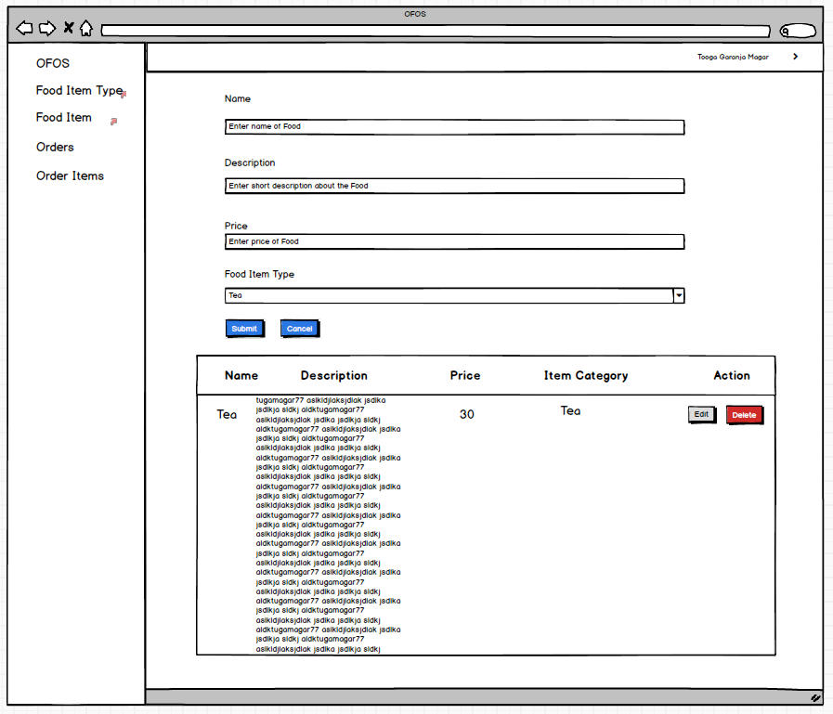

Fig 5: Food Item Type Page

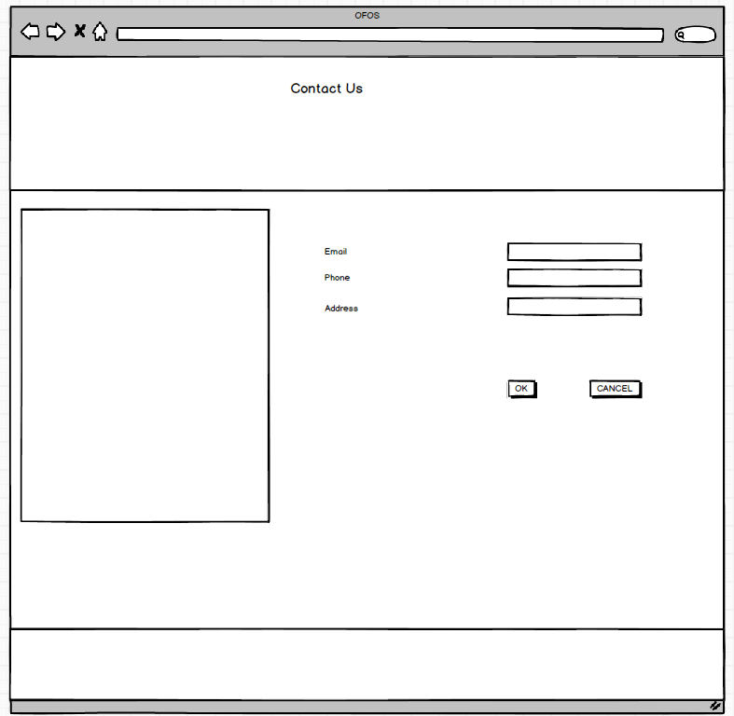

Fig 6: Contact Us Page

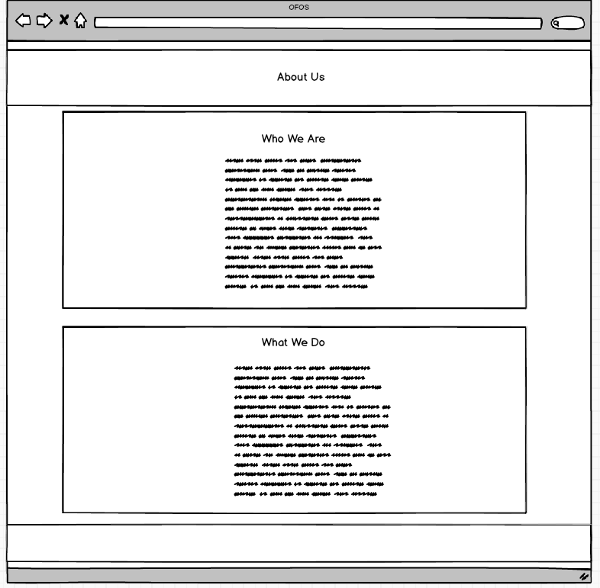

Fig 7: About Us Page

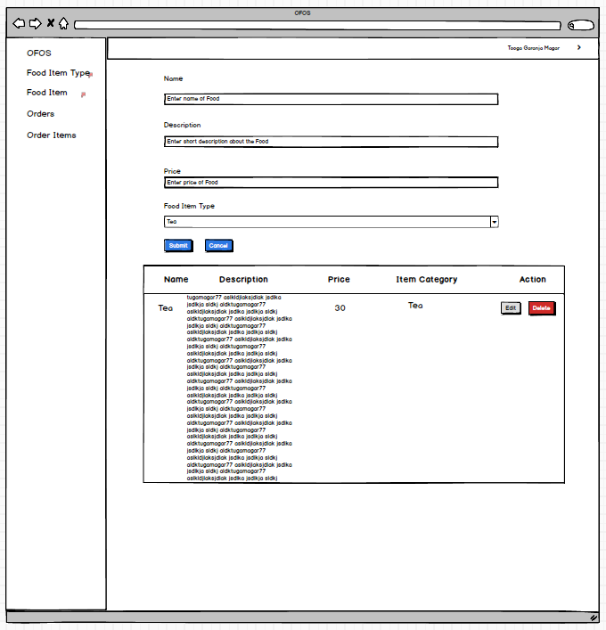

Fig 8: Order Page

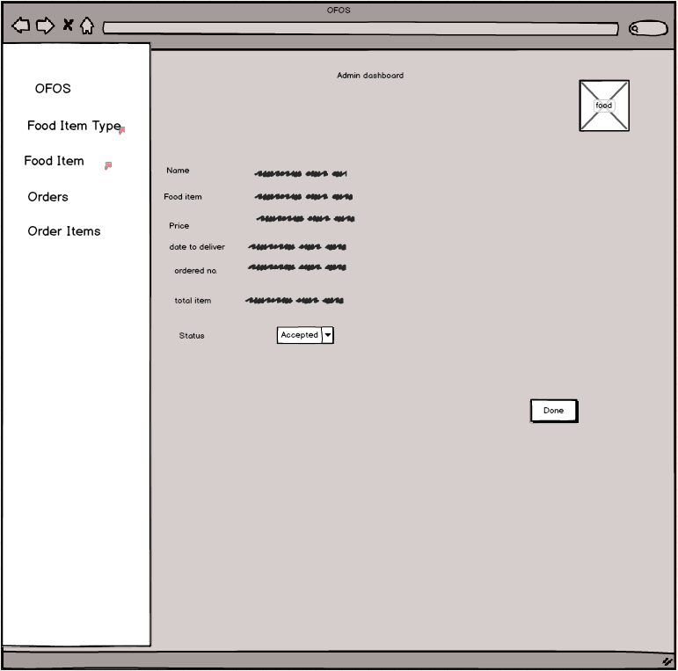

Fig 9: Admin Dashboard