

**Demonstruct**

**PROJECT REPORT**

JANUARY 2022

**GROUP 17**

Tugay Talha İÇEN 210104004084

Yasir GÜNEŞ 210104004079

Deniz ALTINIŞIK 210104004064

Denizhan YILDIZ 210104004085

Salih KARAGÖLLÜ 210104004069

Muhammed Emir SİVRİ 210104004062

Mert Emre ATEŞAĞAOĞLU 210104004046





**Contents**

1.Summary 3

2.Problem Description 3

3.Project Set-Up 3

4.How Demonstruct Operate 3

5.Outputs and Benefits 5

6.Inputs and Outputs 5

7.Results 6

8.Conclusions 6

9.System Block Diagram 6

10.Group 7

11.References 8



**1.Summary**

Demonstruct is a project made by using Arduino. Grasping the working principles of Arduino might be difficult for some beginners. This project aims to teach Arduino from the very beginning with a gamified approach. The Demonstruct app contains many lessons and examples with varying difficulties. Users can create their profiles to earn experience points (XP) by completing lessons and can use their XP points to unlock the next level.

**2.Problem Description**

Arduino is a low cost, easy to use programmable device thus making is an essential device for who interest in making little projects. Arduino uses the C programming language and is a basic computer. It is especially used by people who wants to make their own projects. Because it doesn’t need solder, it can be used for making demo projects with breadboard. Learning how Arduino works can be challenging for beginners so we decided to make this project to ease it for them.

**3.Project Set-Up**

* Arduino Uno
* A to B USB Cable
* Medium Breadboard
* 40 Pin Detachable Male-Male Jumper Cable
* 330 Ohm Resistor
* 10K Ohm Resistor
* 5 mm Red LED
* 5 mm Green LED
* RGB LED
* 10K Potentiometer
* 5mm LDR
* HC-SR04 Ultrasonic Sensor
* Push Buttons (4 Pins)
* LM35 Temperature Sensor
* Buzzer

**4.How Demonstruct Works?**

Demonstruct is designed for Computer Science Engineers who are trying to learn Arduino but has limited resources, time and don’t know where to start from. Demonstruct takes the user’s arduino and coding knowledge from scratch and builds above it until the user’s knowledge is sufficient enough for first to second year assignments given by the university or just for simple-short projects. Demanstrate ensures an arduino that can teach itself since it has all the potential to do it.

Beginners generally have difficulty about where to start so the system tracks each in order to guide them and teach them better. The program supports multi-users and can track each of their progresses independently. Demonstruct keeps all of the user’s progression safe with user identificaion system. Users just have to sign up to the system and let the system do the rest. This guidence has also been made possible by our exp system which is tightly integrated with our user identification system. Also the menu layouts has been made extremely simple in for easier understanding. The user doesn’t need any extra knowledge to slide through menus.

Menus are important, but not as the rest of our system. Demonstruct explains all the codes necessary for the demonstrations and challenges in the continuation of the system. “C codes” which is made by Denizhan, give all the knowledge for “arduino codes” and “arduino codes” category which made by Mert helps users to understand the arduino syntax and gives them an overall understanding with explanations and examples.

Now for the bigger part. One of our main goals was to make an arduino which basically can teach itself. Demonstruct can help users build circuits with diagrams, photos and explanations. After user built the project’s all components, Demonstruct can give order to arduino to detect if the user has built the circuit proper or not. If not, further explanation can be made. If the circuit has been built succesfully, the demonstration part begins. Demonstruct runs the corresponding code to the demonstration and shows how the code Works in physical environment and also while demonstration, the code that Demonstruct runs is being showed. This way one of the biggest difficulties while coding which is “not being able to see what you have done” has been overcomed thanks to Demonstruct. This is a big problem throughout all coders because the code is not a physical thing and it does not notify you when it does or doesn’t work. Demonstruct also gives people some recommendations about the coding ethic so that people don’t code chaotically anymore.

If we go in detail about the circuit detection part, it can detect the present circuit in many various ways like, directly reading analogously from the circuit, digitally reading the circuit, letting users know with LEDs which are being connected in a particular way and with some physical button switch operations. With these methods, our code and arduino can adapt to many different circuits and scenarios. If users wants to find out how it works, they always can look through the code since the program is open source.

After some progession made which the exp system determined, firstly the user will be able to get a better understanding of how some hardwares work like ultrasonic sensor, potentiometer, pushbutton switch and many more. All the steps we mentioned earlier explanation, examples,detection,recommendation and demonstration has been applied throughout the hardwares.

Now that the user has comleted the “hardwares” category, Demonstruct guides the user to the “projects” category. This category is mostly for practicing purposes. Basic projects has being given to the user so that the user can understand everything needed for the aformentioned purposes.

What lies behind this system is almost a 3000 lines of compressed c and arduino code and dozens of quality control and whats fascinating is, the whole system just works in harmony. The Group 17 which is made of 7 people worked really hard to put this together. We did our best and always put original content and the best example of this is our project idea. We made meetings and put deadlines in order to work uniformly and orderly.

**5.Outputs and Benefits**

**Output**

* Demonstruct project

**Outcome**

* Learning Arduino is easier for beginners.

**Benefits**

* People learn programming with Arduino in a fun and easy way.

**6.Inputs and Outputs**

**Inputs**

* HC-SR04 Ultrasonic Sensor
* Push Buttons (4 Pins)
* LM35 Temperature Sensor
* 5mm LDR
* Keyboard

**Outputs**

* Buzzer
* 5 mm Red LED
* 5 mm Green LED
* RGB LED
* Monitor

**7.Results**

Bu projenin ana amacı kendi projelerini yapmak isteyen insanlara kolay, eğlenceli ve hızlı bir yol göstermektir. Günümüzde bir çok kişi teknolojiyle içli dışlıdır. bazı zamanlar herkesin aklından belirli küçük projeler geçer ve bu uygulama bu kişilere en hızlı şekilde projelerini gerçeğe dökme imkanı sunar. Arduino ve Arduino kodlamayı öğrenebilmeleri için uygulamalar,örnekler ve anlatımlar içerir

**8.Conclusion**

In an ever-changing and globalized world, technology and programming have become integral parts of our daily lives. As a result of this, people of all ages and different educational backgrounds might have a desire to develop their projects. Arduino is cut-out for this purpose. This project aims to teach people programming with Arduino in the most basic and quick way with its lessons and exercises.

**9.System-Block Diagram**

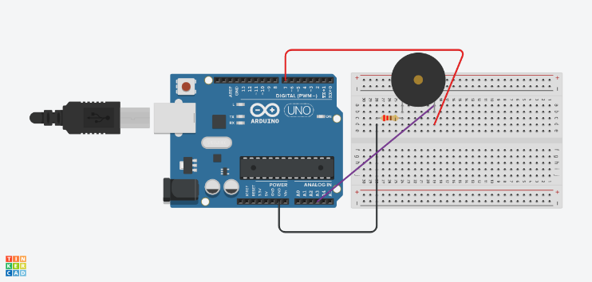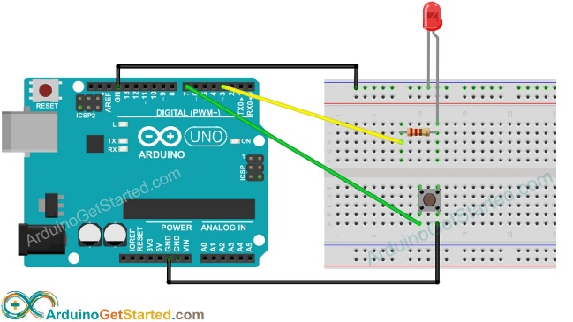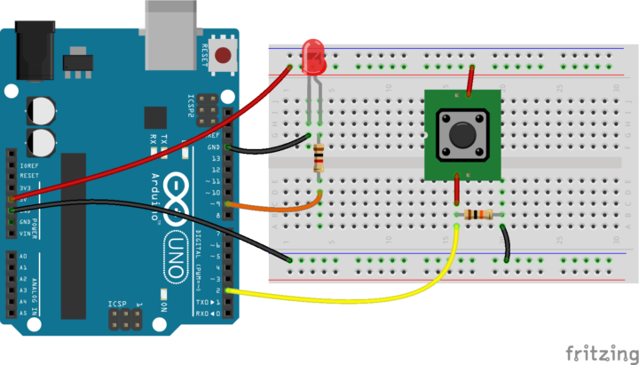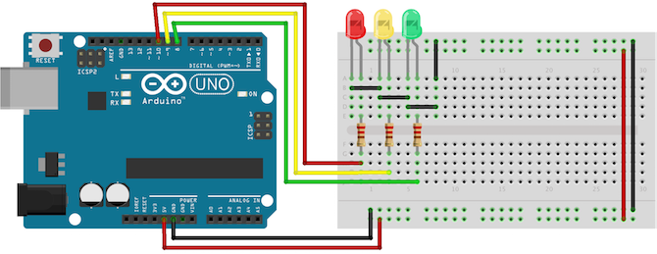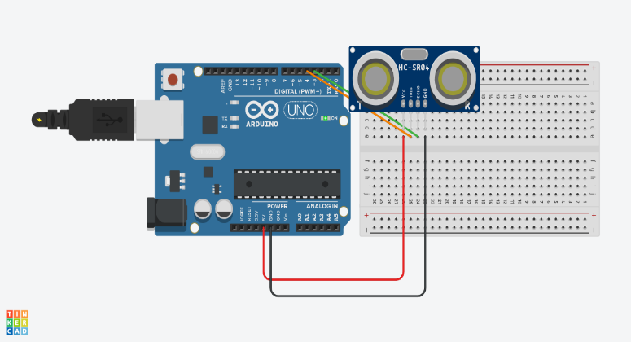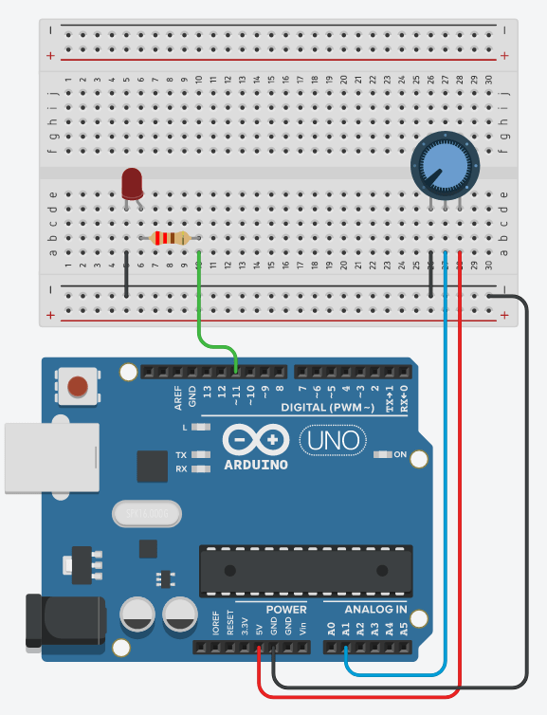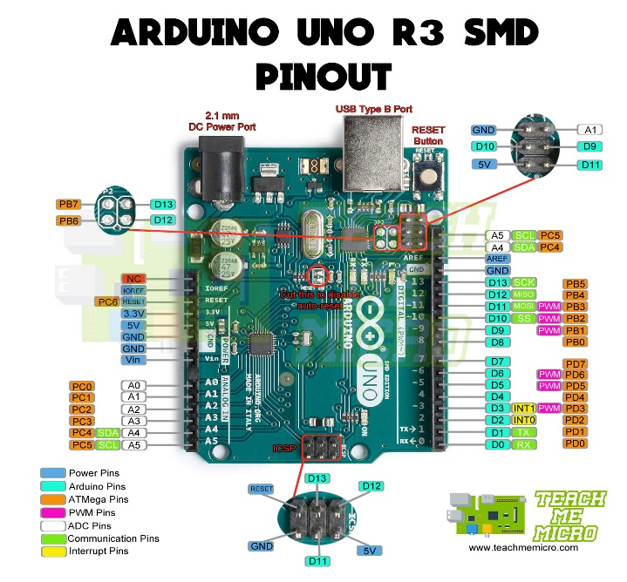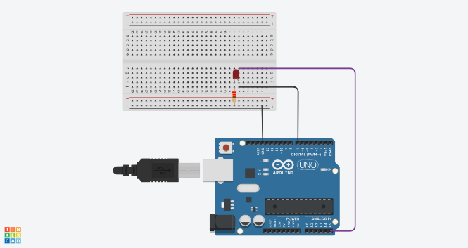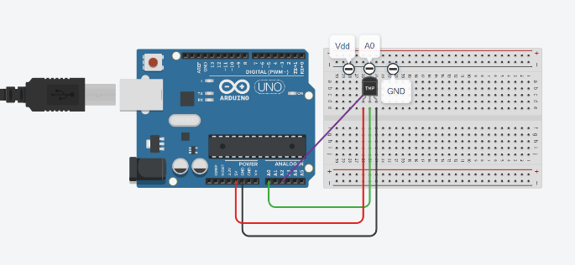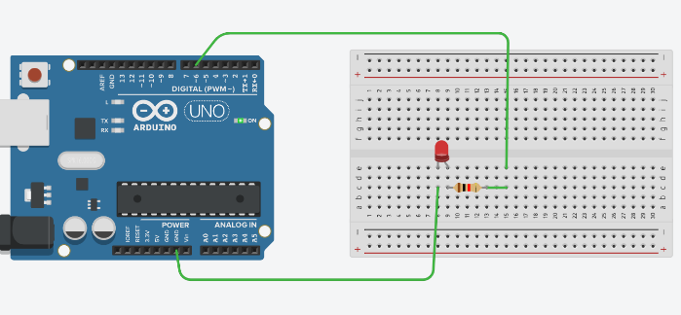

**10.Group**

* Tugay Talha İÇEN - Login system and helped with XP system
* Yasir GÜNEŞ - Connection category
* Deniz ALTINIŞIK - XP system
* Denizhan YILDIZ - Connection category and report
* Salih KARAGÖLLÜ - General organizations, projects category,video, slide presentation and report
* Muhammed Emir SİVRİ - hardware category
* Mert Emre ATEŞAĞAOĞLU - arduino codes category

**11.References**

1. **Tugay Talha İÇEN**
   1. https://stackoverflow.com/questions/15770853/how-to-use-setconsolecursorposition-func
   2. https://www.geeksforgeeks.org/multi-character-literal-in-c-cpp/
   3. https://stackoverflow.com/questions/5801813/c-usleep-is-obsolete-workarounds-for-windows-mingw/17283549
   4. https://docs.microsoft.com/en-us/windows/console/setconsolecursorposition?redirectedfrom=MSDN
   5. https://docs.microsoft.com/en-us/windows/console/getstdhandle?redirectedfrom=MSDN
   6. https://www.oracle.com/solaris/technologies/c-type.html#Contents%20of%20tlist.h|outline
   7. https://www.youtube.com/watch?v=sIEWDOjFub4&list=PLIHume2cwmHdFsJRo5oYG7yQ4NyUx43ql&index=41
   8. https://www.dreamincode.net/forums/topic/414320-hide-password/
   9. https://stackoverflow.com/questions/18496282/why-do-i-get-a-label-can-only-be-part-of-a-statement-and-a-declaration-is-not-a
   10. https://www.geeksforgeeks.org/beep-function-in-c-with-examples/
   11. https://commons.wikimedia.org/wiki/File:ASCII-Table-wide.svg
   12. https://www.programiz.com/c-programming/library-function/string.h/strcmp
   13. <https://www.tutorialspoint.com/c_standard_library/c_function_fread.htm>
2. **Yasir GÜNEŞ**
   1. https://www.arduino.cc/en/Tutorial/Foundations/PWM
   2. https://www.arduino.cc/reference/en/language/functions/analog-io/analogread/
   3. https://www.arduino.cc/reference/en/language/functions/analog-io/analogreference/
   4. https://www.arduino.cc/reference/en/language/functions/analog-io/analogwrite/
   5. https://www.arduino.cc/en/reference/board
   6. https://www.arduino.cc/en/reference
   7. https://www.tinkercad.com/
   8. https://www.youtube.com/watch?v=DRbqCr8UTPc&ab_channel=HobiElektrik-ElektronikDevreYap%C4%B1mlar%C4%B1
   9. https://www.youtube.com/watch?v=5dVejyjTvVg&feature=youtu.be
   10. https://www.researchgate.net/profile/Mugahed-Ghaleb/publication/329042229/figure/fig2/AS:727054244917250@1550354648805/Arduino-UNO-R3-board-4111-Arduino-Uno-Overview-Power-O-USB-power-or-externally-via.png
   11. <https://www.youtube.com/watch?t=470&v=2cNC4k8FMhQ&feature=youtu.be>
3. **Deniz ALTINIŞIK**
   1. https://www.youtube.com/watch?v=1lNL31q4T5I&ab_channel=Dr.ParagShukla
   2. https://www.youtube.com/watch?v=fNXjahQ46jI&ab_channel=BilgisayarKavramlari
   3. https://www.youtube.com/watch?v=H1gR250FWac&t=104s&ab_channel=BilgisayarKavramlari
   4. https://www.youtube.com/watch?v=u6JbAKc1nV0&ab_channel=MelvinCabatuan
   5. <https://www.youtube.com/watch?v=-X6aIOuNCgc&ab_channel=ProgrammingClasses>
4. **Muhammed Emir SİVRİ**
   1. https://create.arduino.cc/projecthub/infoelectorials/project-003-arduino-lm35-temperature-sensor-project-0a43ba
   2. https://arduinogetstarted.com/tutorials/arduino-button-toggle-led
   3. https://roboticsbackend.com/arduino-control-led-brightness-with-a-potentiometer/
   4. <https://create.arduino.cc/projecthub/abdularbi17/ultrasonic-sensor-hc-sr04-with-arduino-tutorial-327ff6>
5. **Salih KARAGÖLLÜ**
   1. https://create.arduino.cc/projecthub/infoelectorials/project-003-arduino-lm35-temperature-sensor-project-0a43ba
   2. https://arduinogetstarted.com/tutorials/arduino-button-toggle-led
   3. https://roboticsbackend.com/arduino-control-led-brightness-with-a-potentiometer/
   4. <https://create.arduino.cc/projecthub/abdularbi17/ultrasonic-sensor-hc-sr04-with-arduino-tutorial-327ff6>
6. **Denizhan YILDIZ**
   1. <https://www.mobilhanem.com/arduino-dersleri-analog-pinler-ve-analog-io-fonksiyonlari/>
   2. <https://diyot.net/arduino-uno-pinleri/>
   3. Htt cps://www.circuitbread.com/ee-faq/what-is-a-breadboard
7. **Mert EMRE**