DOCUMENTATION

CONTENT

Introduction …………………….…………………………………………………….. 1

How to setup your Android device………….………………………………………… 2 - 4

How to Install ARe on your device….……………….………………………………. 4 - 6

How to Run ARe on your device………………………….…………………………… 7 - 8

ARe user controls guide…………………………………………….…………….…… 8 - 10

INTRODUCTION

Note:
Before you can install ARe.apk please ensure your device of choice is AR compatible.

If you would like to check to see if you can run ARe on your Android enabled mobile device, please check from the list of devices on the Google developer page, under supported devices.
https://developers.google.com/ar/devices

ARe is only available for Android devices.

For the purpose of this documentation, I will be using the Samsung Galaxy S8+.

How to Setup your Android device

Before you can run an external application on your Android device (an application not downloaded using Google Play), you have to enable the Special app access in your phone’s settings.

- Turn on your Mobile device
- Open your Android’s Settings
- Scroll down the page until you come to the Apps option. Then click on it.

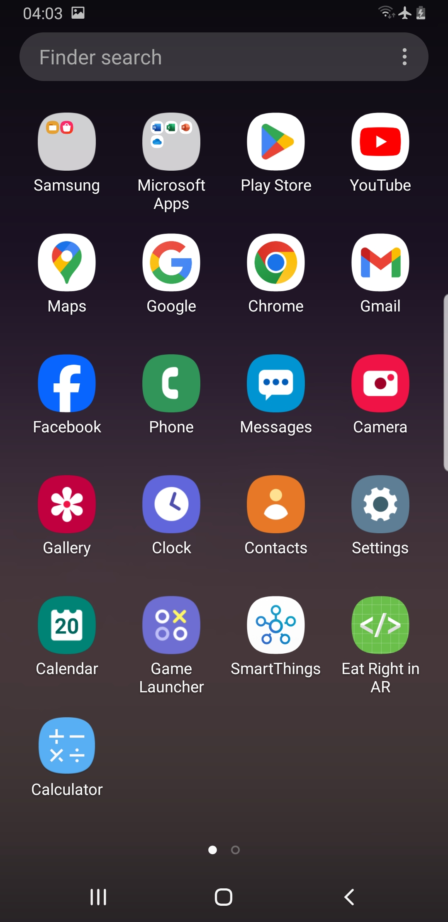
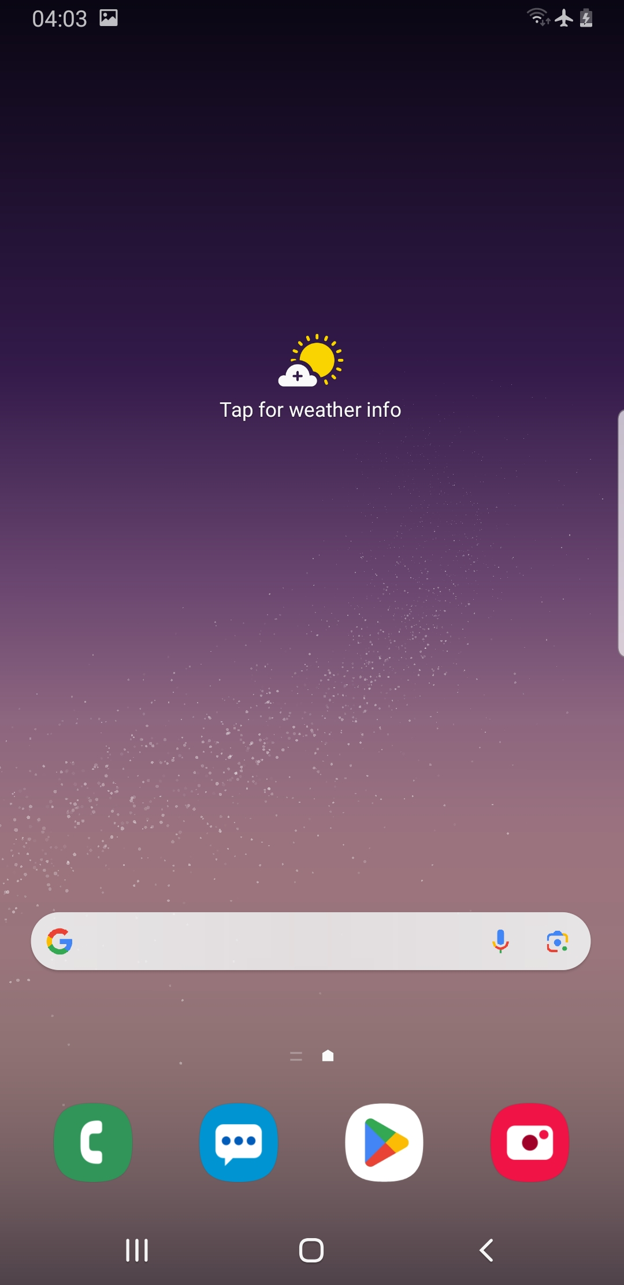
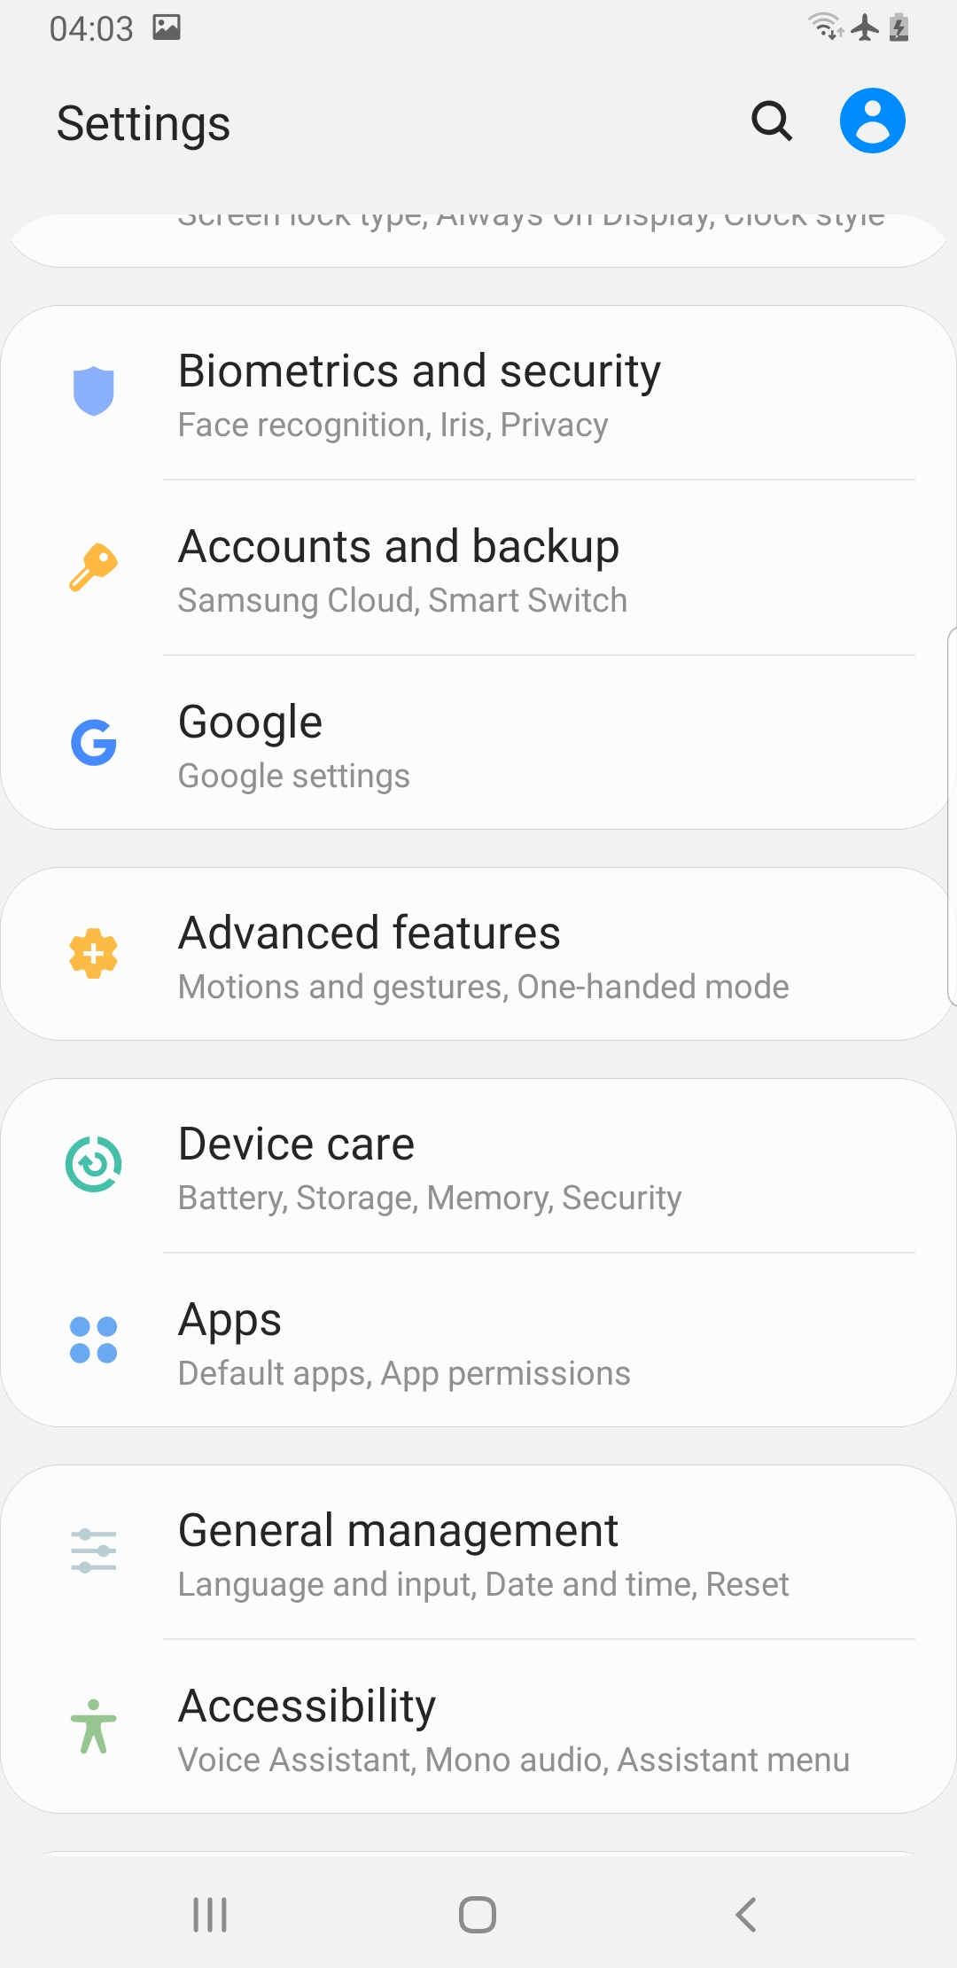

- On the top right corner of the new page, you see an ellipsis. Click on it.
- A menu will appear. From the options given, click Special access.
- From the new page, click on Install unknown apps.

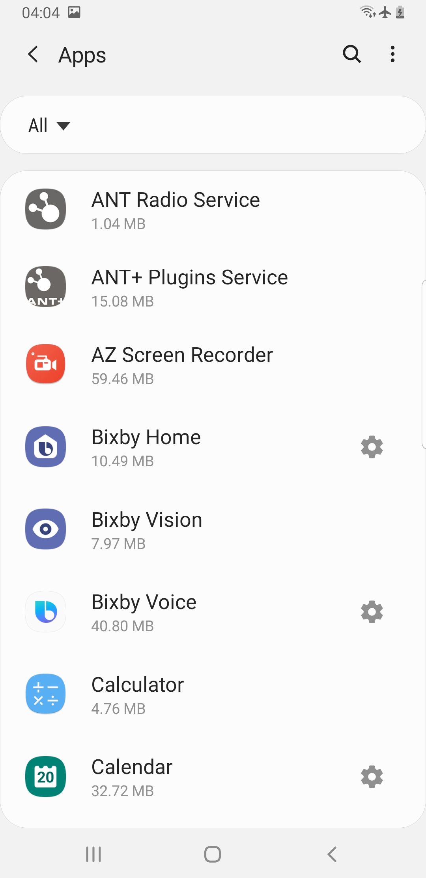
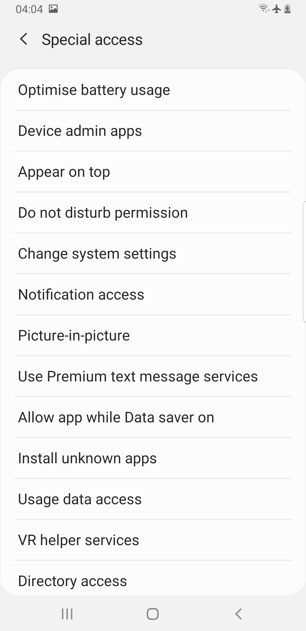
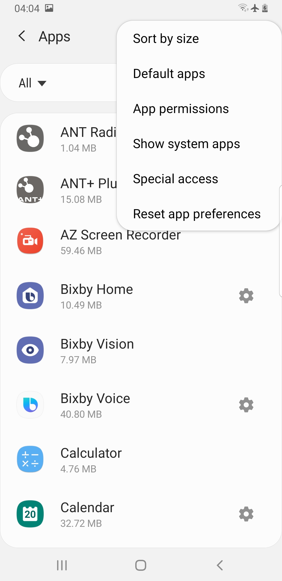

Note: A list of locations will be provided where you can copy the .apk file to and then run the installation. For the purpose of this demonstration, I will be using the My Files location.

- Click on My Files
- On the new page, tap on Allow from this source.

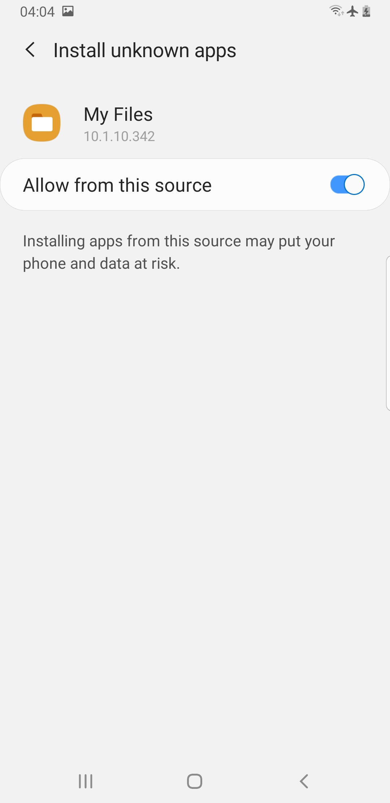
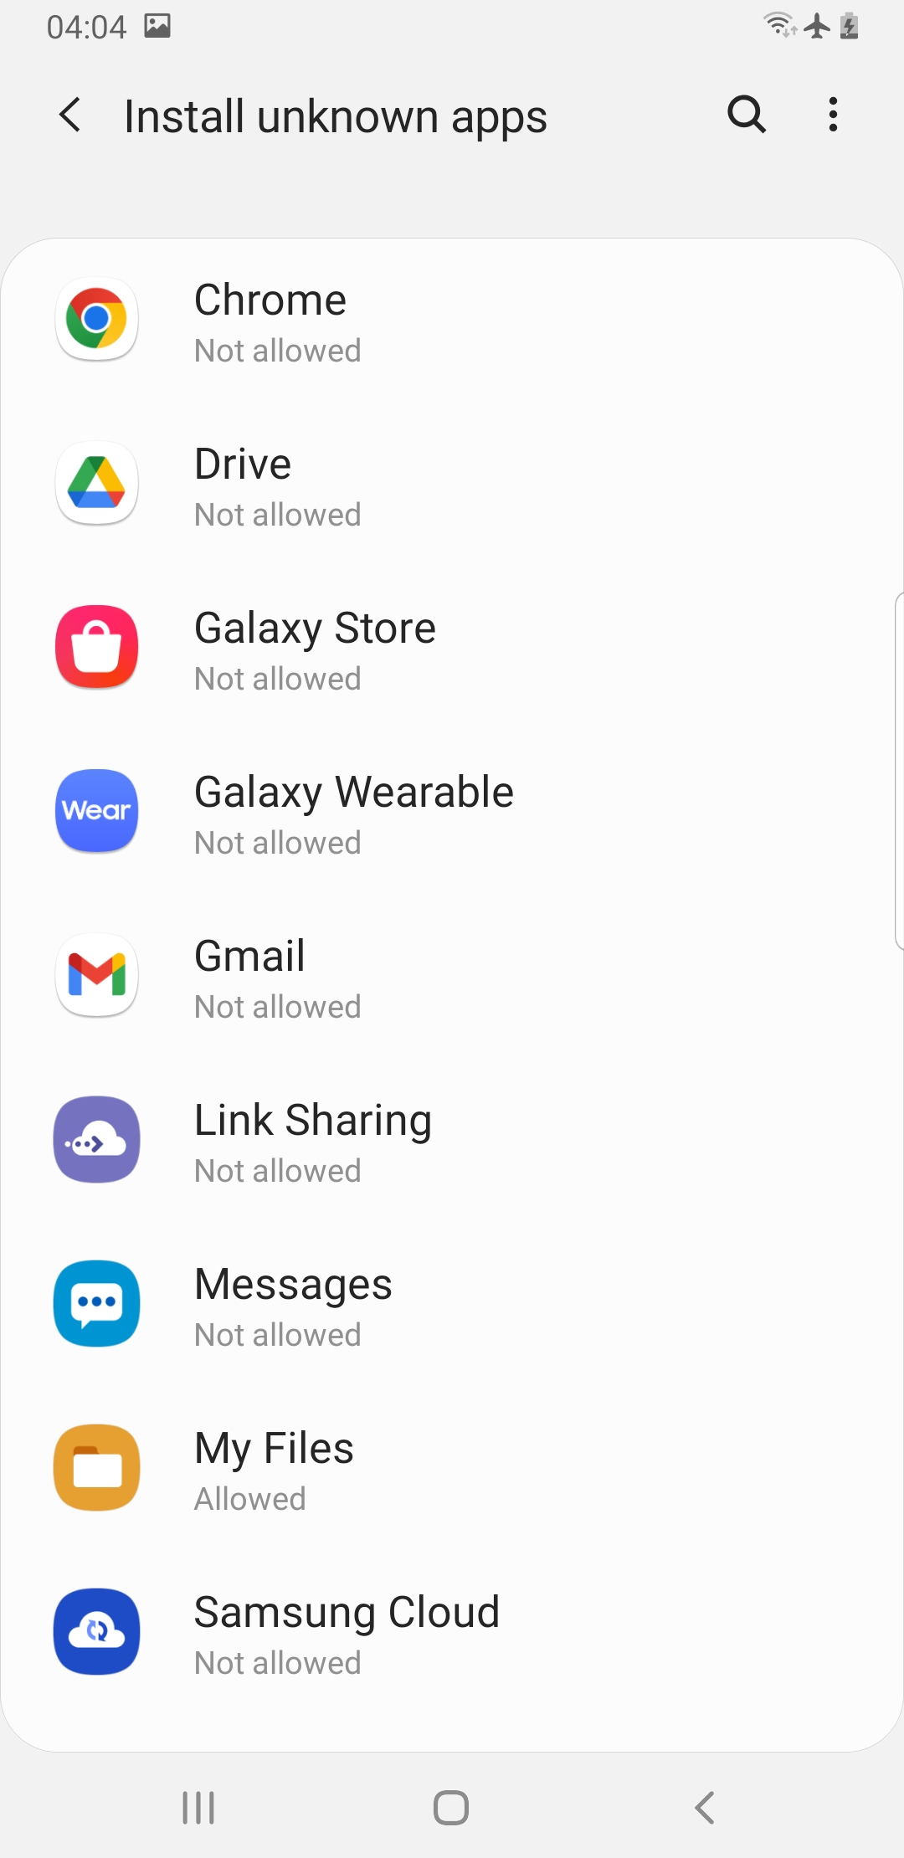

Note: If you are using a slightly older model of the Samsung mobile device or you are using a completely different device entirely, please refer to available resources online for guidance.

How To Install ARe on your device

Note: Download the ARe.apk to a location on your Pc. You can choose to send the file either using bluetooth or usb transfer. For this demonstration, I will be using the usb transfer mode.

- Connect your Android device to your Pc, using a usb cable.

Note: Ensure file transfer option is chosen, if the option appears on your screen.

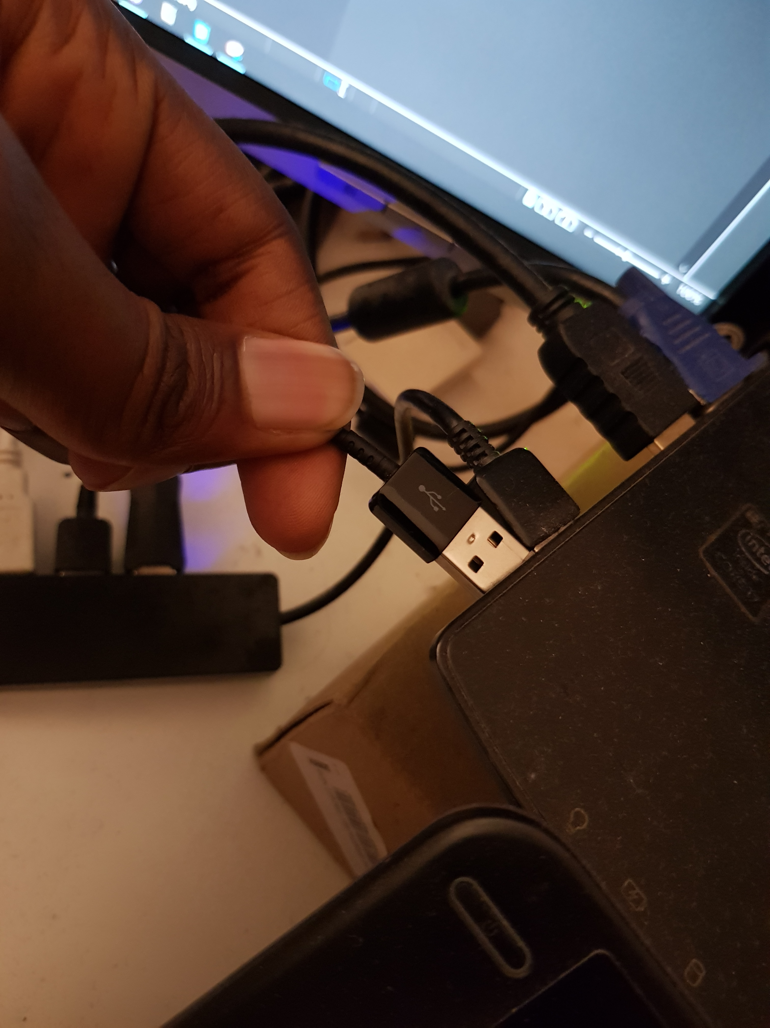
- Navigate to the location where you stored the ARe.apk file.
- Right click and scroll down to the Send to option.
- From the options available, select your mobile device.

Note: At this point the file will be sent to your device.

Go to your Android mobile device
- Turn on your Android mobile device.
- Navigate to the My Files folder. Tap it.
- On the new window, tap the APK: Installation files

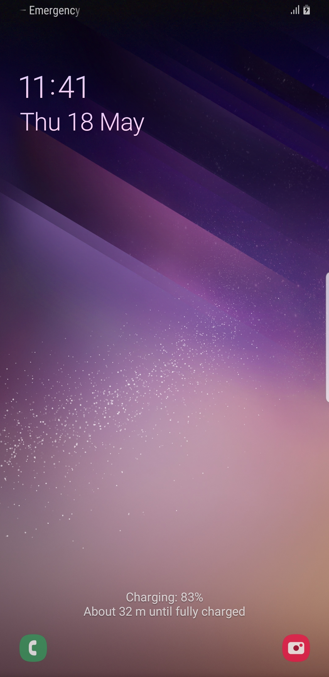
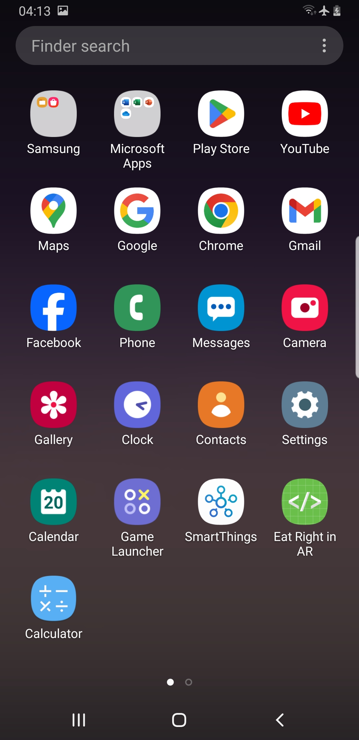
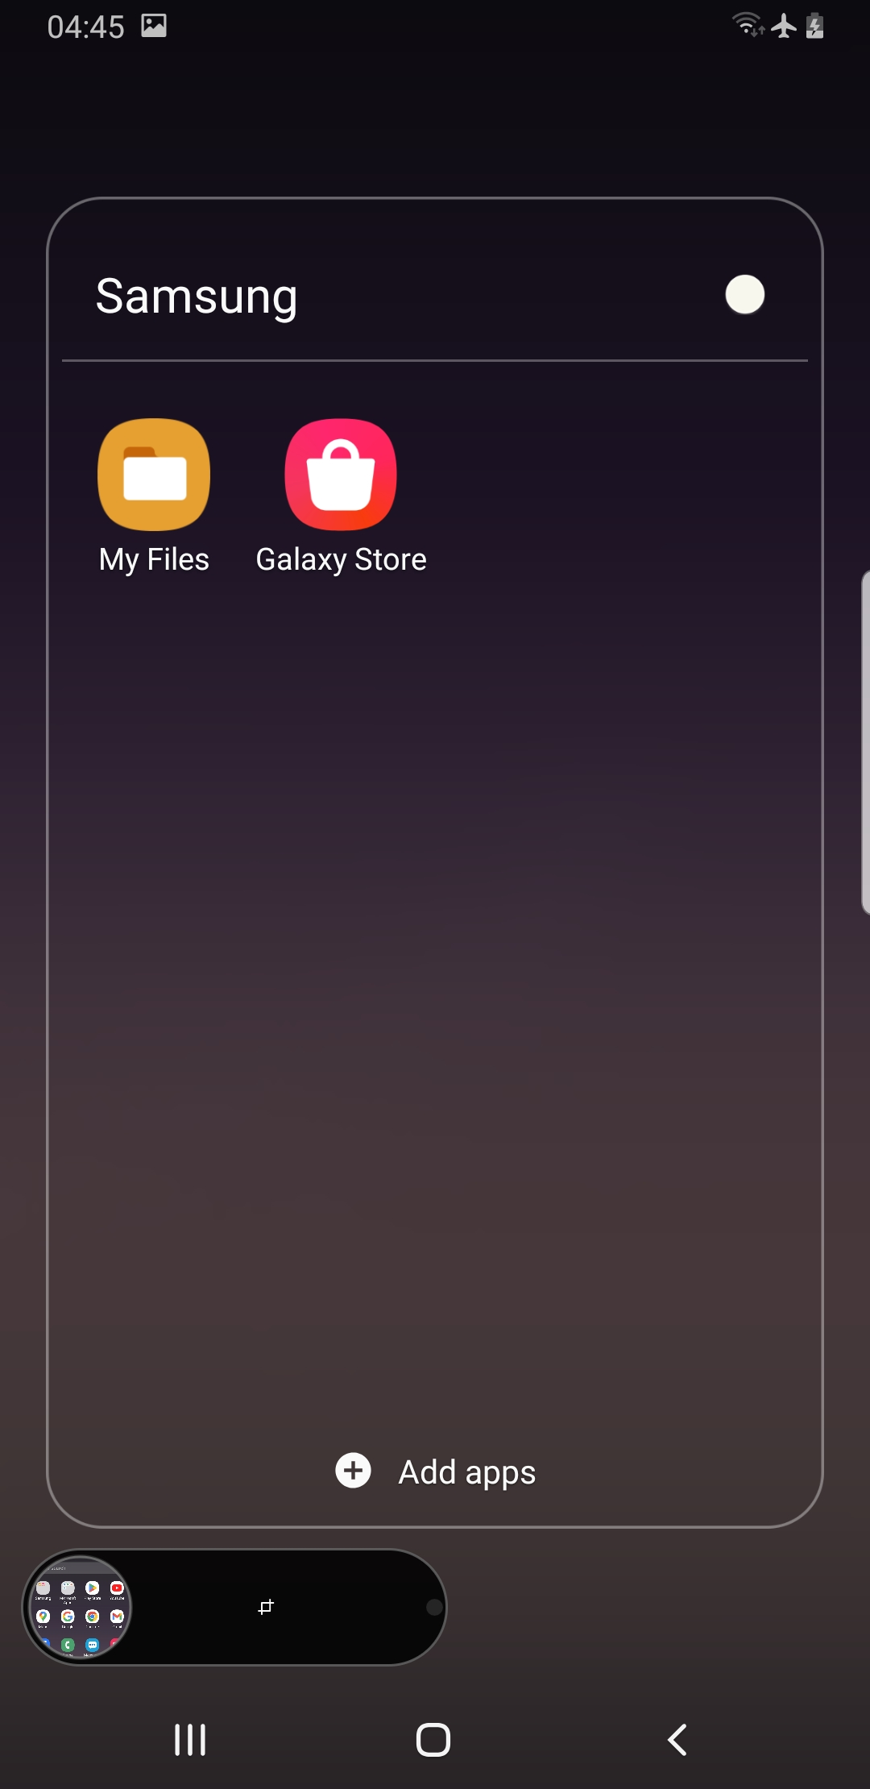

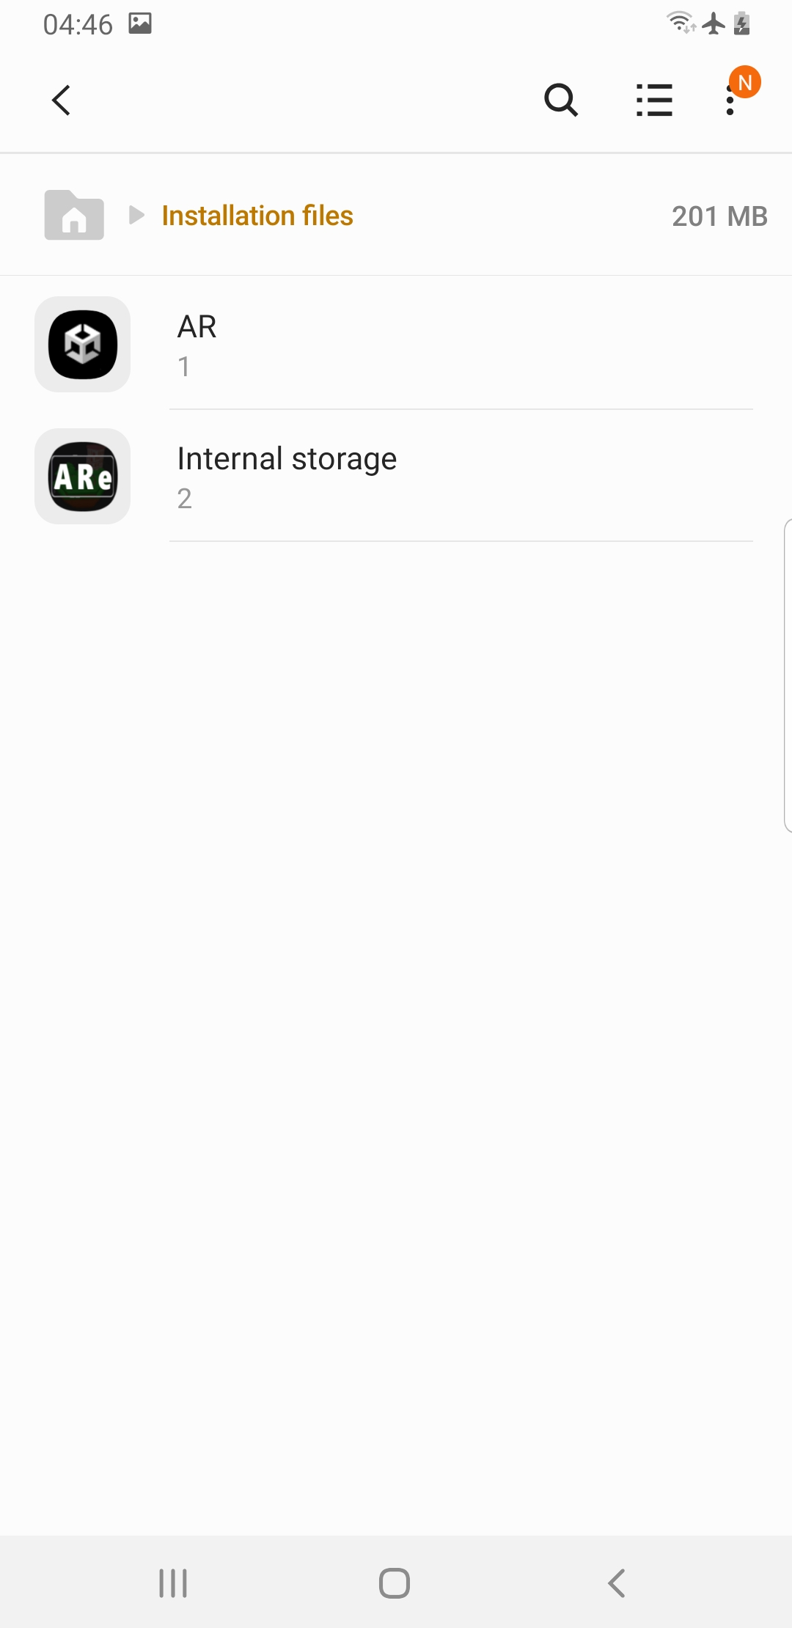
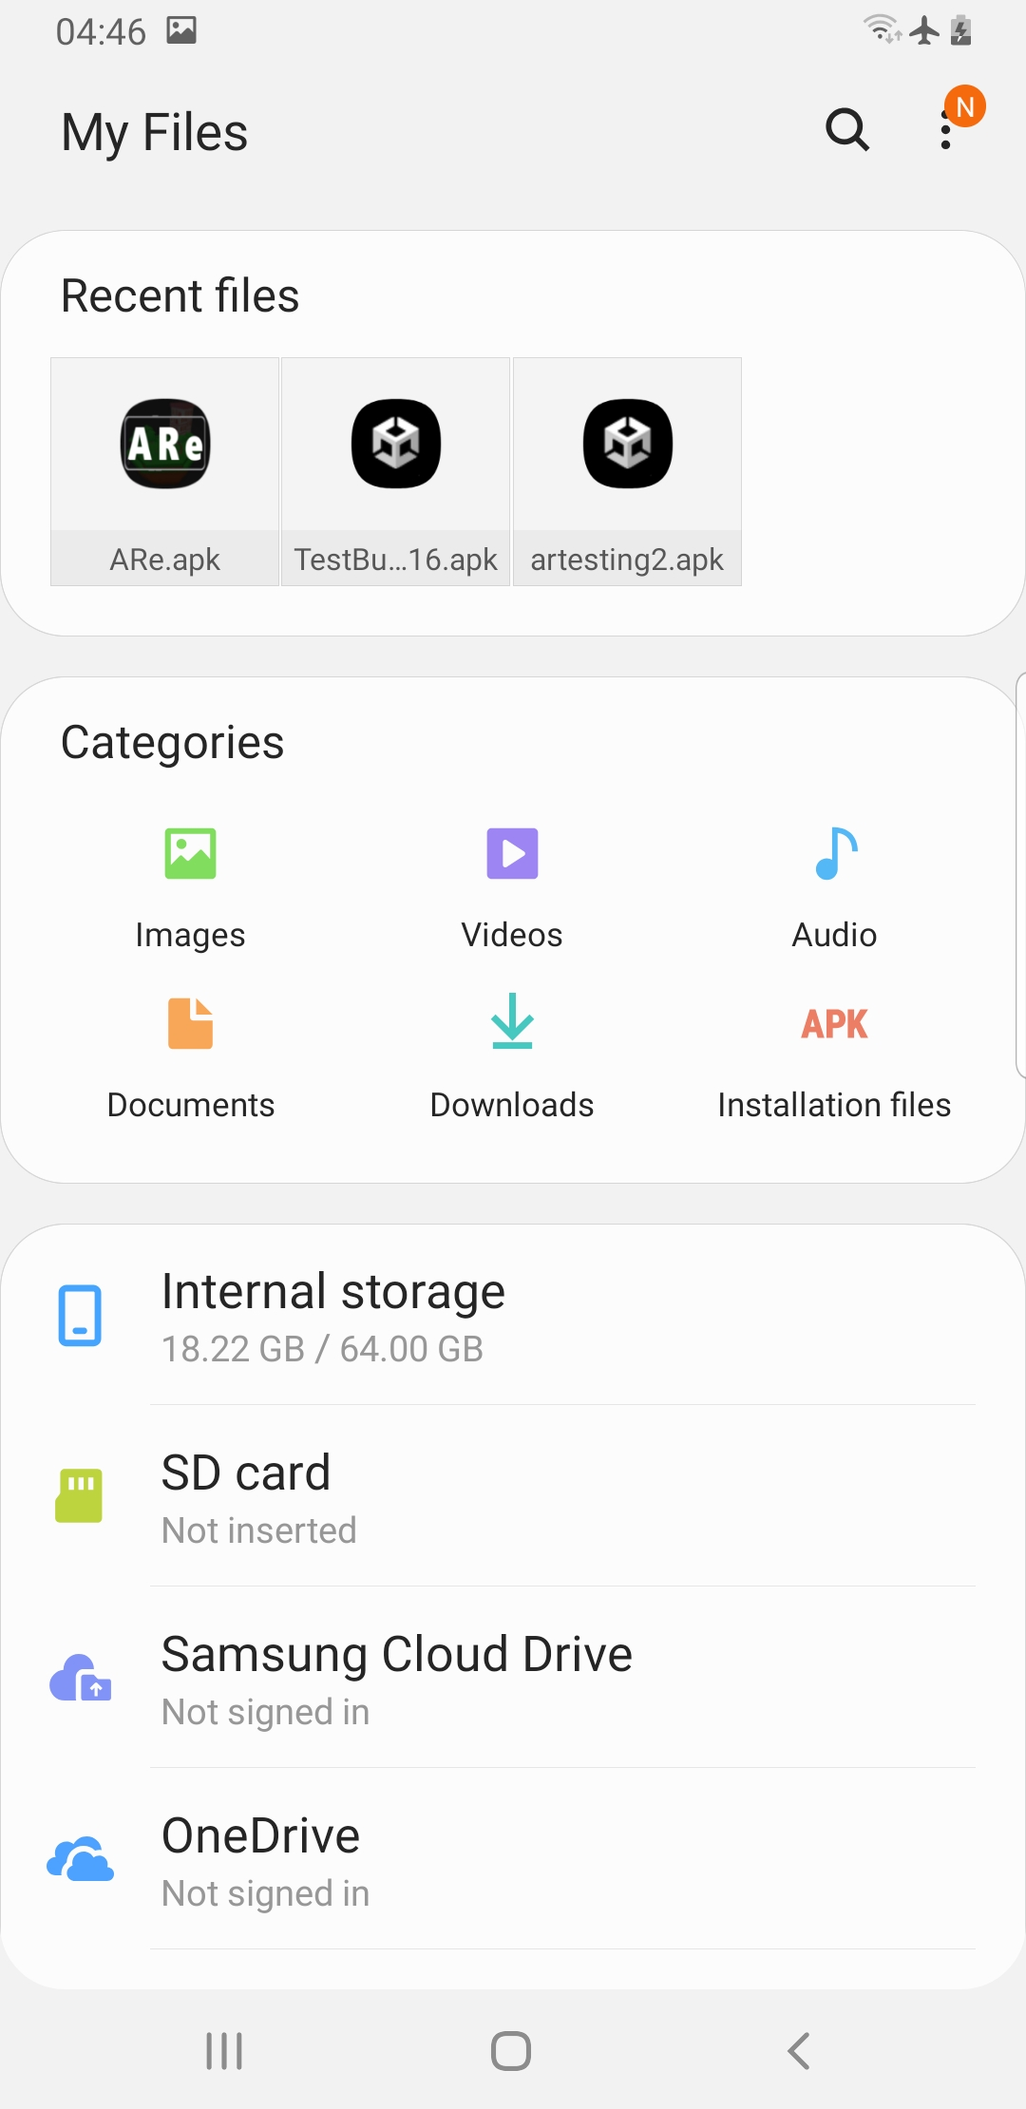
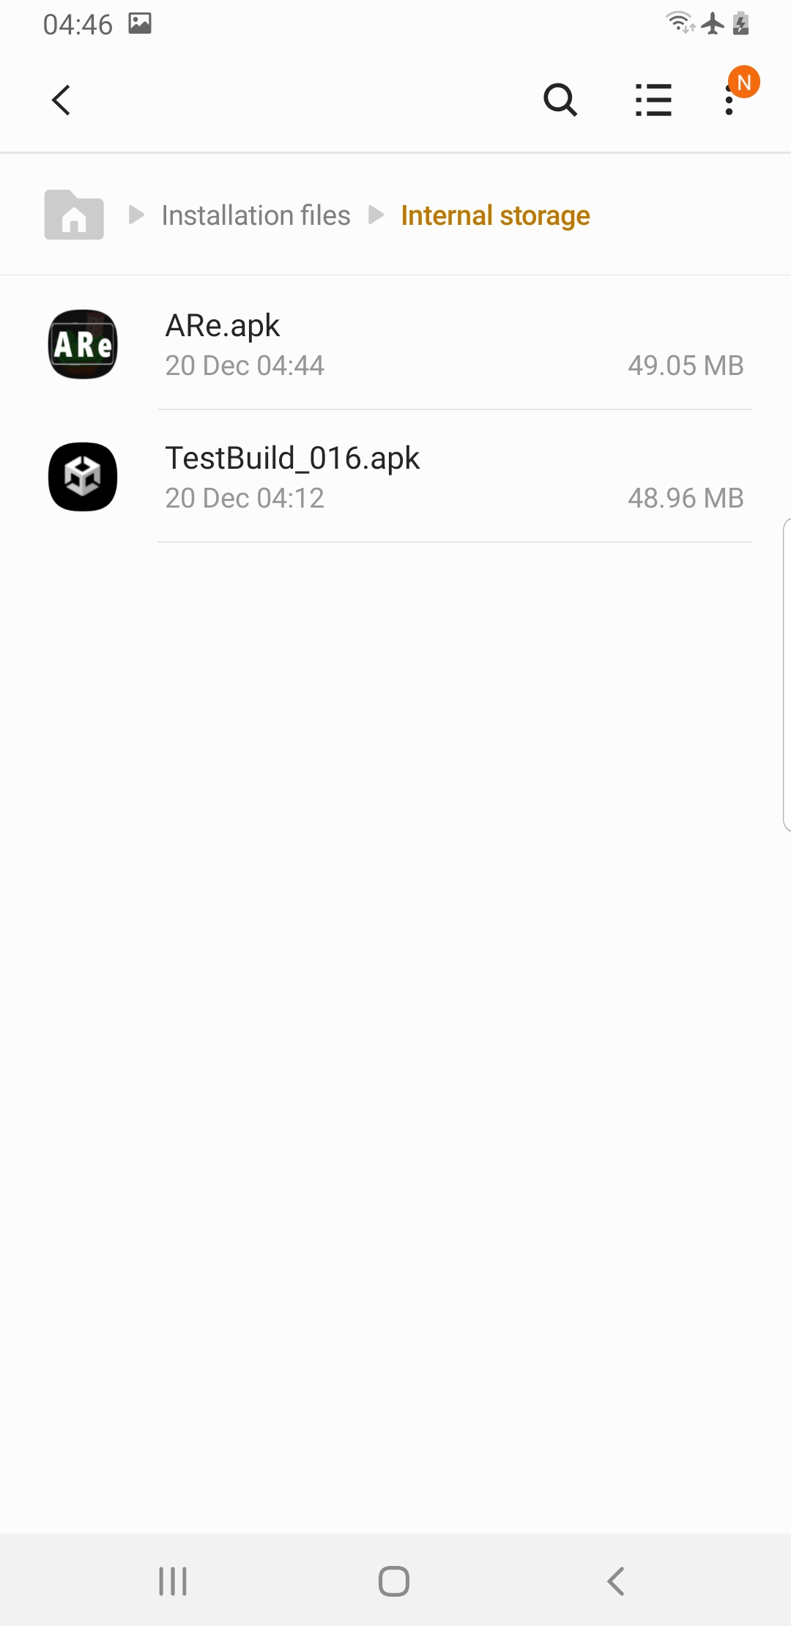

Note: On the Samsung Galaxy S8+, the transferred file will be sent to the Internal storage unless set otherwise.

- Tap the Internal storage option on the new window.
- You will see the ARe.apk file on this new window. Tap the file to begin installation.
- A new window will appear asking for permission to install the file. Tap Install (at the bottom right corner)
- After the application has been installed, tap on Done to return to the last page.

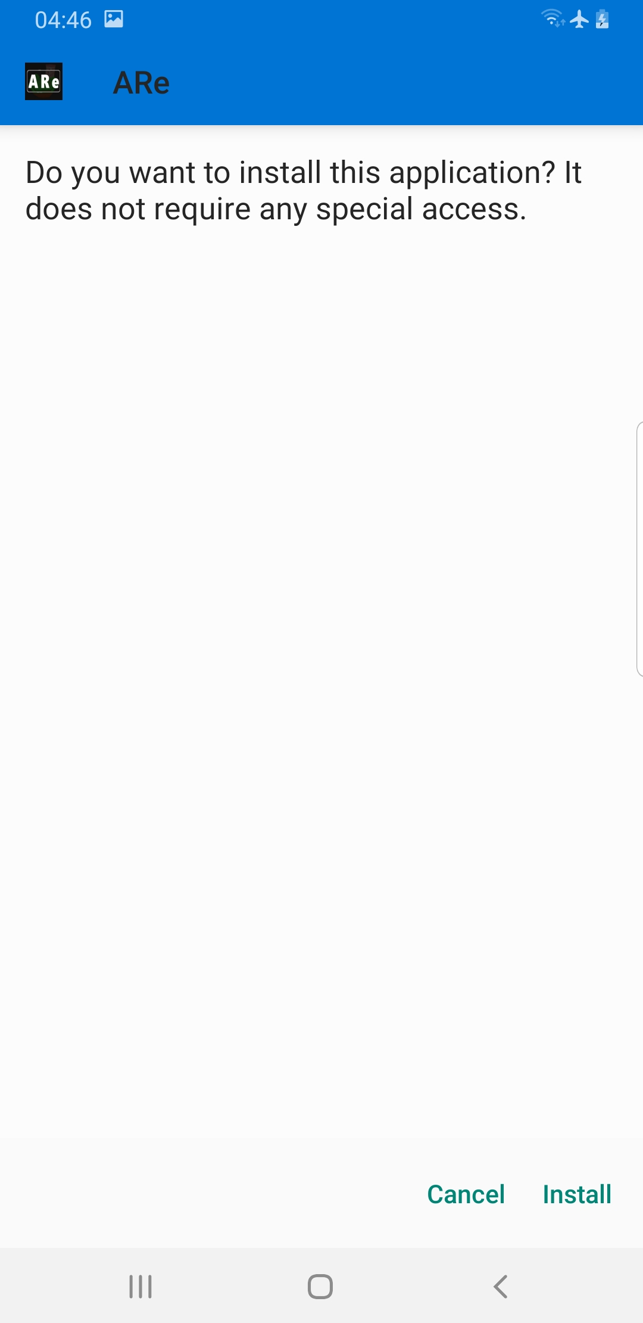
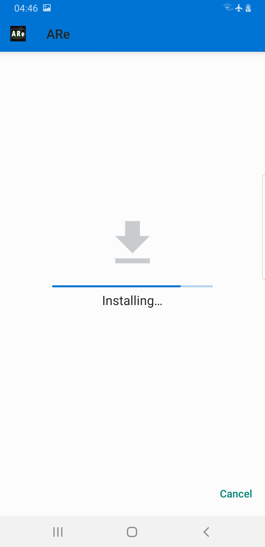
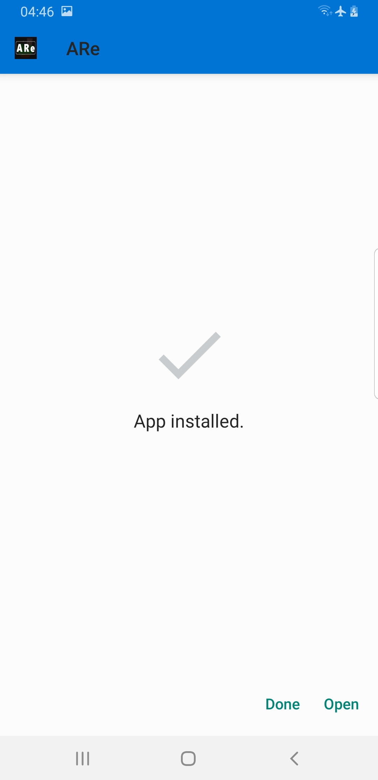

How to Run ARe on your device

- Power your Android mobile device
- Navigate to the location on the apps window where you’ll find the ARe icon
- Tap the icon

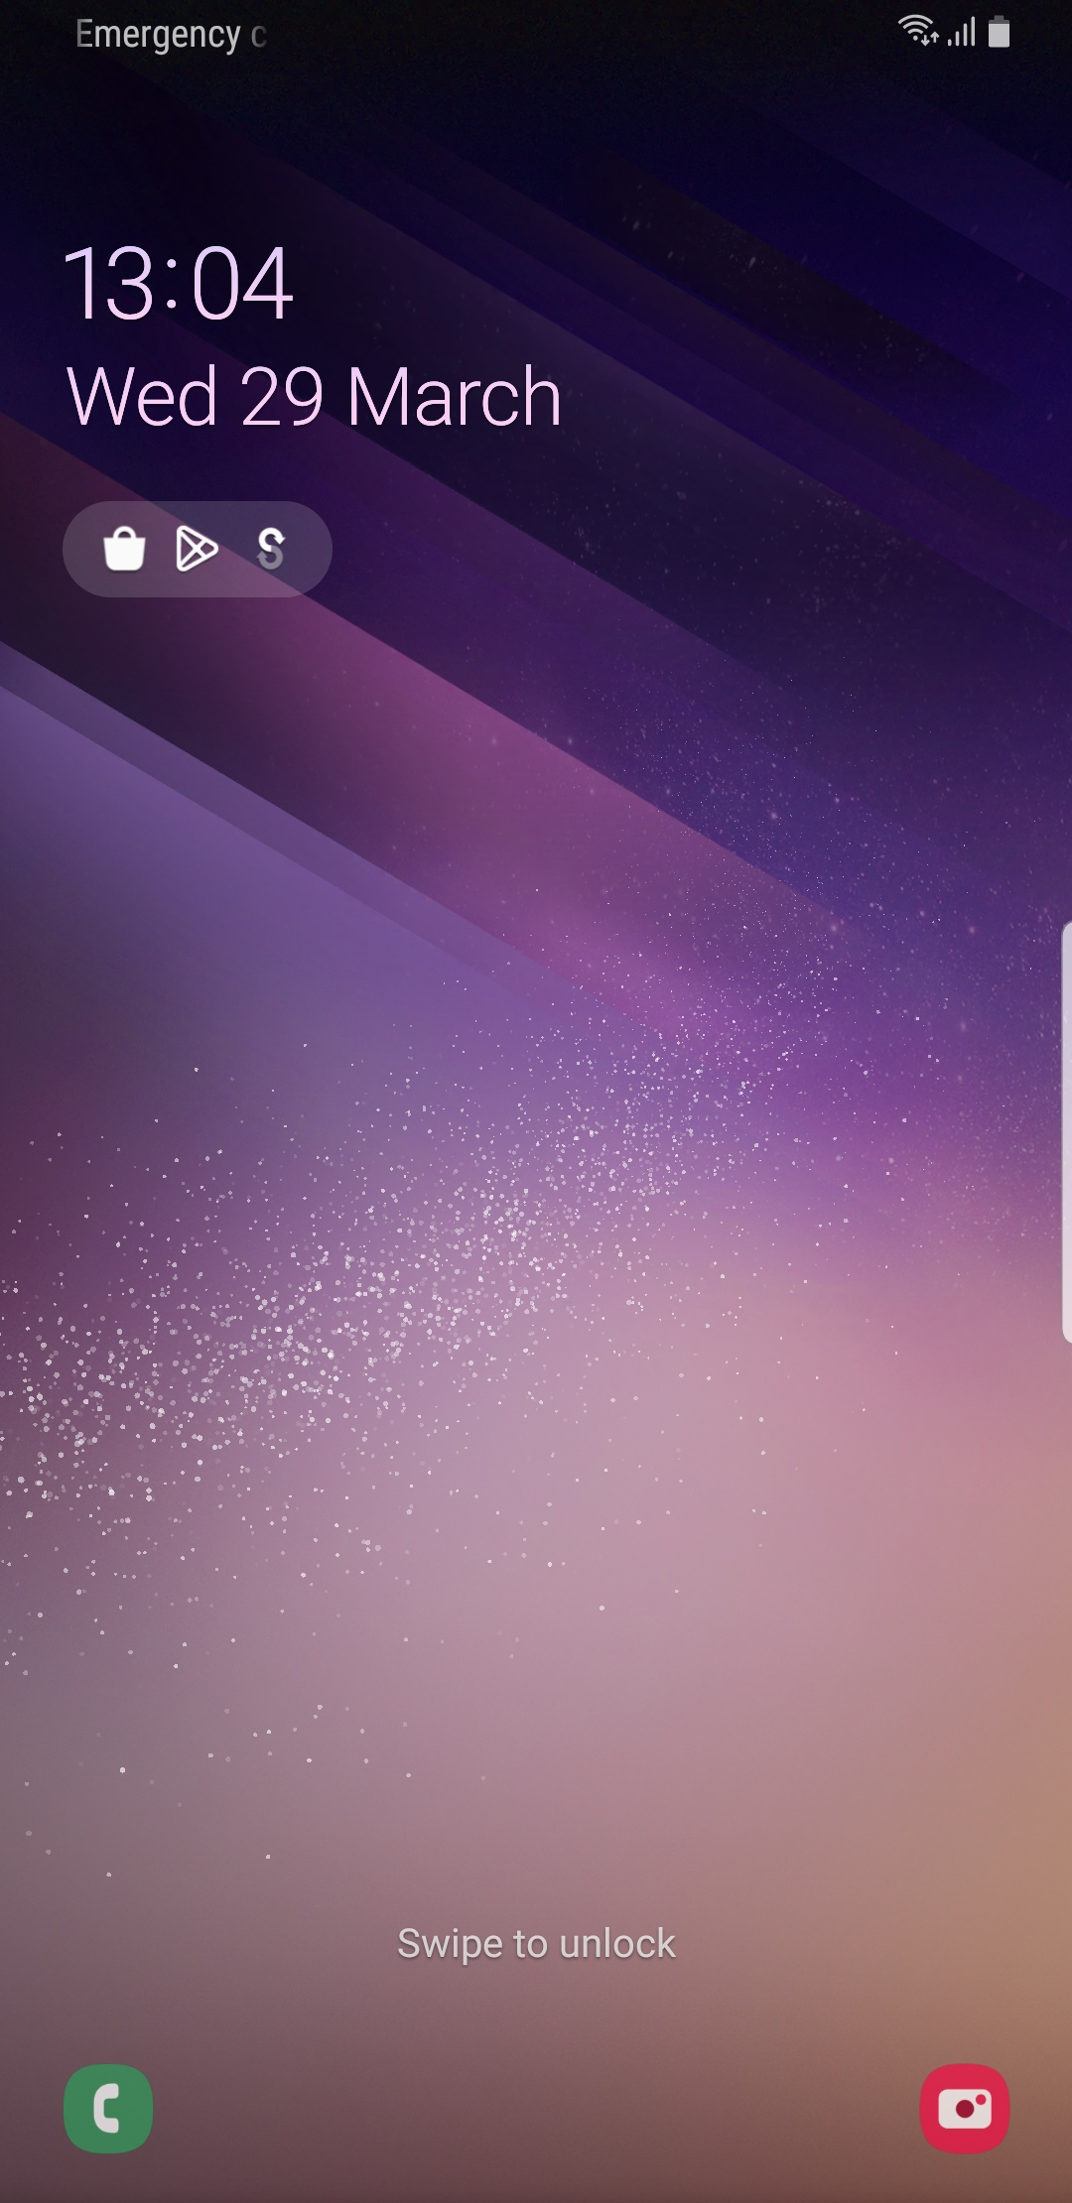
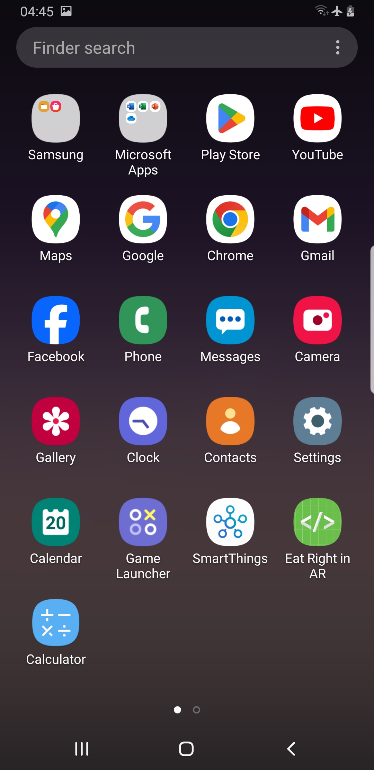
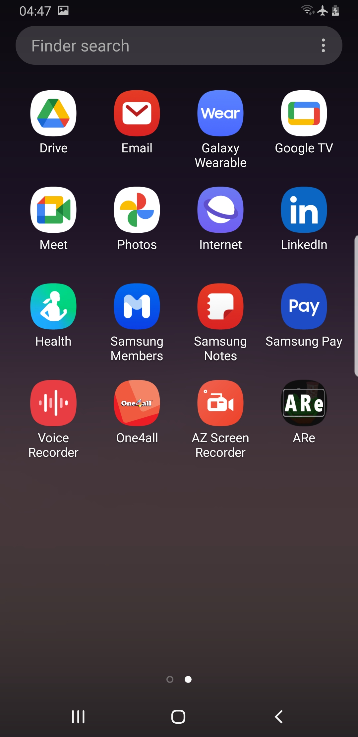

Note: An initial Made in Unity screen will appear shortly on screen. After which a notification requesting access to take pictures and record videos.
- Tap Allow on the on-screen notification.
Note: A blank screen will appear shortly, after which the screen comes live through the camera.

- At this point, select the marker of your choice and place it on a table or flat surface.
- Hold your mobile device in the horizontal position over the image tracker.
- Once the camera recognizes the image tracker, the digital content will be displayed over it.

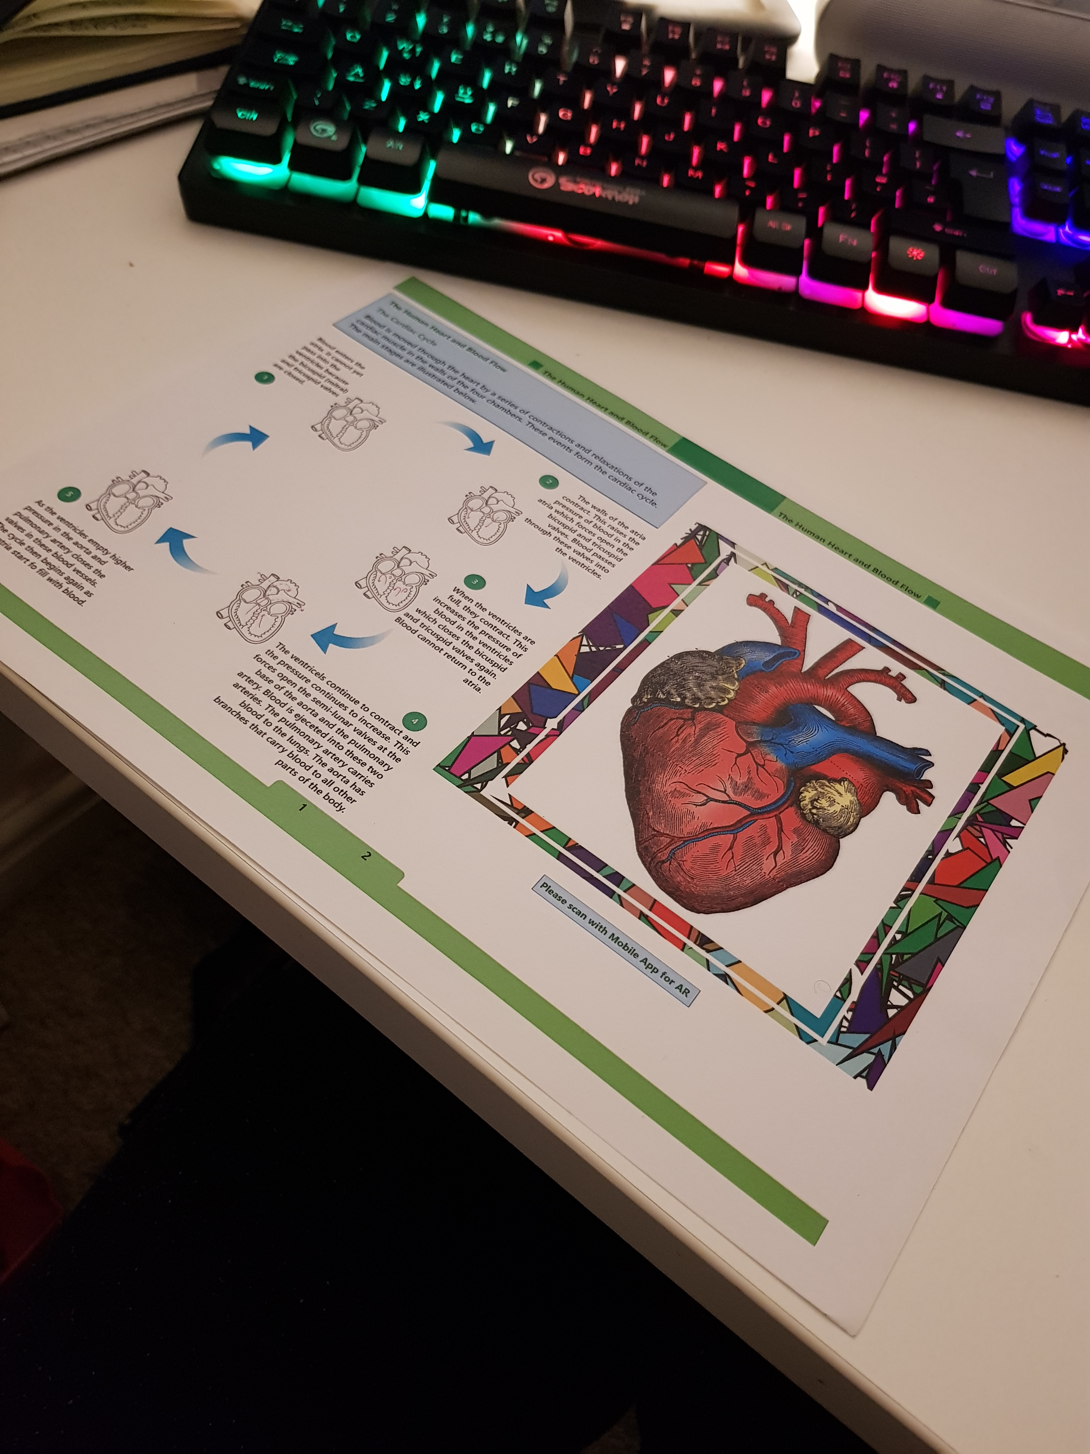
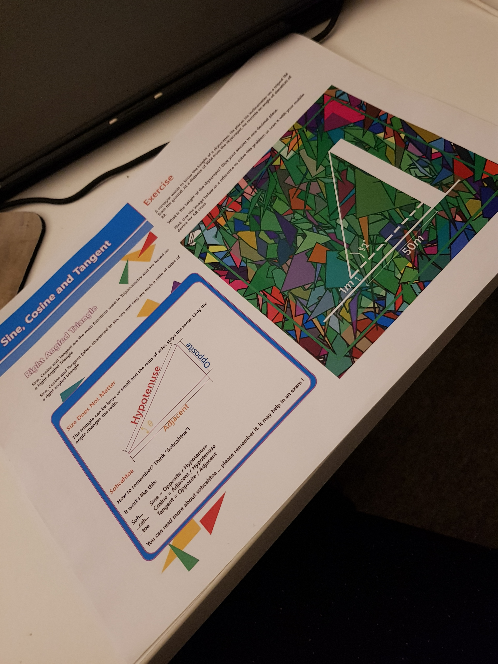
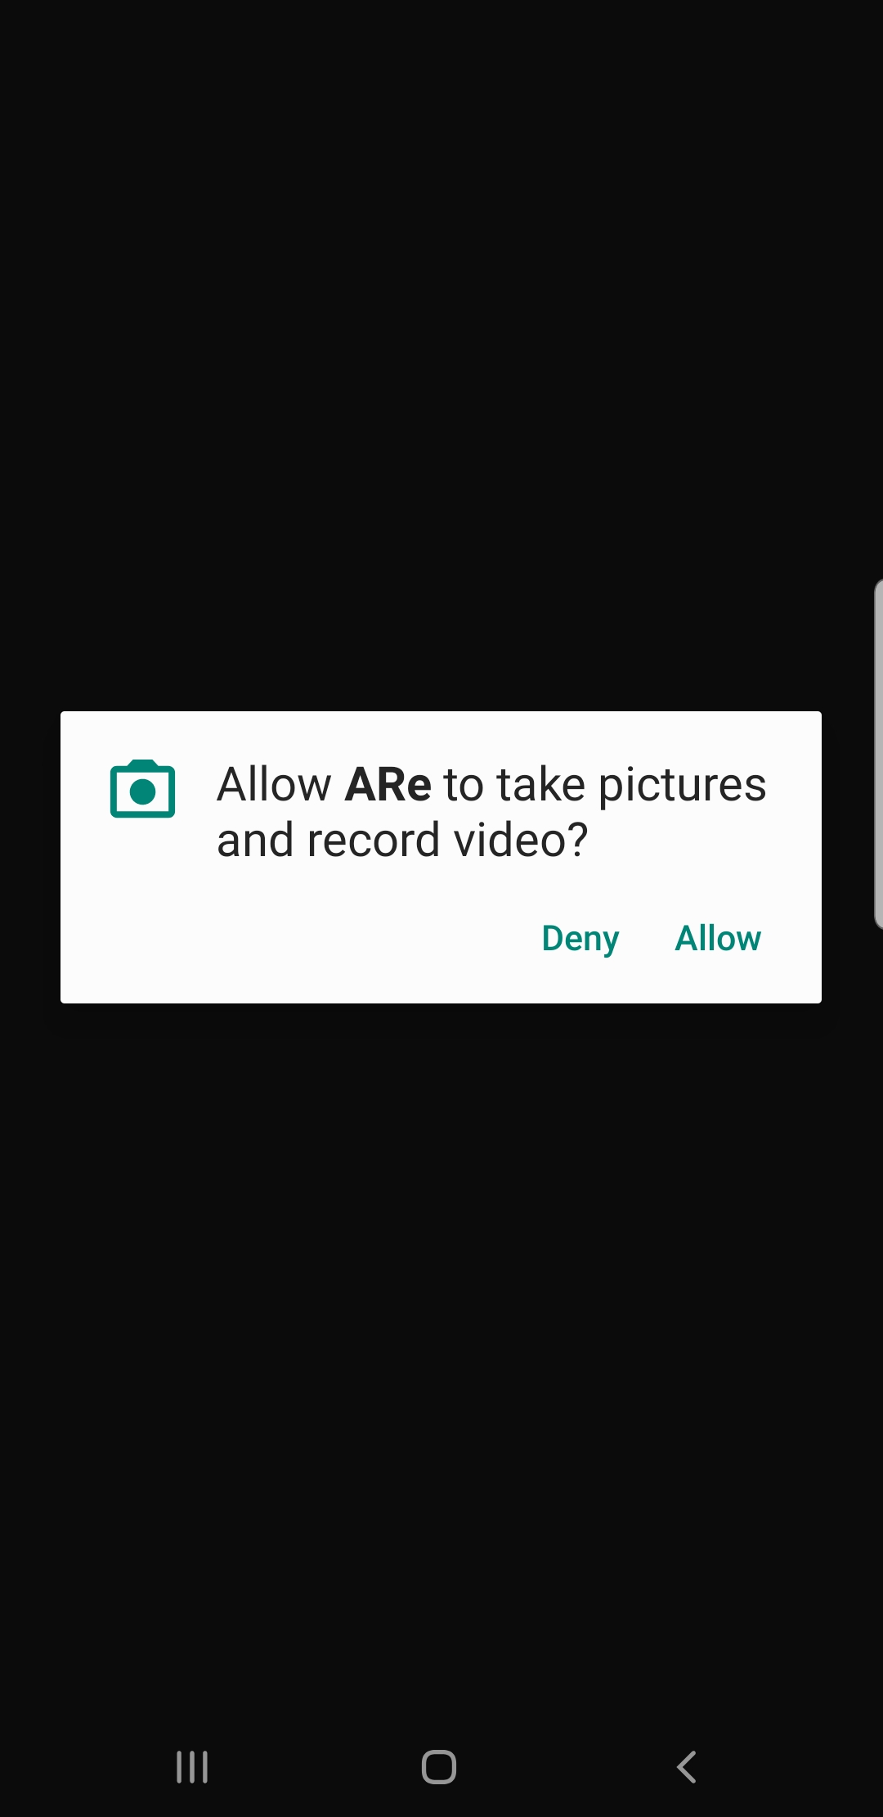

ARe User Controls Guide

Note: ARe uses the known touch screen interaction gestures and special tap and hold actions for additional features. With these controls you’ll be able to move the digital content on screen, rotate it in place, scale to get a better perspective/see things aspects of it in more details, discover hidden information/areas of the content.

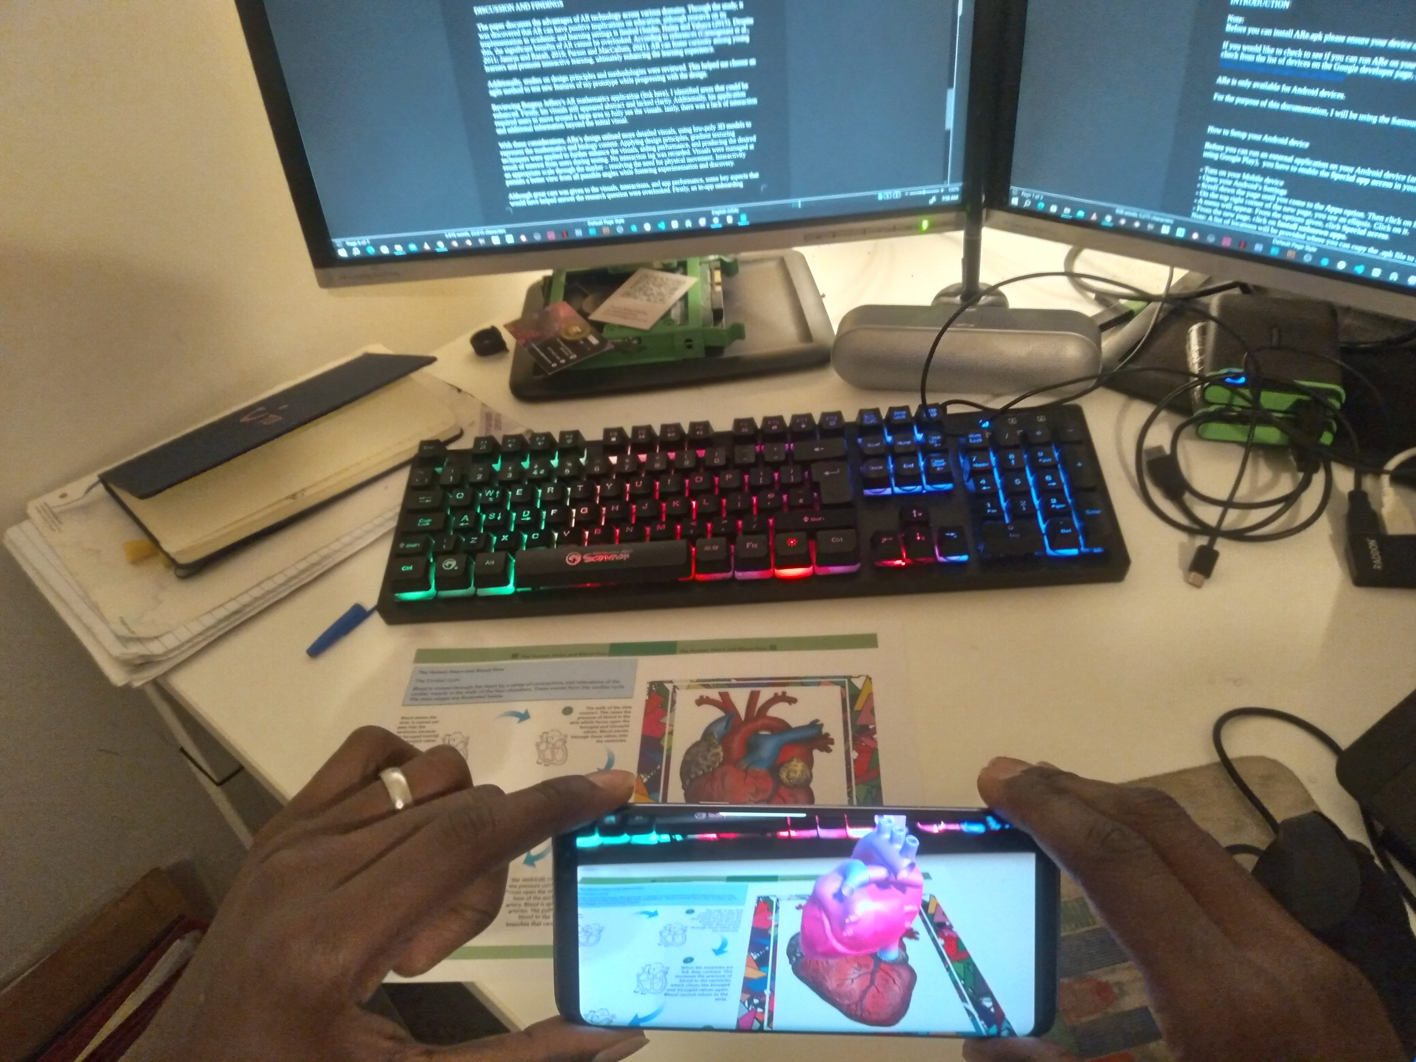
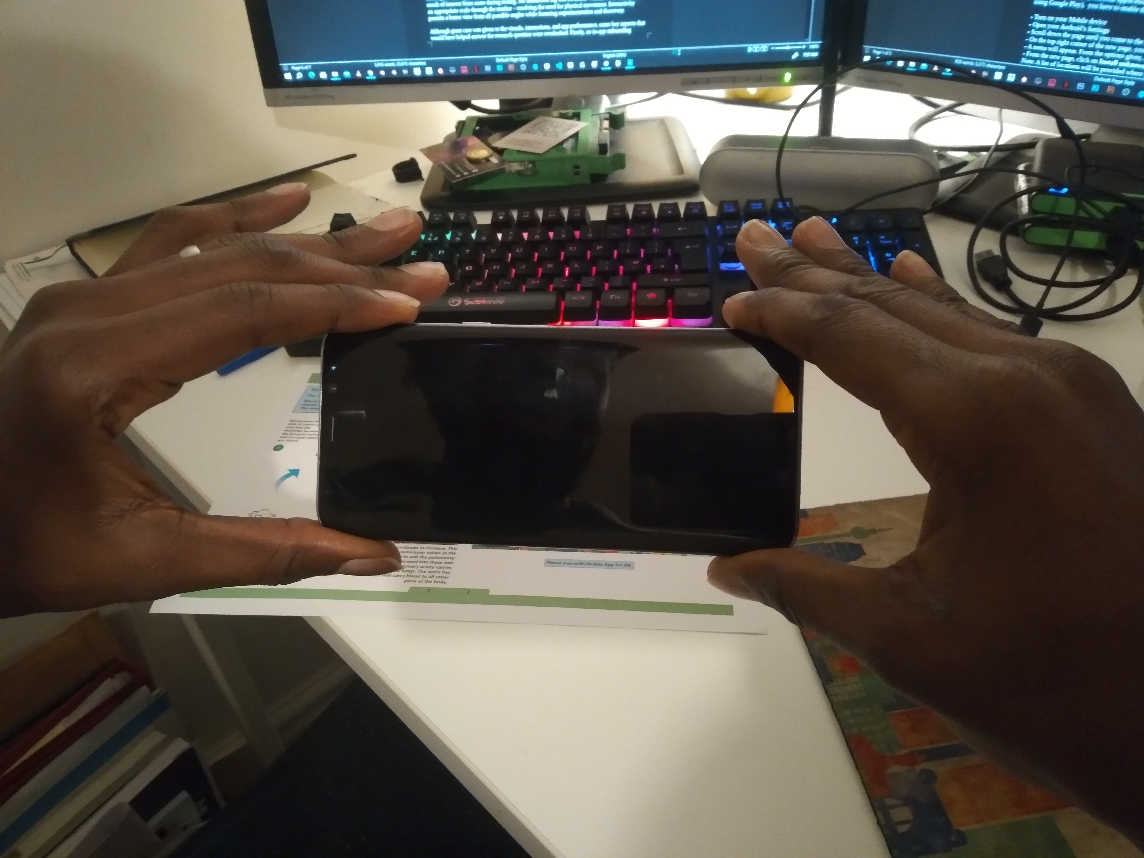

Move

To move the content on your screen in any direction, tap the object with your finger (preferable the index finger) and with your finger still on the object, move/grab in any direction to move it.

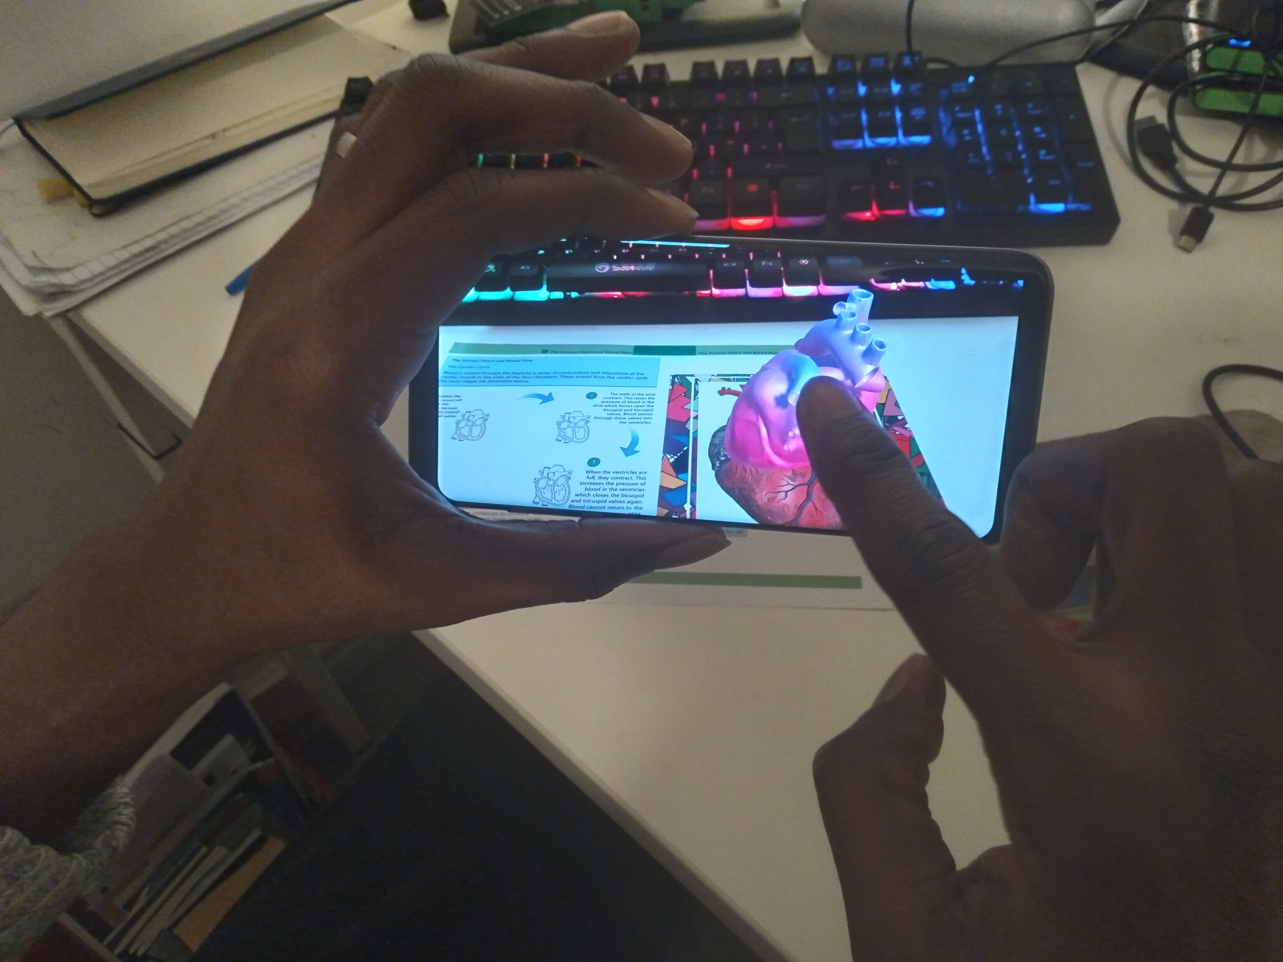

Rotate

For Rotation, slide your finger across any area on the screen outside the know radius of the digital content. To rotate right, swipe finger right on screen. To rotate left, swipe finger left on screen.

Scale

To get a better view of the content, pinch the screen with two fingers (preferable the Index finger and the thumb). To zoom closer, expand the distance between both fingers. To zoom out, bring both fingers closer together.

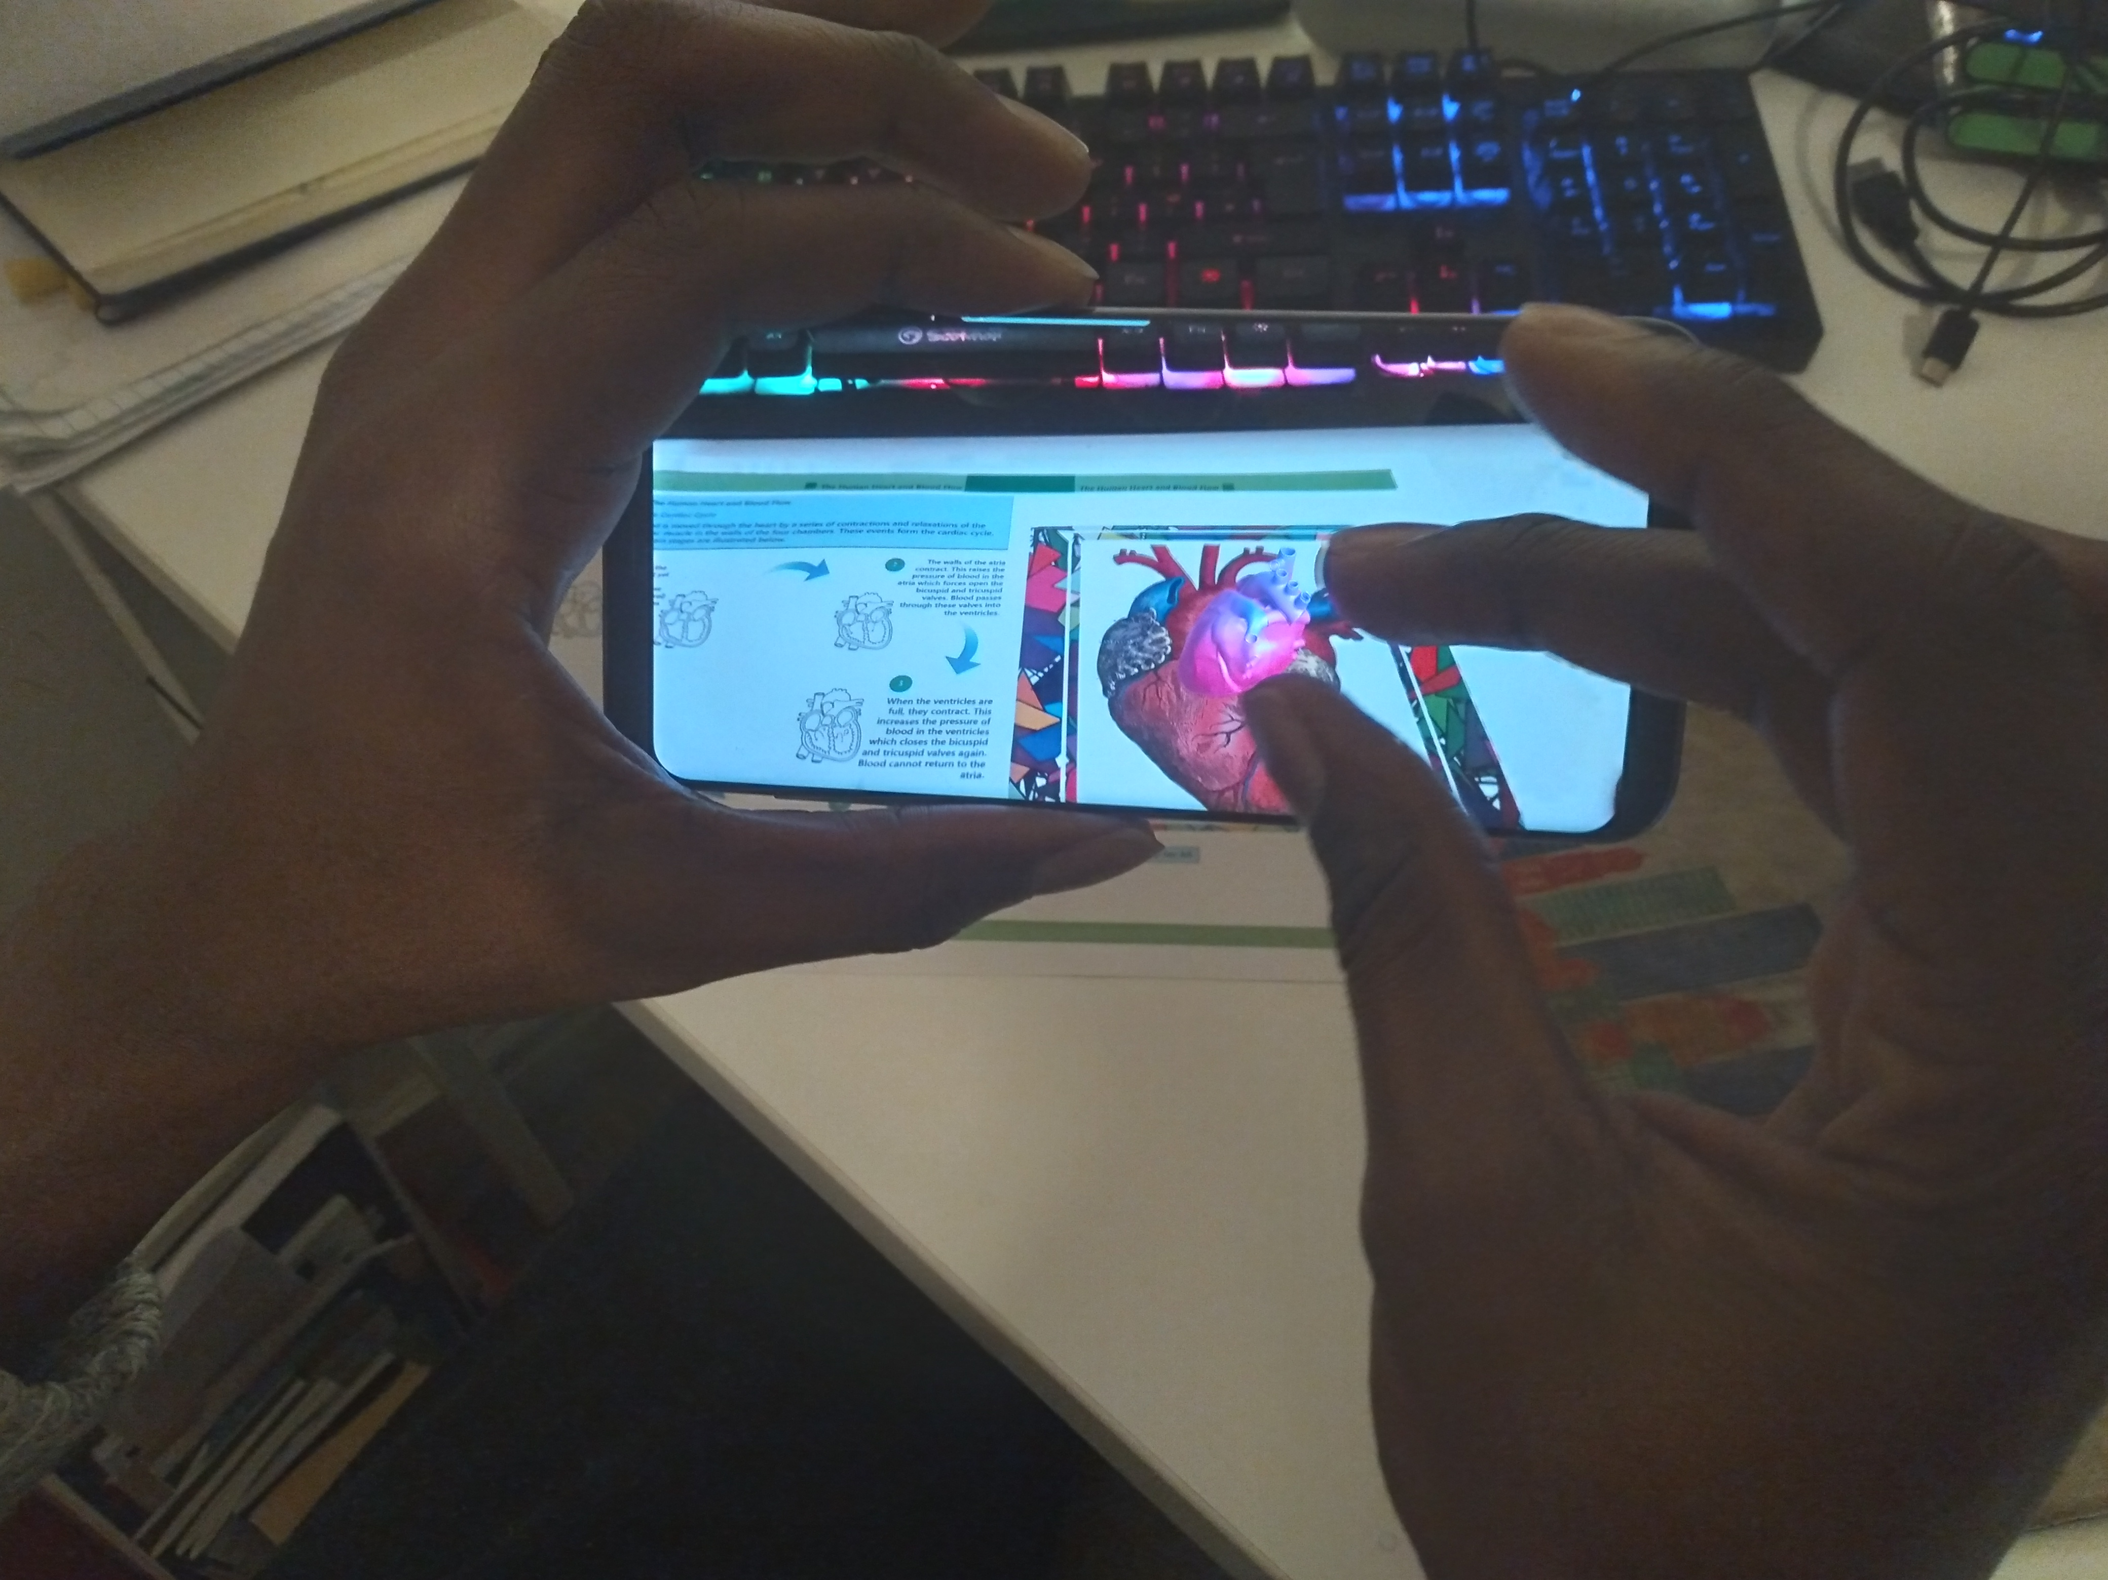
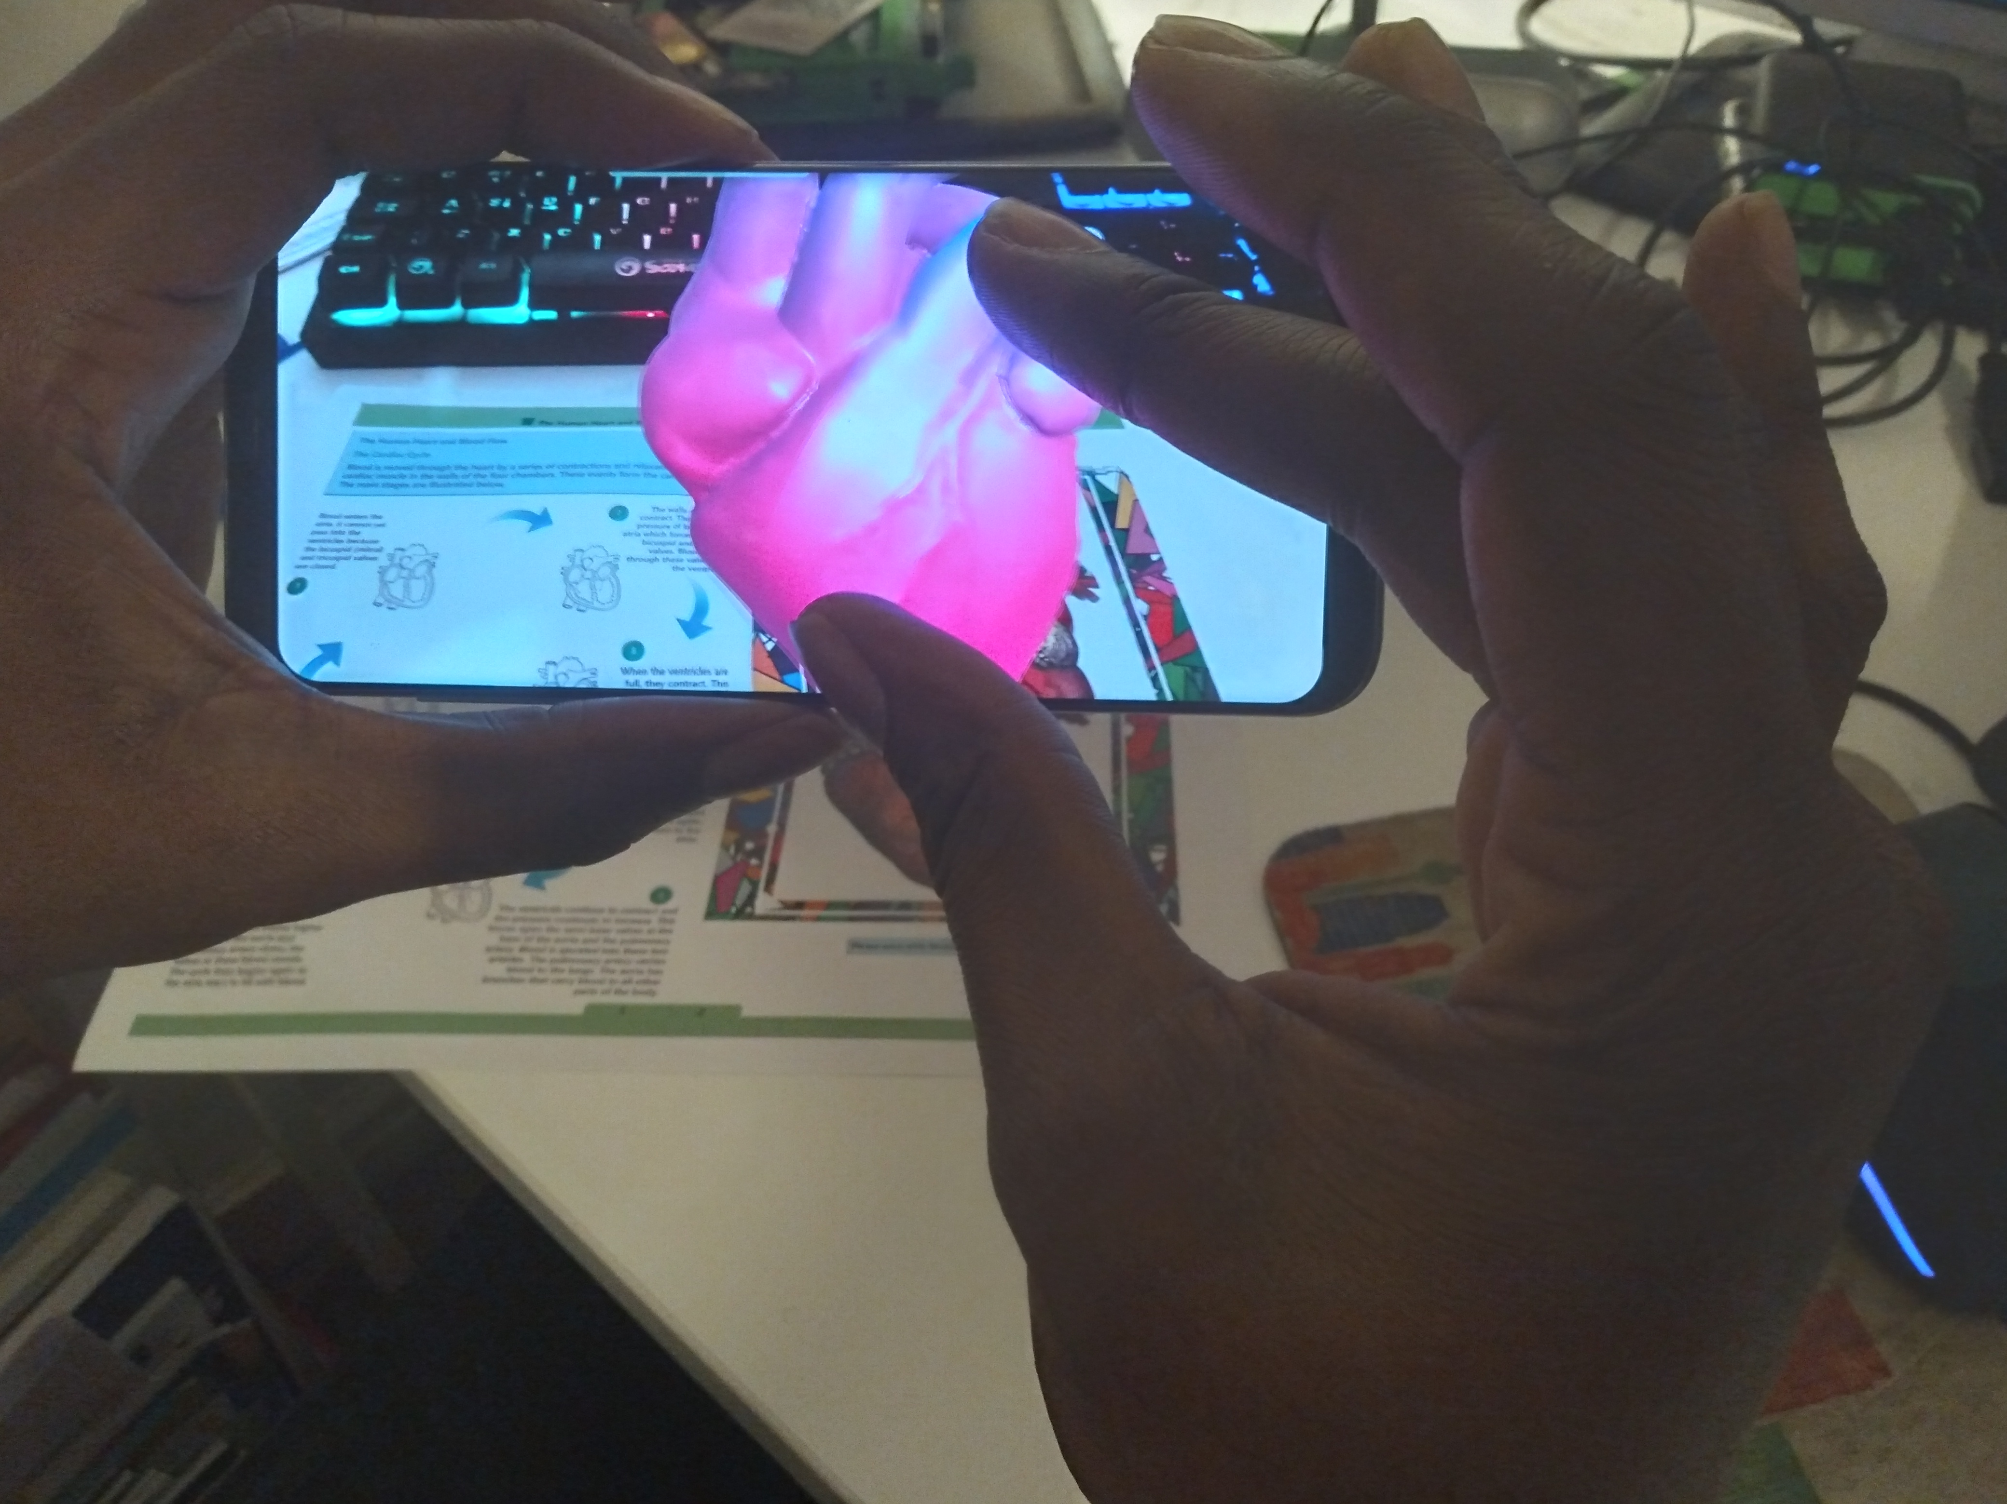

Note: When zoomed in really close, you might be unable to rotate the content on screen. If this happens, zoom out to create enough screen room, then retry rotation action.

Display

Here there are two main options; revealing hidden content/annotations or showing/hiding portions of a content. The actions below works across both interactions depending on the content being interacted with.

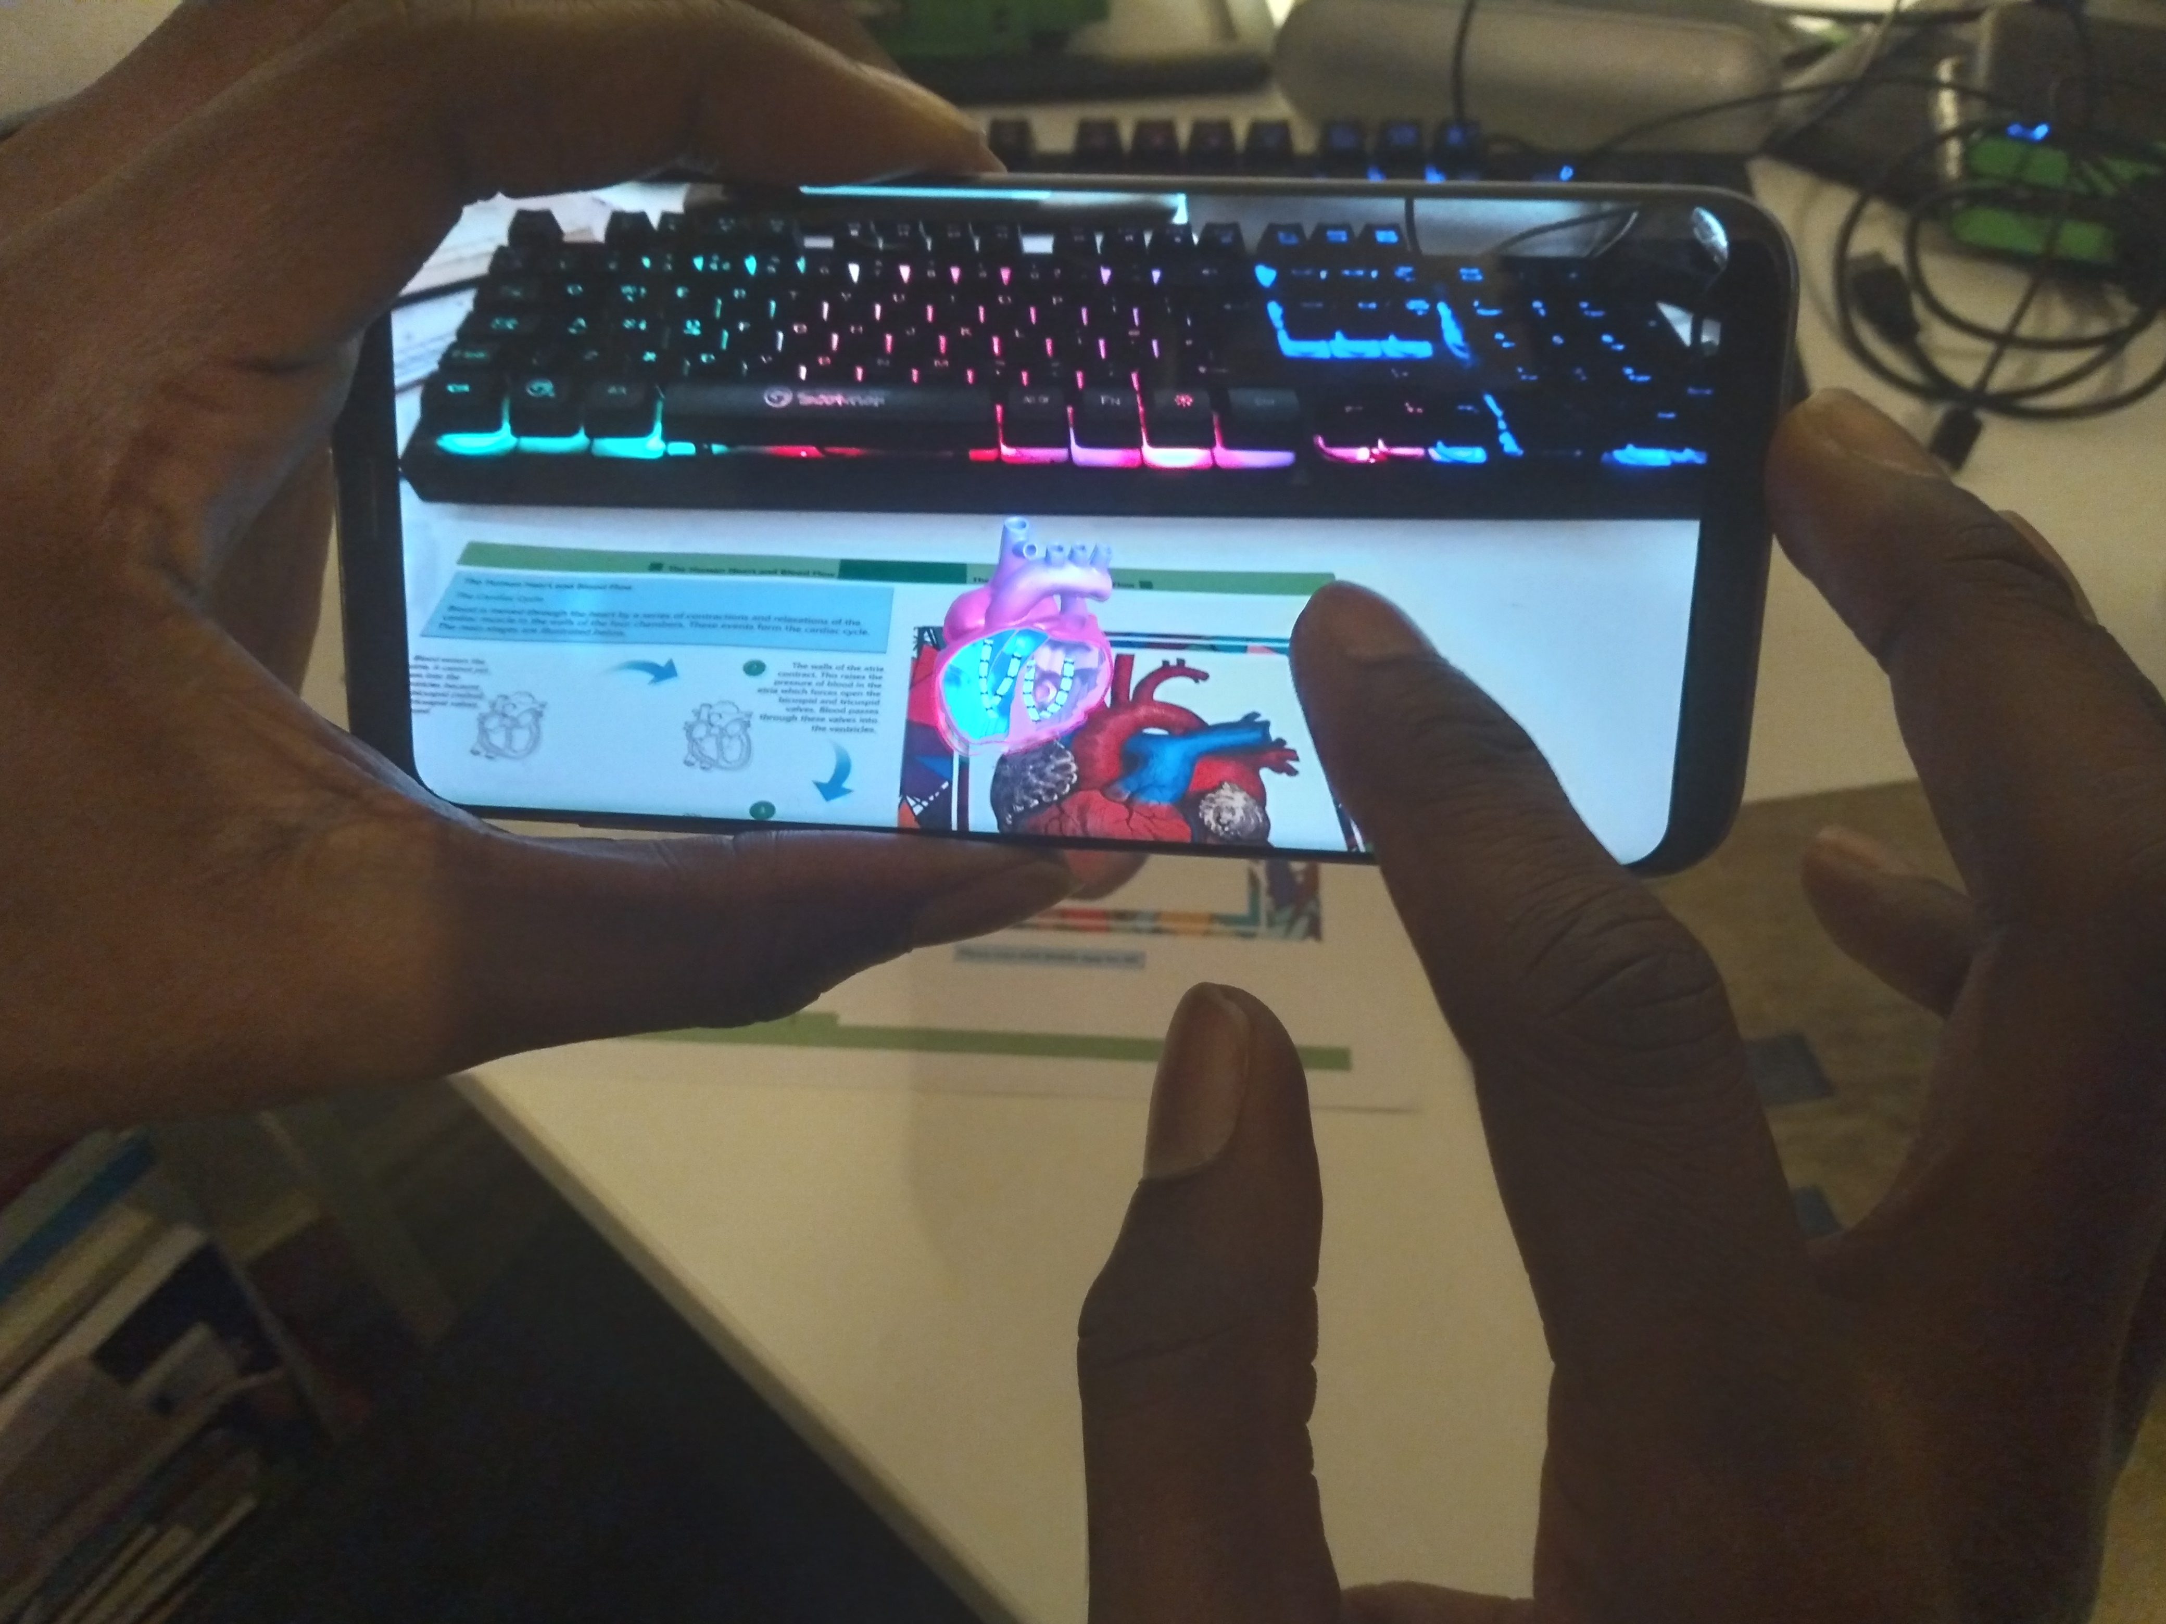
- Double tap to hide/unhide menus, regions of the content.
- Tap and hold down the screen to reveal hidden menus or information.

ote: When you tap and hold the screen, a loading circular timer ui will appear. Once the timer has counted down, release to see the information. To undo recent action, tap and hold down the screen again until the circular timer appears and counts down, then release to undo the recent action.



