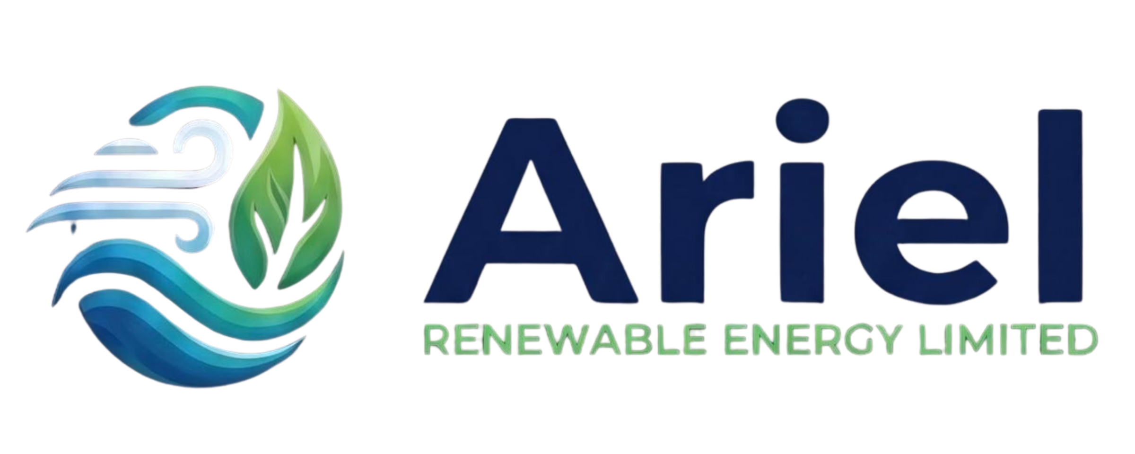
TURNKEY SOLAR EPC & SREDA NET-METERING COMMERCIAL DOSSIER
A Strategic Capital Investment, Technical Architecture & 25-Year Decarbonization Framework for Bangladesh Industrial, Commercial & Institutional Facilities
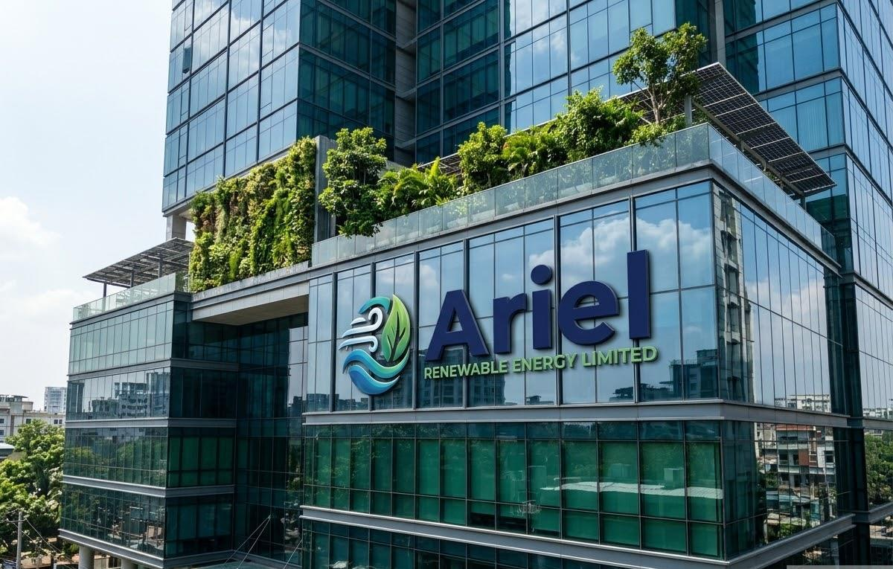

DOCUMENT CLASSIFICATION: Strictly Private & Confidential | ISSUING ENTITY: Ariel Renewable Energy Limited
DOCUMENT REFERENCE: AREL-EPC-2026-BOARD-V1 | PARENT GROUP: ArielMC Enterprise Eco-System
PREPARED FOR: The Board of Directors / Chairman / CEO | SECTOR / PRODUCT: Energy / Solar Infrastructure
REGULATORY FRAMEWORK: SREDA Net-Metering Guidelines 2018 | FINANCING SCHEME: Bangladesh Bank 4.5% Green Refinancing
COMMAND HUB: energy.arielmc.com | crm.arielmc.com | DATE OF ISSUANCE: November 2026 (Commercial Release)

EXECUTIVE TRANSMITTAL NOTE
To: The Chairman, Managing Director & Members of the Board
Subject: Strategic Turnkey Rooftop Solar EPC & Long-Term Energy Cost Insulation
Dear Industrial & Commercial Leaders,
As Bangladesh navigates rapid industrial transformation, energy cost and grid reliability have become the single most decisive determinants of export competitiveness and enterprise profitability. Over the past 36 months, bulk industrial electricity tariffs have escalated continuously, while fossil-fuel supply shocks and captive diesel generation costs (exceeding Tk 32 to 36 per kWh) place unprecedented strain on operational margins.
Concurrently, European and American buyers are strictly enforcing decarbonization mandates. The European Union's Carbon Border Adjustment Mechanism (CBAM), LEED Platinum factory standards, and global Scope-2 greenhouse gas auditing mean that clean power is no longer an optional corporate luxury—it is an existential commercial requirement to protect export volume.
Your rooftop represents an unharvested goldmine. A vacant industrial PEB shed, commercial tower slab, or institutional roof can immediately be converted into a high-yielding, captive power plant producing clean daylight electricity at an amortized Levelized Cost of Electricity (LCOE) of Tk 3.20 per unit—compared to the Tk 11.50 to Tk 15.00 per unit you currently pay the national grid.
Ariel Renewable Energy Limited, a proud subsidiary of the ArielMC enterprise group, provides a total, zero-risk turnkey solution. We assume full legal, structural, civil, and regulatory responsibility: from 3D LiDAR drone surveying and SREDA Net-Metering approvals to high-spec EPC installation and 25 years of guaranteed Operations & Maintenance.
Sincerely and with national pride,
Syed Akramul Hassan
Managing Director & Chief Executive Officer
Ariel Renewable Energy Limited | ArielMC Enterprise Eco-System
Dhaka, Bangladesh • energy.arielmc.com • crm.arielmc.com

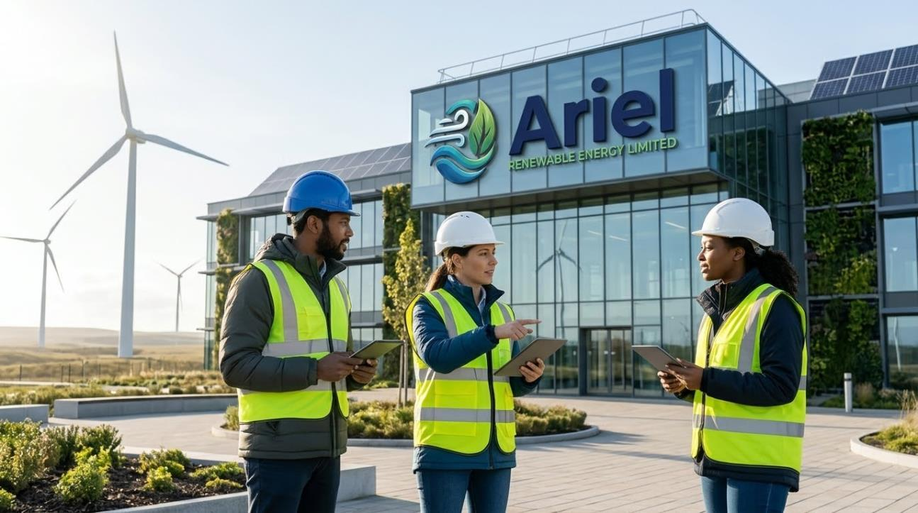

1. THE BANGLADESH ENERGY PARADIGM & ECONOMIC IMPERATIVE
Comparative Tariff Analysis: Legacy Grid Power vs. Ariel Turnkey Solar
Energy Source / Class | Cost / kWh (BDT) | Cost Trend (2026-2035) | Carbon / Buyer Compliance
REB / DESCO Industrial (LT-E/HT-3) | Tk 10.80 - 12.20 / unit | +8% to +12% / year | Fossil-heavy; Scope 2 Penalty
Commercial Peak Grid (Motijheel/Gulshan) | Tk 13.80 - 15.20 / unit | +10% to +14% / year | Zero Green Points; High OPEX
Captive Diesel Generator (Backup) | Tk 32.00 - 38.00 / unit | Tied to crude oil imports | Severe carbon emission & noise
Ariel Turnkey Rooftop Solar (SREDA) | Tk 3.20 / unit (LCOE) | FIXED for 25 Years (Tk 0 Fuel) | 100% Green; CBAM & LEED Certified

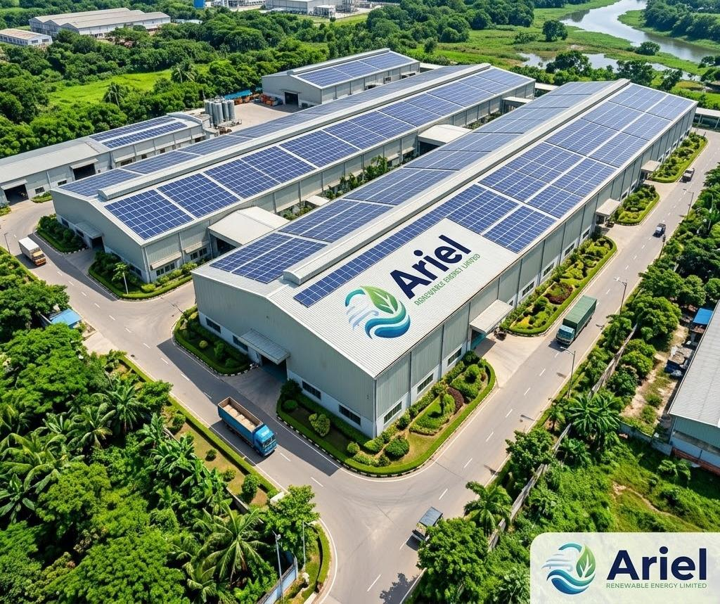

2. ENGINEERED COMMERCIAL PACKAGES (INDUSTRIAL, COMMERCIAL, RESIDENTIAL)
Industrial Packages Suite (C&I Focus)
Package Code | Capacity | Roof Footprint | Monthly Yield | Target Industry Profile
F1: Industrial Base-Load Offset | 300 kWp | ~24,000 sq ft | 36,000 - 39,000 kWh | Washing, dyeing, leather finishing sheds
F2: Megawatt Flagship (Most Popular) | 1,000 kWp (1.0 MWp) | ~78,000 sq ft | 125,000 - 135,000 kWh | Composite RMG, spinning mills, ceramics
F3: Net-Zero Multi-Roof Complex | 2,500 kWp (2.5 MWp) | ~200,000+ sq ft | 315,000 - 340,000 kWh | Large export industrial parks, heavy steel

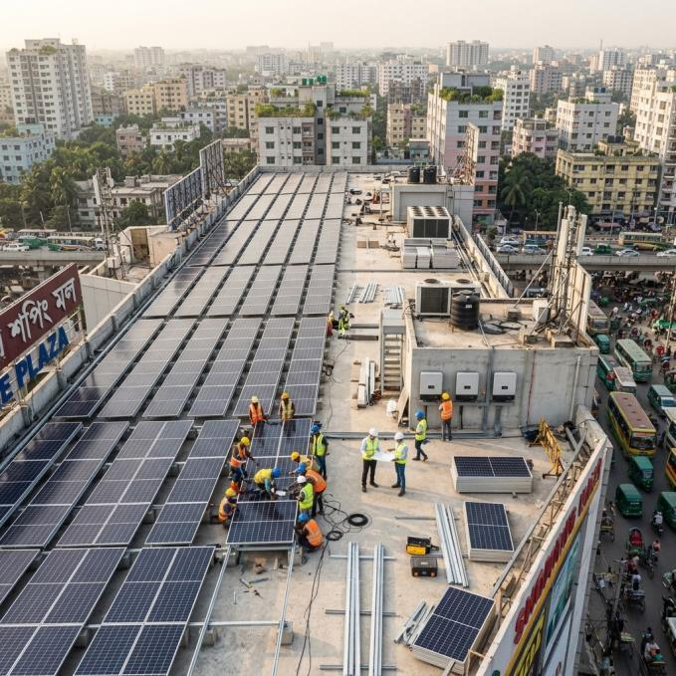

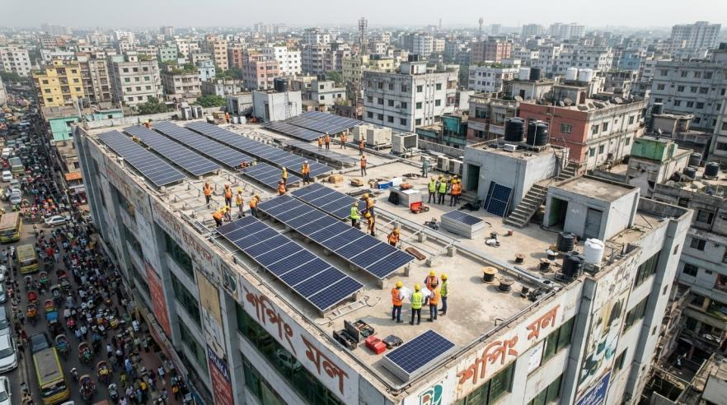
3. TURNKEY INVESTMENT COSTING & 25-YEAR ROI
Package Title | Capacity | Rate (Tk/Wp) | Total BDT | Total USD | Payback Period
F1: Industrial Base-Load | 300 kWp | Tk 52.00 | Tk 1,56,00,000 | ,000 | 3.2 Years
F2: Megawatt Flagship | 1.0 MWp | Tk 49.00 | Tk 4,90,00,000 | ,300 | 3.0 Years
F3: Heavy Industrial Complex | 2.5 MWp | Tk 47.50 | Tk 11,87,50,000 | ,500 | 2.85 Years
C1: Corporate Office Tower | 75 kWp | Tk 62.00 | Tk 46,50,000 | ,750 | 3.1 Years
C2: Retail Mall & Hospital | 200 kWp | Tk 58.00 | Tk 1,16,00,000 | ,600 | 2.9 Years
H1: Urban Villa Micro-Array | 10 kWp | Tk 75.00 | Tk 7,50,000 | ,250 | 4.2 Years
H2: Luxury Hybrid + 15kWh LFP | 20 kWp | Tk 110.00 | Tk 22,00,000 | ,300 | 5.5 Years
H3: Apartment Society Common | 40 kWp | Tk 68.00 | Tk 27,20,000 | ,600 | 3.8 Years

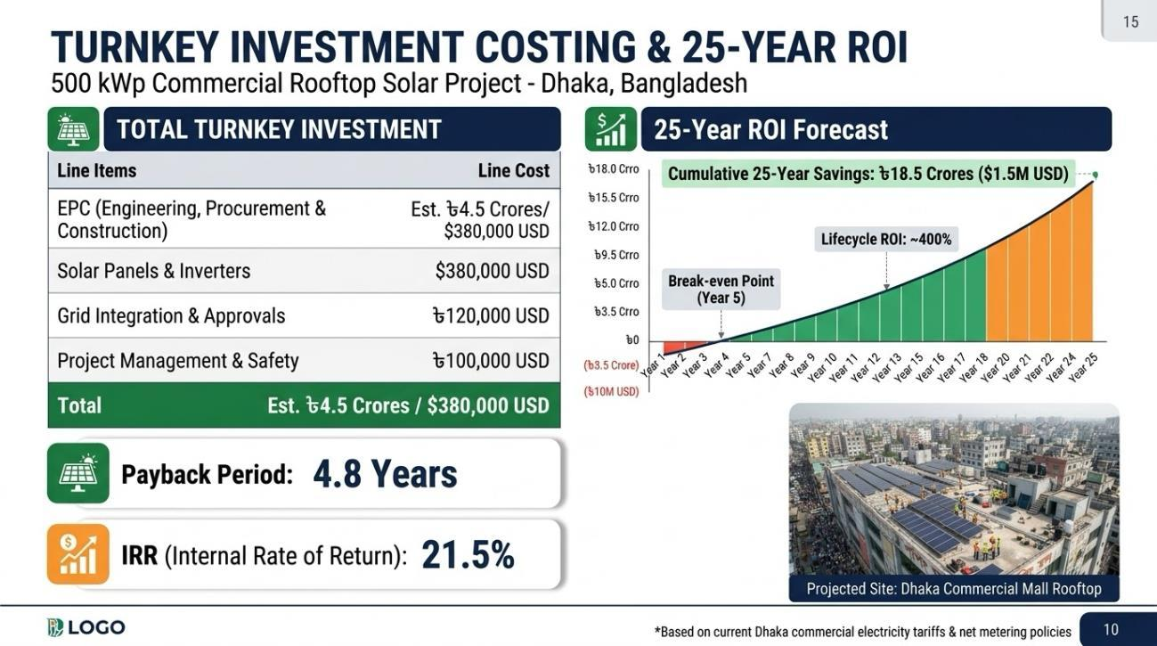

Zero Equity Depletion via Bangladesh Bank Green Refinance Scheme:
Under the Bangladesh Bank Green Transformation Fund (GTF), qualifying manufacturers access 80% project debt at a 4.5% to 5.0% concessionary interest rate. Monthly electricity bill savings surpass monthly debt service, creating positive cashflow from Month 1.

4. PRELIMINARY SITE SURVEY & FEASIBILITY AUTHORIZATION (LOI)
Scope of Complimentary Preliminary Feasibility Audit (Zero Cost & Non-Binding):
• 3D Drone Aerial Photogrammetry & Obstacle Shadow Mapping
• Structural Roof Load Verification (PEB / RCC)
• Substation & Net-Metering Integration Audit
• Historical Utility Bill Analysis & 25-Year Cashflow Model
• Deliverable within 5 Working Days: Bespoke 4-Page Bankable Feasibility Dossier
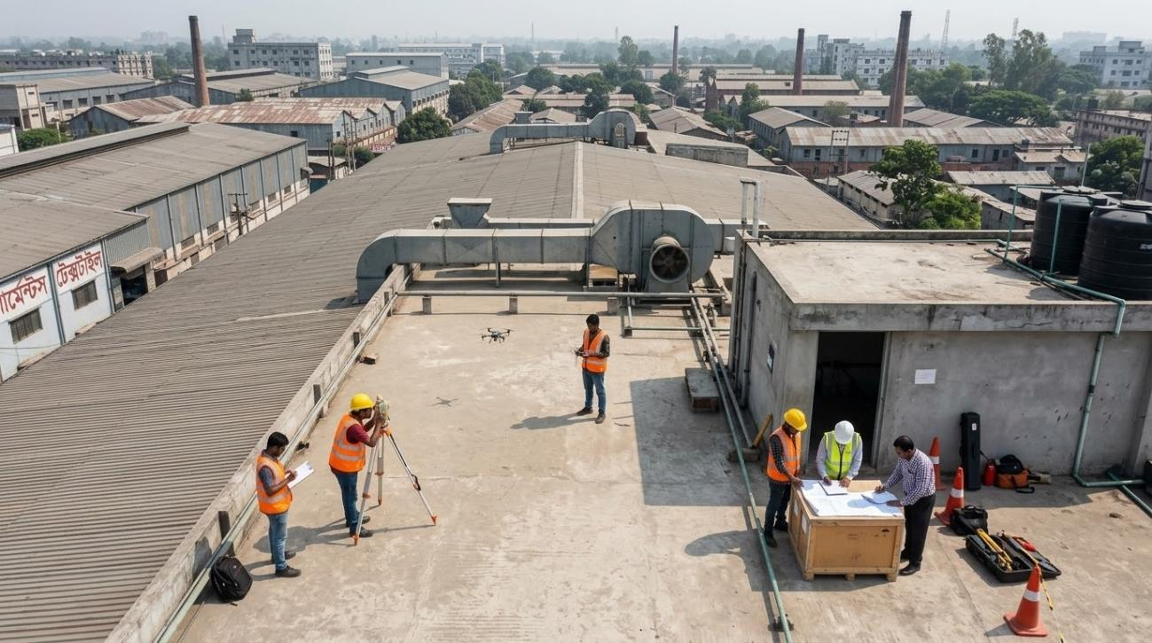

AUTHORIZED ON BEHALF OF CLIENT FACILITY: | ACCEPTED BY ARIEL RENEWABLE ENERGY LIMITED:
________________________________________  Authorized Signatory Signature  Full Name: ______________________________  Designation: Chairman / MD / Director / CEO  Company: _______________________________  Site Address: ___________________________  Date: ____ / ____ / 2026  Corporate Seal / Stamp: | ________________________________________  Ariel Energy Project Director Signature  Full Name: Syed Akramul Hassan  Designation: Managing Director & CEO  Entity: Ariel Renewable Energy Limited  Parent Group: ArielMC Enterprise Eco-System  Date: ____ / ____ / 2026  Official Corporate Seal:

